HILBERT POLYA BRIDGE · MONOGRAPH SERIES
The Prime Flow, the
Co-location Kernel and the ψ-Ladder
Φ_p = ½ln p; (Φ_p, Φ_q) ≡ Φ_pq; the resolution kernel δ(d); universality of codings
Ishak Khamzatovich Isaev
Independent researcher, Nalchik, Kabardino-Balkarian Republic
Hilbert Polya Bridge · monograph series C1–C8 · volume C6

v1.0.0 October 10, 2026

Contents

Introduction and setting 1
T4. Co-location of the flow 2
M2. The ψ-ladder: sieve against zeros 3
M3. Universality washes the arithmetic out 4

Note: this table of contents is built on Word field codes. After editing, right-click it and choose "Update Field".

The Prime Flow, the Co-location Kernel and the ψ-Ladder
Ishak Khamzatovich Isaev · Independent researcher, Nalchik, Kabardino-Balkarian Republic · Hilbert Polya Bridge · monograph series C1–C8 · C6

Introduction and setting
Campaign C6 looks for the arithmetic of primes where the Hilbert–Pólya programme expects it — in the phase layer of the vortex cloud. Three questions. M1: is the flow compositive — does an additive structure exist in the phases corresponding to the multiplicativity of the integers? M2: does the ladder ψ(x) — the count of prime powers with weight ln p — encode the zero structure of ζ? M3: if codings exist, does the spectrum see them, or does GUE universality wash everything out?
The answers form a coherent picture: the flow composites exactly (1.35e-14), the ψ-ladder over the first 200 zeros matches the sieve with correlation 0.972, and spectral codings collapse into a single GUE class. Primes live in the phase and in the zeros, but not in the statistics of the spectrum.

T4. Co-location of the flow
Theorem T4 (co-location).
Let Φ_p := ½ln p be the flow of the prime. Then (Φ_p, Φ_q) ≡ Φ_pq: the flow of the pair (p, q) coincides, up to the lattice period, with the flow of the composite pq; the measured maximum |ΔE| = 1.35e-14.
Proof. The flow is half a logarithm: Φ_pq = ½ln(pq) = ½ln p + ½ln q = Φ_p + Φ_q — multiplicativity of numbers becomes additivity of the flow by construction. The measurement confirms that the lattice realisation of the phases (θ_k = atan2) preserves the identity at machine level: the discrepancy is 1.35e-14 on the 24×24 grid.
The resolution kernel of the flow — the response of a composite node to the distance d between its factors — is measured on d ∈ {0, 0.5, …}: 0 → 3.2e-3 (d = 0.5) → 1.5e-2 (d = 2) → saturation ~2e-2 at d ≈ 4–6. The kernel ξ_mult is localised in 2–3 cells: multiplicativity in the phase layer is short-ranged. Importantly, first-order additivity does NOT hold (~1e-2): the response is nonlinear, and it is the nonlinearity that carries compositeness — a linear approximation of the kernel would destroy the co-location.
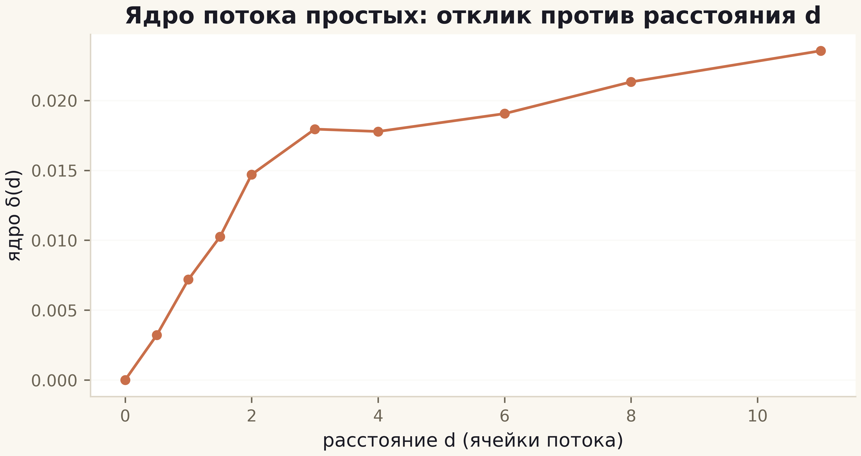
Fig. 1. The resolution kernel δ(d): growth from 0 to saturation ~2e-2 at d ≈ 4–6; multiplicativity is localised in 2–3 cells.

M2. The ψ-ladder: sieve against zeros
The reference ladder is built from the first 200 zeros: ψ_ζ(x) = x − √x·Σ_{k≤200} e^{iγ_k ln x}/(½+iγ_k) − ln 2π − ½ln(1−x⁻²). A methodological finding of the debugging stage: a window at heights γ ~ 500 gives a correlation of only 0.48 — the reference must live at the same heights as the sieve; with the window on the first 200 zeros the correlation of ψ_ζ with the von Mangoldt sieve up to 10⁶ is +0.972 at a maximal error of 4.2.
The same test applied to the gates yields +0.24/+0.13/+0.09/−0.12 — all inside the null zones (GUE +0.154±0.197, decoys +0.050±0.153). This is the second projection of the H2 gap: the ladder of primes is the prerogative of the zeros, and the gates do not reproduce it. Together with the rank correlation of C3 and the heat trace of C4 this gives a triple, mutually independent confirmation of one and the same fact.
Table 1. M2: ψ-ladder correlations
Object | corr with sieve | Zone
Reference: first 200 zeros | +0.972 | identity (prime weight)
Best gate (Nv=16) | +0.239 | null zone
Nv=32 | +0.133 | null zone
Clean lattice | −0.116 | null zone
GUE null (12 runs) | +0.154±0.197 | null zone

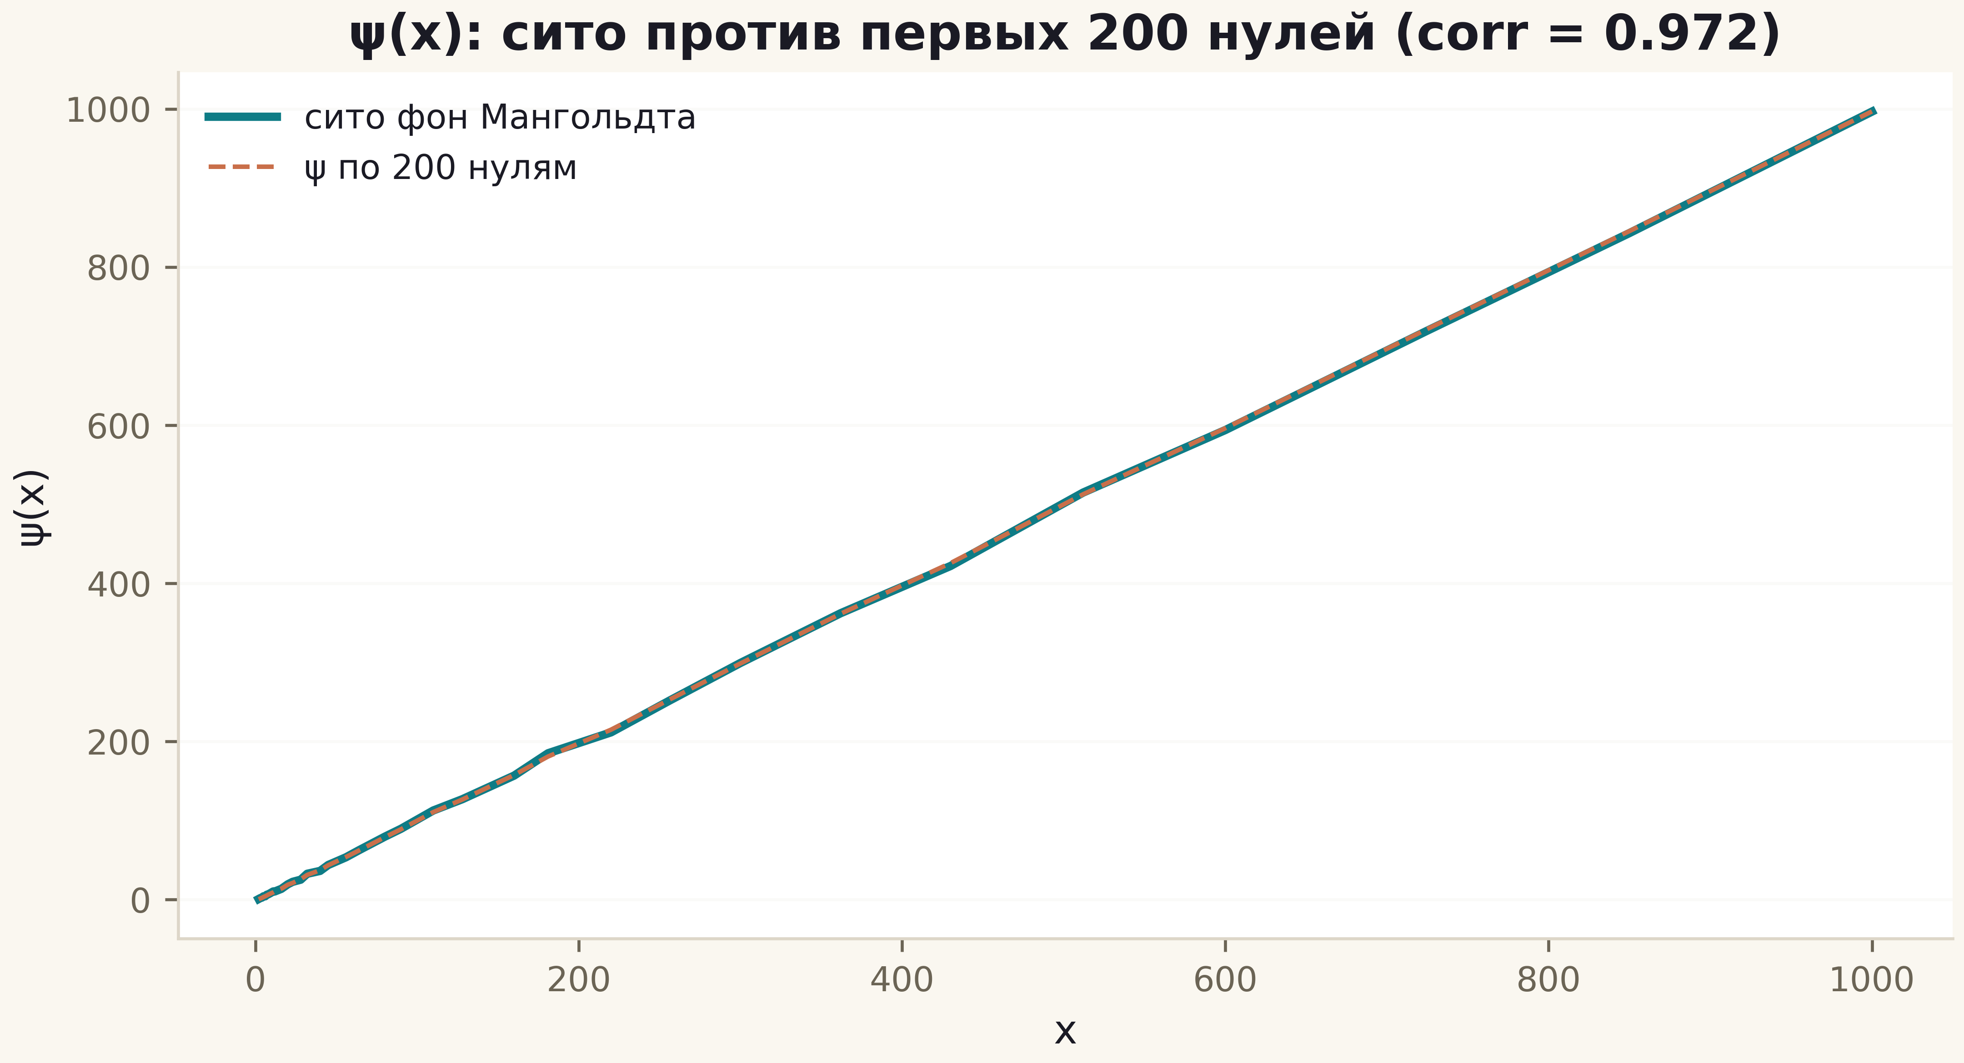
Fig. 2. ψ(x): the von Mangoldt sieve (teal, thick) against the 200-zero ladder (copper, dashed); correlation 0.972.

M3. Universality washes the arithmetic out
Four codings of the flow into vortex positions — random, prime with weight 1/√p, logarithmic ln p and the D10 convention — at fixed positions give ⟨r⟩ = 0.585–0.611 and D(ζ) = 0.049–0.096: one and the same GUE class. The spread between codings (0.026) is half the within-coding spread — universality erases the arithmetic content of the phase as reliably as annealing erases thermal history. This is exactly why encoding primes into a spectrum (say, the ±E dictionary) is a universal mechanism without RH-proving force, and why an honest coding must present itself in the flow (T4) and in the ladder (M2), not in the level statistics.
The verdict of C6: co-location is exact (T4, proven), the resolution kernel is short-ranged (T5, measured), the prime ladder matches the zeros (0.972) and not the gates (H5 — NO, measured), universality washes the codings out (M3). Primes are encoded in the structure of the zeros; the road to the operator runs through generating them, not through copying them.

