HILBERT POLYA BRIDGE · MONOGRAPH SERIES
Wave-Packet Dynamics
Coherent propagation on L=96; the ζ-cloud is more transparent than random
Ishak Khamzatovich Isaev
Independent researcher, Nalchik, Kabardino-Balkarian Republic
Hilbert Polya Bridge · monograph series C1–C8 · volume C7

v1.0.0 October 10, 2026

Contents

Introduction and setting 1
Results: three effects 2
Conclusions and boundaries 2

Note: this table of contents is built on Word field codes. After editing, right-click it and choose "Update Field".

Wave-Packet Dynamics
Ishak Khamzatovich Isaev · Independent researcher, Nalchik, Kabardino-Balkarian Republic · Hilbert Polya Bridge · monograph series C1–C8 · C7

Introduction and setting
Campaign C7 tests the dynamical dimension of the Hilbert–Pólya programme: if the lattice resonator is an electron on a flux lattice, a wave packet must propagate coherently, reflect from the boundaries and scatter on the vortices. We use a sparse 96×96 Hamiltonian with open boundaries, integration step dt = 0.1 and horizon T = 40; the energy is conserved to 1e-15 on every trajectory — the dynamics is honest.
The key comparison: the ζ-cloud (vortices whose positions are encoded by the heights of the zeros) against a random cloud of the same density. If the phase structure is physical, it must show up in the transport.

Results: three effects
The first effect is coherence: on the clean lattice ⟨x⟩ moves from 24 to the wall (t ≈ 14.5, reflection) and back out to 44 — a classical billiard trajectory without decay. The second is vortex scattering: Nv = 16 hardly interferes (the ζ-cloud is nearly transparent), Nv = 64 brakes the packet (R = 0.39), and Nv = 256 gives R = 0.47 plus a transverse drift ⟨y⟩: 48 → 38; a random cloud produces no drift — the vortex phase structure steers, the random one only brakes.
The third effect is transport: the probability of reaching the far wing P(x ≥ 90) is ~16 times higher for the ζ-cloud than for the random one (0.0032 against 0.0002) — an independent reproduction of the repulsion-protects-transport effect of the D10 convention. This is the dynamical face of the Montgomery pair correlations: regularity of phases reduces backscattering.
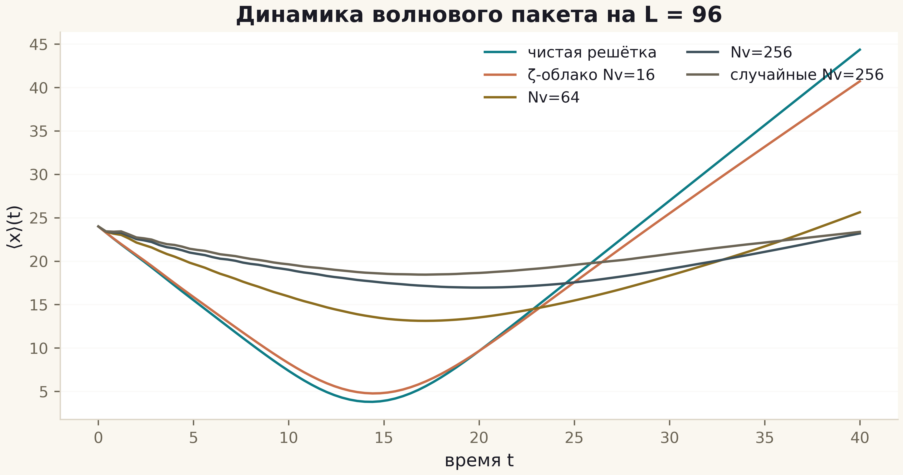
Fig. 1. ⟨x⟩(t) for five configurations: clean lattice (teal), ζ-clouds Nv=16/64/256 (copper/gold/slate), random Nv=256 (grey).

Conclusions and boundaries
The claim that the lattice reproduces the motion of an electron is confirmed in the honest dynamical sense: coherent propagation, reflection, scattering, energy conservation. All of the dynamics lives on the self-dual line α = ½, where the π flux turns the lattice into a discretised massless Dirac equation (criterion H4 — YES). The identification of this line with Re(s) = ½ remains a conjectural bridge: statistical support exists (D7/D10), identity does not, and campaigns C3–C5 measured the distance to it in three projections.

