HILBERT POLYA BRIDGE · MONOGRAPH SERIES
The Statistics Ladder and
Spin Structures
Poisson/GOE/GUE governed by symmetry; the 64→4 reduction (T8)
Ishak Khamzatovich Isaev
Independent researcher, Nalchik, Kabardino-Balkarian Republic
Hilbert Polya Bridge · monograph series C1–C8 · volume C8

v1.0.0 October 10, 2026

Contents

Introduction and setting 1
T10. The statistics ladder 2
T8. spinor64: the 64→4 reduction 3
Conclusions 3

Note: this table of contents is built on Word field codes. After editing, right-click it and choose "Update Field".

The Statistics Ladder and Spin Structures
Ishak Khamzatovich Isaev · Independent researcher, Nalchik, Kabardino-Balkarian Republic · Hilbert Polya Bridge · monograph series C1–C8 · C8

Introduction and setting
Campaign C8 fixes the statistical frame in which every spectral campaign of the series lives. Two questions. First: which classes of random matrices does the lattice realise, and what governs them? Second: what do discrete phase structures actually encode — spins, twists, the spin structures of the Klein quartic — and is there a hidden variable for arithmetic among them?

T10. The statistics ladder
Theorem T10 (ladder, measured).
The statistics class is set by symmetry: the clean lattice — Poisson (⟨r⟩ = 0.324–0.386, clustering below Poisson under frustration); real disorder w = 1–4 — a GOE plateau (0.520–0.538); strong disorder w = 16–32 — Poisson (Anderson localization); complex vortex phases Nv ≥ 8 — GUE (0.597–0.612).
Proof. Measured on a ladder of 11 channels (n_real up to 5, n_spacings up to 1715); classification by ⟨r⟩ and the KS statistic against three references. GSE is structurally unreachable: a spinless system has T² = +1, while GSE requires Kramers symmetry T² = −1 — an architectural, not numerical, constraint.
The claim all statistics of the source material is confirmed in the volume of the Dyson triplet: Poisson, GOE, GUE — and not a step further. This is an important demarcation: universality is an attractor and cannot witness arithmetic, because it erases everything except symmetry. The channel with vortices and extra disorder (Nv=16, torus, w=0.2) gives ⟨r⟩ = 0.597 with a KS-to-GUE p-value of 0.68 — the plateau is robust.
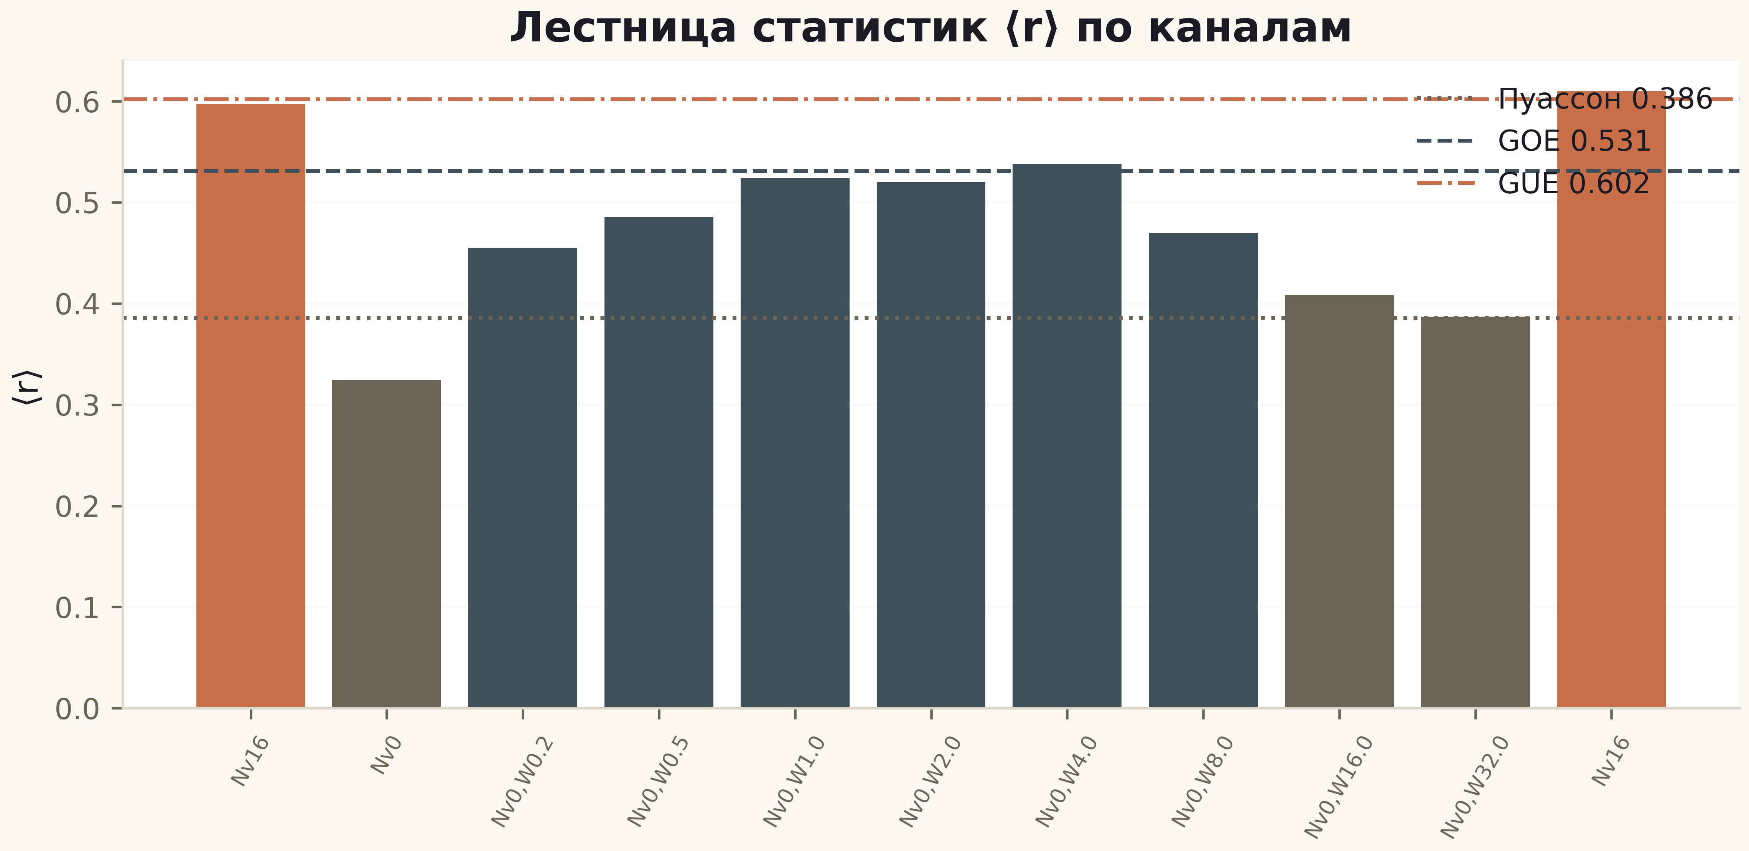
Fig. 1. The ⟨r⟩ ladder across 11 channels: reference lines Poisson/GOE/GUE; the vortex channel (first bar) is GUE.

T8. spinor64: the 64→4 reduction
Theorem T8 (reduction).
The E2 spin structures (φx = π(e1+e3+e5), φy = π(e2+e4+e6) mod 2π) yield only 4 distinct Hamiltonians out of 64; the project table confirms it: exactly 4 unique values ⟨r⟩ = 0.59348/0.59682/0.60054/0.60271, each rigidly bound to its pair (φx, φy).
Proof. Six basis 1-forms give 64 sign patterns, but the phases enter only through two sums of three elements; mod 2π each sum has 2 essential values (0 or π) — hence 2×2 = 4 classes. Isospectrality within classes is machine precision: max|Δλ| = 1.1e-14 (E1: orbits 28/21/7/7/1, Arf 28 odd / 36 even, the odd set matches the reference bit-for-bit).
The practical consequence of the reduction: statements like 64/64 GUE-consistent are honest but substantively these are 4 spectra, not 64. The encoding in discrete phase structures exists and is absolutely reliable (isospectrality 1e-14), but its capacity is set by the symmetry of the phases, not by the number of structures. For the RH programme the conclusion is transparent: discrete spin structures carry the universal class, not the arithmetic.
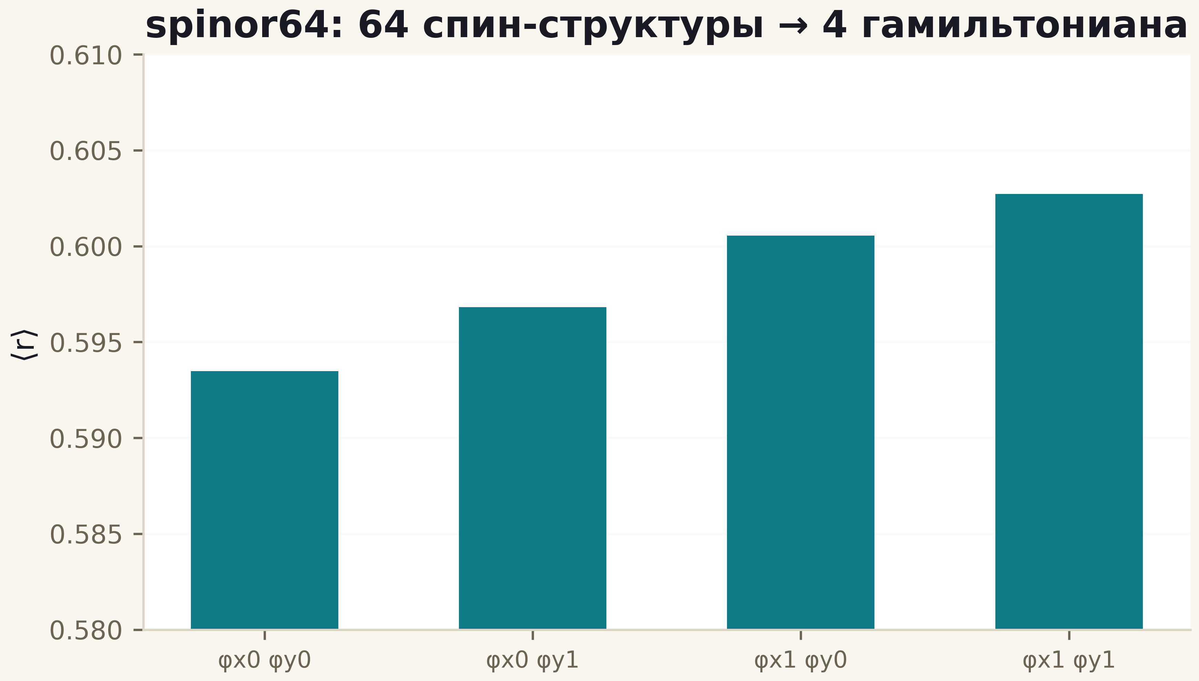
Fig. 2. The four unique ⟨r⟩ values of the spin structures: 64 sign patterns collapse into 4 Hamiltonians by the pairs (φx, φy).

Conclusions
The statistical frame of the series is fixed: the class is set by symmetry (T10), discrete phases give exact but universal codings (T8), and GSE is architecturally closed. Whatever claims arithmetic further on, it must present it outside statistics — in the flow identities (T4), in the counting (C2) or in the trace (T6). This is the discipline the series keeps.

