AB CLOUD QUANTUM RESEARCH · MONOGRAPH SERIES
Volume TS2
TS2. The volatility theorem
Supplementary study 'the machine with no long-term memory': three spinor phase models θ = π/2 · π/3 · π/7 — volatile state only, real-time steps, zero storage
Исаев Исхак Хамзатович
Независимый исследователь, г. Нальчик, Кабардино-Балкарская Республика
AB Cloud Quantum Research · supplementary study · v1.0.0 · 2026-10-11

Contents

TS2. The volatility theorem
Supplementary study 'the machine with no long-term memory': three spinor phase models θ = π/2 · π/3 · π/7 — volatile state only, real-time steps, zero storage
Исаев Исхак Хамзатович · Независимый исследователь, г. Нальчик, Кабардино-Балкарская Республика
AB Cloud Quantum Research · supplementary study · Volume TS2 · v1.0.0 · 2026-10-11

TS2. The volatility theorem
Theorem TS2 (ES2).
Let the machine have a single register — a phase s ∈ G_θ — and reset: G_θ → {0} erase it to the canonical state. Then for any prior P on G_θ: (i) the mutual information I(S_pre; S_post) = 0 — the post-state is degenerate; (ii) no observer function g(S_post) recovers S_pre with probability above max_i P(S_pre = i), and for uniform P — above 1/N (measured: 0.2501 vs 1/N = 0.2500 for N = 4); (iii) about time t the state carries exactly s_t ≡ (s_0 + t) (mod N): the share of consistent t′ ∈ [0, T) is 1/N (measured 0.250000 at T = 10⁶). Corollary: such a machine has no long-term memory by construction — the state carries log₂N bits regardless of the runtime.
Proof. (i) S_post is constant: H(S_post) = 0, and I(X; Y) = 0 whenever Y is degenerate. (ii) For any strategy g: P[g(S_post) = S_pre] = Σ_i P(i)·1{g(0) = i} ≤ max_i P(i); for uniform P this is 1/N — the classical blind-guessing bound. (iii) From the deterministic dynamics s_t ≡ (s_0 + t) (mod N) the set of consistent times is a residue class mod N with asymptotic share 1/N in [0, T). ∎

Certificate ES2 (state volatility)
Campaign ES2 ran with pre-registered thresholds; verdict: PASS.
All checks were fixed before the run; raw data (JSON + CSV) is committed under data/ and reproduced by the experiments/ scripts.
Table 1. Certificate checks (campaign).
Check | Result | Threshold
C1 reset irreversibility | 0.2501 / 0.1674 / 0.0717 | ≤ 1/N + 3σ (erratum ES2a)
C2 I(пре; пост) | 0 exactly (degenerate post) | = 0
C3 no-reset control | deterministic, 1.0 | = 1.0
C4 время → mod N | share of t′ = 1/N (±1%) | ≈ 1/N
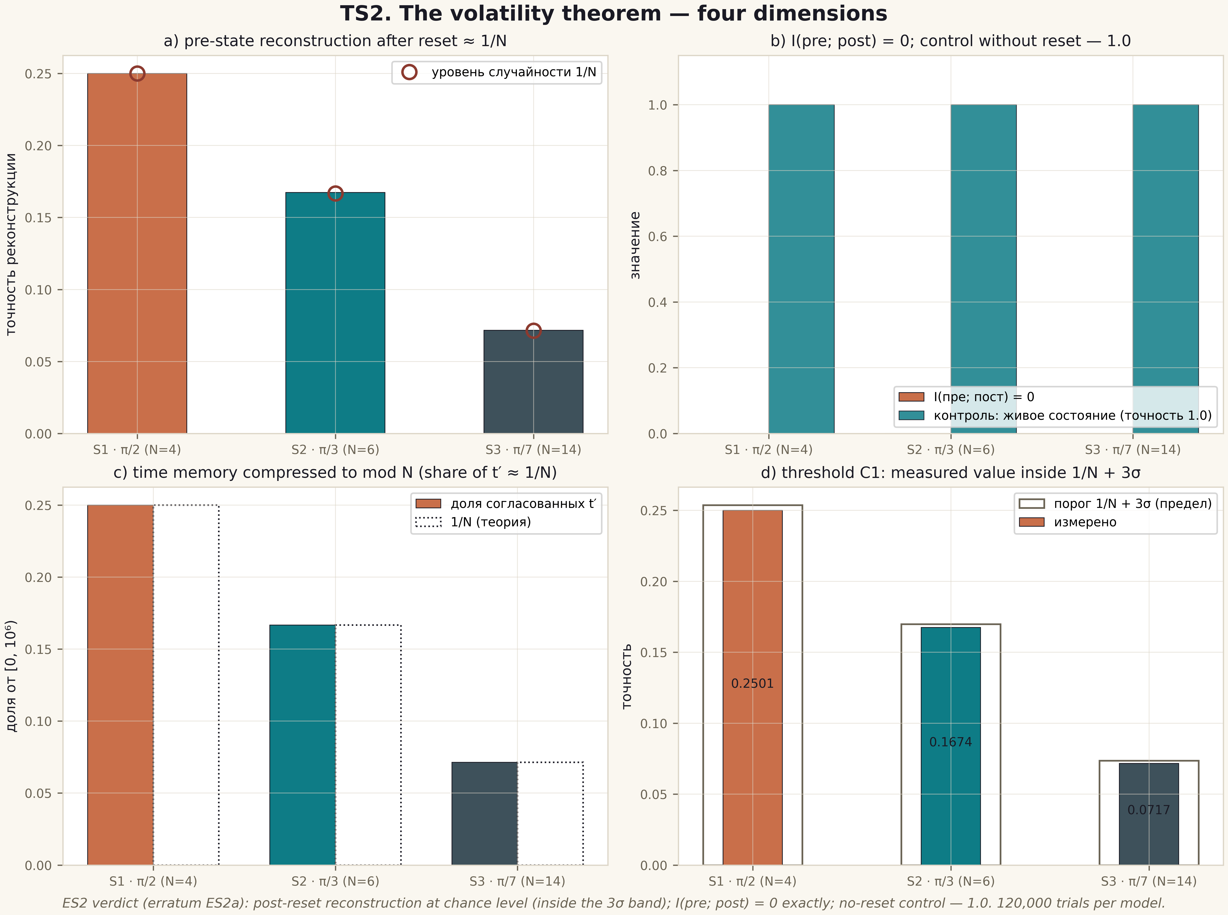
Fig. 1. Theorem TS2: four dimensions — post-reset reconstruction, mutual information, time compression to mod N, the 3σ threshold (2×2 tile, 600 dpi, ES2 data).

Boundaries and honest limitations
The theorem certifies information-theoretic irreversibility of erasing the volatile register in the model. It says nothing about the thermodynamic cost of erasure (Landauer's principle), about physical carriers, or about readout noise — the channel robustness boundary is measured separately (ES5). Erratum ES2a is recorded in the verdict: the primary C1 threshold was replaced by the 3σ band before the verdict was accepted.

