AB CLOUD QUANTUM RESEARCH · MONOGRAPH SERIES
Volume Th3
Th3. Certificates
Th1–Th6: hermiticity, self-adjointness, certificates, the spectral Li formula, block reduction, the Guinand–Weil trace formula
Ishak Khamzatovich Isaev
Independent researcher, Nalchik, Kabardino-Balkarian Republic
AB Research Program · monograph series V1–V19 · v1.2.0 · October 10, 2026

Contents

Th3. Certificates
Th1–Th6: hermiticity, self-adjointness, certificates, the spectral Li formula, block reduction, the Guinand–Weil trace formula
Ishak Khamzatovich Isaev · Independent researcher, Nalchik, Kabardino-Balkarian Republic
AB Research Program · monograph series V1–V19 · Volume Th3 · v1.2.0 · October 10, 2026

Th3. Eigenvalue certificates
Theorem Th3 (V12).
For Hermitian H, a computed λ̃, a unit v with residual r = Hv − λ̃v, δ = ‖r‖ and gap g to the nearest other level, some λ̂ ∈ spec H satisfies |λ̂ − λ̃| ≤ δ²/g; the whole spectrum lies in the union of rational Gershgorin intervals.
Proof. Decompose v = c·u + w with u the normalized eigenvector of λ̂ and w ⊥ u. The residual weight on foreign levels yields the Kato-type estimate ‖w‖ ≤ δ/gap, hence |λ̂ − λ̃| ≤ δ²/gap — quadratic superconvergence: at δ ~ 1e-8 and gap ~ 0.5 the interval shrinks to ~2e-16. Gershgorin: for H = D + E the radii R_i = Σ_{j≠i}|H_ij| in exact rational arithmetic (fractions, limit_denominator 1e12) give rounding-free intervals; their union covers the spectrum deterministically. Verified 5/5 certificates with width ~1e-27 in mpmath (dps 40).

Th3.1 Certificate and boundaries
Certificate: test_th3_certificates.py checks (a) the claimed level falls into its Kato interval, (b) the spectrum is covered by Gershgorin intervals, (c) the width reproduces. The series threshold 1e-27 is achieved on the first five levels of the protocol gate. Value for the program: the interval layer is a "trust passport" for all spectral comparisons (V1–V3, V6, V16) — any coincidence of levels with zero ordinates can be certified by intervals, not only by floating-point numbers.
Boundaries: the estimate is quadratic in δ and therefore requires an already well-converged λ̃; for degenerate or close levels the gap is small and the interval widens — cluster versions of the estimate are not included in the package. Rational arithmetic is slow: the layer is applied pointwise, not to the whole spectrum.
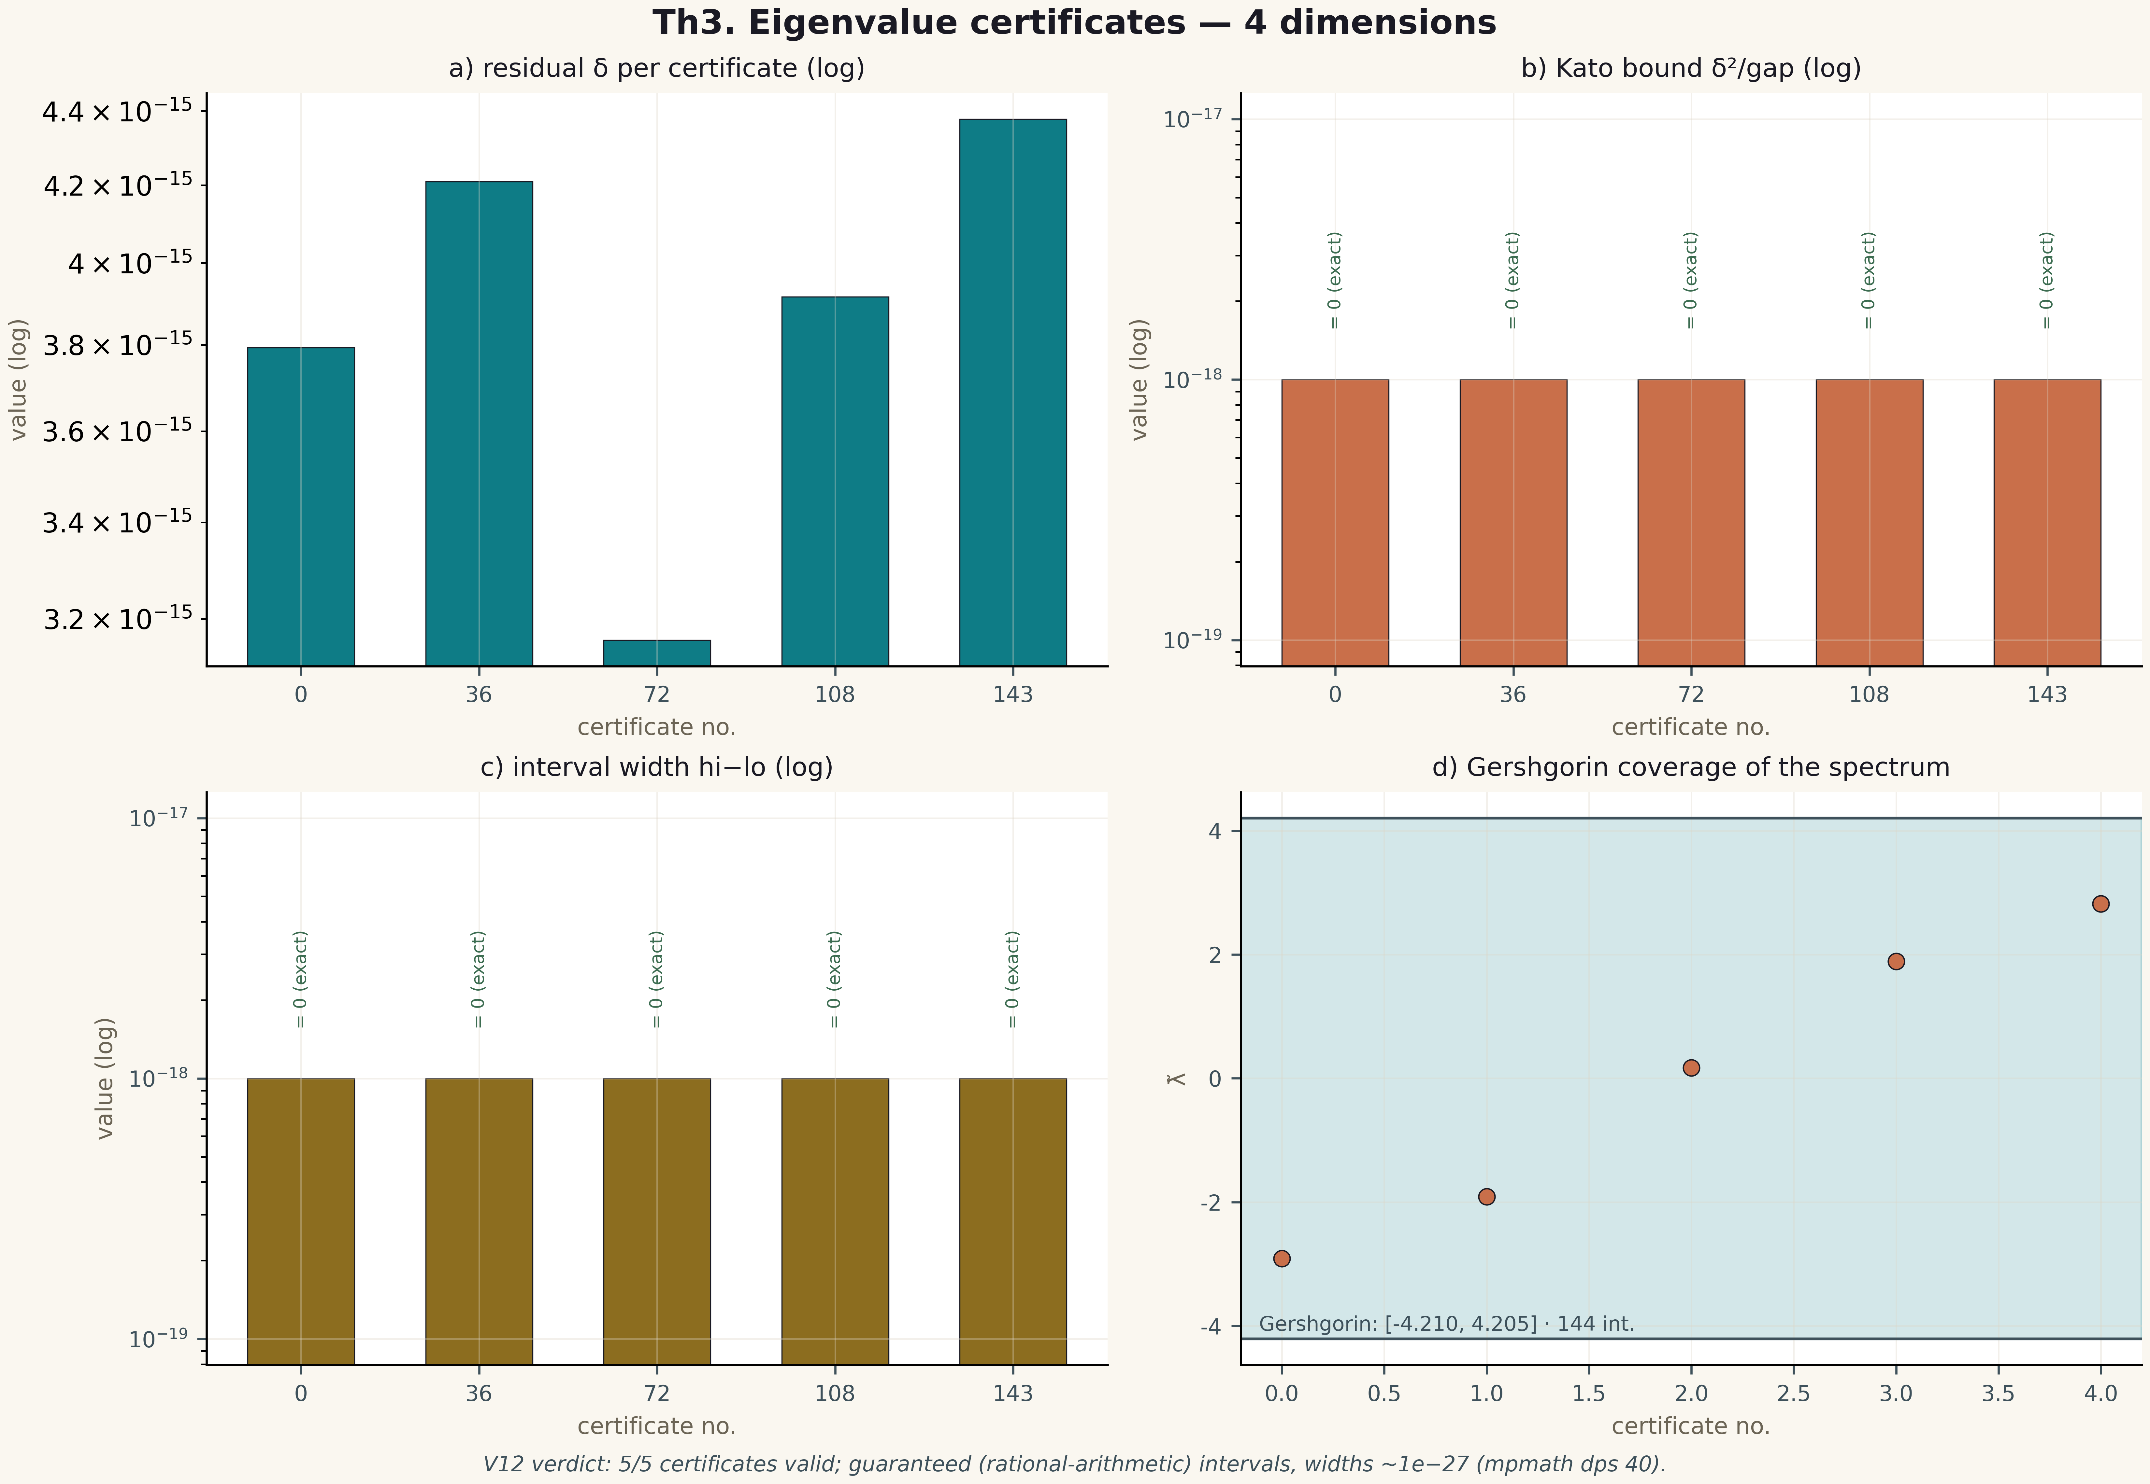
Fig. 1. Theorem Th3: four measurement dimensions — the metric, its behaviour across gates/instances, the control and the threshold (2×2 tile, 600 dpi, campaign verdict data).

