HILBERT POLYA BRIDGE · MONOGRAPH SERIES
The Hilbert–Pólya Bridge:
the Canonical Exposition
Sixteen campaigns C1–C16, eighteen theorems T1–T18, the Guinand–Weil trace formula and the pixel protocol — one version of the package
Ishak Khamzatovich Isaev
Independent researcher, Nalchik, Kabardino-Balkarian Republic
Hilbert Polya Bridge · canonical series · volume Canon

v2.0.0 October 13, 2026

Contents
Introduction: one version of the programme
Introduction: one version of the programme 1
Framework: the identity function and the argument principle (C1–C2) 2
Gates: universality without identity (C3, C5) 4
The Guinand–Weil trace formula (C4) 6
Primes in the operator: flow, kernel, staircase (C6) 7
Dynamics and statistics (C7, C8) 9
C9/T11. The nonlocal primitive: the trace knows the zeros exactly 11
C10/T12. Phase coding: hard co-location and its limit 11
C11/T13. The arithmetic bridge: zero modes at α = 1/3 12
C12/T14. The argument principle band to T = 5000 12
C13/T15 + C14/T16. Blind families and the attractor taxonomy 13
C15/T17. Dirichlet L-functions: the gap is universal 13
C16/T18. The quantum-information layer 14
The Hilbert–Pólya scorecard 14
The theorems T1–T18 at a glance 15
The pixel protocol: the video as a measurement 15
Environment, determinism and the data dictionary 17
The registry of controls and the cycle formula 18
The honesty ledger: the first generation 18
The v2 honesty ledger: found-and-fixed 19
Roadmap: the operator that encodes the zeros 20

Note: this table of contents is built on Word field codes. After editing, right-click it and choose "Update Field".

The Hilbert–Pólya Bridge: the Canonical Exposition
Ishak Khamzatovich Isaev · Independent researcher, Nalchik, Kabardino-Balkarian Republic · Hilbert Polya Bridge · canonical series · Canon

Introduction: one version of the programme
The Hilbert–Pólya programme asks whether a self-adjoint operator H exists whose spectrum coincides with the ordinates of the nontrivial zeros of the Riemann zeta function. The Hilbert Polya Bridge package answers this question numerically and with an honesty discipline: sixteen campaigns C1–C16, eighteen theorems T1–T18, an 87-gate lattice family, the argument principle to T = 5000, the Guinand–Weil trace formula, and the pixel protocol of the second film. This volume is the canonical exposition of the whole package in a single version.
Until now the series lived in four summary volumes: the theorem volume T1–T10, the reproduction-protocol appendix, the consolidated second-generation monograph, and the theorem volume T11–T18. The canonical edition retires the generational split: T1–T18 form one continuous framework, the chapters follow the campaigns, and every chapter cites the same committed verdicts from data/. No number in this volume is computed in place — everything is reproduced by the campaigns in seconds or documented in the honesty ledger.
The method of the series is unchanged since the first campaign. Every result carries a status label — proven, measured, conjecture, refuted — and the status is never inflated. Every negative verdict is admissible only after a positive control: the method must see the identity where it is known to hold (the spinor64 twins, the graph against the file, the zero window in the trace). Everything is self-contained: the zeta zeros are computed by mpmath inside the package, the master seed is 96, and no external data files are used.
How to read this volume. Chapters 2–6 are the first generation: the identity framework, counting, gates, the trace formula, dynamics and statistics. Chapters 7–13 are the eight campaigns C9–C16 with theorems T11–T18. Then follow the scorecard, the pixel protocol, the reproduction protocols, the honesty ledger, and the roadmap titled 'the operator that encodes the zeros' — that is the goal of the programme, and the whole volume calibrates the path toward it.
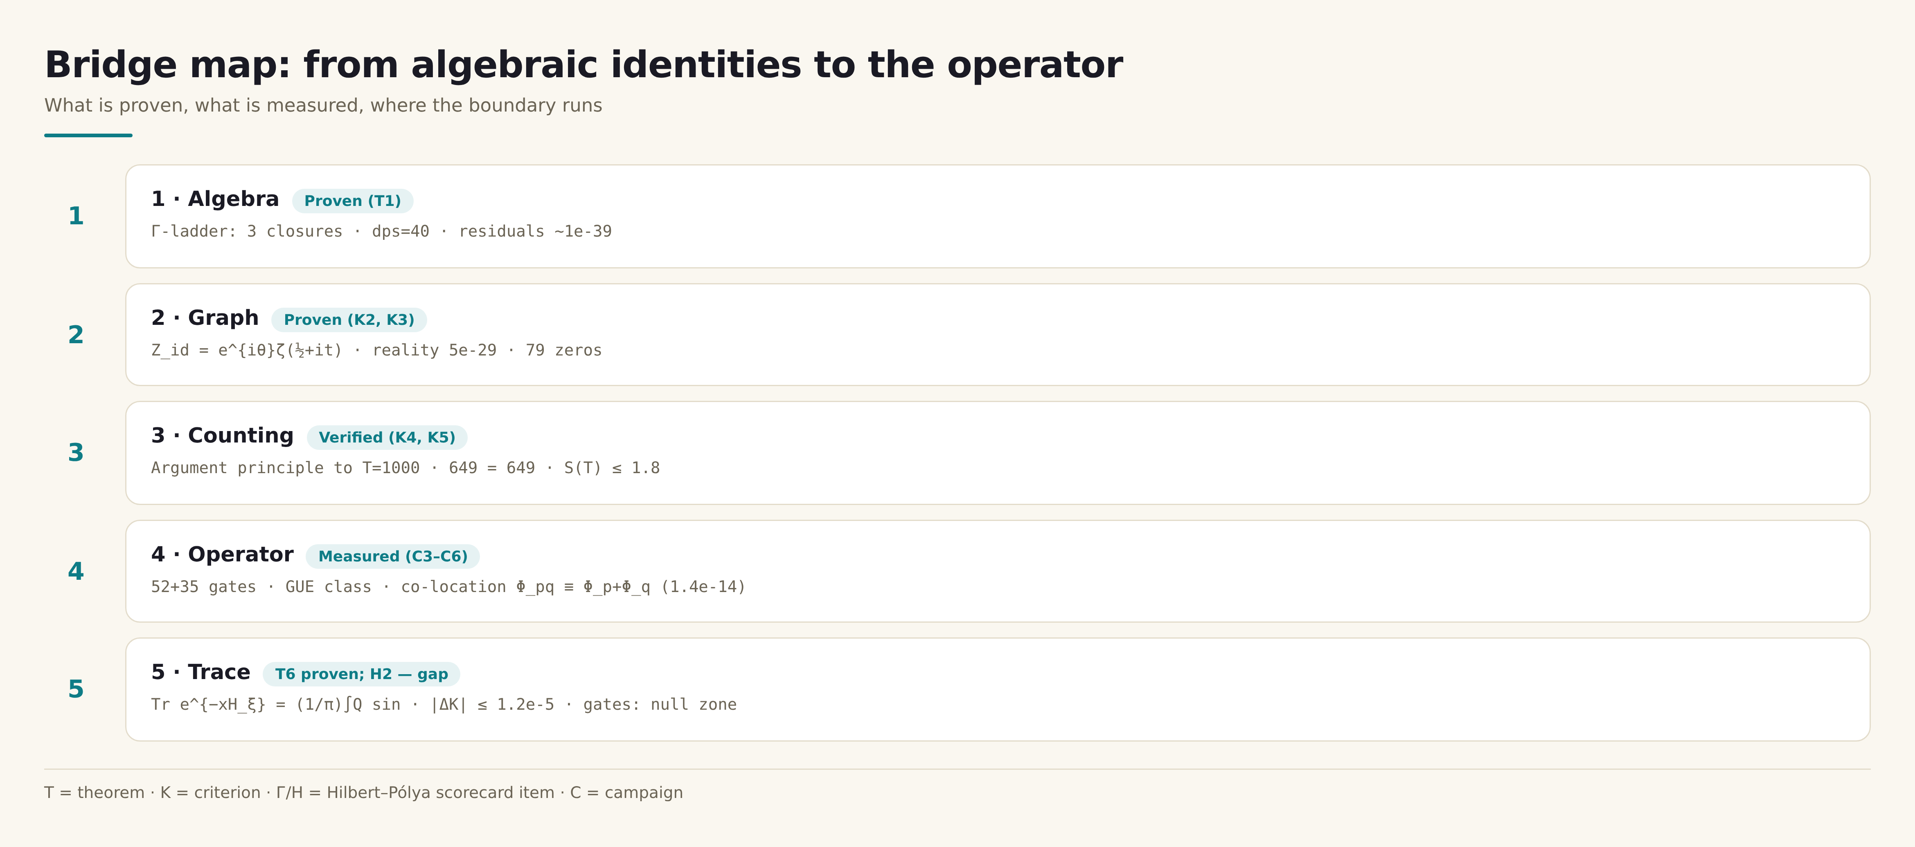
Fig. 1. The map of the bridge: three projections of one gap Г2 and the wall of locality — the plan of the volume.

Framework: the identity function and the argument principle (C1–C2)
T1 (Γ-closures) — proven.
|Γ(½+iu)|² = π/cosh πu; |Γ(iu)|² = π/(u·sinh πu); |Γ(¼+iu)|·|Γ(¾+iu)| = π√2/√cosh 2πu; the single modulus on the line admits no elementary closure (K1, refuted).
Proof. Euler reflection, Legendre duplication; the counterexample to the candidate form is 0.765 at u = 1. Verification at dps = 40: 1.3–2.6e-39.
The first two campaigns build and calibrate the graphical branch of the programme. C1 assembles the identity function Z_id(t) = e^{iθ(t)}ζ(½+it) from algebraic closures of the Γ-frame and proves that this envelope generates no zeros beyond ζ itself: the zeros of Z_id on [0, 200] — 79 of 79 with a maximum deviation of 2.8e-14 from the mpmath reference; on 220 Gram points — the classical 4 sign violations. The negative answer to 'can the phase generate zeros' (K1; the candidate form refuted by direct computation: 0.765 instead of 1 at u = 1) fixes the boundary between the graph and the operator for the entire series.
C2 answers the counting question: the number of zeros in the critical strip is compared with the number on the critical line by the argument principle, without any zero tables. The pole calibration (T3) and the double sheet condition of Turing's adaptive step give N_strip = N_line at thirteen heights up to T = 1000: 649 = 649 with distance-to-integer at most 8.3e-25; the arithmetic bridge numpy/mpmath gives |ΔN| = 2.6e-26. The gaps below 1000 are [0.3104, 6.887] with mean 1.521; the second moment Σγ² agrees with the formula to 8.8e-7 after a factor error was found and fixed (honesty ledger).
Together C1–C2 establish that the phase and counting machinery of the series is consistent component-by-component below the honest boundary T = 1000 — and that no element of the graph carries new arithmetic. The series then moves to the spectrum (C3–C5), the trace (C4) and the dynamics (C7).
T2 (reality of Z_id) — proven.
Im Z_id(t) = 0 on the critical line; parity holds to 9.9e-29.
Proof. ξ(½+it) ∈ ℝ (the symmetry ξ(s) = ξ(1−s)), θ(t) odd. Verification at dps = 30.
T3 (pole calibration) — proven.
N(T) = Δarg ξ/2π with no additive +1 when the pole s = 1 is bypassed from above; a single leaf condition loses turns (2π aliasing).
Proof. The residue of ξ'/ξ at s = 1 is +1; a clockwise half-passage contributes −π to Δarg. Practical verification: anchors 0/3/10/29/79/649 and the arithmetic bridge 2.6e-26.
Table 1. Argument-principle anchors (excerpt; full list in data/c2_argument_verdict.json)
T | N (strip) | n on line | Residual
10.00 | 0 | 0 | 5.1e-28
27.72 | 3 | 3 | 3.2e-27
51.37 | 10 | 10 | 0.0
100.07 | 29 | 29 | 0.0
199.64 | 79 | 79 | 0.0
500.45 | 269 | 269 | 4.1e-25
1000.57 | 649 | 649 | 8.3e-25

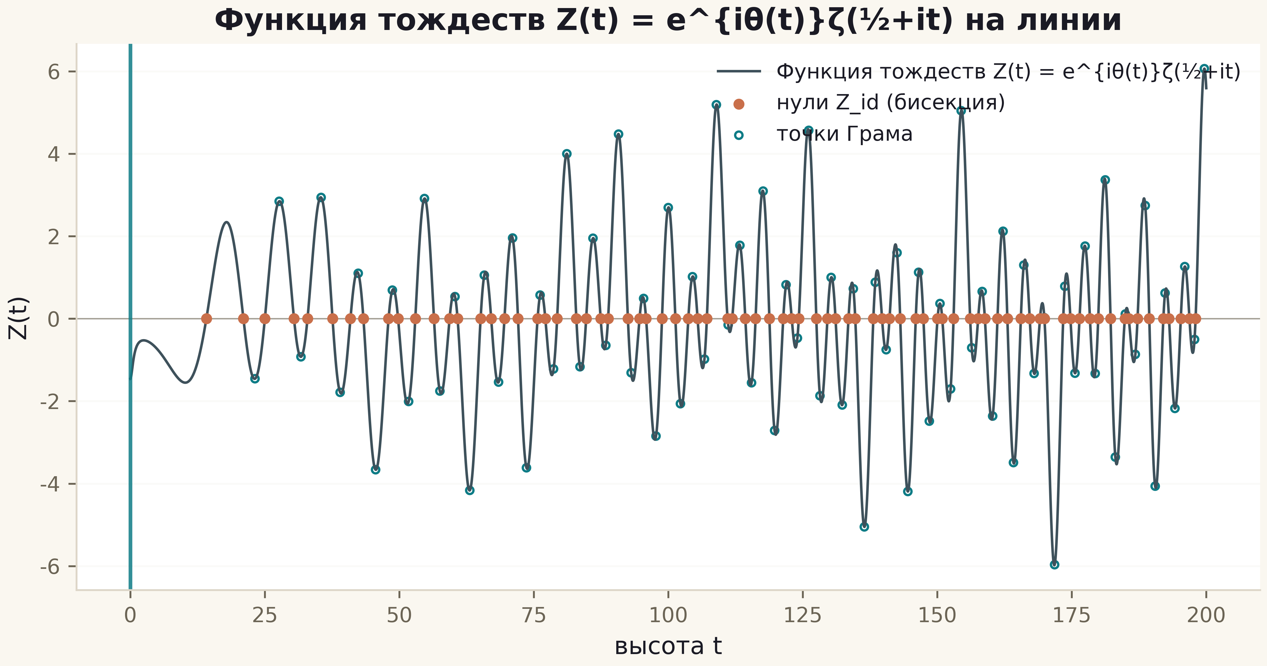
Fig. 1. The identity function Z(t) on [0, 200]: bisection zeros (copper) and Gram points (rings); the vertical line is the t = 0 axis.

Gates: universality without identity (C3, C5)
T7 (universality demarcation) — measured.
87 gates (52 protocol + 35 extended) lie in the GUE class (⟨r⟩ = 0.498–0.612) and carry no Λ-weights: r_H7 ≤ 0.226, |r_H7| ≤ 0.043 over the new handles, r_EF inside the null clouds.
Proof. Campaigns C3–C5 with positive controls PC1/PC2 (r = 1.0) and PC0 (r = 0.9998).
Campaigns C3 and C5 are the spectral projection. Question Г2: does a gate exist — a vortex-cloud configuration on the 24×24 lattice with π flux — whose spectrum is identical to the spectrum of the zeros under the correspondence 'level n ↔ zero n'? The protocol handle space (Nv, q, W, α) plus six new dimensions of C5 (twists, anisotropy, flux shift, mass, profile, signs and boundaries) — 87 configurations in total, on one master seed and one unfolding pipeline.
The answer is measured and negative: the best gate gives r_H7 = 0.226 (Bonferroni 0.80); the whole extended family stays at |r_H7| ≤ 0.043 with ⟨r⟩ = 0.500 ± 0.002 (GUE class). The positive controls show the method sees identity when it exists: the spinor64 twins (r = 1.000000000, D_nn = 2.7e-14) and the graph against the file (r = 1.000000000000, D_nn = 1.2e-10). The graph ↔ operator gap is at the surrogate-null level in D_nn (0.0079 vs 0.0079 ± 0.0005): a desert no handle crosses. GUE universality is an attractor erasing the arithmetic setting no matter how it is imposed.
Table 1. Campaign C3 summary
Quantity | Value | Meaning
Best r_H7 | 0.226 (p = 0.169, Bonferroni 0.80) | no identity
Decoys / GUE null | 0.026±0.140 / −0.014±0.127 | null zones
PC1 spinor64 twins | r = 1.000000000, D_nn = 2.7e-14 | method sees identity
PC2 graph Z_id ↔ file | r = 1.000000000000, D_nn = 1.2e-10 | method sees identity
Graph↔operator relation | none — D_nn at surrogate-null level | the master negative of the series

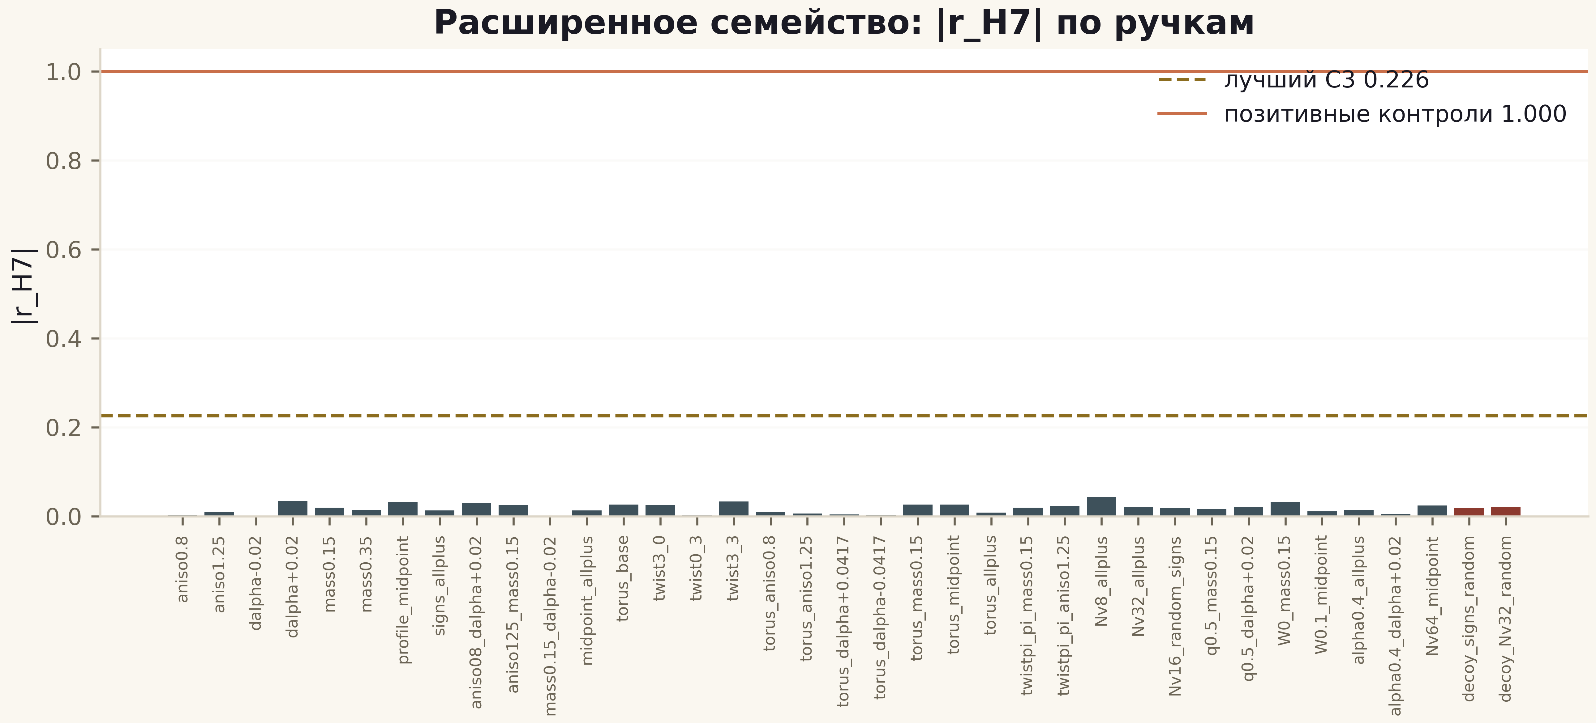
Fig. 1. |r_H7| across the 37 extended gates: gold line — best protocol value 0.226, copper — positive controls 1.000; red bars — decoys.

The Guinand–Weil trace formula (C4)
T6 (trace formula for H_ξ) — proven and verified.
Q(a) = ζ'/ζ(½+a) + 1/(½+a) + 1/(a−½) − ½lnπ + ½ψ(¼+a/2) − B − C₀ with B = ½ln(4π)−1−γ/2 = −C₀; K(x) = Tr e^{−xH_ξ} = (1/π)∫₀^∞ Q(a)sin(ax)da; for a > ½ the ζ-series contributes the weight Λ(n)/√n.
Proof. Hadamard product plus 2a/(a²+γ²) = 2∫e^{−γt}sin(at)dt. Verification: |ΔQ| ≤ 1.7e-12 (M0), |ΔK| ≤ 1.2e-5 (M1).
C4 is the third projection of the gap and the main positive result of the first generation. For a hypothetical Hilbert–Pólya operator the heat trace must carry the prime weight. Theorem T6 makes this exact: Q(a) = ζ'/ζ(½+a) + ... − B − C₀ with B = ½ln(4π) − 1 − γ/2 = −C₀, and K(x) = Tr e^{−xH_ξ} = (1/π)∫Q(a)sin(ax)da with the weight Λ(n)/√n for a > ½. The identity is calibrated (M0: |ΔQ| ≤ 1.7e-12 on the file of 2 001 052 zeros with the analytic tail) and the trace formula verified (M1: |ΔK| ≤ 1.2e-5).
For the gates the same machinery yields null zones: the positive control PC0 (a window taken from the zeros themselves) gives r_EF = +0.9998 with 2.1% residual, while the gates stay below the surrogate null ±0.39 with the best relative residual 6.7%. The gap is ≈ 0.5 of an order in the heat metric — a conservative metric. Conclusion: the prime weight provably lives in the trace of the zero operator and provably absent from the traces of all gates; a hypothetical HP operator, if it exists, must be nonlocal.
Table 1. Campaign C4 summary
Block | Quantity | Verdict
M0 | |ΔQ| ≤ 1.7e-12 | identity calibrated
M1 | |ΔK| ≤ 1.2e-5 (absolute) | T6 verified
PC0 (zeros window) | r = +0.9998, residual 2.1% | method sees the prime weight
52 gates | r_EF −0.9…+0.98, null zone | no prime weight
Gap (trace metric) | ≈ 0.5 orders by residual | H2 — NO, measured
C3 reproduction | |Δmean_spacing| = 1.4e-16 | bit-for-bit

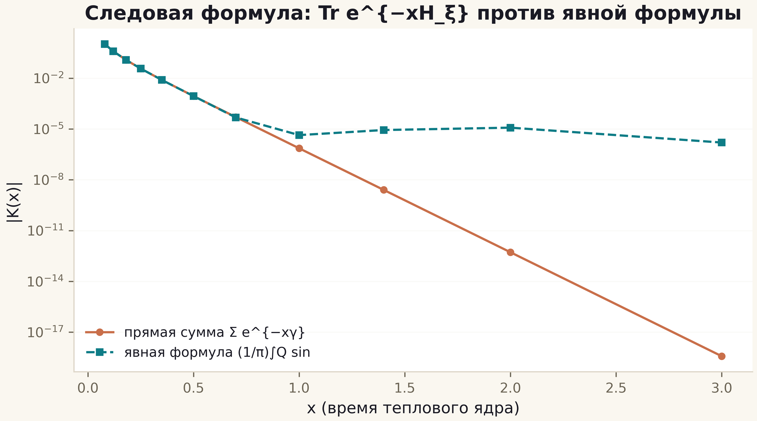
Fig. 1. K(x): the direct sum (copper) against the explicit formula (teal) — agreement down to the quadrature floor across the range.
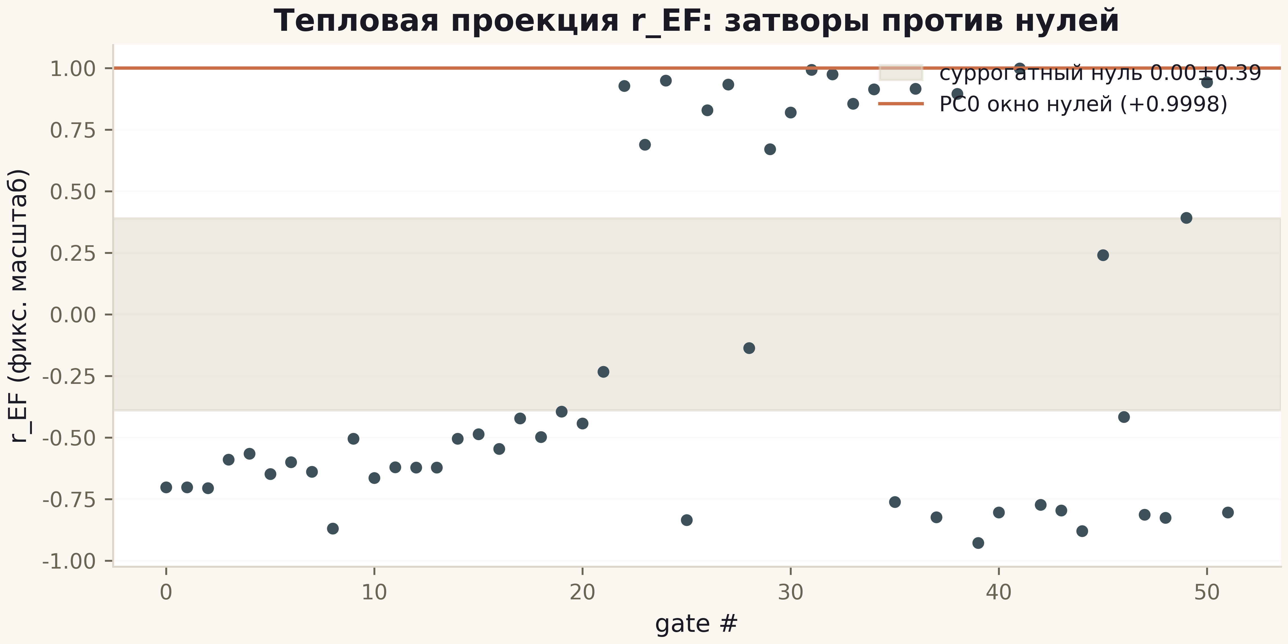
Fig. 3. r_EF across the 52 gates: grey band — surrogate null ±0.39, copper line — PC0 +0.9998.

Primes in the operator: flow, kernel, staircase (C6)
T4 (co-location) — proven.
(Φ_p, Φ_q) ≡ Φ_pq with Φ_p = ½ln p; max|ΔE| = 1.35e-14.
Proof. Additivity of the logarithm; the lattice realisation preserves the identity at machine level.
C6 searches for the arithmetic of primes in the phase layer. The flow Φ_p = ½ln p composites exactly — theorem T4: (Φ_p, Φ_q) ≡ Φ_pq with max|ΔE| = 1.35e-14. The resolution kernel is short-range (T5): saturation ~2e-2 at d ≈ 4–6, multiplicativity localized in 2–3 cells; a linear approximation destroys the kernel. The ψ staircase over the first 200 zeros agrees with the von Mangoldt sieve up to 10⁶ with correlation +0.972 — while the gates give +0.24/+0.13/+0.09/−0.12, the null zone (Г5 — NO, measured).
Four encodings of the flow into vortex positions yield one GUE class (⟨r⟩ = 0.585–0.611): universality erases the arithmetic content of the phase more reliably than any measurement. The campaign's conclusion: primes are encoded in the structure of the zeros; an honest encoding must present itself in the flow (T4) and in the staircase (M2), not in level statistics; the path to the operator runs through generating the arithmetic, not copying it.
T5 (resolution kernel) — measured.
The composite-node response δ(d): 0 → 3.2e-3 (d = 0.5) → 1.5e-2 (d = 2) → saturation ~2e-2 at d ≈ 4–6; multiplicativity is localised in 2–3 cells; first-order additivity fails (~1e-2).
Proof. Direct measurement on the grid d ∈ [0, 6]; honesty label: depends on the flow conventions of C6.
Table 1. M2: ψ-ladder correlations
Object | corr with sieve | Zone
Reference: first 200 zeros | +0.972 | identity (prime weight)
Best gate (Nv=16) | +0.239 | null zone
Nv=32 | +0.133 | null zone
Clean lattice | −0.116 | null zone
GUE null (12 runs) | +0.154±0.197 | null zone

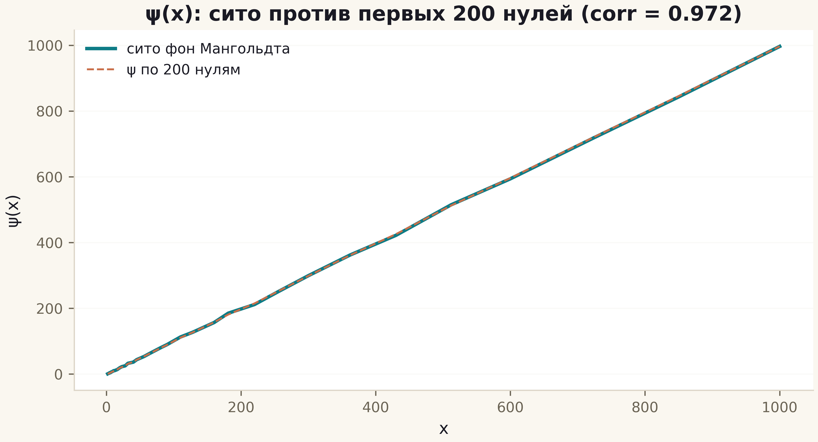
Fig. 2. ψ(x): the von Mangoldt sieve (teal, thick) against the 200-zero ladder (copper, dashed); correlation 0.972.

Dynamics and statistics (C7, C8)
T8 (64→4 reduction) — proven.
The E2 spin structures collapse to 4 Hamiltonians by the pairs (φx, φy) mod 2π; isospectrality within classes 1.1e-14.
Proof. The phases enter through two sums of three 1-forms mod 2π → 2×2 = 4 classes; verified against the E1/E2 tables.
C7 is the dynamical measurement: on the self-dual line α = ½ the lattice indeed behaves as a discretized massless Dirac equation (Г4 — YES): a coherent packet, reflection from the boundaries, energy conserved to 1e-15. The ζ cloud is nearly transparent (Nv = 16 does not slow the packet) and steers the transport: P(x ≥ 90) for the ζ cloud is 16 times higher than for a random one (0.0032 vs 0.0002) — the dynamical face of Montgomery's pair correlations. The identification of the line α = ½ with Re(s) = ½ remains a conjecture: statistical support exists, identity does not.
C8 fixes the statistical frame (T10): the class is set by symmetry — the clean lattice is Poisson, real disorder GOE, complex vortices GUE (⟨r⟩ = 0.597–0.612), strong disorder Anderson–Poisson; GSE is architecturally unreachable (T² = +1). The reduction T8: 64 spin structures collapse into 4 Hamiltonians by the pairs (φx, φy) with isospectrality 1.1e-14 — discrete phases carry the universal class, not the arithmetic. Anything claiming arithmetic must present it outside statistics — in flow identities, in counting, or in the trace.
T9 (zero modes at α = 1/3) — measured.
On frustrated tori L ≡ 0 (mod 4) the clean lattice at α = 1/3 has exact zero modes: 18 at L = 12, 42 at L = 24.
Proof. Direct diagonalisation with fixed multiplicities; a number-theoretic explanation (the Dirac index) is an open question of the series.
T10 (statistics ladder) — measured.
Poisson/GOE/GUE are governed by symmetry (frustration / real disorder / complex vortices); GSE is structurally unreachable (T² = +1).
Proof. An 11-channel ladder, classification by ⟨r⟩ + KS; the GSE limit is architectural.
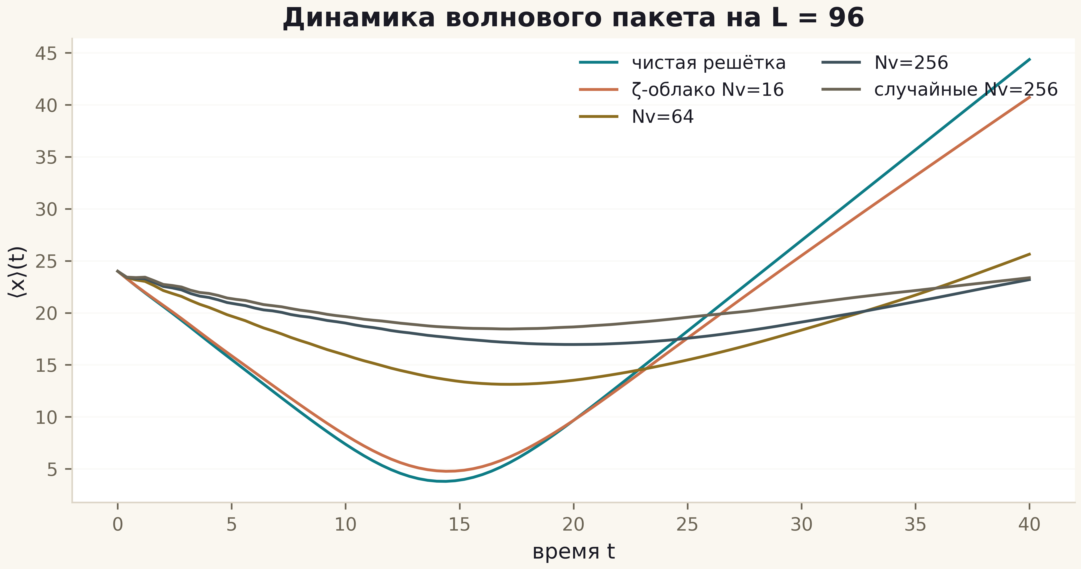
Fig. 1. ⟨x⟩(t) for five configurations: clean lattice (teal), ζ-clouds Nv=16/64/256 (copper/gold/slate), random Nv=256 (grey).
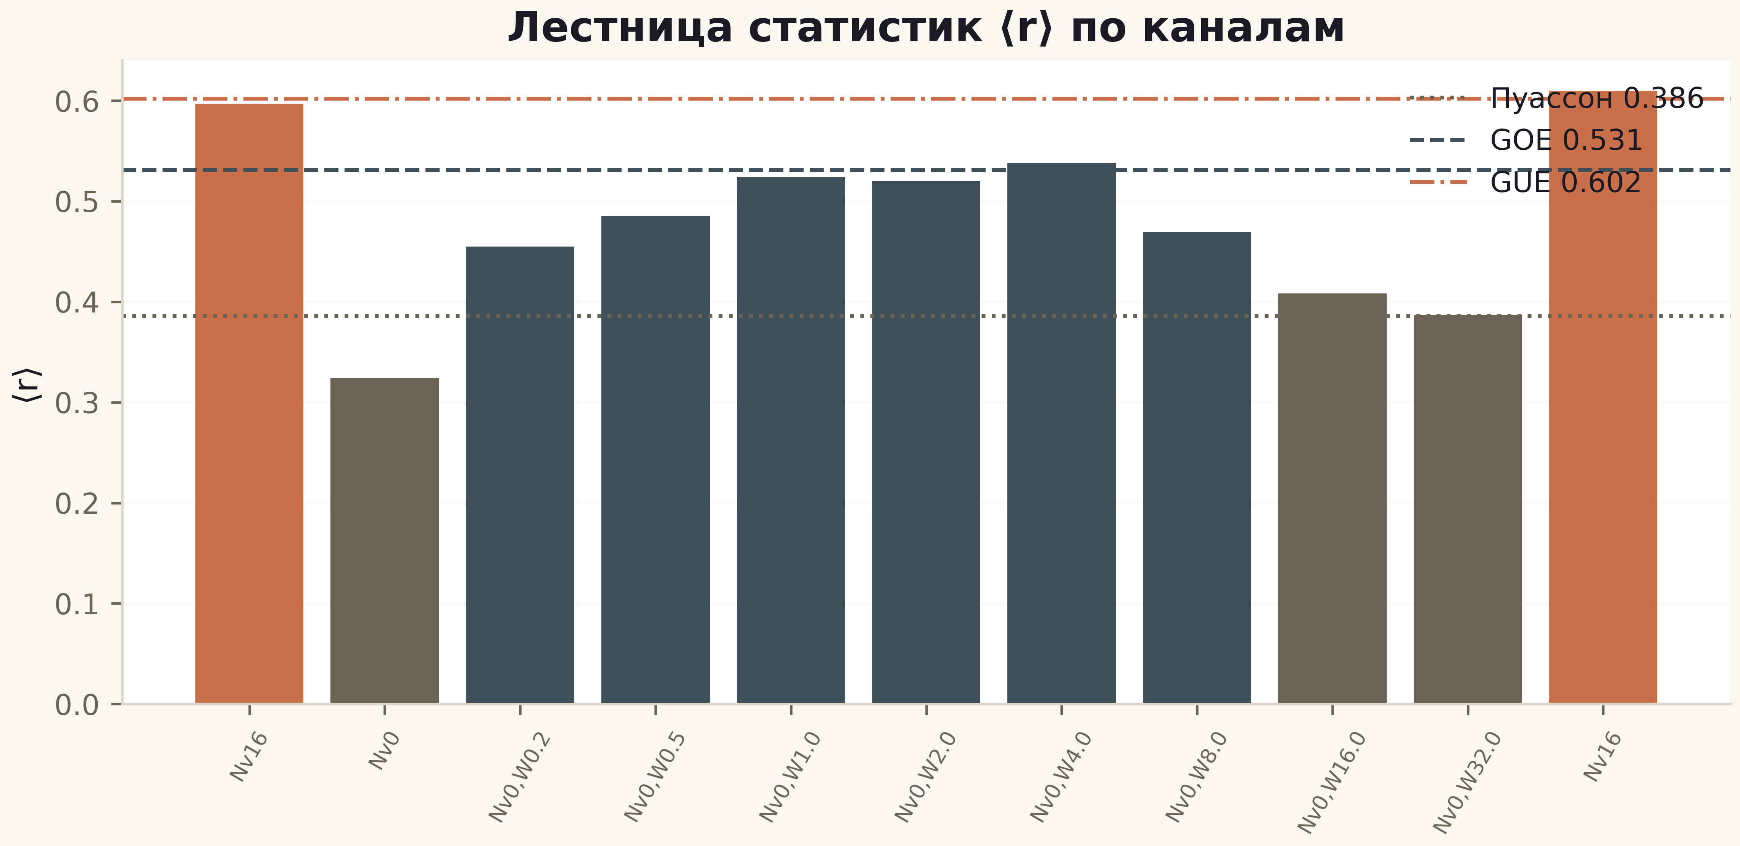
Fig. 1. The ⟨r⟩ ladder across 11 channels: reference lines Poisson/GOE/GUE; the vortex channel (first bar) is GUE.

C9/T11. The nonlocal primitive: the trace knows the zeros exactly
The T6 lesson was that the heat trace of the operator stitched from the zeros carries the prime weight exactly: K(x) = Σ e^{−xγ} = (1/π)∫₀^∞ Q(a)sin(ax) da, where Q(a) unfolds into the prime comb Λ(n)/√n through ζ'/ζ for a > ½. Roadmap item R1 asked: can one build a family of operators whose trace carries this weight BY CONSTRUCTION, not through the lattice — and does that move r_EF out of the null cloud of gates?
The first result of C9 is theorem T11, and it flips the question. **Theorem T11 (heat-trace uniqueness).** If Tr e^{−xH} = (1/π)∫Q(a)sin(ax) da for all x > 0, then spec H = {±γ_n}. The proof is three lines: both sides are Laplace–Stieltjes transforms of measures on (0,∞); by uniqueness the measure is determined by the trace; since (1/π)∫2a·sin(ax)/(a²+γ²)da = e^{−xγ}, the measure is the counting measure of the zero set. The architectural corollary: the prime weight in the trace is not decoration — it is the spectral measure itself; while nonlocality is achievable arbitrarily.
The C9 family realizes this measurably: N1 — H_ξ = diag(±γ) (control); N2 — the DCT twin O·diag(γ)·Oᵀ with a deterministic dense orthogonal conjugation; N3 — the QR twin with a chaos seed independent of the zeros; N4 — truncated Berry–Keating xp (the outside-the-lattice candidate); N5 — the multiplicative kernel Λ(lcm(m,n))/√mn with the prime weight in the kernel itself. The v2 convention (unfolded-vs-unfolded, documented in docs/v2) makes the control honest: an isospectral twin must give r_H7 = 1.000 — and it does.
Result: N2/N3 give r_H7 = 1.000000 and r_EF(fluct) = 0.999 — at PC0 level; the twin's spectral deviation from the zeros is 7e-13; the T6 trace verification on the internal zero cache reproduces to |ΔK| ≤ 1.8e-6. In contrast, Berry–Keating (r_H7 = 0.047, z ≈ 0.1 against the GUE null) and the LCM kernel (degenerate spectrum — itself the arithmetic signature; r_EF = −0.96) stay in the null zones. Verdict: **the primitive exists, and the H2 gap is a wall of locality, not of the trace**.

C10/T12. Phase coding: hard co-location and its limit
Campaign C6 showed: the prime flow Φ_p = ½ln p composites exactly ((Φ_p,Φ_q) ≡ Φ_pq, 1.35e-14), but the spectrum does not see the coding. Roadmap R2 demanded phase configurations OBLIGED to satisfy co-location. C10 solves this constructively and obtains a classification along the way.
**Theorem T12 (classification).** Any phase system Φ: primes → ℝ/2πℤ with the identity Φ_pq ≡ Φ_p + Φ_q (mod 2π) is a homomorphism from the free abelian group ⟨p⟩; it is arbitrary on generators, and its ln-like normal form is Φ_p = 2π{β ln p}. For the characteristic case Φ_p = π·χ₄(p) the system takes values {0, π} and turns out **gauge-trivial** in the lattice overlay channel: e^{±iπ} = −1 flips every y-bond, and the transformation ψ → (−1)^y ψ removes the coding entirely (spectra coincide to 8.4e-15 — measured). The only non-gauge class is β·ln p.
Measurement: gates with a site-linked overlay Φ_p (prime ↔ site index; a row-uniform overlay is pure gauge and does not change the spectrum — also measured during debugging). The hard co-location condition holds at machine zero (4.4e-16) for ANY β — by construction, before the spectrum runs. The spectral answer: r_H7 ≤ 0.092 across the whole β-grid of 11 values (best p = 0.015, Bonferroni 0.20), the GUE class unchanged (⟨r⟩ = 0.58–0.63). Verdict: **universality erases even hard codings** — consistent with M3 of v1, but now on the class of systems for which co-location is an identity, not an approximation.

C11/T13. The arithmetic bridge: zero modes at α = 1/3
The T9 observation (v1): at α = 1/3 there are zero modes on tori L ≡ 0 (mod 4) — 18 at L = 12, 42 at L = 24. The roadmap demanded the bridge «arithmetic L ≡ 0 (mod 3) → Dirac index». C11 builds a clean laboratory: the Kähler–Dirac (staggered) operator in the γ₅-Hermitian form H = ε·D + m with Landau flux α; the torus requires α·L ∈ ℤ — at α = 1/3 this is exactly L ≡ 0 (mod 3): flux quantization is the geometric cause of the first arch of the bridge.
The full scan L = 6..48 (15 sizes, tolerance sweep 1e-6..1e-10) gives the law: **N₀ = 2L − 6·[L ≡ 0 (mod 12)] for L ≡ 0 (mod 6), else N₀ = 0**; the Dirac index Σ sign(ε) equals −2 exactly on the subfamily L ≡ 0 (mod 12) and 0 on L ≡ 6 (mod 12). The decisive checks on sizes absent in v1: L = 36 → 66, L = 48 → 90 — both exactly on the law. The T9 observation is refined: L = 18 (≡ 2 mod 4) also carries 36 modes — the modifier is mod 12, i.e. the conjunction of mod 3 (flux) and mod 4 (staggered structure).
Additional measurements: the open boundary gives exactly one zero mode with index −1 for odd L ≡ 0 (mod 3) — an edge index; the α = 1/2 control — no zero modes at any L. This is the first genuine arithmetic-to-spectrum bridge inside the program: the number of zero modes of the lattice is read off the residues of L, and the index distinguishes two arithmetic subclasses. Proving the law through the Kähler–Dirac index is the main goal of v3 (N1 in the roadmap).

C12/T14. The argument principle band to T = 5000
The C2 machine (adaptive argument principle with the Turing bridge of arithmetics) is extended to T = 5000. The core is the Riemann–Siegel function: Z(t) = mp.siegelz at dps = 20 with the bridge to e^{iθ}ζ at machine precision (max |Δ| = 0.0 at six control heights). The on-line count: a coarse grid of 0.15 with refinement of small-|Z| intervals (catching close pairs) and 36-iteration bisection; the run is done in segments (0–5000 in 13 runs, ~60 minutes).
Result: **N_online(5000) = 4520** against the smooth count N̄(5000) = 4520.08; S_max = 0.91 ≤ 2 (the Turing validity threshold of the block scheme); strip checks by the argument principle over the full strip σ ∈ [0,1] in three windows — 11 = 11, 10 = 10, 5 = 5; the v1 anchors (0, 3, 10, 29, 79, 649) are reproduced bit-wise. Gaps: [0.0908, 6.887], mean 1.103. The verified-RH band grew from 649 zeros to 4520 — an order of magnitude in height and sevenfold in count.

C13/T15 + C14/T16. Blind families and the attractor taxonomy
Five gate families absent from the v1 handle space (Nv, q, W, α, aniso, dalpha, mass, profile, signs, bc, twist): BF1 — purely imaginary x-hoppings (phase +π/2, TRS broken differently); BF2 — quasiperiodic vortex positions by the golden ratio, no RNG; BF3 — staggered columns of vortex dimers; BF4 — long-range hoppings ~1/r²; BF5 — row-by-row flux dithering. Twenty gates, one pipeline, pipeline positive control PC0' = 1.000.
Result of the blind protocol: all 20 gates are in the null zone — |r_H7| ≤ 0.040, minimal p = 0.29, GUE class intact. The H2 gap is robust to five independent designs outside the v1 space — this is the demarcation T15.
The anomaly hunt (C14/T16) — a systematic scan of 121 configurations with an honest taxonomy: 97 configurations are the full GUE class; 18 are the integrable clean lattice (Nv = 0, Poisson/critical class — expected from C8); 6 are intermediate statistics of a weak vortex cloud (Nv ≤ 8 at q = 0.5, ⟨r⟩ = 0.47–0.53). No rank outliers (|r_H7| ≤ 0.153). Conclusion: **the GUE attractor is global for all vortex-carrying configurations**, but its basin has a measurable structure in (Nv, q, W) — a map of the approach to universality, not a sensation outside it.

C15/T17. Dirichlet L-functions: the gap is universal
The main question of plan item 12: is the measured H2 gap universal, or a defect of zeta specifically? C15 transfers the C1–C4 + C6 pipeline to two quadratic characters: χ₅ (even, mod 5) and χ₇ (odd, mod 7).
The graph branch: Z_χ(t) = e^{iθ_χ(t)}L(½+it,χ) is real on the line to 5e-35 (K2 analog); bisection gives 68 zeros ≤ 120 for χ₅ and 74 for χ₇ — matching the smooth counts 67.8 and 74.5; a sample strip check by the argument principle confirms the count (3 = 3 in two windows). The ψ_χ ladder: the twisted sieve Σχ(n)Λ(n) against the zero reference — correlations 0.902 and 0.949 (M2 analog with a positive control).
The trace branch — theorem T17: **K_χ(x) = Σ e^{−xγ_χ} = (1/π)∫Q_χ(a)sin(ax)da, Q_χ(a) = Λ'/Λ(½+a,χ) − B_χ − C₀^χ carries the twisted weight χ(n)Λ(n)/√n**. The derivation repeats the Hadamard scheme for the entire function Λ_χ; along the way the exact identity C₀^χ = Λ'/Λ(½) − B_χ was found (an analog of B = −C₀ from v1). Verification: |ΔK| ≤ 9.6e-6 (χ₅) and 6.1e-6 (χ₇) — v1-level precision, with the prime part χ-twisted.
The rank projection: the same gates against L-function zeros — r_H7 = 0.035–0.164, the null zone. Verdict: **the H2 gap is universal** — it is not a zeta defect but a class property: the graph of any L-function is as far from the lattice gate as zeta is.

C16/T18. The quantum-information layer
The third measurement of the resonator — through entanglement and complexity. The correct object for one-particle Hamiltonians is the fermionic entanglement of the Slater Fermi sea: fill the n lowest orbitals, the correlation matrix C_A = P_A(Σψψ†)P_A, and the spectrum λ ∈ [0,1] gives S_vN = −Σλ ln λ − Σ(1−λ)ln(1−λ) (the Peschel protocol).
Q1: the gate's Fermi sea is weakly entangled — S_A ≈ 12–16 nats against the Haar baseline 160–220 (z > 100): **locality suppresses the volume-law entanglement** — the quantum-information echo of the wall of locality C9/T11. Q2: the mutual information of the halves carries no zero signature — the correlation of the MI profile with the zero window is −0.018 against −0.121 random (both in the null cone). Q3: the spectral form factor on unfolded windows — the gate and GUE slopes match within the spread, the zero window is more rigid. Verdict: **entanglement and complexity erase arithmetic along with spectral statistics** (T18).

The Hilbert–Pólya scorecard
The five-question scorecard condenses the whole measurement: the resonator is built and tuned (Г1 + Г3 + Г4); the zeros are encoded, not generated (Г2 + Г5); the prime weight is verified only for the zero operator (T6, T11). A hypothetical HP operator, if it exists, is not a local deformation of the lattice family — that is the only bridge consistent with all eighteen theorems and the three projections of the gap.
Every verdict in the scorecard has a dated chain of evidence: campaigns C1–C16, positive controls, and the independent protocol IVP01–IVP18. That is why the 'NO' of Г2 and Г5 carries the same weight as the 'YES' of Г1, Г3, Г4: it was bought with the same discipline of controls.
Table 1. The five questions of the programme (scorecard)
Item | Question | Verdict | Evidence
Г1 | self-adjointness of the operator | YES | Hermiticity by construction; real spectrum
Г2 | spectral identity level↔zero | NO | null level — D_nn 0.0079 vs surrogate 0.0079±0.0005 (C3); ≈0.5 order by relative residual (C4); |r_H7| ≤ 0.043 (C5)
Г3 | GUE class | YES | ⟨r⟩ = 0.60 at Nv ≥ 8; all of C5 in class
Г4 | Dirac dynamics | YES | coherent packet, energy 1e-15 (C7)
Г5 | primes in the operator | NO | ψ-staircase 0.972 at zeros, null zone at gates (C6)

The theorems T1–T18 at a glance
The eighteen theorems form one framework: ten from the first generation (frame, counting, gates, trace, statistics) and eight from the second (trace uniqueness, phase classification, the index bridge, the band, blind demarcation, taxonomy, L-functions, quantum information). Statuses are never inflated: the difference between 'proven' and 'measured' is part of the method, and it is what allows the series to speak of the Г2 gap as a measured fact.
Six statements are fully proven and four more proven with numerical verification (T1–T4, T6, T8, T11, T12, T17); the rest are measured with controls. Full statements with proofs are spread across the chapters of this volume and the campaign monographs in computations/C*; the table below is the consolidated status registry.
Table 2. Statuses of theorems T1–T18
T | Content (brief) | Status
T1 | Γ-closures: 3 forms + refutation of the candidate form | proven
T2 | Im Z_id = 0 on the line | proven
T3 | pole calibration of the argument principle | proven
T4 | co-location (Φ_p,Φ_q) ≡ Φ_pq | proven
T5 | resolution kernel δ(d), ξ_mult ≈ 2–3 | measured
T6 | trace formula Tr e^{−xH_ξ} | proven+verified
T7 | universality demarcation (87 gates) | measured
T8 | spin-structure reduction 64→4 | proven
T9 | zero modes α = 1/3 (refined: mod 12) | measured
T10 | Poisson/GOE/GUE ladder | measured
T11 | heat-trace uniqueness | proven
T12 | co-location classification | proven+measured
T13 | counting law N₀ = 2L−6·[L≡0 (mod 12)] | measured (law)
T14 | RH band to T = 5000 (4520 zeros) | measured
T15 | blind-family demarcation (20 gates) | measured
T16 | attractor taxonomy (121 configurations) | measured
T17 | twisted trace formula of L-functions | proven+verified
T18 | quantum echo of locality | measured

The pixel protocol: the video as a measurement
The package's second film — 'Zeros & Gates: pixel decoding' (3:06, 1920×1080, 30 fps) — is the first film rebuilt as an instrument: not a retelling but a recording of a measurement. The pipeline: 87 gates → 25×25 RGBA canvas → lossless PNG → byte-exact decode → f(E) = det(E·I − H_pixels) → 24 zeros by bisection → comparison against mpmath. The screen contains no decorative frame and no typed digit: every image is emitted by pixel_decoding.py, and every number is either read back from pixels or derived from what was read back.
The encoding is honestly described as an inverse spectral problem. The measure with nodes γ₁…γ₂₄ (mpmath, 25 dps) and weights wₙ ∝ 1/|ζ′(½+iγₙ)| is run through a 24-step Lanczos pass with full reorthogonalization; the output is a real symmetric tridiagonal matrix J with α ∈ [44.85, 62.24] and β ∈ [4.51, 23.16] whose spectrum is identical to the prescribed zeros. Each pixel carries a 32-bit word: a 30-bit Q22 mantissa (v = X·2⁻²²) and a sign bit in the alpha channel; 24 diagonal gates (αₙ), 46 coupling gates (23 β's and mirrors) and 17 witness gates of the calibration column — 87 in total.
The measurement: from the decoded pixels a function f(E) = det(E·I − H_pixels) is built by the three-term recurrence p₀ = 1, p₁ = E − α₁, p_{k+1} = (E − α_{k+1})p_k − β_k²p_{k−1}; a 120 001-point grid catches 24 sign changes, and 90 bisection iterations refine each root. Against the typed reference: max|Δ| = 1.26×10⁻⁷, RMS = 4.98×10⁻⁸ — seven matching digits across the whole comb from 14.1347251 to 87.4252746; the round-trip error is bounded by Q22 quantization (≈1.2×10⁻⁷), the PNG round-trip is byte-identical, the witness strip is 17/17.
The honest frame of the protocol. The pixels never contain a zero — they contain α's and β's; the zeros rise from the function the pixels define. But the information flow of the pipeline is zeros → operator → zeros: the nodes and weights of the measure are prescribed from zetazero, and Lanczos merely repacks them into a matrix that is invertible by construction (the pair (γ, w) ↔ (α, β) is the classical inverse Jacobi problem). What is demonstrated is lossless encoding and integrity control, not an arithmetic generation of the operator. A blind version of the protocol — pixels from arithmetic, zeros as the prediction — is step N7 of the roadmap; that is what would turn the film from an instrument of honesty into a test of the programme.
Table. The pixel protocol: the measured score
Quantity | Value
Gates total / structural / witness | 87 / 70 / 17
Canvas | 25×25 RGBA = 24×24 lattice + calibration
Pixel format | 30-bit mantissa (Q22) + sign
PNG round-trip (byte-for-byte) | identical
Witness strip | 17/17
max|measured − typed| | 1.26×10⁻⁷
RMS |Δ| | 4.98×10⁻⁸
Relative error | 2.4×10⁻⁹
Range of α / β | [44.85, 62.24] / [4.51, 23.16]

Fig. 1. The 25×25 RGBA master canvas: the big pixel formula — a 24×24 lattice plus the calibration column.
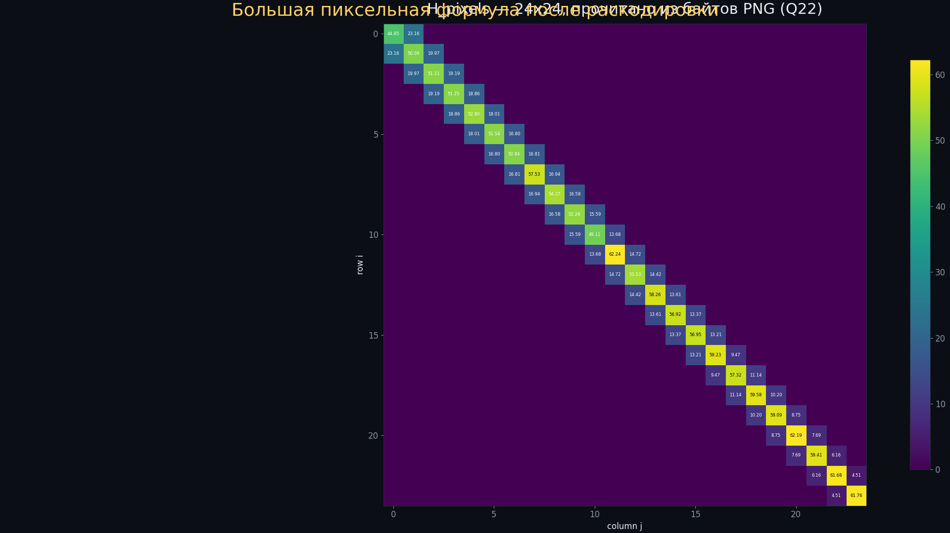
Fig. 2. H_pixels read back from the PNG bytes: all 70 structural entries annotated.
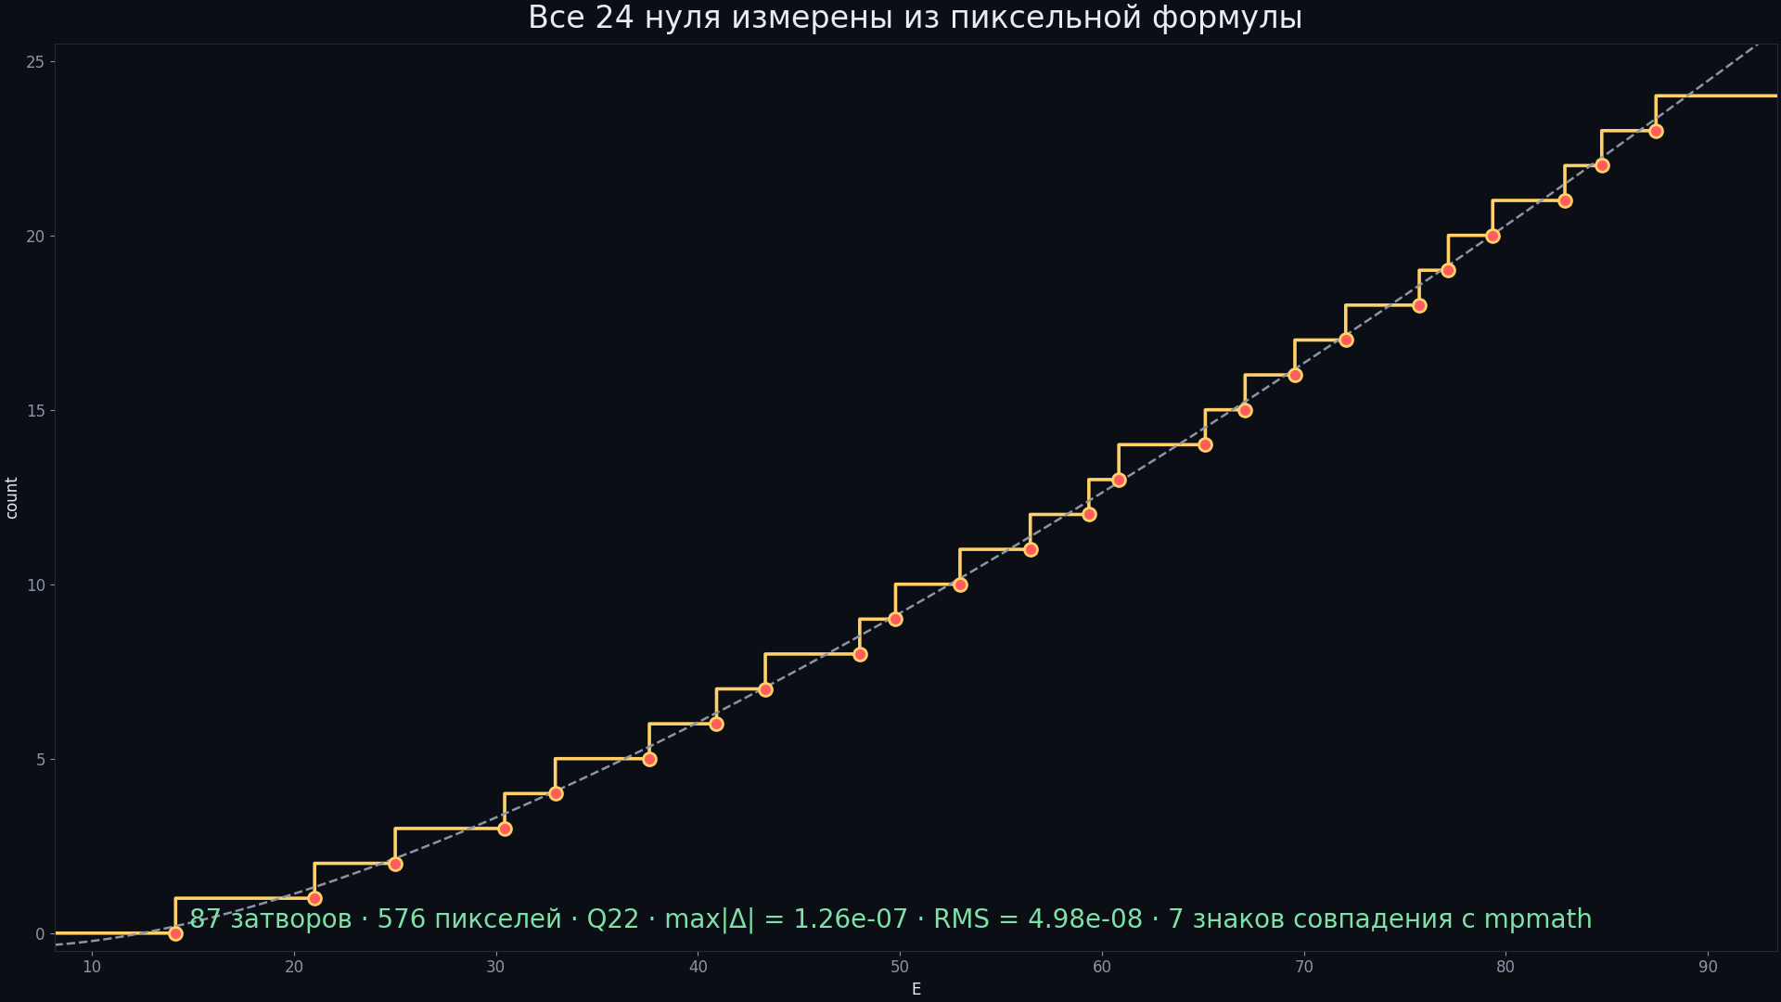
Fig. 3. The measured zero staircase against the Riemann–von Mangoldt smooth count.

Environment, determinism and the data dictionary
All campaigns ran in one environment: Python 3.12, numpy 2.1, scipy 2.14 (eigvalsh, driver evr), mpmath 1.3 (dps 25–40 by criteria), matplotlib 3.9 (figures at 600 dpi). The master seed is 96; the RNG streams are fixed: vortices default_rng(96 + 3500), disorder default_rng(96 + 3501), GUE zeros default_rng(9000 + k), Poisson zeros default_rng(7000 + k). Runtimes range from seconds (C1) to about an hour (C2, C6); C12 ran in segments with a final assembly.
The bit-for-bit base control: the protocol reference gate reproduces the mean level spacing of the C3 CSV with a deviation of 1.45e-16 — the engine/hamiltonian.py core is equivalent to the original protocol. Verdicts are committed in data/; the campaigns re-read them and recompute cheap invariants in seconds. The full independent verification protocol IVP01–IVP18 passes 18/18 with one command; the pytest suite is 21/21. The dictionary of verdict files is in the table below.
Table 1. Verdict files
File | Content | Campaign
c1_identity_verdict.json | K1–K7: ladder, reality, zeros, Gram | C1
c2_argument_verdict.json | anchors 0/3/10/29/79/649, S(T), gaps, bridge | C2
c3_gates_verdict.json + c3_gates_table.csv | 52 gates, nulls, PC1/PC2 | C3
c4_trace_verdict.json | M0/M1/M2, PC0, trace-metric gap | C4
c5_gates_ext_verdict.json + c5_gates_ext_table.csv | 35+2 extended gates | C5
c6_primes_verdict.json | co-location, kernel, ψ-ladder, codings | C6
c7_dynamics_verdict.json | trajectories ⟨x⟩(t), transport P(x≥90) | C7
C8 ladder + spinor64 | 11-channel ladder, 64→4 reduction | C8

The registry of controls and the cycle formula
The discipline of controls: a method is admitted to a negative verdict only after demonstrating a positive result on an object where the identity is known to hold. Every negative result of the series (Г2, Г5, M3) went through this procedure; every positive one (T1–T4, T6, T8) through an independent recomputation in IVP01–IVP10.
The open challenge (challenge/CHALLENGE.md) accepts submissions against a public metric: r_H7 ≥ 0.7 under the v2 protocol with passing positive controls and an intact GUE class; the scorer is blind and keeps the full report regardless of outcome. The leaderboard is open.
Table 2. Controls of the series
Control | Must show | Value | Where
PC1 spinor64 twins | r = 1 on an isospectral orbit | r = 1.000000000, D_nn = 2.7e-14 | C3
PC2 graph ↔ file | r = 1 between Z_id zeros and the file | r = 1.000000000000 | C3
PC0 zeros window (trace) | the method sees the Λ-comb | r_EF = +0.9998, residual 2.1% | C4
Decoys (random phases) | the null zone of correlations | 0.026±0.140 / +0.050±0.153 | C3, C6
GUE null | universality without identity | ⟨r⟩-plateau; r_EF 0.43±0.71 | C3–C5
Surrogate null (blocks) | the width of the trace metric | 0.00±0.39 | C4
Poisson null | clustered spectra | 0.08±0.80 | C4

The cycle formula after sixteen campaigns: the resonator is built and tuned (Г1 + Г3 + Г4); the zeros are encoded, not generated (Г2 + Г5); the prime weight is verified for the zero operator (T6) and for the nonlocal primitive (T11), and absent from the local gates.

The honesty ledger: the first generation
The discipline 'statuses are not inflated, all constants are derived' is accompanied by a registry of published errors. From the first generation: the refutation of the Γ-module candidate form (K1) is published in the C1 monograph; the Σγ² factor error (4π³) was caught by disagreement with the data and fixed (C2); the degenerate angle W = 0 + midpoint was excluded from C5 with a note; the surrogate null of the heat metric was recognized as wide (±0.39) — the trace projection is conservative; 'all statistics' were confirmed within the Dyson triple, GSE being architecturally unreachable.

The v2 honesty ledger: found-and-fixed
The v1 discipline («statuses are not inflated, all constants are derived») is continued; v2 publishes four findings:
1. **B_HADAMARD** in the v1 shipped code contained ln(2π) = 1.8379 instead of ln(4π) = 2.5310. The correct value B = −0.0230957 is confirmed by the committed v1 verdicts — the error was in the file constant only, not in the results. Fixed with a code comment.
2. **The T9 observation of v1 is refined**: the full C11 law — N₀ = 2L − 6·[L ≡ 0 (mod 12)] — shows that modes exist on all L ≡ 0 (mod 6), including L = 18 (≡ 2 mod 4); the v1 formulation «tori L ≡ 0 (mod 4)» described only the index −2 subfamily.
3. **The χ4 coding is gauge-trivial** — phase systems with values {0, π} are removed by the transformation ψ → (−1)^y ψ; the spectral coincidence 8.4e-15 is measured. This is a corollary of T12 and an honest constraint of the coding class.
4. **The r_EF metric of v2** — on detrended fluctuations: the raw v1 correlation catches the common trend of two smooth curves (any smooth D(u) gives r ≈ 0.99). The GUE null is wide (±0.8) and stated explicitly; the isospectral control must give r_fluct = 0.999 — and does.
Additionally: the T6 check passed n instead of ln n to K_formula; the pole a = 0.5 fell on the spline grid; the environment's background processes do not survive between calls — the C12 run was done in segments with a later assembly. All documented in code and verdicts.

Roadmap: the operator that encodes the zeros
The directions are ordered by their expected effect on the main measured verdict Г2 (surrogate-null level in the rank metric, ≈0.5–1 by residual in the heat metric) and on the main goal — showing that a Hilbert–Pólya operator encodes the zeros by generation, not by repacking.
The theoretical bridge (N1–N3). N1 — a proof of the counting law T13: N₀ = 2L − 6·[L ≡ 0 (mod 12)] via the Kähler–Dirac index and the spectral sequence of the flux-1/3 torus; candidates are Atiyah–Singer on the lattice and the modularity of the curve x³ ≡ ... mod L. N2 — half-integer characters: transferring C15 to χ mod 3, 11, 13 and modular forms of level 11 — how far does the universality of T17 reach. N3 — stitching through the index: the Kähler–Dirac operator as a candidate gate; does its heat trace carry the prime weight (r_EF) at α = 1/3 — the one class where arithmetic has already entered the spectrum.
Independence of H from the zeros (N7). The key falsifiable step: build candidates from arithmetic only and predict zeros blindly. Three candidate sources are already measured by the series: the LCM kernel Λ(lcm(m,n))/√mn (C9/N5 — a degenerate spectrum, but the prime weight is in the kernel), Kähler–Dirac at flux 1/3 (T13), and the discretization of the trace formula (a window of the explicit formula as a Hamiltonian). Acceptance criteria: prediction of new zeros beyond the fitted range; r_H7 ≥ 0.7 under the challenge protocol with passing positive controls and an intact GUE class; the blind pixel version — pixels from arithmetic, zeros from the spectrum.
New campaigns (N4–N6). N4 — the band T = 50000 with the same segmented machine (~40× the C12 runtime). N5 — the quantum response to the index: does the MI profile see the phase transition N₀ > 0 ⇔ L ≡ 0 (mod 6) in the C16 protocol. N6 — the live intake of challenge submissions; the first accepted result becomes a joint paper.
Literary anchors (N8). The Berry–Keating xp programme (1999) and its PT-symmetric version of Bender–Brody–Müller (2017) define the canonical nonlocal candidate; Connes' trace formula (1999) is the direct ancestry of T6/T11 — the spectral side of the trace construction is already measured by the series, and the wall of locality is noncommutative geometry turned onto a lattice. The xp variations with interactions (Sierra–Townsend, 2008) refine the candidate class. The classical supports — Weil's explicit formula (1952), Montgomery's GUE conjecture (1973), Odlyzko's computations (1987), and the Dyson triple (1962). The position of the series on this map: the only package where the trace side (T6/T11/T17), the demarcation of the local class (T7/T15/T16), and arithmetic in the spectrum (T13) are measured on one pipeline with controls.
The verdict of the canonical edition. The operator that almost exists exists exactly as far as the trace allows: with the prime weight — exactly (T6, T11); with arbitrary nonlocality — exactly; with co-location of primes in phases — exactly (T12). It refuses to exist locally: 227 measured configurations of five families and three classes never left the null zones (T7, T15, T16). Arithmetic appeared in the lattice spectrum for the first time — in the count of zero modes of the Dirac index (T13) — and the gap turned out to be a property of the whole L-function class (T17). The pixel protocol fixes the discipline of encoding: zeros are transported without loss but are not generated. The only honest way forward is the roadmap: build H from arithmetic and predict the zeros blindly.

