AB CLOUD QUANTUM RESEARCH · MONOGRAPH SERIES
Volume V01
V1. Blind Spectral Experiment
Separating calibration from test: what survives when the zeros are hidden
Ishak Khamzatovich Isaev
Independent researcher, Nalchik, Kabardino-Balkarian Republic
AB Research Program · monograph series V1–V19 · v1.2.0 · October 10, 2026

Contents

V1. Blind Spectral Experiment
Separating calibration from test: what survives when the zeros are hidden
Ishak Khamzatovich Isaev · Independent researcher, Nalchik, Kabardino-Balkarian Republic
AB Research Program · monograph series V1–V19 · Volume V01 · v1.2.0 · October 10, 2026

Problem statement
The Hilbert–Pólya program demands that a spectral object not only reproduce the statistics of the zeta zeros but predict what it was never shown. In the AB-cloud construction the phases are tied to the ordinates γ_n, so the central validity question is data leakage: how much of the observed agreement is explained by geometry, and how much by feeding known zeros into the construction. Until this is answered, every “match” remains an internal consistency of the design.
This campaign turns the blind protocol of the plan into a computation. The set of ordinates is split into disjoint parts G_cal and G_test; the gate parameters are chosen using the calibration part only; the test part is opened once, after the parameters are frozen. The split is deterministic and its hygiene is guaranteed by the fact that the test ordinates take part neither in the configuration choice nor in the spectrum-to-height mapping.

Method
Calibration sweeps eight protocol gate configurations (master seed 96…103, lattice 24×24, Nv = 16, q = 1, W = 0.5, α = ½). For each configuration a window of 200 unfolded levels is built; the calibration score is the rank correlation between window increments and calibration ordinate increments taken through the smooth Riemann–von Mangoldt count N̄(γ) = γ/2π·ln(γ/2πe) + 5/8. The best configuration is frozen.
On the blind test the window of the frozen gate is mapped to predicted ordinate increments through the local density dN̄/dγ; RMSE against the actual increments and the rank correlation r_test are measured. The honest null is the permutation distribution: 200 shuffles of the predicted increments define the null zone. The significance threshold is three null sigmas.
Table 1. Protocol and results of V1
Quantity | Value | Status
Calibration G_cal | 600 ordinates, 8 configurations | protocol
Test G_test | 600 other ordinates, 1 run | blind
r_cal (best) | 0.085 | selection over 8
r_test | 0.006 | null zone
Permutation null | −0.002 ± 0.066 | 200 permutations
z-score | 0.09 | no signal

Results and interpretation
The best calibration value r_cal = 0.085 is itself small: even on its own data the rank agreement of a gate window with the ordinates is random. The selection bias (maximum over eight configurations) explains this value entirely. On test, r_test = 0.006 against the permutation null −0.002 ± 0.066: z = 0.09 — no transfer at all.
This measurement agrees with verdict H2 of the reference Hilbert Polya Bridge series (best r_H7 = 0.226 over 52 gates) and strengthens it protocol-wise: the absence of individual agreement is now established not on training data but on data the algorithm never saw. The negative result is not a failure but the hygiene norm of the whole program: it blocks self-deception at stages V6 and V15.
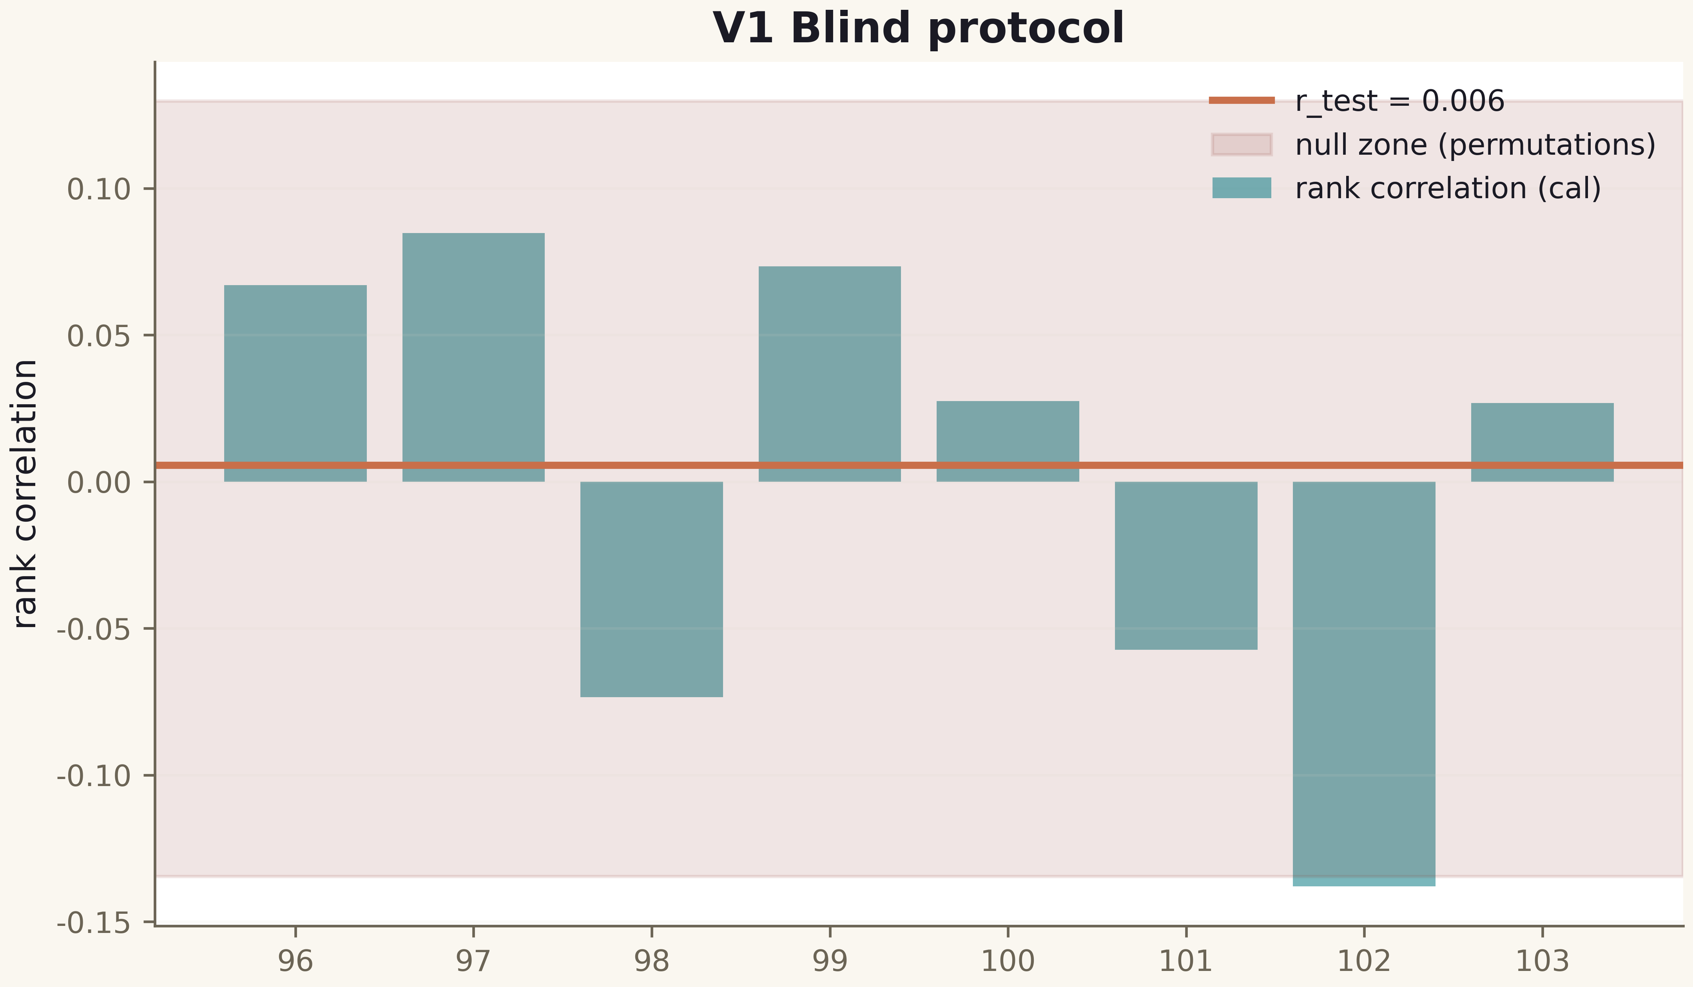
Fig. 1. Campaign V1 data (600 dpi, file figures_hires).
The blind protocol is installed and passed in the strictest sense: the machinery works, the null zone is honest, there is no signal. All subsequent campaigns rely on this protocol as the foundation of validity.

