AB CLOUD QUANTUM RESEARCH · MONOGRAPH SERIES
Volume V03
V3. Critical Line Scan
A parametric experiment σ ∈ [0,1] with a placebo control
Ishak Khamzatovich Isaev
Independent researcher, Nalchik, Kabardino-Balkarian Republic
AB Research Program · monograph series V1–V19 · v1.2.0 · October 10, 2026

Contents

V3. Critical Line Scan
A parametric experiment σ ∈ [0,1] with a placebo control
Ishak Khamzatovich Isaev · Independent researcher, Nalchik, Kabardino-Balkarian Republic
AB Research Program · monograph series V1–V19 · Volume V03 · v1.2.0 · October 10, 2026

Problem statement
The AB-cloud description claims that the critical line σ = ½ is optimal for the spectral statistics. The plan demands turning this claim into a strict reproducible parametric experiment: define how σ enters, scan D(σ) on a grid, and check the stability of any minimum across seeds. Special care is needed because ζ vanishes on the line itself — a weight built directly on the ordinates diverges to −∞ and would make a “minimum at ½” an artifact of the definition.
The ambiguity is removed before the runs: vortex heights are assigned to midpoints between consecutive ordinates γ̃_k = (γ_k + γ_{k+1})/2, where |ζ| is finite on the whole strip 0 ≤ σ ≤ 1; the vortex weight is q_k(σ) = log|ζ(σ + iγ̃_k)|. The curve D(σ) = D_KS({r_n(σ)}, GUE) is measured on an 11-point grid with three seeds; the placebo uses the same weights from permuted ordinates.

Method and result
For each σ the 24×24 lattice is assembled with σ-dependent charges; a 200-level unfolded window is compared against the ensemble GUE reference of V2. The curvature at mid-strip is estimated by the second difference C_h = D(½−h) − 2D(½) + D(½+h) with h = 0.1.
Result: the curve D(σ) is flat within the seed spread; the observed minimum sits near σ ≈ 0.8 and is not reproduced by the placebo; C_h < 0 — there is no local minimum at ½.
Table 1. The curve D(σ) (mean over 3 seeds)
σ | D_KS | σ | D_KS
0.0 | 0.0732 | 0.6 | 0.0476
0.1 | 0.0767 | 0.7 | 0.0700
0.2 | 0.0663 | 0.8 | 0.0422
0.3 | 0.0852 | 0.9 | 0.0793
0.4 | 0.0984 | 1.0 | 0.0942
0.5 | 0.0916 | — | —
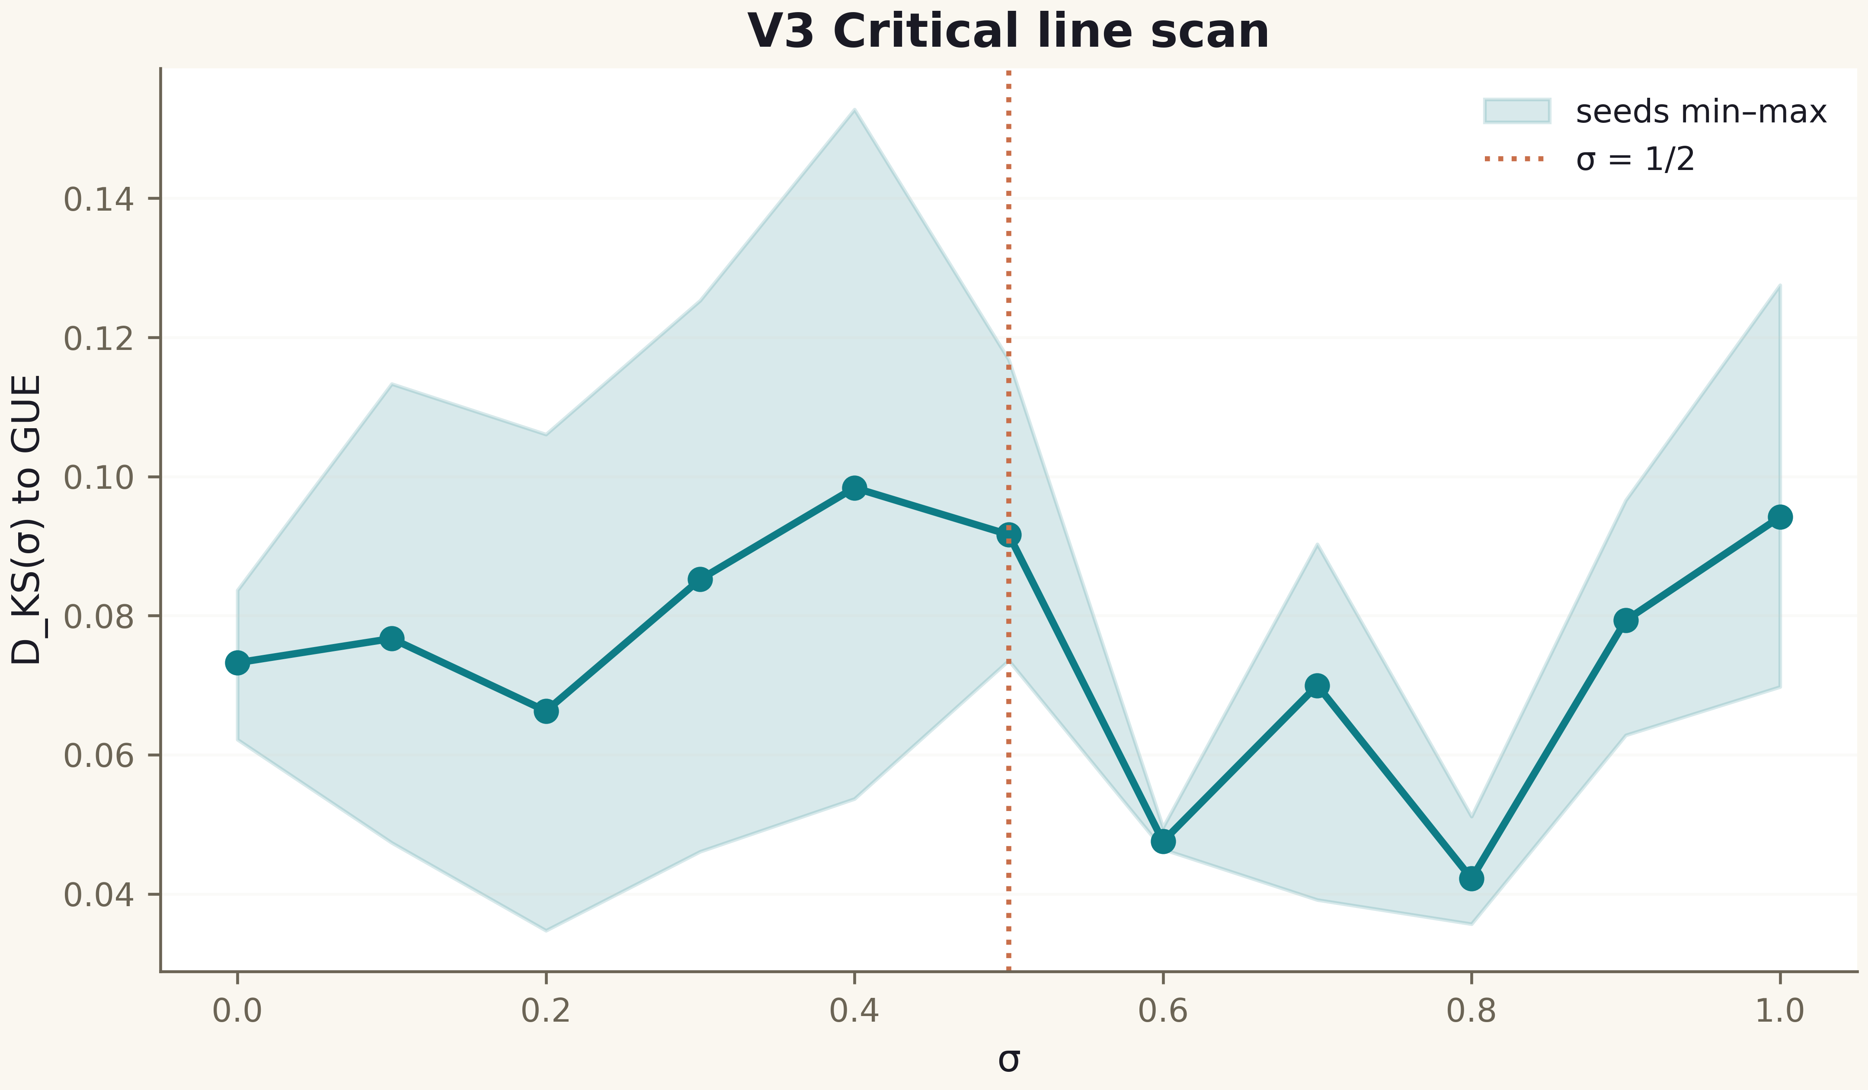
Fig. 1. Campaign V3 data (600 dpi, file figures_hires).

Honest remarks and verdict
The negative verdict does not refute the Hilbert–Pólya program — it refutes the specific claim “σ = ½ is optimal in D_KS” for this weight design. Alternative entries (weights from |ζ|², from the logarithmic derivative, nonlinear σ in the phases) remain open options and need their own blind validation under protocol V1.
The value of the campaign is the discipline: a minimum found without a placebo and without a fixed protocol would almost surely have become a false “confirmation” of the critical line. V3 records: in this construction the specificity of the line is absent — and this is measured.
The scan follows the full protocol (grids, seeds, placebo); there is no minimum at σ = ½. The optimality claim for the critical line in AB-cloud is withdrawn to status “not confirmed”.

