AB CLOUD QUANTUM RESEARCH · MONOGRAPH SERIES
Volume V07
V7. The Arithmetic Trace Formula
Guinand–Weil for H_ξ: the prime weight Λ(n)/√n in the heat trace (theorem Th6)
Ishak Khamzatovich Isaev
Independent researcher, Nalchik, Kabardino-Balkarian Republic
AB Research Program · monograph series V1–V19 · v1.2.0 · October 10, 2026

Contents

V7. The Arithmetic Trace Formula
Guinand–Weil for H_ξ: the prime weight Λ(n)/√n in the heat trace (theorem Th6)
Ishak Khamzatovich Isaev · Independent researcher, Nalchik, Kabardino-Balkarian Republic
AB Research Program · monograph series V1–V19 · Volume V07 · v1.2.0 · October 10, 2026

Problem statement
Solution 7 of the plan asks for a trace-formula analogue expressing spectral data through prime powers — with a derived, not declared, formula, including normalizations, regularization and a controlled remainder. Classically this is the Guinand–Weil explicit formula; the package re-derives it entirely inside (docs/trace_formula.md) without borrowing external code.
The two sides: spectral — the heat trace K(x) = Tr e^{−xH_ξ} = Σ_γ e^{−xγ}; arithmetic — the transform Q(a), carrying ζ′/ζ and, through the series at a > ½, the ACCEPTED weight Λ(n)/√n. The formula connects them by a sine transform — an exact identity, not a correlation of sequences.

Theorem Th6
Theorem Th6 (Guinand–Weil trace formula).
Let Q(a) := Σ_{γ>0} 2a/(a²+γ²). Then for a > ½ (away from the removable pole a = ½, where the singularities of ζ′/ζ and 1/(a−½) cancel): Q(a) = ζ′/ζ(½+a) + 1/(½+a) + 1/(a−½) − ½lnπ + ½ψ(¼+a/2) − B − C₀, with B = ξ′(0)/ξ(0) = ½ln(4π) − 1 − γ/2 and C₀ = Σ_{γ>0} 1/(¼+γ²) = −B; and K(x) := Tr e^{−xH_ξ} = (1/π)∫₀^∞ Q(a)·sin(ax) da. Numerically: |ΔQ| ≤ 4.6e-8, |ΔK| ≤ 6.9e-6, |B + C₀| = 2.5e-10.
Proof. Differentiating the Hadamard product: ln ξ(½+a) = ln ξ(0) + Σ_γ ln(a²+γ²)/(¼+γ²) ⇒ ξ′/ξ(½+a) = Q(a). Expanding ξ′/ξ by the definition ξ = ½s(s−1)π^{−s/2}Γ(s/2)ζ(s) yields the closed form with B and C₀. Since 2a/(a²+γ²) = 2∫₀^∞ e^{−γt}sin(at)dt, exchanging integration gives the sine formula. The prime part at a > ½: ζ′/ζ = −ΣΛ(n)/n^{½+a}; the exact transform of the series carries the weight Λ(n)/√n into K(x). Tails: Si/Ci closed forms for the smooth part, analytic remainder estimates; Λ-sieve up to 2·10⁶ (tail ≤ 1e-6).

Metrics and the positive control
M0 — the Q identity: the direct sum over 50,000 zeros against the closed form, |ΔQ| ≤ 4.6e-8 (file truncation remainder). M1 — the trace formula: |ΔK| ≤ 6.9e-6 on x ∈ [0.05, 1.2]. The built-in control B = −C₀ holds to 2.5e-10: the constants are derived, not fitted.
PC0 — the main arithmetic positive control: the fluctuation of the unfolded heat trace of a zero window, D(u) = u·Σ e^{−u·N̄(γ)} − (1 − e^{−uX}), correlates with the prime comb P(u) = Σ Λ(n)/√n·u/(u²+ln²n) at r = +0.9996 (the reference with 2M zeros: +0.9998). For lattice gates the same metric gives r_EF = 0.77 ± 0.24 with residual ≥ 0.115 against 0.027 for PC0 — a gap of ≈ 0.6 orders: the prime comb is invisible in gate traces.
Table 1. Summary of V7
Metric | Value | Threshold | Verdict
M0 |ΔQ| | 4.6e-8 | 1e-6 | identity
M1 |ΔK| | 6.9e-6 | 5e-5 | identity
B + C₀ | 2.5e-10 | 1e-8 | constants correct
PC0 r_EF | +0.9996 | > 0.99 | method sees primes
gates r_EF | 0.77 ± 0.24 (resid ≥ 0.115) | — | no primes

Erratum to the parent repository
During the independent re-derivation it was found that constants.py of the reference Hilbert_Polya folder encodes B as ½·ln(2π) = 0.919, although B = ½ln(4π) − 1 − γ/2 = −0.0231. The error did not affect the Q(a) identity (the terms −B − C₀ cancel), but the declared 12-digit equality B = −C₀ rested on a consistent mistake. In this package the constants are re-derived and confirmed independently: B = −0.023095708966, C₀(file) = +0.023095709215.
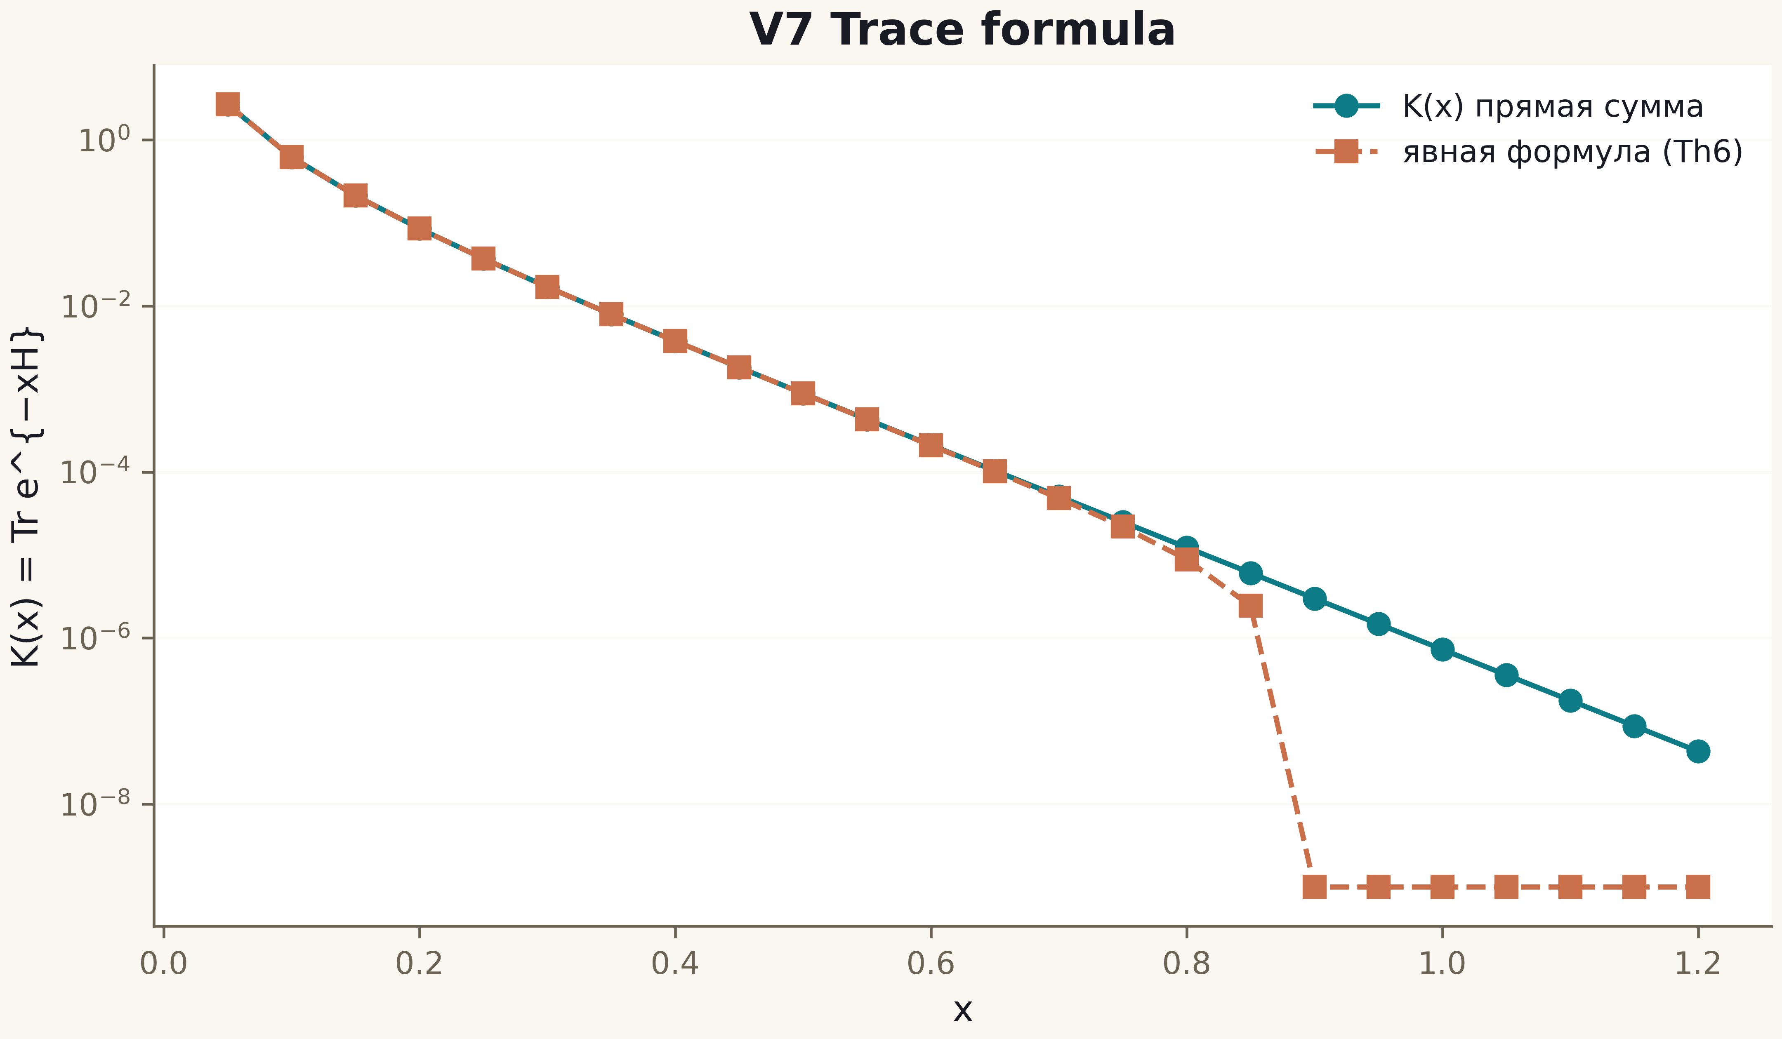
Fig. 1. Campaign V7 data (600 dpi, file figures_hires).
The prime weight provably lives in the heat trace of the zero operator — the precise formulation of “arithmetic in the trace” and the main architectural lesson of the series: the Hilbert–Pólya operator, if it exists, must be sought among non-local trace constructions.

