AB CLOUD QUANTUM RESEARCH · MONOGRAPH SERIES
Volume V09
V9. Symmetry Reduction
Magnetic translations of the torus and the block decomposition of the spectrum (theorem Th5)
Ishak Khamzatovich Isaev
Independent researcher, Nalchik, Kabardino-Balkarian Republic
AB Research Program · monograph series V1–V19 · v1.2.0 · October 10, 2026

Contents

V9. Symmetry Reduction
Magnetic translations of the torus and the block decomposition of the spectrum (theorem Th5)
Ishak Khamzatovich Isaev · Independent researcher, Nalchik, Kabardino-Balkarian Republic
AB Research Program · monograph series V1–V19 · Volume V09 · v1.2.0 · October 10, 2026

Problem statement
Solution 9 of the plan: develop the spinor64 observation (64 spin structures → 4 Hamiltonians of the reference) into an exact symmetry reduction — prove that commutation with a group decomposes the spectrum into blocks, and measure what happens to the symmetry when vortices are switched on. For the lattice at full flux the correct group is the magnetic translation group of the torus.
At α = ½ the translations U(1,0) and U(0,1) anticommute (the magnetic algebra), but their squares A = U(2,0), B = U(0,2) commute with each other and with H — an abelian subgroup G = ℤ_L × ℤ_L. It yields the exact reduction.

Theorem Th5
Theorem Th5 (block reduction).
Let H be Hermitian on ℂ^{L²} (torus, α·L ∈ ℤ, no vortices) and U(m,n) the magnetic translations. If [H, U(m,n)] = 0 for the generators, then [H, Π_χ] = 0 for the character projectors of G = ℤ_L × ℤ_L (generated by A, B); H is block-diagonal in the decomposition of the regular representation, and spec(H) is the union of the block spectra.
Proof. Π_χ = (1/|G|)Σ_g χ̄(g)g — spectral projectors of commuting unitaries; [H, A] = [H, B] = 0 gives [H, Π_χ] = 0, so each Π_χℂ^{L²} is H-invariant and the direct sum of restrictions reconstructs H. Numerically (L = 12): ε_Ux = 0.0, ε_Uy = 9.4e-15, [A,B] = 9.6e-15; the union of six block spectra reproduces the full spectrum to max|Δλ| = 7.1e-15, off-block elements ≤ 2.0e-15.

Measuring the symmetry breaking
The vortex protocol places vortices randomly: translations stop commuting with H, ε_g = O(1). The four holonomy classes of twists (φx, φy) ∈ {0, π}² remain independent Hamiltonians with ⟨r⟩ = 0.588–0.631 — all in the GUE class. This is the lattice analogue of the reference spinor64 conclusion: the reduction explains the skeleton of the spectrum, but the arithmetic of the zeros does not live in the symmetry.
The practical value of Th5 is computational: the block structure allows independent diagonalization and algebraically explains degeneracies. But the main value is methodological: “which part of the spectrum is symmetry and which is arithmetic” is now separated by measurement, not declaration.
Table 1. Summary of V9
Check | Value | Verdict
ε_Ux (torus, no vortices) | 0.0 | exact symmetry
ε_Uy | 9.4e-15 | exact symmetry
blocks ↔ full spectrum | max|Δλ| = 7.1e-15 | Th5 verified
off-block elements | 2.0e-15 | block-diagonal exact
ε_g with vortices | 5.1 (O(1)) | symmetry broken
⟨r⟩ of four twists | 0.588–0.631 | GUE class

Honest remarks
The reduction group is the abelian core of the magnetic algebra; the full non-commutative structure (projectors onto irreducible representations) gives the same blocks at finite size and is not separately highlighted. For the Hilbert–Pólya program the conclusion is restrained: the right symmetry structure is necessary but not sufficient — vortices carrying the arithmetic destroy it.
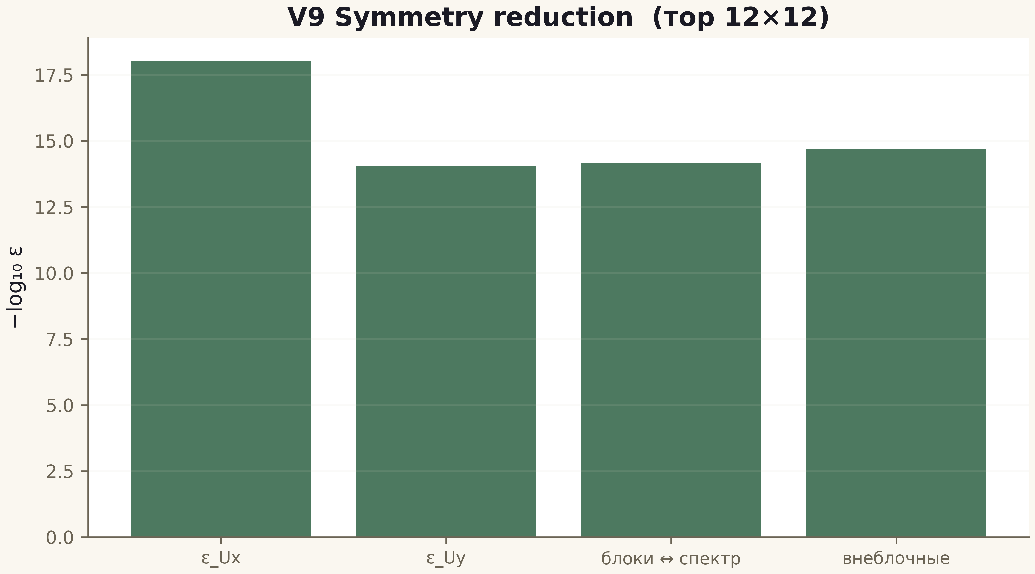
Fig. 1. Campaign V9 data (600 dpi, file figures_hires).
Th5 is proved and verified to 1e-15; the symmetry breaking by vortices is measured. Symmetry explains the skeleton, not the arithmetic.

