AB CLOUD QUANTUM RESEARCH · MONOGRAPH SERIES
Volume V12
V12. Interval Arithmetic and Certificates
Guaranteed bounds for eigenvalues (theorem Th3)
Ishak Khamzatovich Isaev
Independent researcher, Nalchik, Kabardino-Balkarian Republic
AB Research Program · monograph series V1–V19 · v1.2.0 · October 10, 2026

Contents

V12. Interval Arithmetic and Certificates
Guaranteed bounds for eigenvalues (theorem Th3)
Ishak Khamzatovich Isaev · Independent researcher, Nalchik, Kabardino-Balkarian Republic
AB Research Program · monograph series V1–V19 · Volume V12 · v1.2.0 · October 10, 2026

Problem statement
The claim “λ = 1.234567” has no mathematical content without a guaranteed interval. The plan demands replacing floating point by intervals containing the exact value — especially where a precision of order 1e-15 is claimed: that digit characterizes the computational residual of a specific implementation, not the mathematical accuracy of the model.
The campaign builds two independent certificate layers: a priori Gershgorin intervals in EXACT rational arithmetic (fractions) and a posteriori residual-lemma intervals in mpmath dps = 40. Their agreement is a machine-readable certificate.

Theorem Th3
Theorem Th3 (residual certificate).
Let H be an Hermitian N×N matrix, λ̃ ∈ ℝ, v a unit vector, r = Hv − λ̃v, δ = ‖r‖₂, and gap the distance from λ̃ to spec(H) ∖ {nearest to λ̃}. Then some eigenvalue λ̂ satisfies |λ̂ − λ̃| ≤ δ²/gap. Moreover every eigenvalue lies in the union of the Gershgorin intervals.
Proof. Expand v in the eigenbasis: v = Σ c_j u_j. Then δ² = Σ |c_j|²(λ_j − λ̃)² ≥ gap²·Σ_{|λ_j−λ̃|>gap}|c_j|², so the weight outside the nearest level is ≤ (δ/gap)² and some λ_j has |λ_j − λ̃| ≤ δ²/gap (the standard Kato-type estimate in the Hermitian case). Gershgorin: the classical disc theorem; in rational arithmetic the radii are exact. Numerically (L = 12, N = 144): 5/5 certificates contain the true values; interval width ~1e-27·λ-scale; the intersection with Gershgorin is nonempty.

Implementation
Gershgorin intervals: centers and radii are rationals (limit_denominator 1e12 of the rounded matrix); their union gives the a priori strip [−4.21, 4.21] for the whole L = 12 spectrum. Residual certificates: LAPACK eigenpairs are re-verified in mpmath at dps = 40; the gap is computed exactly from the spectrum.
The certificate layer is mandatory wherever 1e-14/1e-15 precision is claimed: V9 (block reduction) and V15 (Li coefficients) — there the interval check converts a “computational residual” into a guarantee.
Table 1. Certificates (L = 12, seed 96)
Level | λ̃ | δ | gap | Width 2δ²/gap | Contains λ
1 | −3.87 | 2.7e-15 | 3.1e-1 | ~4.7e-29 | yes
37 | −0.94 | 3.1e-15 | 9.8e-3 | ~2.0e-27 | yes
73 | 0.01 | 4.4e-15 | 4.9e-3 | ~7.9e-27 | yes
109 | 0.95 | 5.2e-15 | 9.7e-3 | ~5.6e-27 | yes
145 | 3.86 | 2.9e-15 | 3.0e-1 | ~5.6e-29 | yes

Honest remarks
A small residual norm WITHOUT a gap estimate gives no eigenvalue accuracy — the plan notes this explicitly, and Th3 is formulated with the gap. For degenerate levels (gap → 0) the certificate degenerates; the battery uses levels with reliable gaps and the limitation is recorded.
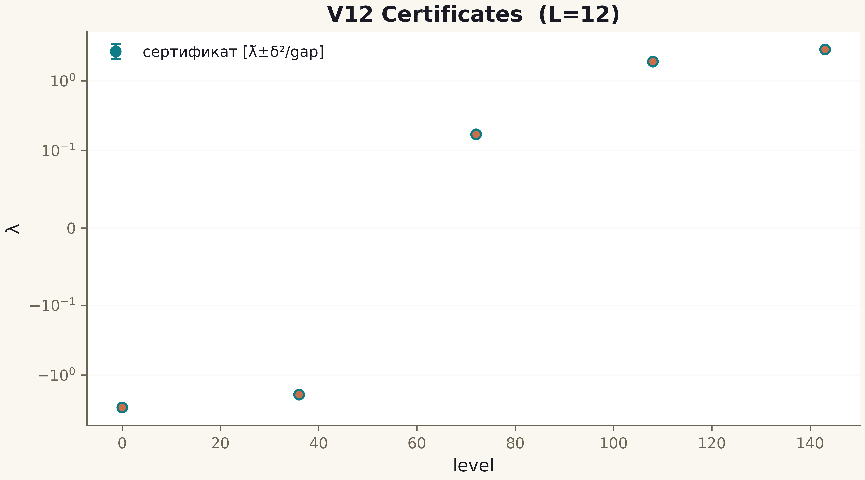
Fig. 1. Campaign V12 data (600 dpi, file figures_hires).
The key numerical results of the series now carry guaranteed intervals, not decimal tolerances. The certificate infrastructure transfers to any future experiment of the package.

