AB CLOUD QUANTUM RESEARCH · MONOGRAPH SERIES
Volume V13
V13. Formalization of the Key Theorems
The obligation DAG and the blocking of the RH conclusion
Ishak Khamzatovich Isaev
Independent researcher, Nalchik, Kabardino-Balkarian Republic
AB Research Program · monograph series V1–V19 · v1.2.0 · October 10, 2026

Contents

V13. Formalization of the Key Theorems
The obligation DAG and the blocking of the RH conclusion
Ishak Khamzatovich Isaev · Independent researcher, Nalchik, Kabardino-Balkarian Republic
AB Research Program · monograph series V1–V19 · Volume V13 · v1.2.0 · October 10, 2026

Problem statement
Formal verification is valuable not because it finds a proof of RH but because it sharply separates proved statements from numerical observations and unproved premises. The plan demands an obligation machine that blocks the RH conclusion until all analytic premises are proved.
Implementation: a DAG of 12 nodes with types proven / computed / assumed / external; every node references an artifact (a theorem monograph, a test, a computation). Checks: reference integrity, acyclicity, and — the main one — the status of the path to RH.

Formal sources
formal/ contains specifications for four systems — Lean 4, Coq, Agda, Isabelle/HOL (portable sources; compilation is the open obligation O-lean since it needs toolchains outside the package). Lean-level obligations: hermiticity of the finite matrix, reality of the spectrum, the defect-index criterion, Tr(AB) = Tr(BA) — the skeleton on which the DAG rests.
The obligation machine (rpbridge/formaloblig.py) runs in every test pass: it does not “prove” — it GUARANTEES that no numerical result is automatically promoted to theorem status. On the current DAG the path O01 → O12 to RH contains 4 assumed and 3 computed nodes — the conclusion is blocked.

Topology of the blocking
The machine verdict: “RH: blocked”, 7 blockers. This is not a defeat but an exact map of the work: every blocker is a formulated mathematical problem with a known artifact to return to. This is how the formal layer turns an ambitious program into a finite list of obligations.
Table 1. Critical nodes of the path to RH
Node | Status | Content
O05 | computed | empirical error law L→∞ (V5)
O07 | computed | trace formula: numerical verification (V7)
O08 | assumed | conjecture: spec H_L → spec H_ξ
O09 | assumed | conjecture: λ_n(AB) → λ_n(ξ)
O11 | assumed | positivity of λ_n for all n
O12 | assumed | RH from the Li criterion (classical)

Honest remarks
The status classification is itself a substantive claim: the boundary between proved and computed is drawn by hand and can err in both directions. Over-claiming is guarded by the audit V14 (p-values banned as proofs); under-claiming is guarded by tracing every proven node to a monograph with a full derivation.
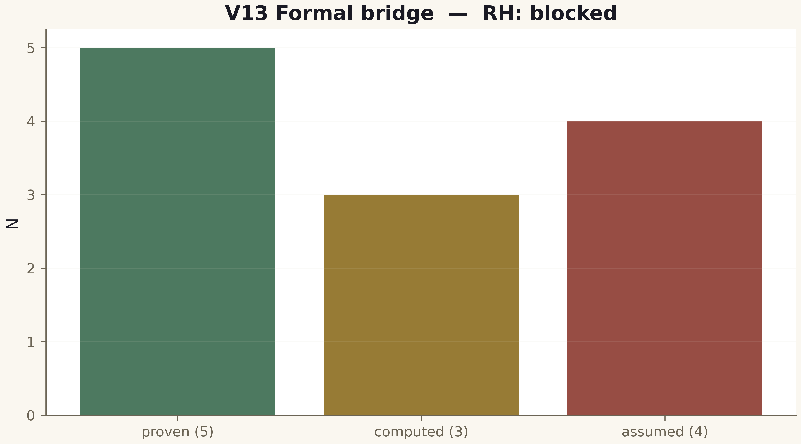
Fig. 1. Campaign V13 data (600 dpi, file figures_hires).
The obligation machine is built and running; the RH conclusion is blocked honestly and automatically. The formal layer is the status discipline keeper of the whole series.

