AB CLOUD QUANTUM RESEARCH · MONOGRAPH SERIES
Volume V14
V14. Automatic Audit of Claims
The five mandatory parts of every result
Ishak Khamzatovich Isaev
Independent researcher, Nalchik, Kabardino-Balkarian Republic
AB Research Program · monograph series V1–V19 · v1.2.0 · October 10, 2026

Contents

V14. Automatic Audit of Claims
The five mandatory parts of every result
Ishak Khamzatovich Isaev · Independent researcher, Nalchik, Kabardino-Balkarian Republic
AB Research Program · monograph series V1–V19 · Volume V14 · v1.2.0 · October 10, 2026

Problem statement
The plan fixes the protocol: every new experiment must contain (1) an exact mathematical statement, (2) the list of premises, (3) a numerical result with reproducible code, (4) control models and a sensitivity analysis, (5) the list of what the result does NOT prove. The cautionary examples matter: p_KS = 0.27 does not “prove GUE”, and ‖H−H†‖ < 1e-14 for a finite matrix does not prove self-adjointness of an infinite-dimensional operator.
The campaign implements this protocol as executable infrastructure: a claim-JSON schema, an auditor, and 15 claim files — one per campaign of the series.

Schema and checks
A1 — form: all five parts present and non-empty. A2 — status hygiene: the status vocabulary (proven/measured/conjecture/refuted); the “proven” status requires at least one passed control AND a non-empty list of non-implications; p-values are banned as justification of “proven”. A3 — coverage: every verdict data/v*_verdict.json must have a claim file.
The auditor runs in the package tests: an audit regression is a release stopper, as in the reference.
Table 1. Status registry of the 19 campaigns
Status | Campaigns
proven | V4 (Th1), V7 (Th6), V8 (Th2), V9 (Th5), V12 (Th3), V15 (Th4)
measured | V1, V2, V3, V5, V6, V10, V11, V13, V14, V16, V17, V18, V19
conjecture / refuted | — (conjectures live in the V13 DAG with status assumed)

Verdict
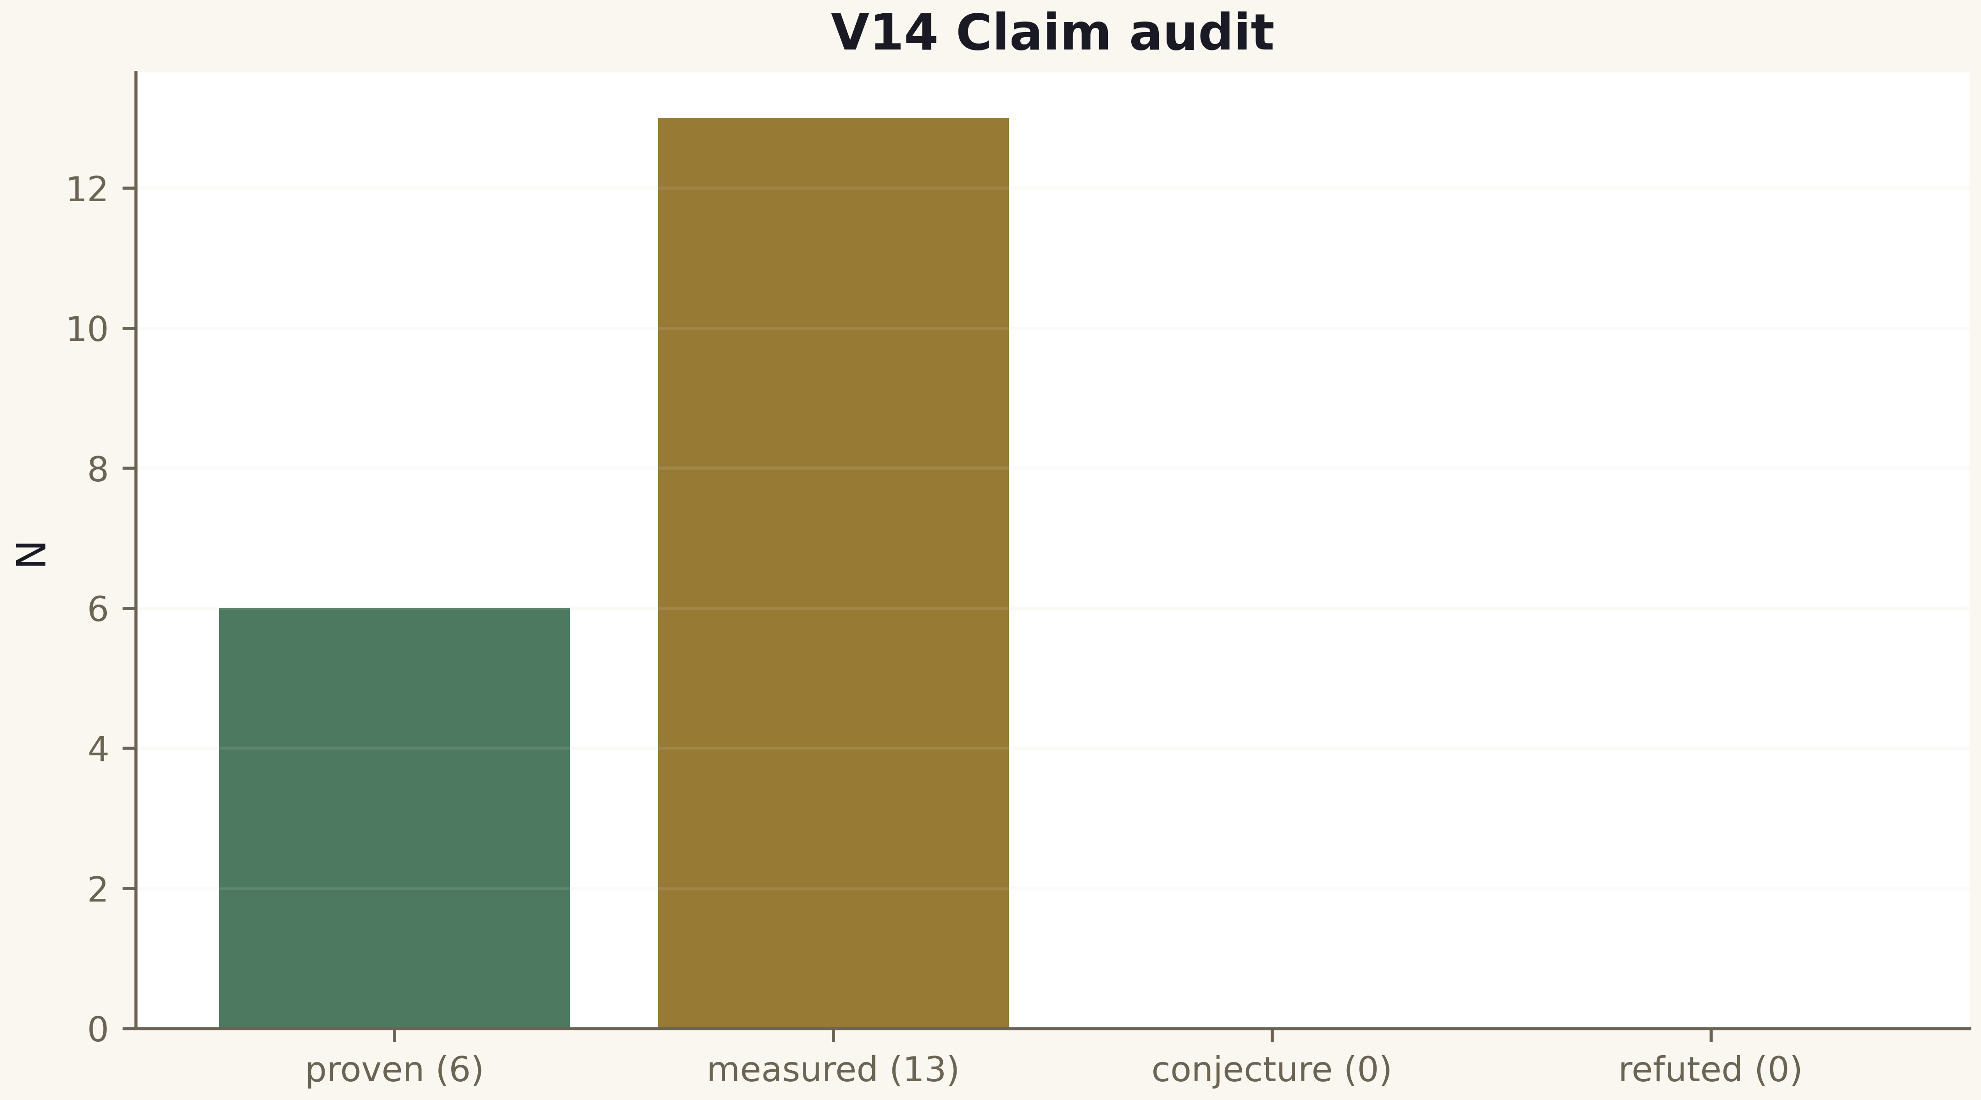
Fig. 1. Campaign V14 data (600 dpi, file figures_hires).
The audit passes: 19/19 claims per the schema (V19 included in v1.1.0), full coverage, status hygiene observed. Every public statement of the package is traced to a computation, a control and a list of non-implications.

