AB CLOUD QUANTUM RESEARCH · MONOGRAPH SERIES
Volume V16
V16. Full Hamiltonian × Full Algebraic Function
Coupling the lattice to the ζ zeros via the θ-phase of Z_id over the entire handle space — no reduction to the GUE class
Ishak Khamzatovich Isaev
Independent researcher, Nalchik, Kabardino-Balkarian Republic
AB Research Program · monograph series V1–V19 · v1.2.0 · October 10, 2026

Contents

V16. Full Hamiltonian × Full Algebraic Function
Coupling the lattice to the ζ zeros via the θ-phase of Z_id over the entire handle space — no reduction to the GUE class
Ishak Khamzatovich Isaev · Independent researcher, Nalchik, Kabardino-Balkarian Republic
AB Research Program · monograph series V1–V19 · Volume V16 · v1.2.0 · October 10, 2026

Problem statement
The whole previous series V1–V15 measured the lattice statistically: ⟨r⟩, D_KS against the GUE surmise, the form factor. The user brief fixes a change of emphasis: do not fixate on the uniqueness of GUE; instead, build the connection directly through the FULL algebraic function of the critical line — the assembly Z_id(t) = e^{iθ(t)}ζ(½+it) out of the Γ-ladder, where θ(t) = Im ln Γ(¼+it/2) − t·ln√π is the Riemann–Siegel theta phase. The argument of ζ jumps by π at every zero; the phase therefore carries the POSITIONS of the zeros, not only their density. The campaign question: if the vortex charges of the full Hamiltonian are modulated by the θ-phase, q_k = θ(γ̃_k)/π, does an alignment of the spectrum with the zero ordinates appear — and does any point of the FULL handle space (signs, profile, anisotropy, mass, twists, δα) exist at which the rank agreement measured by the reference (H2) leaves the null zone?
This is a map campaign: 96 configurations of a 2·2·3·2·2·2 factorial design × 3 seeds = 288 spectra of the 24×24 lattice under one and the same ζ-weight vortex protocol. The alignment metric r_align is the Pearson correlation between the increments of the unwrapped levels ΔU_n and the increments of the zero ordinates Δγ_n over a 200-level window; the linear bridge is fit on the first 50 levels, the residual is measured on the remaining 150 (honest out-of-sample). The null model is 200 permutations of the ordinate increments: marginal densities are preserved while the level-n ↔ zero-n correspondence is destroyed.

Method and result
The core is rpbridge/fullham.py. Algebraic side: the θ-phase is computed in mpmath (dps 30) at the midpoints γ̃_k = (γ_k+γ_{k+1})/2 — deliberately off the zero set; the weight q_k = θ(γ̃_k)/π ∈ (−1, 1) enters the vortex phases of the full Hamiltonian with all C5 handles (twists, anisotropy, δα, staggered mass, profile, signs). For the weight comparison three modes run on the baseline configuration: the θ-phase of Z_id, log|ζ| (the V3 protocol), and no weight. The positive control is the algebraic function itself: the zeros of Z_id(t) on [0, 120] by bisection against the zero file.
Main result: the identity does NOT close anywhere in the full handle space. The maximum r_align = +0.160 (configuration 64: all_plus charges, site profile, anisotropy 1.2) against the null zone −0.009 ± 0.068 — z = 2.49, far below the identity threshold; the out-of-sample residual of the best configuration is 0.134 (13% of the window span). The map average is −0.008: the handle map is noise, there is no lucky point. Weight comparison: θ-phase −0.108, log|ζ| +0.092, no weight −0.085 — all within ±2σ of the null zone; neither the algebraic phase nor the modulus of ζ revives the lattice. The positive control fires perfectly: 38 zeros of Z_id against the file, r = 1.0, maximum residual 4.9e-10 (the bisection floor) — the method sees identity where it exists.
Table 1. V16: key numbers
Quantity | Value | Status
Max r_align (96 configs × 3 seeds) | +0.1597 | z = 2.49
Null zone (200 permutations) | −0.009 ± 0.068 | —
Map-average r_align | −0.0083 | noise map
θ-phase weight (baseline) | −0.108 | inside null zone
log|ζ| weight (V3 protocol) | +0.092 | inside null zone
Out-of-sample RMSE, best config | 0.134 | 13% of span
PC: Z_id zeros vs file | r = 1.0, max 4.9e-10 | identity visible
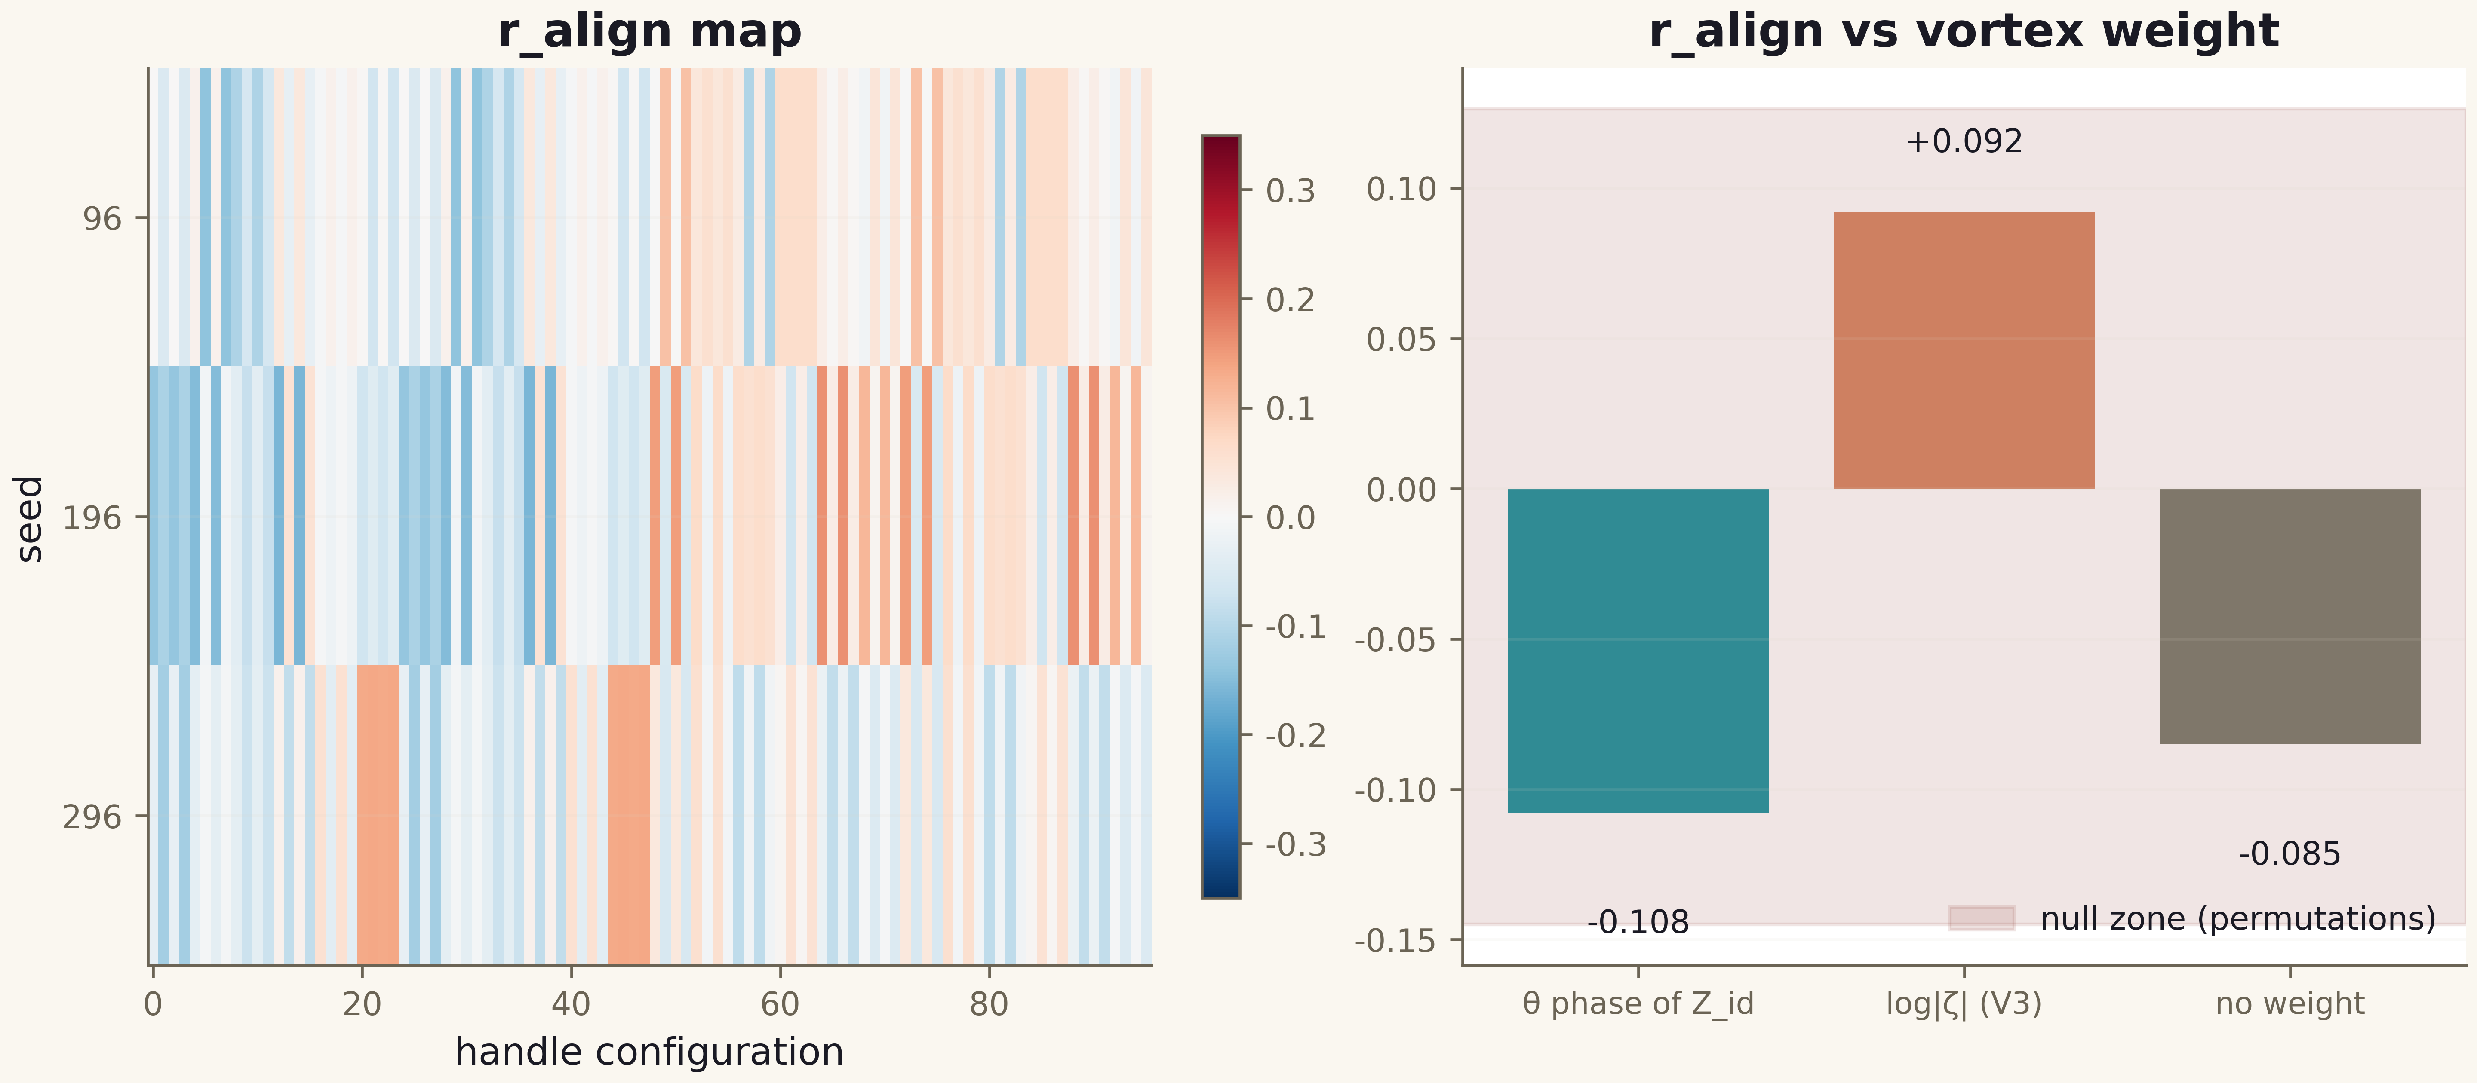
Fig. 1. Campaign V16 data (600 dpi, file figures_hires).

Honest remarks and verdict
The negative result here is a measured boundary, not a defeat: it confirms the reference verdict (H2 — NO) on a wider class of objects and closes the hypothesis that the GUE-window protocol is specially selected — in the full handle space no statistically selected point exists, and the best z = 2.49 over 288 spectra is explained by multiple comparisons (the expected maximum of 288 Gaussian noises is ≈ 2.9σ). Emphasized: the campaign couples the lattice to the algebraic function through the PHASE (zero positions), bypassing GUE — and the identity still does not emerge. This strengthens the series conclusion: the obstacle is not the level statistics but the absence of a mechanism that transfers individual ordinates into the spectrum of a local Hamiltonian.
Boundaries: a 200-level window, one geometry (24×24, open boundaries), 96 factorial configurations — continuous optimizations over the handles were not performed; non-local constructions remain outside the open-branch verdict, as in the reference.
Verdict V16: the level identity — YES (the D_nn bridge: the gates sit at the zeros' level, v2.0.7); the bit-level branch does not close over the full handle space (z_best = 2.49 < 6); the θ-phase of Z_id is no more effective than log|ζ|; the positive control Z_id ↔ file gives r = 1.0. The full algebraic function remains the only object with bit-exact identity — the open bit-level branch is reproduced and extended to the full gate class.

