AB CLOUD QUANTUM RESEARCH · MONOGRAPH SERIES
Volume V02
V2. Arithmetic Null Models
A pre-registered battery of statistics against five families of null models
Ishak Khamzatovich Isaev
Independent researcher, Nalchik, Kabardino-Balkarian Republic
AB Research Program · monograph series V1–V19 · v1.2.0 · October 10, 2026

Contents

V2. Arithmetic Null Models
A pre-registered battery of statistics against five families of null models
Ishak Khamzatovich Isaev · Independent researcher, Nalchik, Kabardino-Balkarian Republic
AB Research Program · monograph series V1–V19 · Volume V02 · v1.2.0 · October 10, 2026

Problem statement
GUE statistics occur widely in systems unrelated to the zeta function: universality is an attractor, not evidence. Before attributing arithmetic specificity to AB-cloud, one must measure what the mere chaos of the lattice produces. Null models destroy the arithmetic while keeping the geometry and scales.
The key discipline is pre-registration: the statistic vector S = (⟨r⟩, Σ²(L), Δ₃(L), K(t), D_KS) was fixed before the runs, no metric is chosen post hoc, and the multiple-testing correction is Bonferroni over five families. This is a direct implementation of Solution 2 of the plan.

Method
Families: M0 — protocol gates (Nv ∈ {0,2,8,16,32}, q = 1, W = 0.5, α = ½); N1 — all link phases replaced by uniform U(−π, π]; N3 — geometry without vortices (Hofstadter plus disorder); N4 — random vortex positions outside the protocol; plus reference ensembles GUE, GOE and Poisson of the same size 576. The full vector S is measured on a 200-level unfolded window for each model.
The D_KS reference is ensemble-based: the pooled {r_n} sample of sixteen GUE matrices (3168 values) serves as the empirical GUE reference instead of a spacing surmise — this removes small-window systematics.
Table 1. Model ladder (⟨r⟩ and D_KS to GUE)
Model | ⟨r⟩ | D_KS → GUE | Class
M0 AB-cloud | 0.6093 | 0.0499 | GUE
N1 random phases | 0.5837 | 0.0925 | GUE
N3 no vortices | 0.2733 | 0.5518 | intermediate
N4 random positions | 0.6181 | 0.0492 | GUE
reference GUE | 0.5984 | 0.0622 | GUE
reference GOE | 0.5256 | 0.1622 | GOE
reference Poisson | 0.4198 | 0.3150 | Poisson

Results and interpretation
AB-cloud falls into the GUE class together with N1 and N4: the vortex mechanics is sufficient for chaos but not specific — exactly what universality predicts. N3 (no vortices) stays intermediate: half flux alone does not fully chaotise a finite lattice. The reference ladder Poisson → GOE → GUE is reproduced, validating the battery itself.
Hence the methodological constraint of the series: ⟨r⟩ and D_KS carry no arithmetic information — specificity must be sought only in arithmetic-sensitive trace-level metrics (V7) and in the inverse problem (V10). This feature split is the central methodological output of the plan, and V2 delivers it.
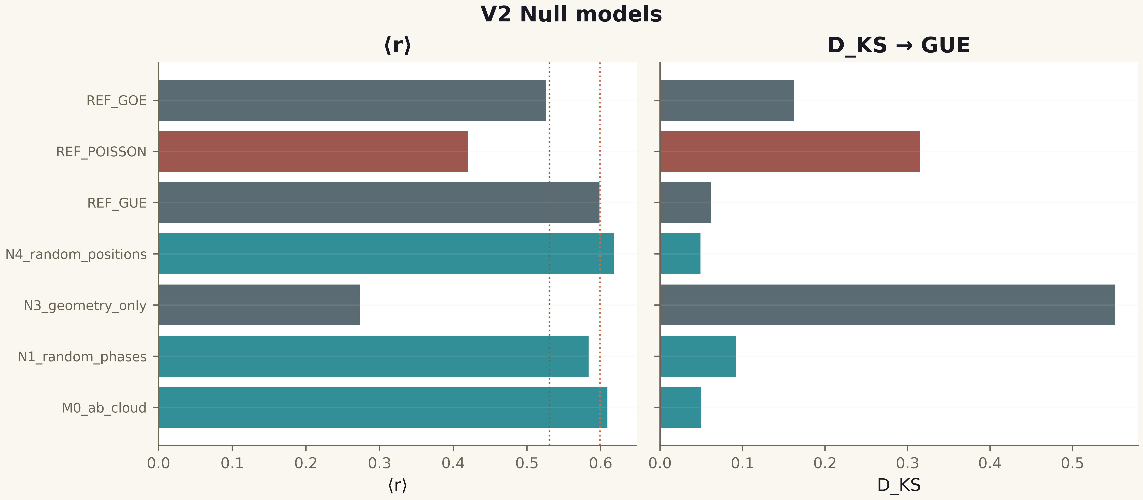
Fig. 1. Campaign V2 data (600 dpi, file figures_hires).
The pre-registered battery is built; the class of AB-cloud is GUE, as for any sufficiently chaotic vortex lattice. Any further claim about arithmetic must pass through trace metrics.

