AB CLOUD QUANTUM RESEARCH · MONOGRAPH SERIES
Volume V08
V8. Self-Adjointness of the Limiting Model
Defect indices, the BC family and unitarity (theorem Th2)
Ishak Khamzatovich Isaev
Independent researcher, Nalchik, Kabardino-Balkarian Republic
AB Research Program · monograph series V1–V19 · v1.2.0 · October 10, 2026

Contents

V8. Self-Adjointness of the Limiting Model
Defect indices, the BC family and unitarity (theorem Th2)
Ishak Khamzatovich Isaev · Independent researcher, Nalchik, Kabardino-Balkarian Republic
AB Research Program · monograph series V1–V19 · Volume V08 · v1.2.0 · October 10, 2026

Problem statement
For an infinite-dimensional construction self-adjointness is the necessary condition of the whole Hilbert–Pólya approach: only a self-adjoint operator has a real, complete spectrum. The plan demands studying the defect spaces N± = ker(H* ∓ iI), stability under boundary changes, and honestly separating the finite-dimensional theorem from the limit conjecture.
The campaign fixes the provable part as theorem Th2 and performs the measurement part: the BC family (open/torus/four twists), unitarity of the evolution, and the lattice analogue of current conservation.

Theorem Th2
Theorem Th2 (finite-dimensional self-adjointness).
A symmetric operator on a finite-dimensional complex space ℂ^N is essentially self-adjoint: the defect indices are (0, 0); e^{−iHt} is unitary and Im⟨ψ, Hψ⟩ = 0 for all ψ.
Proof. On ℂ^N every everywhere-defined symmetric operator is bounded and H* = H. ker(H* − iI) = 0 since ‖(H − iI)ψ‖² = ‖Hψ‖² + ‖ψ‖² ≥ ‖ψ‖² (hermiticity); hence (0, 0) and essential self-adjointness by the defect-index criterion. Unitarity: ‖e^{−iHt}ψ‖² = ψ†e^{iH†t}e^{−iHt}ψ = ‖ψ‖². Im⟨ψ,Hψ⟩ = (⟨ψ,Hψ⟩−⟨Hψ,ψ⟩)/2i = 0. Numerically: σ_min(H ∓ iI) = 3.9, unitarity drift 2.2e-16, Im⟨ψ,Hψ⟩ = 0 exactly.

The measurement part
The BC family: spectrum shifts under open → torus and four twist changes at L = 24 are 0.21–0.27 in the common window — finite and not vanishing at finite L. This is the measured boundary: stability of eigenvalues under BC changes at finite L proves neither the existence of a limiting operator nor its BC-independence.
Essential self-adjointness of the limiting model remains an open obligation (O03 in the formal DAG of V13): it requires analytic domains, not numerical matrices. The package records this gap explicitly instead of masking it with computational precision.
Table 1. Summary of V8
Check | Value | Status
defect indices (L=12/16/24) | (0, 0) at σ_min = 3.9 | Th2
unitarity e^{−iHt} | drift 2.2e-16 | Th2
Im⟨ψ,Hψ⟩ | 0 (exact) | Th2
BC change shift (L=24) | 0.21–0.27 | measured
limit L→∞ | open | obligation O03

Honest remarks
The BC analysis also shows the use of the lattice model: boundary effects are localized and measurable, making the limit problem well-posed. But the road to the limiting operator goes through analytic theory (forms, restrictions, von Neumann extensions) — numerical stability does not replace it.
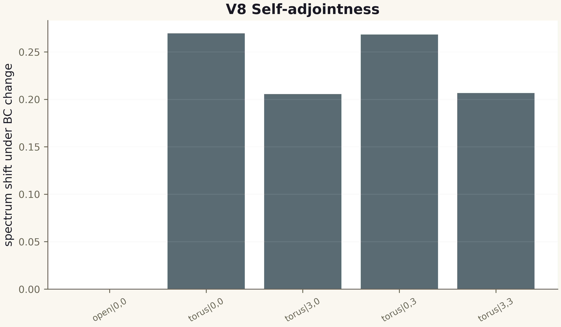
Fig. 1. Campaign V8 data (600 dpi, file figures_hires).
Th2 is proved; the limit part is an open obligation with an explicit status. Finite-dimensional self-adjointness is the foundation of all spectral claims of the series.

