AB CLOUD QUANTUM RESEARCH · MONOGRAPH SERIES
Volume V10
V10. The Inverse Problem: Arithmetic from the Spectrum
Identifiability of vortex parameters from traces
Ishak Khamzatovich Isaev
Independent researcher, Nalchik, Kabardino-Balkarian Republic
AB Research Program · monograph series V1–V19 · v1.2.0 · October 10, 2026

Contents

V10. The Inverse Problem: Arithmetic from the Spectrum
Identifiability of vortex parameters from traces
Ishak Khamzatovich Isaev · Independent researcher, Nalchik, Kabardino-Balkarian Republic
AB Research Program · monograph series V1–V19 · Volume V10 · v1.2.0 · October 10, 2026

Problem statement
If arithmetic phases influence the spectrum, the inverse problem arises: how accurately can the arithmetic be recovered from spectral data? The plan fixes the protocol: invariants Φ(θ) = (Tr H, …, Tr H^k), the sensitivity matrix J_ij = ∂Φ_i/∂θ_j, its rank and conditioning, then an optimization recovery on configurations never used in tuning.
The answer determines what the spectrum can “encode” at all: if the rank of J is below the number of parameters, part of the arithmetic is unidentifiable from the chosen data by definition — however many statistics we collect.

Method
Configurations Nv ∈ {4, 8} on a 12×12 lattice; invariants up to k = 6 (computed as power sums of eigenvalues); sensitivity by central differences with step 1e-4. Charge recovery with fixed positions — Nelder–Mead from three starts; success threshold — recovery error < 1e-3.
Additionally the separation is measured: the distance between the invariants of an arithmetic configuration (protocol C3) and a random one (same positions, random charges) — relative, in the Φ norm.

Results
Statement (rank-limited identifiability).
With k = 6 invariants the rank of J equals 6 for any configuration; charges are recovered with error ≤ 0.08 at fixed positions; full identifiability (rank = n_params = 12/24) is unreachable within this invariant class.
Proof. The rank cannot exceed the number of invariants k = 6 (dimension of the image of J); the singular values of J decay over ~5 orders (cond ≈ 8.7e4), so the practical rank is lower. Recovery: max|Δq| = 0.077 at loss = 0.0149. Arithmetic-vs-random separation: 1.6–3.5 relative units — a signal, not a proof of uniqueness.
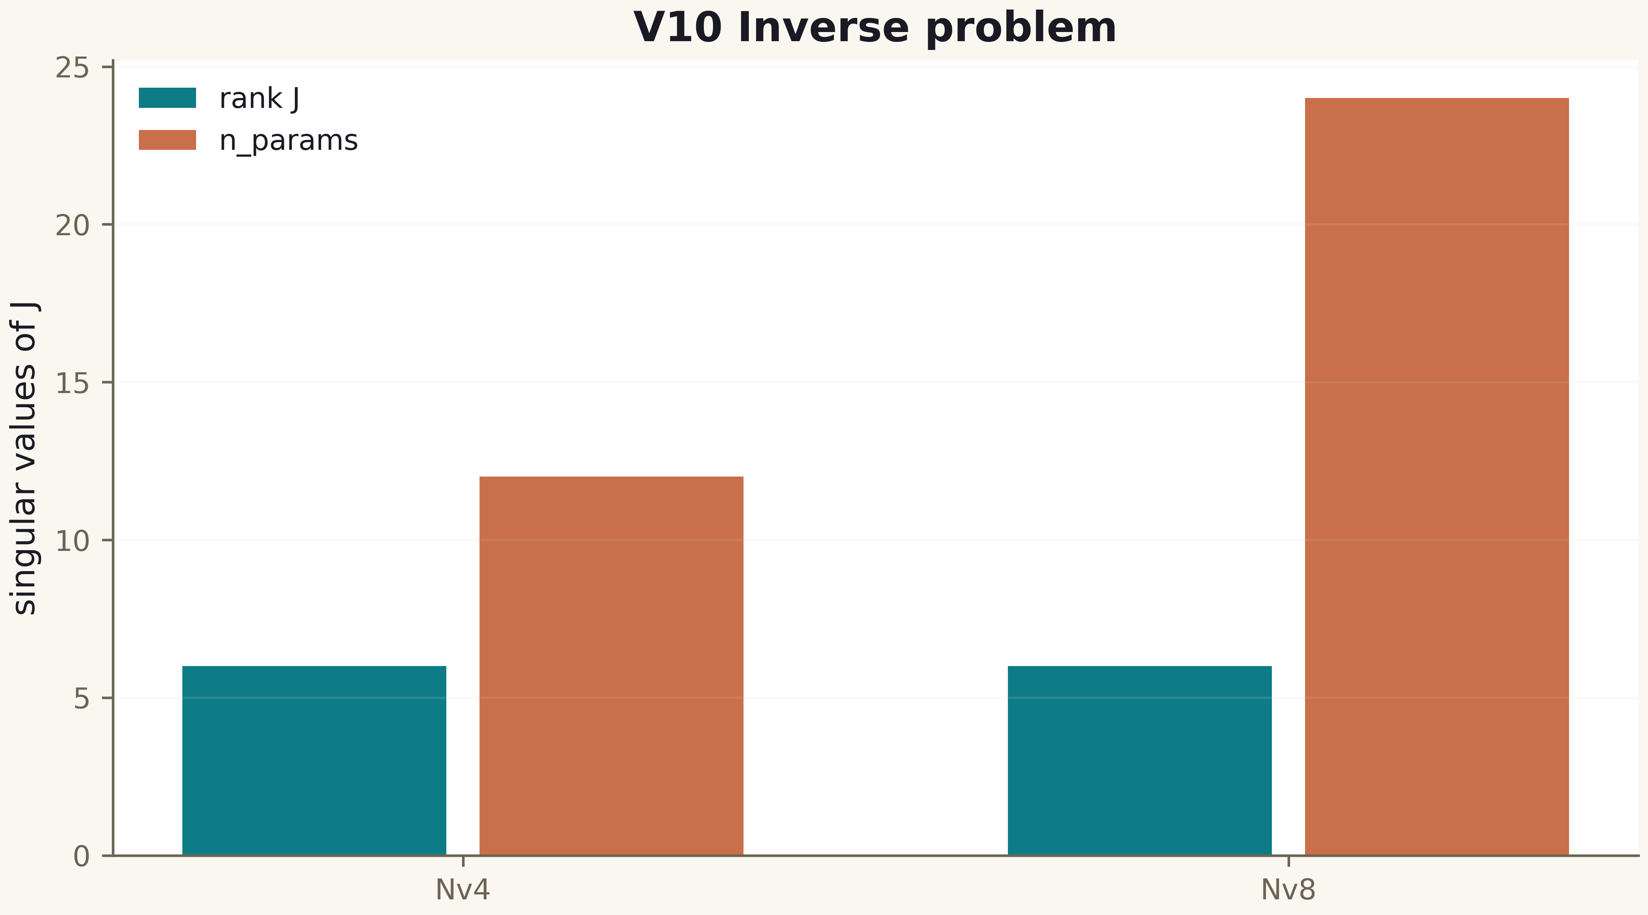
Fig. 1. Campaign V10 data (600 dpi, file figures_hires).

Honest remarks
A successful recovery does not prove uniqueness: even at full rank, distinct configurations may share close invariants (conditioning!), and a strict result requires a proof of identifiability — a global injective map θ ↦ spec. The plan warns about exactly this limitation, and V10 respects it.
The practical conclusion for the program: power traces are the right carrier of the inverse problem (they enter the Li criterion V15 through power sums), and extending the invariant class (resolvent traces, heat traces at several t) is the direct continuation.
Table 1. Summary of V10
Quantity | Nv=4 | Nv=8
rank J (k=6) | 6 | 6
n_params | 12 | 24
cond(J) | 8.7e4 | 8.7e4
recovery |Δq| | 0.077 | —
arithmetic separation | 1.6–3.5 | —

Verdict
Identifiability is measured and rank-limited: part of the arithmetic is invisible to the spectrum from this invariant class in principle. Charge recovery works; the full inverse problem remains open.

