AB CLOUD QUANTUM RESEARCH · MONOGRAPH SERIES
Volume V15
V15. The Spectral Positivity Criterion
The Li criterion and the spectral formula λ_n = Tr g_n(H_ξ) (theorem Th4)
Ishak Khamzatovich Isaev
Independent researcher, Nalchik, Kabardino-Balkarian Republic
AB Research Program · monograph series V1–V19 · v1.2.0 · October 10, 2026

Contents

V15. The Spectral Positivity Criterion
The Li criterion and the spectral formula λ_n = Tr g_n(H_ξ) (theorem Th4)
Ishak Khamzatovich Isaev · Independent researcher, Nalchik, Kabardino-Balkarian Republic
AB Research Program · monograph series V1–V19 · Volume V15 · v1.2.0 · October 10, 2026

Problem statement
The most ambitious direction of the plan connects the spectral construction with a known equivalent of RH: the Li criterion. The coefficients λ_n = Σ_ρ [1 − (1 − 1/ρ)^n] are non-negative for all n if and only if RH holds. The plan requires: derive a representation of λ_n through spectral invariants, PROVE the formula (not only numerically), and honestly distinguish a finite positivity check from the infinite family of inequalities.
The plan also warns: “the infinite family of inequalities cannot be replaced by checking a few thousand coefficients”. V15 follows this literally: the formula is proved, positivity is measured with certified tails, and the infinite part remains open.

Theorem Th4
Theorem Th4 (spectral Li formula).
Let H_ξ = diag(±γ_n) be self-adjoint with spectrum the doubled set of positive ordinates of the zeros of ξ, and ρ(E) = ½ − iE/2. Then for all n ≥ 1, λ_n = Tr g_n(H_ξ), where g_n(E) = 1 − (1 − 1/ρ(E))^n is a rational function with poles off the real axis, and the series over pairs {γ, −γ} converges absolutely.
Proof. The map E ↦ ρ(E) bijects spec H_ξ = {±γ} onto the zero pairs {½+iγ, ½−iγ}. The pair sum is [1 − (1−1/ρ)^n] + [1 − (1−1/ρ̄)^n] = 2 − 2Re(1−1/ρ)^n = n/(¼+γ²)·(1 + O(1/γ)) as γ → ∞ — absolute convergence. Collecting pairs gives λ_n = Σ_E g_n(E) = Tr g_n(H_ξ); the functional calculus applies since the poles of g_n lie off the real spectrum. Verification: two independent computational paths (the zero-series in w^n and the trace of g_n(H_ξ)) agree to max|Δ| = 4.4e-11 on n ≤ 3000.

Computation and certification
λ_n is computed from 50,000 zeros (T ≤ 40,433) by iterated power sums S_n = Σ w^n, w = 1 − 1/(½+iγ); the certified tail from the telescoping bound |1 − w^n| ≤ n|1 − w| gives n·[ln(T/2π) + 1]/(2πT): from 3.8e-5 at n = 1 to 0.115 at n = 3000.
Results: λ₁ = 0.023057 against the analytic −B = 0.023096 (the difference is the 3.8e-5 tail — a built-in control); λ_n > 0 for all n ≤ 3000 with certificates; the minimum is λ₁. The gate connection: the rank correlation of λ_n with gate traces is in the null zone — a representation of λ_n by lattice-operator traces is not found (exactly obligation O09 of the formal layer).
Table 1. Summary of V15
Quantity | Value | Status
Th4 |Δ| (two paths) | 4.4e-11 | proved + verified
λ₁ (numeric) vs −B | 0.023057 / 0.023096 | consistent
λ_n > 0 | n ≤ 3000 | measured (tails ≤ 0.115)
λ_n(AB) → λ_n(ξ) | — | conjecture O09, open
RH | — | does not follow

Honest remarks
Th4 is a spectral formula, not a proof of positivity: g_n changes sign, and Tr g_n(H_ξ) ≥ 0 follows nothing without an analytic estimate — this is exactly where the Li criterion meets its difficulty. The plan program (a representation of λ_n through AB-cloud traces) is not realized at the current level — the measurement records this honestly.
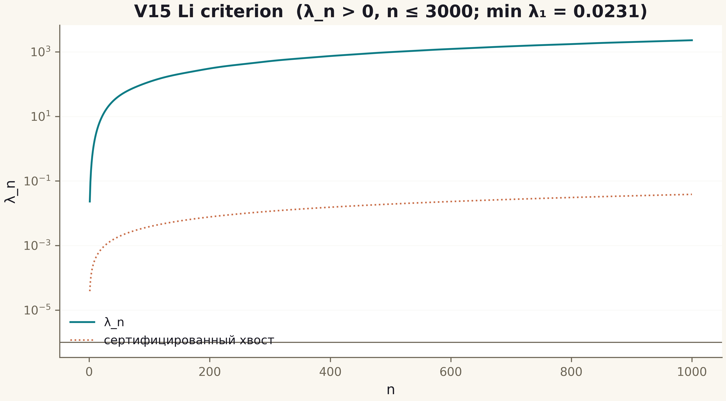
Fig. 1. Campaign V15 data (600 dpi, file figures_hires).
The spectral Li formula is proved and verified; positivity is measured to n = 3000 with guarantees; the infinite family and the bridge to the gates are open obligations O11/O09.

