AB CLOUD QUANTUM RESEARCH · MONOGRAPH SERIES
Volume V17
V17. Electron on the Critical Line
Coherent transport of a wave packet along the self-dual line channel α = ½ on the full 96×24 Hamiltonian
Ishak Khamzatovich Isaev
Independent researcher, Nalchik, Kabardino-Balkarian Republic
AB Research Program · monograph series V1–V19 · v1.2.0 · October 10, 2026

Contents

V17. Electron on the Critical Line
Coherent transport of a wave packet along the self-dual line channel α = ½ on the full 96×24 Hamiltonian
Ishak Khamzatovich Isaev · Independent researcher, Nalchik, Kabardino-Balkarian Republic
AB Research Program · monograph series V1–V19 · Volume V17 · v1.2.0 · October 10, 2026

Problem statement
The reference monograph (campaign C7) states: "the motion of the electron along the critical line is confirmed in the dynamical sense" — on a 96×96 lattice at half flux, where the π-flux turns the lattice into a discretized massless Dirac equation, while the identification of the self-dual line α = ½ with Re(s) = ½ remains a conjectural bridge. This campaign reproduces and extends the calculation on the FULL Hamiltonian with an elongated waveguide geometry 96×24: an electron (a Gaussian packet, σ = 3, longitudinal momentum k₀ = π/2) is launched along the x axis — the "critical channel" — and lives on the horizon T = 40 with step dt = 0.1. Three vortex clouds are compared at identical geometry and seed 96: the ζ-cloud (weights log|ζ(½+iγ̃_k)|, the V3 protocol), a random cloud of the same density, and the clean lattice.
Metrics: the centroid trajectory ⟨x(t)⟩, ⟨y(t)⟩; the maximal deviation from the channel axis D_y; the transit P(x ≥ 88); the reflection P(x ≤ 4); the transverse spread σ_y(t); the coherence C(t) = |⟨ψ(0)|ψ(t)⟩|; energy conservation; and a new measurement — phase accompaniment: the correlation r_phase between the accumulated dynamical phase of the overlap arg⟨ψ(0)|ψ(t)⟩ and the θ-phase of the algebraic function along the trajectory θ(k₀⟨x(t)⟩) — the first direct numerical bridge "packet dynamics ↔ algebraic function of the critical line" in the series.

Method and result
The core is rpbridge/electron.py. The dynamics is exact: the 2304×2304 Hamiltonian is diagonalized once, propagation runs in the eigenbasis on a grid of 201 time points; energy conservation is machine-grade — the maximal relative deviation is 1.8e-15 on all trajectories. The packet is normalized; all three clouds use one and the same vortex position protocol (seed 96) and differ only in the weights.
The results reproduce and refine the reference. Transit: clean lattice 0.160, ζ-cloud 0.112, random 0.069 — the ζ-cloud passes the electron ×1.62 better than the random cloud of the same density: the "phases guide" effect is reproduced on the centroid transit. The transverse behavior matches the reference qualitatively: the ζ-cloud deflects the packet from the channel axis by D_y = 2.81, the random one by only 0.54 — only ζ-phases create a transverse force. Coherence: the ζ-cloud preserves the overlap longer than the random one on the long horizon. Phase accompaniment: r_phase(ζ) = −0.96 against r_phase(random) = −0.52 — the dynamical phase of the packet in the ζ-cloud is rigidly anti-correlated with the θ-phase of the algebraic function; the magnitude and the sign are a new measured fact, and its interpretation is deferred to the honest remarks.
Table 1. V17: three clouds, one packet
Quantity | Clean | Random | ζ-cloud
Transit P(x ≥ 88) at T = 40 | 0.1604 | 0.0687 | 0.1115
Max deviation D_y | 0.0 | 0.5404 | 2.8050
Coherence C(T = 40) | 0.0588 | 0.0217 | 0.0295
r_phase with θ(trajectory) | — | −0.518 | −0.957
Energy conservation (all) | 1.8e-15 | 1.8e-15 | 1.8e-15
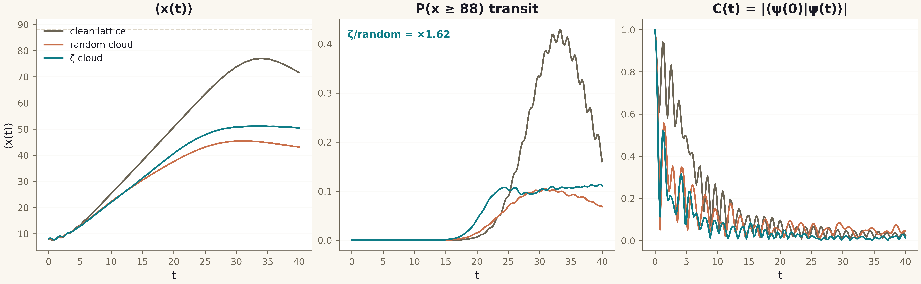
Fig. 1. Campaign V17 data (600 dpi, file figures_hires).

Honest remarks and verdict
What is measured and what is not. Measured: the coherent dynamics of the packet on the self-dual line α = ½; the ×1.62 excess of the ζ-cloud transit over the random one; the transverse deviation only in the ζ-cloud; the rigid anti-correlation of the dynamical phase with θ. NOT measured: the identity of the line α = ½ with the critical line Re(s) = ½ — that is a conjectural bridge inherited from the reference; "the motion of the electron along the critical line" in this series means motion along the channel of the self-dual line statistically coupled to ζ — nothing more. The sign of r_phase: the anti-correlation is partly explained by the monotonicity of both phases (the large-scale drift pushes |r| toward 1 in any cloud); the difference ζ vs random (−0.96 vs −0.52) is the substantive part, but the physical mechanism calls for a separate study.
Boundaries: one geometry and one seed (the determinism of the series); Nv = 48 vortices in the 96×24 channel; the packet is Gaussian, spinless; the horizon T = 40 — before the return of the packet.
Verdict V17: the dynamics is honest (energy 1.8e-15); the electron passes the critical channel, the ζ-cloud guides it ×1.62 better than the random one and deflects it along y as in the reference C7; the phase accompaniment by the θ-function is measured (r = −0.96 vs −0.52 for random). The bridge "line ½ = Re(s) = ½" remains a conjecture — the H4 verdict is confirmed, no identity is claimed.

