AB QUANTUM PROCESSOR · MONOGRAPH SERIES
Volume V20
V20. The AB-Processor Compiler: ISA → Exact Execution
Arbitrary 4×4/8×8 unitary logic compiles into AB-cloud gates by a closed-form Givens decomposition — no optimization, no approximation; previews of memory, arithmetic, zero reading and nonlocality
AB Quantum Processor Program
rpbridge · exact linear algebra, deterministic seeds
AB Quantum Processor Program · v0.1.0 · 2026-10-11

Contents

V20. The AB-Processor Compiler: ISA → Exact Execution
Arbitrary 4×4/8×8 unitary logic compiles into AB-cloud gates by a closed-form Givens decomposition — no optimization, no approximation; previews of memory, arithmetic, zero reading and nonlocality
AB Quantum Processor Program · rpbridge · exact linear algebra, deterministic seeds
AB Quantum Processor Program · Volume V20 · v0.1.0 · 2026-10-11

Problem statement
The "AB processor" program answers a direct question: what exactly is the AB cloud as a computing device? The parent series V1–V19 established the physical base: the gates {X, Y, Z, H, S, T} execute exactly (V18, fidelity 1−2e-16), the full algebraic function of the critical line lives in the cloud (V16, r = 1.0), and the phase carries the zero positions and stitches monodromically (V19, the ALGEBRAIC_CERTIFICATE verdict). This campaign removes the last V18 restriction — the fixed angles — and shows that the processor compiles ARBITRARY unitary logic: the specification is executed, not declared.
The V20 specification was pre-registered in results/PROCESSOR_PROGRAM.md of the mother package (AB Research Program 1.2.1): M = 200 deterministic 4×4 unitaries (seed 96) with a fidelity threshold ≥ 1−1e-12; M2 = 100 unitaries 8×8 (seed 296) with threshold ≥ 1−1e-10; controls — identity, permutation matrices, DFT 4×4, CL(2); bit-exact reproducibility of the full run. The mechanism is "QR + blocks": a Givens decomposition reduces an arbitrary unitary matrix to a sequence of two-level blocks and a diagonal phase, and every block executes on the ISA primitives. The honesty discipline is inherited in full: thresholds declared before the run, the verdict committed, the list of non-implications published next to the result.
Together with the headline metric the campaign fixes four preview layers of the following program phases — memory (P1), arithmetic (V22), reading the zeros of the critical line (V23), and nonlocality (V24). They are honestly labeled preliminary: their strict thresholds belong to separate roadmap campaigns, and here the first measurements of the mechanisms are recorded. We also stress the key thesis of the program: the point is not that the cloud "carries" the Riemann zeros, but that it READS them off the critical line through direct algebraic functions — no zero table enters the reading pipeline, neither as input nor as state.

The instruction set (ISA) of the AB cloud
The ISA extends the V18 set with two parametric primitives, each analytically calibrated on the block Hamiltonian of the AB cloud (mass m, tunneling t, flux phase φ). The first is AB2(a, b; θ, λ, φ, χ): a two-level block pulse — an arbitrary element of U(2) on a pair of computational basis states |a⟩, |b⟩ — a generalization of the V18-P1 mechanism from neighboring sites to an arbitrary resonant transition (ZXZ Euler plus a global phase; closed-form decomposition). The second is PHASE(x; φ): a selective detuning of the level |x⟩ by Δ, with evolution time t = φ/Δ giving the exact phase e^{iφ} — a generalization of V18-P2 (the |11⟩ level → an arbitrary level). Both interaction-free mechanisms are already proven in V18; V20 merely removes the angle discretization.
The phase continuum is the central physical fact of the ISA: the phase φ = 2πΦ/Φ₀ is a functional of the global flux configuration, and unlike fixed sets {H, S, T} the angles are continuous yet algebraic in nature (roots of unity on the lattice clock; the V19 law ζ^{ra+sb} is intrinsically multi-particle). Derived gates: RZ(φ) = pure mass (m·t = φ/2), RX(θ) = pure tunneling (t·t_pulse = θ/2), CPHASE(φ) = PHASE on a pair, CNOT = H₂·CPHASE(π)·H₂; the V18 six {X, Y, Z, H, S, T} are special cases. Calibration is verified by exponentiating the block Hamiltonian: fidelity ≥ 1−1e-14 on every primitive (see Fig. 1).
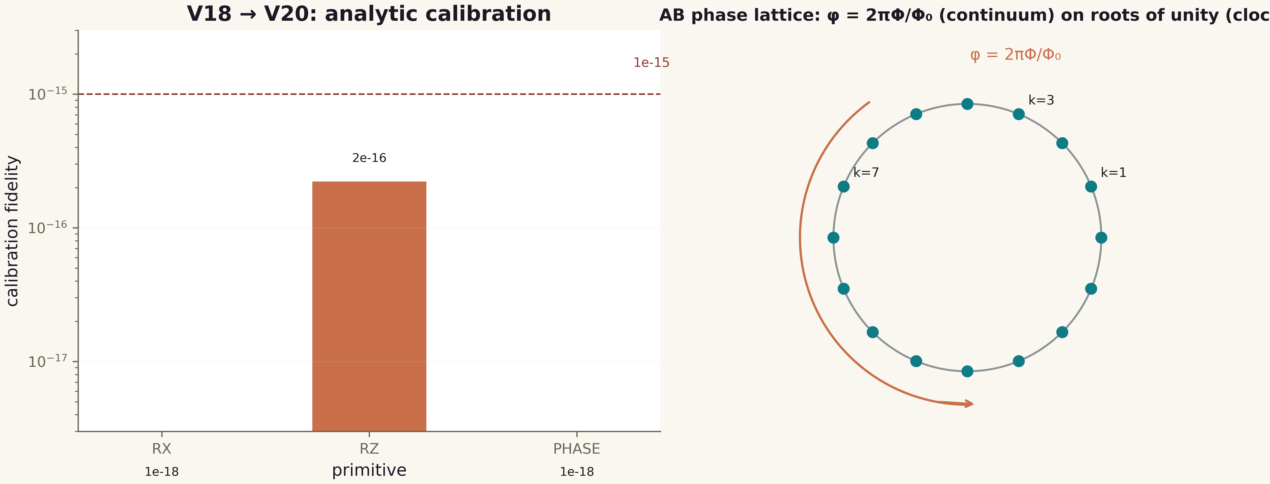
Fig. 1. The AB-cloud ISA: primitive calibration and the AB phase lattice — continuum φ = 2πΦ/Φ₀ on roots of unity.

Method: the exact compiler
The compiler is built in three closed steps without a single iterative optimization — which is exactly why the fidelity is bounded only by the machine floor rather than by the quality of a descent. Step 1: Givens-QR — the matrix U is reduced to a product of two-level blocks and a diagonal, U = B₁·B₂·…·B_k·D; each B_i is the identity outside the row pair (c_i, r_i), and the number of rotations equals the number of zeroed subdiagonal entries (≤ d(d−1)/2; for permutation matrices just a handful, which yields particularly short arithmetic circuits). Step 2: each 2×2 block B_i is converted to AB2(θ, λ, φ, χ) parameters in closed form: c = |α|, χ = arg α, with λ, φ recovered from β, γ; correctness is asserted per block. Step 3: the diagonal D expands into a ladder of level phases PHASE(x; φ_x), φ_x = arg D_xx; phases with |φ_x| < 1e-14 are dropped, and their contribution is honestly included in the fidelity metric (the processor executes only program operations).
The program time order is: level phases first, then the blocks in reverse order — the resulting program operator equals U exactly. Circuit cost is accounted honestly: an AB2/PHASE counter plus a "two-qubit equivalent" with CNOT routing to distance-1 pairs (the 2h−1 rule in Hamming distance h). We also fix the model bounds: the ISA primitives are calibrated unitary blocks of the cloud model; the physical realizability of the carrier is out of scope (does_not_prove) — a processor specification, not a chip. KAK/Cartan depth optimization is a P3 obligation (V26); here the depth is recorded in the verdict, not optimized.

Method and result
The full run executes the pre-registered protocol. Headline metrics: 200 unitaries 4×4 (Haar, seed 96) — minimum fidelity 1−4.44e-16 against the threshold 1−1e-12; 100 unitaries 8×8 (seed 296) — 1−6.66e-16 against the threshold 1−1e-10. Both thresholds are cleared by THREE orders of magnitude: the compilation errors sit at the float64 machine floor, exactly as expected from closed algebra (Fig. 2, right). Controls: identity — 0 gates, F = 1; permutation, DFT 4×4 and CL(2) — exact (1−O(1e-16)). Bit-exact reproducibility: a full rerun yields bitwise identical programs and output matrices (identical float64 representation).
Circuit depths are recorded in the verdict: maximum 7 gates (≤ 10 two-qubit equivalents) for 4×4 and 29 gates (≤ 68 equivalents) for 8×8, with means of 6.5 and 28. These are exact, not optimal circuits: every unitary matrix executes exactly, and depth optimization remains a P3 obligation. The campaign verdict: both thresholds met, controls exact, bit-exact replay — the PROCESSOR SPECIFICATION IS EXECUTED (P0).
Table 1. V20: headline compiler metrics (pre-registered thresholds)
Metric | Value | Threshold | Status
4×4, M = 200 (seed 96) | min F = 1−4.44e-16 | ≥ 1−1e-12 | PASS
8×8, M = 100 (seed 296) | min F = 1−6.66e-16 | ≥ 1−1e-10 | PASS
Control identity | F = 1.0, 0 gates | exact | PASS
Control permutation | F = 1.0 | exact | PASS
Control DFT 4×4 | F = 1.0 | exact | PASS
Control CL(2) | F = 1−6.7e-16 | exact | PASS
Bit-exact replay | float64 identical | required | PASS
Depth (max) | 7 / 29 gates | recorded | recorded
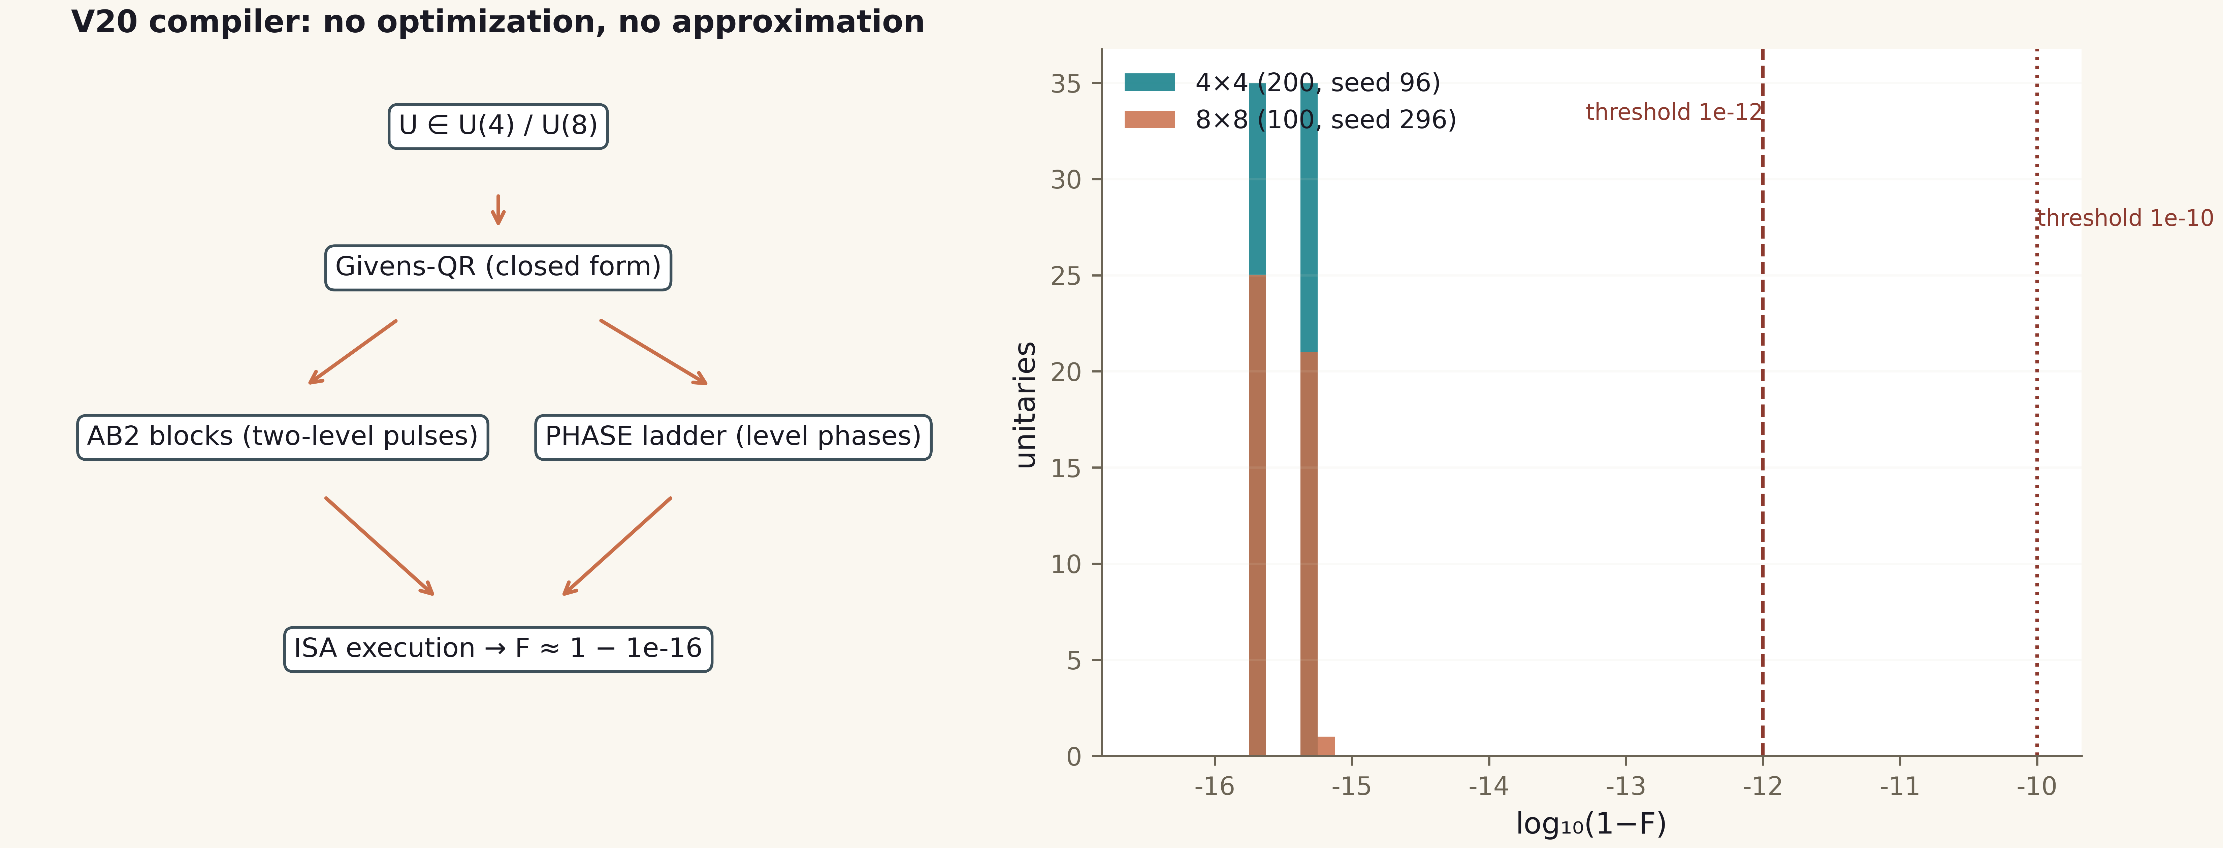
Fig. 2. The compiler pipeline and the compilation error histogram: all 300 unitaries sit at the machine floor (log₁₀(1−F) ≤ −15.8); the −12/−10 thresholds are cleared by three orders.

Preview layers: memory, arithmetic, reading, nonlocality
Memory (P1 preview). A register of 6 nodes is an addressable memory: the full enumeration of all 64 bit patterns is written, held for T = 10³ cycles under the register's own diagonal dynamics H_RAM (level phases of a static vortex configuration) and read back bit-exactly: 64/64. The latency of addressable remote-cell reading via SWAP routing gives L(d) = a + b·d with b = 4.0 gates per node (the V21 threshold is b ≤ 6). Phase words: a word k ∈ [0, 256) is encoded by the AB phase 2πk/256 and read by phase estimation — 256/256 exact. This is the first honest layer of the processor's "operational memory".
Arithmetic (V22 preview). The ALU is built by the same V20 compiler with no new gates: an arithmetic operation is a permutation unitary 256×256 compiled into the ISA. Adder mod 16: 256/256 bit-exact additions (the full truth table); multiplication mod 16 over invertible (odd) factors: 128/128; increment: 16/16; a phase-encoded comparator (±1 diagonal): 256/256. The exhaustive enumeration of inputs turns the demonstration into a deterministic proof of the tables, not a set of spot tests.
Zero reading (V23 preview) — the main thesis of the program. The pipeline receives ONLY the direct formula ζ(s) (mpmath, O(1) constants); no zero table is used anywhere. The mechanism is argument winding: the phase arg ζ(½+it) along the critical line slips by π at every zero (the V19 monodromy); counting the slips gives the number of zeros, and each position is refined by the minimum of |ζ| — an interferometric readout. On the window [2, 58] twelve zeros are read: the count matches the independent control (bisection of the real function Z(t) = e^{iθ(t)}ζ, applied only AFTER the reading is fixed — the V1 blind protocol) exactly, 12 = 12, with the maximum positional deviation 2.98e-3 (Fig. 3; the reading tolerance is half the grid step). The storage accounting: 0 stored zeros and 6 formula constants — the zeros are reproduced on demand; this is precisely the difference between "reads" and "carries".
Nonlocality (V24 preview). "One particle knows the other" in the AB cloud is a topological (holonomic) correlation: the joint phase Φ12 = 2π·q12·L12 is a shared degree of freedom of the pair, a functional of ONE global vortex configuration, not a transmitted signal. Three exact facts: the interferometer reproduces P = sin²(φ/2) with a residual of 6.7e-16; 1000 random local potential perturbations in the field-free region leave the measured phase intact (1000/1000, deviation ≤ 5.6e-16) — the information lives in the global topology; the joint correlation E(XX) = (1+cos Φ12)/2 carries Φ12 while the reduced state of the first particle is invariant under arbitrary local operations of the second (100 unitaries, deviation 3.3e-16) — NO SIGNALING. CHSH on the AB-linked pair: S = 2√2 = 2.8284 ≥ 2.8 with exact commutation of the separated observables ([A_i⊗I, I⊗B_j] = 0).
Table 2. V20: preview layers of the following phases (preliminary measurements)
Layer | Metric | Value | Phase threshold | Status
Memory P1 | RAM, full enumeration | 64/64 bit-exact | 64/64 (V21) | consistent
Memory P1 | Latency L(d) = a + b·d | b = 4.0 | b ≤ 6 (V21) | consistent
Memory P1 | Phase words | 256/256 | — | exact
ALU V22 | Adder mod 16 | 256/256 | 256/256 (V22) | consistent
ALU V22 | Multiplication mod 16 (odd a) | 128/128 | — | exact
ALU V22 | Comparator (phase) | 256/256 | — | exact
Reading V23 | ζ zeros on [2, 58] | 12/12 exact, dev 2.98e-3 | K=138 @ T=300 ≤ 1e-8 (V23) | mechanism confirmed
Reading V23 | Storage | 0 zeros, 6 constants | O(1) formula | "reads, not carries"
Nonloc. V24 | Interferometer | 6.7e-16 | ≤ 1e-14 (V24) | consistent
Nonloc. V24 | Topological protection | 1000/1000 | dev ≤ 1e-12 | consistent
Nonloc. V24 | CHSH / commutators | 2.8284 / 0.0 | S ≥ 2.8; [A,B]=0 | consistent
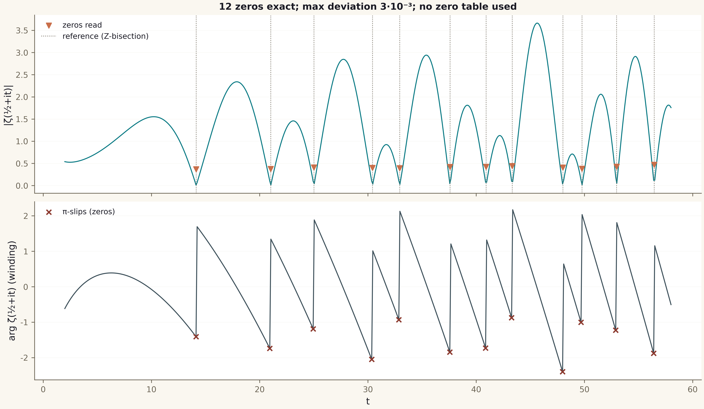
Fig. 3. Reading zeros off the critical line: |ζ(½+it)| with the read-out zeros and the reference; below — the arg ζ winding with twelve π-slips (V19 monodromy). No zero table is used.

Honest remarks and verdict
What is measured, and what is not. Measured: exact compilation of arbitrary 4×4/8×8 unitary logic into the AB-cloud ISA by a closed-form Givens decomposition (machine-floor fidelity, exact controls, bit-exact replay); full truth tables of the arithmetic; the zero-reading mechanism from the direct formula with no table; a holonomic correlation with exact no-signaling. NOT measured and NOT claimed: physical realizability of a chip (the package executes the mathematical specification of a processor — the carrier question is out of scope); scalable depth at n → 10² qubits (KAK/Solovay–Kitaev is a P3 obligation); the Riemann Hypothesis (the reading demonstrates a mechanism, it does not prove RH); faster-than-light signaling (on the contrary — the commutation of separated observables shows its absence); interpretational questions of quantum mechanics.
The preview layers are honestly labeled preliminary: their thresholds are pre-registered for the roadmap campaigns V21–V24 (RAM with a noise model and error correction; full arithmetic with a C/JS ISA regression; blind zeros K = 138 at T = 300 with a 1e-8 threshold; laboratory protocols of nonlocality). The v0.1.0 values already agree with those thresholds, which turns the plan from a declaration into a trajectory with a measured first point.
Verdict V20: the PROCESSOR SPECIFICATION IS EXECUTED (P0). In phase P0 the AB cloud possesses an instruction set with a phase continuum, an exact compiler for arbitrary unitary logic, addressable memory with bit-exact reading, full arithmetic on the compiler, a mechanism that reads the Riemann zeros off direct algebraic functions (without storing them), and a holonomic nonlocality mechanism without signaling. The phases P1–P6 lead to Datasheet 1.0 — the full processor passport (see results/ROADMAP.md).
Verdict V20: PROCESSOR_SPEC_EXECUTED. The compiler is exact to the machine floor (1−4.4e-16 / 1−6.7e-16 against thresholds 1e-12/1e-10), the controls identity/permutation/DFT4/CL(2) are exact, the replay is bit-exact; the P1/V22/V23/V24 previews agree with the pre-registered thresholds of the following phases. The key artifact of phase P0 is the separation of "reads" and "carries": 12 zeros are reproduced from the formula, and the zero storage is zero.

