AB CLOUD QUANTUM RESEARCH · MONOGRAPH SERIES
Volume TS1
TS1. The phase-cycle theorem
Supplementary study 'the machine with no long-term memory': three spinor phase models θ = π/2 · π/3 · π/7 — volatile state only, real-time steps, zero storage
Исаев Исхак Хамзатович
Независимый исследователь, г. Нальчик, Кабардино-Балкарская Республика
AB Cloud Quantum Research · supplementary study · v1.0.0 · 2026-10-11

Contents

TS1. The phase-cycle theorem
Supplementary study 'the machine with no long-term memory': three spinor phase models θ = π/2 · π/3 · π/7 — volatile state only, real-time steps, zero storage
Исаев Исхак Хамзатович · Независимый исследователь, г. Нальчик, Кабардино-Балкарская Республика
AB Cloud Quantum Research · supplementary study · Volume TS1 · v1.0.0 · 2026-10-11

TS1. The phase-cycle theorem
Theorem TS1 (ES1).
Let θ = π/k, k ∈ ℕ, and R: φ ↦ (φ + θ) mod 2π be a rotation of the circle S¹. Then: (i) the orbit of any point of the state lattice G_θ = {0, θ, 2θ, …} closes after exactly N = 2k steps (for the model phases: θ = π/2 → N = 4, θ = π/3 → N = 6, θ = π/7 → N = 14); (ii) the minimal angular gap between distinct states equals 2π/N = π/k; (iii) the lattice is uniform: the points split the circle into N equal arcs. Corollary: the machine capacity is log₂N bits per cycle (from 2 to 3.80735 bits/step for the model phases), while step and memory remain O(1).
Proof. (i) Closure: N·θ = 2k·(π/k) = 2π ≡ 0 (mod 2π), hence R^N = id. Minimality: if m·θ ≡ 0 (mod 2π), then mπ/k = 2πj for some j ∈ ℤ, whence m = 2kj ≥ 2k for m > 0 — so the minimal period is exactly 2k. (ii) Adjacent lattice points differ by θ = π/k = 2π/(2k); for any i ≠ j the circular distance between iθ and jθ is a multiple of θ and at most π, so the minimal gap is θ = 2π/N. (iii) The N points {iθ} = {2πi/N} are the roots of unity — uniform by construction. ∎

Certificate ES1 (phase cycles)
Campaign ES1 ran with pre-registered thresholds; verdict: PASS.
All checks were fixed before the run; raw data (JSON + CSV) is committed under data/ and reproduced by the experiments/ scripts.
Table 1. ES1 certificate checks.
Check | Result | Threshold
C1 period = 2k | 4/6/14 = periods exactly | = 2k
C2 min gap | matches 2π/N to 1e-9 | ±1e-9
C3 uniformity | ≤ 8.9e-16 rad | ≤ 1e-9
C4 серия k = 2…16 | N(π/k) = 2k for all k | = 2k
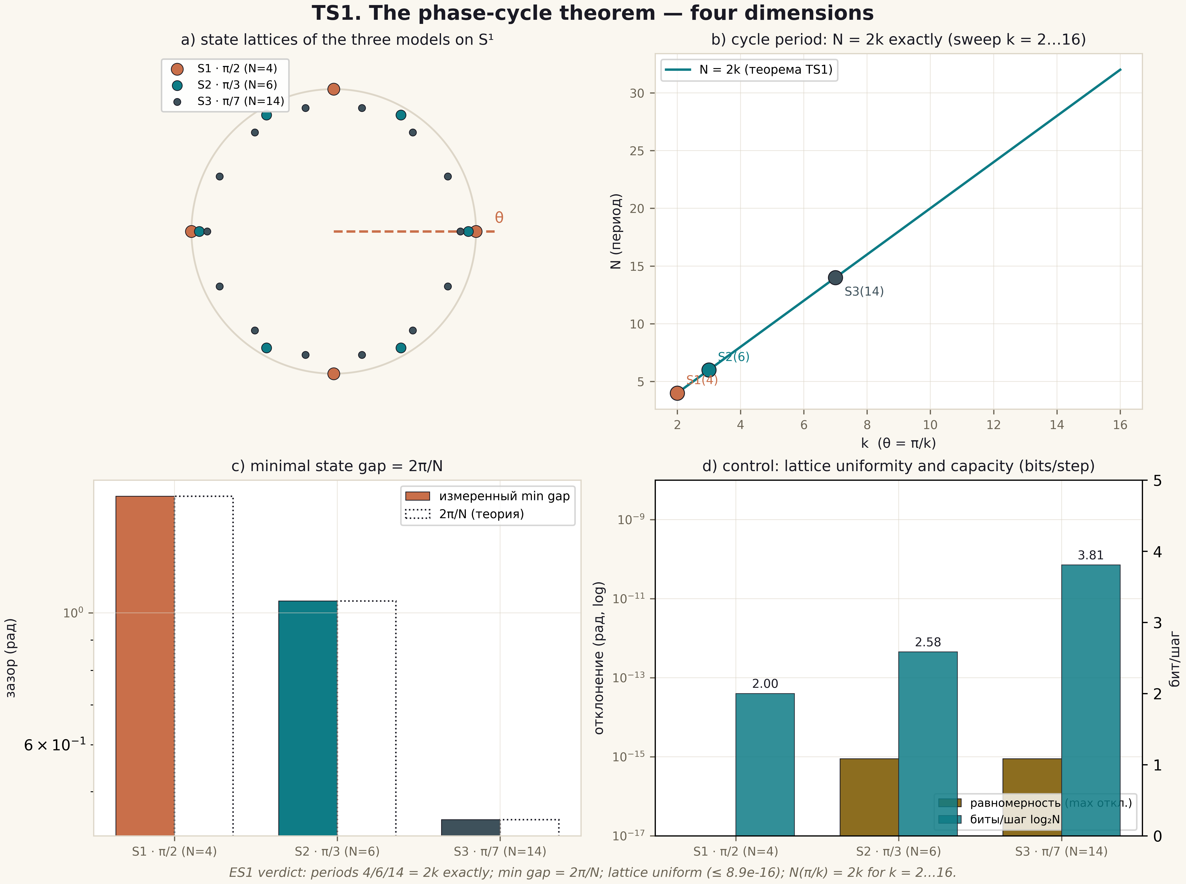
Fig. 1. Theorem TS1: four dimensions — state lattices, the period N = 2k, the minimal gap, the uniformity and capacity control (2×2 tile, 600 dpi, ES1 verdict data).

Boundaries and honest limitations
The theorem certifies closure of the phase lattices of the chosen models and the formula N = 2k; it says nothing about physical realisation of spinor phases or coherent carriers and is unrelated to the Riemann hypothesis. The capacity log₂N grows logarithmically in k while the robustness gap shrinks as 1/k — the capacity-vs-robustness trade-off is published as an honest boundary (see ES5).

