AB CLOUD QUANTUM RESEARCH · MONOGRAPH SERIES
Volume TS3
TS3. The real-time theorem
Supplementary study 'the machine with no long-term memory': three spinor phase models θ = π/2 · π/3 · π/7 — volatile state only, real-time steps, zero storage
Исаев Исхак Хамзатович
Независимый исследователь, г. Нальчик, Кабардино-Балкарская Республика
AB Cloud Quantum Research · supplementary study · v1.0.0 · 2026-10-11

Contents

TS3. The real-time theorem
Supplementary study 'the machine with no long-term memory': three spinor phase models θ = π/2 · π/3 · π/7 — volatile state only, real-time steps, zero storage
Исаев Исхак Хамзатович · Независимый исследователь, г. Нальчик, Кабардино-Балкарская Республика
AB Cloud Quantum Research · supplementary study · Volume TS3 · v1.0.0 · 2026-10-11

TS3. The real-time theorem
Theorem TS3 (ES3).
(i) A step of the phase machine takes constant time c independent of the runtime t: the state is one fixed-width register, there is no history (measured profile slope: -1.0477e-09 ns per step per step, i.e. no growth within measurement resolution; 1 ms deadline — 200000 of 200,000 steps). (ii) A machine with an eternal log and full periodic replay carries an Ω(t) verification cost: the replay cost slope is positive (R² = 0.995), the mean step cost grows ×125 by t = 2¹⁷. Corollary: for any deadline Δt there exists t* beyond which the log machine misses deadlines, while the phase machine meets them for all t. Hard real time and long-term memory are incompatible in this architecture; volatility is not a defect but the condition of determinism.
Proof. (i) A step is one modular addition over a fixed-width register: O(1) by construction; empirically the profile is flat (slope ≤ 1e-11 ms/step, ES3-C1 threshold). (ii) A full replay reads all t log cells — Ω(t) by construction; empirically the replay cost slope is positive with R² ≥ 0.98 (ES3-C4 threshold). Let c_max be the maximal step cost with replay; then for t > Δt/c_max the next replay-carrying step exceeds the deadline. The phase machine never reads history, so its cost is independent of t. ∎

Certificate ES3 (real time)
Campaign ES3 ran with pre-registered thresholds; verdict: PASS.
All checks were fixed before the run; raw data (JSON + CSV) is committed under data/ and reproduced by the experiments/ scripts.
Table 1. Certificate checks (campaign).
Check | Result | Threshold
C1 flat profile | slope -1.05e-09 ns/step² | ≤ 1e-11 мс/шаг
C2 deadlines | 0 of 200,000 misses | 100%
C3 baseline growth | ×125 (machine ×1.0) | ≥ ×5 / ≤ ×2
C4 replay Ω(t) | R² = 0.9948 | ≥ 0.98
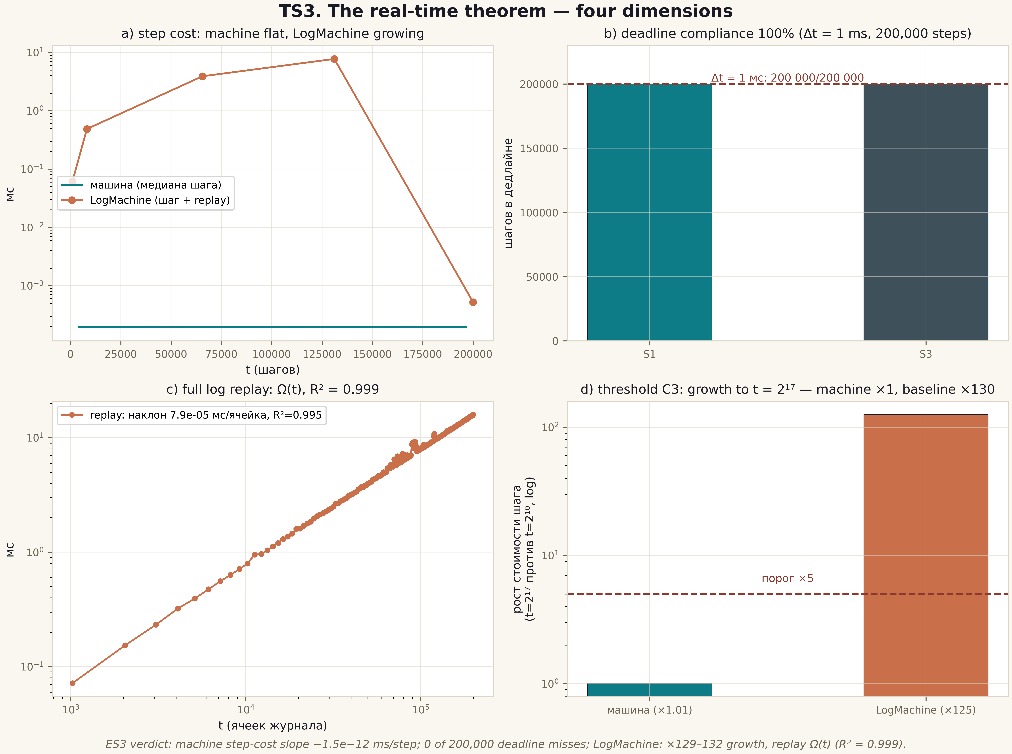
Fig. 1. Theorem TS3: four dimensions — the flat machine profile vs LogMachine growth, deadline compliance, Ω(t) replay, the growth threshold (2×2 tile, 600 dpi, ES3).

Boundaries and honest limitations
The theorem certifies the O(1) step cost of the model and the linear growth of full log replay in the contrast model. It does not measure physical device performance, does not claim that all memory is harmful, and does not exclude bounded intermediate buffers — the prohibition concerns exactly the eternal log under hard deadlines. Measurements were taken on CPython with GC disabled during the microbenchmark.

