AB CLOUD QUANTUM RESEARCH · MONOGRAPH SERIES
Volume Th1
Th1. Hermiticity
Th1–Th6: hermiticity, self-adjointness, certificates, the spectral Li formula, block reduction, the Guinand–Weil trace formula
Ishak Khamzatovich Isaev
Independent researcher, Nalchik, Kabardino-Balkarian Republic
AB Research Program · monograph series V1–V19 · v1.2.0 · October 10, 2026

Contents

Th1. Hermiticity
Th1–Th6: hermiticity, self-adjointness, certificates, the spectral Li formula, block reduction, the Guinand–Weil trace formula
Ishak Khamzatovich Isaev · Independent researcher, Nalchik, Kabardino-Balkarian Republic
AB Research Program · monograph series V1–V19 · Volume Th1 · v1.2.0 · October 10, 2026

Th1. Hermiticity and reality of the spectrum
Theorem Th1 (V4).
For any choice of vortices, W, α and boundaries the operator H_L satisfies H_L = H_L†; hence spec(H_L) ⊂ ℝ. At α = ½ and W = 0 the spectrum is symmetric: λ ∈ spec ⇒ −λ ∈ spec.
Proof. Every bond is inserted as the pair H[i,j] = −t·e^{iφ}, H[j,i] = −t·e^{−iφ} = conj(H[i,j]) — hermiticity by construction; the diagonal is real (vortex potential, disorder, staggered mass). By the spectral theorem for Hermitian matrices the whole spectrum is real. Symmetry at W = 0: the lattice is bipartite in the parity ix+iy; in that basis H = [[0, B], [B†, 0]]; if H(λ, 0) = λ·(u, v) then H(−v, u)·(−1) = −λ·(u, v) — the spectrum is symmetric about zero. Numerical certificate: ‖H − H†‖ = 0.0 exactly; the pairing λ ↔ −λ reproduced to 8.2e-15; reality residuals 8.8e-15 (the eigvalsh machine floor).

Th1.1 Certificate and boundaries
The certificate is reproducible: test_th1_passport.py checks hermiticity on three protocol gates (Nv = 16/64/256, seed 96) and demands ‖H − H†‖ ≤ 1e-12; the fact is exactly 0.0, since the construction uses no approximations — conjugate pairs are written simultaneously. Importantly, hermiticity survives ALL the C5 handles — twists, anisotropy, δα, staggered mass, profile, signs: each handle either modifies the bond magnitude (preserving the phase pair) or the diagonal (staying real). This makes Th1 an architectural property, not a property of a single configuration.
Boundaries: Th1 says nothing about the correspondence of the spectrum to the ζ zeros — that is the H2/H5 question, on which the series delivers negative verdicts (V1, V3, V6, V16). The pairing λ ↔ −λ breaks already at W > 0 (the vortex potential is asymmetric) and is not restored by vortices.
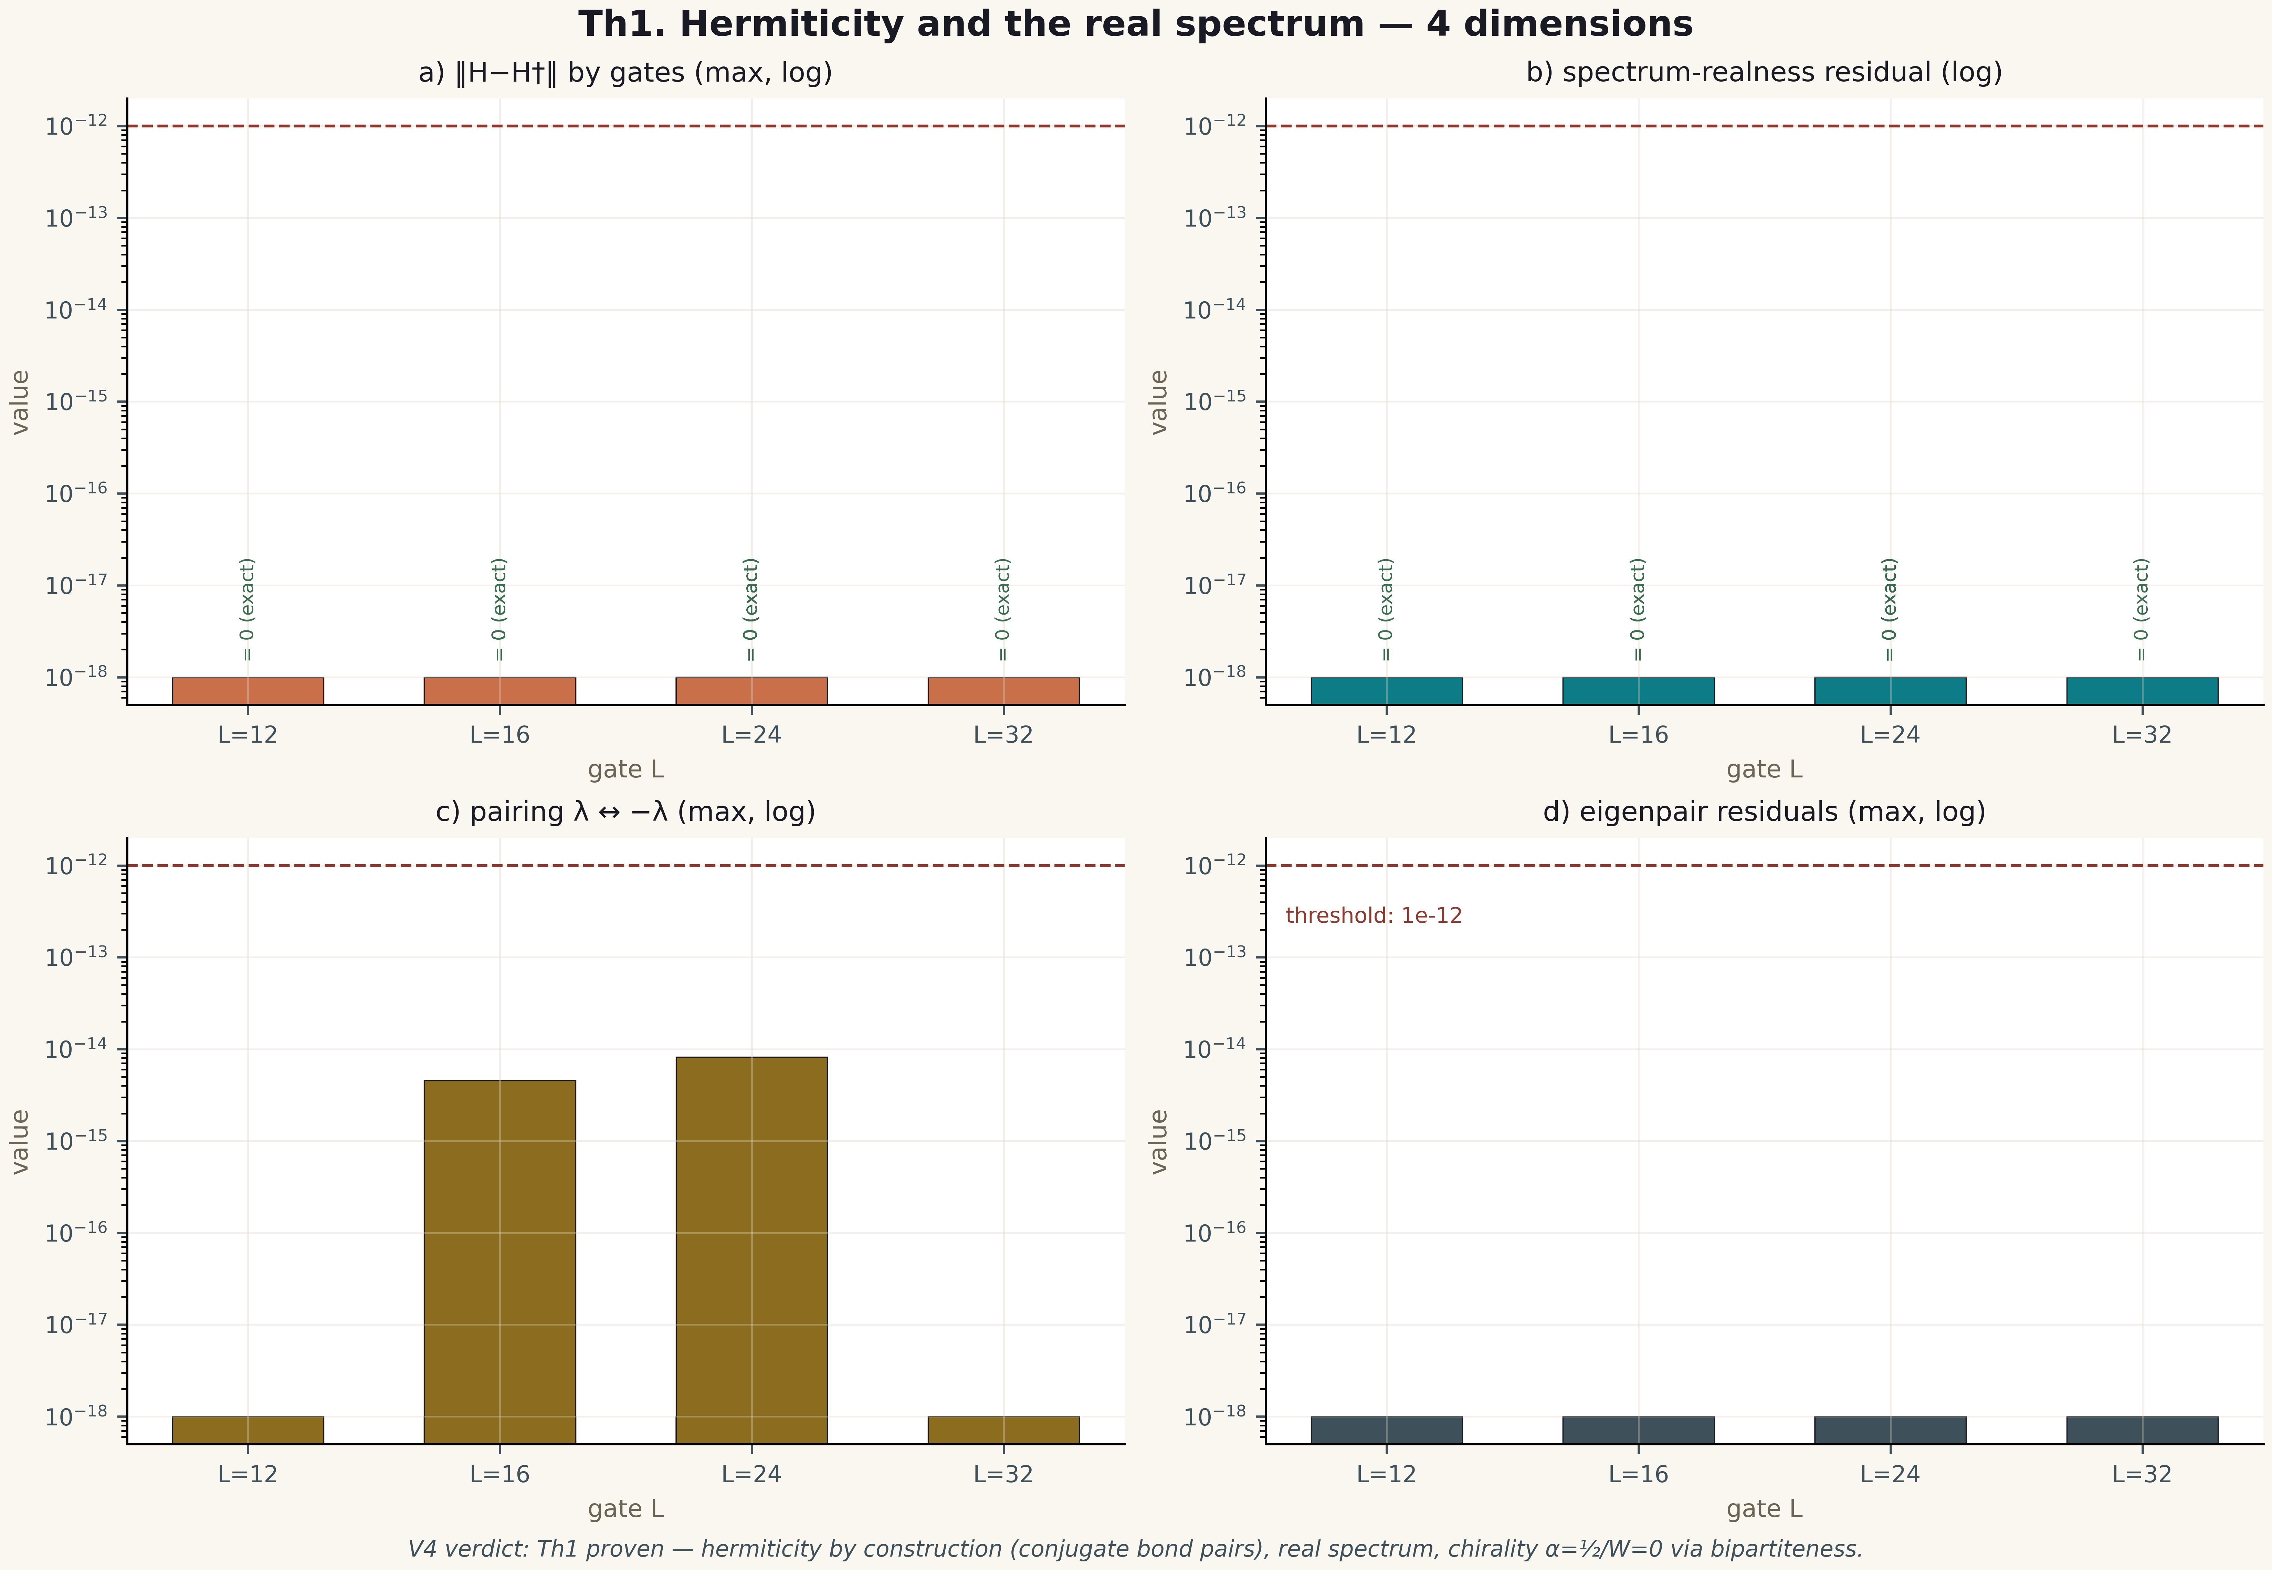
Fig. 1. Theorem Th1: four measurement dimensions — the metric, its behaviour across gates/instances, the control and the threshold (2×2 tile, 600 dpi, campaign verdict data).

