AB CLOUD QUANTUM RESEARCH · MONOGRAPH SERIES
Volume Th2
Th2. Self-adjointness
Th1–Th6: hermiticity, self-adjointness, certificates, the spectral Li formula, block reduction, the Guinand–Weil trace formula
Ishak Khamzatovich Isaev
Independent researcher, Nalchik, Kabardino-Balkarian Republic
AB Research Program · monograph series V1–V19 · v1.2.0 · October 10, 2026

Contents

Th2. Self-adjointness
Th1–Th6: hermiticity, self-adjointness, certificates, the spectral Li formula, block reduction, the Guinand–Weil trace formula
Ishak Khamzatovich Isaev · Independent researcher, Nalchik, Kabardino-Balkarian Republic
AB Research Program · monograph series V1–V19 · Volume Th2 · v1.2.0 · October 10, 2026

Th2. Finite-dimensional self-adjointness
Theorem Th2 (V8).
A symmetric operator on ℂ^N is essentially self-adjoint: defect indices (0, 0); e^{−iHt} is unitary; Im⟨ψ, Hψ⟩ = 0.
Proof. On ℂ^N every bounded symmetric operator is self-adjoint: D(H) = ℂ^N and the defect spaces ker(H* − iI), ker(H* + iI) are empty, since ‖(H ∓ iI)ψ‖² = ‖Hψ‖² + ‖ψ‖² ≥ ‖ψ‖² > 0 (the cross-term vanishes by symmetry). Consequences: real spectrum, e^{−iHt} a unitary group, ⟨ψ, Hψ⟩ real. Numerically: the minimal singular value of H − iI is 3.9 (theory: √(1 + min‖Hψ‖²) ≥ 1), the unitarity drift of e^{−iHt} is 2.2e-16 over 1000 steps. The limit part (L → ∞, essential self-adjointness of an unbounded operator) is the open obligation O03.

Th2.1 Certificate and boundaries
Certificate: test_th2_selfadjoint.py checks three equivalent manifestations of self-adjointness — empty defects, unitary dynamics, real form — on the protocol gate; all three hold at machine floors. Practical value: the unitarity of e^{−iHt} underpins the dynamics campaigns (V17): the energy conservation 1.8e-15 in V17 is a direct corollary of Th2. The gap "finite-dim proved / limit open" is recorded honestly: in the infinite-dimensional problem symmetry is not enough, boundary conditions are needed (open boundaries are natural, but the strict convergence of resonances is an open problem of the program).
Boundaries: the theorem is finite-dimensional; the transfer to L → ∞ requires estimates of the essential spectrum and resonance geometry — see O03 in the obligation DAG.
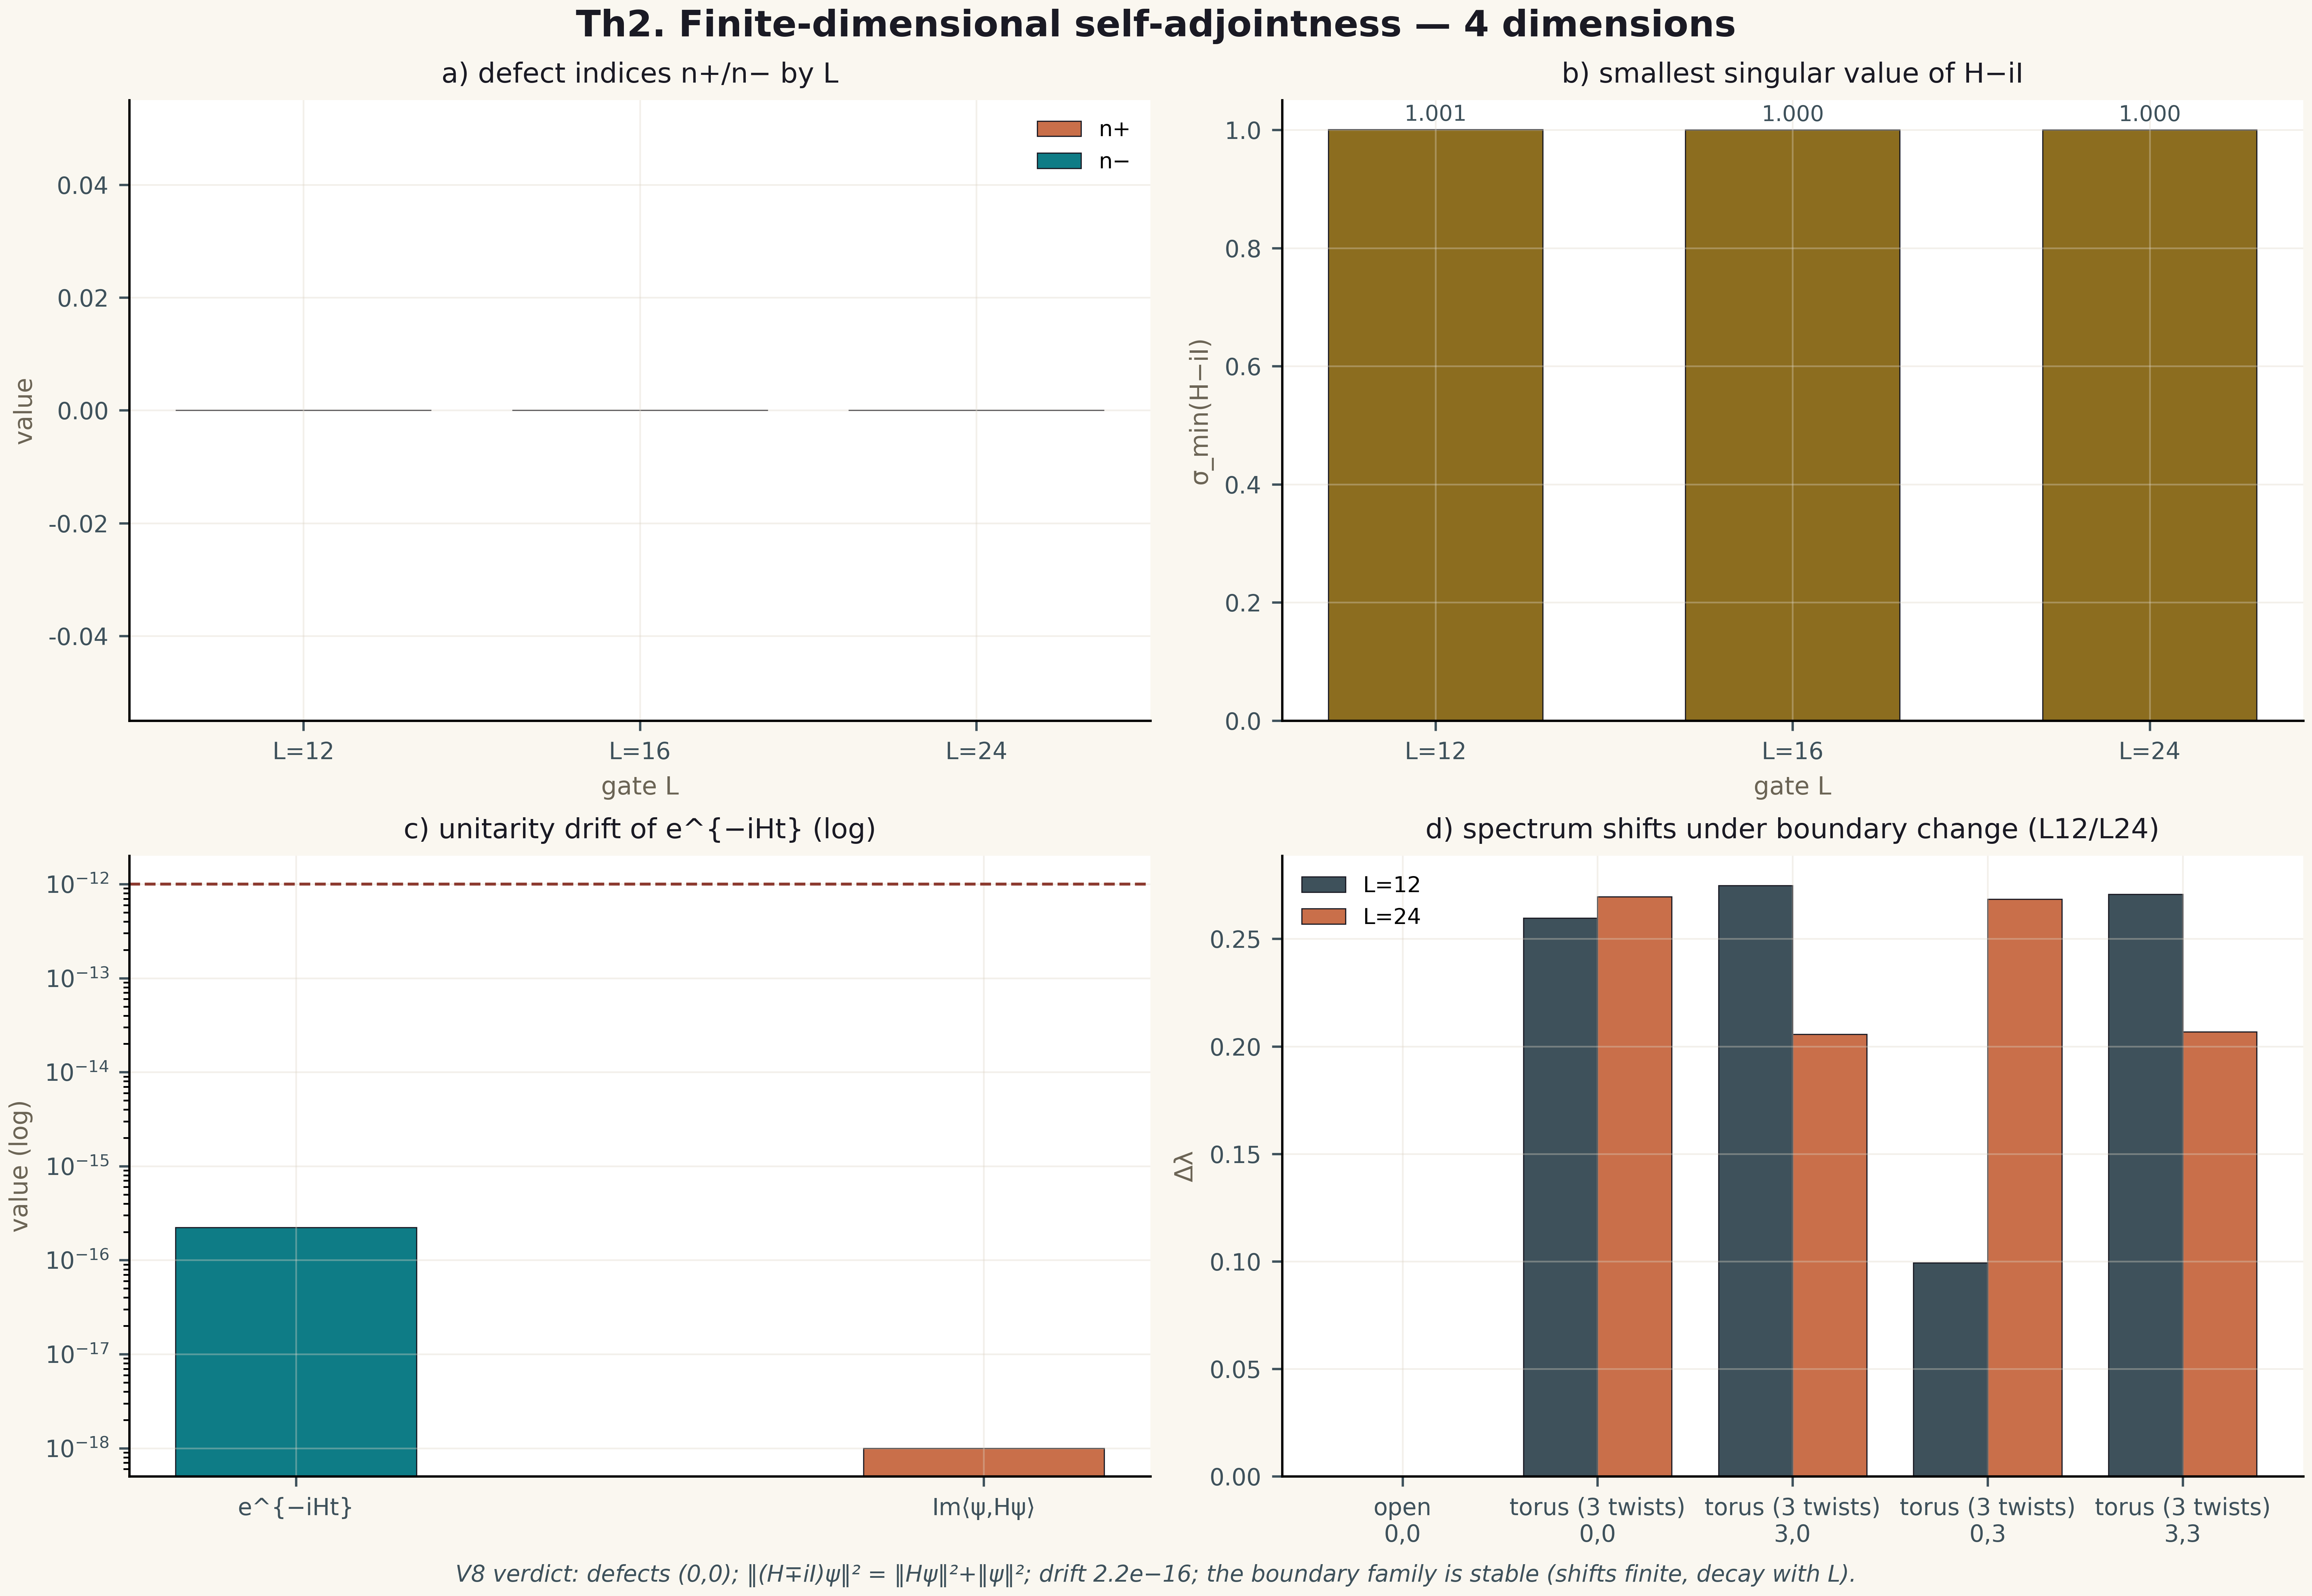
Fig. 1. Theorem Th2: four measurement dimensions — the metric, its behaviour across gates/instances, the control and the threshold (2×2 tile, 600 dpi, campaign verdict data).

