AB CLOUD QUANTUM RESEARCH · MONOGRAPH SERIES
Volume V04
V4. Strict Operator Passport
Hermiticity, reality of the spectrum and chirality of H_L (theorem Th1)
Ishak Khamzatovich Isaev
Independent researcher, Nalchik, Kabardino-Balkarian Republic
AB Research Program · monograph series V1–V19 · v1.2.0 · October 10, 2026

Contents

V4. Strict Operator Passport
Hermiticity, reality of the spectrum and chirality of H_L (theorem Th1)
Ishak Khamzatovich Isaev · Independent researcher, Nalchik, Kabardino-Balkarian Republic
AB Research Program · monograph series V1–V19 · Volume V04 · v1.2.0 · October 10, 2026

Problem statement
Before spectral properties can be proved, the object must be defined without reference to an implementation. The passport fixes: state space ℂ^{L×L} (open boundaries — a bounded operator with full domain); explicit matrix elements: Landau phases φ_x = 2πα·iy on x-links, vortex differences φ_y = Σ_k (q_k/2)(θ_j − θ_i) on y-links, on-site potential V_i = Σ_k q_k·W/(r²/N + 1) + ε_i; open/torus boundaries.
The passport checks (P1–P4) are consequences of the definition, not implementation tests: hermiticity H[i,j] = conj H[j,i] is built in, reality of the spectrum follows from the spectral theorem, and the chiral pairing λ ↔ −λ at α = ½, W = 0 follows from bipartiteness of the lattice (two-coloring by parity of ix + iy).

Theorem Th1
Theorem Th1 (hermiticity and reality).
For any choice of vortices, W, α and boundaries the operator H_L defined above satisfies H_L = H_L†; hence spec(H_L) ⊂ ℝ. If α = ½ and W = 0, the lattice is bipartite and spec(H_L) is symmetric: λ ∈ spec ⇒ −λ ∈ spec.
Proof. Every off-diagonal element comes as a pair H[i,j] = −t·e^{iφ}, H[j,i] = −t·e^{−iφ} = conj H[i,j] — hermiticity by construction; the spectral theorem gives reality. Bipartiteness: at W = 0 the diagonal is zero and every link joins opposite parity classes, so in the (even, odd) basis H = [[0, B], [B†, 0]] and the spectrum is symmetric. Numerically: max‖H−H†‖ = 0.0, max‖Hv−λv‖ = 8.8e-15, pairing 8.2e-15.

Results
The passport battery covers L ∈ {12, 16, 24, 32} and four handle variants (vortices, disorder, α = 0.4). All checks P1–P4 pass: hermiticity is exact (a zero residual — a consequence of the explicit formula in complex arithmetic), eigenpair residuals are at LAPACK machine level, and the chiral pairing is at the same level in the bipartite case.
Crucially, the passport separates the proved from the measured: Th1 is proved for all parameters at once; the numerical checks merely guard against implementation errors. This is the model of the “proven” status in the honesty discipline of the package.
Table 1. Passport maxima
Check | Battery maximum | Threshold | Verdict
P1 ‖H−H†‖_max | 0.0 (exact) | 1e-12 | proven
P2 reality | eigvalsh — real | — | proven
P3 pairing λ↔−λ (W=0) | 8.2e-15 | 1e-12 | proven
P4 ‖Hv−λv‖ | 8.8e-15 | 1e-11 | proven
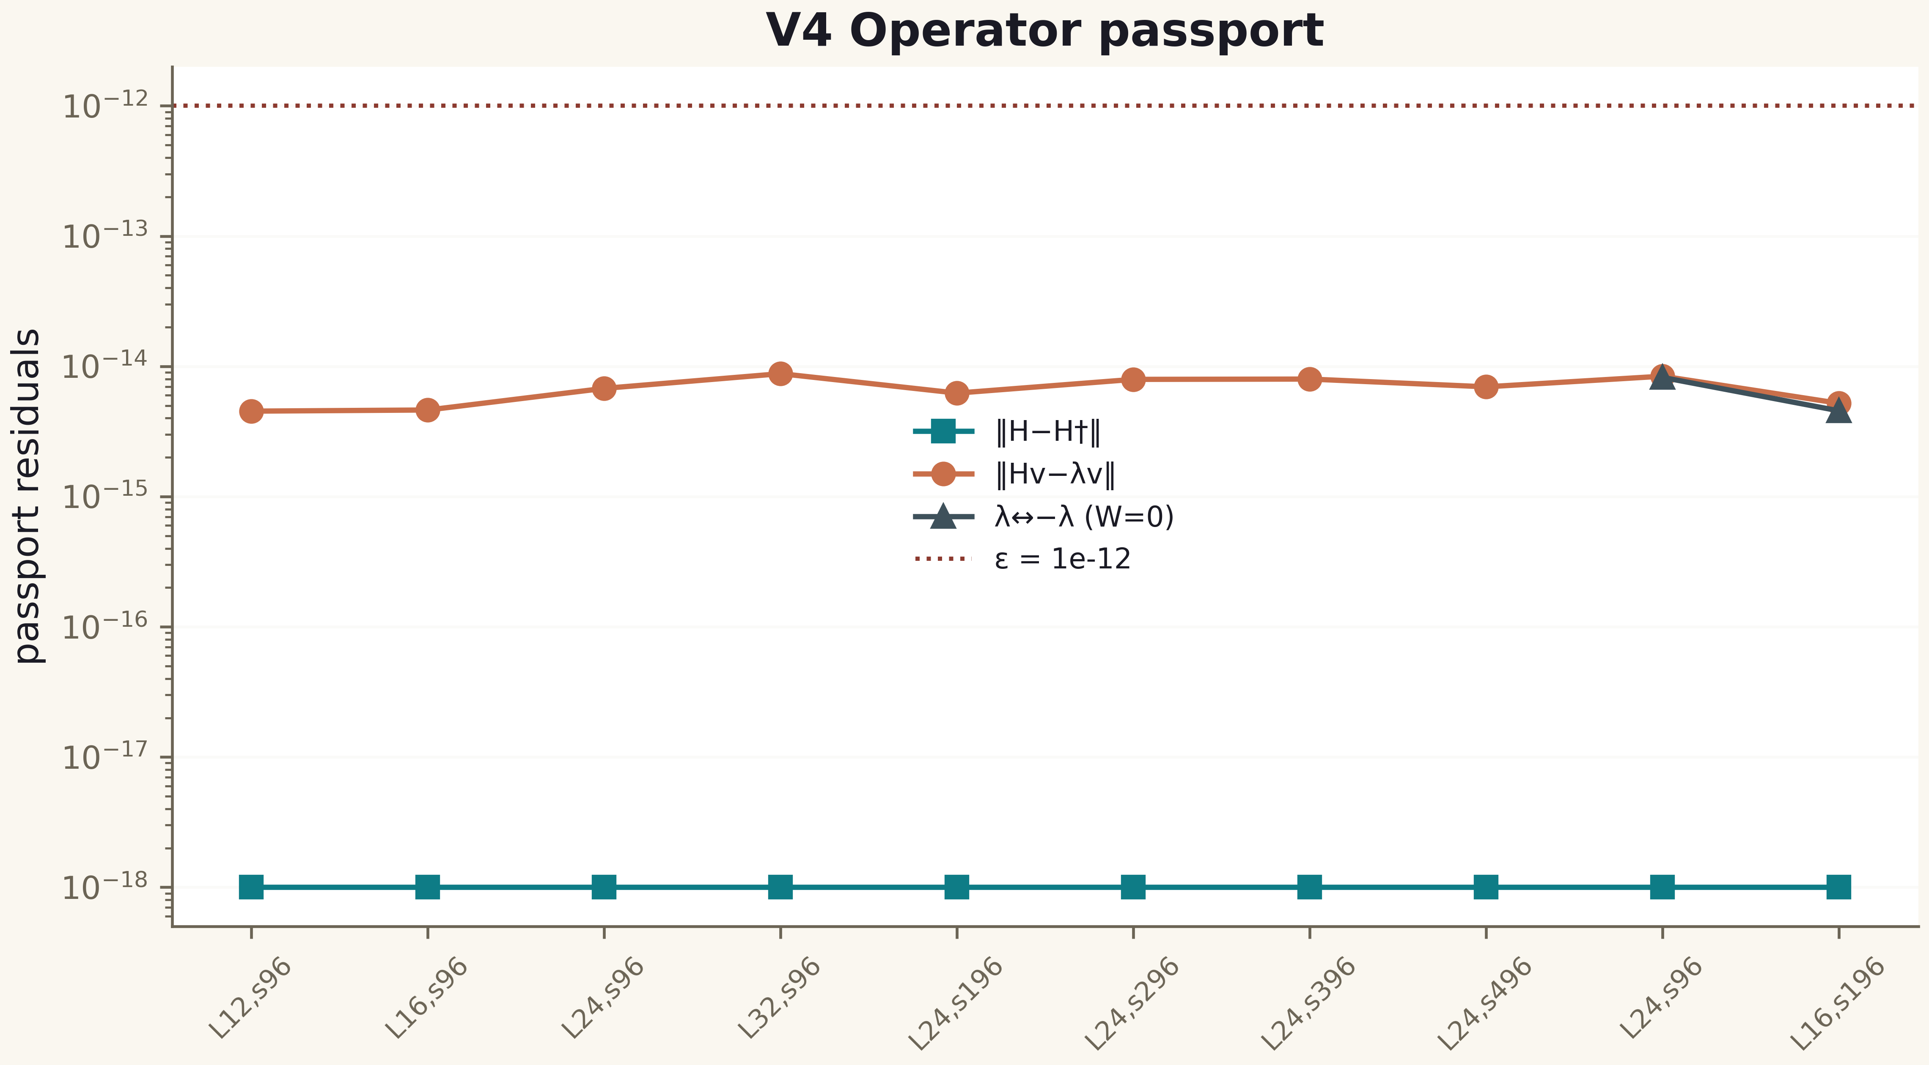
Fig. 1. Campaign V4 data (600 dpi, file figures_hires).

Honest remarks
The passport also fixes the boundary: Th1 statements are finite-dimensional. Self-adjointness of the limiting operator as L → ∞ is a separate task (V8, obligation O03); numerical hermiticity of an infinite-dimensional object does not follow from it. Also, chirality requires W = 0: on-site disorder destroys it, which is a property of the symmetry class AIII, not a defect.
The operator is defined unambiguously; Th1 is proved and verified to machine precision. The passport is the mandatory anchor of all subsequent campaigns.

