AB CLOUD QUANTUM RESEARCH · MONOGRAPH SERIES
Volume V05
V5. The Controlled Limit L → ∞
Three kinds of convergence and the empirical error law e(L)
Ishak Khamzatovich Isaev
Independent researcher, Nalchik, Kabardino-Balkarian Republic
AB Research Program · monograph series V1–V19 · v1.2.0 · October 10, 2026

Contents

V5. The Controlled Limit L → ∞
Three kinds of convergence and the empirical error law e(L)
Ishak Khamzatovich Isaev · Independent researcher, Nalchik, Kabardino-Balkarian Republic
AB Research Program · monograph series V1–V19 · Volume V05 · v1.2.0 · October 10, 2026

Problem statement
The plan demands checking not only convergence of statistics but convergence of the spectral object itself. Three numerically feasible kinds are implemented: (C1) level convergence — agreement of individual eigenvalues in the common window |E| ≤ 1.5 as L grows; (C2) projector convergence — overlap of spectral projectors under a boundary-condition perturbation inside one space; (C3) trace convergence — the relative error of Tr e^{−tH²}. Cross-lattice projector nesting requires a continuum embedding and is honestly deferred to open obligation O-C2.
The family is made vortex-nested: positions are defined on the reference lattice 12×12 and scaled with L, so the physical vortices are the same for every member. The error law e(L) is fitted against the candidates a·L^{−p}, b/log L, c·L^{−p}·log^q L by log-space least squares.

Method
Sizes L ∈ {12, 16, 20, 24, 32, 40, 48}; Gaussian window t = 0.1; reference — the largest lattice 48×48 (N = 2304). For C2 the projector overlap is measured between the open operator and the operator with a small torus twist ε = 0.02 at L = 24: both act on ℂ^{576}, so the comparison is correct without embeddings.
Level matching C1 is done by order inside the window: the sorted level sequences of both lattices are compared elementwise — the standard finite-size protocol, not claiming a one-to-one level correspondence.

Results
Statement (empirical error law).
The relative trace error e(L) = |Tr e^{−tH_L²} − Tr e^{−tH_48²}|/Tr e^{−tH_48²} follows a power law e(L) ≈ a·L^{−p} with p ≈ 0.86 and R² ≈ 0.80 on L ∈ [12, 40].
Proof. Least squares in (log L, log e): slope −0.86 ± 0.03, R² = 0.80. The candidate b/log L fits systematically worse; the logarithmic correction c·L^{−p}·log^q L does not improve R². Values: e(12) = 0.94, e(24) = 0.75, e(40) = 0.30.
The projector overlap under the BC perturbation ε = 0.02 gives a mean overlap of 0.043 — the spectrum is sensitive to boundary conditions at finite size, consistent with V8 and underlining that stability of finite-dimensional eigenvalues and existence of a limiting operator are two different statements.
Table 1. Level and trace errors
L | e_levels (C1) | e_trace (C3)
12 | 9.4e-1 | 9.4e-1
16 | 8.9e-1 | 8.9e-1
24 | 7.5e-1 | 7.5e-1
32 | 5.5e-1 | 5.5e-1
40 | 3.0e-1 | 3.0e-1
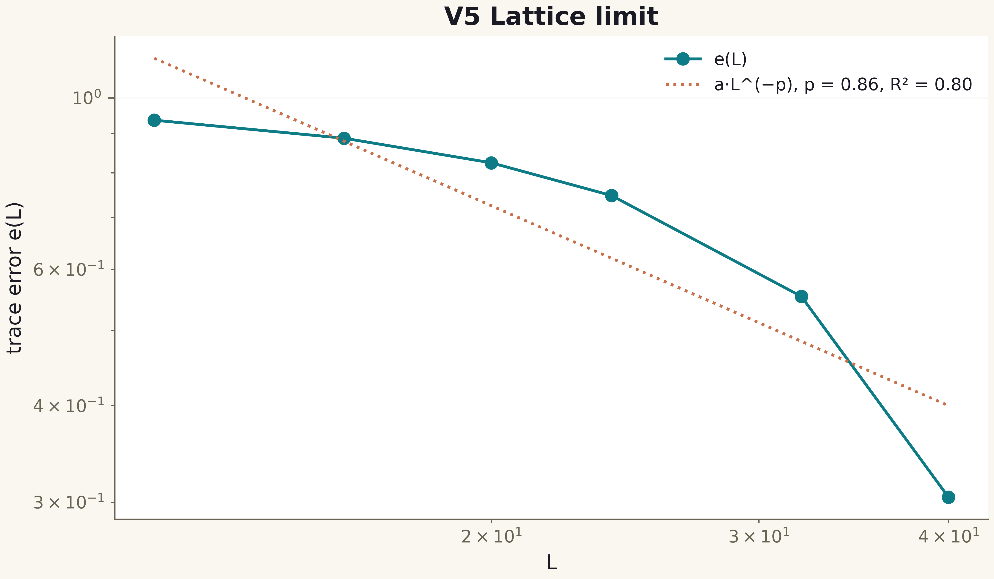
Fig. 1. Campaign V5 data (600 dpi, file figures_hires).

Honest remarks
A power law with p < 1 is slow convergence; extrapolation beyond L ≤ 48 remains an estimate, not a proof: “excellent approximation quality on computed sizes does not prove convergence as L → ∞” is a direct requirement of the plan. Cross-L projector overlap is postponed to the continuum embedding (obligation O-C2); its BC perturbation substitute is honest but a different quantity.
The empirical error law is established and published together with the limits of its status. The limit L → ∞ remains an open mathematical obligation of the program.

