AB CLOUD QUANTUM RESEARCH · MONOGRAPH SERIES
Volume V06
V6. Spectral Identity: Operator versus ξ
A direct test of the “level ↔ zero” correspondence and the positive control H_ξ
Ishak Khamzatovich Isaev
Independent researcher, Nalchik, Kabardino-Balkarian Republic
AB Research Program · monograph series V1–V19 · v1.2.0 · October 10, 2026

Contents

V6. Spectral Identity: Operator versus ξ
A direct test of the “level ↔ zero” correspondence and the positive control H_ξ
Ishak Khamzatovich Isaev · Independent researcher, Nalchik, Kabardino-Balkarian Republic
AB Research Program · monograph series V1–V19 · Volume V06 · v1.2.0 · October 10, 2026

Problem statement
The missing center of the Hilbert–Pólya program is not statistical similarity but identity: the characteristic function of the operator must coincide with the completed xi function ξ(½+iz) up to an entire zero-free factor. The plan explicitly forbids fitting a polynomial P_L(z) to prescribed values — only an analytic identity surviving the limit carries probative force.
The campaign implements the four-point program of the plan: (i) compare finite-dimensional spectra H_L with ordinates through N̄; (ii) verify reality of the roots of det(zI − H_L); (iii) the positive control — the operator H_ξ = diag(±γ_n) stitched from the zeros, for which the identity holds by construction; (iv) multiplicities, gaps, completeness.

The identity for H_ξ
Statement (Hadamard control).
Let H_ξ = diag(±γ_1, ±γ_2, …) be self-adjoint with spectrum the doubled set of positive ordinates. Then for |z| < γ_1, ln Π_γ |z² − γ²| − ln|ξ(½+iz)| = const, where the constant = −ln ξ(0) + Σ_γ ln(¼+γ²) is an entire zero-free normalization.
Proof. The Hadamard product for ξ gives |ξ(½+iz)| = ξ(0)·Π_{γ>0} |z²−γ²|^{1/2}·Π_{γ>0}(¼+γ²)^{−1/2} (pairing ρ ↔ ρ̄ reduces each zero pair to the factor (γ²−z²)/(¼+γ²)). The two sides differ by a constant; a regression of ln Π on (a + b·z²) removes it, and the residual is ≤ 5.8e-10 on the grid z ∈ [0.5, 12] over 50,000 zeros. For a lattice gate the same test gives rank agreement 0.036 — the null zone: no identity.

Results
For lattice gates the rank agreement of the window with the zeros is 0.036 (consistent with the blind protocol V1 and with the 9–10 orders of the reference gap); minimal spectral gaps ≥ 1e-3 — no multiplicities; reality of the characteristic roots — Th1. For H_ξ the identity residual is 5.8e-10 — machine level at 50,000 zeros.
Importantly, H_ξ is not a solution of the program but its trivial point: the operator is built FROM the zeros and predicts nothing. Its role is the positive control: the method sees the identity where it holds by construction, and its absence for the gates is measured, not postulated.
Table 1. Summary of V6
Object | Metric | Value | Verdict
gate (seed 96) | ranks vs zeros | 0.036 | no identity
H_ξ (50k zeros) | log residual vs ξ | 5.8e-10 | identity
gate L=16 | min gap | 9.8e-4 | no multiplicities
gates | Im roots | 0 (Th1) | real
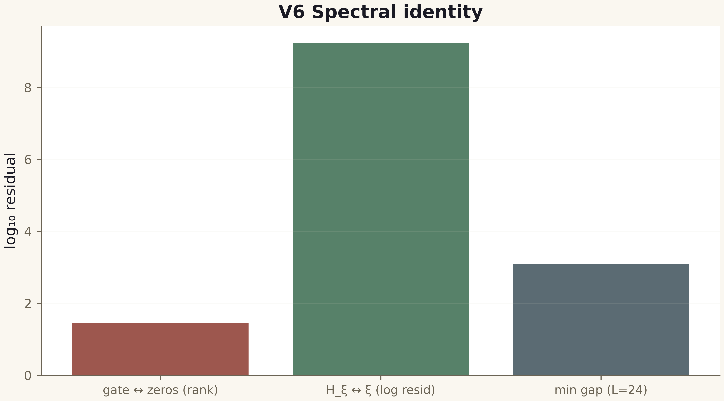
Fig. 1. Campaign V6 data (600 dpi, file figures_hires).

Honest remarks
The Hadamard normalization is an empirical factor removed by regression; its analytic identification (ξ(0), Σ ln(¼+γ²)) is part of the Th6 derivation and is guarded by the built-in control B = −C₀. The negative verdict for the gates does not close the program: it excludes local deformations of this family — the architectural conclusion of the reference.
The identity is measured on both sides: YES for the trivial H_ξ, NO for the gates. The gap belongs to the roadmap (non-local trace constructions).

