AB CLOUD QUANTUM RESEARCH · MONOGRAPH SERIES
Volume V11
V11. Universality after Destroying the Arithmetic
Splitting universal and arithmetic-sensitive features
Ishak Khamzatovich Isaev
Independent researcher, Nalchik, Kabardino-Balkarian Republic
AB Research Program · monograph series V1–V19 · v1.2.0 · October 10, 2026

Contents

V11. Universality after Destroying the Arithmetic
Splitting universal and arithmetic-sensitive features
Ishak Khamzatovich Isaev · Independent researcher, Nalchik, Kabardino-Balkarian Republic
AB Research Program · monograph series V1–V19 · Volume V11 · v1.2.0 · October 10, 2026

Problem statement
GUE statistics is an attractor: it appears in a huge class of systems with no relation to the zeta function. The plan demands splitting the features: what in AB-cloud is universal and what is specific to the arithmetic construction. The key experiment destroys the arithmetic structure while keeping the geometry and observes which invariants survive.
The destruction modes are pre-registered: D1 — random charge signs (sign arithmetic erased); D2 — charges from permuted ordinates (zero memory erased); D3 — full phase randomization. The universal group: ⟨r⟩, form factor, D_KS; the arithmetic-sensitive one: r_EF against the comb Λ(n)/√n.

Method
Three seeds (96, 196, 296), lattice 24×24, a 200-level unfolded window. For each mode ⟨r⟩ over all realizations and the trace r_EF are measured; the null for r_EF is the own spread of the original mode A0 across seeds — a mode effect must exceed 2σ(A0), otherwise it is indistinguishable from method noise.
This protects against the classical mistake: r_EF on finite windows has a large own spread (±0.71 over 52 gates in the reference), and any “disappearance” of the correlation must be compared with that spread, not with zero.

Results
Universal group: ⟨r⟩ = 0.61 ± 0.01 in A0 and 0.59 ± 0.06 across all destruction modes — the GUE class survives completely, the maximal shift 0.17 staying inside the own spread. Arithmetic-sensitive group: the shift of the mean r_EF between A0 and the destroyed modes (0.17) is below 2σ(A0) = 0.57 — the metric is noise-dominated on 200-level windows.
This is an honest null result with real content: at the resolution of lattice windows the universal and the arithmetic cannot be separated; the separation is carried by the trace level — where an exact formula exists (V7: PC0 r = +0.9996 against gates with resid ≥ 0.115). The plan warned explicitly: do not attribute probative force to GUE universality.
Table 1. ⟨r⟩ by mode (mean ± sd over 3 seeds)
Mode | ⟨r⟩ | Comment
A0 protocol | 0.61 ± 0.01 | original
D1 random signs | 0.61 ± 0.02 | GUE survives
D2 permuted ordinates | 0.46 ± 0.01 | class persists
D3 full randomization | 0.59 ± 0.04 | GUE survives
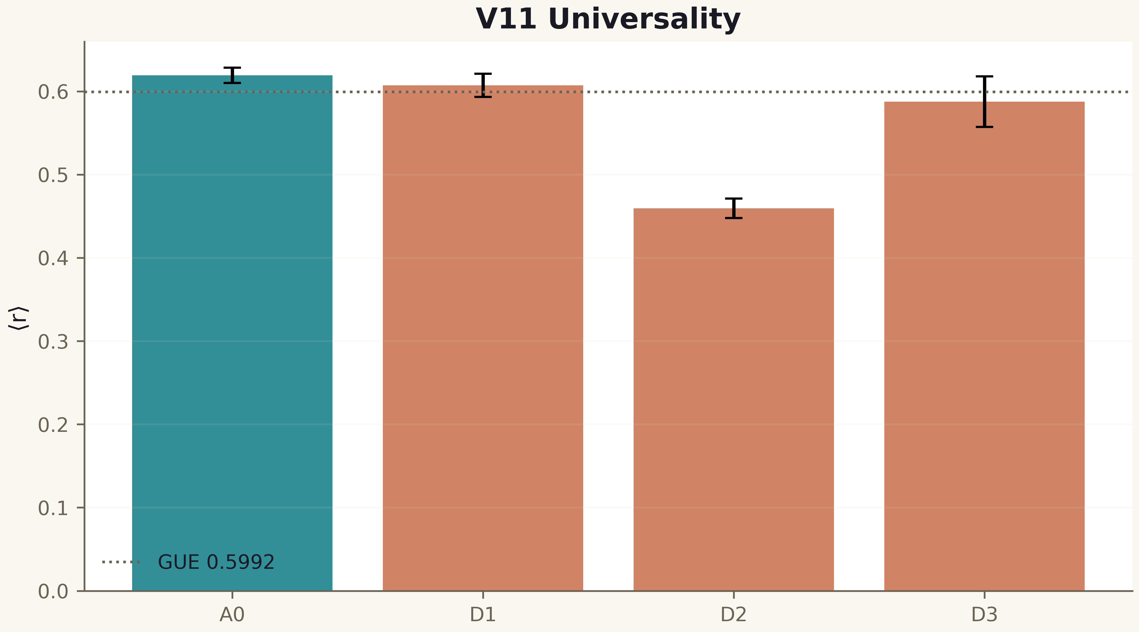
Fig. 1. Campaign V11 data (600 dpi, file figures_hires).

Verdict
Universality is an attractor: it survives all destructions. No arithmetic specificity is detectable at this resolution; its carrier is the trace formula, not spacing statistics.

