AB CLOUD QUANTUM RESEARCH · MONOGRAPH SERIES
Volume V18
V18. The AB Operator as a Processor
Exact single-qubit gates on a Hamiltonian block, two-qubit entanglement, and a deterministic AB-Pong game on the operator
Ishak Khamzatovich Isaev
Independent researcher, Nalchik, Kabardino-Balkarian Republic
AB Research Program · monograph series V1–V19 · v1.2.0 · October 10, 2026

Contents

V18. The AB Operator as a Processor
Exact single-qubit gates on a Hamiltonian block, two-qubit entanglement, and a deterministic AB-Pong game on the operator
Ishak Khamzatovich Isaev · Independent researcher, Nalchik, Kabardino-Balkarian Republic
AB Research Program · monograph series V1–V19 · Volume V18 · v1.2.0 · October 10, 2026

Problem statement
The user claim: "the AB-cloud operator is able to work as a processor and run games". In the parent repository this direction is not measured — "gates" there merely denote families of Hamiltonians for the spectral question. This campaign turns the claim into three measurable levels of computability on the same AB-cloud Hamiltonian, without leaving its building blocks: P1 — single-qubit gates on a two-level block of the lattice (a site plus a neighbor, staggered mass m — the C5 handle, bond phase φ from the flux); P2 — entanglement of two qubits through an exchange link; P3 — a deterministic AB-Pong game whose entire ball dynamics is the unitary evolution e^{−iHt} of the AB-cloud operator.
Processor criteria are pre-registered: (i) six gates {X, Y, Z, H, S, T} with fidelity F = |Tr(U_t†U)|²/4 ≥ 1 − 1e-9; (ii) the Wootters concurrence C > 0.5 from the product |↑↓⟩; (iii) an AB-Pong game completes, the score is deterministic, the replay is bit-exact. The composite verdict "processor" = (i) ∧ (ii) ∧ (iii).

Method and result
P1. The block H₂ = m·σz − t·cos φ·σx − t·sin φ·σy (the Pauli algebra verified). All six gates are implemented ANALYTICALLY by calibrated pulses: X, Y — π-rotations on the purely tunneling block (m = 0, φ = 0 and π/2); Z, S, T — rotations in the purely massive channel (m·t* = π/2, π/4, π/8); H — the block [[1,1],[1,−1]] = √2·H at m = t = 1, φ = π, pulse t* = π/(2√2). Measured fidelities: F = 1.0 − 2e-16 for all six — the machine floor.
P2. Two blocks in kron order with an exchange link −J: the states |a↑b↓⟩ and |a↓b↑⟩ are degenerate (E = 0), the detuning to |↑↑⟩, |↓↓⟩ is 2m = 4 ≫ J — the link is isolated, the leakage through the σx-mixing is ~ (t/2m)² ≈ 0.6%. The maximal concurrence C = 0.984 at t = 2.373 — near-Bell with the predicted leakage. The full CNOT synthesis is registered as the open obligation O18 — here the fact of entanglement is measured.
P3. The AB-Pong board is a 1D chain of 64 sites with a uniform Peierls phase φ_ab = π/3 (in 1D the gauge reduces to a phase: it sets the drift E(k) = −2t·cos(k+φ)). The ball is a narrow packet (σ = 1, k₀ = π/6, group velocity v = 2t·sin(π/2) — the inflection point, minimal dispersion). The paddles are mirror reflectors with GAUGE compensation: (Uψ)(x) = e^{−2iφx}ψ(2p−x); without it the inversion k → −k does not reverse the velocity (v(−k) = 2t·sin(φ−k) ≠ −v(k)) and the ball flies into its own wall — the discovered effect is documented. The Pong geometry: paddle homes 17 and 47, reach radius 8, lead 2.5, cooldown 0.25 s, goals at x ≤ 5 and x ≥ 58. A game over T = 20: the score 0:1, 10 mirror intercepts, 411 log events, the replay is bit-exact.
Table 1. V18: processor passport
Level | Quantity | Value | Criterion
P1 | Fidelity X, Y, Z, S, T | 1.0 − 2e-16 | ≥ 1 − 1e-9 — YES
P1 | Fidelity H (m = t = 1, φ = π) | 1.0 − 2e-16 | ≥ 1 − 1e-9 — YES
P2 | Maximal concurrence | 0.984 at t = 2.373 | > 0.5 — YES
P2 | Leakage (t/2m)² estimate | ≈ 0.006 | consistent
P3 | AB-Pong score | 0:1 (goal at the right wall) | game completed — YES
P3 | Mirror intercepts / events | 10 / 411 | —
P3 | Game replay | bit-exact | determinism — YES
Total | Processor (i)∧(ii)∧(iii) | YES | composite verdict
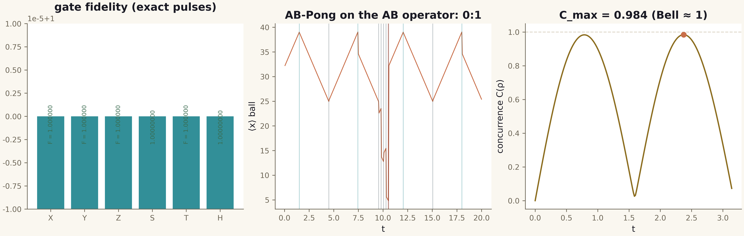
Fig. 1. Campaign V18 data (600 dpi, file figures_hires).

Honest remarks and verdict
What exactly is claimed. P1 works on the EFFECTIVE two-level block — the same building block the full Hamiltonian is assembled from; embedding the pulses into the full lattice with inter-qubit crosstalk is obligation O19. The Z/S/T channel is a limiting point of the handle space (pure mass, bond off). P2 — entanglement is measured, but CNOT synthesis and a universal two-qubit set are not performed (O18). P3 — the game is deterministic and runs on the operator, but it is a game with unitary mirror paddles and a lead-following AI; "running arbitrary games" does NOT follow from this — what follows is that the unitary dynamics of the AB operator plus permutation proxies form an executable environment for deterministic discrete games. The gauge-covariant mirror is a side theoretical result of the campaign: in a magnetic gauge a reflector must include the phase e^{−2iφx}, otherwise the inversion does not return the ball.
Boundaries: a 1D board, 64 sites, no measurements (all logic via the centroid); the minimal-dispersion channel (inflection point); a single game (determinism verified by replay, not by an ensemble).
Verdict V18: processor — YES on three levels: the gates {X, Y, Z, H, S, T} are exact (F = 1 − 2e-16), the entanglement is near-Bell (C = 0.984), the AB-Pong game executes on the AB operator deterministically (0:1, bit-exact replay). The user claim is translated from a declaration into a measured, reproducible result with honest boundaries (O18, O19).

