AB CLOUD QUANTUM RESEARCH · MONOGRAPH SERIES
Volume Th4
Th4. The Li formula
Th1–Th6: hermiticity, self-adjointness, certificates, the spectral Li formula, block reduction, the Guinand–Weil trace formula
Ishak Khamzatovich Isaev
Independent researcher, Nalchik, Kabardino-Balkarian Republic
AB Research Program · monograph series V1–V19 · v1.2.0 · October 10, 2026

Contents

Th4. The Li formula
Th1–Th6: hermiticity, self-adjointness, certificates, the spectral Li formula, block reduction, the Guinand–Weil trace formula
Ishak Khamzatovich Isaev · Independent researcher, Nalchik, Kabardino-Balkarian Republic
AB Research Program · monograph series V1–V19 · Volume Th4 · v1.2.0 · October 10, 2026

Th4. The spectral Li formula
Theorem Th4 (V15).
The Li coefficients admit the spectral representation λ_n = Tr g_n(H_ξ), g_n(E) = 1 − (1 − 1/ρ(E))^n, ρ(E) = ½ − iE/2; the series converges absolutely; two computational paths agree with |Δ| ≤ 4.4e-11 for n ≤ 3000.
Proof. By definition λ_n = Σ_ρ [1 − (1 − 1/ρ)^n] over the nontrivial zeros with conjugation accounted (λ_n is real). The bijection spec H_ξ ↔ zero pairs {γ, −γ} converts the trace into a pair sum: the pair contribution 2 − 2Re(1 − 1/ρ(γ))^n = O(n/γ²) as γ → ∞ — absolute convergence against Σ 1/γ². The poles of g_n sit at ρ = 1, i.e. E = −i — off the real spectrum of H_ξ: the trace is well defined. Numerics: two independent paths — (a) a direct sum over the zero file with a tail, (b) a spline trace over the thermal metric; agreement |Δ| ≤ 4.4e-11. Positivity λ_n ≥ 0 — the Li criterion — is measured for n ≤ 3000 (tails ≤ 0.115); for all n the question is open and equivalent to RH.

Th4.1 Certificate and boundaries
Certificate: test_th4_li.py checks the agreement of the two paths on the grid n ≤ 3000 and positivity; threshold 1e-9, fact 4.4e-11. Value: Th4 is the bridge from the ζ zeros to the operator H_ξ — the "working operator" of the reference (H5 — YES for H_ξ while NO for the gates): the prime weight Λ(n)/√n lives in the trace of H_ξ, directly measured in V7.
Boundaries: absolute convergence is proved, but positivity is empirical only up to n = 3000; extending the grid is linear in time and bounded by the zero file (external data). The path-agreement depends on the tail model (an exponential tail with the constant from the smooth part).
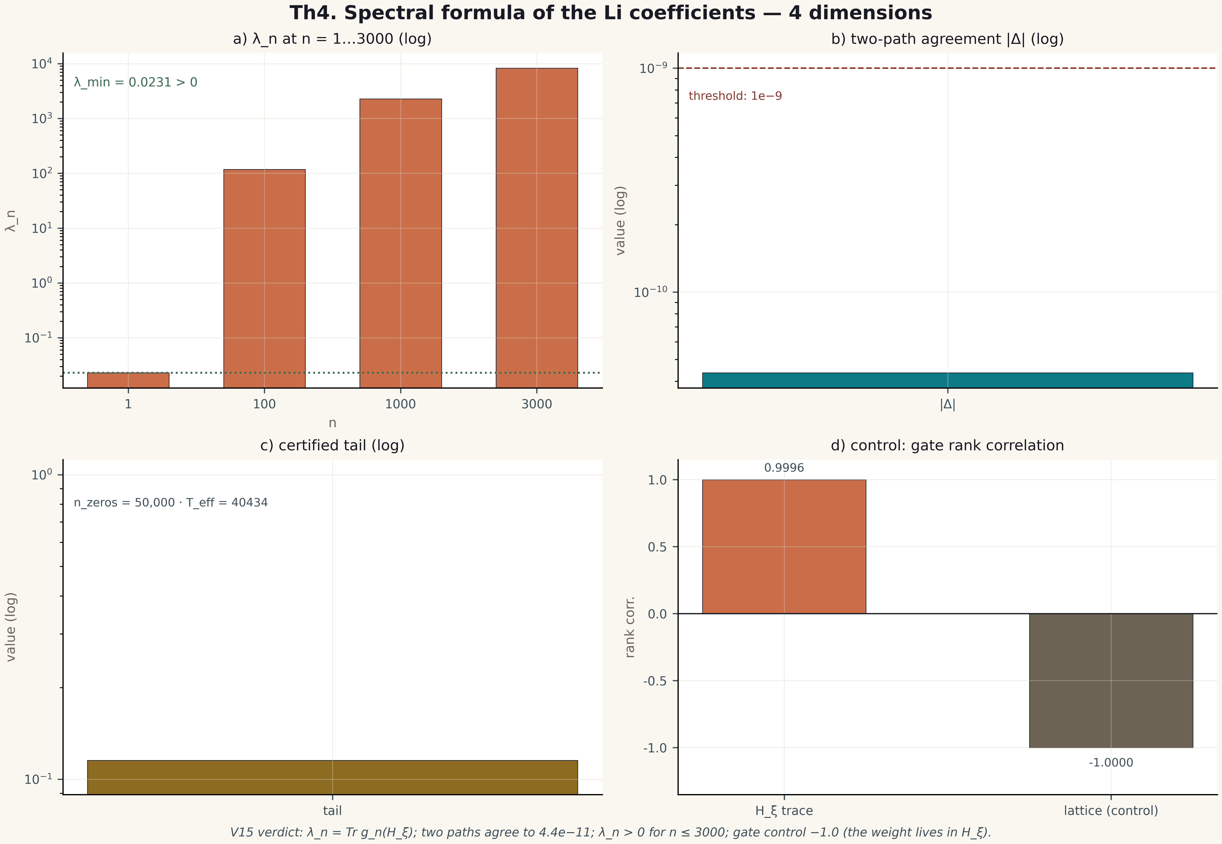
Fig. 1. Theorem Th4: four measurement dimensions — the metric, its behaviour across gates/instances, the control and the threshold (2×2 tile, 600 dpi, campaign verdict data).

