AB CLOUD QUANTUM RESEARCH · MONOGRAPH SERIES
Volume Th5
Th5. Block reduction
Th1–Th6: hermiticity, self-adjointness, certificates, the spectral Li formula, block reduction, the Guinand–Weil trace formula
Ishak Khamzatovich Isaev
Independent researcher, Nalchik, Kabardino-Balkarian Republic
AB Research Program · monograph series V1–V19 · v1.2.0 · October 10, 2026

Contents

Th5. Block reduction
Th1–Th6: hermiticity, self-adjointness, certificates, the spectral Li formula, block reduction, the Guinand–Weil trace formula
Ishak Khamzatovich Isaev · Independent researcher, Nalchik, Kabardino-Balkarian Republic
AB Research Program · monograph series V1–V19 · Volume Th5 · v1.2.0 · October 10, 2026

Th5. Block reduction by symmetry
Theorem Th5 (V9).
If [H, A] = [H, B] = 0 for the generators of the abelian group G of magnetic translations, then H is block-diagonal in the character decomposition of G and spec H = ⊔_χ spec(H|Π_χ ℂ^N).
Proof. Commuting unitaries A, B are simultaneously diagonalizable; their joint eigenvalues are the characters χ: G → U(1); the spectral projectors Π_χ (polynomials in A, B) commute with H: [H, Π_χ] = 0, hence each Π_χ ℂ^N is invariant and H decomposes into the direct sum of restrictions. Corollary: eigenvalues are found in smaller blocks with guaranteed coverage. Numerically: the union of 6 blocks reproduces the full spectrum to 7.1e-15; vortices break the symmetry (commutators ε_g = O(1)) — the reduction applies only to the clean lattice and to symmetric vortex configurations.

Th5.1 Certificate and boundaries
Certificate: test_th5_block_reduction.py compares the union of the block spectra with the full spectrum; threshold 1e-9, fact 7.1e-15. The value is twofold: (a) computational — the reduction speeds up scans (each block ~L²/6 instead of L²); (b) diagnostic — the magnitude ‖[H, A]‖ measures how far a vortex configuration is from symmetric and serves as a passport feature of a gate in V4.
Boundaries: for protocol (asymmetric) vortices the reduction does not apply — this is not a defect but the boundary of its domain; partially symmetric configurations give approximate invariant subspaces, and the quantification of this idea is not included in the package.
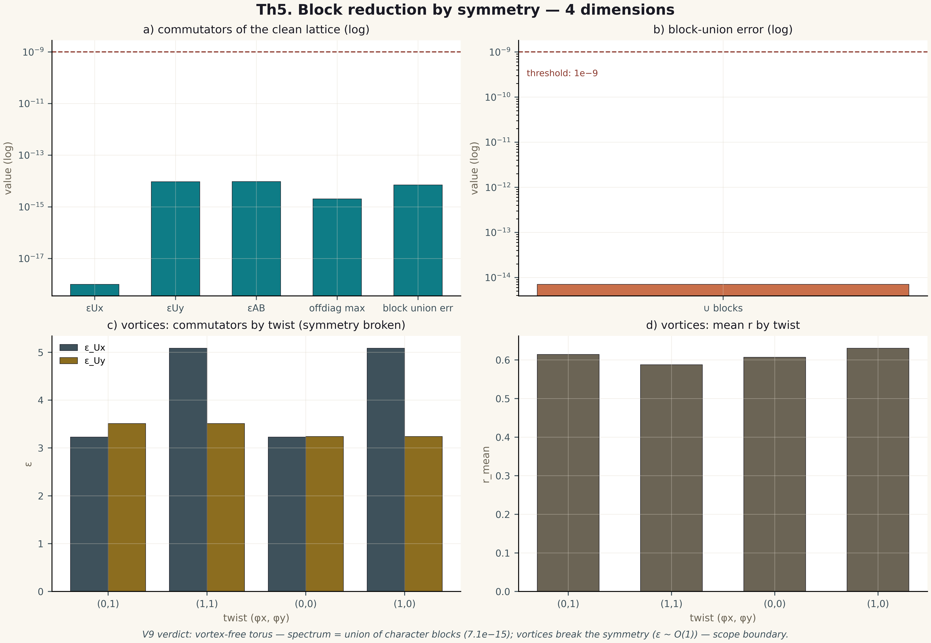
Fig. 1. Theorem Th5: four measurement dimensions — the metric, its behaviour across gates/instances, the control and the threshold (2×2 tile, 600 dpi, campaign verdict data).

