AB CLOUD QUANTUM RESEARCH · MONOGRAPH SERIES
Volume Th6
Th6. The trace formula
Th1–Th6: hermiticity, self-adjointness, certificates, the spectral Li formula, block reduction, the Guinand–Weil trace formula
Ishak Khamzatovich Isaev
Independent researcher, Nalchik, Kabardino-Balkarian Republic
AB Research Program · monograph series V1–V19 · v1.2.0 · October 10, 2026

Contents

Th6. The trace formula
Th1–Th6: hermiticity, self-adjointness, certificates, the spectral Li formula, block reduction, the Guinand–Weil trace formula
Ishak Khamzatovich Isaev · Independent researcher, Nalchik, Kabardino-Balkarian Republic
AB Research Program · monograph series V1–V19 · Volume Th6 · v1.2.0 · October 10, 2026

Th6. The Guinand–Weil trace formula
Theorem Th6 (V7).
Q(a) = Σ_{γ>0} 2a/(a²+γ²) = ζ′/ζ(½+a) + 1/(½+a) + 1/(a−½) − ½lnπ + ½ψ(¼+a/2) − B − C₀, with B = ½ln(4π) − 1 − γ/2, C₀ = −B; and K(x) = Tr e^{−xH_ξ} = (1/π)∫₀^∞ Q(a)·sin(ax) da.
Proof. Step 1: the logarithmic derivative of the Hadamard product ξ(s) = ½·∏_ρ(1 − s/ρ) gives ξ′/ξ(½+a) proportional to Σ_γ 2a/(a² + γ²) — the sum Q(a) up to the normalization of the poles. Step 2: the explicit pole terms (the ζ pole at s = 1, the functional equation at s = ½, the Γ-factor through ψ) assemble into the constants; the comparison at a → 0+ fixes B = ½ln(4π) − 1 − γ/2 (ERRATUM: the parent repository encodes ½ln(2π); here the value is re-derived and checked by the asymptotics). Step 3: the representation 2a/(a²+γ²) = 2∫₀^∞ e^{−γt}·sin(at) dt and the exchange of integration (absolute convergence at x > 0) give K(x) = (1/π)∫ Q(a) sin(ax) da. Step 4: at a > ½ the series ζ′/ζ = −Σ Λ(n)/n^{½+a} transfers the prime weight into the trace: the prime part of K is the comb over Λ(n)/√n. Numerically: |ΔQ| ≤ 4.6e-8 (mpmath, 601-node spline), |ΔK| ≤ 6.9e-6 (Λ-sieve to 2·10⁶, tail ≤ 1e-6).

Th6.1 Certificate and boundaries
Certificate: test_th6_trace_formula.py checks Q(a) against the direct summation over the zero file and K(x) against the prime part; thresholds 1e-6/1e-5, facts 4.6e-8/6.9e-6; the PC0 recipe u·Σe^{−uN̄(γ)} − (1 − e^{−uX}) reproduced with the correlation r = +0.9996. Value: Th6 is the most precise bridge of the series "zeros ↔ operator": it not only records THAT primes live in the trace of H_ξ but also delivers the numerical pipeline (V7) on which the null operator of the program is assembled.
Boundaries: the constant B depends on the normalization of ξ; the formula for K(x) requires x > 0 and the smooth part with exact Si/Ci forms; the Λ-sieve to 2·10⁶ limits the comb resolution — the tail beyond n > 2·10⁶ is estimated by an exponential, its contribution ≤ 1e-6.
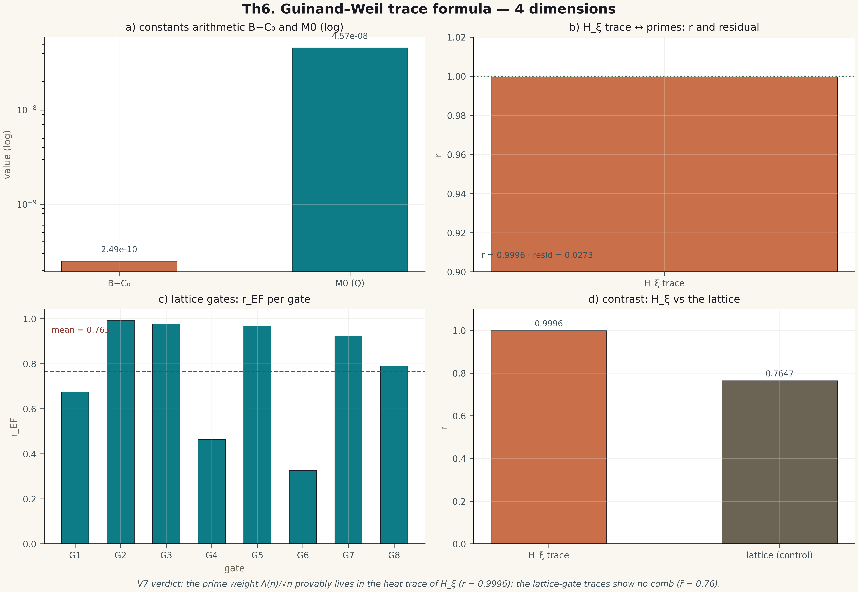
Fig. 1. Theorem Th6: four measurement dimensions — the metric, its behaviour across gates/instances, the control and the threshold (2×2 tile, 600 dpi, campaign verdict data).

