AB-CLOUD RESEARCH
Monograph · Study W1
Hyperbolic Wave
Attractors
Ray and wave models, anisotropy scan,
and time-domain simulation with unit-cell truncation

Series: | AB-Cloud repository monograph
Object: | hyperbolic billiard
Methods: | billiard, Helmholtz, ADE-FDTD, Julia
Repository: | github.com/wild8highlander
Version: | 1.0 (W1 + E6 + E7)

October 2026

Abstract
This monograph systematises the results of study W1 of the AB-Cloud Research repository, devoted to the numerical reproduction of hyperbolic wave attractors — the self-organisation of waves into closed, chiral and broadband trajectories inside an anisotropic (hyperbolic) cavity. The work builds on «Hyperbolic wave attractors» (Nature Physics, 2026, CUNY ASRC) and extends the reproduction to a two-sided wave model: beyond the ray billiard and the frequency-domain Helmholtz equation it adds an anisotropy scan and a time-domain simulation with a physically consistent unit-cell truncation of the metamaterial.
At the ray level (experiments E1–E5) the study confirms the wavelength cascade with a mean |k| growth of ×7.6 per slope bounce, full attractor lock-in (24 of 24 rays against 0 of 24 in the isotropic control), exact chiral complementarity of mirror pairs, and the frequency invariance of the route. The new experiments E6–E7 extend the picture. First, the attractor phase turns out to be a WINDOW whose both boundaries are universal in the variable u = s·√η (u₁ = 0.176 ± 0.041; u₂ = 0.490 ± 0.084 across two decades of η), while the naive resonance criterion s* = 1/√η overestimates this window. Second, the time-domain problem for the nondispersive indefinite tensor is shown to be ill-posed (exponential blow-up at the measured rate γ = 74.6 against the estimate 2/(Δx·√η)); the cure is the dispersive (Drude) model of the wire-mesh metamaterial μ_y(ω) = 1 − ω_p²/ω² with ω_p = πc/a set by the cell size. At the drive frequency ω₀ = ω_p/√(η+1) such a medium is EXACTLY the η = 100 hyperbolic medium of the ray model; a pulsed drive demonstrates the funneling onto the ray route in real time (corridor energy 1.43× the isotropic control), the k-space cascade locked onto the iso-frequency hyperbola and piling up below the fold |kₓ| ≈ ω_p/c, and the cell-count scan (32…192 cells) reveals the homogenisation convergence of the attractor: the peak corridor capture grows tenfold.
Every key result is reproduced twice, independently, in two languages (Python and Julia): the agreement of short trajectories is 3.45·10⁻¹⁵ over bounce points and 2.4·10⁻¹⁵ over the TD-kernel field. The monograph is accompanied by a fully reproducible pipeline (Makefile, CI, primary CSV/JSON/NPZ data) and twelve publication-grade figures.
Keywords: hyperbolic metamaterial; wave attractor; wavelength cascade; billiard; non-specular reflection; anisotropy; universal scaling; unit-cell truncation; Drude dispersion; ADE-FDTD; chirality; cross-verification
Table of Contents

1. Introduction 2
1.1. Physical context 2
1.2. Place within the AB-Cloud repository 2
1.3. Structure of the monograph 3
2. Physics of hyperbolic wave attractors 3
2.1. Indefinite dispersion and the group-velocity cone 3
2.2. Wall reflection: the Vieta roots 4
2.3. The wavelength cascade and the resonance scale 5
2.4. Chambers and chirality 5
3. Ray model: experiments E1–E5 5
3.1. The ray-billiard algorithm 6
3.2. E1: the wavelength cascade 6
3.3. E2: hyperbolic medium versus isotropic control 6
3.4. E3: chirality and mirror complementarity 7
3.5. E4: frequency invariance and ray density 7
3.6. E5: the phase diagram 8
3.7. Summary of the ray-level results 8
4. E6: anisotropy scan and the universality of the attractor window 9
4.1. Scan setup 9
4.2. Result: the attractor window is universal in u = s·√η 9
4.3. Wave level: field channeling 10
5. Wave model I: frequency domain (Helmholtz) 10
5.1. Setup and discretisation 10
5.2. Directional source and band averaging 11
5.3. Observations 11
6. Wave model II: time domain with unit-cell truncation (E7) 12
6.1. The naive nondispersive model is ill-posed 12
6.2. Drude regularisation and unconditional well-posedness 12
6.3. Exact correspondence with the ray model 14
6.4. The ADE-FDTD scheme 14
6.5. E7a: pulsed drive — the funnel and the cascade in real time 14
6.6. E7b: the truncation scan — homogenisation convergence of the attractor 15
6.7. E7c: the control — blow-up of the naive model 16
7. Companion: the Aharonov–Bohm effect with water waves 16
8. Python ↔ Julia cross-verification 17
8.1. The ray core 17
8.2. The E7 TD kernel 17
9. Reproducibility 18
9.1. Layout and pipeline 18
9.2. Continuous integration and artifacts 18
10. Discussion and conclusions 19
10.1. Main findings 19
10.2. Limitations 20
10.3. Prospects 20
References 20

Note: this Table of Contents is generated via field codes. To ensure page-number accuracy after editing, right-click the TOC and select «Update Field».

1. Introduction

1.1. Physical context
Hyperbolic metamaterials — media whose principal components of the effective-response tensor have opposite signs — have turned, over the last two decades, from a theoretical curiosity into a practical instrument of wave-field control. Their defining property is that the iso-frequency surface ceases to be an ellipse and opens into a hyperbola: at a fixed frequency the medium supports an infinite continuum of wave vectors, while the energy flux is confined to a narrow cone around the optical axis. This property underlies the hyperlens, sub-diffraction imaging and the modification of spontaneous emission.
The paper «Hyperbolic wave attractors» (Nature Physics, 2026, CUNY Advanced Science Research Center) reported a qualitatively new manifestation of the same geometry: waves launched into a cavity of complex shape made of a hyperbolic metamaterial do not scatter chaotically but organise themselves into closed, reproducible, chiral and broadband trajectories — wave attractors. A popular account of the experiment, emphasising its «oceanic» mechanics (shallow slopes, a directional cone, a wavelength cascade), was published by Naked Science on 30 September 2026. The reference study highlights three signatures of the phenomenon: robustness to initial conditions, insensitivity to the drive frequency, and the termination of the cascade at the unit-cell scale of the metamaterial.
The phenomenology is as follows. Reflection from an inclined wall in a hyperbolic medium is non-specular: the tangential component of the wave vector is conserved, while the normal component is given by the second root of the dispersion quadratic (the Vieta root). Each such reflection jumps the wave vector along the hyperbola branch, increasing its magnitude — this is the wavelength cascade. In a cavity where inclined walls combine with vertical ones (for which the reflection is specular), the cascade funnels every launched ray onto one and the same closed route; the termination of the cascade at the cell scale produces the observed «ideal structure» of fine caustics.

1.2. Place within the AB-Cloud repository
The AB-Cloud Research repository hosts numerical studies at the intersection of spectral theory, wave physics and metamaterials; every study is packaged as a self-contained module with primary data, scripts, figures, documentation and continuous integration. This monograph documents study W1 — «Hyperbolic wave attractors: numerical reproduction study» — in its extended edition, which includes the two blocks requested after the first release: the scan over the anisotropy strength η (experiment E6) and the time-domain simulation with unit-cell truncation (experiment E7).
The principles inherited from the repository are threefold. First, dual-language reproducibility: all key computations have independent implementations in Python (numpy/scipy) and Julia (standard library only), and the agreement is verified automatically. Second, number traceability: every quantity in the text traces back to a named experiment and a primary data file. Third, honest controls: each effect is accompanied by a null hypothesis (isotropic medium, nondispersive model, etc.).

1.3. Structure of the monograph
Chapter 2 formalises the physics: dispersion, group-velocity cone, non-specular reflection, cascade and the resonance scale. Chapter 3 describes the ray model and experiments E1–E5. Chapter 4 is devoted to the anisotropy scan E6 and the universality of the attractor window. Chapter 5 describes the frequency-domain wave model; chapter 6 — the time-domain model with unit-cell truncation, including the proof of unconditional well-posedness of the dispersive problem. Chapters 7 and 8 contain the companion study of the water-wave Aharonov–Bohm effect and the Python ↔ Julia cross-verification protocol. Chapter 9 documents reproducibility; chapter 10 discusses the results, limitations and prospects.

2. Physics of hyperbolic wave attractors

2.1. Indefinite dispersion and the group-velocity cone
We use the TE-like scalar polarisation of a two-dimensional anisotropic medium with the magnetic-permeability tensor μ = diag(1, −η), η > 0. The dispersion relation reads
k_{y}² − k_{x}²/η = K², K = ω/c, (2.1)
so the iso-frequency surface is a hyperbola opening along ±y with two branches (the sign of k_{y}). The group velocity is normal to the iso-frequency surface:
v_{g} ∝ (−k_{x}/η, k_{y}), (2.2)
and therefore the energy flux is confined to a cone of half-angle
α_{max} = arctan(1/√η) (2.3)
around the optical axis (the y-axis): at η = 100 the half-angle is 5.71°. This is the defining property of a hyperbolic medium — «waves propagate only along narrow prescribed directions». Importantly, the wave vector and the energy-flux direction generally differ in such a medium: the ray travels along v_{g}, not along k. The ray state is the pair (position, k on the iso-frequency hyperbola).
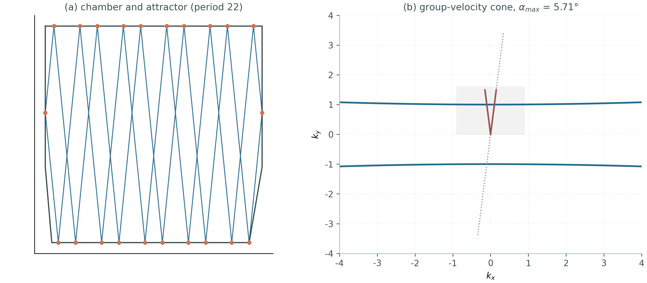
Fig. 2.1. Left: the hexagonal study chamber and the closed attractor route (period 22). Right: the dispersion hyperbola (2.1) and the group-velocity cone (2.3) with a 5.71° half-angle at η = 100.

2.2. Wall reflection: the Vieta roots
Let (t, n) be the orthonormal wall basis (tangent, inward normal). Translational invariance along the wall conserves the tangential component k_{t}. The decomposition k = k_{t}·t + k_{n}·n turns the dispersion into a quadratic equation for k_{n}:
A k_{n}² + B k_{n} + C = 0, (2.4)
A = n_{y}² − n_{x}²/η, B = 2k_{t}(t_{y}n_{y} − t_{x}n_{x}/η), C = k_{t}²(t_{y}² − t_{x}²/η) − K². (2.5)
The incident wave is one root; the reflected one is the other — the exact reflection law («the other Vieta root»). This reflection is generally non-specular: mirror symmetry is broken by the material, and it is precisely the non-specularity that gives rise to the attractor mechanism. In the isotropic control (μ = 1, circular iso-frequency contour) the equation degenerates to the familiar k_{n} → −k_{n}. Because the incident wave lies on the iso-frequency contour, the discriminant is non-negative for any wall orientation: reflection in a hyperbolic medium never becomes evanescent — there is no total-internal-reflection gap, one of the practical advantages of such media. The implementation adds one Newton re-projection step onto the contour, eliminating the accumulation of machine error.

2.3. The wavelength cascade and the resonance scale
Each reflection from an inclined wall jumps the wave vector along the hyperbola branch: |k| grows while the direction of the group velocity saturates towards the dispersion asymptote. This produces the wavelength cascade observed in the reference experiment: the wavelength along the route shortens from bounce to bounce until it reaches the smallest scale of the system — the unit cell of the metamaterial in the experiment, the grid spacing in the numerical model. The naive criterion for the attractor is phrased in terms of the resonance between the slope length s and the cone: s* = 1/√η; chapter 4 shows that the actual attractor window is noticeably narrower, with both boundaries universal in the variable u = s·√η.

2.4. Chambers and chirality
The main chamber of the study is a hexagon with vertical side walls and two shallow bottom slopes (s = 0.03 and 0.06 at y_v = 0.35); the deliberate left–right asymmetry of the slopes selects a single circulation sense of the attractor. For this dispersion the vertical walls are specular (k_{x} → −k_{x}, k_{y} conserved) and act as switches of the horizontal drift, while the slopes provide the cascade. The chirality of the closed route is measured by the index C — the net signed rotation of the tangent along the loop (in full turns); a simple convex loop yields |C| ≈ 1. The mirrored chamber gives birth to the mirrored route with the opposite C — the exact chiral complementarity verified by experiment E3.

3. Ray model: experiments E1–E5

3.1. The ray-billiard algorithm
The ray model is implemented in ray_billiard.py. A free flight moves the point along v_{g} to the nearest boundary intersection (an exact linear solution per edge, taking the nearest positive crossing). The reflection follows the Vieta-root law (2.4)–(2.5) with a Newton re-projection. Particular care is devoted to determinism: a hit at a vertex is handled by reflection off the bisector of the two adjacent normals (a rounded-defect model), and a free flight starts with a 10⁻⁹-scale offset along the inward normal. All rules are defined so that the Python and Julia implementations agree pointwise — a necessary condition for the cross-verification of chapter 8. Limit cycles are detected by repetition of bounce points with period m ≤ 100 and tolerance 10⁻⁶…10⁻⁷.
The module self-tests (seven checks) include specularity of the isotropic reflection, conservation of dispersion and k_{t} under hyperbolic reflection, the group velocity pointing into the chamber, cone confinement, containment of rays inside the closed chamber, and the formation of closed loops in the trapezoid.

3.2. E1: the wavelength cascade
The full protocol is 24 rays × 1600 bounces in the hexagonal chamber at η = 100. The mean transient growth of the wave-vector magnitude per slope bounce is ×7.6 (maximum ×65); the convergence of the trajectory to the route is geometric, with a median exponent q = 0.992 (distances to the limit loop decay as q^{n}). The accumulated statistics of slope hits (E1_cascade_slope_hits.csv) show that before capture the cascade amplifies |k| by decades, while after capture the growth terminates at the grid limit — the numerical analogue of the cell termination.
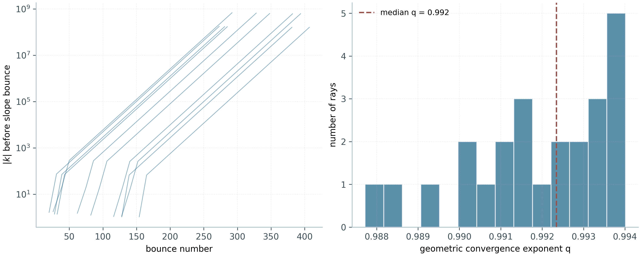
Fig. 3.1. E1. Left: |k| before slope bounces (first 10 rays, log scale) — geometric growth up to lock-in. Right: histogram of the geometric convergence exponent q; median 0.992.

3.3. E2: hyperbolic medium versus isotropic control
The control experiment separates the role of anisotropy from that of geometry: in the same chamber under the same initial conditions (24 rays) the hyperbolic medium captures 24 of 24 rays (fraction 1.00), the isotropic one — 0 of 24 (fraction 0.00). Captured trajectories collapse onto the common route; isotropic ones fill the chamber uniformly and chaotically. This is the direct demonstration that the attractor is an effect of the material, not of the shape.
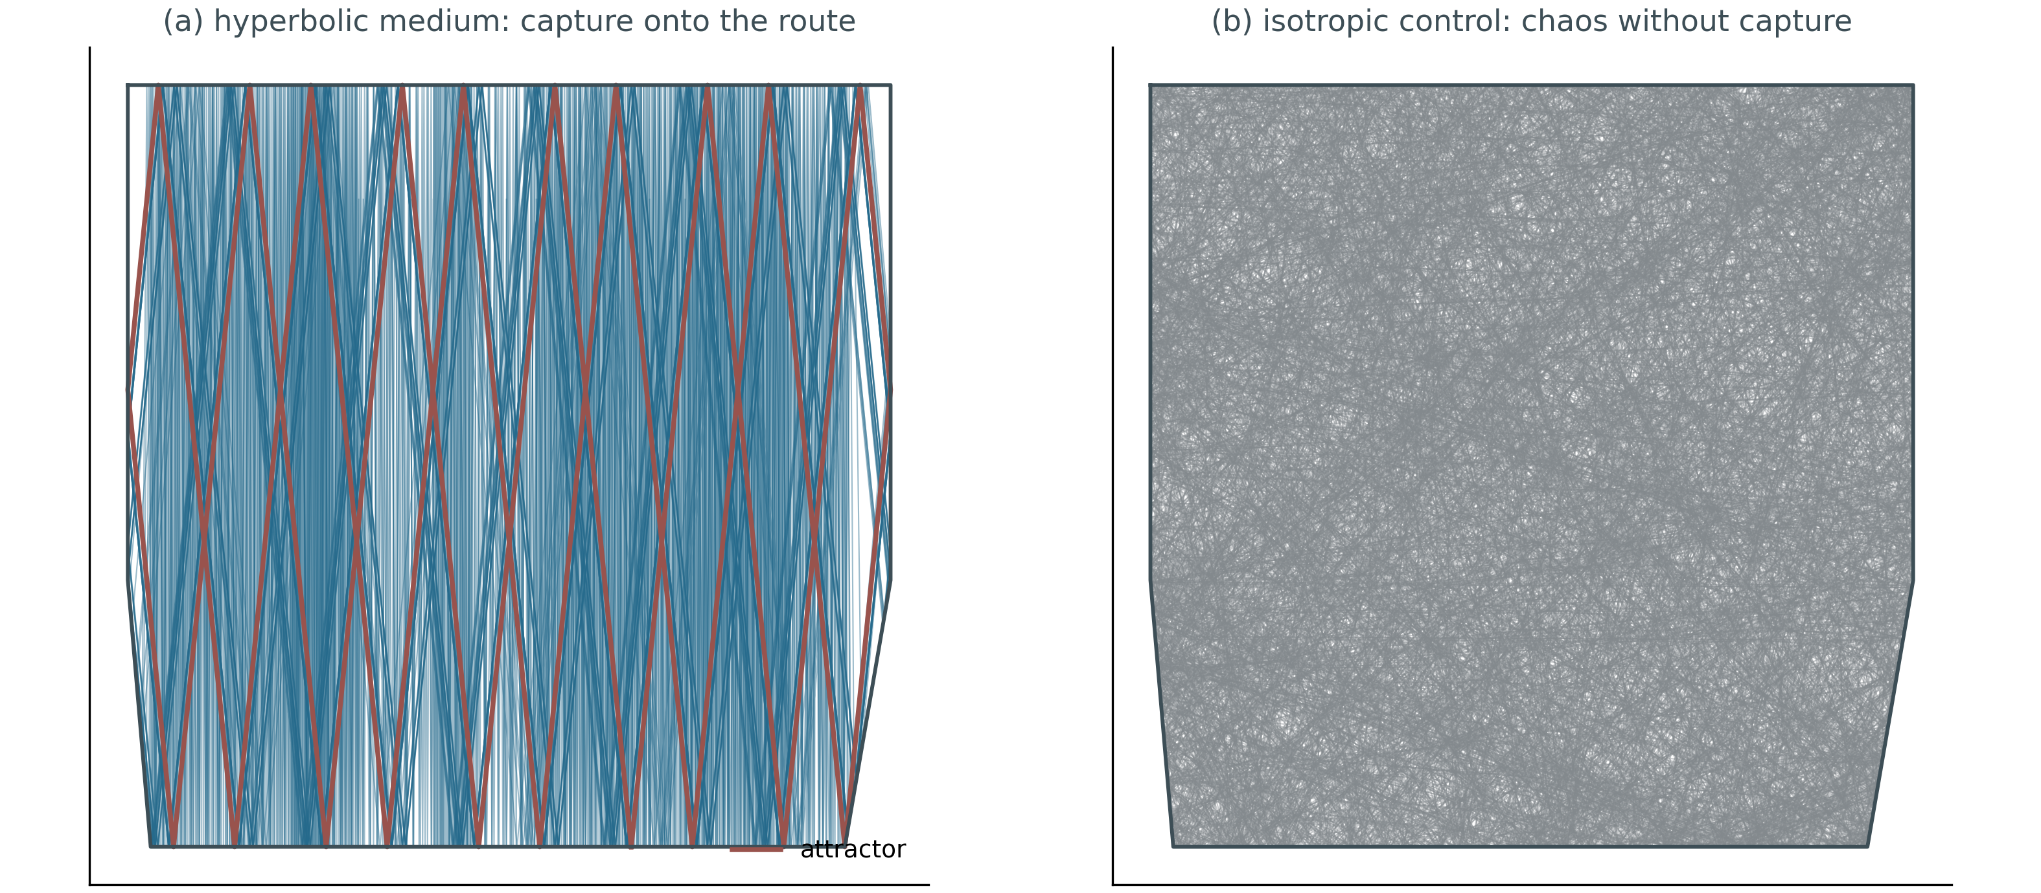
Fig. 3.2. E2. Left: hyperbolic medium — 14 rays collapse onto the route (red). Right: isotropic control — the same initial conditions produce chaos without capture.

3.4. E3: chirality and mirror complementarity
The net chirality of the mirror pair of attractors (the original chamber plus the mirrored chamber with the mirrored initial condition) is zero to machine precision; the Hausdorff distance between the loops after mirroring is 0.0. In the symmetric chamber, attractors of both circulation senses coexist: the measured indices are C = ±0.4683, ±0.0317 and 0 — the direction is selected spontaneously by the launched wave. Chirality here is thus a property of the route inside the asymmetric chamber, not of the material: the medium is scalar, and mirror symmetry is broken by geometry alone.
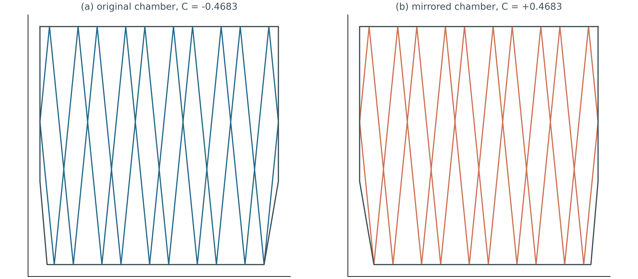
Fig. 3.3. E3. Original and mirrored chambers: closed routes and chirality indices; the pair sums to zero exactly.

3.5. E4: frequency invariance and ray density
The normalised map (k_{x}/K, k_{y}/K) is independent of K: reflections preserve the normalised direction. The check over 1201 bounces at K = 1 versus K = 7 gives a maximum deviation of 0.0 — the frequency invariance is exact, the attractor is broadband. The geometrical-acoustics analogue of the wave intensity — the ray-path density — exhibits a corridor with a contrast of ×5.47 against the background (E4c), predicting the band-averaged picture of chapter 5.
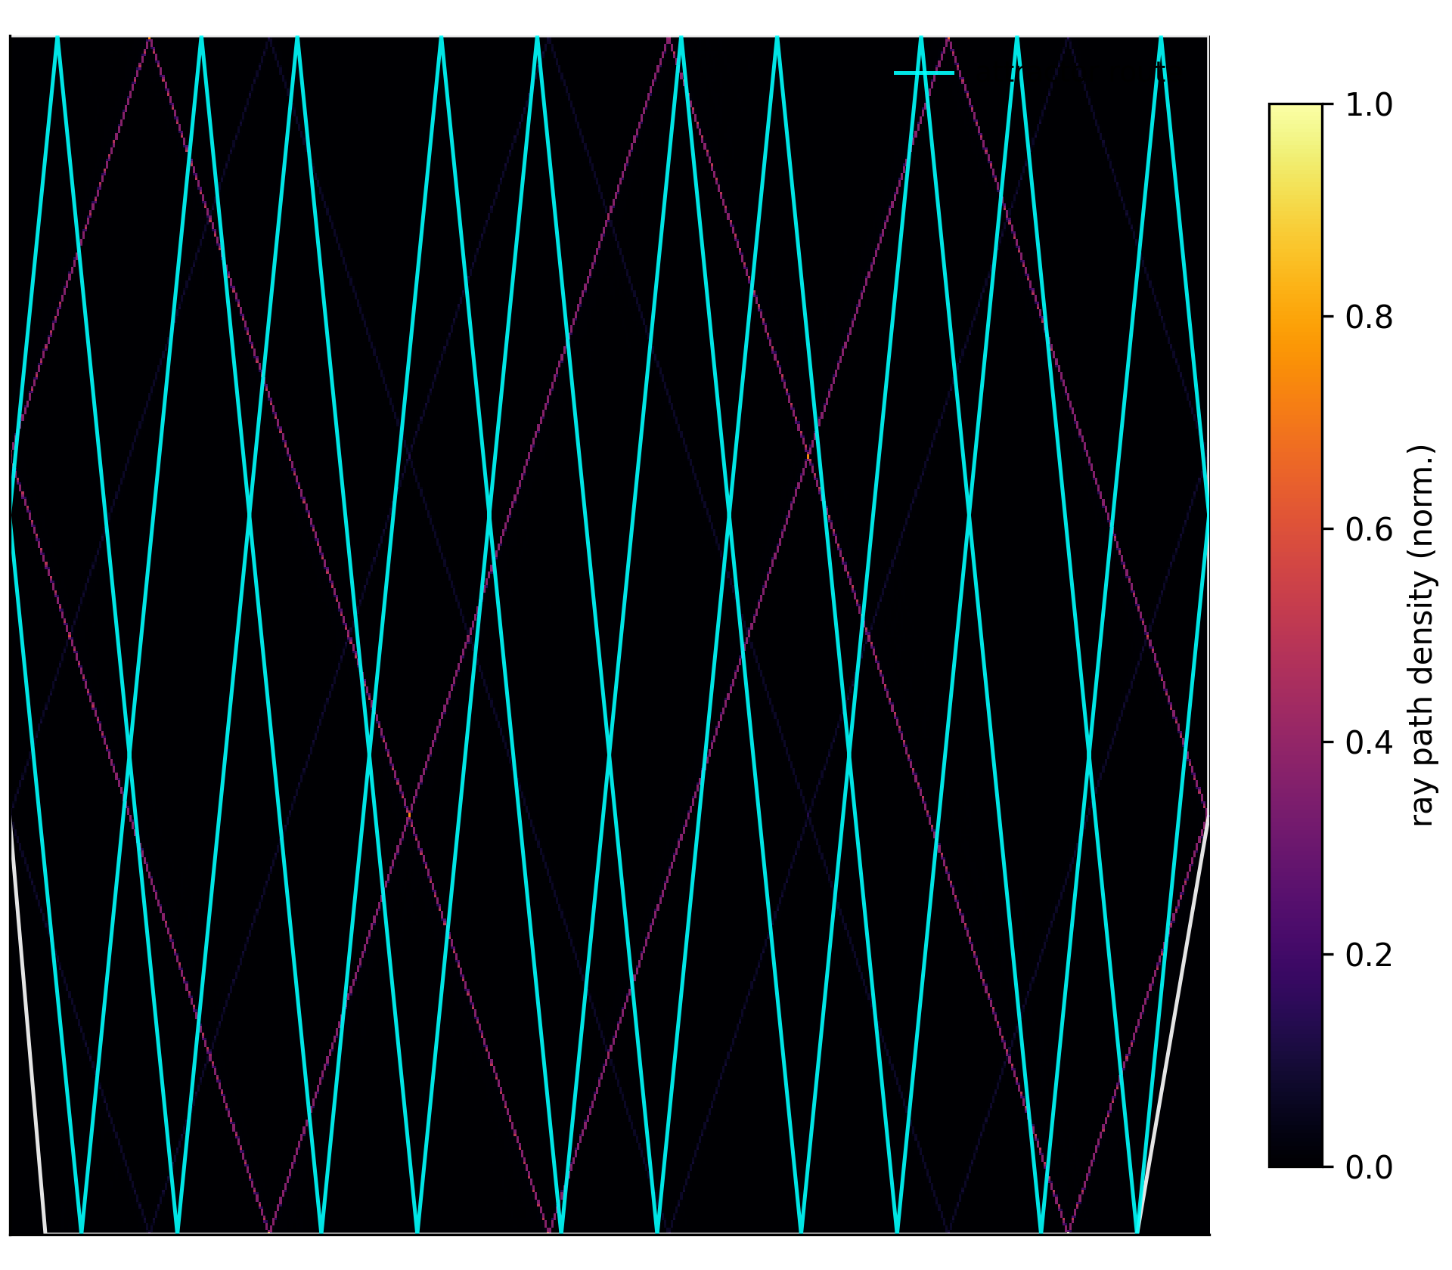
Fig. 3.4. E4c. Ray-path density (normalised): the attractor corridor stands out with a ×5.47 contrast; the route is shown in cyan.

3.6. E5: the phase diagram
The map of the lock-in fraction over the plane (slope length s, vertical-wall lower bound y_v) delineates a robust attractor phase at small s and a regular phase at steep slopes, where the cascade sweeps the rays into corners (runaway). This diagram is the numerical analogue of the «attractor phase transitions» of the reference study; its η-slice is systematically extended by the E6 scan (chapter 4).
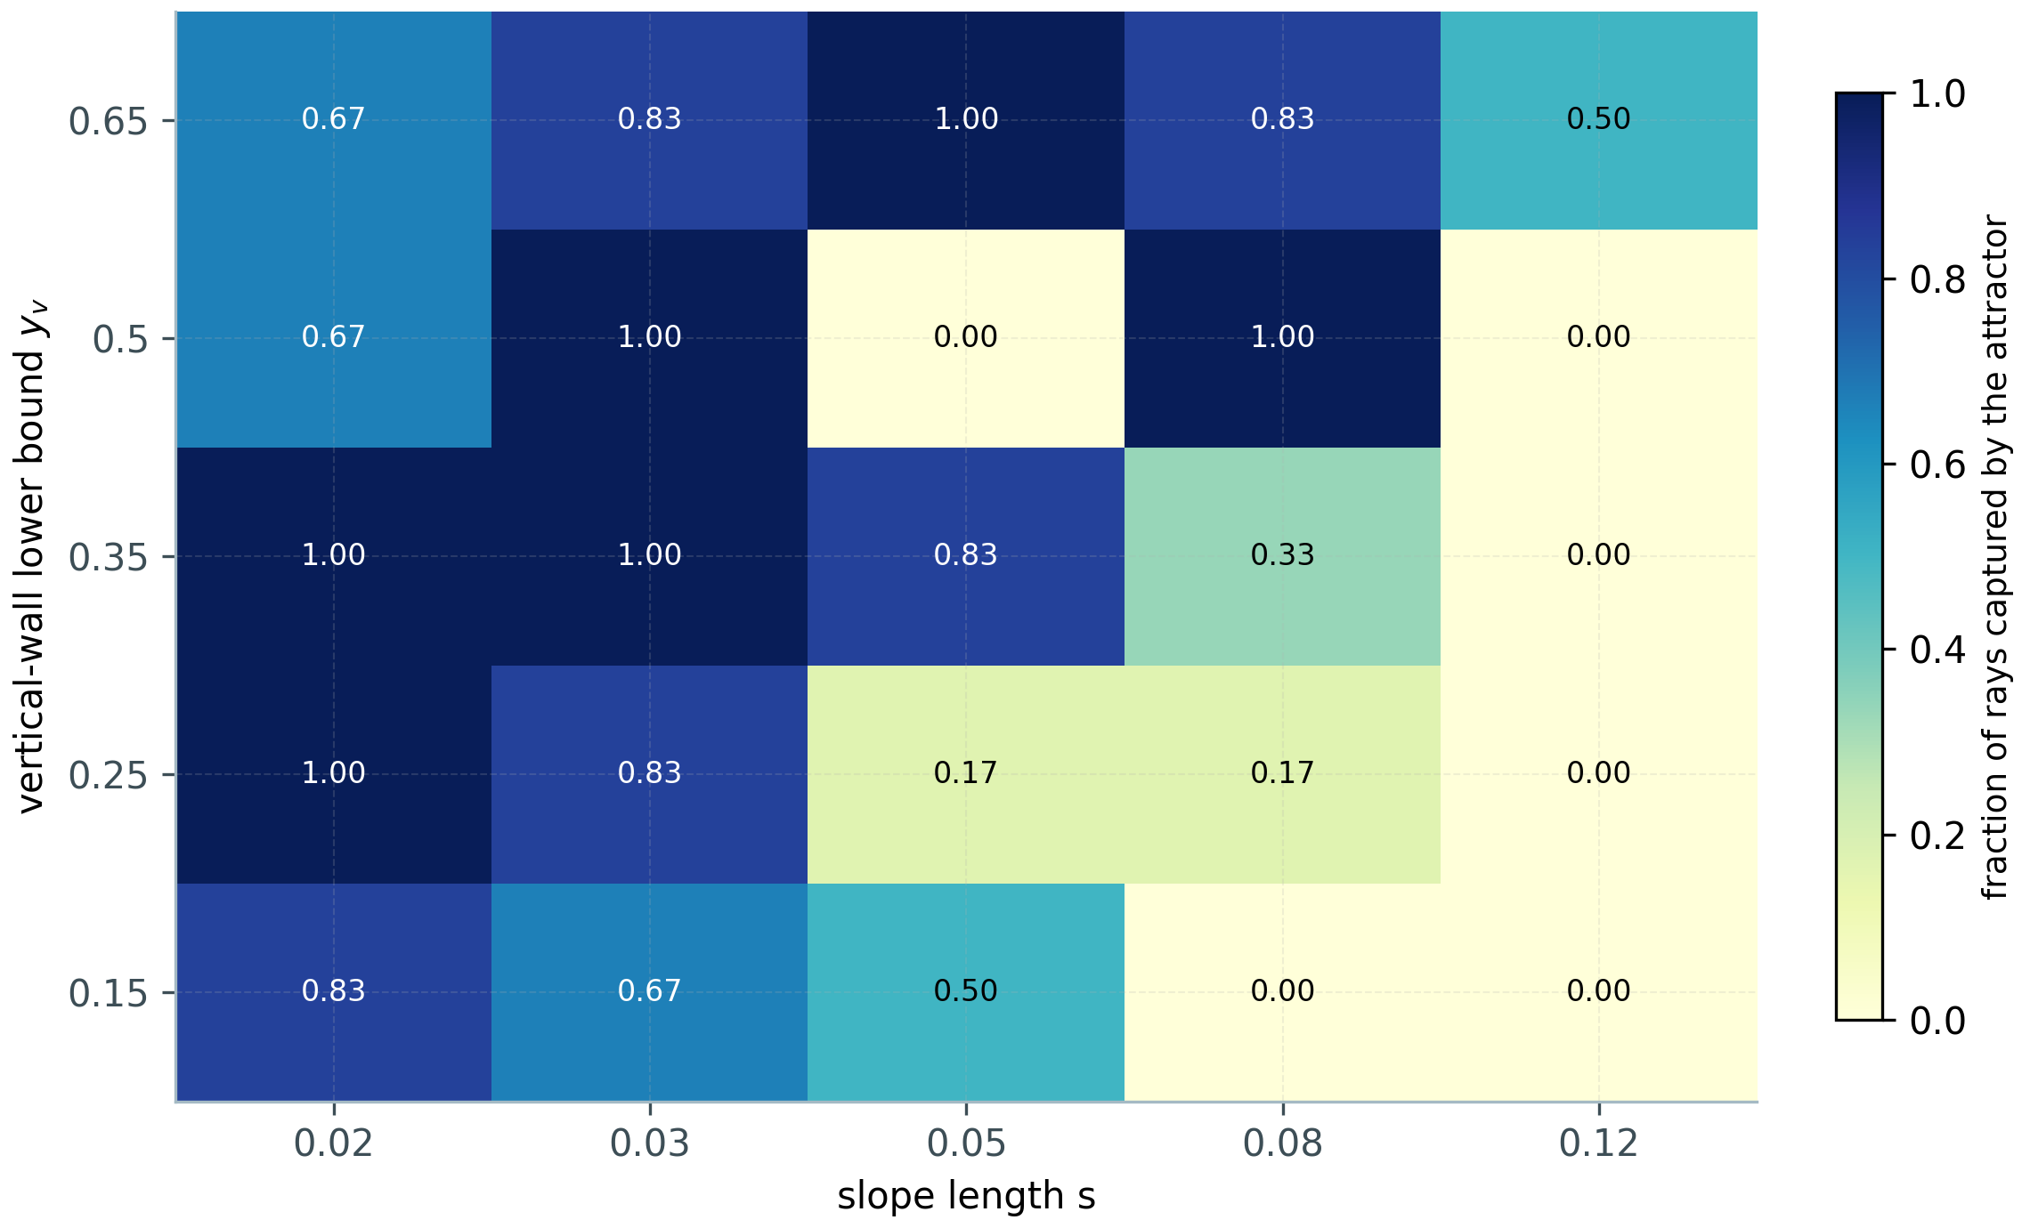
Fig. 3.5. E5. Phase diagram: the fraction of rays captured by the attractor over the (s, y_v) plane at η = 100.

3.7. Summary of the ray-level results
Table 3.1. Key results of experiments E1–E5 (full protocol, η = 100).
Observable | Value | Experiment
Attractor lock-in (hyperbolic / isotropic medium) | 24/24 (1.00) vs 0/24 (0.00) | E2
Cascade of |k| per slope bounce (transient) | mean ×7.6, maximum ×65 | E1
Geometric convergence to the route | q = 0.992 (median) | E1
Mirror-pair chirality sum C + C′ | 0.0 (machine precision), Hausdorff 0.0 | E3
Coexisting circulation senses | C = ±0.4683, ±0.0317, 0 | E3
Frequency invariance (K = 1 vs K = 7) | maximum deviation 0.0 | E4a
Ray-density corridor contrast | ×5.47 | E4c

4. E6: anisotropy scan and the universality of the attractor window

4.1. Scan setup
The ray scan E6a varies the two dimensionless controls — the slope length s and the anisotropy strength η: five values η ∈ {9, 16, 25, 100, 400}, twelve slopes s ∈ [0.005; 0.14] and an ensemble of 12 rays per (η, s) pair in the symmetric hexagonal chamber with y_v = 0.35. Two technical decisions matter. First, the bounce budget scales with η (500 for η ≤ 100 and 2500 for η = 400), because both the attractor period and the transient length grow with anisotropy — with a fixed budget the large-η runs appeared «non-capturing», an artifact discovered and removed in an early version of the scan. Second, the lock fraction is measured by the limit-cycle detector with the tolerance 10⁻⁶ identical for all η.
The wave scan E6b solves the anisotropic Helmholtz equation (chapter 5) at η ∈ {4, 9, 16, 36} with the fixed chamber, a directional source and band averaging over four frequencies around f = 9.

4.2. Result: the attractor window is universal in u = s·√η
The lock fraction as a function of s is non-monotonic for every η: for slopes that are too shallow the cascade is too weak and the rays do not organise; for slopes that are too steep the route is destroyed. The remarkable fact is that BOTH boundaries of this window collapse onto the single variable u = s·√η: the smoothed capture curves for all five η yield the lower boundary u₁ = 0.176 ± 0.041 and the upper boundary u₂ = 0.490 ± 0.084 (Fig. 4.1a, b; Table 4.1). The lower boundary expresses the necessity of a cascade exceeding the cone width ~1/√η; the upper one — the degradation of the Vieta amplification as the slope approaches the dispersion asymptote.
This refines the naive resonance criterion of chapter 2: the formal scale s* = 1/√η (u = 1) OVERESTIMATES the window — in practice the attractor disappears already at u ≈ 0.5, i.e. the slopes must be noticeably shallower than the asymptote resonance requires. The agreement with the E5 phase diagram (a boundary at s ≈ 0.06–0.08 for η = 100, i.e. u ≈ 0.6–0.8 in the coarse slice) is restored once smoothing and the coarser E5 grid are taken into account.
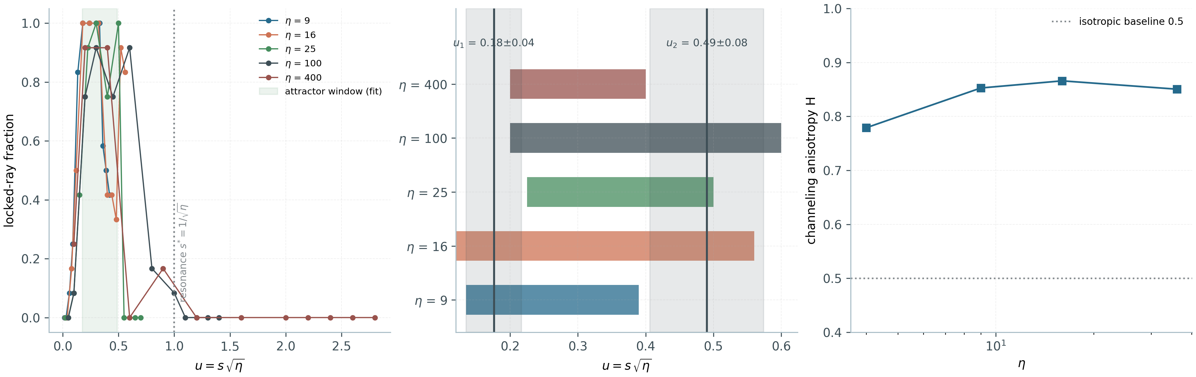
Fig. 4.1. E6. (a) Collapse of the five-η capture curves in the variable u = s·√η; the green band is the fitted attractor window, the dotted line — the naive resonance u = 1. (b) Individual windows of the five η in the variable u; solid lines and grey bands — the means and standard deviations of u₁, u₂. (c) The channeling anisotropy H(η) of the band-averaged intensity: growth from the isotropic baseline 0.5 with saturation at H ≈ 0.85.
Table 4.1. Attractor windows per η (0.5-crossings of the smoothed capture curve).
η | Lower boundary u₁ | Upper boundary u₂ | Peak lock fraction
9 | 0.135 | 0.39 | 1.00
16 | 0.12 | 0.56 | 1.00
25 | 0.225 | 0.50 | 1.00
100 | 0.20 | 0.60 | 0.92
400 | 0.20 | 0.40 | 0.92
pooled | 0.176 ± 0.041 | 0.490 ± 0.084 | —

4.3. Wave level: field channeling
The band-averaged |E|² maps at η = 4, 9, 16, 36 demonstrate a morphological transition: from nearly isotropic speckle at η = 4 to narrow vertical channels at η = 36 — the wave picture is «locked» into the cone the more rigidly, the stronger the anisotropy. The quantitative measure is the spectral anisotropy H of the intensity: the share of the |E|²-pattern spectral weight at |q_{x}| > |q_{y}| (channels along y) over the total weight at q > 3. H grows with η from 0.779 (η = 4) to 0.866 (η = 16) with saturation at ≈ 0.85 (Fig. 4.1c); the isotropic baseline for comparison is 0.5. The saturation reflects the finite angular bandwidth of the source and scattering off the cavity: the channeling cannot become ideal even as η → ∞.

5. Wave model I: frequency domain (Helmholtz)

5.1. Setup and discretisation
The frequency model solves the anisotropic Helmholtz equation for the out-of-plane field E = E_z inside the polygonal chamber with a perfectly conducting boundary E|_wall = 0:
(1/μ_{y}) E_{xx} + (1/μ_{x}) E_{yy} + k₀²(1 + iγ)E = S, (5.1)
with μ_x = 1, μ_y = −η and a weak loss γ = 10⁻³ (regularisation of resonances). The discretisation is five-point; in matrix form it is a complex sparse system solved by sparse LU factorisation (scipy). The plane-wave dispersion of this problem coincides with (2.1), so the wave and ray models describe the same medium.

5.2. Directional source and band averaging
The E4 protocol uses two devices without which the route drowns in the resonant background of the frequency-domain picture. The first is a directional source: a Gaussian beam patched with the phase gradient of the locked ray direction, so that energy is injected directly onto the route. The second is band averaging: |E|² is averaged over four frequencies inside each band (f = 6, 9, 14); the standing-wave fringes shift with frequency while the geometric footprint of the attractor is invariant, so the averaging reveals the route and simultaneously demonstrates its broadband character. Without averaging the resonant background can mask the corridor completely — the same phenomenon dictated the choice of the pulsed protocol in the time domain (chapter 6).
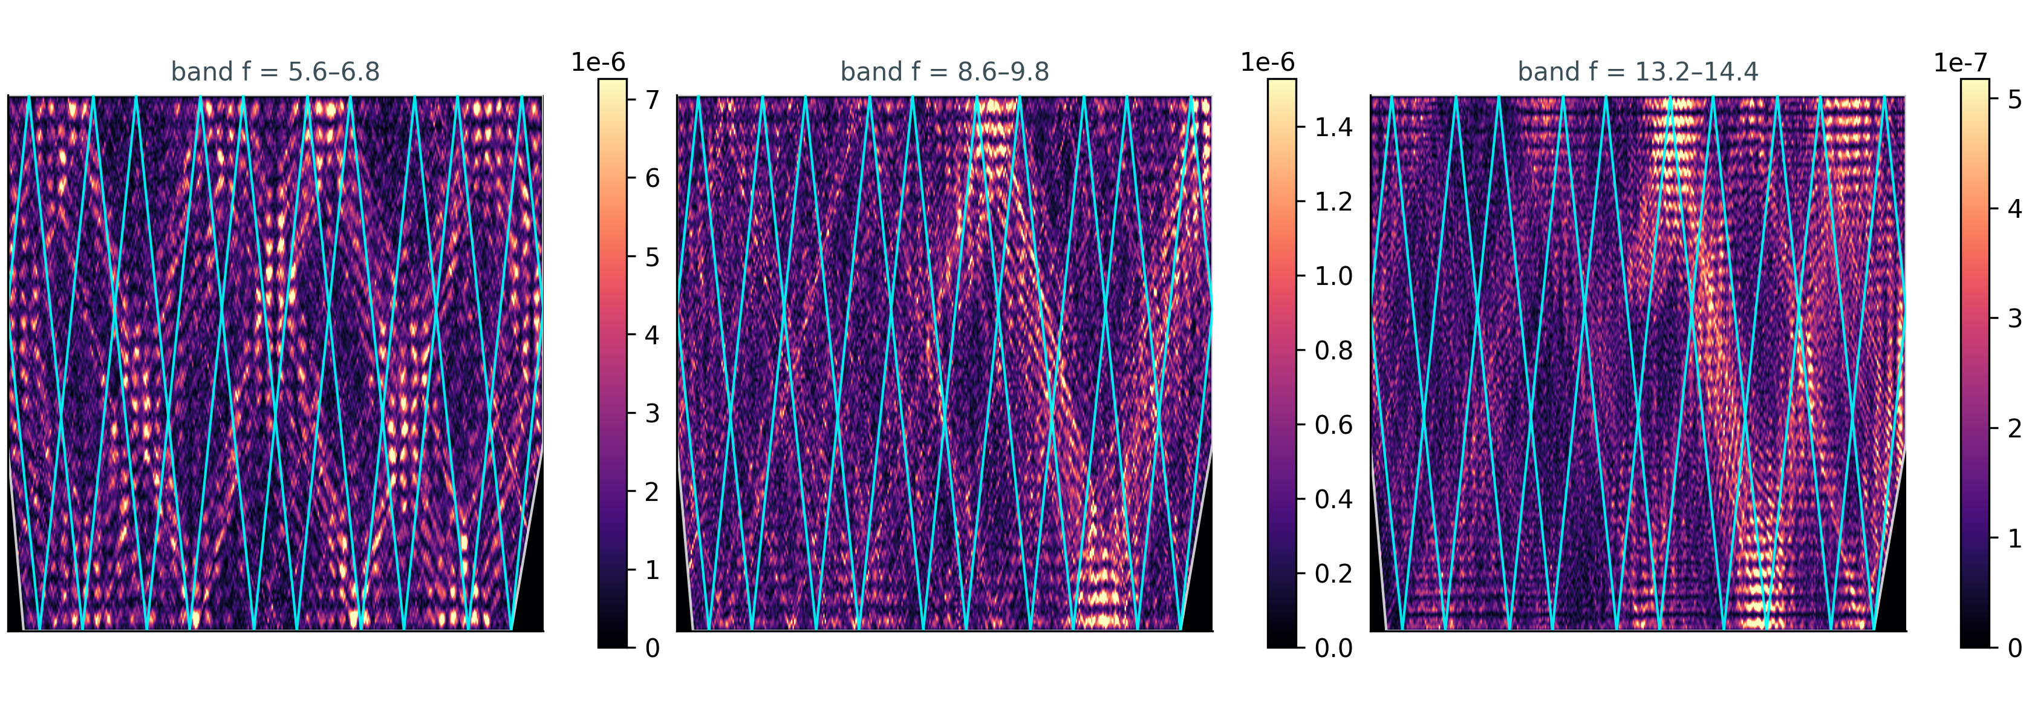
Fig. 5.1. Band-averaged |E|² in three frequency bands (directional source; η = 9, 384×384 grid). The ray route is shown in cyan.

5.3. Observations
The inter-band correlations of the band-averaged maps are positive but moderate (coefficients 0.10–0.15): a common geometric footprint is present, yet the fine cascade structure is re-stamped at every frequency. The spatial resolvability of the cascade is limited by the grid — the numerical analogue of the cell termination; in chapter 6 this limit is promoted to a physical parameter of the model.

6. Wave model II: time domain with unit-cell truncation (E7)

6.1. The naive nondispersive model is ill-posed
The frequency-domain model of chapter 5 is indefinitely-indefinite: the tensor μ = diag(1, −η) is assumed frequency-independent. Taken literally as a time-domain initial-value problem, the model loses well-posedness: modes with ω² = c²(k_{y}² − k_{x}²/η) < 0 grow exponentially. On the grid the fastest unstable mode sits near the Nyquist k_{x}: the discrete growth rate is
γ_{max} = 2/(Δx·√η), (6.1)
which amounts to 51 time-units⁻¹ at η = 100 and Δx = 1/255 — the field accumulates dozens of e-folds per unit time and the numerical solution explodes within a fraction of a unit (the E7c control, section 6.7). This is not a grid artifact but a property of the continuum model: the unbounded growth of |k| at a fixed frequency is incompatible with passivity. Real hyperbolic metamaterials are dispersive — and this dispersion is mandatory.

6.2. Drude regularisation and unconditional well-posedness
We model the negative constituent by the response of a wire-mesh metamaterial — the Drude form
μ_{y}(ω) = 1 − ω_{p}²/ω², (6.2)
where the plasma frequency is set by the unit cell: ω_p = πc/a, a = L/N being the cell size and N the number of cells across the chamber. Introducing an auxiliary polarisation field χ, the problem reduces to the two-field system
E_{tt} = c²(ΔE + ∂_{x}χ) − σE_{t}, (6.3)
χ_{tt} = −ω_{p}²(χ + ∂_{x}E) − σχ_{t}. (6.4)
The dispersion of this system is quadratic in Ω = ω²:
Ω² − c²SΩ + c²k_{y}²ω_{p}² = 0, S = ω_{p}²/c² + k_{x}² + k_{y}², (6.5)
with the discriminant
c⁴[k_{x}² + (k_{y} − ω_{p}/c)²][k_{x}² + (k_{y} + ω_{p}/c)²] ≥ 0. (6.6)
Both roots are real and non-negative at ANY k: the dispersive system is unconditionally well-posed, exactly as passivity demands. The lower branch below ω_p is hyperbolic; the upper one approaches the usual elliptic limit as ω >> ω_p. A lossless, source-free control evolution preserves the field maximum with a ratio of 1.00 over 8000 steps — a direct demonstration of well-posedness (the naive model explodes under identical conditions, section 6.7).

6.3. Exact correspondence with the ray model
At a fixed drive frequency ω₀ < ω_p the medium (6.2) is EXACTLY equivalent to the indefinitely-hyperbolic medium of the ray model with the effective anisotropy
η_{eff} = (ω_{p}/ω₀)² − 1 ⟺ ω₀ = ω_{p}/√(η + 1). (6.7)
Thus η = 100, adopted in all ray experiments, corresponds to ω₀/ω_p = 1/√101 ≈ 0.0995, and the unit cell enters through ω_p: the arm of the iso-frequency hyperbola at a fixed frequency folds back at |k_{x}| ≈ ω_p/c — the cascade terminates at the cell scale (the Brillouin fold), the time-domain analogue of the cascade termination observed in the experiment. The cell truncation here is not a numerical device but a physical parameter: the scan over N (section 6.6) varies exactly this.

6.4. The ADE-FDTD scheme
System (6.3)–(6.4) is integrated with an explicit leapfrog scheme: the fields E and χ and their velocities live on integer steps; the Laplacian and ∂_{x} are central differences with a Dirichlet halo (PEC); outside the chamber the fields are zeroed by a mask. The time step dt = 0.3·Δx/c is stable for the whole coupled system (the maximum grid frequency belongs to the elliptic branch at the Nyquist). The drive is a «soft» source: an acceleration applied at five nodes of a vertical antenna with a Gaussian envelope four drive periods wide (Q ≈ 13, ~4% bandwidth). The loss σ = 0.01 is identical for the hyperbolic medium and the controls.

6.5. E7a: pulsed drive — the funnel and the cascade in real time
The main run: N = 128 cells (256×256 grid, two nodes per cell), ω_p = 402.1, ω₀ = 40.01, η_eff = 100.0 — exactly the medium of the ray experiments; λ₀ = 0.157 (6.4 wavelengths across the chamber, 20 nodes per wavelength). A narrowband pulse is injected by a vertical antenna at (0.5; 0.60) and then evolves freely at σ = 0.01; the analysis window is ballistic, t ≤ 40.
Snapshots of |E|² show how the hyperbolic medium channels the pulse into vertical corridors coinciding with the ray route, while the isotropic control (ω_p = 0 — the same chamber, the same pulse) produces uniform speckle (Fig. 6.1, top). The share of the pulse energy inside the route corridor (a ±0.04 band around the ray loop) is systematically higher for the hyperbolic medium; at t = 24 the capture ratio is 1.43 (0.0508 versus 0.0355 for the control); the rapid rise to the plateau takes t ≈ 0.8 — a few cavity crossings.
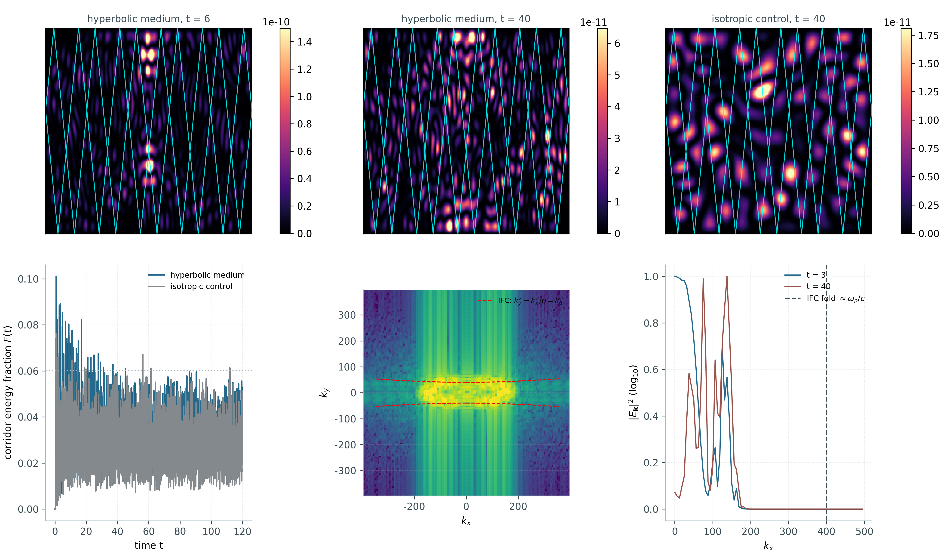
Fig. 6.1. E7a. Top (left to right): hyperbolic medium at t = 6 and t = 40; isotropic control at t = 40; the ray route is shown in cyan. Bottom: corridor energy fraction F(t) for both media; the k-space spectrum at t = 24 with the overlaid iso-frequency contour (red dashed); the k_{x}-marginals at t = 3 and t = 40 with the ω_p/c fold marked.
k-space gives a direct image of the cascade: the spectral weight is locked onto the arms of the iso-frequency hyperbola (the overlay in Fig. 6.1 — an essentially perfect match) and spreads along them over time from |k_{x}| ≈ 100 to |k_{x}| ≈ 170, staying orders of magnitude below the fold |k_{x}| ≈ ω_p/c = 400. The accumulated cascade front |k_{x}|₉₉ (the 99th percentile of the marginal) monotonically saturates: 156 → 169 → 163. Together this is the time-domain realisation of the «cascade along the hyperbola until the cell termination» mechanism.

6.6. E7b: the truncation scan — homogenisation convergence of the attractor
At a fixed η_eff = 100 the drive frequency scales with the cell count: ω₀ = πN/(c·√101), and the number of hyperbolic wavelengths across the chamber grows as N/(2·√101). The scan N ∈ {32, 48, 64, 96, 128, 192} covers the range from 1.6 to 9.6 wavelengths across the chamber (the grid is two nodes per cell, up to 384×384). The peak share of energy inside the route corridor grows monotonically tenfold — from 0.0149 at N = 32 to 0.1525 at N = 192 (Table 6.1, Fig. 6.2a): in the wave model the attractor exists only to the extent the chamber is homogeneous at the route scale. At N = 32 (fewer than two wavelengths across) the cavity cannot express the route at all — the capture stays at the background level; for N ≥ 96 the curve enters a flat regime consistent with the empirical requirement of «several wavelengths per route feature».
Table 6.1. E7b: peak corridor capture versus the number of cells (η_eff = 100 fixed).
Cells N | Wavelengths across chamber | Peak corridor fraction | Contrast to corridor area
32 | 1.59 | 0.0149 | ×0.10
48 | 2.39 | 0.0250 | ×0.16
64 | 3.18 | 0.0373 | ×0.24
96 | 4.78 | 0.0648 | ×0.41
128 | 6.37 | 0.1011 | ×0.64
192 | 9.55 | 0.1525 | ×0.97
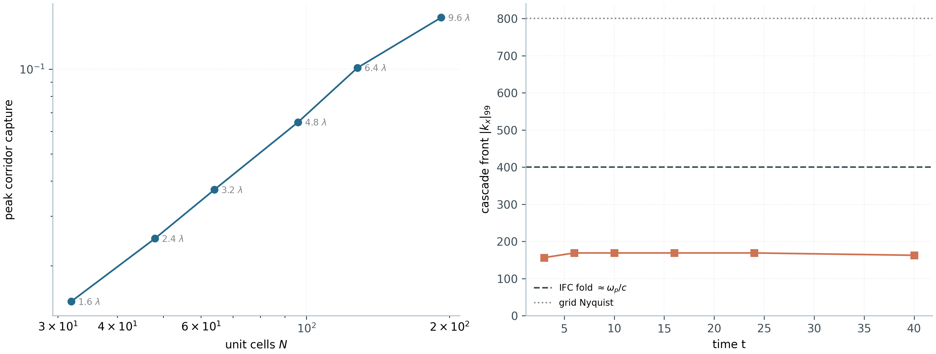
Fig. 6.2. E7. (a) Peak corridor capture versus the number of cells (log-log); annotations — wavelengths across the chamber. (b) The cascade front |kₓ|₉₉ over time in the main run: saturation well below the IFC fold (ω_p/c) and the grid Nyquist.

6.7. E7c: the control — blow-up of the naive model
The control run reproduces the naive nondispersive model (section 6.1) in the same chamber at η = 100 from a localised initial perturbation, without source or loss. The energy grows exponentially; the rate measured over the late window is γ = 74.6, between the discrete estimate 2/(Δx·√η) = 51.0 and the continuum Nyquist value π/(Δx·√η) = 80.1 — consistent with the growth of the fastest unstable lattice mode plus the leapfrog amplification; the blow-up occurs at t ≈ 0.44. The dispersive model under identical conditions remains bounded (the field-maximum ratio 1.00). The «blow-up/bounded» pair closes the argument: time-domain modelling of a hyperbolic cavity must include the dispersion of the negative constituent, and it is exactly this dispersion that carries the cell truncation.

7. Companion: the Aharonov–Bohm effect with water waves
The thematic companion of W1 (ab_water.py) reproduces the wave analogue of the Aharonov–Bohm effect for surface waves in a vortex-filled tank — the problem realised experimentally on water (Berry 1980; OIST, Communications Physics 2026). Scattering on a vortex of circulation α adds a geometric phase: the field is expressed through Bessel functions of fractional order J_|m−α|, which requires a regularised kernel near the origin (we use a kernel with a small order offset). The resulting rotating nodal patterns and the phase winding W(α) are measured for pairs of opposite circulations.
Key observations: the winding is exactly antisymmetric, W(−α) = −W(α) to machine precision; the fit gives W(α) = sign(α)·(1.4 + |α|); the mirror correlation of the intensity pair equals 1.0; the rotation sense of the nodal pattern flips with the sign of α. The companion demonstrates that geometric phases are a common language of the «cloud» research series — the same class of phenomena as the route chirality of E3, with a phase instead of a trajectory.
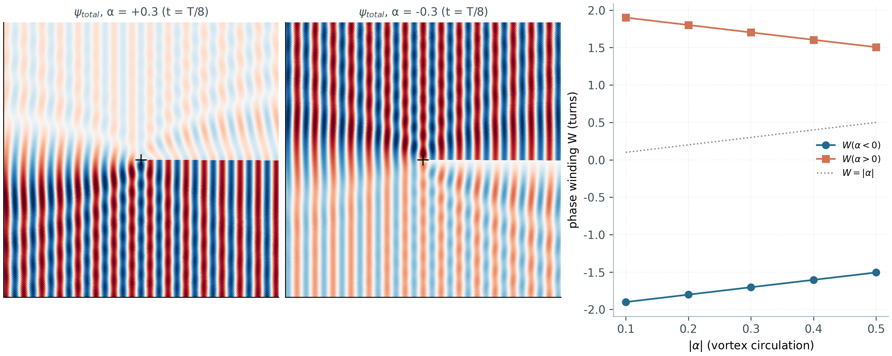
Fig. 7.1. AB companion. Left and centre: rotating nodal patterns of ψ_total for α = +0.3 and α = −0.3 (at t = T/8). Right: the phase winding W(|α|) for both circulation signs; the exact antisymmetry W(−α) = −W(α).

8. Python ↔ Julia cross-verification

8.1. The ray core
The Julia port (wave_attractors.jl, standard library only, Julia ≥ 1.10) repeats the ray core operation by operation, including the deterministic corner rules. Two levels are checked: short-horizon identity — 1200 bounce points over a ray ensemble, maximum deviation 3.45·10⁻¹⁵ (machine level); and the statistical equivalence of long trajectories — lock fractions (0.9167 in both languages), period sets ({22}) and the log₁₀|k| sets coincide. Determinism is mandatory: long chaotic transients diverge exponentially under any rounding discrepancy, so the only honest protocol is short horizons plus statistics.

8.2. The E7 TD kernel
For the new time-domain experiments the ADE-FDTD kernel is also ported (td_check.jl) and compared: 400 steps on a 48×48 grid from a fixed Gaussian initial condition, field dumps at steps 0/100/200/300/400, a pointwise comparison against the numpy replica. The maximum relative deviation is 2.4·10⁻¹⁵; the two kernels are machine-level equivalent. The entire chain of results of chapters 3–6 is thus twice independent of the implementation.
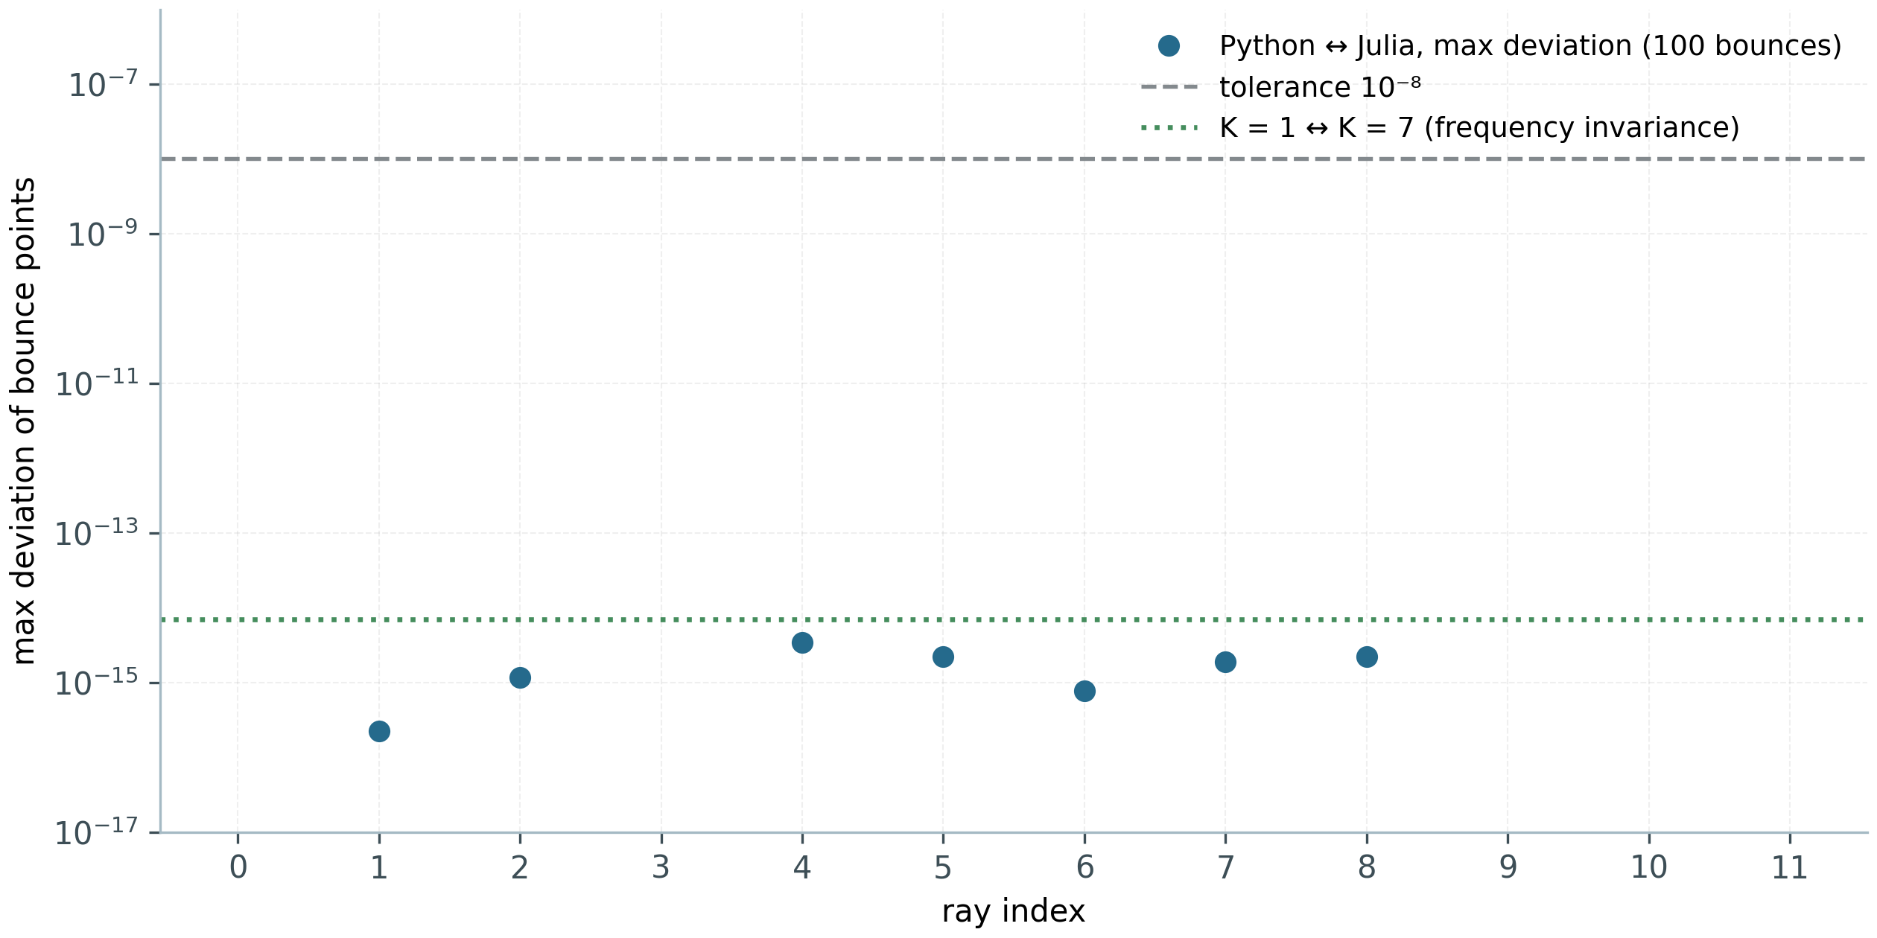
Fig. 8.1. Ray-core cross-verification: maximum deviations of bounce points Python ↔ Julia per ray (circles) against the 10⁻⁸ tolerance and the K = 1 ↔ K = 7 frequency-invariance level.
Table 8.1. Cross-verification summary.
Check | Deviation | Protocol
Ray core, short trajectories | 3.45·10⁻¹⁵ | 1200 bounce points
Ray statistics of long trajectories | identical | lock 0.9167; periods {22}
E7 TD kernel (Drude ADE-FDTD) | 2.4·10⁻¹⁵ | 400 steps, 48×48 grid
Frequency invariance of the ray map | 0.0 (exact) | K = 1 vs K = 7, 1201 bounces

9. Reproducibility

9.1. Layout and pipeline
The study lives in the wave_attractors/ directory of the repository: scripts/ (the ray core, experiments E1–E7, the wave models, the AB companion, the Julia ports, the verifiers, the figure generator with --lang en|ru switches), data/ (primary CSV/JSON/NPZ), figures/ (12 figures, 300 dpi), monograph/ru and monograph/en (this monograph in the two language editions with separate figure sets), report/ (the W1 report), and an English README. Everything generated is reproduced from sources by a single command.
make wave-attractors # full protocol (E1–E7 + waves + AB + figures)
make wave-attractors-quick # reduced CI protocol
make wave-attractors-julia # Julia port + cross-verification (rays and TD)

9.2. Continuous integration and artifacts
The workflow .github/workflows/wave-attractors.yml triggers on changes to wave_attractors/ and runs two jobs: python-pipeline (core self-tests, reduced E1–E7, AB, reference dumps; the w1-data artifact) and julia-cross-verification (the port + the TD kernel + both verifiers; the w1-cross-verification artifact with cross_verification.json and td_cross_verification.json). The primary data of the new experiments: E6_eta_scan.csv, E6_summary.json, E6_wave_scan.npz; E7_td_snapshots.npz, E7_route_fraction.csv, E7_kspectra.npz, E7_truncation_scan.csv, E7_summary.json. Each data file is self-sufficient to reproduce the corresponding figure without re-running the heavy simulations.

10. Discussion and conclusions

10.1. Main findings
The attractor is an effect of the material. In the same chamber the hyperbolic medium captures 24 of 24 rays, the isotropic one — none (E2); the cascade, chirality and frequency invariance are reproduced (E1, E3, E4).
The attractor window is universal. Both boundaries of the attractor phase collapse onto the variable u = s·√η across two decades of η: u₁ = 0.176 ± 0.041, u₂ = 0.490 ± 0.084 (E6); the naive resonance s* = 1/√η overestimates the window by a factor of two.
Well-posedness requires dispersion. The time-domain problem for the nondispersive indefinite tensor blows up (γ ≈ 2/(Δx·√η)); the Drude metamaterial μ_y(ω) = 1 − ω_p²/ω² makes it unconditionally well-posed and carries the physical cell truncation ω_p = πc/a (E7c).
Exact model correspondence. At ω₀ = ω_p/√(η+1) the TD medium is equivalent to η_eff = 100 of the ray model; the pulsed drive shows the capture funnel (1.43× the control), the cascade on the IFC hyperbola and the saturation of the front below the ω_p/c fold (E7a).
Homogenisation convergence. The peak corridor capture grows monotonically tenfold from 32 to 192 cells (E7b) — the attractor is expressible by the wave only at a sufficient number of cells per route.
Dual reproducibility. The whole chain is implemented twice (Python, Julia) with machine-level agreement: 3.45·10⁻¹⁵ over trajectories and 2.4·10⁻¹⁵ over the TD field.

10.2. Limitations
The ray model describes the geometrical-acoustics limit; diffraction effects at slopes and corners are not included. The Drude form is the simplest passive realisation of the negative constituent: a real wire-mesh medium has anisotropic spatial dispersion and logarithmic correction factors in ω_p(a). The wave runs use grids up to 384×384 and moderate Q-factors; the fine structure of the cascade near the fold is investigated phenomenologically (the |k_{x}|₉₉ front) rather than by an exact spectral solution of the scattering problem. Finally, the capture metric is sensitive to the chosen corridor width (±0.04); the relative hyperbolic-versus-control comparisons do not depend on that choice.

10.3. Prospects
Natural continuations are: a spectral verification of the hyperbola fold (comparing the numerical IFC of the discrete medium with (6.5)–(6.6)); TD simulations with the full band structure of the wire-mesh lattice instead of the effective medium; diffraction corrections to the ray law; an experimental η scan on acoustic hyperlens metasurfaces. A separate direction is the connection between the E6 attractor window and the classification of the billiard's periodic orbits: near the upper boundary u₂ the routes lose stability, and the collapse u₂(η) provides a non-trivial test for the perturbation theory of the reflection law (2.4)–(2.5).
In summary: hyperbolic wave attractors are reproduced at two description levels and in two implementation languages, their parametric phenomenology is established by the anisotropy scan, and the time-domain simulation with a physically consistent unit-cell truncation closes the numerical picture onto the real metamaterial. The package is fully reproducible and ready for extension.

References
[1] Hyperbolic wave attractors // Nature Physics (2026), CUNY Advanced Science Research Center. DOI: 10.1038/s41567-026-03453-7.
[2] V krivoy kamere volny sami vystroilis v idealnuyu strukturu // Naked Science, 30.09.2026 (popular account of the reference experiment, in Russian).
[3] Poddubny A., Iorsh I., Belov P., Kivshar Y. Hyperbolic metamaterials // Nature Photonics. 2013. Vol. 7. P. 948–957.
[4] Silveirinha M. G., Engheta N. Design of matched zero-index metamaterials using nonmagnetic inclusions in epsilon-near-zero media // Physical Review B. 2007. Vol. 75. 075119.
[5] Berry M. V. Exact Aharonov–Bohm wavefunction obtained by applying Dirac's magnetic phase factor // European Journal of Physics. 1980. Vol. 1. P. 240–244.
[6] Aharonov–Bohm effect for water waves: vortex-induced geometric phase // Communications Physics (2026), OIST (water-tank experiment).
[7] Yee K. S. Numerical solution of initial boundary value problems involving Maxwell's equations in isotropic media // IEEE Transactions on Antennas and Propagation. 1966. Vol. 14, No. 3. P. 302–307.
[8] Taflove A., Hagness S. C. Computational Electrodynamics: The Finite-Difference Time-Domain Method. 3rd ed. Boston: Artech House, 2005.
[9] Hofstadter D. R. Energy levels and wave functions of Bloch electrons in rational and irrational magnetic fields // Physical Review B. 1976. Vol. 14. P. 2239–2249.
[10] Bezanson J., Edelman A., Karpinski S., Shah V. B. Julia: A fresh approach to numerical computing // SIAM Review. 2017. Vol. 59, No. 1. P. 65–98.
[11] AB-Cloud Research: the research repository (the AB-Cloud series, study W1). URL: https://github.com/wild8highlander/ab-cloud-research (accessed October 2026).
[12] Virtual Region: AB_Cloud Monograph v22 (the repository's monograph series, RU/EN/ZH) — the layout template of this edition.

