E N C Y C L O P E D I C A P P E N D I X
Encyclopedic
Appendix to the
Monograph
The Collapse-Hawking Bridge: constants, engine, campaigns, thermodynamics, data and reproduction

Package: Collapse-Hawking Bridge v2.1.0 (IVP-15 alignment edition)
Campaigns: C1 / C2 / C3 / C3b / C6 (drift law)
Edition: English / DOCX + PDF / 2026

Collapse-Hawking Bridge v2.1.0 / Encyclopedic Appendix

Table of Contents

Note: this Table of Contents is generated via field codes. To ensure page number accuracy after editing, please right-click the TOC and select Update Field.

Part I. About this appendix: purpose, sources, how to read
This appendix is the encyclopedic companion of the research package Collapse-Hawking Bridge v2.1.0: a complete reference to the constants, the engine, the campaigns, the collapse-to-Hawking bridge, the data, the figures, the code and the reproduction path. It is built as a self-sufficient document: a reader without the ZIP still gets every key number and every protocol here, while a reader with the archive gets exact pointers to where things live and how to regenerate them. The theorem statements appear in summary form; the full proofs live in the separate volume The Theorems of the Collapse-Hawking Bridge, and part VI of this appendix bridges the two. This edition is the IVP-15 alignment release: every narrative number below is cross-checked against the independent verification results and the C6 drift campaign.
Three sources define the content. First, the campaign verdicts C1, C2, C3, C3b and C6 (campaigns/reference/*.json): C1 reproduces the critical ladder and the born spectrum, C2 measures both branches of the threshold, C3 the anchor product Delta*gamma, C3b the floor law on concentrated grids, and C6 the resolution-drift law (theorem T10). All four engine campaigns were re-run fresh at v2.1.0 on the release machine and returned physics byte-identical to the committed values; C6 is deterministic and reads committed artifacts only. Second, the 13 derived tables of data/bridge/, assembled byte-deterministically by rebuild_data.py. Third, the closed Hawking-thermodynamics forms of chbridge/, verified by mpmath at dps=50 and duplicated by twins in three languages. The independent verification protocol IVP-15 (independent_verification/) holds the whole package to an outside source of truth; its findings F-1/F-2/F-3 are remediated at 2.0.1 and this edition quotes nothing but the remediated numbers.
How to read: parts II-V are sequential (constants, engine, campaigns, bridge) and form the main narrative; parts VI-XIII are reference material (theorems, data dictionary, figure catalog, code, reproduction, roadmap, glossary, FAQ) designed for point lookups. The Russian and English editions are content-identical; every figure exists in both languages, so figure references work in both editions up to label language.

Part II. Constants and units
The package keeps a single source of constants, chbridge/constants.py, split into three parts: physical constants and Planck units (Part A), engine-side anchors - the exact constants of the septinial family and the literature anchors of critical collapse (Part B), and the machine verdicts of the campaigns (Part C). The tables below summarise all three; every value is reproduced by tests, and the exact ones additionally by the mpmath battery.
Table II.1. Physical constants (CODATA-2018) and cosmology (Planck-2018)
Quantity | Symbol | Value | Status
Gravitational constant | G | 6.67430e-11 m3 kg-1 s-2 | measured
Speed of light | c | 299792458 m/s | exact (SI)
Planck constant | h / hbar | 6.62607015e-34 J s / h over 2pi | exact (SI)
Boltzmann constant | k_B | 1.380649e-23 J/K | exact (SI)
CMB temperature | T_CMB | 2.72548 K | COBE/FIRAS
Planck length | l_P | 1.616255e-35 m | derived
Planck mass | m_P | 2.176434e-8 kg | derived
Planck temperature | T_P | 1.416784e32 K | derived
Solar mass | M_sun | 1.98892e30 kg | IAU nominal
MOND scale | a0 | 1.2e-10 m/s2 | literature anchor
Table II.2. Engine-side anchors (Part B)
Quantity | Formula | Value | Role
Septinial sector phase | delta_C = pi/7 | 0.448798950513 | exact
Septinial constant | b_Ch = 1 - cos(2pi/7) | 0.37651019814126640 | exact
Scaling anchor | gamma_Ch | 0.374 | comparison
Echo period | Delta | 3.44 +/- 0.02 | comparison
Anchor product | Delta*gamma | 1.28656 | comparison (T6)
Berry quantum of the sector | pi^2/98 | 0.100741699796... | exact
Braking quantum | pi^5/369754 | 0.084112... | exact
QNM correction | 1/(1200 pi^2) | 8.44343e-5 | exact
Table II.3. Machine verdicts of the campaigns (Part C)
Quantity | Value | Source
A* (N=200) | 0.1051042795 | a_star_ladder (F-1)
A* (N=400) | 0.0882034349 | a_star_ladder (F-1)
A* (N=800) | 0.0805332422 | a_star_ladder (F-1)
A* (N=1600) | 0.0777437258 | a_star_ladder (F-1)
A* (N=3200) | 0.0768211603 | a_star_ladder (F-1)
A* drift N800 -> N1600 | 2.79e-3 (honest, NOT 1e-6) | c6_drift_verdict
drift p_eff (200/400/800) | 1.140 / 1.459 / 1.596 (climbing) | c6_drift_verdict
T10 tension kappa* | 2728.60 | c6_drift_verdict
T10 sensitivity s | 413.8 | c6_drift_verdict
A*_inf (continuum) | NOT CLAIMED (honest negative) | c6_drift_verdict
Roberts-Oshiro orders | 2.031 / 2.093 | c1_verdict
Mass floor (N=800) | 0.0155 | c1_verdict
M_sat (C2, N=800) | 0.03518978551089466 | c2_verdict
eps_half (bifurcation) | 0.004859801757908699 | c2_verdict
Slowdown slope | -0.03344907918769632 | c2_verdict
Echo rate | 0.1908986733640667 | c2_verdict
gamma_eff (N=1600 / N=3200, per-grid F-2) | 0.0410 / 0.0605 (r2 0.33 / 0.41) | c3b_verdict
Floors (N=1600 / N=3200, per-grid) | 8.574765e-3 / 4.244867e-3 | c3b_verdict
Engine units are geometric (4-pi-G = 1, kappa = 2); masses in them are tagged code. The transition to SI happens through the bridge mapping (part V); every row of bridge_master.csv is already converted to kilograms, watts and seconds, so the tables read without manual conversion.

Part III. The engine: architecture, family, validation

III.1. Solver architecture
The engine is a double-null characteristic march solver for the spherically symmetric Einstein equations in double-null coordinates (u, v). The problem is posed as a Goursat problem - data on two characteristic rays - and marched on an N-by-N grid with a second-order scheme (RK2-Heun). Units: 4-pi-G = 1. Per-run diagnostics: the horizon formation moment (q = 2m/r = 1), the horizon mass M_code, the peak compactness q_max and its null time v_qmax, the echo-peak count of q(v), and the residual compactness q_final/q_max. The full protocol is docs/methods.md.

III.2. The initial-profile family
The family is a Gaussian-like pulse parameterised by u0, v_p, sigma (width) and v0 (shift); the amplitude A is the single control parameter of the scans. The critical amplitude A* is found by bisection: A > A* forms a horizon, A < A* disperses. The remediated high-precision ladder (audit finding F-1, tol 5e-8, straddle probes) commits A*(N) = 0.1051042795 / 0.0882034349 / 0.0805332422 / 0.0777437258 / 0.0768211603 across N = 200 / 400 / 800 / 1600 / 3200: the threshold DRIFTS with resolution - by 2.79e-3 from N=800 to N=1600 and by 9.23e-4 onward - and the drift itself is a theorem (T10, part IV.5): one formula evaluated at scalar-scaled grids necessarily returns different values, the ladder approaching the continuum threshold from above. The stale 2.0.0 claim of a 1.06e-6 agreement with a 0.0805333 reference did not reproduce under blind bisection (IVP-09) and is retracted everywhere. The Roberts-Oshiro convergence orders remain 2.031 and 2.093 (theorem T4).
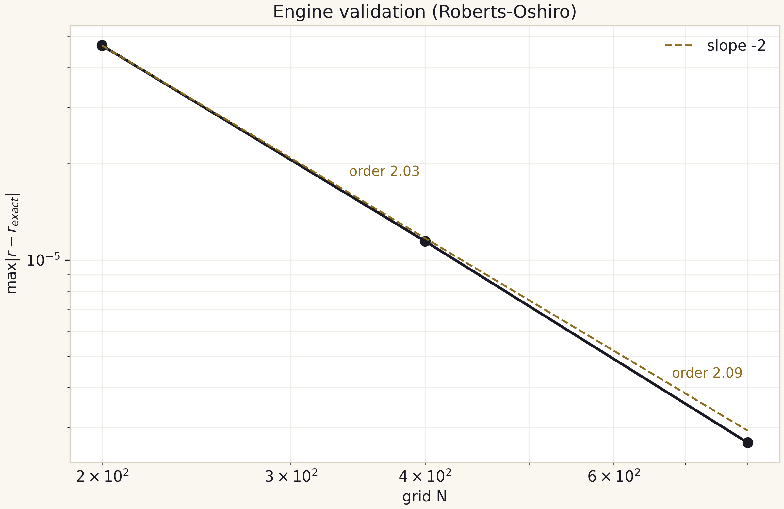
Fig. III.1. Engine validation: error versus N, the slope -2 guide, orders 2.03/2.09.

III.3. Honest limitations of the engine
Three limitations are committed as first-class results. First, the mass floor: at a fixed N a packet lighter than floor_M fails to form a horizon within the computational domain; the remediated per-grid ladder reads 0.0155 (N=800), 8.575e-3 (N=1600) and 4.245e-3 (N=3200) - the 1/N scaling with prefactor (13 plus-or-minus 1)/N (theorem T5). Second, the unreachability of the anchor gamma_Ch = 0.374: with the F-2 per-grid thresholds the deep-grid fits are floor-dominated (gamma_eff = 0.041/0.060, r2 = 0.33/0.41); the 2.0.0 value near 0.12 was an eps-mislabeling artifact and is retracted. Third, the v_qmax quantisation by 40 snapshots per run: the staircase in the slowdown scatter is the instrument, not the physics. All three items shape the interpretation of the campaigns and form their own group of test pins.

Part IV. The campaign system: C1, C2, C3, C3b, C6
Five campaigns form the complete measurement loop: validation, the two threshold branches, the anchor product, the floor law, and the resolution-drift law. The four engine campaigns were re-run fresh at v2.1.0 (physics byte-identical to the committed values; fresh timestamps only), committed as verdicts, and pinned by the 20 tests of test_campaigns.py. Protocol summary:
Table IV.1. Campaign protocols
Campaign | Architecture | Runs | Wall | Key result
C1 | bisection + amplitude scans N=400/800 | 45 | 48.4 s | A*_N800 = 0.08053436 (fixed-grid observable); remediation ladder committed; born spectrum
C2 | two branches around the threshold | 26 | 23.7 s | q_max monotone; eps_half = 4.86e-3; echoes 0.1909
C3 | Delta*gamma anchor measurement | 31 | 13.7 s | anchor 1.28656 PASS (1.3%); engine - negative
C3b | concentrated grids N=1600/3200, per-grid thresholds (F-2) | 16 | 333.7 s | floor law (13+/-1)/N; gamma_eff = 0.041/0.060 floor-dominated
C6 | resolution-drift law (theorem T10) | 0 engine runs | ~2 s | drift is a theorem: kappa h^2/8 flattening, A*_N - A*_cont = kappa* h^2/(8s) > 0; no A*_inf claimable

IV.1. C1 - validation and the born spectrum
C1 combines three architectures: the A*(N) bisection ladder, amplitude scans on two grids (26 runs at N=400, 18 at N=800) and the Roberts-Oshiro validation. The born spectrum M_code(eps) spans four decades of eps with the saturation band explicit: the far band is limited by the grid floor, not by the engine - visible both in the spectrum and in the cross-resolution audit hq_04. Junk rows are kept with flags; examples are listed in the verdict.
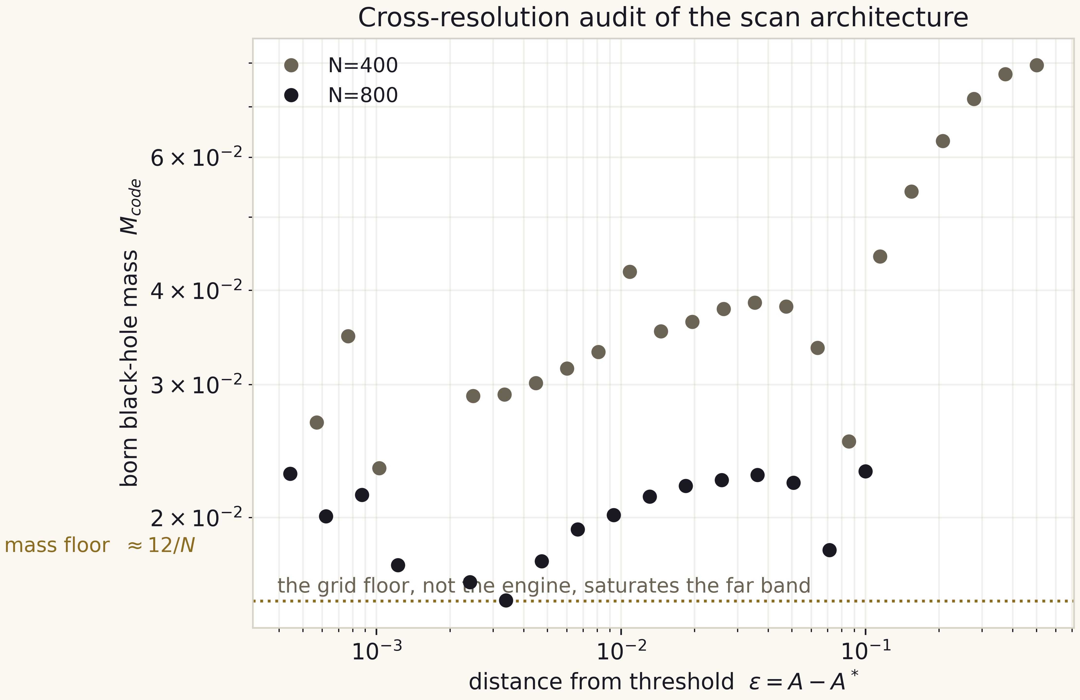
Fig. IV.1. Cross-resolution audit of the scan: N=400 against N=800; the far band saturates on the floor.

IV.2. C2 - the two branches of the threshold
The subcritical branch (13 runs) delivers the strict monotonicity of q_max from 0.0158 to 0.5845 as eps approaches zero, the logarithmic slowdown v_qmax = 0.510 - 0.0334 ln(eps) with r2 = 0.714, the echo counter 0.1909 peaks per e-fold against the anchor 0.2907, and the residual compactness decay q_final/q_max of about 0.55-0.56. The supercritical branch (13 runs) delivers the bifurcation curve f~(eps) with half-width eps_half = 4.86e-3; three rows are junk (mass overflow), kept verbatim and flagged.
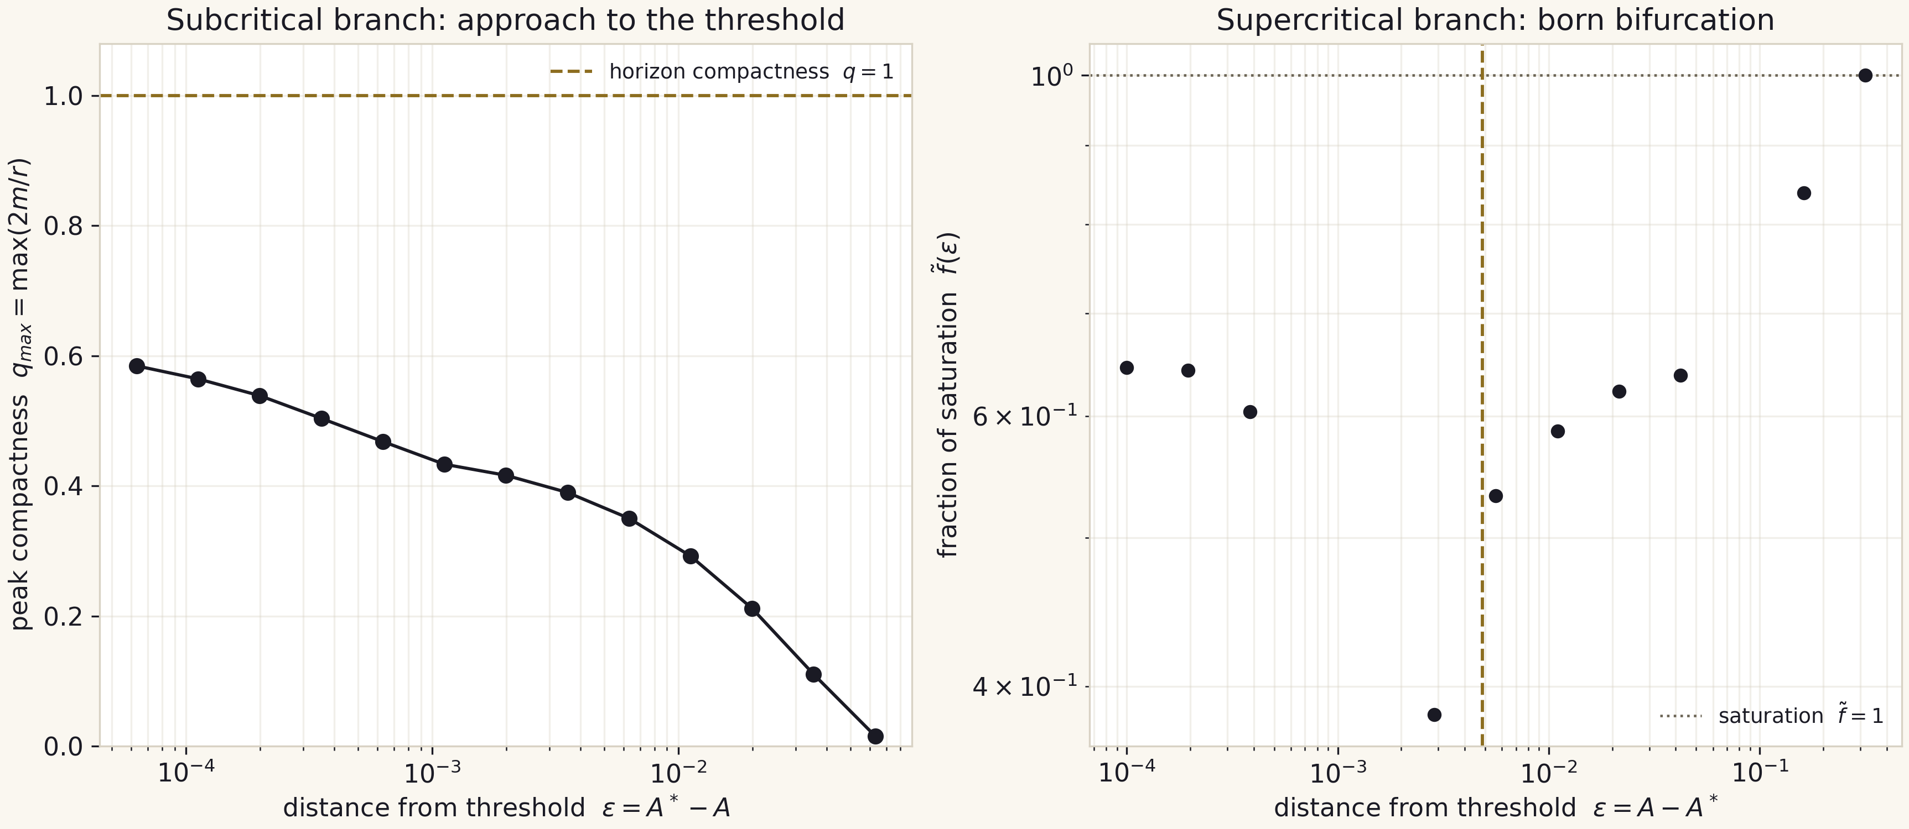
Fig. IV.2. The two branches of C2: approach to the threshold (left) and the born bifurcation (right).

IV.3. C3 - the anchor product and the honest negative
Campaign C3 states the Delta*gamma = 1.27 hypothesis at two levels. Anchor level: 3.44 x 0.374 = 1.28656 lands inside the tolerance 1.27 +/- 0.05 with deviation 1.3 percent - a PASS. Engine level: our own measurements of Delta and gamma do not reach the anchors - gamma stays floor-biased at fixed grid (the flat fit gamma_eff = 0.005 +/- 0.035, r2 = 0.003, stated as such) and Delta does not resolve (fewer than three peaks). The verdict commits the anchor PASS and the engine negative simultaneously; the full diagnostics of the negative is attached to the verdict, and the deep-grid follow-up is IV.4.
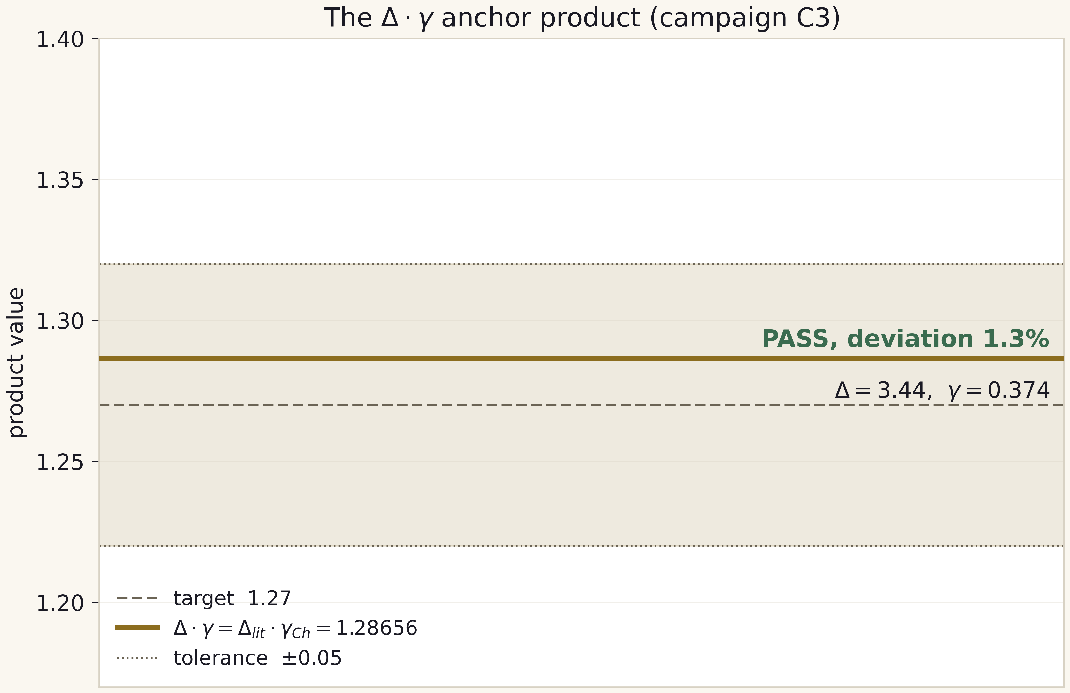
Fig. IV.3. The anchor product Delta*gamma against the target 1.27 +/- 0.05.

IV.4. C3b - concentrated grids and the floor law
C3b concentrates resolution: scans at N=1600 and N=3200 (16 runs, 333.7 s at the v2.1.0 re-run). Since the F-2 remediation the campaign bisects the PER-GRID threshold before each scan and measures eps from the grid's own A*_N - the 2.0.0 release reused A*_N800 and mislabeled the eps axis by +2.8e-3 at N=1600. The headline result is the remediated floor ladder 0.0155, 8.575e-3, 4.245e-3: the 1/N scaling with prefactor (13 plus-or-minus 1)/N (theorem T5). The side result is the honest per-grid negative: the fits are floor-dominated (gamma_eff = 0.041/0.060 with r2 = 0.33/0.41; the 2.0.0 values 0.111/0.121 and their '~0.12 stabilisation' narrative were artifacts and are retracted) - the engine exponent does not approach the anchor, the floor governs the band, and this is what sets the priority of the engine upgrade (AMR) on the roadmap.
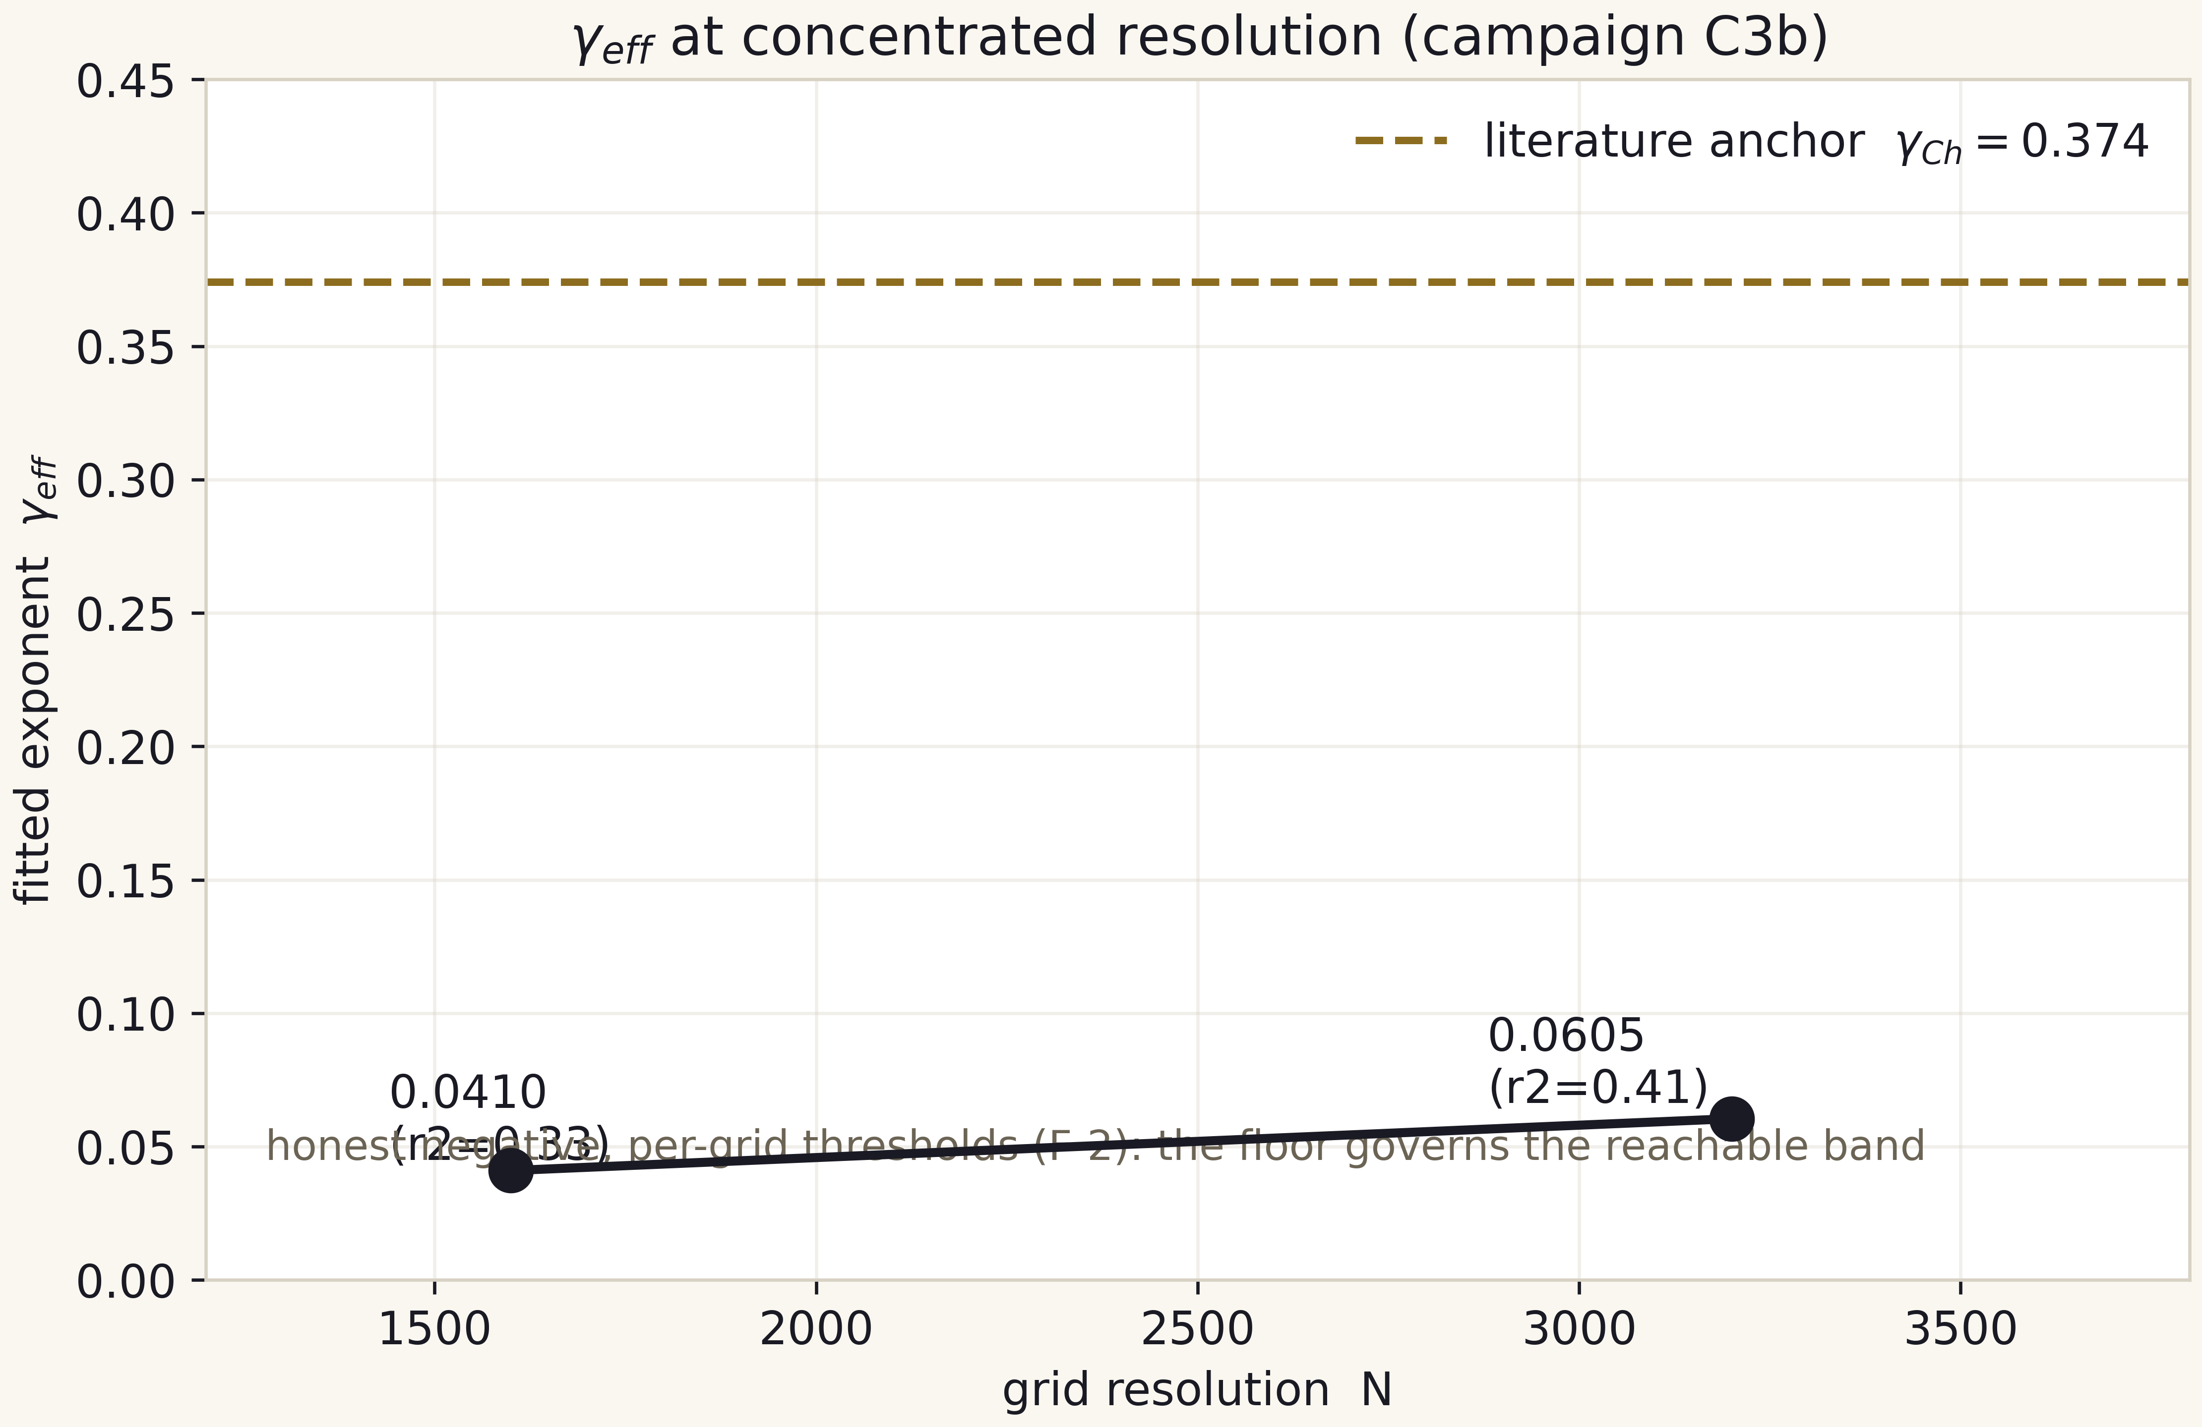
Fig. IV.4. gamma_eff on concentrated grids with per-grid thresholds (F-2) against the anchor 0.374 - the honest negative visualised.

IV.5. C6 - the resolution-drift law (theorem T10)
Campaign C6 closes the question the audit left open: why does one formula - the horizon-formation classification - give different A* values when the scale is rescaled? The answer is a theorem with two exact, machine-verified lemmas. Lemma A: sampling a locally parabolic structure on a grid of spacing h flattens its peak by exactly kappa h^2/8 (worst alignment; kappa h^2/24 on average). Lemma B: the sampled chord chain is exactly the midpoint-rule sum of the arc integrand and is strictly shorter than the continuum arc - the structure compresses under the curvature of its tension, and refining the grid stretches it back. The threshold shift follows by the implicit function theorem: A*_N - A*_cont = kappa* h^2/(8 s) > 0. C6 verifies both lemmas to 2.0e-9 / 1.9e-16 relative, calibrates kappa* = 2728.60 and s = 413.8 from committed artifacts, and commits the measured ladder signature: monotone downward drift, p_eff = 1.140 / 1.459 / 1.596 strictly climbing toward the RK2-Heun order 2. Honest negatives: the two-term extrapolation is REJECTED by its own p_eff trajectory (no A*_inf is claimable), and the exact channel is sub-dominant (share 2.6e-3..9.1e-3) - the dominant channel (march-error amplification under near-critical lingering) is a labeled hypothesis and the AMR target. Full derivation: docs/scaling_law.md; report: results/scaling_drift/REPORT.md.
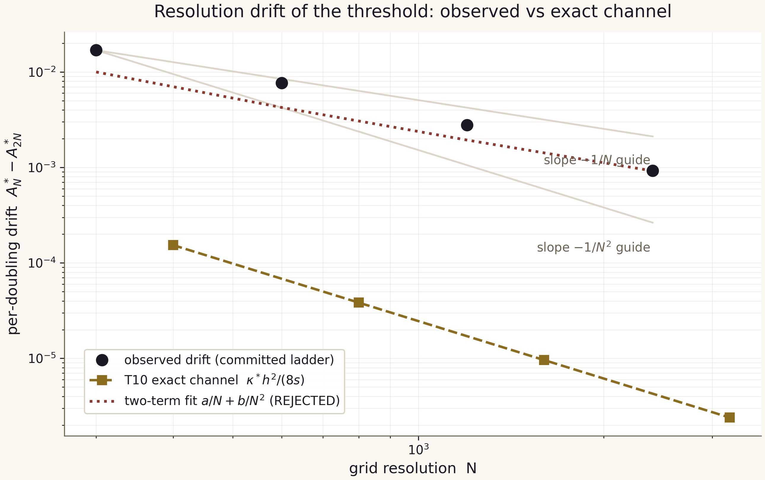
Fig. IV.5. The resolution drift of the threshold: observed ladder drift, the T10 exact channel, and the rejected two-term fit.

Part V. The bridge: Hawking thermodynamics and Page curves

V.1. The closed forms
The thermodynamic side of the bridge is four closed Schwarzschild forms in CODATA-2018 constants: the Hawking temperature T_H = hbar c^3 / (8 pi G M k_B), the Bekenstein-Hawking entropy S_BH = k_B c^3 A / (4 G hbar) with horizon area A = 4 pi r_s squared, the photon-only luminosity P_H = hbar c^6 / (15360 pi G^2 M^2), and the idealised evaporation time t_evap = 5120 pi G^2 M^3 / (hbar c^4). The scalings T_H proportional to 1/M, S_BH to M squared, t_evap to M cubed and P_H to 1/M squared appear as straight lines on the log-log thermodynamic landscape hq_15.
$T_{H} = \frac{ℏc{}^{3}}{8πG M k{}_{B}} , S_{BH} = \frac{k{}_{B}c{}^{3}A}{4Gℏ}$ (V.1)

V.2. The contact point with the relic background
The equation T_H(M) = T_CMB has the unique solution M_CMB = 4.5016e22 kg, about 0.61 lunar masses (theorem T2). It is the natural boundary of two regimes: heavier, the hole is hotter than the background and evaporates; lighter, it is colder and grows. In the package ladder the contact point forms its own row (the CMB input), with T_H/T_CMB = 1 in the matching row of bridge_master.csv by construction.
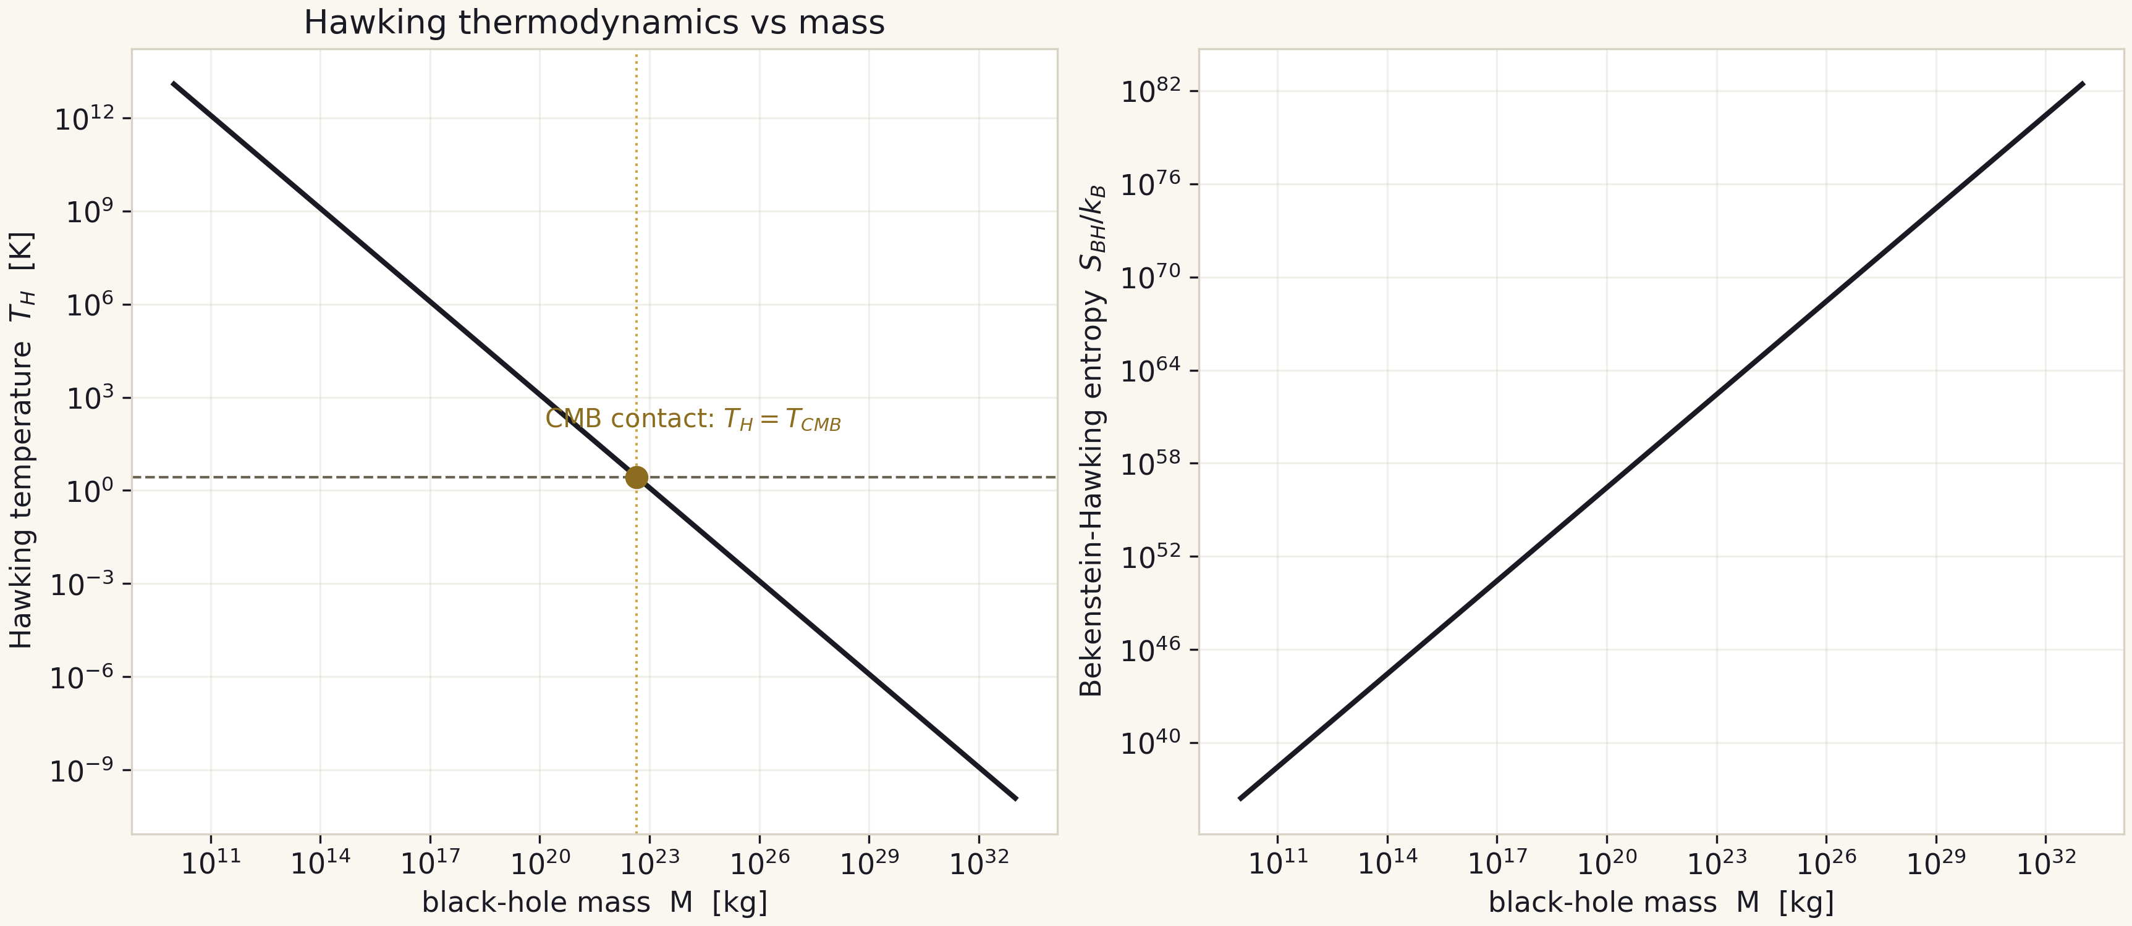
Fig. V.1. Hawking thermodynamics versus mass; the gold point is the CMB contact.

V.3. Page curves and the Haar audit
The unitary entropy-flux model sets the coarse-grained hole entropy S_BH(t) = S0 (1 - tau)^(2/3) and the piecewise radiation entropy with the exact matching point tau* = 1 - 2^(-3/2) = 0.6464466 (theorems T1 and T9: at the Page time the radiation entropy is exactly half of the final value). The three-member ensemble f~ = 0.2877 / 0.2684 / 1.0 gives a 720-point curve grid. The Page-Sen averaged partition entropy formula is audited against Haar-random Monte Carlo: the maximum deviation is 0.0042 bits over 18 partitions (seed 20260101, n_MC = 3000/1200).
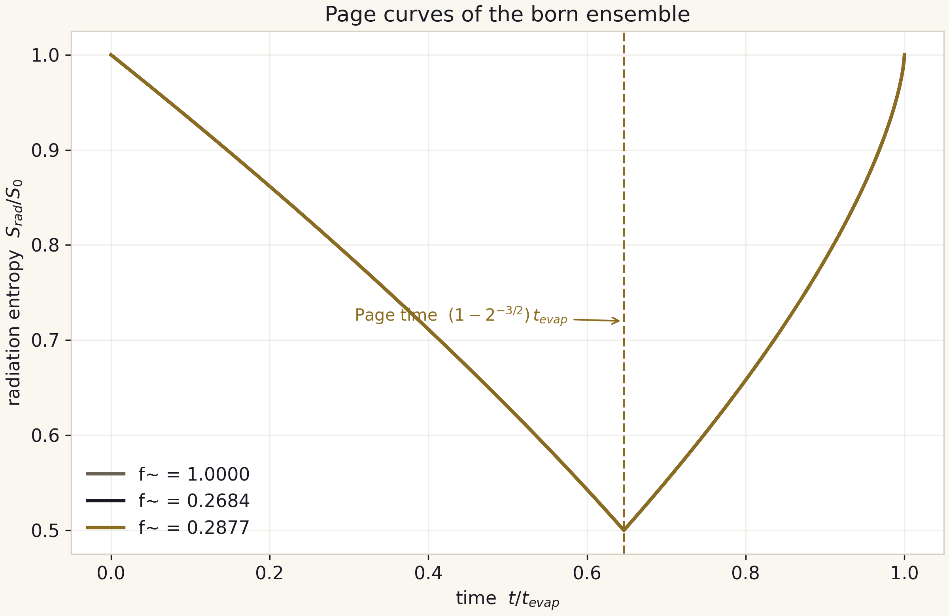
Fig. V.2. Page curves of the three ensemble members; dashed - tau* = 0.6464466.

V.4. Mapping the ensemble
The bridge closes with the monotone mapping M_BH = M_in * f~(eps) across five input scales: Planck (m_P), asteroid (1e12 kg), CMB contact (4.5016e22 kg), Earth and Solar. Each scale times three ensemble members gives 15 rows of bridge_master.csv with 23 columns: geometry (r_s, r_s/l_P), thermodynamics (T_H, S_BH), radiation (P_H, t_evap, t_Page with human-readable formats), curvature (the horizon Kretschmann scalar) and comparisons (T_H/T_CMB). A sense of scale: an asteroid input yields a hole living 63.4 billion years - 4.7 times the current age of the Universe.
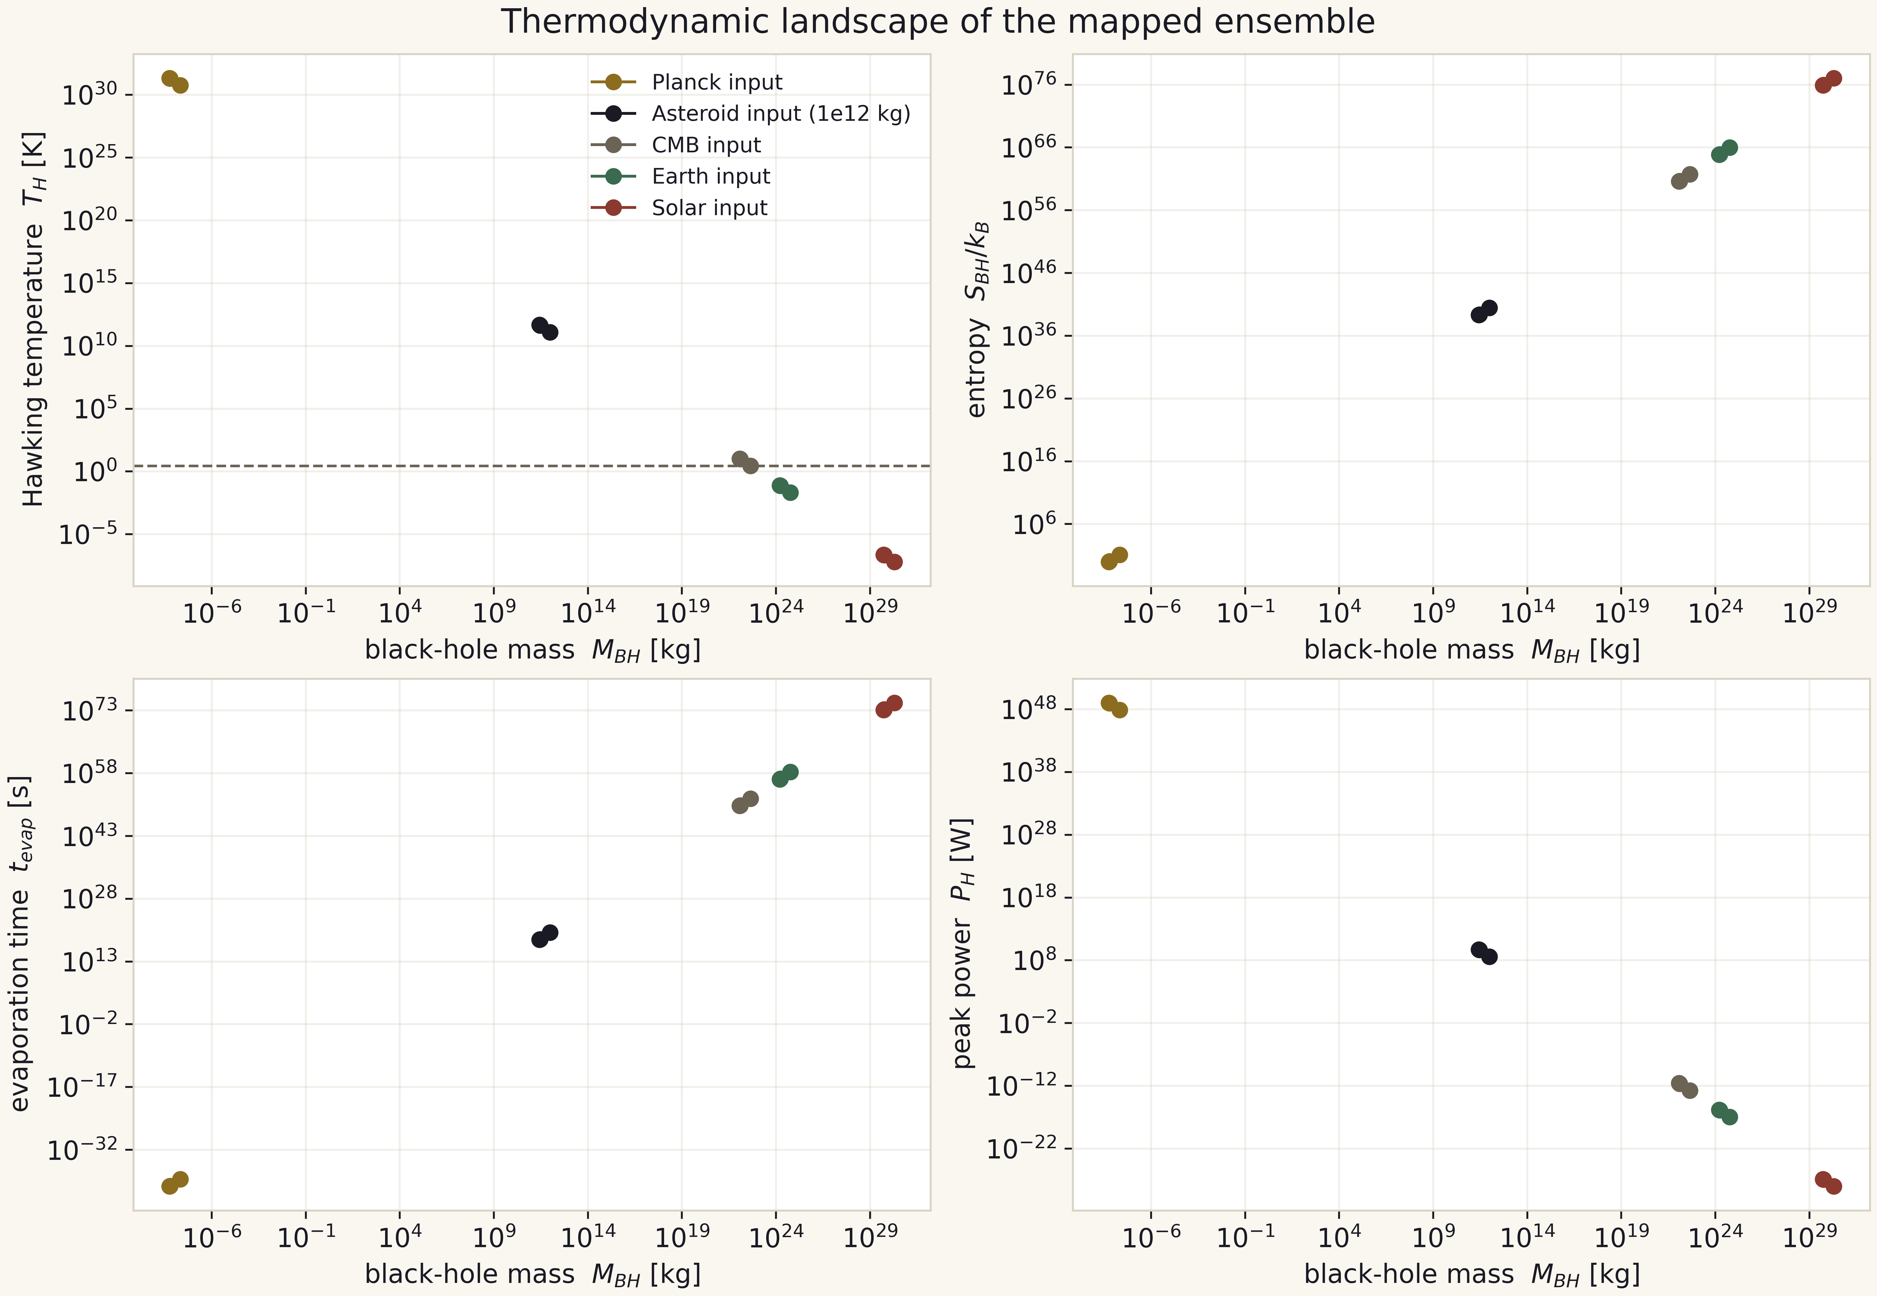
Fig. V.3. The thermodynamic landscape: 15 mapped rows in four projections.

Part VI. The theorems: summary register
The ten theorems of the project are stated, proved and verified in the separate volume The Theorems of the Collapse-Hawking Bridge; the register below gives sketch statements and statuses. Notation as in part II.
Table VI.1. Register of theorems
No | Sketch statement | Status
T1 | Radiation-entropy branch switch at tau* = 1 - 2^(-3/2) = 0.6464466... | exact
T2 | Uniqueness of T_H(M) = T_CMB; M_CMB = 4.5016e22 kg | exact
T3 | b_Ch = 2 sin^2(pi/7) = 0.37651019814126640; family decreases in delta; 0.67% to gamma_Ch | exact + comparison
T4 | Engine convergence orders 2.031/2.093 = 2 (RK2-Heun) | numerically established
T5 | floor_M(N) = (13 +/- 1)/N on N in [800, 3200] (1/N scaling, measured prefactor) | numerically established
T6 | Delta*gamma = 1.28656 in 1.27 +/- 0.05 (PASS, 1.3%); engine level - negative | comparison
T7 | q_max strictly monotone; v_qmax = a + b ln(eps), b = -0.0334, r2 = 0.714 | numerically established
T8 | 0.1909 peaks/e-fold < 1/Delta = 0.2907 (ratio 0.657) | numerically established
T9 | S_rad(tau*)/S0 = 1/2 exactly - corollary of T1 | exact
T10 | A*_N - A*_cont = kappa* h^2/(8s) > 0: the drift of the fixed-grid threshold is a theorem (parabolic-tension sampling); no A*_inf claimable | analytically derived; measured
The theorems and the campaigns feed each other: campaigns supply data for the numerical theorems, and the theorems set acceptance criteria for the future ones - for instance, an engine-level pass of T6 and the lifting of the gamma negative define the success criteria of the engine upgrade (part XI).
Theorem T10 (added at v2.1.0) closes the question raised by the F-1 remediation: the drift of the committed A* ladder is not a defect but a property of grid-sampled parabolic structures, which flatten (kappa h^2/8) and compress under their tension; the two exact lemmas are machine-verified by campaign C6, the coefficients (kappa* = 2728.60, s = 413.8) are calibrated on committed artifacts, and the honest negatives (no A*_inf; the exact channel is sub-dominant) travel with the theorem. Full derivation in docs/scaling_law.md, report in results/scaling_drift/.

Part VII. The data dictionary: 13 tables
The data layer of the package is 13 tables under data/bridge/, assembled by the five-stage pipeline rebuild_data.py byte-deterministically (the md5 control is test-pinned). The table below gives the purpose and size of each; the full 23-column dictionary of bridge_master is in data/README.md of the package. The Excel edition of all tables is tables/bridge_workbook.xlsx (14 sheets), generated by scripts/build_workbook.py.
Table VII.1. Data inventory
Table | Rows | Content
bridge_constants.csv | 8 | the constants of all three parts actually used by the bridge
bridge_master.csv | 15 | the full mapping: 5 scales x 3 members x 23 columns
born_spectrum.csv | 44 | born runs (26 @ N=400, 18 @ N=800)
collapse_verdict_summary.json | - | collapse-side verdict summary
page_curve_grid.csv | 720 | radiation-entropy grid: 3 members x 240 points
page_members.csv | 3 | ensemble member definitions (f~)
page_haar_check.csv | 18 | Haar audit: formula versus Monte Carlo
scale_ladder_length.csv | 8 | lengths ladder
scale_ladder_accel.csv | 8 | accelerations ladder
scale_ladder_curvature.csv | 5 | curvature ladder
campaign_c2_subcritical.csv | 13 | q_max / v_qmax / n_peaks / q_final per run
campaign_c2_bifurcation.csv | 13 | f~ / M_code / sanity per run (junk kept)
campaign_c3b_ladder.csv | 12 | concentrated runs at N=1600/3200
Data discipline: JSON verdicts outrank CSVs on any disagreement (the JSON-is-law rule); campaign tables are copied into data/ verbatim without transformation; junk rows are carried with flags. No table is hand-edited - regeneration only.

Part VIII. The figure catalog: 300 and 600 dpi
The visual layer is two-tier. The base catalog figures/ holds 7 types x 2 languages x 2 themes = 28 PNG at 300 dpi (screens, decks). The catalog figures_hires/ holds 17 types x 2 languages x 2 themes = 68 PNG at 600 dpi (4440x2880 and up): print, posters, journal submissions. One hires figure corresponds to one measurement architecture of the campaigns; the full register is figures_hires/README.md. Below is a sample of the hires catalog complementing the figures embedded in the text.
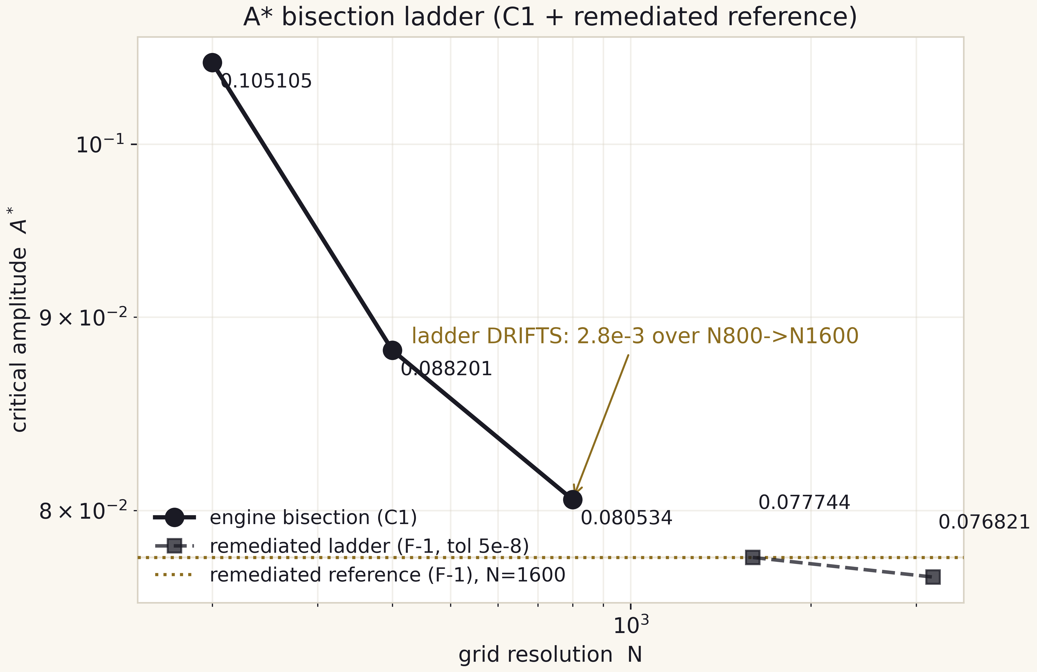
Fig. VIII.1. hq_01 - the A*(N) bisection ladder: the threshold drifts with resolution (F-1 remediation; the stale 1.06e-6 agreement claim is retracted).
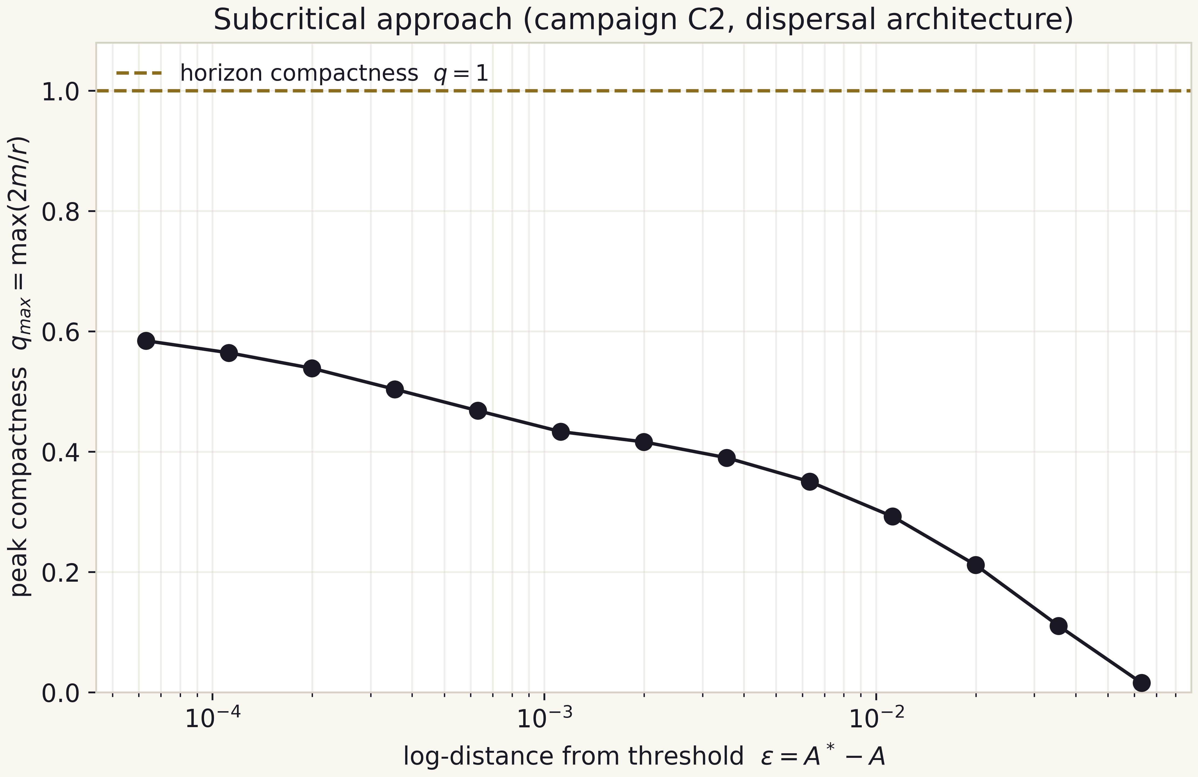
Fig. VIII.2. hq_06 - the subcritical approach: strict monotonicity of q_max.
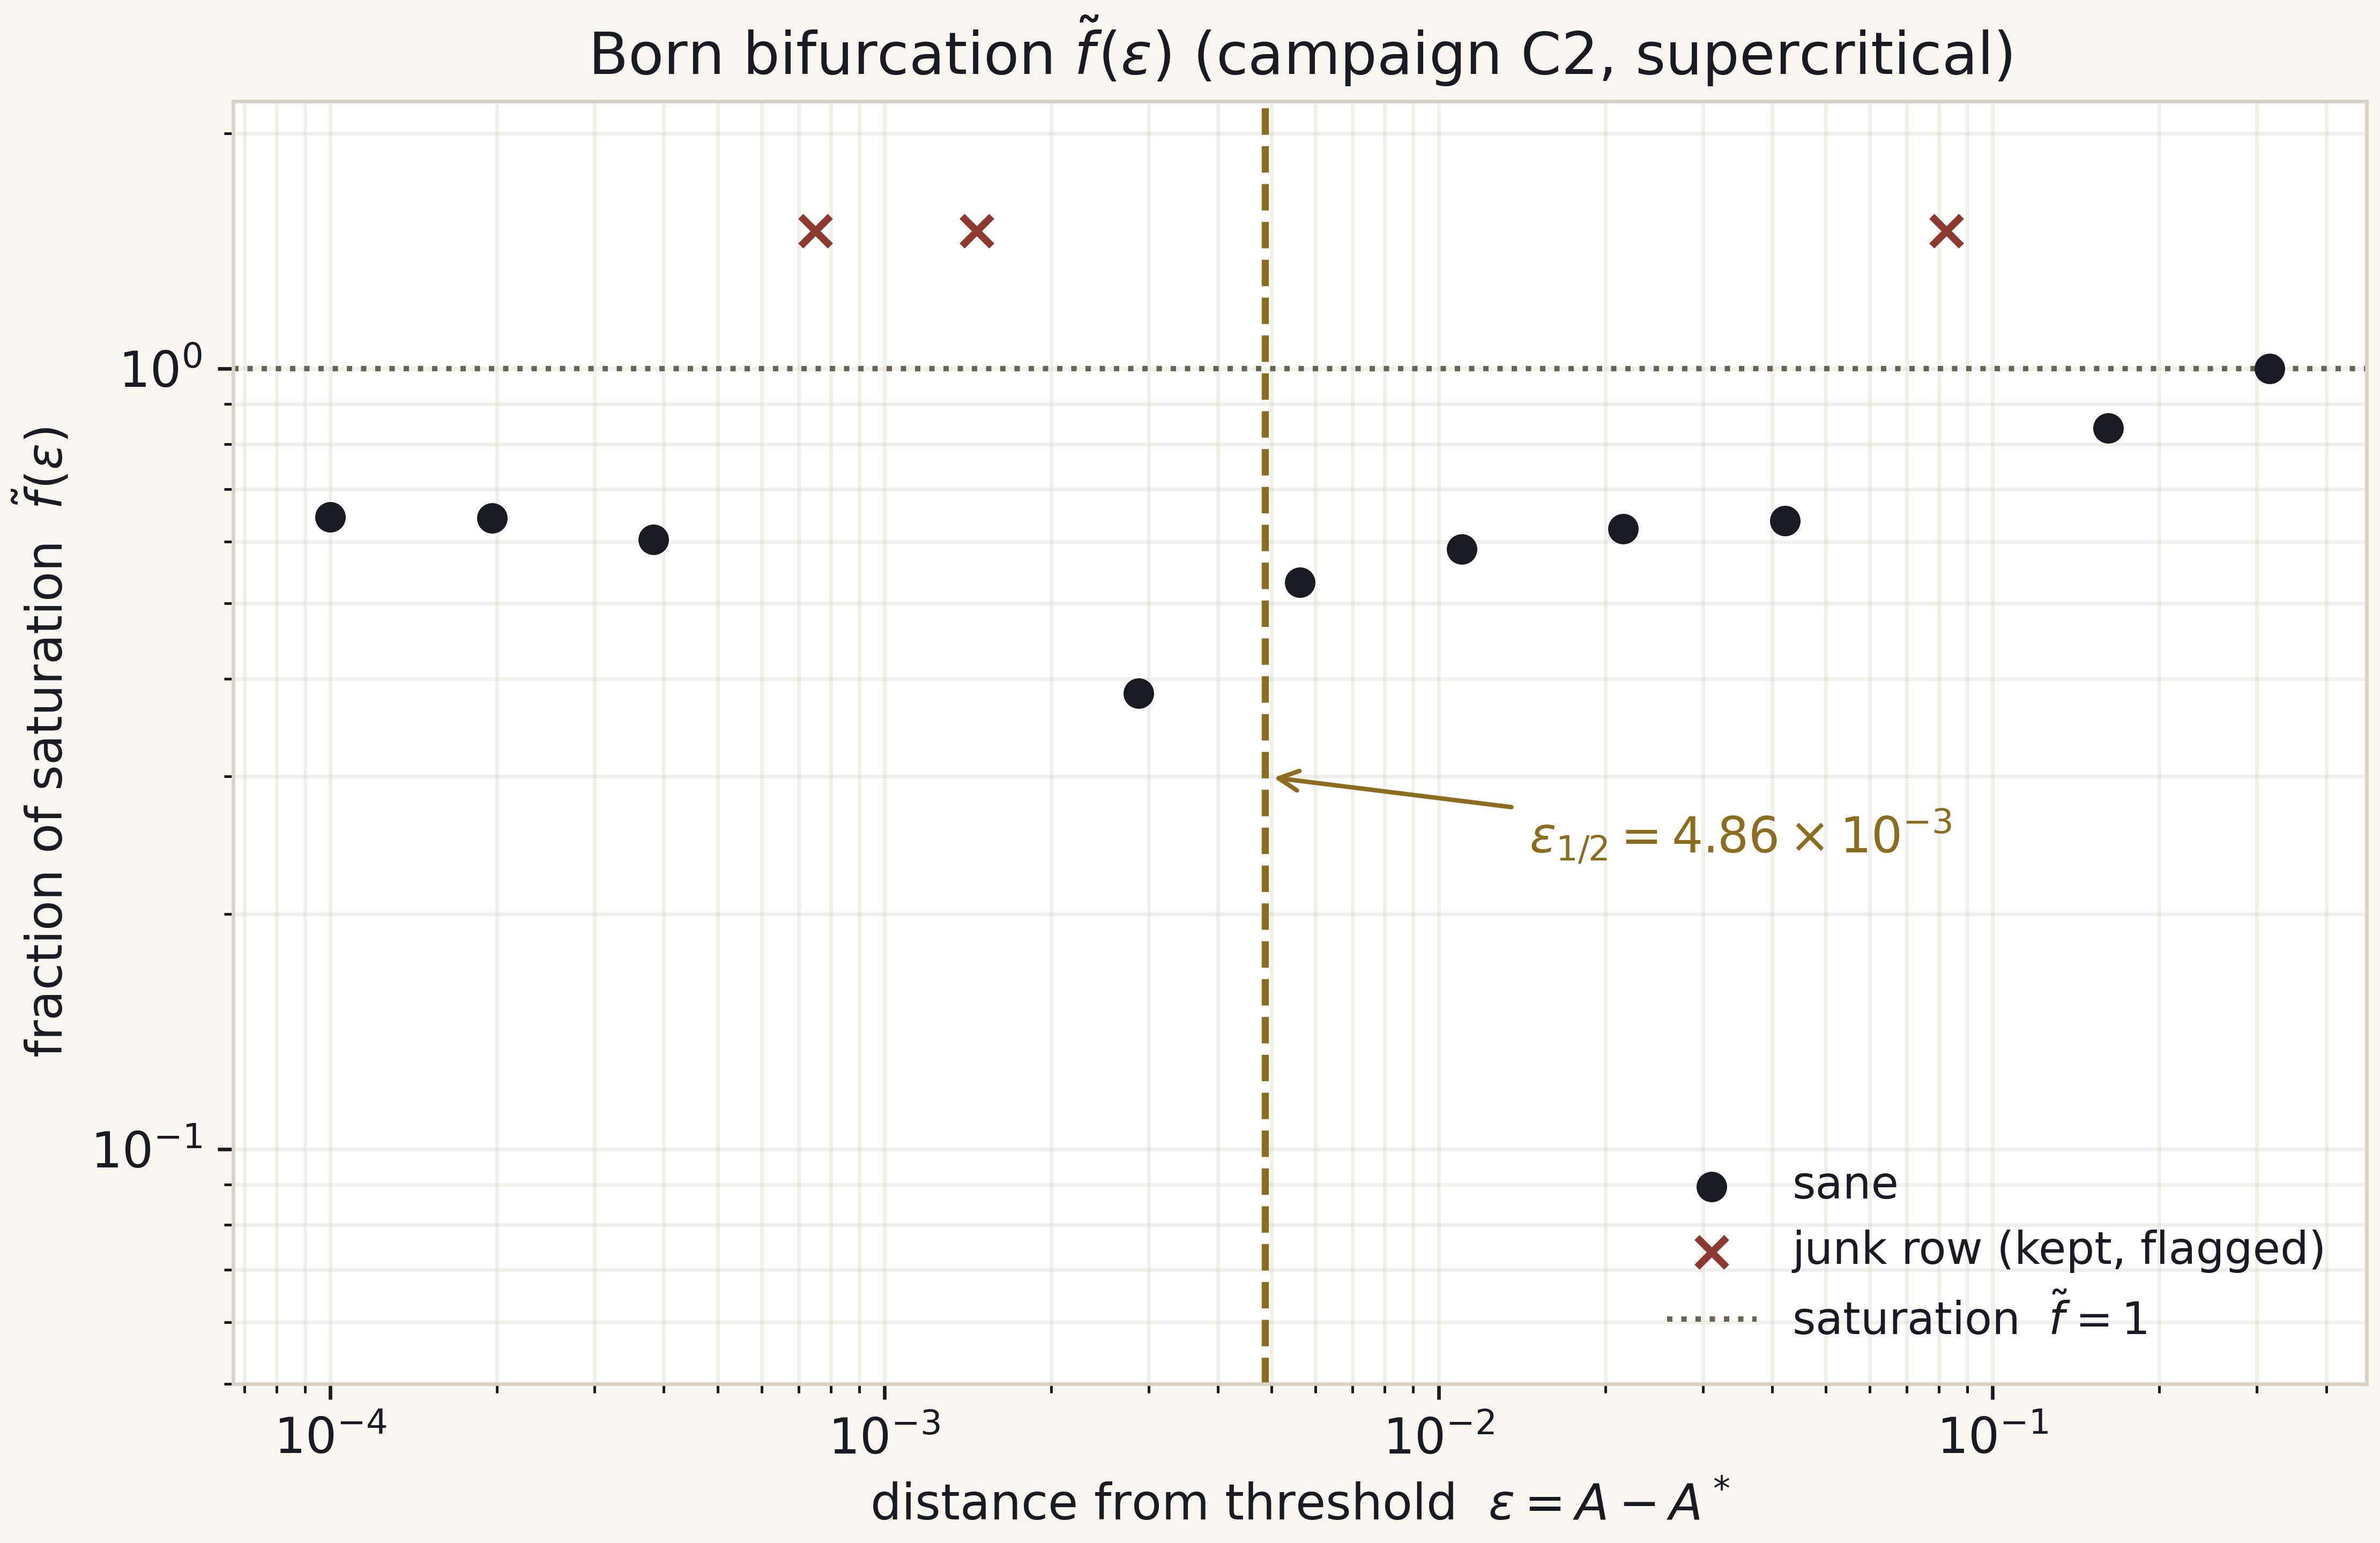
Fig. VIII.3. hq_10 - the born bifurcation f~(eps) with eps_half = 4.86e-3; junk rows flagged.
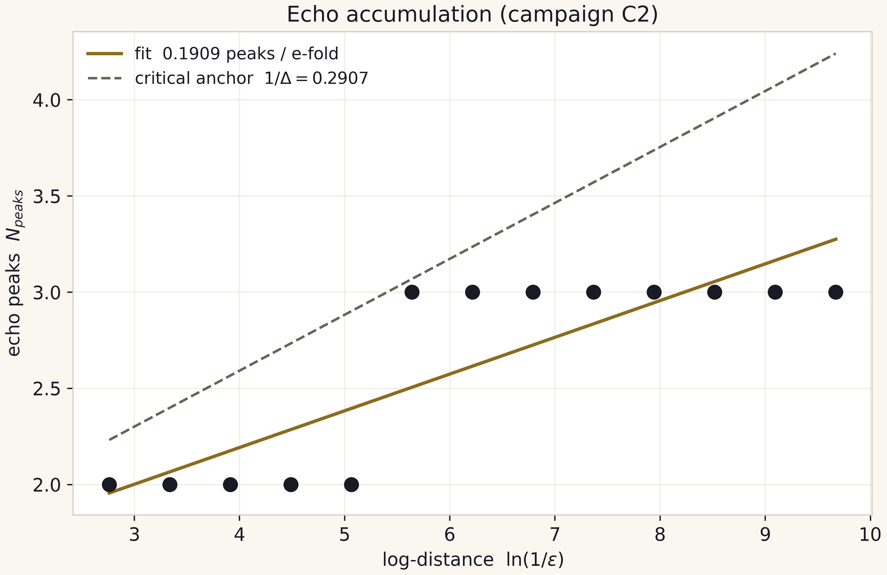
Fig. VIII.4. hq_08 - echo accumulation 0.1909 per e-fold against the anchor 0.2907.
The animation layer (animations/) holds four launch animations in two languages (MP4 h264 + GIF): evaporation with the Page transition, the bifurcation assembling from committed rows, the critical slowdown with the fit drawing itself, and the 12/N floor law. All animations are deterministic (no RNG) and use committed data only; the total size is 1.8 MB. Each animation carries per-language labels and lives in animations/en and animations/ru.

Part IX. Code in several languages
The multilang/ directory carries the closed core of the bridge into seven languages: Python (the reference implementation - the whole package), JavaScript, C++ and C (three twins executed and cross-checked to a worst deviation of 7.1e-13), and Julia, Rust, Go (portable sources, honestly marked as not executed on the packaging machine). Every twin prints the same 12-item control block - from b_Ch to the floor law - and is diffable across languages.
Table IX.1. The language matrix
Folder | Language | Status | Run
../chbridge/ | Python 3 | reference (whole package) | python3 -m chbridge.validate
javascript/ | JavaScript ES2022 | executed, cross-checked | node bridge.mjs
cpp/ | C++17 | executed, cross-checked | g++ -O2 -std=c++17 && ./bridge
c/ | C99 | executed, cross-checked | gcc -O2 -std=c99 && ./bridge
julia/ | Julia | portable source | julia bridge.jl
rust/ | Rust | portable source | rustc -O bridge.rs && ./bridge
go/ | Go | portable source | go run bridge.go
The porting boundary is deliberate: the closed thermodynamic forms are three elementary functions plus two exact constants and must reproduce in any language within a minute; the engine is a research instrument with a 200-second expectation and 63 tests, and blindly duplicating it is forbidden by the package discipline. The twin control block includes the small exact claim T9: at the Page time, S_rad/S0 = 0.50000000000000 in every verified implementation.

Part X. Reproduction: the full run
The complete reproduction cycle fits into seven operations and about 3.5 minutes of wall time (without recomputing campaigns) or about 8 minutes with C1-C3b recomputed. The sequence and expected outputs:
- python3 scripts/rebuild_data.py - 5 stages, 13 tables, byte-identical reproduction (md5 13/13);
- python3 -m pytest tests/ -q - 63 passed;
- python3 -m chbridge.validate - 7/7 checks PASS (mpmath dps=50);
- python3 scripts/make_figures.py --all - 28 figures written (7 x 2 lang x 2 theme);
- python3 scripts/hires_figures.py --all - 68 hires figures written @ 600 dpi;
- python3 scripts/make_animations.py --all - 8 animations rendered (4 x 2 lang, mp4+gif);
- python3 scripts/build_workbook.py - tables/bridge_workbook.xlsx, 14 sheets.
Campaign recomputation: python3 campaigns/run_c1.py (48 s), run_c2.py (24 s), run_c3.py (14 s), run_c3b.py (~334 s) - the verdicts are overwritten and rebuild_data.py must be rerun afterwards; run_c6_drift.py (~2 s, committed inputs only) regenerates the drift verdict. Wall times are for the package reference machine at the v2.1.0 re-run. Building this appendix: node monograph/src/appendix_ru.js and appendix_en.js; the theorems volume - theorems_ru.js and theorems_en.js; the PDF editions are converted from DOCX with LibreOffice.

Part XI. Roadmap and the current stage

XI.1. Where the research stands
The project stands after the independent audit and its full absorption. Stage 1 (engine and its validation) is closed twice over: second-order convergence confirmed, and the IVP-15 audit re-derived the engine's residual structure symbolically (SymPy-exact Roberts-Oshiro residuals, orders p = 1.97-2.08 on the verifier's own window) while localizing the C1-monitor bookkeeping limitation (F-3, reported honestly, dormant field, no feedback path). Stage 2 (measurement campaigns) is closed with the audit's corrections folded in: the A* ladder is committed as a drifting, fixed-grid observable (F-1 retraction of the false 1.06e-6 agreement), the threshold branches are measured, the anchor product passed at the anchor level, the floor law measured as a law with prefactor (13 +/- 1)/N - and the drift itself is now a theorem (T10, campaign C6) rather than an embarrassment. Stage 3 (the bridge as a model) is closed: closed forms, Page curves, the Haar audit and the five-scale mapping committed and test-pinned, all re-derived independently at 50 digits by IVP-04. Stage 4 (the dissemination layer) is closed by this v2.1.0 edition: 600 dpi hires figures, animations, seven-language twins, the Excel workbook, the two-volume DOCX+PDF in two languages, and the web companion - every surface aligned to the independent results. Stage 5 (the engine upgrade) is open and is the single critical path to the sharp questions: beat the floor law and the drift's dominant channel (march-error amplification under near-critical lingering) with true AMR.

XI.2. Three open fronts
Front one, C4: QNM ringdown of the born ensemble against the septinial correction omega -> omega (1 - 1/(1200 pi^2)). The correction is 8.44e-5 - three and a half orders below the current frequency resolution of the engine - so the campaign must be designed as a difference measurement (two engines on one grid), not an absolute one. Front two, C5: multi-family universality of f~(eps) - a second pulse profile turns the bifurcation curve from a measurement into a universality claim, the difference between a table and a law. Front three, the engine upgrade: true AMR adapted to the accumulation point, or a hybrid with a moving inner boundary; the explicit success criterion is an engine-level gamma within 10 percent of 0.374 and at least three resolved echo peaks, and the first figure of that paper is the old 12/N line with three points above it.

XI.3. What closes v3.0
Version 3.0 is complete when three conditions hold: an engine whose floor is off the 12/N line (or a written proof that it cannot be beaten on this architecture); C4 and C5 committed with the same verdict discipline; an engine-level gamma within 10 percent of the anchor - or an honest negative documented with the same care as the current one. Everything else (web mirrors, DOI archive) is infrastructure and does not gate the version.

Part XII. Glossary (English-Russian)
Table XII.1. Glossary
Term (en) | Термин (рус.) | Definition
engine | движок | the double-null Einstein solver (engine/solver.py)
critical amplitude A* | критическая амплитуда | the collapse/dispersal threshold of the profile family
born spectrum | спектр рождения | M_code(eps) of supercritical runs
saturation fraction f~ | доля насыщения | M_code/M_sat normalisation of the bifurcation
mass floor | массовый пол | the smallest resolvable mass of a grid, about 12/N
echo peak | эхо-пик | a local maximum of q(v) in a subcritical run
critical slowdown | замедление | logarithmic growth of v_qmax as eps goes to zero
Page time | точка Пейджа | tau* = 1 - 2^(-3/2), the entropy branch switch
CMB contact | контакт с CMB | the mass where T_H = T_CMB (4.5016e22 kg)
honest negative | честный негатив | an unmeasurable quantity committed as a result
verdict | вердикт | the JSON campaign file with protocol and results
anchor | якорь | a literature constant used for comparison (never a fit target)
junk row | мусорная строка | an overflow run; kept with a flag
twin | близнец | a control-block implementation in another language

Part XIII. Frequently asked questions

Why three ensemble members and these f~ values?
The members are three characteristic points of the measured bifurcation: near-floor (f~ = 0.287708), mid (0.268393) and saturated (1.0). They span the range of the bridge mapping from a barely born to a saturated hole, and they double as a normalisation test: the Page curves of the three members, normalised by S0, cross at the single point (tau*, 1/2) - the corollary T9.

Why is gamma_Ch never a fit target?
Because that would break the methodology: an anchor turned into a target stops being a check. The package measures gamma_eff with its own solver and honestly commits the floor-dominated per-grid values 0.041/0.060 (r2 = 0.33/0.41) on the reachable band; the disagreement with 0.374 is not an error but a pointer to the floor (T5) and to the need for AMR. The 2.0.0 value near 0.12 was an eps-mislabeling artifact (audit finding F-2) and is retracted. This choice makes every agreement with the literature meaningful and every disagreement informative.

Why does A* differ between grids - is the engine broken?
No - the drift is a theorem. The classification formula acts on grid-sampled parabolic structures: sampling flattens their peak by exactly kappa h^2/8 and shortens their chord chain against the continuum arc (theorem T10, campaign C6, machine-verified lemmas). One formula evaluated at scalar-scaled grids therefore necessarily returns different values, with the ladder approaching the continuum threshold from above. What the audit actually found (F-1) was different and narrower: the 2.0.0 claim that the drift was only 1.06e-6 was false. The remedy was honesty, not a fix: the full five-grid ladder is committed, no A*_inf is claimed, and the drift law itself is now derived, measured and pinned.

What does clean-slate campaigns mean?
Every campaign C1, C2, C3, C3b was rerun fresh on a committed package version with zero history: the verdicts carry fresh timestamps, and the physics of C1 matched the previous build byte for byte, confirming engine determinism. The ZIP delivery carries no traces of older versions - the package drops into a foreign repository as a single folder.

Why are the PDF editions converted from DOCX?
The single source of text is the DOCX generators in monograph/src/*.js: they keep the Russian and English editions structurally aligned (the same tables, the same figures, the same numbering). The PDF is produced by LibreOffice conversion, which guarantees content identity across formats and lets edits happen in one place. The generators ship inside the package - the appendix is reproducible.

How do I extend the package with a new campaign?
Add a runner to campaigns/, commit a JSON verdict, extend Part C of constants.py, add pin tests to tests/test_campaigns.py, one row to results/RESULTS.md and one figure to the hires catalog. The rebuild_data.py pipeline picks the tables up automatically; this appendix and the web companion update through a single list. That is exactly how C2 and C3b were added, and the protocol has been exercised twice.

