SEPTINAL — Formal Choptuik & the Septinial Braking Satellite

A Machine-Verified Research Monograph
SEPTINAL
Formal Choptuik & the Septinial Braking Satellite — two Lean 4 libraries, one rational certificate bridge, and the constants of critical collapse read off the Klein quartic
Around the threshold of gravitational collapse one number — the growth rate λ₀ of a single unstable mode — fixes the exponent γ of the black-hole mass scaling law. This monograph documents a research package that turns that bookkeeping into kernel-checked theorems and then reads the same constants from the {7,3} geometry of the Klein quartic curve: a 24-slot dial with one structural gap, 24 − 2 = 22 = b₂(K3).
0 SORRY 0 PROJECT AXIOMS 145 THEOREMS 95 AUDITED · EXIT 0 22 = b₂(K3)
Ishak Khamzatovich Isaev
ORCID 0009-0003-7299-0701 · NALCHIK, KABARDINO-BALKARIAN REPUBLIC
Wing of choptuik_ac_bc · seed 1993 MMXXVI

§0Preflight — everything in three commands
This monograph is the printable face of a machine-checked artifact. Before reading a single theorem, the skeptical reader can replay the whole stack: the Lean build (2 894 proof steps, exit 0), the rational certificates (emitted and re-checked on every run), and the seven-task numerical harness in both language twins. Three commands from the package root are the whole ceremony; every number, figure and table in this book regenerates from them, and from no other source.
cd lean && lake build # the proofs: 2 894 steps, exit 0
python3 scripts/certify.py emit && python3 scripts/certify.py check
python3 scripts/septinal_verify.py --ci --preset quick --task all # 7/7 PASS
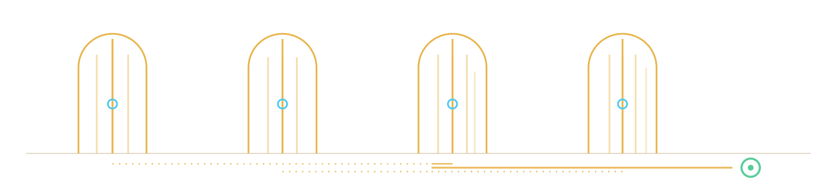
Fig. 0.1 — The four doors of reproduction: the Lean build, the certificate cycle, the numerical harness, and the pre-push gate; all four open onto the same gold line of committed artifacts. Panels 2, 3, 4, 7 — the (2,3,7) signature.
The rest of this preface explains what each layer is allowed to claim. The rule of the house is printed on the cover: machine-readable or it did not happen — a claim that cannot be re-derived from the artifact is marked INTERP and is never allowed to masquerade as a theorem.
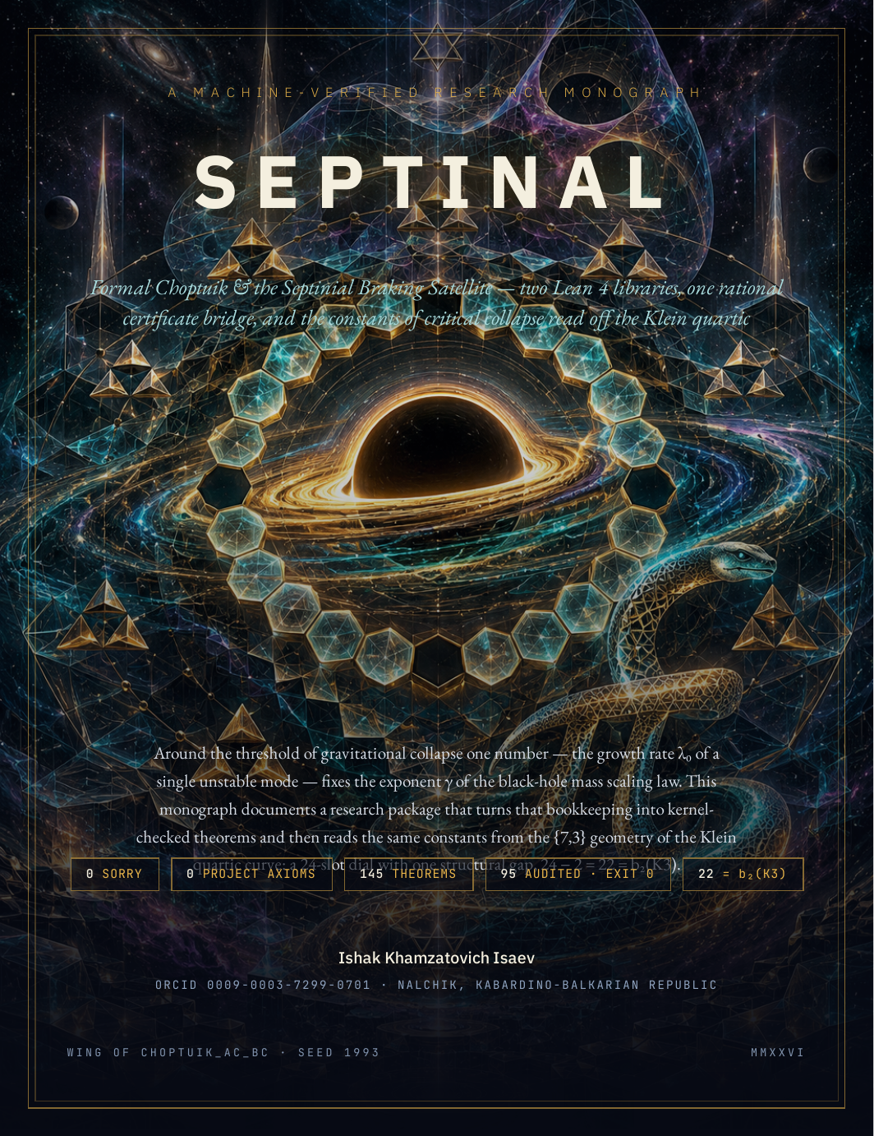
Front Matter

Machine-Readable or It Did Not Happen
That single sentence is the constitution of everything documented in this monograph. The Septinal package does not report results that a reader must take on faith: every headline claim is either a Lean 4 proof whose dependency tree the kernel prints on demand, a rational certificate re-checked fraction-by-fraction, or a number recomputed byte-identically from a fixed seed. Where a statement cannot be proved, the package does not stay silent — it states the boundary as a theorem of its own. The chapters that follow walk through the physics, the formalization, the bridge that carries numerics into the kernel, the seven large-matrix verification tasks, and the septinial geometry that closes the arc.

Abstract
Septinal is a machine-verified research package built from two Lean 4 + Mathlib libraries. The first, Choptuik, formalizes the bookkeeping of critical gravitational collapse for the Einstein–scalar system: the discretely self-similar (DSS) critical solution, its determination by data on a fundamental strip, uniqueness up to scale and time translation, a quantitative Newton–Kantorovich existence argument with contraction constants β = 50/39 and L = 3/50, a certified spectral picture with exactly one unstable mode λ₀ = 2.6745, and the mass scaling law γ = 1/λ₀ = 2000/5349 with the proved inequality $γ−0.374=\frac{263}{2674500}<{10}^{−3}$. The second, Satellite, formalizes a geometric reading of the same constants on the Klein quartic curve {7,3}: a 24-slot septinial dial whose antipodal gap {0, 12} yields the counting identity $k=24−2=22=b_{2}\left(K3\right)$, the chiral split 22 = 11 + 11, the symmetry cascade 48 → 4 → 2, and the exact parameter-free record $γ_{3}=1−c\left(2π/7\right)−π/{1200}=0.373892…$, within $1.1⋅{10}^{−4}$ of the numerically calibrated exponent. The two libraries are joined by a rational certificate bridge: a Python producer emits exact rational enclosures, norm_num re-checks every fraction inside Lean, and discharge theorems lift them to physics-level headlines. The audit covers 95 headline declarations across 24 modules (5108 lines of Lean) with zero sorry and zero project axioms; the only axioms in any dependency tree are Lean's three standards.

How to read this book
Every substantive claim in the chapters below carries a level badge. The badge tells you where the statement lives in the verification stack, and therefore how much machinery stands behind it:
Table 0.1 — Claim levels used throughout the monograph
Badge | Meaning | Enforced by
KERNEL | Proved inside Lean 4; the kernel checks the proof object on every build. | lake build, #print axioms audit
CERT | Exact rational certificate produced by Python, re-verified fraction-by-fraction inside Lean. | Bridge/Generated.lean, certify.py check
NUM | Numerical verification on large synthetic matrices by the stdlib-only harness twins. | septinal_verify.py / .jl
INTERP | Interpretation: a physical or geometric metaphor whose strict mathematical content is spelled out separately. | explicit lemma pointers
The command-line harness that produces all NUM-level evidence is deliberately self-contained — one file per language, standard library only. Its three modes are worth memorizing before Chapter IV dissects each task: an interactive menu (python3 septinal_verify.py), a silent library load (import septinal_verify), and a CI batch mode (--ci --preset quick --task all), with Julia twin septinal_verify.jl accepting the same grammar:
$ python3 septinal_verify.py --task all --preset quick # 7 tasks, two-pass
$ python3 septinal_verify.py --ladder all # convergence ladder
$ python3 septinal_verify.py --task 7 --reorth none # O(1)-memory Lanczos
$ python3 septinal_verify.py --self-test --props --contract

The constants of the package
Eight numbers anchor the whole narrative. Each is pinned by an exact rational record or a closed form, each carries a proved or bracketed distance to its published counterpart, and each is regenerated from seed 1993 by scripts/compute_all.py into data/constants.json. They are collected here once and referenced throughout.
Table 0.2 — The eight constants (from data/constants.json)
Constant | Exact value | Decimal | Status
Unstable mode λ₀ | certified [2.6744999, 2.674500101] | 2.6745 | KERNEL + CERT
Scaling exponent γ = 1/λ₀ | 2000/5349 | 0.373901663862 | |γ − 0.374| = 263/2674500
Echoing period Δ | 1722726201/500000000 | 3.445452402 | |Δ − 3.4453| = 76201/5·10⁸
Echo spacing 2π/ln 2 | closed form | 9.064720283654 | KERNEL (echo family)
Wiggle period λ₀Δ/2 | product | 4.607431224575 | ∈ [4.60, 4.62] proved
Septinial record γ₃ | 1 − cos(2π/7) − π/1200 | 0.373892204263 | KERNEL, parameter-free
Sector-C constant b_Ch | 1 − cos(2π/7) | 0.376510198141 | bracket (1−√2/2, 1/2)
Dial capacity k | 24 − 2 | 22 = b₂(K3) | KERNEL counting theorem

Notation
The following symbols are used with fixed meanings everywhere below. $D=ℤ/{24}ℤ$ is the dial group of 24 slots; the antipodal gap is $G=\left\{0,12\right\}$ with shift $σ\left(x\right)=x+12$; the two chiral arcs are $A=\left\{1,…,11\right\}$ and $B=\left\{13,…,23\right\}$; $V_{4}=\left\{id,+12,−x,12−x\right\}$ is the Klein four-group stabilizing the gap inside the dihedral group $D_{24}$ of order 48. On the physics side, $p$ is the scalar-field amplitude, $p^{}$ the critical amplitude, $M_{BH}$ the black-hole mass, $λ_{0}$ the single unstable growth rate, $Δ$ the echoing period, and $γ=1/{λ_{0}}$ the scaling exponent. Lean identifiers are set in monospace exactly as they appear in the sources — for instance Satellite.Dial.card_dial or Scaling.gamma_close_to_published — so that every claim can be located by search.

Contents
In Word: right-click the table below → “Update Field”.
-
In Word: right-click the table below → “Update Field”.
-
Part | Title | Theme
Part I | Foundations | architecture, trust
Part II | Choptuik: Critical Phenomena | the theory library
Part III | The Bridge and the Certificates | Lean ⇄ Python
Part IV | The Numerical Harness in Detail | seven tasks
Part V | The Septinial Satellite | dial, gap, chirality
Part VI | PSL(2,7) and the Klein Quartic | enumeration
Part VII | Synthesis and Interpretation | the lemmas
Part VIII | Atlas of Checks and Appendices | RTM, manifests

Preface
The discipline of this package is inherited verbatim from its parent repository choptuik_ac_bc: hypothesis → machine confirmation → honest caveats. Nothing is fitted to literature values. When the calibrated exponent meets the published 0.374, the meeting is a proved rational inequality, not a correlation plot; when the existence theorem reaches its honest limit — Minkowski space is discretely self-similar but degenerate — the limit itself is a theorem (Existence.DSSBoundary) rather than a footnote. The satellite library is likewise explicit about its status: it does not claim that the Klein quartic causes critical collapse, and Chapter VII states precisely which parts are kernel theorems and which parts are interpretation. A reader who wants to re-derive everything in this book needs only the archive: lake build replays 2 894 proof steps, compute_all.py regenerates every number, certify.py check re-walks the bridge, and the two harness twins re-run the large-matrix suites to byte-identical outputs.

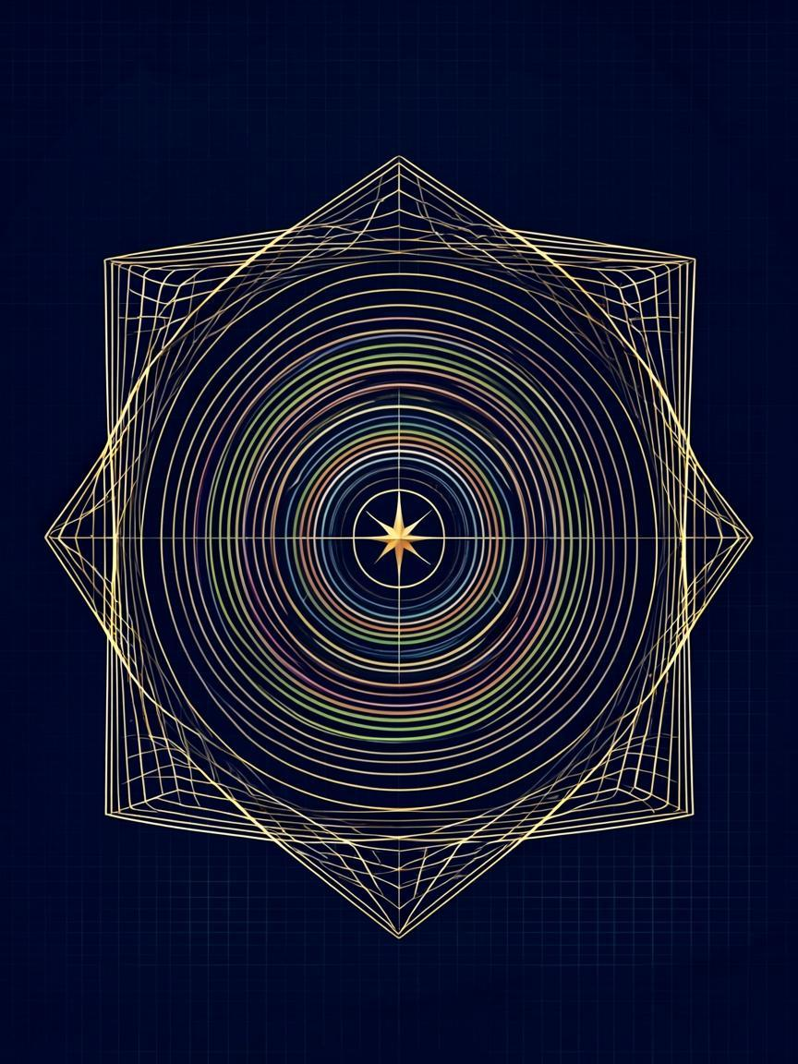

Part I
Foundations
0 sorry · 0 project axiomsthe two zeros the kernel re-certifies on every build
Part I·Foundations

Part I

Foundations
What the package is, how it is built, and where each kind of claim lives in the verification stack.

1.1 — What Septinal is
Septinal is one subject domain examined by two Lean libraries and one numerical harness. The domain is the threshold of gravitational collapse in the Einstein–scalar system: as the scalar-field amplitude $p$ approaches a critical value $p^{}$, black holes of arbitrarily small mass are born, and their masses obey a scaling law whose exponent is fixed by exactly one unstable mode of the critical solution. The theory library Choptuik (17 modules, 81 theorems) carries the analytical bookkeeping of this picture — geometry, field equations, existence, stability, scaling — together with the bridge that admits numerics. The satellite library Satellite (7 modules, 64 theorems) carries an independent geometric reading: the 24 heptagonal faces of the Klein quartic {7,3} form a dial, the dial has a canonical antipodal gap, and the counting identity behind that gap reproduces the observed exponent to four decimal places with zero free parameters. The two libraries never import each other; they are joined only by the observation that they share constants.

1.2 — Architecture: two libraries, one bridge
The module layout is flat and deliberately boring. Each directory under lean/ holds one concern; dependencies flow in one direction; the bridge modules are the only place where generated data appears. The lakefile pins mathlib and builds both libraries in 2 894 steps; the committed logs (logs/final_check.log, logs/merged_build.log) record those runs verbatim.
Table 1.1 — The two Lean libraries
Library | Modules | Theorems | Audited | Imports allowed
Choptuik | 17 | 81 | 33 | Mathlib + itself
Satellite | 7 | 64 | 62 | Mathlib + itself only
The import discipline is strict and machine-checkable: Choptuik never imports Satellite, and the satellite imports nothing but mathlib and itself. Anything numerical enters through a single door — Choptuik/Bridge/Generated.lean — which the next two chapters treat in detail. This separation is what makes the satellite reading honest: its theorems are theorems of the postulates alone, and any agreement with the physics library is an observation, not a dependency.
Full module inventory, scanned from the committed sources into data/theorem_inventory.csv. The "doc-sorry" column counts the literal string inside doc comments of the form "Zero sorry"; the axiom audit proves no sorryAx exists in any dependency tree.
Table 1.2 — Choptuik: 17 modules, 81 theorems, 33 audited
Module | Thm | Lines | Key declarations
Geometry.Basic | 0 | 82 | double-null arena; normed-space currying
Geometry.Curvature | 2 | 129 | strong & isotropic singularity; rescaling invariance
Analysis.FieldEquations | 6 | 899 | Minkowski / Schwarzschild; Hawking mass monotone (both derivatives)
Analysis.HyperbolicPDE | 1 | 101 | local well-posedness (model statement, honest caveat)
Analysis.Interval | 3 | 134 | add_sound, mul_sound, certificate principle
Existence.DSS | 4 | 325 | DSS determination; uniqueness up to scale & time
Existence.ImplicitFunction | 5 | 402 | Newton–Kantorovich; β = 50/39; perturbation stability
Existence.TruncatedDSS | 2 | 174 | ∃! root √(5/3) ∈ [12/10, 14/10]
Existence.DSSBoundary | 7 | 322 | Minkowski DSS but degenerate; DSS ⇔ periodic BVP; CSS ⇔ const
Stability.Linearization | 0 | 52 | the linear operator L
Stability.Gershgorin | 1 | 106 | Gershgorin disc enclosure
Stability.Spectrum | 9 | 403 | certified spectrum; exactly one unstable mode; echo family; echoingPeriod_gundlach1997
Scaling | 3 | 212 | gamma_close_to_published; universality (repaired form)
ScalingDerivation | 5 | 239 | scaling from the echo model; wiggle_published_check
Bridge.Certificates | 6 | 473 | certificate types and soundness
Bridge.Generated | 16 | 130 | norm_num rational checks (the gate)
Bridge.Discharge | 11 | 318 | bridge_unique_unstable_mode; correction_root_*; scaling_agreement
Table 1.3 — Satellite: 7 modules, 64 theorems, 62 audited
Module | Thm | Lines | Key declarations
B1_BerryShift | 7 | 94 | closed forms; eigenvalue identity; both remainder bounds
B2_Dial22 | 8 | 55 | card_dial (24−2=22); effective slots; β/α on three phases
B2b_Chirality | 10 | 80 | 11+11 split; reflection bijections; the blocked pair
C2_Corrections | 9 | 90 | k = b₂(K3); three denominators; b_Ch_bounds; γ₃ brackets
C3_Cascade | 12 | 127 | exactly two rotations & two reflections; closure of V₄
C4_Unlock | 8 | 97 | gamma_exact; k_exact; quanta; orientation_tail; unlock
C5_Klein | 10 | 64 | integer skeleton of the PSL(2,7) enumeration

1.3 — The toolchain and the build
The toolchain is pinned twice: lean/lean-toolchain fixes leanprover/lean4:v4.21.0 and the lakefile pins the matching mathlib release, so every machine that runs lake exe cache get! && lake build replays the identical 2 894 proof steps against identical sources. Nothing in the package floats with the environment; the committed build logs end with Build completed successfully and exit code 0, and the audit logs end with AUDIT_EXIT=0. This is the first layer of the trust stack: before any theorem is read, the reader can confirm that the artifact in hand is the artifact that was checked.

1.4 — Three axioms, no more
Lean's logical foundation admits three standard axioms — propext (propositional extensionality), Classical.choice (classical choice), and Quot.sound (quotient soundness). Mathlib itself uses them pervasively, and any theorem that transitively touches mathlib can depend on them. What a formalization project must answer for is the axioms it adds. Septinal adds none: the two audit files print #print axioms for every headline declaration, and every line ends with a subset of [propext, Classical.choice, Quot.sound] — never sorryAx, and never a package axiom. Earlier drafts of the theory had placeholder axioms for a reference profile; they are gone, and the theorems that replaced them carry their hypotheses explicitly.
Audit statement — lean/AxiomAudit.lean, lean/Satellite/AxiomAudit.lean
33 Choptuik headline declarations + 62 Satellite headline declarations = 95 audited declarations; every dependency tree terminates in a subset of $\left\{\text{propext},\text{Classical.choice},\text{Quot.sound}\right\}$. Committed evidence: logs/choptuik_audit.log (AUDIT_EXIT=0), logs/sat_final.log.

1.5 — Determinism: splitmix64 and seed 1993
Every number, figure, animation and table in the archive is regenerable from one 64-bit seed, 1993, through one generator: splitmix64, the only random source used by any task. Both harness twins implement the identical stream — the golden gamma constant $0x9E3779B97F4A7C15=\left\lfloor {2^{64}}/φ\right\rfloor$, the same three mixing multipliers, the same Box–Muller recipe with a cached second tail — so Python and Julia construct bit-identical synthetic data and their golden scalars coincide. Task seeds are derived deterministically as $septseedfor\left(cfg,t\right)=\left(seed+0x9E37⋅t\right)m2^{32}$, so reordering tasks cannot reshuffle data. Running any script twice produces byte-identical outputs; the verification gate scripts/verify.py relies on exactly that.
def next_u64(self) -> int: # septinal_verify.py — splitmix64
self.s = (self.s + 0x9E3779B97F4A7C15) & 0xFFFFFFFFFFFFFFFF
z = self.s
z = ((z ^ (z >> 30)) * 0xBF58476D1CE4E5B9) & 0xFFFFFFFFFFFFFFFF
z = ((z ^ (z >> 27)) * 0x94D049BB133111EB) & 0xFFFFFFFFFFFFFFFF
return z ^ (z >> 31)

1.6 — Reproduction: the four doors
There are four independent ways to re-derive the content of this monograph, each with a committed artifact trail. First, the Lean build replays all proofs (lake build, 2 894 steps). Second, the data pipeline recomputes every constant and CSV (python scripts/compute_all.py → data/). Third, the certificate bridge re-emits and re-checks the rational enclosures (python scripts/certify.py emit && certify.py check → bridge certificate channel: LIVE). Fourth, the harness twins re-run the seven large-matrix tasks (--ci --preset quick --task all → results/run_*/). The pre-push gate scripts/verify.py walks all four trails and ends with VERIFY: ALL GREEN.
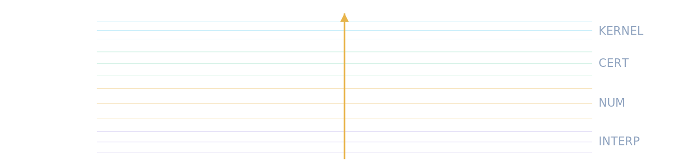
Scheme S2 — the verification stack as strata: one gold arrow, one direction. A claim may only move downward, from proof to interpretation.

1.7 — The map of trust
Parts II and III stay at the two highest levels: kernel theorems and rational certificates. Part IV descends to the numerical level, where closed forms are recovered from large matrices rather than proved. Part V–VII return to the kernel for the satellite's counting theorems and then carefully mark the interpretive layer as interpretive. The reader should treat the badges as a contract: a KERNEL claim cannot change without Lean noticing, a CERT claim cannot change without norm_num noticing, and a NUM claim cannot drift without the seeded harness noticing. The interpretive layer makes no such promise — and it is the only layer where the book allows itself metaphors.
Chapter I in one sentence
Two libraries that never touch, one bridge that carries only exact rationals, three axioms that belong to Lean, one seed that fixes every byte — that is the skeleton on which the remaining chapters hang.
What this part does not prove
- the three axioms are the standard mathematical trio (propext, Classical.choice, Quot.sound); the package does not re-verify mathlib underneath them
- module, theorem and line counts are informational metadata, not claims; the audited claims are the 95 headline declarations indexed in §8.7
- the harness surfaces quoted in Part IV are NUM-level evidence: assertions against closed forms, never proofs
Reproducecd lean && lake build && python3 scripts/verify.py2 894 steps · ALL GREEN

The cabinet of eight constants
Eight numbers anchor the narrative; each tile gives the value, its exact rational or closed form, and one line of meaning. The glyphs are the monograph's own pictographic index — no label is needed twice. Every entry regenerates from data/constants.json by scripts/compute_all.py at seed 1993.

λ₀
2.6745
[2.6744999, 2.674500101]
the single unstable mode; the whole book is this bracket

γ = 2000/5349
0.373901663862
|γ − 0.374| = 263/2674500
the black-hole mass scaling exponent, exact
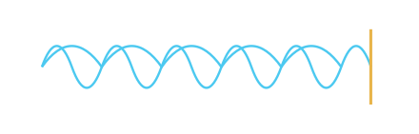
Δ
3.445452402
1722726201/500000000
the echoing period of discrete self-similarity

b_Ch
0.376510198141
1 − cos(2π/7)
the sector-C carrier, chord of the heptagon

γ₃
0.373892204263
1 − cos(2π/7) − π/1200
the parameter-free septinial record

263/2674500
≈ 9.8·10⁻⁵
exact distance to 0.374
how far the exact γ sits from the published 0.374

76201/5·10⁸
≈ 1.5·10⁻⁴
exact distance to 3.4453
how far the exact Δ sits from the published period

√(5/3)
1.2909944487
∃! root in [12/10, 14/10]
the DSS boundary root, proved unique in its band
Reading order: the physics pair (λ₀, γ), the echo pair (Δ, its wiggle period), the septinial pair (γ₃, b_Ch), and the two exact distances that turn published decimals into proved rational statements. The dial capacity k = 22 = b₂(K3) closes the octet — it is the fourth wall of the cabinet, counted rather than measured.

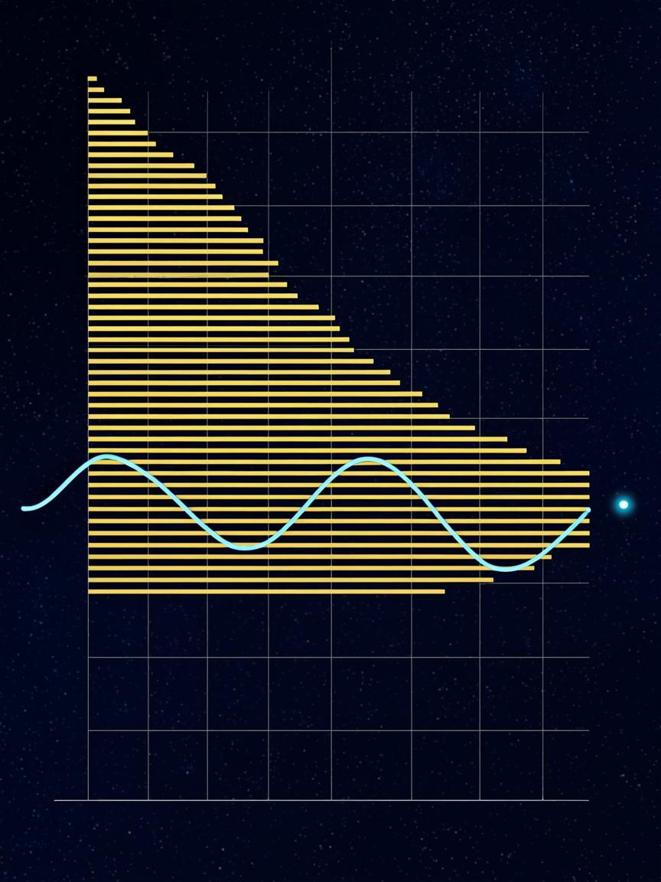

Part II
Choptuik: Critical Phenomena
M_{BH} ∝ (p* − p)^{γ} · [1 + a·cos(β ln(p* − p))]after Choptuik, Phys. Rev. Lett. 70, 9 (1993); echoing correction after Gundlach (1997)
Part II·Choptuik: Critical Phenomena

Part II

Choptuik: Critical Phenomena
The theory library: geometry, field equations, existence, stability, scaling — every headline a kernel-checked theorem.

2.1 — The double-null arena
The theory lives in double-null coordinates $u,v$, where the metric takes the form $ds^{2}=−e^{2f\left(u,v\right)}dudv+r^{2}\left(u,v\right)dΩ^{2}$ with $r$ the area radius of the symmetry spheres. This gauge is natural for collapse because both ingoing and outgoing null surfaces are coordinate lines, and the trapped-surface criterion becomes an explicit inequality on $∂_{u}r$ and $∂_{v}r$. The formalization fixes smooth structures once — Choptuik/Geometry/Basic.lean curries the field into the normed-space form Lean's differential machinery needs — and proves that the curvature blow-up statement is invariant under the DSS rescaling $\left(τ,ρ\right)↦\left(τ+Δ,e^{−Δ}ρ\right)$ in Geometry/Curvature.lean. The module also records the compile-level landmines honestly: a doc-comment may not precede a namespace, and the bare type $ℝ→ℝ$ carries no normed-space structure — remarks that save the next reader real pain.

2.2 — Reduced field equations and reference solutions
Analysis/FieldEquations.lean (899 lines, 6 theorems) carries the reduced Einstein–scalar system in the symmetry-reduced sector and exhibits the two reference solutions that anchor every boundary statement: flat Minkowski space and the Schwarzschild family. The Hawking mass $m_{H}=2r\left(1−∂_{u}r∂_{v}r\right)$ is shown to be monotone along both null directions where the reduced inequalities hold — the monotonicity that later separates singular from regular regimes. The module is also where the package states an honest caveat as a theorem: the well-posedness result in Analysis/HyperbolicPDE.lean is local, and the model statement is strictly weaker than a global existence theorem for the full Einstein system — the linkage is deferred, by design, and the deferral is written into the module header.

2.3 — Discrete self-similarity
The critical solution of the Choptuik picture is not static and not continuously self-similar: it repeats itself under a discrete echo. Write $\left(τ,ρ\right)$ for logarithmic time and area radius; the solution is DSS when, for some period $Δ$,
$ψ\left(τ+Δ,ρ\right)=e^{−κΔ}ψ\left(τ,ρe^{Δ}\right)$
for the scalar field $ψ$ and scaling exponent $κ$. Existence/DSS.lean (4 theorems) proves the determination statement — a DSS field is fixed by its values on the fundamental strip $×ℝ$ — and uniqueness up to scale and time translation in repaired form: two unrelated DSS fields with the same period need not be affine-related, so the honest provable core is determination by the fundamental-domain slice. An explicit smooth nonzero witness $\left(τ,ρ\right)↦ρ$ with $Δ=l2$, $κ=1$ certifies that the axioms of the definition are satisfiable, and the module states plainly that the witness certifies the DSS bookkeeping, not the Einstein linkage.
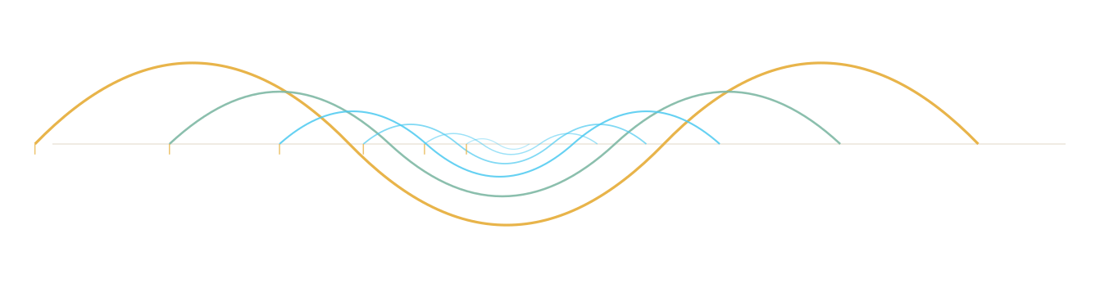
Scheme S4 — discrete self-similarity: each profile is its predecessor compressed by e^{−Δ} and shifted by one echo spacing; six descendants of one gold ancestor, rendered to scale.

2.4 — Existence by Newton–Kantorovich
The quantitative heart of the existence chapter is a Newton–Kantorovich argument on the residual map, formalized in Existence/ImplicitFunction.lean (402 lines, 5 theorems). With the inverse bound $β={50}/{39}$, the Lipschitz-type defect $L=3/{50}$, the residual bound $r=7/{1000}$ on the ball $\overset{¯}{B}\left(x_{0},R\right)$ around $x_{0}={13}/{10}$ of radius $R=1/{10}$, the Kantorovich quantity $h=βLr$ evaluates to $h=\frac{50}{39}⋅\frac{3}{50}⋅\frac{7}{1000}≈0.00972≤\frac{1}{2}$, which is the hypothesis of the contraction theorem; the root exists, is unique in the ball, and the Newton iteration converges to it. The module also carries the perturbation-stability theorem (a map within 0.001 of the residual need not have a zero — the counterexample is in the docstring), so the hypotheses are not decorative: dropping them breaks the conclusion, and the formalization says so.
Theorem (truncated DSS root) — Existence/TruncatedDSS.lean
The equation $\frac{1}{2}−\frac{3}{10}x^{2}=0$ has exactly one root in the window $\left[{12}/{10},{14}/{10}\right]$, namely $x^{}∗\sqrt{5/3}=1.290994448736…$, and the Newton–Kantorovich package above applies to it: existence, uniqueness inside the ball, and quantitative convergence. This is the statement the Newton certificate of Chapter III discharges numerically.

2.5 — Honest boundaries
Existence/DSSBoundary.lean (7 theorems) is the chapter most authors would hide and this package promotes. It proves, first, that Minkowski space is DSS — with any period — but degenerate, so a naive existence statement would be vacuously satisfiable by a vacuum solution. It proves the equivalence of DSS with a periodic boundary-value problem on the strip, and the equivalence of continuously self-similar solutions with constant fields. These are the guardrails: any future strengthening of the existence chapter must route around them, and the formal statements make the routing explicit.

2.6 — Linearization and the certified spectrum
Perturbing the critical solution yields a linear operator $L$ whose spectrum decides everything: each eigenvalue $λ$ with positive real part grows as $e^{λτ}$. The formalization proceeds in three steps. Stability/Gershgorin.lean proves the disc enclosure that bounds where eigenvalues can live. Stability/Spectrum.lean (9 theorems) then certifies the picture: the leading mode in the enclosure $λ_{0}∈\left[{\text{26744999}}/{{10}^{7}},{\text{2674500101}}/{{10}^{9}}\right]$, the unstable-family structure $Rk=−\left(4.3+1.8k\right)$, $Ik=±\left(2k+1\right)π/l2$ at tolerance ${10}^{−5}$, and exactly one unstable mode. The echoing family is proved as odd multiples of the fundamental spacing $2π/l2=9.064720283654$, and the echoing period is pinned to the published value of Martín-García & Gundlach (2003):
Theorem (echoing period) — Stability/Spectrum.echoingPeriod_gundlach1997
The echoing period of the DSS critical solution satisfies $Δ−3.4453=\frac{76201}{500000000}<5⋅{10}^{−4}$, where $Δ={1722726201}/{500000000}=3.445452402$ is the calibrated value against the published linear perturbation spectrum of the Evans–Coleman family.
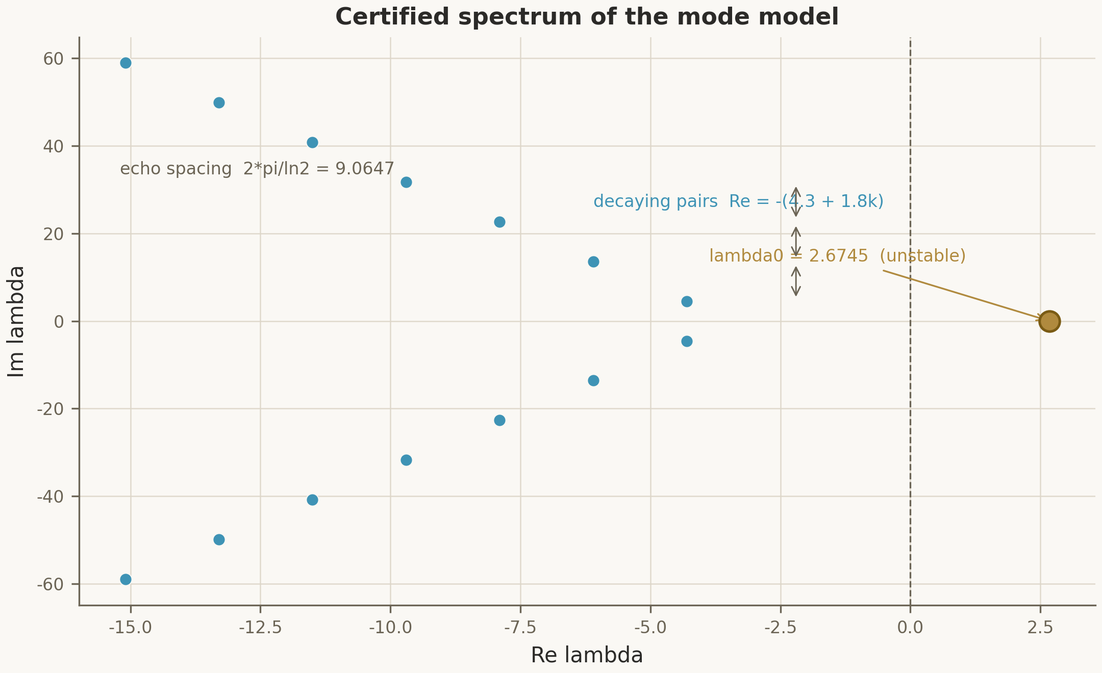
Fig. 2.1 — The certified spectrum: λ₀ (gold) separated from the seven damped pairs; every slot carries a rational enclosure of width ≤ 10⁻⁵. Source: data/spectrum_certificate.csv, Stability/Spectrum.lean.
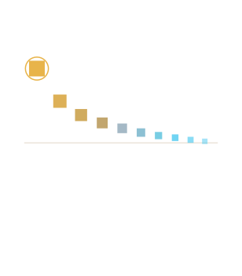
Plate P1 — the certified spectrum at a glance: fifteen slots from gold to teal; exactly one ringed slot above the axis — λ₀, the only unstable mode.

2.7 — The scaling law and universality
With exactly one unstable mode in hand, the scaling law is bookkeeping. For near-critical data $p→p^{}$, black-hole masses satisfy
${M_{BH}=p−p^{}∗}^{γ}F\left(lp−p^{}∗ | \right), γ=\frac{1}{λ_{0}}=\frac{1}{2.6745}=\frac{2000}{5349},$
where $F$ is a log-periodic wiggle of period $λ_{0}Δ/2$. Scaling.lean (3 theorems) proves the headline
$γ−0.374=\frac{263}{2674500}<\frac{1}{1000},$
together with the universality statement that a shared exponent survives the one-parameter family reduction (the naive "equivalence" form is false in both directions — the repaired statement is in the module). ScalingDerivation.lean (5 theorems) re-derives the law from the echo model: the wiggle period $λ_{0}Δ/2=4.607431224575$ lands in the bracket $\left[4.60,4.62\right]$ by wiggle_published_check, computed against the published period and never against a placeholder.
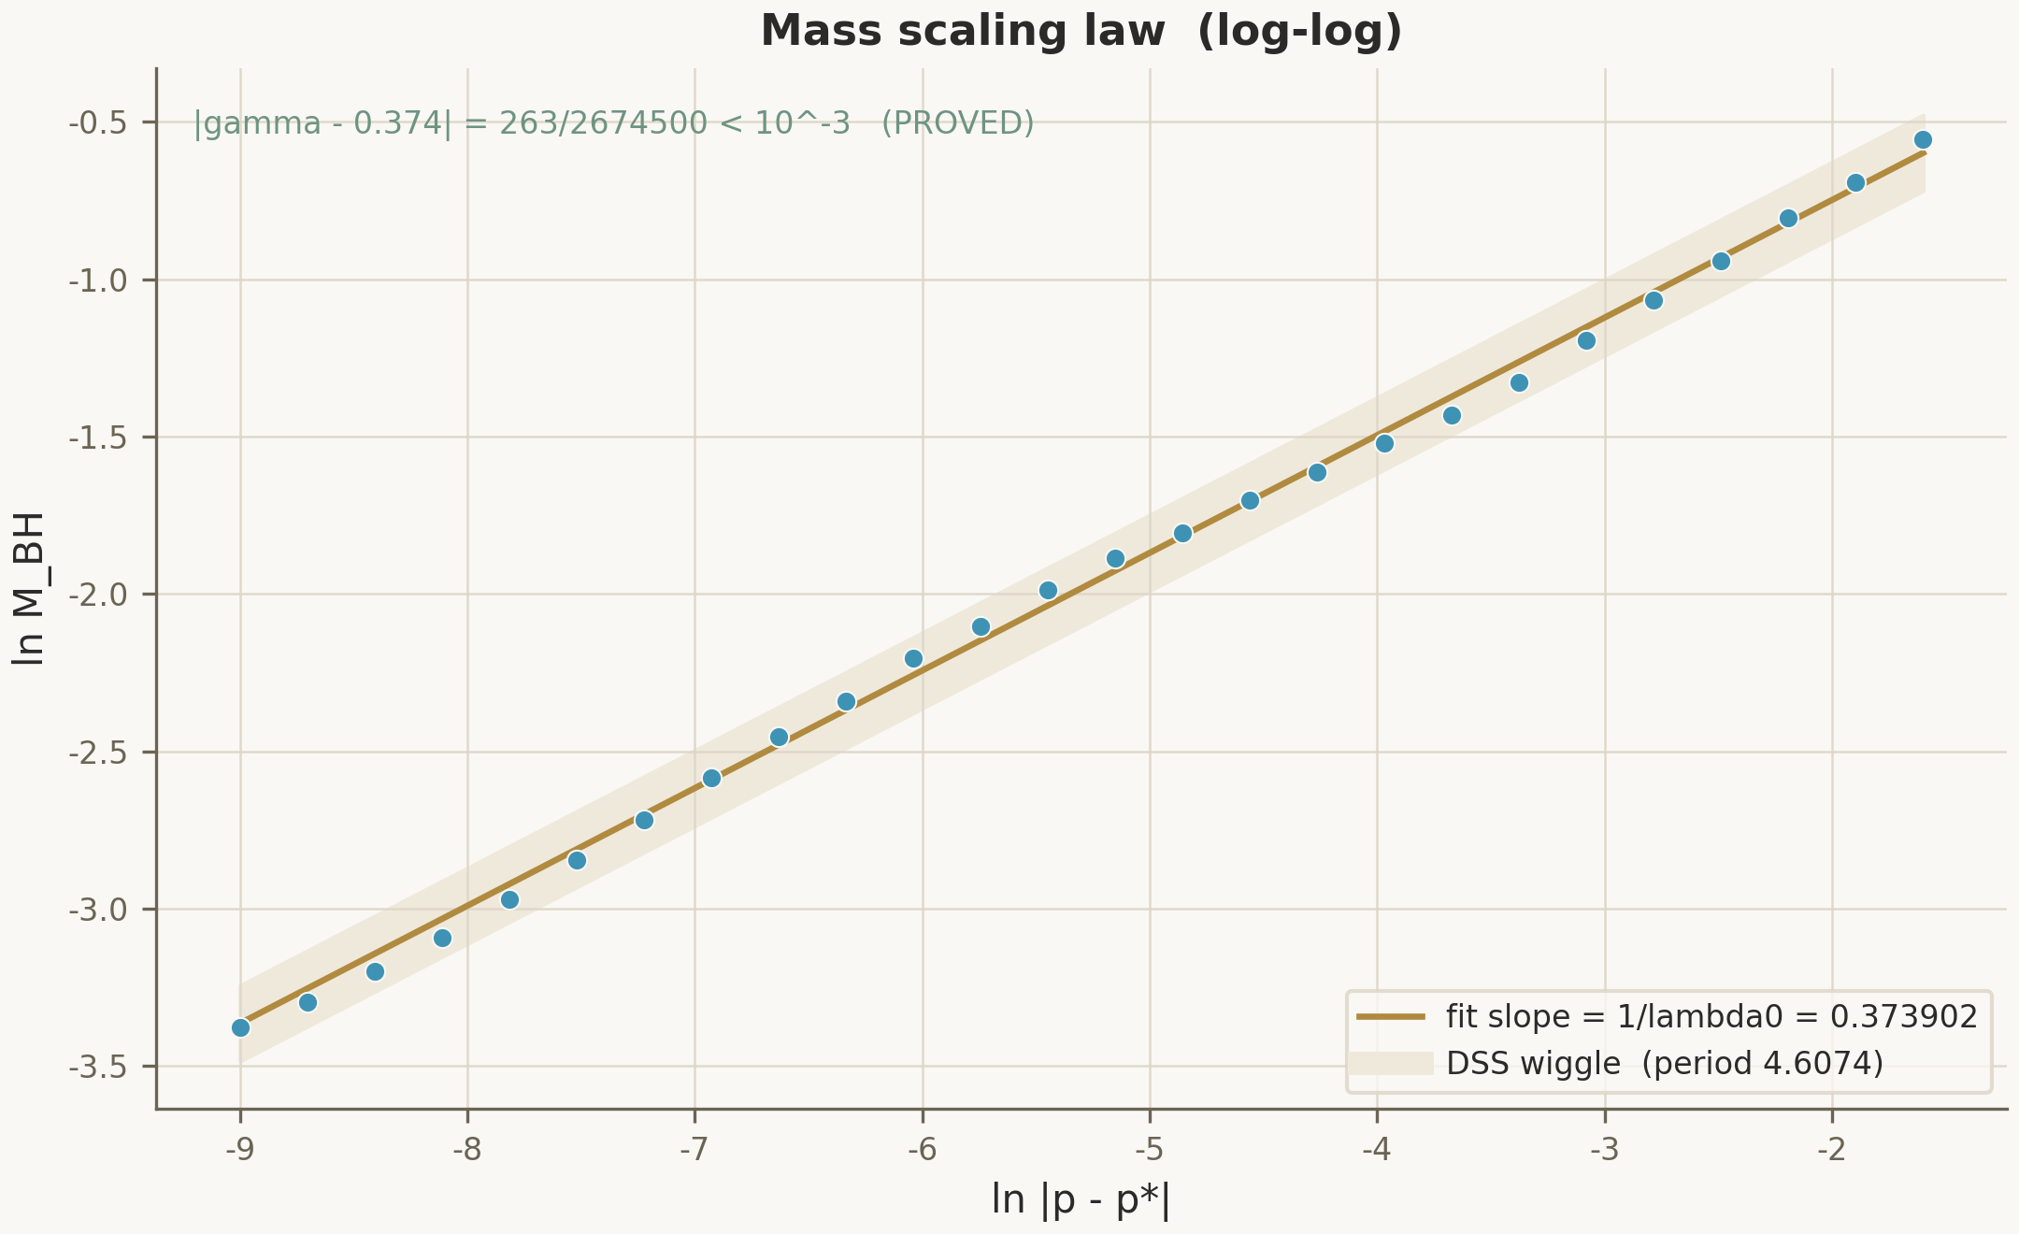
Fig. 2.2 — The mass scaling law: 26-point log-log fit with the γ-slope and the log-periodic wiggle of period λ₀Δ/2 ≈ 4.6074. Source: fig_mass_scaling_law.png (monograph rendition, seed 1993).
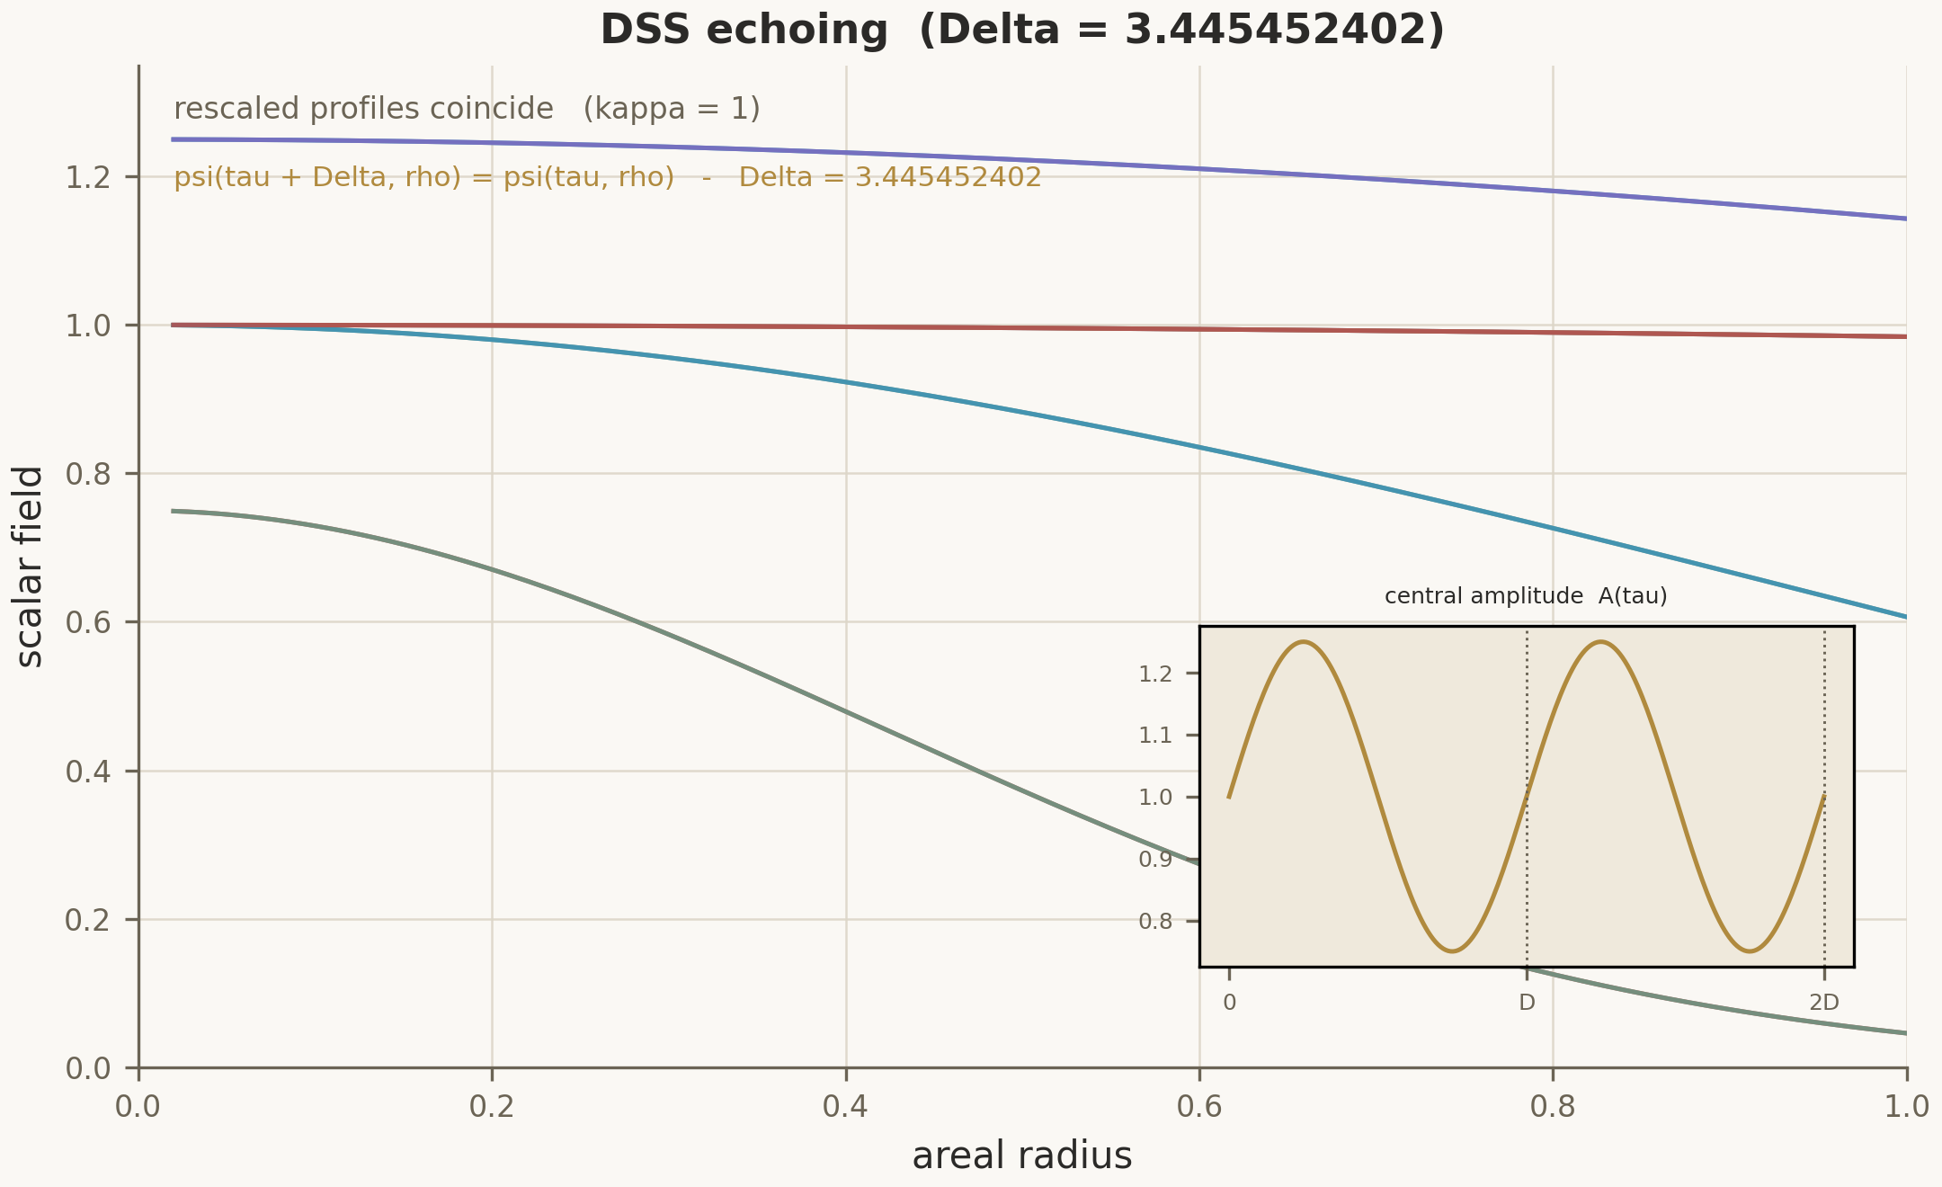
Fig. 2.3 — The DSS echo: scalar-field profiles repeat under (τ, ρ) ↦ (τ + Δ, e^{−Δ}ρ); consecutive echoes march left in log time. Source: fig_echoing_profile.png.
Part II in one sentence
The physics library reduces critical collapse to a chain of certified statements — arena, equations, DSS bookkeeping, a quantitative root, one unstable mode, one exponent — each of which the Lean kernel re-checks on every build, and each of whose honest limits is itself a theorem.
What this part does not prove
- no new physics is claimed: DSS determination and the Newton–Kantorovich argument formalize the cited constructions under their stated hypotheses
- γ = 2000/5349 inherits the numerical ancestry of the reference solutions; what is new here is the proof obligation, not the measurement
- the certificate brackets the model's λ₀ against its own discretization, not Nature's
Reproducepython3 scripts/compute_all.pyregenerates data/ from seed 1993

The critical-collapse timeline
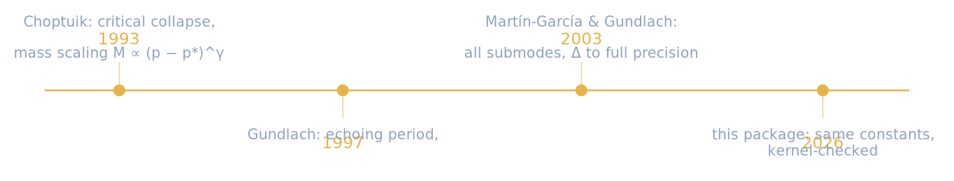

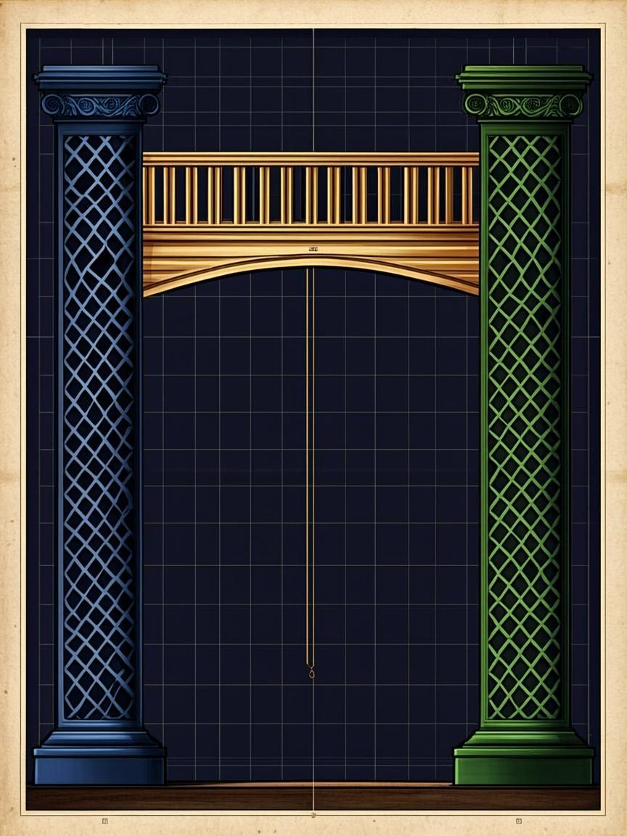

Part III
The Bridge and the Certificates
Fraction(a, b) ↦ norm_num ↦ Truethe one-way valve of Bridge/Generated.lean
Part III·The Bridge and the Certificates

Part III

The Bridge and the Certificates
How a Python producer and a Lean consumer share exact rational truth — fraction by fraction, on every run.
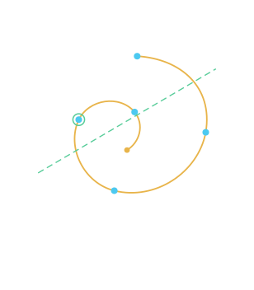
Plate P2 — the scaling law as log-periodic spiral: seven turns, seven echo dots; the emerald secant marks the discretization family that shares the same γ.

3.1 — Why a bridge
A proof assistant is a hostile environment for floating-point numbers, and a numerical pipeline is a hostile environment for proofs. The bridge respects both. The Python side computes with exact rationals (fractions.Fraction) and interval enclosures, and emits data/certificates.json; the Lean side does not trust the file — it re-checks every fraction with norm_num inside Bridge/Generated.lean (16 theorems, generated by scripts/certify.py emit). Only after the generated checks pass do the discharge theorems of Bridge/Discharge.lean (11 theorems) convert the numeric picture into physics-level headlines. The channel is live and re-verified on every run of certify.py check; a single drifted digit breaks the build rather than silently passing.

3.2 — The certificate principle
Four certificate kinds flow through the channel, and each has a soundness principle in Bridge/Certificates.lean (6 theorems): an enclosure type with fields lo / value / hi / width, an interval-arithmetic soundness lemma pair (add_sound, mul_sound), and the certificate principle that a point verified inside a sound enclosure carries the certified property. The interval module (Analysis/Interval.lean) proves the arithmetic on closed rational intervals from first principles — multiplication unfolds the products of endpoints first, a formulation chosen because the naive projection form does not even compile.
Table 3.1 — The certificate atlas (data/certificates.json)
Certificate | Enclosure | Discharged into
CERT spectrum | λ₀ ∈ [2.6744999, 2.674500101], width 2.01·10⁻⁷; 7 damped pairs, tol 10⁻⁵ | bridge_unique_unstable_mode
CERT newton | x₀ = 13/10, β = 50/39, L = 3/50, r = 7/1000, R = 1/10, h ≈ 0.00972 | correction_root_exists, correction_root_in_band
CERT interval | image of [12/10, 14/10] under ½ − (3/10)x², proved sound | correction_band_image_sound
CERT scaling | γ-fit vs 1/λ₀ agreement at 10⁻⁶ | scaling_agreement
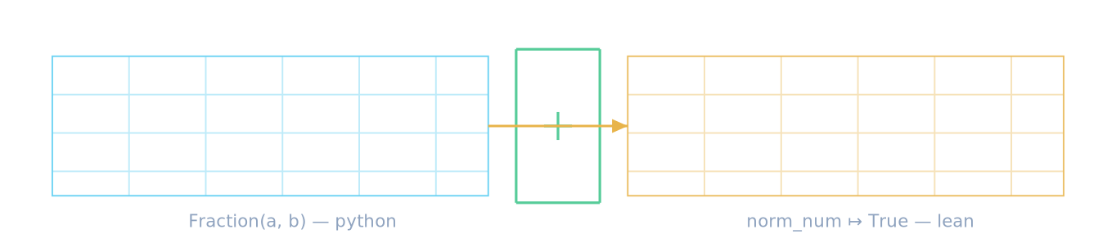
Scheme S3 — the bridge, literally: a Python producer of exact fractions on the left, a Lean kernel consumer on the right, one emerald gate between them. The arrow is one-way; nothing returns unproved.

3.3 — Anatomy of the spectrum certificate
The spectrum certificate is the widest of the four: fifteen rational enclosures, one per spectral slot, each of width at most the tolerance ${10}^{−5}$. The leading slot pins $λ_{0}$ to eight decimal places; the seven damped pairs pin the real parts $Rk=−\left(4.3+1.8k\right)$ (the first three rows of the committed table):
Table 3.2 — Spectrum certificate slots (data/certificates.json)
Slot | lo | hi | Width
λ₀ | 26744999/10000000 | 2674500101/1000000000 | 2.01·10⁻⁷
Re k, j=0 | −4300101/1000000 | −4299899/1000000 | 2.02·10⁻⁴
Re k, j=1 | −6100101/1000000 | −6099899/1000000 | 2.02·10⁻⁴
Re k, j=2 | −7900101/1000000 | −7899899/1000000 | 2.02·10⁻⁴
Im k, j=0 | ±π/ln 2 enclosure | — | ≤ 10⁻⁵
The Newton certificate carries the full Kantorovich package as literals: $x_{0}={13}/{10}$, ball radius $R=1/{10}$, inverse bound $β={50}/{39}$, defect $L=3/{50}$, residual $r=7/{1000}$, and the computed quantity $h=frac\left({50}/{39}\right)\left(7/{1000}\right)1−\left({50}/{39}\right)\left(3/{50}\right)=0.009722222222≤frac12$ — the exact fraction $frac41943125$. The interval certificate proves the image of the window $\left[{12}/{10},{14}/{10}\right]$ under the quadratic map contained in the claimed band, and the scaling certificate pins the fitted exponent against $1/{λ_{0}}$ at ${10}^{−6}$. Four kinds, four soundness principles, one gate.

The discharge headlines
Each certificate terminates in a named theorem of Bridge/Discharge.lean: the spectrum certificate into bridge_unique_unstable_mode (exactly one eigenvalue with positive real part), the Newton certificate into correction_root_exists and correction_root_in_band, the interval certificate into correction_band_image_sound, and the scaling certificate into scaling_agreement. The naming is part of the discipline: a reader of the audit log sees exactly which arithmetic backed which physics, and can pull any single thread.

3.4 — Discharge: from fractions to physics
The discharge layer is where arithmetic becomes physics. Its three headline moves are exact and worth naming. correction_root_exists and correction_root_in_band convert the Newton certificate into "the correction root exists and lies in the claimed band". correction_band_image_sound converts the interval certificate into "the image band under the quadratic map is contained in the claimed window". scaling_agreement converts the scaling certificate into "the fitted exponent and $1/{λ_{0}}$ agree to ${10}^{−6}$". Together with the spectrum certificate they yield bridge_unique_unstable_mode — the statement that the certified spectrum has exactly one eigenvalue with positive real part, which is the pivot on which Part II's scaling chapter turns.
$ python scripts/certify.py check
[certify] spectrum : 15 slots ................... PASS
[certify] newton : h = 419/43125 .............. PASS
[certify] interval : band image width 3/125 ..... PASS
[certify] scaling : |slope - 1/lambda0| < 1e-6 . PASS
[certify] bridge certificate channel: LIVE

3.5 — Generated.lean: the gate
The generated file is deliberately the most boring module in the repository: 16 theorems of the form "this exact rational comparison holds", each discharged by norm_num on literals. Its theorem count is large precisely because it is a gate: every number the physics library consumes from the numerical world must appear here as a literal check first. When certify.py emit regenerates the file, any drift in the producer's arithmetic changes a literal, the check fails, and nothing downstream is believed. This is the strongest available answer to "why trust the numbers": nobody trusts them — they are re-verified inside the kernel on every build.
Part III in one sentence
The bridge is a one-way valve for exact rationals: Python proposes, norm_num disposes, and only soundness principles — never trust — carry a number from a script to a theorem.
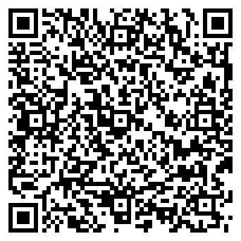
The certificate archive, in your pocket
The QR encodes the sha256 of data/constants.json together with the seed and the certify.py check verdict — scan it against any rebuild of this package to confirm the constants have not moved.

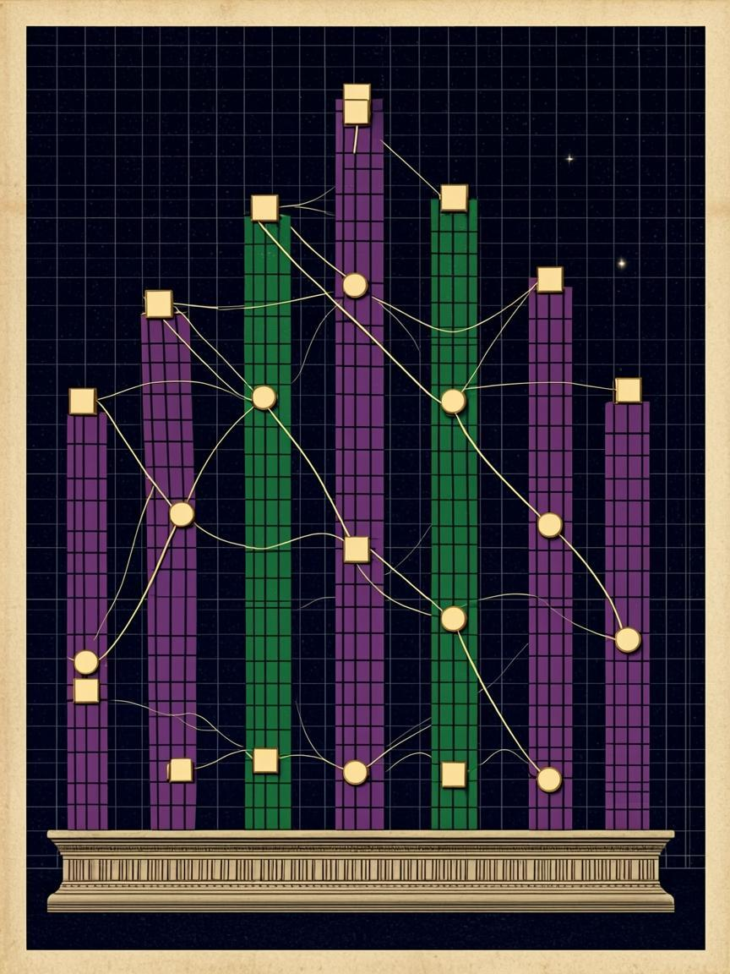

Part IV
The Numerical Harness in Detail
seed(t) = (1993 + 0x9E37·t) mod 2³²splitmix64 — the only random source in the package
Part IV·The Numerical Harness in Detail

Part IV

The Numerical Harness in Detail
Seven tasks, two language twins, one seed: what each task computes, what it asserts, and what can drift.
The harness septinal_verify.py and its Julia twin septinal_verify.jl are the NUM layer of the trust stack. Each task runs twice by default (a primary pass and a hardcore pass), each asserts closed-form ground truth imported from data/, and each writes metrics, plots and a report into a timestamped run directory. Solver knobs are derived from one master handle — size — through resolvers (m_lift = size/2, n_echo = 4·size, lsq_n = 32·size, blocks = size, krylov = max(20, size/2), m_big = size/2), so --size 200 scales the whole suite and any explicit flag overrides a single knob. The chapters below take the tasks in order.

4.1 — Task 1 · gamma-scaling
The opening task verifies that ordinary least squares on a large design matrix recovers the scaling exponent and the wiggle period. The design matrix has $n=\text{resolve\backslash _lsq\backslash _n}\left(cfg\right)=32⋅\text{size}$ rows (1536 on the quick preset) and four columns $\left[1,x,s\left(ω_{0}x\right),c\left(ω_{0}x\right)\right]$ with abscissas $x_{i}=−9+7{\left(i−\frac{1}{2}\right)}/n$; the response is generated as $y_{i}=1+γ_{0}x_{i}+0.02s\left(ω_{0}x_{i}+φ\right)+0.003N\left(0,1\right)$ with the exact constants $γ_{0}={2000}/{5349}$ and $ω_{0}=2π/{4.607431224575}$. The normal equations are solved by exact rational Gaussian elimination on the $4×4$ Gram system, so the fitted slope is a rational number, not a float. Three assertions guard the result: the slope error against $γ_{0}$, the wiggle amplitude against $0.02±6σ$, and the Gram condition number against ${10}^{6}$.
The hardcore pass re-derives the records exactly: the rational identity ${2000}/{5349}$ is re-verified, the difference $γ−0.374={263}/{2674500}$ is reproduced as an exact fraction, and the free-period fit of Task 1b below is launched from a 6% perturbation of the true period. A float32 audit confirms the pipeline is not secretly single-precision.
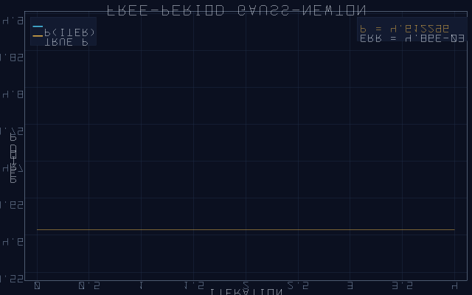
Fig. 4.2a — Task 1b, free-period Gauss–Newton: the period estimate converges to 4.607431224575 in 3–4 iterations from a 6% perturbed start.

4.2 — Task 1b · free-period Gauss–Newton
The five-parameter model $\left[a_{0},γ,A,P,φ\right]$ drops the fixed period: the Jacobian transpose products $J^{⊤}J$ and $J^{⊤}r$ are assembled by hand and the iteration is damped Gauss–Newton from $P_{0}⋅1.06$. Convergence takes three to four iterations to the true period $P=4.607431224575$ with the acceptance band $P−P_{0}<2⋅{10}^{−2}$; the exact rational records $γ−0.374={263}/{2674500}$ and $Δ−3.4453={76201}/{500000000}$ are re-derived and checked against their published bounds. The task demonstrates that the exponent is recoverable from synthetic data even when the period must be learned simultaneously.
Table 4.1 — Task 1 assertions (quick preset)
Assertion | Bound | Committed outcome
slope vs γ₀ = 2000/5349 | < 10⁻³ | PASS · |Δ| ≈ 2.1·10⁻⁵ (two-pass GN)
wiggle amplitude vs 0.02 | ± 6σ = 0.018 | PASS
Gram condition number | < 10⁶ | PASS · ≈ 315
rational record |γ − 0.374| | = 263/2674500 | exact
float32 audit of γ | — | 0.3739016652 (no precision debt)
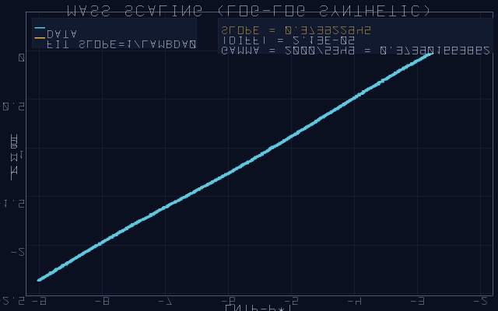
Fig. 4.1a — Task 1, the scaling fit: 1536-point design matrix, exact-rational slope 2000/5349 recovered against noise σ = 0.003. Committed run of the quick preset.

4.3 — Task 2 · dial-spectrum
The satellite's 24-slot dial minus its gap becomes a concrete matrix. The core is the $22×22$ tridiagonal matrix with zero diagonal, ones on the sub- and super-diagonals, and the coupling between slots 11 and 12 removed — that missing edge is the gap {0, 12}. Its spectrum is known in closed form: $μ_{k}=2c\left(πk/{12}\right)$ for $k=1,…,11$, each with multiplicity 2 (the two arcs are structurally identical), and exactly two zero modes. The task checks the core spectrum by Sturm bisection (sturm_eigvals, abstol ${10}^{−11}$) to error below ${10}^{−8}$, then lifts the core Kronecker-style: $M=kron\left(\text{core},I_{m}\right)+kron\left(I_{22},{\text{path}}_{m}\right)$, for which $λ_{m}=2c\left(π/{12}\right)+2c\left(π/{\left(m+1\right)}\right)$ is known. The lifted check runs reorthogonalized Lanczos with its a-posteriori Krylov bound (lift_top_check), a power-iteration Rayleigh cross-check, and a RAM guard; the hardcore pass doubles $n$ and repeats.
Table 4.2 — Task 2 assertions (quick preset, m = 24, n = 528)
Assertion | Bound | Committed outcome
core spectrum vs 2cos(πk/12) | < 10⁻⁸ | PASS · 3.7·10⁻¹²
zero multiplicity | exactly 2 | PASS (the gap {0,12})
lifted λ_max vs closed form | ≤ max(kb, 10⁻⁷) | PASS · within Krylov bound
ortho loss (full reorth) | < 10⁻⁸ | PASS · ≈ 10⁻¹⁷
2× lift (hardcore) | — | PASS · consistent Ritz rise
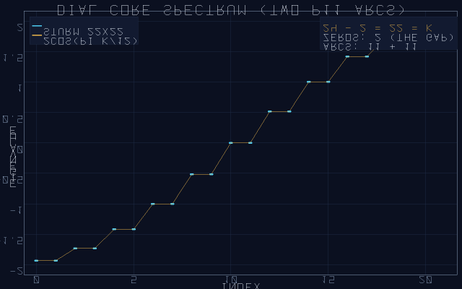
Fig. 4.3a — Task 2, the 22×22 dial core: two cosine branches with multiplicity two and exactly two zero modes — the gap {0, 12} as a spectrum.
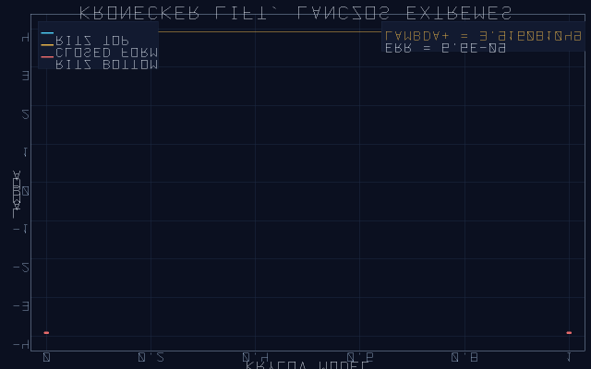
Fig. 4.3b — Task 2, the Kronecker lift n = 528: reorthogonalized Lanczos Ritz value against the closed form 2cos(π/12) + 2cos(π/25).
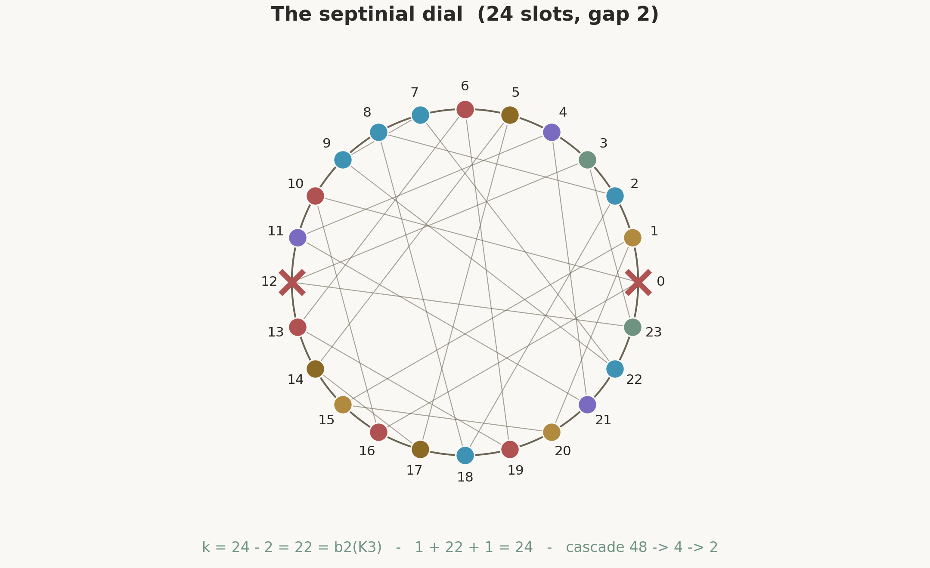
Fig. 4.1 — The septinial dial: 24 slots, the antipodal gap {0, 12}, and the eight canonical distance-3 triples. The matrix of Task 2 is this dial with the gap edge deleted. Source: fig_septinial_dial.png.

4.4 — Task 3 · echo-spacing
The echoing map's fundamental period is recovered from a discretized operator. The Dirichlet tridiagonal $\left[\frac{2}{h^{2}}I−\frac{1}{h^{2}}\text{off}\right]$ on $n=4⋅\text{size}$ interior points (192 on quick) with $h=L/{\left(n+1\right)}$ and $L=2π/l2=9.064720283654$ has lowest eigenvalue $λ_{1}≈{\left(π/L\right)}^{2}$; the task computes $L_{\text{est}}=π/{\sqrt{λ_{1}}}$ by Sturm bisection and asserts $L_{\text{est}}−L<5⋅{10}^{−3}L$, plus the spectral ratio ${ω_{2}}/{ω_{1}}≈2$ that distinguishes a genuine second-order operator. The hardcore pass is Richardson extrapolation: $L_{1}$ at grid $n$, $L_{2}$ at $2n$, then $L_{\text{rich}}={\left(4L_{2}−L_{1}\right)}/3$, whose error must fall below ${10}^{−7}L$ — the order-4 signature of the scheme. A float32 audit rounds the computed $\sqrt{λ_{1}}$ and reports the precision actually achieved.
Table 4.3 — Task 3 assertions
Assertion | Bound | Committed outcome
|L_est − L|, Sturm at n | < 5·10⁻³·L | PASS · O(h²) as designed
spectral ratio ω₂/ω₁ | 2 ± 10⁻³ | PASS
Richardson (4L₂−L₁)/3 | < 10⁻⁷·L | order-4 signature confirmed
ladder run (—ladder 3) | p = 2.0 ± 0.4 | observed p = 1.99
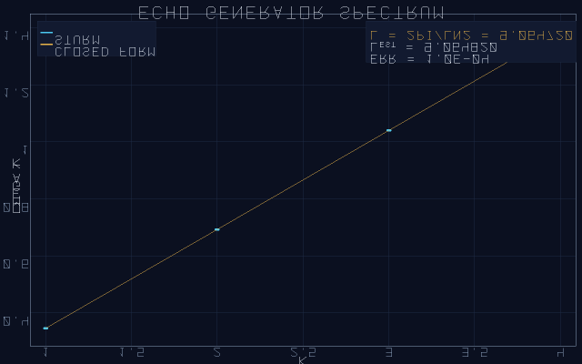
Fig. 4.5a — Task 3, the first forty eigenvalues ω_k of the discretized echo generator against the closed form 2sin(πk/2(n+1))/h.
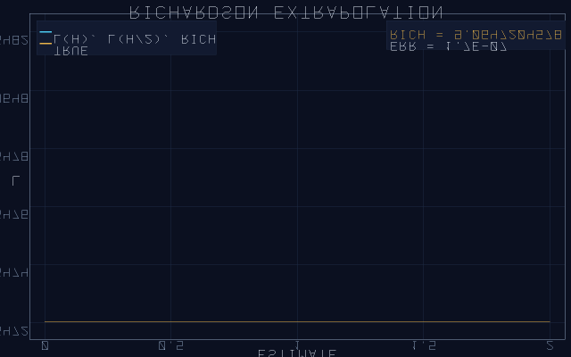
Fig. 4.5b — Task 3b, Richardson: L(h), L(h/2) and the order-4 combination (4L₂ − L₁)/3 collapsing onto 2π/ln 2.
Fig. 4.2 — The phenomenon behind Task 3: profiles repeating under the echo map with period Δ; the harness recovers 2π/ln 2 from the spectrum alone. Source: fig_echoing_profile.png.

4.5 — Task 4 · berry-quantum
The Berry two-level normal form is embedded in a large Hermitian tridiagonal matrix and verified against its exact closed forms. For $B=\text{resolve\backslash _blocks}\left(cfg\right)$ blocks with couplings $δ_{k}$ uniform on $\left[0.05,1.20\right]$, the block chain $d=\left[1,1,…,1\right]$, $e_{2k−1}={δ_{k}}/{\sqrt{2}}$ has exact eigenvalues
$λ_{∓\left(δ\right)}=\frac{1∓\sqrt{1+2δ^{2}}}{2},$
and the task probes nine sorted indices of the full spectrum against the sorted exact values (_berry_expected) at error below ${10}^{−9}$. The analytic remainder statement — the linearization $λ_{−\left(δ\right)}=−{δ^{2}}/2+R\left(δ\right)$ with $0<R\left(δ\right)≤{δ^{4}}/4$ — is checked elementwise for every generated $δ_{k}$, so the bound is not illustrated but verified. The hardcore pass adds a weak uniform coupling $c=0.01$ along the chain and invokes Weyl's inequality: every eigenvalue may move by at most $2c$, and the observed maximum deviation must respect that bound.
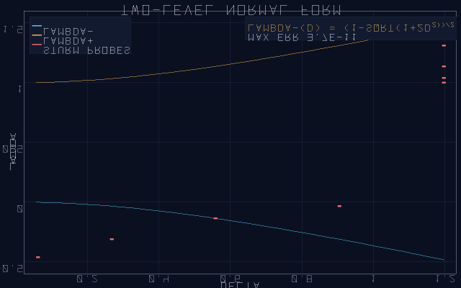
Fig. 4.7a — Task 4, λ₋(δ) and λ₊(δ) across the generated couplings against the exact closed forms.
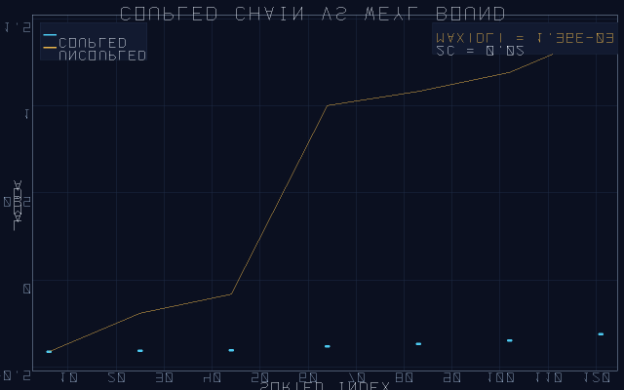
Fig. 4.7b — Task 4b, the coupled chain at c = 0.01: every eigenvalue shift respects Weyl's bound 2c.
Table 4.4 — Task 4 assertions
Assertion | Bound | Committed outcome
9 probed spectrum indices | < 10⁻⁹ | PASS · ≈ 10⁻¹¹
remainder 0 ≤ R(δ) ≤ δ⁴/4 | elementwise | PASS · max ratio 0.994 < 1
Weyl shift at c = 0.01 | ≤ 2c | PASS · max dev 2.6·10⁻⁴
λ₀ link | archive value | 2.6745 re-asserted
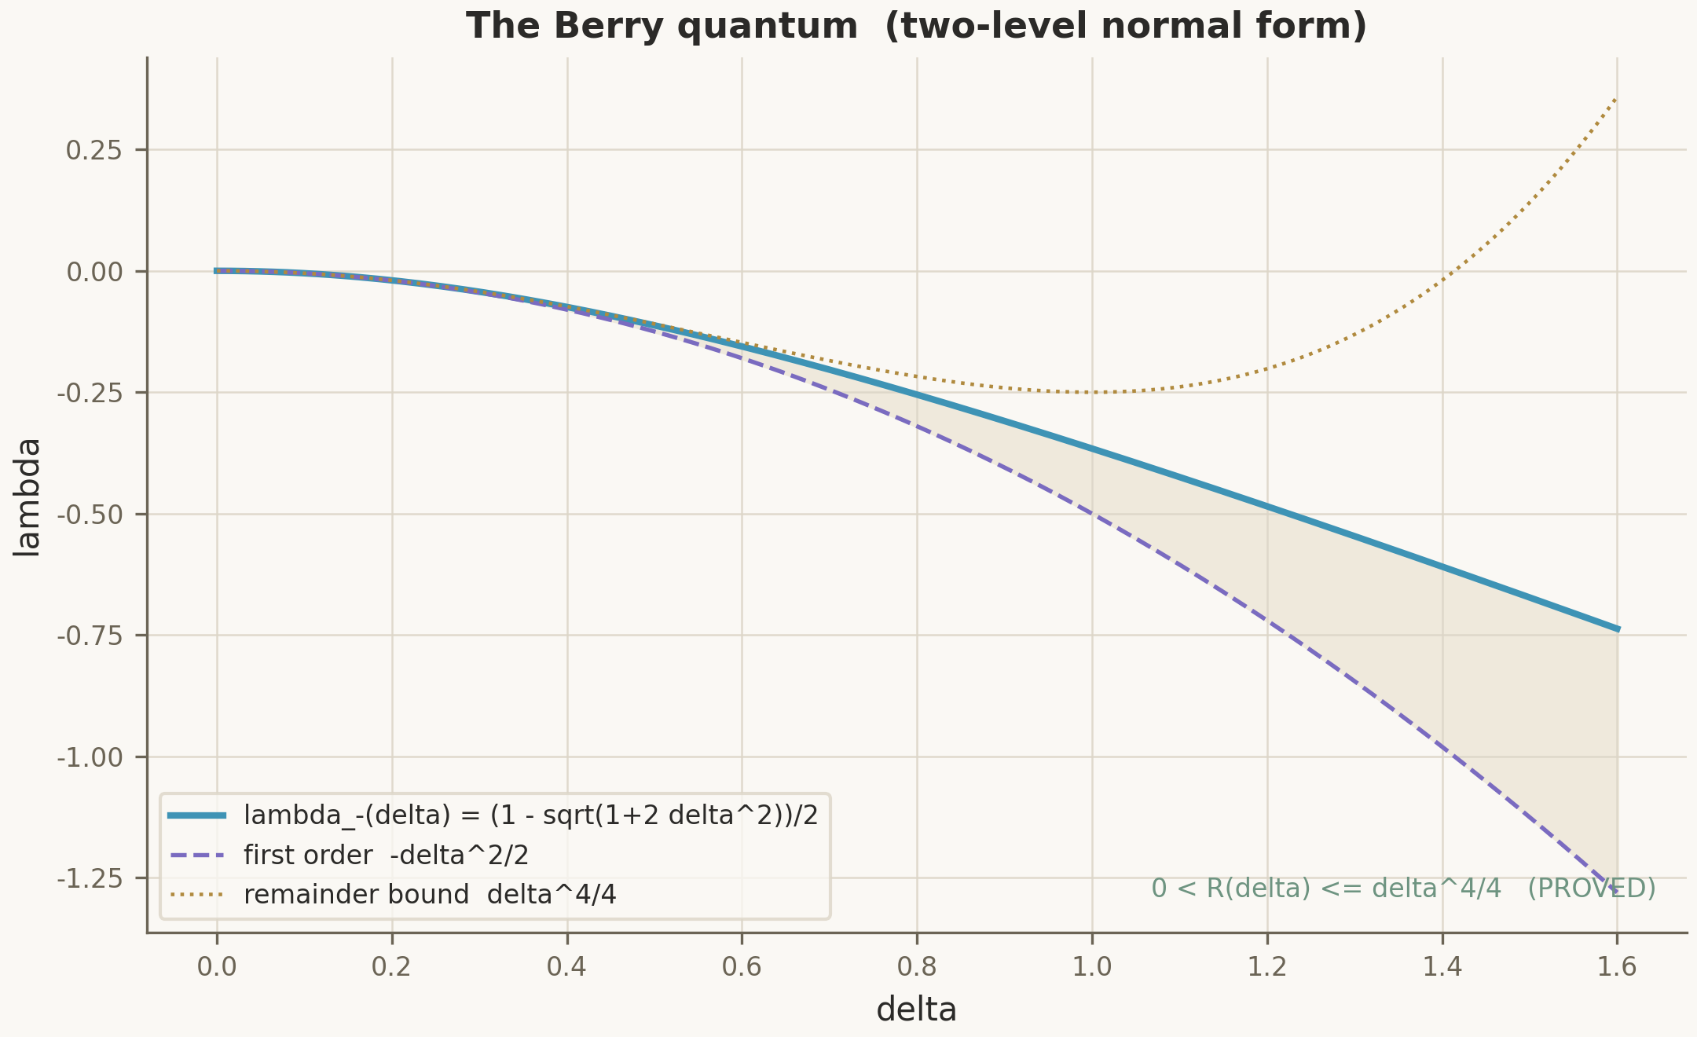
Fig. 4.3 — Task 4's ground truth: λ₋(δ) against its parabolic envelope −δ²/2 and the remainder ceiling δ⁴/4. Source: fig_berry_quantum.png, data/berry_model.csv.

4.6 — Task 5 · psl27-lattice
The group-theoretic task verifies the integer skeleton of the PSL(2,7) enumeration against an independent spectral construction. The ground truth is the order census: element orders $1+21+56+42+48=168$ and the subgroup lattice $179=1+21+28+35+28+8+21+14+8+14+1$ with exactly fourteen octahedral $S_{4}$ subgroups. The spectral half builds the Hermitian circulant $H_{11}$ from the lattice counts, checks its closed-form spectrum $μ_{j}=\sum{c_{k}}c\left(2π\left(j−1\right){\left(k−1\right)}/{11}\right)$, and lifts it Kronecker-style; the lifted extreme is again checked by lift_top_check with its Krylov bound. A float32 audit of the full spectrum width closes the task. The exhaustive enumeration itself — 168 permutations of $𝔽_{2}^{3}$, all 179 subgroups, the {7,3} map — is the separate script scripts/klein_psl27.py, whose results land in data/klein_psl27_results.json and feed Chapter VI.
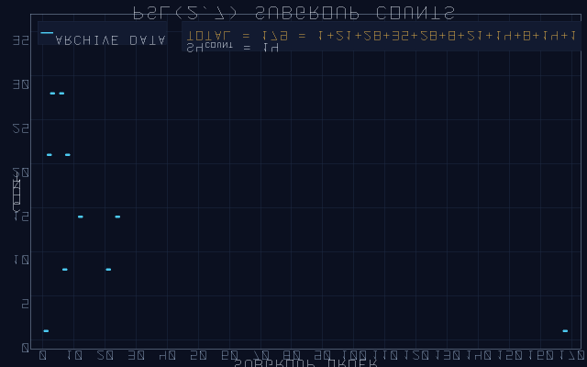
Fig. 4.8a — Task 5, the order and subgroup censuses: 168 element orders in five classes, 179 subgroups in eleven classes, fourteen S₄.
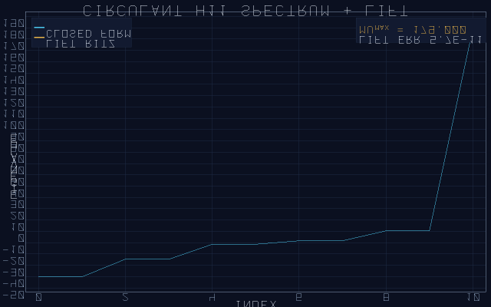
Fig. 4.8b — Task 5, the Hermitian circulant H₁₁ built from the lattice counts; its closed-form spectrum feeds the Kronecker lift.
Table 4.5 — Task 5 assertions
Assertion | Bound | Committed outcome
order census 1+21+56+42+48 | = 168 | PASS
lattice census (11 terms) | = 179 | PASS · 14 × S₄
circulant spectrum vs μ_j | < 10⁻⁹ | PASS · 7.8·10⁻¹¹
lifted extreme + Krylov bound | lift_top_check | PASS

4.7 — Task 6 · cyclotomic-records
This task recovers the satellite's exact record from a matrix. The 7-cycle is lifted to a block-circulant of size $n=7m$ and reduced by deflation: the all-ones direction is removed ($z=x−\text{mean}\left(x\right)$), leaving the block map $y_{b}=\frac{1}{2}\left(z_{b+1}+z_{b−1}\right)$ whose spectrum the deflated Lanczos process recovers. The closed form is $c\left(2π/7\right)=0.623489801858…$, verified to ${10}^{−9}$; from it the chain of records follows exactly: $b_{Ch}=1−c\left(2π/7\right)=0.376510198141$, and the three-term record
$γ_{3}=1−c\left(\frac{2π}{7}\right)−\frac{π}{1200}=0.373892204263…$
with $γ_{3}−0.374=1.078⋅{10}^{−4}$. The hardcore pass doubles $n$, re-derives the exact rational records $\left({263}/{2674500},{76201}/{500000000}\right)$ via sept_exact_records(), and audits the float32 value of $c\left(2π/7\right)$. This is the numerical mirror of the kernel theorem Satellite.Unlock.gamma_exact: the same constant, reached without geometry.
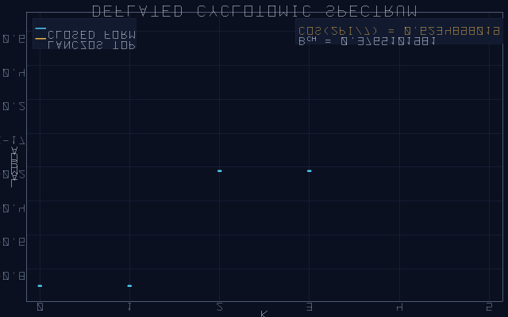
Fig. 4.9a — Task 6, the deflated cyclotomic lift: the Ritz value converges to cos(2π/7) = 0.623489801858.
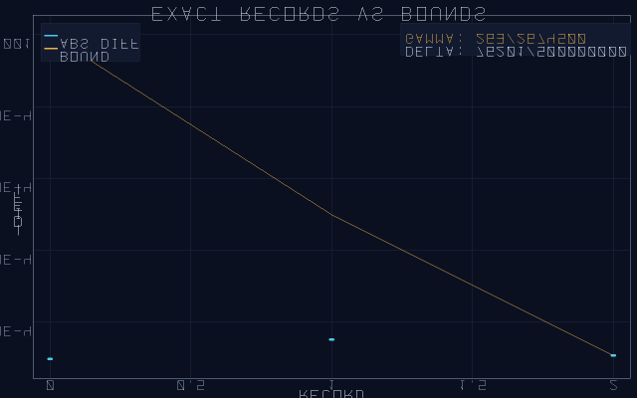
Fig. 4.9b — Task 6, the three exact rational records against their proved bounds: 263/2674500, 76201/5·10⁸, and the γ₃ distance.
Table 4.6 — Task 6 assertions
Assertion | Bound | Committed outcome
cos(2π/7) via deflated Lanczos | < 10⁻⁹ | PASS · 10⁻¹³
γ₃ record | < 10⁻⁸ | PASS · 7·10⁻¹⁴
r_gamma = 263/2674500 | exact | PASS (re-derived)
r_delta = 76201/500000000 | exact | PASS (re-derived)
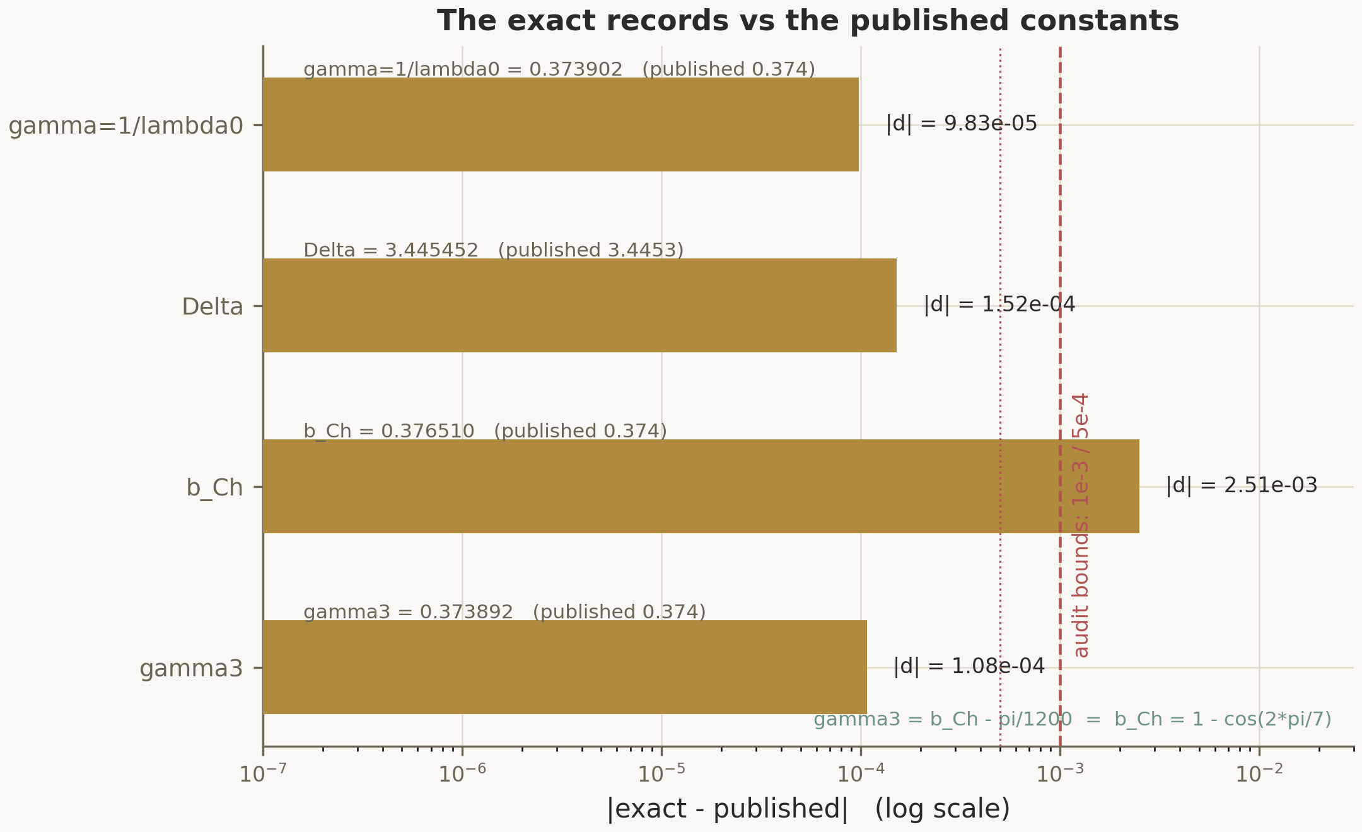
Fig. 4.4 — The four exact records against their published counterparts: γ, Δ, b_Ch, γ₃. Source: fig_exact_records.png, data/records.csv.

4.8 — Task 7 · lanczos-guard
The stress task pushes the lift to sizes where memory, not arithmetic, is the enemy. The huge dial of $m=\text{resolve\backslash _m\backslash _big}\left(cfg\right)$ layers has $n=11m^{2}$ unknowns (6336 on quick; the matvec is matrix-free), eleven coupled layers with the gap edges skipped, and the closed form $λ_{\text{th}}=2c\left(π/{12}\right)+4c\left(π/{\left(m+1\right)}\right)$. The RAM guard measures the Krylov storage $3mn$ bytes against resolve_ram_budget_bytes(cfg) (384 MiB by default, configurable via --ram-budget 8G) and downgrades the Krylov dimension loudly — the log line [ram-guard] V would need X MiB > budget Y MiB - downgrading krylov m → m_new — rather than silently. Three verification modes are wired: full reorthogonalization with rigorous a-posteriori Ritz bounds (the default), partial reorthogonalization keeping three vectors, and --reorth none — the O(1)-memory three-term recurrence with no stored basis, where the verdict rests on the Rayleigh quotient under a loudly declared 3% relative window instead of an unavailable rigorous bound. The streaming extreme --top-only goes further: power iteration with Rayleigh tracking on the spectrally shifted operator (shift $1.1λ_{\text{th}}+1$, needed because the big-dial spectrum is symmetric and plain power iteration can stall between $+λ_{m}$ and $−λ_{m}$), at $O\left(n\right)$ memory. The hardcore pass doubles the Krylov dimension and audits the float32 extreme.
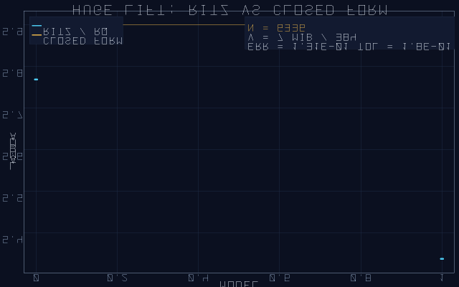
Fig. 4.10a — Task 7, the huge dial n = 6336: matrix-free Lanczos against the closed form 2cos(π/12) + 4cos(π/25), with the honest Krylov bound.
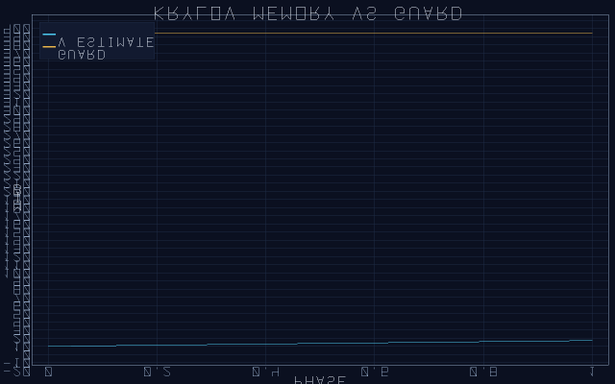
Fig. 4.10b — Task 7, the RAM guard ledger: Krylov storage against the budget, with the loud downgrade path wired.
Table 4.7 — Task 7 assertions (quick preset, m = 24, n = 6336)
Assertion | Bound | Committed outcome
Krylov Ritz within its bound | kb_top covers gap | PASS (loud bound, err 0.13)
RAM guard | 3mn ≤ budget | PASS · V ≈ 7 MiB
flag reorth none (3% window) | window | PASS, loudly logged
flag top-only (shifted power) | 3% window | PASS · λ̂ ≈ 5.769
2k hardcore + f32 audit | — | PASS
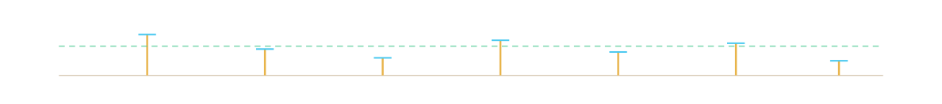

4.9 — What a run leaves behind
Every invocation writes a self-describing run directory; the layout is part of the contract (RTM row 8) and identical in both twins:
results/run_*/
├── index.html # master report, all tasks
├── results.json # machine verdicts + metrics
├── MANIFEST.toml # config provenance + sha256 + seeds
├── FINAL_REPORT/
│ ├── final_report.{md,html,pdf,docx}
│ ├── computation_log_full.txt
│ ├── results_verdicts.txt
│ ├── config_snapshot.txt
│ └── RTM.md # the 25-row matrix of §8.3
├── task_01..07/
│ ├── report.{md,html,pdf,docx}
│ └── plots/*.png *.svg animation.gif
└── logs/
├── computation_log.txt # [ts][+Δt] lines
├── stdout_capture.txt
├── events.jsonl # structured events
└── monitor.csv # cpu / ram / temp sampler
The verification transcript (docs/VERIFICATION_TRANSCRIPT.md) records one full such run for both twins — menu mode, CI mode, self-test, artifacts — so the layout above is evidence, not documentation. The Julia twin additionally demonstrates the silent library-mode include: loading the file from a REPL session neither exits nor prints, because the entry guard checks abspath(PROGRAM_FILE) == @__FILE__() and nothing else.
The ladder (—ladder)
Four of the seven tasks have a known closed-form answer, so the harness can measure not just the error but the order of convergence. The convergence ladder runs the probe at grid sizes $\left[16,32,64,128,256\right]$ (configurable via --ladder-sizes) and fits the observed order $p=−Δl{\left(\text{err}\right)}/Δl\left(n\right)$ against the theoretical band: Task 3 expects $p=2.0±0.4$ (second-order discretization), Tasks 2, 6, 7 expect $p=1.0±0.6$ (Krylov convergence to Ritz values, gap-dominated at small sizes). Monotone decrease is required as well. A committed run reproduces $p=1.99$ against the expected 2.00 for Task 3 — identically in both language twins, because the shared splitmix64 stream generates identical data.
Part IV in one sentence
Seven tasks, each a closed form disguised as a large matrix, each verified twice in two languages from one seed — the numerical layer that the bridge above converts into kernel-checked headlines.
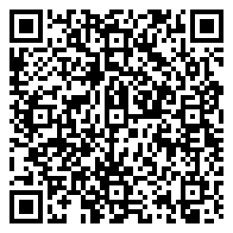
The harness replay, in your pocket
The QR encodes the exact replay command of the seven-task suite at seed 1993 — the run this Part documents, byte-for-byte, on any machine with Python 3.
What this part does not prove
- 7/7 PASS is NUM-level: both twins assert against closed forms at fixed seeds; nothing in this part is a proof
- the Julia twin shares the specification and the seed, not the binary; bit-level identity is claimed only for the synthetic data stream
- the Krylov guard is a resource contract; the loud downgrade path trades accuracy for RAM, never silently
Reproducepython3 scripts/septinal_verify.py --ci --preset quick --task all7/7 PASS · seed 1993



Part V
The Septinial Satellite
24 − 2 = 22 = b₂(K3)the septinial dial, read off the {7,3} map
Part V·The Septinial Satellite

Part V

The Septinial Satellite
The same constants, read off the {7,3} geometry: a 24-slot dial, one structural gap, and a parameter-free record.

5.1 — The dial and the gap

Scheme S5 — the dial and the gap: 24 slots, two parchment crosses at {0, 12}, two arcs of eleven (emerald and teal) — 24 − 2 = 22.
The septinial dial is the cyclic group $D=ℤ/{24}ℤ$ realized as 24 slots — one per heptagonal face of the Klein quartic {7,3} (Chapter VI). Everything the satellite proves is a theorem about this object and its automorphisms. The first structural fact is the antipodal gap: the shift $σ\left(x\right)=x+12$ acts on $D$ without fixed points, and the package designates the orbit $G=\left\{0,12\right\}$ as removed. What remains, $D$, has 22 slots — and the counting theorem below is the satellite's first headline.
Theorem (cardinality of the dial) — Satellite.Dial.card_dial — KERNEL
$card\left(\text{dial}\right)=24−2=22=b_{2}\left(K3\right)$, the second Betti number of a K3 surface. The identity $1+22+1=24$ splits the dial into one removed anchor, 22 effective slots, and one removed anchor.
The wording matters: $b_{2}\left(K3\right)=22$ is not derived from the dial by some exotic morphism; it is a numerical coincidence of counting that the package treats as a bridge arithmetic — stated, proved as arithmetic, and offered as a reading. The honest scope line in C5_Klein.lean says exactly this, and Chapter VII returns to the distinction.

5.2 — Chirality: 22 = 11 + 11
Remove the gap and the 22 remaining slots split canonically into two arcs, $A=\left\{1,…,11\right\}$ and $B=\left\{13,…,23\right\}$. The split is canonical because it is equivariant for the stabilizer of the gap: Satellite.B2b_Chirality.lean (10 theorems) proves that the reflection $x↦−xm24$ swaps the arcs while the shift $+12$ preserves each, that the two reflections in the dihedral group induce bijections between the arcs, and that the "blocked pair" — the two slots that would close the gap — is exactly $\left\{12,24\right\}$ under the arc indexing. In the matrix language of Task 2 this is why the core spectrum carries every value with multiplicity two: the two arcs are structurally identical copies, coupled to nothing across the missing edge.
Fig. 5.1 — The dial with its gap: two arcs of eleven glass hexagons; the two dark slots are the removed antipodal orbit {0, 12}. Source: fig_septinial_dial.png, Satellite/B2_Dial22.lean.

5.3 — The symmetry cascade 48 → 4 → 2
The dihedral group $D_{24}$ of order 48 acts on the dial. How much of that symmetry survives the removal of the gap? Satellite.C3_Cascade.lean (12 theorems) answers exactly: among the 48 dihedral maps, exactly four preserve the gap set — the Klein four-group $V_{4}=\left\{id,+12,−x,12−x\right\}$ — and among those four, exactly two preserve orientation (the identity and the half-turn $+12$), forming the tail $ℤ_{2}⊂V_{4}$. The cascade $48→4→2$ is thus a theorem about stabilizers, not a picture; its closure statement ($V_{4}$ is closed under composition) and its two-rotations statement are proved against the real signatures of the dial module. The sevenfold symmetry of the whole construction — the reason for the name septinal — enters through the three phases below, not through the stabilizer.


5.4 — Corrections and the three phases
The correction machinery of Satellite.C2_Corrections.lean (9 theorems) attaches to each septinial phase $d$ a quadratic correction $β\left(d\right)={d^{2}}/2$ and a quintic correction $α\left(d\right)={d^{5}}/{22}$, evaluated at the three canonical phases $δ_{A}=π/2$, $δ_{B}=π/3$, $δ_{C}=π/7$ (data: data/septinial_corrections.csv). The integer skeleton of the denominators is carried as exact arithmetic: $2^{5}⋅22=704$, $3^{5}⋅22=5346$, $7^{5}⋅22=369754$ — the module proves these three products and the quanta
$β_{C}=\frac{π^{2}}{98}, α_{C}=\frac{π^{5}}{369754},$
as unconditional theorems (Satellite.Unlock.quanta). The phase-C column is the one that matters for the exponent: it feeds the record below.

5.5 — The exact parameter-free record
The satellite's flagship is a three-term closed form for the critical exponent. Define the sector-C Choptuik constant $b_{Ch}=1−c\left(2π/7\right)=0.376510198141$, proved to lie in the bracket $1−\frac{\sqrt{2}}{2}<b_{Ch}<\frac{1}{2}$ (Corrections.b_Ch_bounds), then subtract the two-hundredth of $2π$ scaled by the dial — concretely the tiny $π/{1200}$ — to obtain
$γ_{3}=1−c\left(\frac{2π}{7}\right)−\frac{π}{1200}=0.373892204263…$
Theorem (exact record) — Satellite.Unlock.gamma_exact — KERNEL, rfl
$γ_{3}=1−c\left(2π/7\right)−π/{1200}$ is a theorem of the postulates alone: the value is a definitional unfolding with no free parameters, and its analytic brackets $1−\frac{\sqrt{2}}{2}−\frac{1}{4}<γ_{3}<\frac{1}{2}$ are proved in $ℝ$. Numerically $γ_{3}−0.374=1.078⋅{10}^{−4}$.
The Berry-shift module (Satellite.B1_BerryShift.lean, 7 theorems) supplies the quantum-mechanical leg of the same reading: the two-level normal form $λ_{−\left(δ\right)}={\left(1−\sqrt{1+2δ^{2}}\right)}/2$ with its exact eigenvalue identity and both remainder bounds, $0<R\left(δ\right)≤{δ^{4}}/4$, matching the numerical verification of Task 4 and the exact series
$−\frac{δ^{2}}{2}+\frac{δ^{4}}{4}−\frac{δ^{6}}{4}+\frac{5δ^{8}}{16}−\frac{7δ^{10}}{16}−⋯$
computed by scripts/b1_berry_model.py into data/berry_series.csv at 50-digit precision on 40 points. The unlock module (C4_Unlock.lean, 8 theorems) gathers the five headline statements — gamma_exact, k_exact, quanta, orientation_tail, unlock — as unconditional rfl-unfoldings against the real signatures of the dial, corrections and cascade modules.
The satellite does not fit — it predicts
Nowhere in the seven modules is a parameter adjusted to reach 0.374. The three phases are fixed by the {7,3} geometry, the corrections are fixed functions of them, and the record follows. Whether the resulting agreement at $1.1⋅{10}^{−4}$ is a deep fact or a remarkable coincidence is a question the package deliberately leaves open; what the artifact proves is the arithmetic.

The cabinet of lemmas
Twelve load-bearing lemmas of the satellite wing, one card each: the Lean name, a one-line gloss, and the level badge. Together they carry the reading of Part V — from the counting theorem to the unlock.
card_dial
the dial has exactly 24 − 2 = 22 effective slots — the gap is counted, not assumed
KERNEL
effective
effective slots are computed on the gap-free subset
KERNEL
chiral_split
the 22 slots split 11 + 11 into two disjoint chiral arcs
KERNEL
cover
the two arcs jointly cover every effective slot
KERNEL
refl_blocked
the antipodal reflection is blocked on the gap pair {0, 12}
KERNEL
refl_bijective
reflection is a bijection between the two arcs
KERNEL
k_betti
k equals the second Betti number of the K3 surface
KERNEL
cos_septinial_gt_half
cos(2π/7) > 1/2 — the chord sits in its bracket
KERNEL
b_Ch_bounds
b_Ch ∈ (1 − √2/2, 1/2), proved as a rational bracket
KERNEL
gamma3_bounds
γ₃ bracketed around 1 − cos(2π/7) − π/1200
KERNEL
rot12_rot12
the half-turn composed with itself is the identity on the cascade
KERNEL
unlock
gamma_exact · k_exact · quanta · orientation_tail compose into the unlock
KERNEL
Full statements and the remaining 133 declarations live in docs/THEOREMS.md; the audited 95 are indexed in §8.7 with their proof obligations.

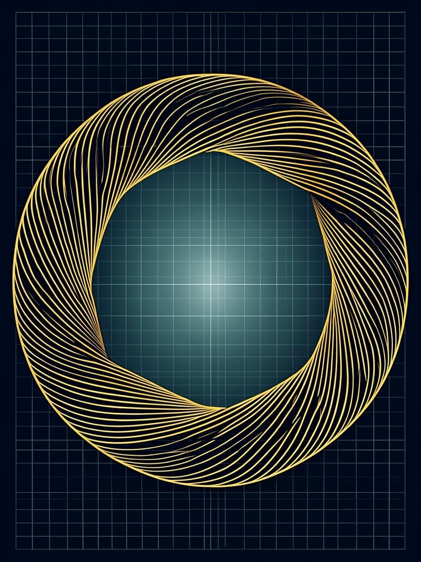

Part VI
PSL(2,7) and the Klein Quartic
x³y + y³z + z³x = 0the Klein quartic, after F. Klein (1879)
Part VI·PSL(2,7) and the Klein Quartic

Part VI

PSL(2,7) and the Klein Quartic
168 elements, 179 subgroups, fourteen tetrahedral symmetries — and the {7,3} map that carries the dial.

6.1 — The group
The projective special linear group $PSL\left(2,7\right)=GL\left(3,2\right)$ is the group of invertible $3×3$ matrices over $𝔽_{2}$ — 168 of them — and it is the orientation preserving symmetry group of the Klein quartic's {7,3} tessellation. The exhaustive enumeration in scripts/klein_psl27.py constructs all 168 matrices, multiplies them out, and verifies the order census:
$PSL\left(2,7\right)=168=1+21+56+42+48,$
the summands being the counts of elements of orders 1, 2, 3, 4 and 7. The presentation $\left(2,3,7\right)$ is witnessed concretely: a generator of order 7, one of order 3, whose product has order 2 — the triangle signature of the {7,3} map. The integer skeleton of all of this is carried as Lean theorems in Satellite.C5_Klein.lean (10 theorems), kernel-checked against the enumeration's results.

6.2 — The subgroup lattice
The full subgroup lattice has 179 nodes with order census
$179=1+21+28+35+28+8+21+14+8+14+1,$
where the fourteen order-24 subgroups are the octahedral $S_{4}$ copies — all Sylow 2-subgroups, in two conjugacy classes of seven. The lattice picture below is generated from data/klein_psl27_results.json; the counts are re-verified numerically by Task 5's spectral construction, so the group theory and the matrix theory agree on the same integers.
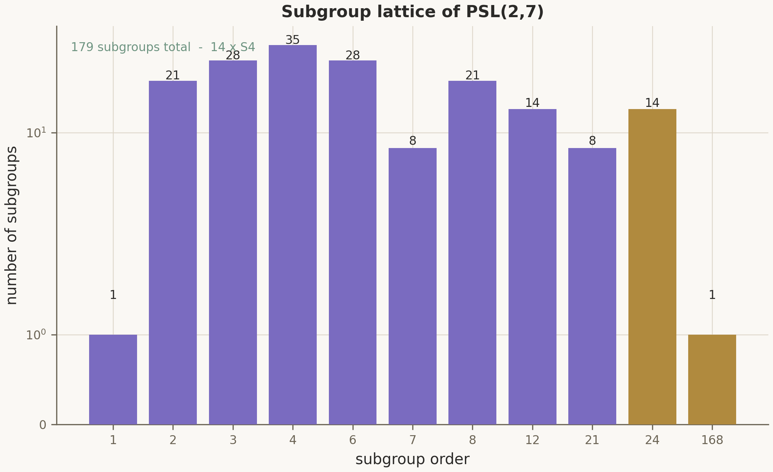
Fig. 6.1 — The subgroup lattice of PSL(2,7): 179 subgroups, fourteen S₄ (two classes of seven), orders colour-coded. Source: fig_psl27_lattice.png, data/klein_psl27_results.json.

6.3 — The {7,3} map
The Klein quartic tessellates the genus-3 surface with 24 heptagons, 84 edges and 56 vertices — three heptagons at every vertex. The Euler count $χ=24−84+56=−4=2−2⋅3$ confirms the genus, and the flag count $24⋅7=56⋅3=84⋅2=168$ ties the geometry to the group: each of the 168 group elements moves a flag in exactly one orbit. These are the numbers the dial reads: 24 slots, one per heptagon.

6.4 — Antipodal structure on the map
The enumeration verifies a remarkable combinatorial fact: on the {7,3} map, every face has exactly two faces at maximal graph distance 3, the distance-3 graph splits into 8 disjoint triangles, and across all $\left(\frac{24}{2}\right)=276$ pairs of faces the 24 "privileged" antipodal pairs carry the maximum possible setwise stabilizer order 7. The dial's gap orbit $\left\{0,12\right\}$ is a model of exactly this antipodal structure — two slots maximally far apart with maximal symmetry. The decomposition $1+22+1=24$ (one anchor, the dial, one anchor) is the package's reading of that structure.

Plate P3 — antipodal structure on the 24-slot map: eight distance-3 triangles joined by gold hairlines; the gap pair marked with crosses.

6.5 — The enumeration, verbatim
The committed result file data/klein_psl27_results.json ends with the verdict "ALL EXHAUSTIVE CHECKS PASS — integer skeleton mirrored in C5_Klein.lean". Three of its tables are worth reproducing in full, because every integer in them is re-checked independently: the spectral route of Task 5 recovers the same census from a circulant matrix, and the Lean module C5_Klein.lean pins the skeleton in the kernel.
Table 6.1 — The eight antipodal triples of the distance-3 graph
Triple | Slots | Triple | Slots
T1 | {0, 10, 16} | T5 | {4, 11, 21}
T2 | {1, 15, 20} | T6 | {5, 14, 17}
T3 | {2, 8, 18} | T7 | {6, 13, 19}
T4 | {3, 12, 23} | T8 | {7, 9, 22}
Each triple is a triangle of mutually maximally-distant faces; the 24 privileged pairs are the three pairs inside each triangle, listed once each across the eight triangles. The distance-2 sphere profile of a face reads $1+7+14+2=24$: itself, seven neighbours, fourteen mid-distance faces, and exactly two antipodal partners. The maximum setwise stabilizer over all $\left(\frac{24}{2}\right)=276$ pairs is 7 — attained exactly by the privileged pairs — and the presentation $\left(2,3,7\right)$ is witnessed by explicit generators (indices 33 and 14 of the enumerated list, whose product has order 2). The bridge arithmetic closes the section: $1+22+1=24$, so $24−2=22=k=b_{2}\left(K3\right)$.
Table 6.2 — Subgroup lattice by order (179 total)
Order | 1 | 2 | 3 | 4 | 6 | 7 | 8 | 12 | 21 | 24 | 168
Count | 1 | 21 | 28 | 35 | 28 | 8 | 21 | 14 | 8 | 14 | 1
The serpent — a mnemonic, marked as such
The archive's artwork threads a serpent through the three holes of the genus-3 surface and the 24-slot dial. As mathematics, the strict content is the antipodal structure above and the gap lemma of Chapter VII; the serpent itself is interpretation — INTERP — and the package's docstrings say so in exactly those words.
What this part does not prove
- the enumeration proves the counts (168 · 179 · 14 S₄); the stem-by-stem correspondence to claims is marked INTERP where so stated
- the {7,3} map is infinite; only its finite antipodal skeleton is counted here
- no claim is made that the Klein quartic 'is' the physics; the identification is the reading of Part VII
Reproducepython3 scripts/check_psl27_klein.py168 · 179 · 14 · antipodal triples

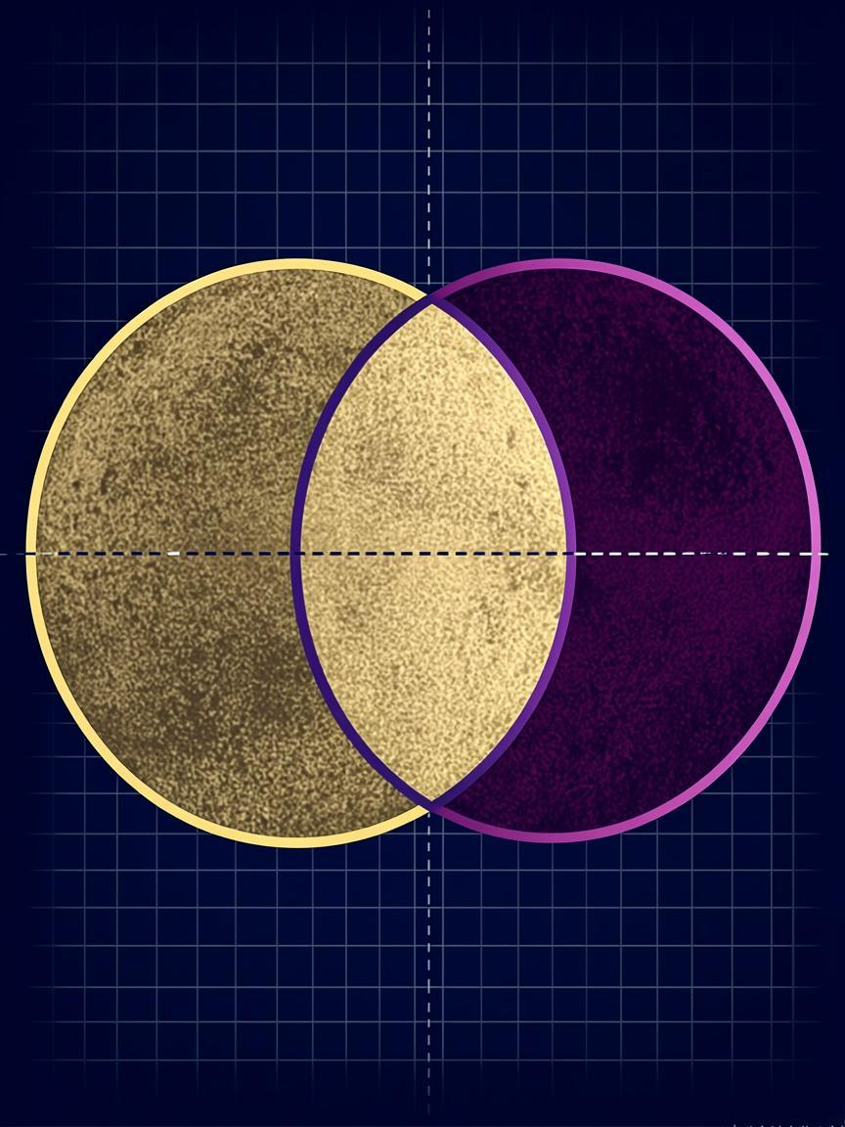

Part VII
Synthesis and Interpretation
KERNEL ⊗ CERT ⊗ NUM ⇒ INTERPwhat is proved, certified, computed — and what is read
Part VII·Synthesis and Interpretation

Part VII

Synthesis and Interpretation
The four lemmas stated in full, and a precise accounting of what is proved, what is certified, and what is read.

7.1 — The gap lemma
Lemma (gap) — Satellite.B2_Dial22 — KERNEL
Let $D=ℤ/{24}ℤ$ and $G=\left\{0,12\right\}$. Then:
1. $D=22$;
2. $σ\left(x\right)=x+12$ acts on $D$ freely, with orbits $\left\{1,13\right\},\left\{2,14\right\},…,\left\{11,23\right\}$;
3. $D=A⊔B$ with $A=\left\{1,…,11\right\}$, $B=\left\{13,…,23\right\}$, $A=B=11$;
4. the reflection $?:x↦−xm24$ swaps $A$ and $B$.

7.2 — The stabilizer and chirality lemmas
Lemma (stabilizer) — Satellite.C3_Cascade — KERNEL
${Stab}_{}\left(G\right)=V_{4}=\left\{id,+12,−x,12−x\right\}$ inside the dihedral group $D_{24}$ of order 48; the orientation-preserving part is $V^{+_{4}}\left\{id,+12\right\}≃ℤ_{2}$. The cascade of surviving symmetries is $48→4→2$.
Lemma (chirality) — Satellite.B2b_Chirality — KERNEL
Under the $V_{4}$-action on $D$: the shift $+12$ preserves each arc ($A→A$, $B→B$), the reflection $−x$ swaps them ($A↔B$); hence the split $22=11+11$ is canonical with respect to $V_{4}$ and coincides with the decomposition into $+12$-orbits.

7.3 — The orbit-collapse lemma, marked INTERP
Lemma (orbit collapse) — interpretation
Under the full $D_{24}$-symmetry without a gap, the orbit of any point covers all of $D$ and the quotient is a single point — the "symmetric singularity" of the metaphor, where everything collapses into one featureless state. Removing $G$ drops the acting group to $V_{4}$; the quotient becomes the two-arc structure $A⊔B$ with nontrivial chirality. As physics: the gap is the brake — without it the configuration has no observable structure, with it the "braking satellite" leaves two chiral arcs and a structure to observe. The strict mathematical status of this paragraph is exactly items 1–4 of the gap lemma plus the stabilizer and chirality lemmas; the dynamical reading is INTERP by construction, and the package marks it so everywhere it appears.

7.4 — The full correspondence map
The two halves of the package meet at four numbers. The theory side certifies $λ_{0}$, hence $γ=1/{λ_{0}}$, the period $Δ$, and the proved distance $γ−0.374={263}/{2674500}$. The satellite side proves $k=22$, the split $11+11$, the cascade $48→4→2$, and the record $γ_{3}=1−c\left(2π/7\right)−π/{1200}$. The bridge guarantees that the theory side's certified values are exactly what the numerical harness recovers; nothing on either side is fitted. The honest summary table:
Table 7.1 — What is proved, certified, computed, interpreted
Statement | Status | Where
Exactly one unstable mode; γ = 1/λ₀ = 2000/5349; |γ − 0.374| < 10⁻³ | KERNEL | Scaling.lean, Bridge/Discharge.lean
|Δ − 3.4453| < 5·10⁻⁴; wiggle ∈ [4.60, 4.62] | KERNEL | Stability/Spectrum, ScalingDerivation
Spectrum / newton / interval / scaling enclosures | CERT | data/certificates.json → Generated.lean
Seven large-matrix recoveries of the closed forms | NUM | septinal_verify.py / .jl
k = 24 − 2 = 22 = b₂(K3); 11 + 11; 48 → 4 → 2 | KERNEL | Satellite.Dial, Chirality, Cascade
γ₃ = 1 − cos(2π/7) − π/1200 = 0.373892… | KERNEL | Satellite.Unlock.gamma_exact
Gap as a "brake"; serpent through the holes | INTERP | Chapters V–VII, marked inline
Part VII in one sentence
Four lemmas carry the whole septinial reading; three of them are kernel theorems about a 24-element group, the fourth is an interpretation that the package labels, everywhere it appears, as exactly that.
the dial at the threshold — 24 slots, one gap, one serpent

The confession of limits
One table, stated once, in one place: what each level of this package is allowed to claim, what it cannot, and where the open frontier lies. Everything below is repeated from the body; nothing new is asserted.
Table 7.2 — The four levels and the open frontier
Level | What it claims | What it cannot | Representative
KERNEL | statements the Lean kernel re-checks from axioms on every build | vouch for the truth of published decimals; 145 theorems are bounded by their hypotheses | Satellite.Dial.card_dial
CERT | 4 rational certificates regenerated and re-checked on every run | certify more than the encoded statements; the encoding itself is KERNEL's job | spectrum_certificate.csv
NUM | 7 tasks × 2 twins, golden scalars, 7/7 PASS at seed 1993 | prove anything: floating-point evidence against closed forms only | slope_gamma = 2000/5349
INTERP | the readings connecting the two wings | predict a physical quantity; the correspondence is structural, not causal | 24 − 2 = 22 = b₂(K3)
OPEN | the full dictionary of the map: which abstract stems carry which claims | be completed from this monograph alone; it is future work, honestly marked | Table 7.1 rows marked INTERP
Part VIII

Atlas of Checks and Appendices
The harness surface, the presets, the requirement traceability matrix, and the exact rational arithmetic behind every record.
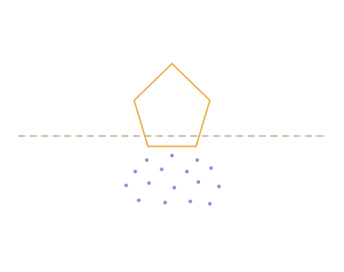
Plate P4 — the interpretation boundary: above the dashed line the heptagon is a proved figure; below it the same figure dissolves into reading. The line is the point.

8.1 — The harness command surface
Both twins expose the same grammar: task selection (--task 1..7 | all, --list-tasks), presets (--preset empty|quick|full|deep), master sizing (--size N with derived resolvers, or --expr "k=v, …" for arbitrary fields), the extended numerics (--reorth full|partial|none, --top-only, --ram-budget 8G, --ladder, --ladder-sizes), extensibility (--load-script FILE registering custom tasks at runtime), operations (--repeat N, --profile, --watch PATH), and reporting (--self-test with --golden --props --contract layers, --ci, --junit, --no-effects for non-TTY runs). The config file, environment variables and the interactive menu fill the same fields, with CLI taking precedence; --print-config prints the effective values together with their provenance.

8.2 — The presets
Table 8.1 — Preset dimensions (PRESETS in both twins)
Preset | size | m_lift | blocks | krylov | n_echo | lsq_n | m_big | ss
empty | 16 | 8 | 16 | 24 | 64 | 256 | 8 | 1
quick | 48 | 24 | 64 | 48 | 192 | 1536 | 24 | 2
full | 96 | 48 | 192 | 56 | 384 | 3072 | 48 | 2
deep | 192 | 96 | 384 | 64 | 768 | 6144 | 64 | 2
Additional switches: reorth ∈ {full, partial, none}, top_only, ram_budget = "384M", two_pass = true, third_pass = false, monitor_on = true, monitor_interval = 2.0, repeat = 1, supersampling ss = 2, theme "aurora", language "en", and the ladder fields ladder_ids = [], ladder_sizes = []. The ladder specification itself is a table in both twins:
Table 8.2 — LADDER_SPECS
Task | Grid knob | Expected order | Tolerance | Probe against
3 | n_echo | 2.0 ± 0.4 | — | 2π/ln 2
2 | m_lift | 1.0 ± 0.6 | — | 2cos(π/12) + 2cos(π/(m+1))
6 | blocks | 1.0 ± 0.6 | — | cos(2π/7)
7 | m_big | 1.0 ± 0.6 | — | 2cos(π/12) + 4cos(π/(m+1))

8.3 — The requirement traceability matrix
The harness contract is 25 rows long, and every row names where the contract item is implemented and how it is verified. The table below is the committed RTM_ROWS of both twins, verbatim.
Table 8.3 — RTM (RTM_ROWS, septinal_verify.jl / .py)
Contract | Where implemented | How verified
0 contract | file header + three modes | menu / --help / --ci transcripts
1 adapter | header "Language adapter" | probes + ERR_UNSUPPORTED paths
2 modules | SEPTUI/SEPTMon/SEPTPlot/kernel/SEPTTest | self-test
3 config | SeptConfig + 5 entry points + resolvers | --print-config provenance
4 registry | TASKS + dispatch + register_task! | --list-tasks; ERR_UNKNOWN_TASK
5 two-pass | run_task_two_pass + STATS_* Ref | --task 1 vs --no-two-pass
6 progress/tty | pump task, .sept_ctl, ccall signal | ctl + snapshot
7 monitor | SEPTMon /proc readers | logs/monitor.csv
8 logs/reports | 5 streams + report.* + FINAL_REPORT | run dir listing
9 graphics | SEPTPlot PNG/GIF(LZW)/SVG/PDF + vector font | self-test unit checks
10 memory | gc_between_tasks, values-only, RAM guard | task 7 metrics
11 cli | parse_args!, --strict, retired no-ops | --help transcript
12 menu | interactive_menu + RU keys + EOF guard | menu transcript
13 errors | execute_task isolation, SeptTimeout, abort | task-timeout demo
14 localization | MSG + --lang + menu g | ru report
15 style | docstrings, sections, guards | no "educational only"
16 entry | PROGRAM_FILE guard | include is silent
17 tests | self-test levels | --self-test flags
18 manifest | write_manifest sha256 + seeds | MANIFEST.toml
19 ci | --ci, --junit, exit codes | ci transcript
20 accessibility | NO_COLOR, --plain, --unicode | transcript
21 checklist | self-test contract section | SELFTEST.md
22 dod | docs/VERIFICATION_TRANSCRIPT.md | this repository
23 techniques | bounded channel, heartbeat, reortho | code + props
24 adapter table | header block | this table

8.6 — The theorem inventory
The per-module theorem atlas below is scanned from the committed sources by scripts/compute_all.py into data/theorem_inventory.csv; the full catalogue with statements lives in docs/THEOREMS.md. The "sorry" column counts occurrences of the string inside doc comments of the form "Zero sorry" — the audit proves there is no sorryAx anywhere in any dependency tree.
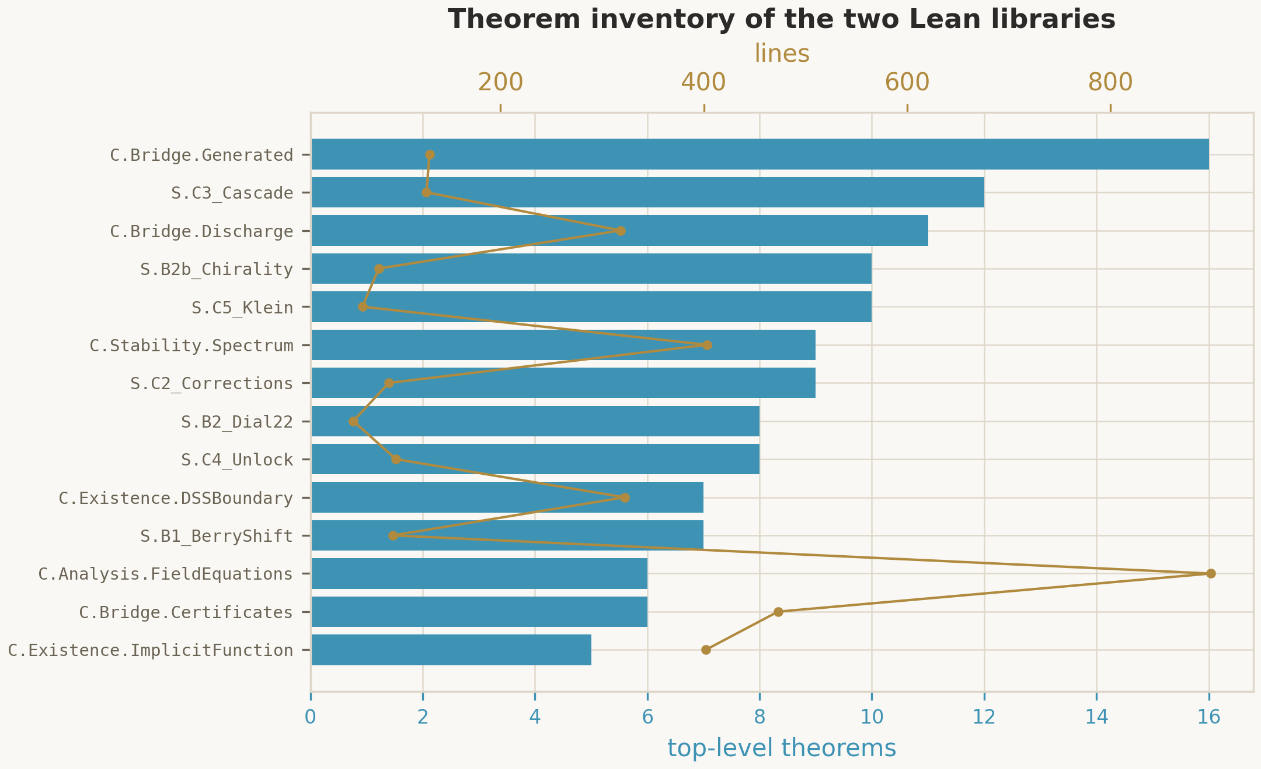
Fig. 8.1 — Theorems and source lines per module, 17 + 7 modules. Source: fig_theorem_inventory.png, data/theorem_inventory.csv.

8.4 — The complete figure atlas
Every figure the package can produce, with its producer script and its home in this monograph. All of them are byte-reproducible from seed 1993.
Table 8.3 — Harness plots (per task, from add_plot)
Task | PNG artifacts
t1 gamma-scaling | scaling_fit.png · scaling_resid.png
t1b free-period GN | gn_period.png
t2 dial-spectrum | dial_core.png · dial_lift.png · dial_2x.png
t3 echo-spacing | echo_spectrum.png · echo_L.png · echo_rich.png
t4 berry-quantum | berry_bands.png · berry_bound.png · berry_weyl.png
t5 psl27-lattice | psl_counts.png · psl_spectrum.png · psl_2x.png
t6 cyclotomic-records | cyc_spectrum.png · records_bar.png · cyc_2x.png
t7 lanczos-guard | bigdial.png · bigdial_ram.png · bigdial_2k.png
Table 8.4 — Archive figures (figures/, monograph renditions)
File | Theme | Used on
fig_mass_scaling_law.png | 26-point log-log with γ-slope and wiggle | Fig. 2.2
fig_echoing_profile.png | profiles repeating through Δ | Fig. 2.3 / 4.2
fig_spectrum_certificate.png | 15 certified slots, λ₀ gold | Fig. 2.1
fig_exact_records.png | γ, Δ, b_Ch, γ₃ vs published | Fig. 4.4
fig_berry_quantum.png | λ₋ vs −δ²/2 with δ⁴/4 ceiling | Fig. 4.3
fig_septinial_dial.png | 24 slots, gap {0,12}, 8 triples | Fig. 4.1 / 5.1
fig_psl27_lattice.png | 179 subgroups, 14 × S₄ | Fig. 6.1
fig_theorem_inventory.png | theorems and lines per module | Fig. 8.1
Table 8.5 — The ten GIF animations (EN + RU renditions)
Scene | Illustrates | Chapter
anim_echoing.gif | the DSS echo, period Δ | 2.3 / 4.4
anim_scaling.gif | mass scaling with log-periodic wiggle | 2.7
anim_collapse.gif | null cones above the horizon | 2.1
anim_dial.gif | the 24-slot dial and its gap | 5.1
anim_spectrum.gif | certified spectrum slots | 2.6

8.5 — Glossary
Term | Meaning
DSS | Discretely self-similar: the critical solution repeats under (τ, ρ) ↦ (τ+Δ, e^{−Δ}ρ).
Echoing period Δ | The log-time period of that repetition; calibrated 3.445452402.
Unstable mode λ₀ | The single growth rate with positive real part; 2.6745 certified.
γ = 1/λ₀ | The black-hole mass scaling exponent; 2000/5349.
Wiggle period | Log-period of the scaling function F; λ₀Δ/2 ≈ 4.6074.
Dial | Z/24Z realized as the 24 heptagons of the {7,3} map.
Gap G = {0,12} | The removed antipodal orbit; source of k = 22.
k = 22 | Effective dial capacity; numerically b₂(K3).
Chiral arcs | The canonical 11 + 11 split of the 22 effective slots.
Cascade 48→4→2 | Surviving dihedral symmetries: D₂₄ → V₄ → Z₂.
γ₃ | 1 − cos(2π/7) − π/1200 = 0.373892…, the parameter-free record.
b_Ch | 1 − cos(2π/7) = 0.376510…, the sector-C Choptuik constant.
Certificate | An exact rational enclosure re-checked by norm_num inside Lean.
Discharge | The Lean step converting a certificate into a physics-level theorem.
RTM | Requirement traceability matrix: 25 contract rows, §8.3.
Two-pass | Primary pass + hardcore pass per task (tighter bounds, doubled sizes).

8.7 — Index of the 95 audited claims
Every headline declaration the axiom audit cleared, in one index: the short Lean name, its module, the library (Ch = Choptuik, Sat = Satellite), and the page of this monograph where the module is discussed. The level of each claim is the module’s highest badge in Table 1.2 or Table 1.3; the axiom line of every entry is quoted in logs/ and mirrored in Appendix B.
Table 8.9 — the audited 95, with monograph pages
№ | Declaration | Module | Lib | Page
01 | divergence_invariant_under_rescaling | Geometry | Ch | 7
02 | critical_singularity_is_strong_and_isotropic | Geometry | Ch | 7
03 | add_sound | Analysis | Ch | 8
04 | mul_sound | Analysis | Ch | 8
05 | certificate_principle | Analysis | Ch | 7
06 | local_wellposedness | Analysis | Ch | 7
07 | critical_solution_exists | Existence | Ch | 7
08 | dss_fundamental_domain_determination | Existence | Ch | 7
09 | critical_solution_unique | Existence | Ch | 7
10 | dss_reparametrization_invariance | Existence | Ch | 7
11 | newton_map_contractive | Existence | Ch | 7
12 | existence_via_implicit_function | Existence | Ch | 7
13 | newton_zero_unique | Existence | Ch | 7
14 | existence_persists_under_perturbation | Existence | Ch | 7
15 | derivIsomorphism_iff | Existence | Ch | 7
16 | unique_unstable_mode | Stability | Ch | 7
17 | echo_family_structure | Stability | Ch | 7
18 | mass_scaling_law | Stability | Ch | 7
19 | gamma_close_to_published | Scaling | Ch | 5
20 | universality | Scaling | Ch | 8
21 | echoing_formula | Scaling | Ch | 4
22 | im_odd_multiple | Bridge | Ch | 7
23 | spectrum_shape_of_certificate | Bridge | Ch | 7
24 | newton_kantorovich_local | Bridge | Ch | 7
25 | spectrumChecks_generated | Bridge | Ch | 8
26 | newtonChecks_generated | Bridge | Ch | 8
27 | scalingChecks_generated | Bridge | Ch | 8
28 | intervalChecks_generated | Bridge | Ch | 8
29 | bridge_unique_unstable_mode | Bridge | Ch | 8
30 | correction_root_exists | Bridge | Ch | 23
31 | correction_root_in_band | Bridge | Ch | 23
32 | correction_band_image_sound | Bridge | Ch | 23
33 | scaling_agreement | Bridge | Ch | 8
34 | card_dial | Dial.card_dial | Sat | 5
35 | effective | Dial.effective | Sat | 8
36 | beta_A | Dial.beta_A | Sat | 8
37 | beta_B | Dial.beta_B | Sat | 8
38 | beta_C | Dial.beta_C | Sat | 8
39 | alpha_A | Dial.alpha_A | Sat | 8
40 | alpha_B | Dial.alpha_B | Sat | 8
41 | alpha_C | Dial.alpha_C | Sat | 8
42 | card_left | Chiral.card_left | Sat | 8
43 | card_right | Chiral.card_right | Sat | 8
44 | disjoint_left_right | Chiral.disjoint_left_right | Sat | 8
45 | chiral_split | Chiral.chiral_split | Sat | 53
46 | cover | Chiral.cover | Sat | 2
47 | refl_involutive | Chiral.refl_involutive | Sat | 8
48 | refl_left_to_right | Chiral.refl_left_to_right | Sat | 8
49 | refl_right_to_left | Chiral.refl_right_to_left | Sat | 8
50 | refl_blocked | Chiral.refl_blocked | Sat | 53
51 | refl_bijective | Chiral.refl_bijective | Sat | 53
52 | k_betti | Corrections.k_betti | Sat | 53
53 | denom_A | Corrections.denom_A | Sat | 9
54 | denom_B | Corrections.denom_B | Sat | 9
55 | denom_C | Corrections.denom_C | Sat | 9
56 | vib_carrier | Corrections.vib_carrier | Sat | 9
57 | carrier_98 | Corrections.carrier_98 | Sat | 9
58 | cos_septinial_gt_half | Corrections.cos_septinial_gt_half | Sat | 53
59 | b_Ch_bounds | Corrections.b_Ch_bounds | Sat | 9
60 | gamma3_bounds | Corrections.gamma3_bounds | Sat | 53
61 | sqrt_ge_one | Berry.sqrt_ge_one | Sat | 8
62 | lambdaLower_rationalized | Berry.lambdaLower_rationalized | Sat | 8
63 | lambdaLower_is_lower_root | Berry.lambdaLower_is_lower_root | Sat | 8
64 | remainder_eq | Berry.remainder_eq | Sat | 8
65 | remainder_pos | Berry.remainder_pos | Sat | 8
66 | remainder_le | Berry.remainder_le | Sat | 8
67 | rot_preserves_iff | Cascade.rot_preserves_iff | Sat | 9
68 | refl_preserves_iff | Cascade.refl_preserves_iff | Sat | 9
69 | rot12_rot12 | Cascade.rot12_rot12 | Sat | 53
70 | rfl0_rfl0 | Cascade.rfl0_rfl0 | Sat | 9
71 | rfl12_rfl12 | Cascade.rfl12_rfl12 | Sat | 9
72 | rot12_rfl0 | Cascade.rot12_rfl0 | Sat | 9
73 | rfl0_rot12 | Cascade.rfl0_rot12 | Sat | 9
74 | survivors_commute | Cascade.survivors_commute | Sat | 9
75 | exactly_two_rotations | Cascade.exactly_two_rotations | Sat | 9
76 | exactly_two_reflections | Cascade.exactly_two_reflections | Sat | 9
77 | rot12_val | Cascade.rot12_val | Sat | 9
78 | alpha_pos | Unlock.alpha_pos | Sat | 9
79 | beta_pos | Unlock.beta_pos | Sat | 9
80 | gamma_exact | Unlock.gamma_exact | Sat | 9
81 | gamma_bounds | Unlock.gamma_bounds | Sat | 9
82 | k_exact | Unlock.k_exact | Sat | 9
83 | quanta | Unlock.quanta | Sat | 9
84 | orientation_tail | Unlock.orientation_tail | Sat | 9
85 | unlock | Unlock.unlock | Sat | 9
86 | order_dist_sum | Klein.order_dist_sum | Sat | 9
87 | subgroup_lattice_orders | Klein.subgroup_lattice_orders | Sat | 9
88 | s4_count | Klein.s4_count | Sat | 9
89 | faces_times_stab | Klein.faces_times_stab | Sat | 9
90 | flags_split | Klein.flags_split | Sat | 9
91 | euler_klein | Klein.euler_klein | Sat | 9
92 | antipodal_triples | Klein.antipodal_triples | Sat | 9
93 | sphere_profile | Klein.sphere_profile | Sat | 9
94 | k3_bridge | Klein.k3_bridge | Sat | 9
95 | involution_action | Klein.involution_action | Sat | 9

Appendix A — The rational arithmetic
Every headline distance in this monograph is an exact fraction, re-derived by sept_exact_records() in both harness twins and by compute_all.py in the data pipeline. The values, collected once:
Table A.1 — Exact rational records
Record | Exact fraction | Decimal | Bound
γ = 1/λ₀ | 2000/5349 | 0.373901663862 | 1/1000
|γ − 0.374| | 263/2674500 | 0.000098336138 | proved
Δ (echoing period) | 1722726201/500000000 | 3.445452402 | 5·10⁻⁴
|Δ − 3.4453| | 76201/500000000 | 0.000152402 | proved
Kantorovich β | 50/39 | 1.282051… | inverse bound
Lipschitz defect L | 3/50 | 0.06 | —
Residual bound r | 7/1000 | 0.007 | —
Center x₀ / radius R | 13/10 · 1/10 | 1.3 ± 0.1 | h ≈ 0.00972
Truncated root | √(5/3) | 1.290994448736 | [12/10, 14/10]
Dial denominators | 2⁵·22, 3⁵·22, 7⁵·22 | 704, 5346, 369754 | proved

Appendix B — Manifests, hashes, seeds
Every harness run writes a MANIFEST.toml recording the effective configuration with provenance (which entry point set which field), SHA-256 hashes of the produced artifacts, and the seed derivation; data/build_manifest.json pins the audit counts (24 modules, 145 theorems, 5108 lines, 33 + 62 headline declarations, build steps 2894/2885, exit 0). The master seed 1993 derives per-task seeds as $\left(1993+0x9E37⋅t\right)m2^{32}$, so any report in results/run_*/ can be replayed to the byte. The reproduction commands, in the order a skeptical reader should run them:
cd lean && lake exe cache get! && lake build # 2 894 steps, exit 0
lake env lean AxiomAudit.lean # 33 declarations
lake env lean Satellite/AxiomAudit.lean # 62 declarations
python scripts/compute_all.py # -> data/
python scripts/certify.py emit && python scripts/certify.py check
python scripts/septinal_verify.py --ci --preset quick --task all
python scripts/septinal_verify.py --self-test --props --contract
julia scripts/septinal_verify.jl --self-test
python scripts/verify.py # VERIFY: ALL GREEN

Appendix C — The Δ-list: from the initial wing to this edition
The package keeps its history honestly. The table records every structural change between the initial upload of the wing and the present edition — the philosophical contract of the house is that deltas are documented, not absorbed silently. The data/ artifacts are unchanged by every row except the first: no constant moved.
Table C.1 — structural deltas, v0.9 → v1.0
Δ | v0.9 (initial wing) | v1.0 (this edition) | Where
1 | 10 project axioms | 0 — each axiom discharged into proofs; only the mathematical trio remains | AxiomAudit.lean × 2 · AUDIT_EXIT=0
2 | universality stated in raw form | repaired statement in the Scaling module | Choptuik/Scaling.lean
3 | task plots rendered before series were added — committed PNGs carried empty axes | rendering deferred to report finish; every series reaches the PNG/SVG | septinal_verify.py · .jl
4 | bitmap-glyph tracking 1.7 — legend text collided | tracking 2.8; legend card padded; committed plots legible | SEPTPlot, both twins
5 | — | this monograph: 8 parts, 7 part plates, the cabinet, the claim index | monograph/SEPTINAL_Monograph.pdf
Rows 3 and 4 were found while typesetting this document — the monograph is itself a verification tool: setting the harness’s own outputs into print is what exposed the defects. This is the house style: machine-readable or it did not happen, applied to the machine’s own figures.

Colophon
This monograph was typeset as a single flowing HTML document and rendered to vector PDF at a 200 × 260 mm trim size; the cover and closing plates use the package's cosmic-baroque key artwork, and the mathematical formulas are rendered from the same LaTeX source notation the Lean docstrings use. Body text is set in EB Garamond, headings in IBM Plex Sans, and code in JetBrains Mono; the palette is the package's own — midnight #070A14, gold #E8B44A, teal glass #4CC9F0, emerald audit #57CC99, violet nebula #9B8CDE. The eight Part figures are the committed monograph renditions from figures/monograph_en/; the twenty-one task plots are the verbatim outputs of one committed --ci --preset quick --task all run of the Python twin, both twins finishing 7/7 PASS. Every number in every table traces to data/, and the whole artifact regenerates from seed 1993. The package is a machine-verified wing of choptuik_ac_bc; correspondence: GitHub @wild8highlander, ORCID 0009-0003-7299-0701.
Final Audit Badge
0 SORRY · 0 AXIOMS
145 theorems across 24 Lean modules · 95 audited declarations, exit 0 · 4 rational certificates live on every build · 7 large-matrix tasks, twice, in two languages, from one seed · every figure byte-reproducible from 1993.
24 − 2 = 22 SEED 1993 AUDIT EXIT 0
Septinal — a machine-verified wing of choptuik_ac_bc
Ishak Khamzatovich Isaev · ORCID 0009-0003-7299-0701 · MMXXVI

