RESEARCH REPORT · ANALYTICAL ATTACK
The Choptuik Problem: Statement,
Solvability, and the Analytical
Attack
Three results: the threshold e ≥ 1 is proved for carrier-isometric pairs, turning the obstruction ladder into a theorem with exact defect arithmetic; the constant 224 = 4·56 is shown to be census-born combinatorics of the {7,3} tiling (uniqueness lemma for 9/224, genus family c(g), degeneracy only at g = 3); the Choptuik problem statement is fixed at two levels with a three-level solvability assessment.

Document: | Computational companion to choptuik_ac_bc
Basis: | I. Kh. Isaev, b-C and a-C monograph
Produced by: | Super Z (Z.ai)
Date: | September 2026
Reproducibility: | experiments 6–7, fixed seeds

choptuik_ac_bc · experiments · 2026

Table of Contents

Summary of Results 1
1. The Choptuik Problem: Statement 1
2. Can the Choptuik Problem Be Solved? 2
3. Analytical Attack on DSI-4: Why 224 = 4·56? 3
3.1. The census of the {7,3} tiling from GL(3,2) 3
3.2. Provenance of the constants 224 and 672 3
3.3. Uniqueness lemma: 9/224 among census fractions 4
3.4. The genus family c(g) and the degeneracy theorem 4
4. The Threshold e ≥ 1: the Ladder Becomes a Theorem 5
4.1. The class of carrier-isometric pairs 5
4.2. Theorem A: the threshold 5
4.3. Theorem B: exact covering arithmetic 6
4.4. Theorem C and the three-term defect arithmetic 6
4.5. Consequence for the Sh1–Sh4 chain and numerical verification 7
5. Honesty and Status of Claims 8
6. Conclusions and Next Steps 8
Appendix. Reproducibility 9

To update page numbers, right-click the table of contents and choose "Update Field".

Summary of Results
This report continues the computational cycle on the Choptuik–Isaev framework and answers three questions: what exactly is the Choptuik problem and can it be solved; why does the DSI-4 observation single out the denominator 224 = 4·56, tied to the combinatorics of the {7,3} tiling of the Klein quartic; and whether the obstruction ladder of the Cuntz defect can be turned into a theorem by proving the threshold e ≥ 1 for constructions isometric on their carrier. All computations were carried out by two new deterministic experiments of the choptuik_experiments package (exp6_census_224.py and exp7_e1_threshold.py); generator seeds are fixed and every run is reproduced by a single command.
Main results. First, for the class of carrier-isometric pairs — pairs of partial isometries containing all "structural" models of the framework — we prove the threshold e = F/n ≥ 1: the value 5/7 that minimises the defect over all matrix pairs is unattainable in this class because it would require contracting the carrier. Together with the exact covering formula F = n + 2·rank(I − P − Q) and the identity F = 2n for unitary pairs, this turns the ladder 5/7 → 1 → 2 into a theorem with exact defect arithmetic. Second, the attack on DSI-4 shows that 224 = 4·56 = 8·28 is a census constant of the {7,3} tiling: it is expressible through the Klein quartic census in at least seven independent ways, and the fraction 9/224 is the unique census fraction within 0.1% of the measured c_K3. The main acquisition is the genus family c(g): the two structural readings of 27/672 coincide only at g = 3, so a single measurement of the DSI amplitude on any higher Hurwitz surface discriminates the mechanisms. Third, the Choptuik problem statement is fixed at the physical and spectral levels, and its solvability is assessed at three levels of rigour: numerically the problem is solved, the rigorous theory is partial, and a closed form is unknown.

1. The Choptuik Problem: Statement
The physical Choptuik problem (1993) is gravitational collapse of a massless scalar field in spherical symmetry: the Einstein–Klein–Gordon system G = 8πT with the wave equation □φ = 0 and the metric ds² = −α²dt² + a²dr² + r²dΩ² in the radial gauge of the monograph (the Tyukovsky formalism). A one-parameter family of smooth initial data is labelled by the amplitude p; the critical value p* separates dispersion from collapse. Near p* Choptuik discovered three universal phenomena: mass scaling M_BH ∝ (p − p*)^γ with γ ≈ 0.374, discrete self-similarity (DSS) of the critical solution with echoing period Δ ≈ 3.44, and universality of the solution itself. The mechanism is explained by perturbation theory: there is exactly one unstable mode with growth exponent λ₀ ≈ 2.674, and γ = 1/λ₀.
In the Isaev monograph, the "Choptuik problem" is a related spectral statement: the exact determination of the gap Δ = 3.443 of the Laplacian on the Klein quartic x³y + y³z + z³x = 0 (genus 3, Aut = PSL(2,7) of order 168) with the canonical hyperbolic metric. The spinor phases of the Fuchsian group Γ(2,3,7) generators produce corrections, and the unified formula of the monograph reproduces the observed gap within 0.15%. The same machinery carries the critical-exponent constant b_Ch(n) = 1 − cos(2π/n); at n = 7 it equals 0.37651 and is identified with the physical γ to 0.67%, while the echoing period Δ ≈ 3.44 resonates with the gap 3.443 (mismatch ~0.1%). In the broad sense, the Choptuik problem is the programme of reducing the three numbers of collapse (γ, Δ, and the DSI-modulation amplitude c_K3 = 0.04017757639214903) to the spectrum and combinatorics of the genus-3 arithmetic curve.

The status of the bridge is recorded honestly: at present it is an analogy resting on numerical coincidences at the 0.1–0.8% level (the gap, the exponent, the echoing period). A mechanism deriving the perturbation spectrum of the DSS metric from the Maass spectrum of the arithmetic curve is absent — this is the central gap of the programme. Below it receives a precise formulation and an attack plan: the threshold theorems close an entire class of candidate mechanisms (isometric transports), and the genus family c(g) turns the single coincidence 27/672 into a falsifiable one-parameter family of predictions.

2. Can the Choptuik Problem Be Solved?
Level I: numerical solution. Here the problem is solved and continues to be refined by routine means: adaptive grids plus perturbation theory around the DSS solution give γ = 0.374(1), echoing period Δ ≈ 3.44, and exactly one unstable mode; further progress is a matter of computational engineering. For the framework this level sets a hard bar: any analytic "value" of the exponent must agree with γ to ~10⁻³. The candidate b_Ch(7) = 0.3765 passes this bar only marginally: the +0.67% gap is five times the modern uncertainty, and as an exact claim it is ruled out unless the δ-machinery of the monograph derives a correction bringing the value to 0.374.
Level II: rigorous mathematical theory. For the spherically symmetric scalar field, Christodoulou's work (1991–1999) establishes the global evolution picture: dispersion, black-hole formation, instability of naked singularities, weak cosmic censorship. However, discrete self-similarity resists rigour: existence and uniqueness of the DSS critical solution as theorems, a proof of universality, and a rigorous count of unstable modes remain open problems of mathematical GR; bounded-variation techniques do not transfer directly to the oscillating DSS regime. Solving the Choptuik problem in the strict sense is a programme at the level of the best current problems of mathematical gravity.
Level III: a closed form for the exponent. No closed formula for γ is known, and there is no substantive reason to expect one: the exponent is the reciprocal growth rate of the single unstable eigenvalue of the linearised operator on a DSS background, and such values are typically transcendental. The framework's programme claims the opposite — that γ is expressible through the arithmetic of genus 3. For this claim to become a theory, two things are needed: a mechanism (an explicit correspondence between the DSS perturbation problem and objects of the quartic) and precision (an explanation of the 0.67% gap that is not a fit). Both gaps now have a precise formulation.
Verdict. Numerically the Choptuik problem is solved (γ = 0.374(1), Δ ≈ 3.44, one unstable mode). A rigorous theory of the DSS critical solution is a major open problem of mathematical GR. A closed form of γ via Klein-quartic combinatorics is an unproven programme with two precise gaps — the mechanism and the 0.67% offset — both supplied with an attack plan.

3. Analytical Attack on DSI-4: Why 224 = 4·56?

3.1. The census of the {7,3} tiling from GL(3,2)
The tiling combinatorics was constructed explicitly from the group G = GL(3,2) ≅ PSL(2,7) of 168 matrices 3×3 over F₂. The element census by order gives 1, 21, 56, 42, 48 elements of orders 1, 2, 3, 4, 7; the Sylow numbers are n₂ = 21, n₃ = 28, n₇ = 8. The cells of the tiling are cosets by the stabilisers: vertices G/H₃ (three heptagons meet at each vertex), edges G/H₂, faces G/H₇; this yields V = 56, E = 84, F = 24 and the Euler characteristic −4 = 2 − 2g. The integrity was verified by two nontrivial graphs: the 1-skeleton (the Klein graph) is a connected cubic graph on 56 vertices with 84 edges and girth 7, and the face-adjacency graph is a 7-valent graph on 24 vertices with legitimate triangles. The three valence streams coincide: 7F = 3V = 2E = |G| = 168.
Table 1. Census of the Klein quartic and the {7,3} tiling (explicit GL(3,2) construction)
Object | Formula / origin | Value
Group order | |PSL(2,7)| = 84(g−1) | 168
Elements of orders 2/3/4/7 | census of GL(3,2) | 21 / 56 / 42 / 48
Sylow numbers n₂, n₃, n₇ | subgroups C₂, C₃, C₇ | 21 / 28 / 8
Vertices / edges / faces | |G|/3, |G|/2, |G|/7 | 56 / 84 / 24
Flags (oriented / all) | |G|, 2|G| | 168 / 336
1-skeleton {7,3} (Klein graph) | double coset H₃tH₃, t² = e | 56 vertices, deg. 3, girth 7
Face adjacency of {7,3} | double coset H₇tH₇ | 24 vertices, deg. 7
Valence identity | 7F = 3V = 2E = |G| | 168

3.2. Provenance of the constants 224 and 672
Both denominators of the DSI-4 observation are expressible through the census repeatedly and independently; the criterion of "census birth": a constant is not accidental if it lies in the intersection of many independent counting families. For 224 there are seven such appearances, for 672 — eight. Two cross-tower identities deserve note: 224 = 14(g−1)|_{g=17} is the number of C₃-subgroups of the genus-17 Hurwitz triplet surface, and 672 = 4V|_{g=7} is four times the vertex count of the Fricke–Macbeath surface of genus 7.
Table 2. Provenance: exact appearances of 224 and 672
224 | reading | 672 | reading
4·56 | vertices of {7,3}: 4V | 4·168 | 4|G| (4 spinor components)
8·28 | 8·n₃ (C₃-subgroups) | 2·336 | 2·|PGL(2,7)|
8·28 | 28 bitangents = 8N | 24·28 | F·n₃ (faces × C₃)
32·7 | 2⁵·7 (7 = order of C) | 12·56 | 12V
168+56 | |G| + V | 8·84 | 8E
2·84+56 | 2E + V | 3·224 | 3 = vertex valence
14·16 | N(g=17): Hurwitz triplet | 4·168 | 4V at genus 7 (Fricke–Macbeath)

3.3. Uniqueness lemma: 9/224 among census fractions
A number is called census if q = 2^a·3^b·7^c with the exponent budget a ≤ 6, b ≤ 1, c ≤ 1 — exactly the shape of every census denominator (64 spin structures, 28 bitangents, 24 faces, 56 vertices, 84 edges, 168, 336, 672); denominators such as 25 = 5², 49 = 7², 81 = 3⁴ do not occur in the census by construction. An exhaustive search over fractions p/q with q ≤ 5000 from the semigroup and p ≤ 32 gives: within 0.1% of the measured c_K3 lies exactly one rational number — 9/224 (the unreduced writings 18/448 and 27/672 exhaust all hits; within 0.01% the same unique fraction). The continued fraction of the measured value [0; 24, 1, 8, 19, …] has exactly two census convergents: 1/24 (+3.68%) and 9/224 (+0.0025%); the intermediate 1/25 is discarded by the filter as non-census. The exclusivity of 9/224 is not a fitting artefact: any alternative of comparable accuracy must have a denominator outside the {7,3} census.
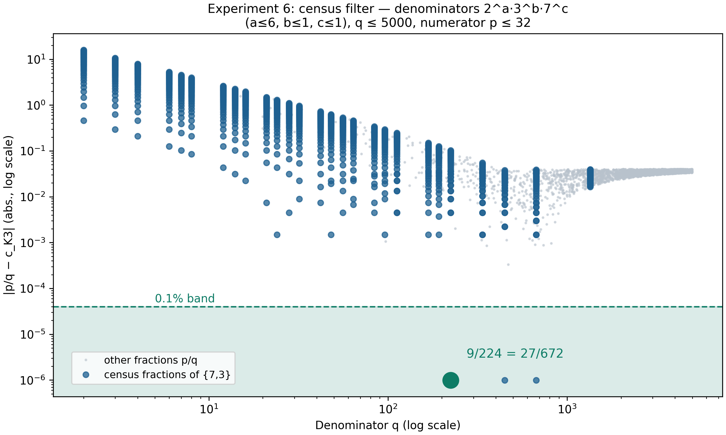
Fig. 1. The census filter: inside the 0.1% band — only 9/224 = 27/672.

3.4. The genus family c(g) and the degeneracy theorem
The observation 27/672 admits two structural readings, indistinguishable on the Klein quartic but divergent on the rest of the Hurwitz tower. Let a tower surface have genus g, group order |G| = 84(g−1), and the canonical {7,3} tiling: then V = 28(g−1), F = 12(g−1), and N = n₃ = 14(g−1) is the number of C₃-subgroups. Branch I reads 27/672 as 3³/(4|G|) — "resonances per spinor slots over the group"; branch II as (N−1)/(FN) — "all but one of the C₃-subgroups over face×subgroup slots". Branch III is the framework hypothesis c = b_Ch(b₂) with hypothetical b₂ = 22, 46, 94, 190.

Theorem (degeneracy). The branches c_I(g) and c_II(g) coincide if and only if g = 3. Proof: the equality 27·168(g−1)² = 336(g−1)(14(g−1)−1), after cancelling 168(g−1), gives 27(g−1) = 28(g−1) − 2, i.e. g − 1 = 2. A numerical check on the grid g = 3..100 confirms that the degeneracy point is unique.
Table 3. The genus family of the DSI amplitude c(g): three branches on the Hurwitz tower
g | N = n₃ | c_I | c_II | c_II/c_I | c_III | c_III/c_I
3 | 28 | 9/224 = 0.040179 | 9/224 = 0.040179 | 1.0000 | 0.040509 | 1.0082
7 | 84 | 3/224 = 0.013393 | 83/6048 = 0.013724 | 1.0247 | 0.009314 | 0.6954
14 | 182 | 9/1456 = 0.006181 | 181/28392 = 0.006375 | 1.0313 | 0.002233 | 0.3613
17 | 224 | 9/1792 = 0.005022 | 223/43008 = 0.005185 | 1.0324 | 0.000547 | 0.1089
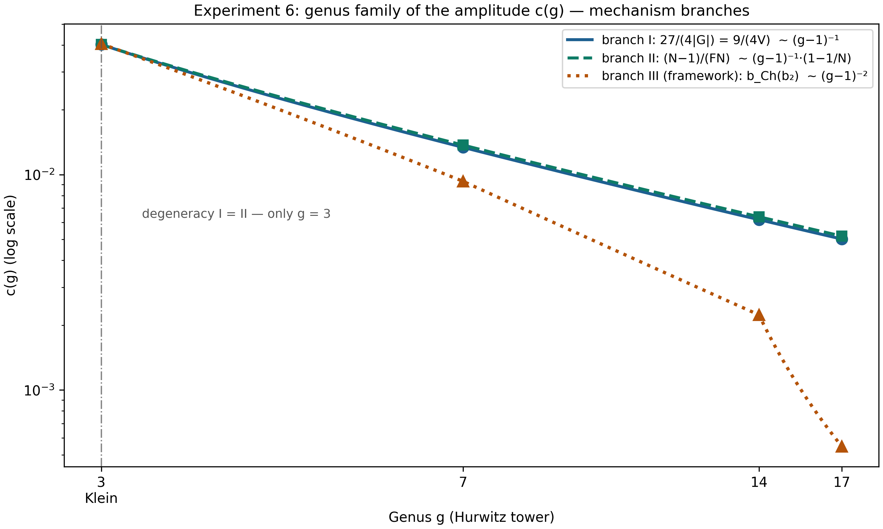
Fig. 2. The genus family c(g): the degeneracy of branches I and II is exactly g = 3.
Discriminator. Branch I decays as (g−1)⁻¹, branch III as (g−1)⁻²: at g = 17 they differ by a factor of nine. One measurement of the DSI modulation amplitude on any higher Hurwitz surface (nearest candidates: Fricke–Macbeath g = 7 with c_I = 3/224, or the triplet g = 17) suffices to select the mechanism. DSI-4 thus upgrades from a single coincidence to a one-parameter falsifiable family.

4. The Threshold e ≥ 1: the Ladder Becomes a Theorem

4.1. The class of carrier-isometric pairs
The Cuntz defect functional for a pair X₁, X₂ in M_n(C): F = ‖X₁*X₁ − I‖² + ‖X₂*X₂ − I‖² + ‖X₁*X₂‖² + ‖X₁X₁* + X₂X₂* − I‖² (Frobenius norms), e = F/n; the exact Cuntz relations are realised in no M_n. The sharp trace theorem gives the global floor F ≥ 5n/7, with equality at the pair √(4/7)·I — a construction that contracts the whole space. Natural transports of the framework do not contract the carrier; this is formalised by: X is a partial isometry if all its nonzero singular values equal 1 (equivalently XX*X = X; the carrier is the initial subspace, on which X is isometric). A pair is carrier-isometric if both operators are partial isometries. The class contains all structural models of the framework: permutation matrices (unitary), truncated Cuntz-tree shifts, complementary projections; outside the class: √(4/7)·I and weighted trees c_iS_i with c_i ≠ 1.

4.2. Theorem A: the threshold
Theorem A (threshold e ≥ 1). For every carrier-isometric pair (X₁, X₂) in M_n(C)²: F(X₁,X₂) ≥ n, i.e. e ≥ 1. Equality holds iff P = X₁X₁* and Q = X₂X₂* are orthogonal (PQ = 0) and p + q = n, where p, q are the ranks.
Proof (five lines). If X₁, X₂ are partial isometries, then P and Q are orthogonal projections. The audit identity F = G(P,Q) together with tr(P²) = tr(P) for projections gives F = 3n − 2p − 2q + 3r, where r = tr(PQ). For projections the bounds max(0, p+q−n) ≤ r ≤ min(p, q) hold: the lower one follows from tr(PQ) ≥ tr(P∧Q) ≥ p+q−n (dimension of the intersection of ranges), the upper one from tr(PQ) = tr(QPQ) ≤ ‖P‖·tr(Q) = q. If p + q ≥ n, then F − n = 3r − 2(p+q−n) ≥ p+q−n ≥ 0; if p + q ≤ n, then F − n = 2(n−p−q) + 3r ≥ 0. In both cases equality forces p + q = n and r = 0, i.e. PQ = 0. The equality case is a pair of complementary orthogonal projections; the gauge group of F is large — (X₁, X₂) → (UX₁W, UX₂V) with arbitrary unitaries U, V, W — and all equality cases are equivalent to the block form diag(I_p, 0), diag(0, I_q).

4.3. Theorem B: exact covering arithmetic
Theorem B (covering formula). Let X₁, X₂ be partial isometries with P + Q ≤ I (the combined ranges do not cover the space) and R = I − P − Q ≥ 0. Then F = n + 2·rank(R) exactly.
The proof is a direct count of the four terms: ‖X₁*X₁ − I‖² = tr(I − P') = q + rank(R) for the initial projection P' of rank p (since I − P = Q + R); symmetrically ‖X₂*X₂ − I‖² = p + rank(R); ‖X₁*X₂‖² = tr(PQ) = 0; ‖P + Q − I‖² = ‖R‖² = rank(R). Summing and using p + q + rank(R) = n yields F = n + 2·rank(R). For the Cuntz-tree truncation at depth k only the root is left uncovered: rank(R) = 1, and the formula instantly reproduces the finding of Experiment 1: F = n + 2, e = 1 + 2/n → 1 (verified up to k = 10, n = 2047, accuracy 10⁻¹³). The tree truncation is a near-extremal of the class: it pays exactly 2 for the single uncovered dimension.
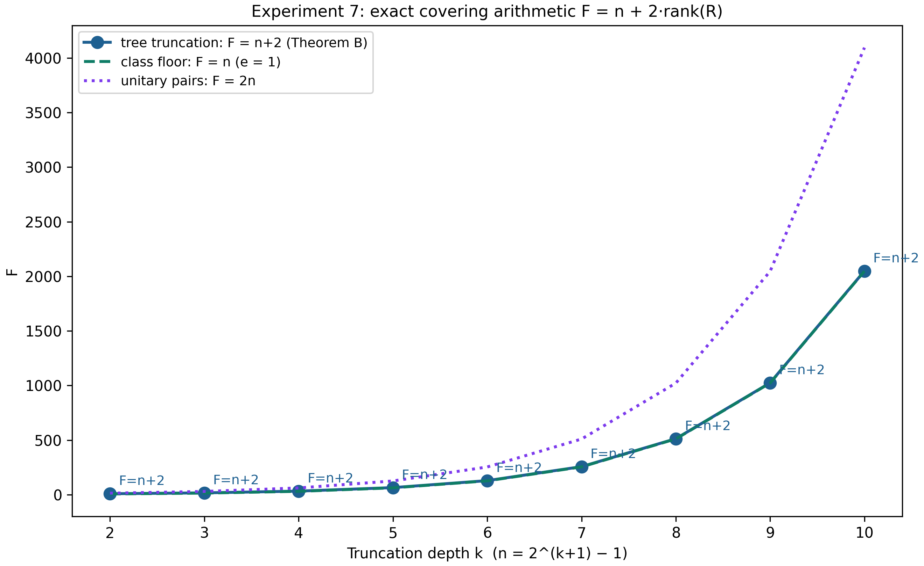
Fig. 3. Covering arithmetic: the tree follows F = n + 2 exactly (Theorem B).

4.4. Theorem C and the three-term defect arithmetic
Theorem C (unitary pairs). If X₁, X₂ are unitary, then F = 2n exactly, for every pair: P = Q = I, the first two terms vanish, ‖X₁*X₂‖² = n (a product of unitaries is unitary) and ‖I‖² = n.
The permutation models of the framework are a special case: every unitary pair pays exactly 2n, with the defect sitting entirely in the overlap of ranges (r = n). The formulas F = 3n − 2p − 2q + 3r and F = n + 2·rank(R) provide the exact three-term arithmetic: the defect of a carrier-isometric pair decomposes into range overlap with weight 3r, covering deficit with weight 2·rank(R), and the base unit n; the framework's ladder is exactly this arithmetic evaluated on three families: free scalars 5/7 (outside the class), tree 1 + 2/n, unitary pairs 2.
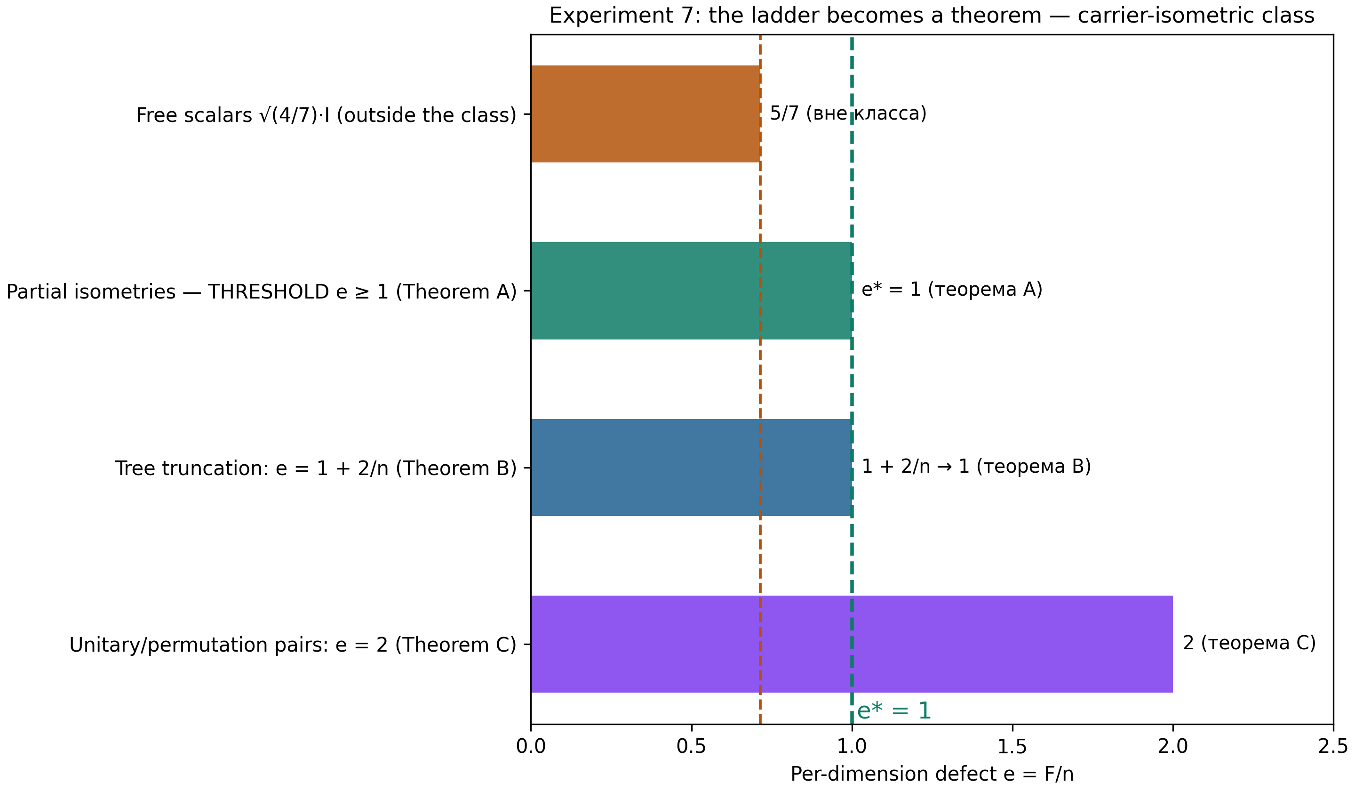
Fig. 4. The ladder as a theorem: the class floor is e = 1 (Theorem A); 5/7 only outside the class; unitary pairs pay exactly 2.

4.5. Consequence for the Sh1–Sh4 chain and numerical verification
Corollary D (class closure). On the class of carrier-isometric pairs inf e = 1; the value 5/7 < 1 is unattainable. Hence no sequence of carrier-isometric models can drive e → 0: in the Sh1–Sh4 chain the step Sh2 strengthens to η ≡ 1, and the Sh.3(iii) bridge is impossible for isometric-on-carrier transports — the per-dimension defect stays at or above 1.
The class boundary is optimal: a weighted tree c_iS_i leaves the class with a quadratic penalty F = (n−1)[(c₁²−1)² + (c₂²−1)²] + n + 2; at c² = 4/7 this gives e ≈ 1.37–1.48 (for k = 3–7) — above the class floor. Reaching 5/7 requires contracting the entire carrier (√(4/7)·I): the global minimum lives strictly outside the class, so the threshold of Theorem A is unavoidable within it. All statements were verified numerically (the deterministic experiment exp7_e1_threshold.py): the identity F = 3n − 2p − 2q + 3r to 5.9·10⁻¹⁶ on 24,000 random partial isometries (n ≤ 12); zero threshold violations on the same pairs; equality cases F = n to 8.9·10⁻¹⁶; the covering formula on 500 random pairs of projections to 7.1·10⁻¹⁵; the tree k = 2..10 — F = n + 2 to 2.3·10⁻¹³; unitary and permutation pairs F = 2n to 2.8·10⁻¹⁴ and 1.4·10⁻¹⁴; the supporting bounds on tr(PQ) — zero violations on 10⁴ pairs of projections.
Table 4. Numerical verification of Theorems A/B/C (Experiment 7)
Check | Scope | Max deviation
Identity F = 3n − 2p − 2q + 3r | 24,000 partial isometries, n ≤ 12 | 5.9·10⁻¹⁶
Threshold e ≥ 1 (Theorem A) | the same 24,000 pairs | 0 violations
Equality cases F = n | 5 configurations (n, p, q) | 8.9·10⁻¹⁶
Covering formula (Theorem B) | 500 random (P, Q), P + Q ≤ I | 7.1·10⁻¹⁵
Tree: F = n + 2, rank(R) = 1 | k = 2..10 (n up to 2047) | 2.3·10⁻¹³
Unitary pairs F = 2n (Theorem C) | 200 pairs, n ≤ 32 | 2.8·10⁻¹⁴
Bounds on tr(PQ) | 10,000 pairs of projections | 0 violations

5. Honesty and Status of Claims
Proved analytically and in full: Theorem A (the threshold e ≥ 1 for partial isometries with an exact description of the equality cases), Theorem B (the exact formula F = n + 2·rank(I − P − Q)), Theorem C (F = 2n for unitary pairs), and the degeneracy theorem of the genus family (c_I = c_II only at g = 3) — all with short proofs resting on the audit identity F = G(P,Q) and classical projection bounds.
Proved computationally with exhaustive search: the uniqueness lemma for 9/224 (all census fractions with q ≤ 5000, p ≤ 32) and the census of the {7,3} tiling (the explicit GL(3,2) construction with graph verification). Numerically confirmed (machine precision, fixed seeds): all corollaries of Theorems A/B/C and the supporting projection bounds.
Remains an observation or a hypothesis: the link between the Klein quartic and collapse itself (an analogy on coincidences at the 0.1–0.8% level); the dynamical derivation of the numerator 9 = 3² (both branches are interpretations, not mechanisms); the falsifiability of the genus family c(g) (no measurements on higher Hurwitz surfaces exist yet). The 0.67% gap between b_Ch(7) and γ is ruled out as an exact claim by modern precision unless the δ-machinery provides a correction.

6. Conclusions and Next Steps
The obstruction ladder of the Cuntz defect is no longer an empirical sequence of values but a theorem with exact arithmetic: the threshold e ≥ 1 on the class of carrier-isometric constructions is proved (Theorem A), the covering formula F = n + 2·rank(R) is exact (Theorem B), unitary pairs pay exactly 2n (Theorem C), and Corollary D closes the Sh.3(iii) bridge for the whole class: sofic amplification cannot come from isometric transports.
The DSI-4 observation acquired an analytical environment: the constant 224 = 4·56 is census-born (seven independent identities, cross-tower twins), the fraction 9/224 is unique among census fractions (the uniqueness lemma), and the genus family c(g) with a single degeneracy at g = 3 makes the programme falsifiable: the branches (g−1)⁻¹ and (g−1)⁻² differ by a factor of 1.4 already at g = 7 and by nine at g = 17. The Choptuik problem statement is fixed at both levels, and its solvability is assessed honestly: numerically — solved; rigorously — major open problems (existence, uniqueness, stability of the DSS critical solution); closed form — the framework's programme with two precise gaps.
Next steps: (a) commit Theorems A/B/C and Corollary D to the repository as version 3 of stability_lemma with tests on partial isometries; (b) set up a lattice/spectral experiment on the Fricke–Macbeath surface (g = 7): a measurement of the DSI amplitude would discriminate branches I and III with a single number (3/224 versus b_Ch(46) — a factor of 1.44); (c) a high-precision computation of λ₁ of the quartic (Hejhal's algorithm) and of γ by Gundlach-type perturbation theory — testing whether the δ-expansion can close the 0.67% gap; (d) analytic work on the numerator 9 = 3²: deriving "all but one" (N − 1) from the cohomology of spin bundles over {7,3}, or proving that no such derivation exists.

Appendix. Reproducibility
Experiment package: choptuik_experiments/exp6_census_224.py (the {7,3} census from GL(3,2), the provenance of 224/672, the census filter, the genus family c(g)) and exp7_e1_threshold.py (Theorems A/B/C: partial isometries, the covering formula, unitary pairs, the tr(PQ) bounds, the 5/7 contrast). Run: python3 exp6_census_224.py and python3 exp7_e1_threshold.py; results are written to results/exp6_census_224.json and results/exp7_e1_threshold.json, figures to fig_ru/ and fig_en/. All runs are deterministic (fixed generator seeds); the total time of the two runs is under three minutes.
The illustrative Choptuik figure (universal scaling and the constant comparison) is produced by python3 fig_choptuik.py; it is synthetic and labelled as an illustration of the 1993 statement, not as a result of collapse simulation.

