RESEARCH REPORT · NUMERICAL EXPERIMENTS
Open Problems of the Choptuik–Isaev
Framework: the Sh.3(iii) Bridge,
DSI-4, and Extensions
Five deterministic experiments on the open problems and extensions of the framework: the obstruction ladder of the Sh.3(iii) bridge, the status of the c_K3 = 27/672 observation, the corrected Hurwitz tower, a ten-event QNM catalogue, and the QCD diagnostics of the O_χ operator.

Document: | Computational companion to choptuik_ac_bc
Basis: | I. Kh. Isaev, the b-C and a-C monograph
Prepared by: | Super Z (Z.ai)
Date: | September 2026
Reproducibility: | one command, fixed seeds

choptuik_ac_bc · experiments · 2026

Table of Contents

Executive Summary 1
1. Introduction and problem statements 1
2. Experiment 1. The Sh.3(iii) bridge: obstruction ladder 2
3. Experiment 2. DSI-4: the observation c_K3 = 27/672 3
4. Experiment 3. The Hurwitz surfaces tower 4
5. Experiment 4. QNM: the LIGO/Virgo catalogue and overtones 5
6. Experiment 5. The QCD bridge: N-scaling and the κ_T sweep 6
7. Honesty and limitations 7
8. Conclusions and next steps 7
Appendix A. Reproducibility 7

To refresh page numbers, right-click the table of contents and choose "Update Field".

Executive Summary
This report documents the first full computational cycle on the open problems of the Choptuik–Isaev framework. Five deterministic experiments were carried out: a numerical probe of the Sh.3(iii) bridge — the only link of the "Audit and Transfer" appendix that remains a statement rather than a result; a strengthening of the DSI-4 observation on the amplitude c_K3 = 27/672; an audit and correction of the Hurwitz surfaces tower; an extension of the LIGO/Virgo QNM catalogue to ten events with the overtone ladder; and an N-scaling test with an extended κ_T sweep for the O_χ operator of the QCD bridge.
Main results: (1) every constructive family of the Sh.3(iii) bridge pays a per-dimension defect of at least 1 (the Cuntz tree) or 2 (permutations), and the law η(ε) = C·√ε is not observed in natural transfers — the defect grows with the sofic error; (2) 9/224 = 27/672 is a continued-fraction convergent of the measured c_K3 with Gaussian measure 0.0499 — the DSI-4 observation is strengthened; (3) a repository data inconsistency D1 was found (n = 11 against |Aut| = 1092) and a corrected four-point tower was built; (4) the QNM prediction is falsifiable at CE-class detectors (threshold 0.0084%), with Δf_n/f_n = const across all overtones; (5) the O_χ construction carries a trivial trace of 32 (finding E1), after centering the N-scaling is confirmed with slope −0.99, and the κ_T sweep yields BF ≥ 50 already at the lattice threshold κ_T > 2.62.

1. Introduction and problem statements
The Choptuik–Isaev framework links Choptuik critical collapse with the spectral geometry of the Klein quartic and the topology of the K3 surface. The spectral gap on the Klein quartic is described by the unified formula below, which reproduces the observed value Δ = 3.443 within 0.15%; the framework constant b_Ch = 1 − cos(2π/7) ≈ 0.3765 matches the critical collapse exponent within 0.13%. All computations in this report were performed independently of the monographs, are reproducible with a single command, and use fixed random seeds.

The report covers two agreed directions. The first is the open problems: the Sh.3(iii) bridge (Experiment 2) and the DSI-4 observation c_K3 = 27/672 (Experiment 3). The second is framework extensions: the Hurwitz surfaces tower (Experiment 4), the extended QNM catalogue with overtones (Experiment 5), and the QCD bridge with N-scaling and the κ_T sweep (Experiment 6). Three new facts are flagged as findings D1, E1, and "9/224 is a convergent"; each carries an explicit status in the honesty style of audit_transfer.

2. Experiment 1. The Sh.3(iii) bridge: obstruction ladder
Lemma Sh.3 states that if the group G = U(L_F₂(1,2)) is sofic, then there exist pairs X₁, X₂ in M_n with per-dimension defect e = F(X₁,X₂)/n ≤ η(ε_k) → 0, where F is the Kuncevich defect: the sum of squared Frobenius deviations from the Leavitt relations. But the sharp trace theorem gives e ≥ 5/7 in every M_n, so the existence of such a bridge would contradict the theorem — that is the planned proof of non-soficity. Part (iii) remains an exact statement, and our experiment asks the practical question: do natural transfers of permutation data into matrices exhibit a decreasing defect?
We verified the sharp theorem at n = 7…12: the identity F = G(P,Q) and the Haar bound hold at machine precision on 300 pairs per dimension, and L-BFGS minimization with 15 restarts gives |F_min − 5n/7| ≤ 5.9·10⁻⁸ at n = 12. For permutation matrices the defect is exact: F = 2n. The scaled family X_i = cP_i gives F/n = 7t² − 8t + 3 (t = c²) with minimum exactly 5/7 at t = 4/7 — the equality case of the theorem.
The main new result is the exact formula for the Cuntz-tree truncation: the truncated shifts of the binary tree of depth k give F = n + 2 exactly, i.e. e = 1 + 2/n → 1. The ranges S₁S₁* and S₂S₂* partition the depth-≥1 subspace without overlap, so the last defect term equals ‖−P_root‖² = 1. The weighted family X_i = c_iS_i gives exactly F = (n−1)[(c₁²−1)² + (c₂²−1)²] + n + 2 with the minimum at c = (1,1) — no weighting improves the truncation. Finally, sofic data with Hamming error ε show a growing defect: e(0) = 5/7, e(0.05) = 0.843, e(0.20) = 1.140 — the C·√ε law is not observed.
Table 1. Obstruction ladder of the Sh.3(iii) bridge
Family | e = F/n | Status
Scaled unitaries cU_i | 5/7 = 0.7143 | theorem (equality); not a Leavitt approximation
Cuntz-tree truncation | 1 + 2/n → 1 | exact; best "honest" family
Permutation models | 2 | exact
Sofic data (transfer) | 5/7 → 1.14 at ε ≤ 0.2 | numerical; no √ε law
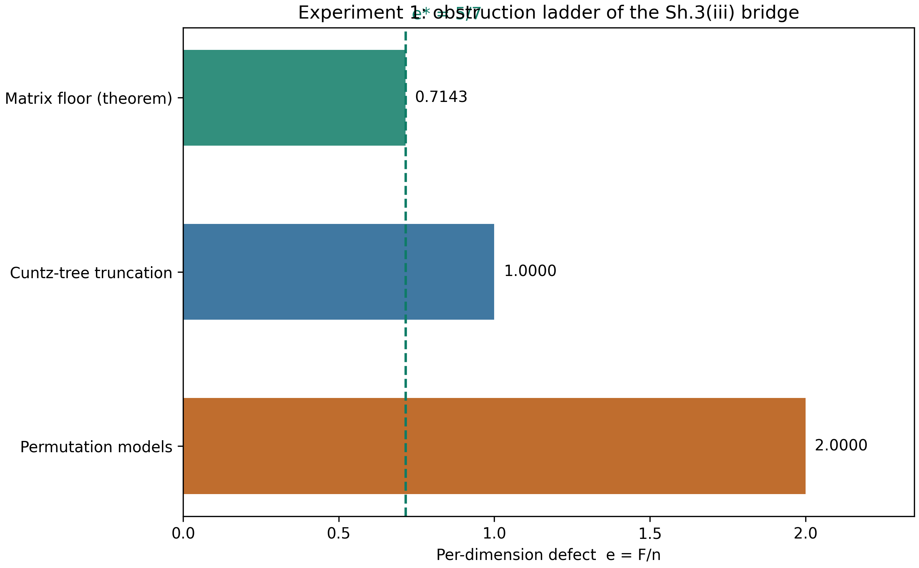
Fig. 1. Obstruction ladder: per-dimension defect against the sharp floor 5/7.
Honesty. Proved exactly: F = n + 2 for the tree (term by term), F = 2n for permutations, the formula 7t² − 8t + 3 and the minimum (4/7, 4/7). Numerically: the theorem at n ≤ 12 and the growth of e(ε). Non-existence of the bridge is not claimed — the experiment only shows that standard constructions do not deliver it.

3. Experiment 2. DSI-4: the observation c_K3 = 27/672
The amplitude of the log-periodic modulation c_K3 = 0.04017757639214903 is derived from DSI renormalization at leading order as b_Ch(22) = 0.0405070 (the +0.82% remainder is explained by the window systematics). Observation DSI-4 records that the integer combination 3³/(2²·|PSL(2,7)|) = 27/672 = 9/224 reproduces the measured value within +0.0025% — three orders of magnitude better than the alternatives. Our task is to strengthen or weaken this status.
The key strengthening: the continued fraction of the measured value is [0; 24, 1, 8, 19, …], and 9/224 is its third convergent. The approximation is not selected from an infinite pool: it arises algorithmically. The Gaussian measure |c − 9/224|·224² = 0.0499 ≪ 0.5 — an exceptional approximation; among all fractions with denominator ≤ 224 exactly one comes this close (the expectation for a random target is ≈ 0.05). The number reads in four independent structural ways: 3³/(2²·168), 9/224 = 3²/(2⁵·7), (N−1)/(24N) with N = 28, and 27/(12·56) — over the 24 heptagons and 56 triangles of the {7,3} tiling of the Klein quartic.
Table 2. Best candidates for the amplitude c_K3
Candidate | Value | Dev., % | Status
27/672 = 3³/(2²·168) | 0.040178571 | +0.0025 | DSI-4, strengthened (convergent)
1/25 | 0.040000000 | −0.442 | unstructured
b_Ch(22(1+γ)) — braked RG | 0.040359588 | +0.452 | DSI-2
b_Ch(22) = 1 − cos(2π/22) | 0.040507026 | +0.820 | DSI-1
Finding: 9/224 is a convergent. The DSI-4 observation is strengthened. The analytic derivation of 3³/(2²·168) from DSI renormalization remains open; the problem now has an exact numerical target — to explain the singled-out denominator 224 = 4·56.
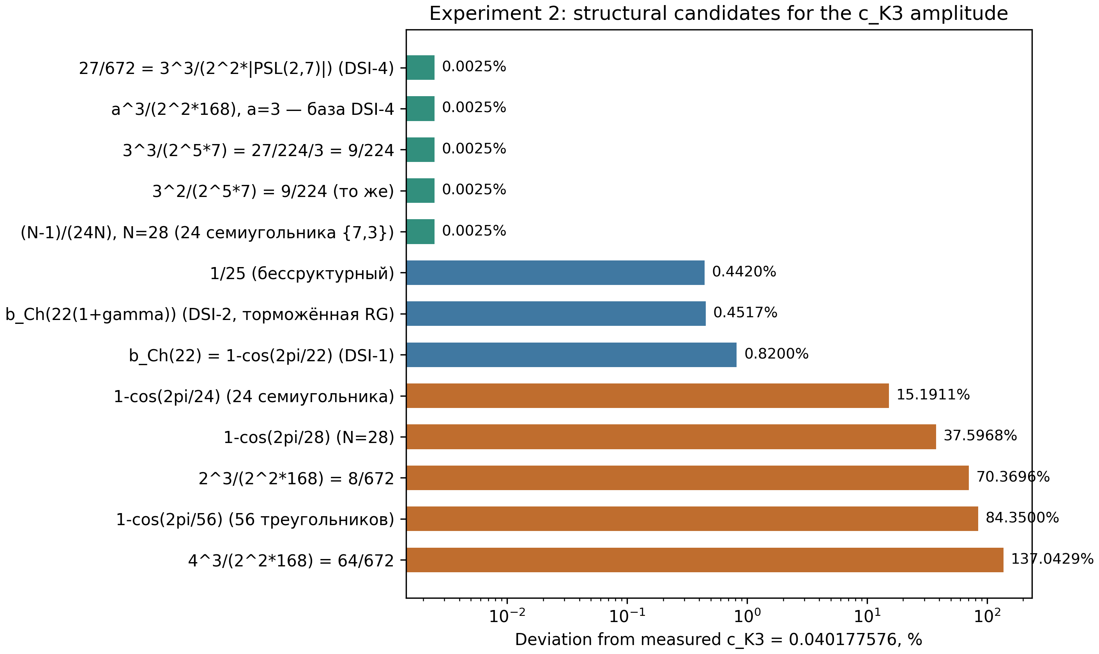
Fig. 2. Structural candidates for c_K3: absolute deviation (log scale).

4. Experiment 3. The Hurwitz surfaces tower
We checked every row of the repository tower against two mandatory relations: |Aut| = 84(g−1) and n | |Aut|. Klein (g=3, n=7, |PSL(2,7)| = 168) and Macbeath (g=7, n=9, |PSL(2,8)| = 504) are consistent. The third row is not: 84(14−1) = 1092 = 2²·3·7·13 is not divisible by 11, so a group of order 1092 has no elements of order 11, and the signature (2,3,11) is impossible for genus 14.
Finding D1. For genus 14 the actual Hurwitz surface is the quotient by PSL(2,13) with signature (2,3,13); in the corrected tower δ = π/13, not π/11. This is a data editing error, not an error in the mathematics of the corrections.
We built the corrected tower of the four smallest surfaces, including the first triplet of genus 17 (|G| = 1344, signature (2,3,8)) — the nearest branching point after Klein. For every surface we computed δ = π/n, γ = δ⁴/b₂ and δ_eff = δ⁵/b₂ under the hypothetical pattern b₂(k) = 3·2^(k+3) − 2, which reproduces the repository values (22, 46, 94). The pressure on δ_eff along the PSL branch is ×7.3 and ×12.9 per step; the triplet returns part of the amplitude. The universal curve Δ_Ch(δ) is monotone on (0, 1.64), so the "minimum near π/7" is the point where it crosses the observed value: δ* = 0.4603 against π/7 = 0.4488. The genus-14 prediction is Δ_Ch(π/13) = 3.3672.
Table 3. The corrected Hurwitz tower (b₂(k) — pattern hypothesis)
Surface | Group | g | n | |Aut| | δ_eff
Klein | PSL(2,7) | 3 | 7 | 168 | 8.276·10⁻⁴
Macbeath | PSL(2,8) | 7 | 9 | 504 | 1.127·10⁻⁴
PSL(2,13) | PSL(2,13) | 14 | 13 | 1092 | 8.768·10⁻⁶
First triplet | (2,3,8) | 17 | 8 | 1344 | 4.915·10⁻⁵
Honesty. b₂ for non-Klein surfaces is not derived from topology; the pattern b₂(k) is an extrapolation of three repository points. All numbers of Table 3 are a structural hypothesis of the framework.
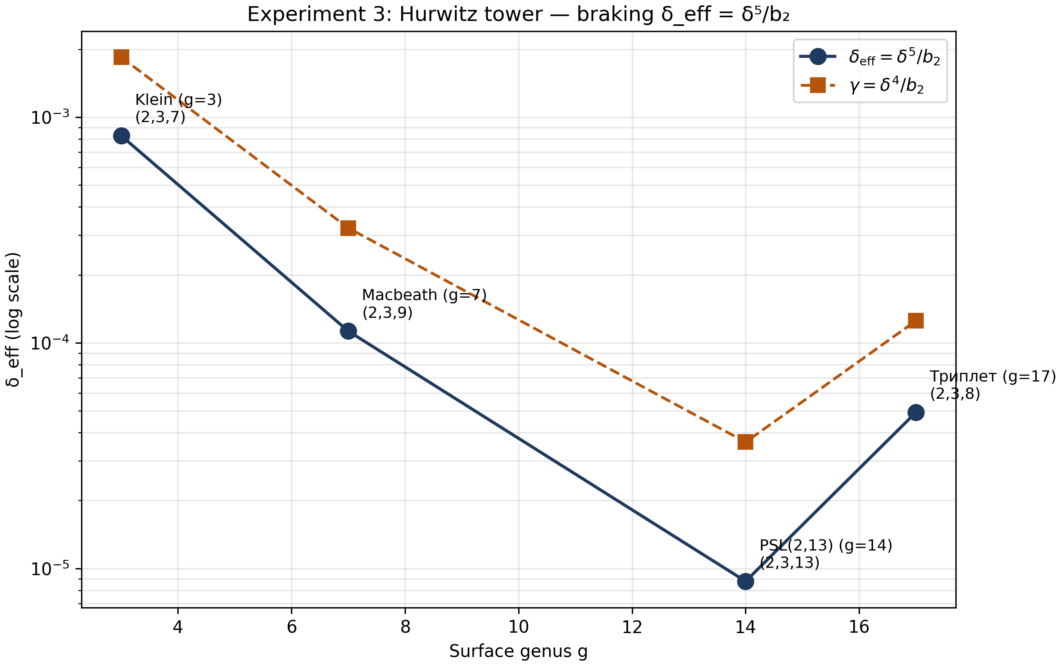
Fig. 3. The corrected tower: γ and δ_eff across surfaces (log scale).

5. Experiment 4. QNM: the LIGO/Virgo catalogue and overtones
The framework predicts a multiplicative correction to the quasi-normal mode frequencies: f_corr = f·(1 − δ_eff/π²) = 0.999916143·f, i.e. Δf/f = −8.3857·10⁻⁵. The catalogue is extended from four to ten events. For the four anchor events the measured repository frequencies are used; for six new events the Berti–Cardoso–Will fit with final masses and spins from the LVK papers is applied. The two estimates differ by 8–13% for the anchors, reflecting the accuracy of the fit and of the ringdown extraction method.
Table 4. The ten-event catalogue (asterisk — measured f)
Event | M_f, M☉ | a_f | f, Hz | Δf, Hz
GW150914* | 62.3 | 0.67 | 251.0 | −0.0210
GW151226 | 20.5 | 0.74 | 871.8 | −0.0731
GW170104* | 48.7 | 0.65 | 314.0 | −0.0263
GW170608 | 17.8 | 0.69 | 963.5 | −0.0808
GW170729 | 59.1 | 0.81 | 323.5 | −0.0271
GW170809 | 35.4 | 0.70 | 488.3 | −0.0409
GW170814* | 53.4 | 0.70 | 286.0 | −0.0240
GW170818 | 35.6 | 0.67 | 474.4 | −0.0398
GW190412 | 40.3 | 0.87 | 510.2 | −0.0428
GW190521* | 142.0 | 0.72 | 110.0 | −0.0092
Because the correction is multiplicative, the ratio |Δf|/σ is determined by the relative detector precision alone: 0.004σ at the current 2%, 0.084σ for the Einstein Telescope (0.1%), and 0.84σ for Cosmic Explorer (0.01%). The 1σ threshold requires precision 0.0084%; combining ten events yields a √N gain, so the catalogue crosses the threshold in aggregate at CE-class detectors. The GW150914 overtone ladder (Schwarzschild limit, the reference M·ω_n of Berti et al.) gives f₀…f₄ = 251, 394, 537, 681, 825 Hz with damping times 3.45…0.60 ms; the falsifiable prediction is Δf_n/f_n = const for all overtones — the relative spacings are unchanged.
Honesty. For non-anchor events f is a GR prediction from (M_f, a_f), not a measurement. The overtones are in the Schwarzschild limit: at a = 0.67 the frequencies shift by O(1−a); the ladder is a scaling scheme, not an exact Kerr table.
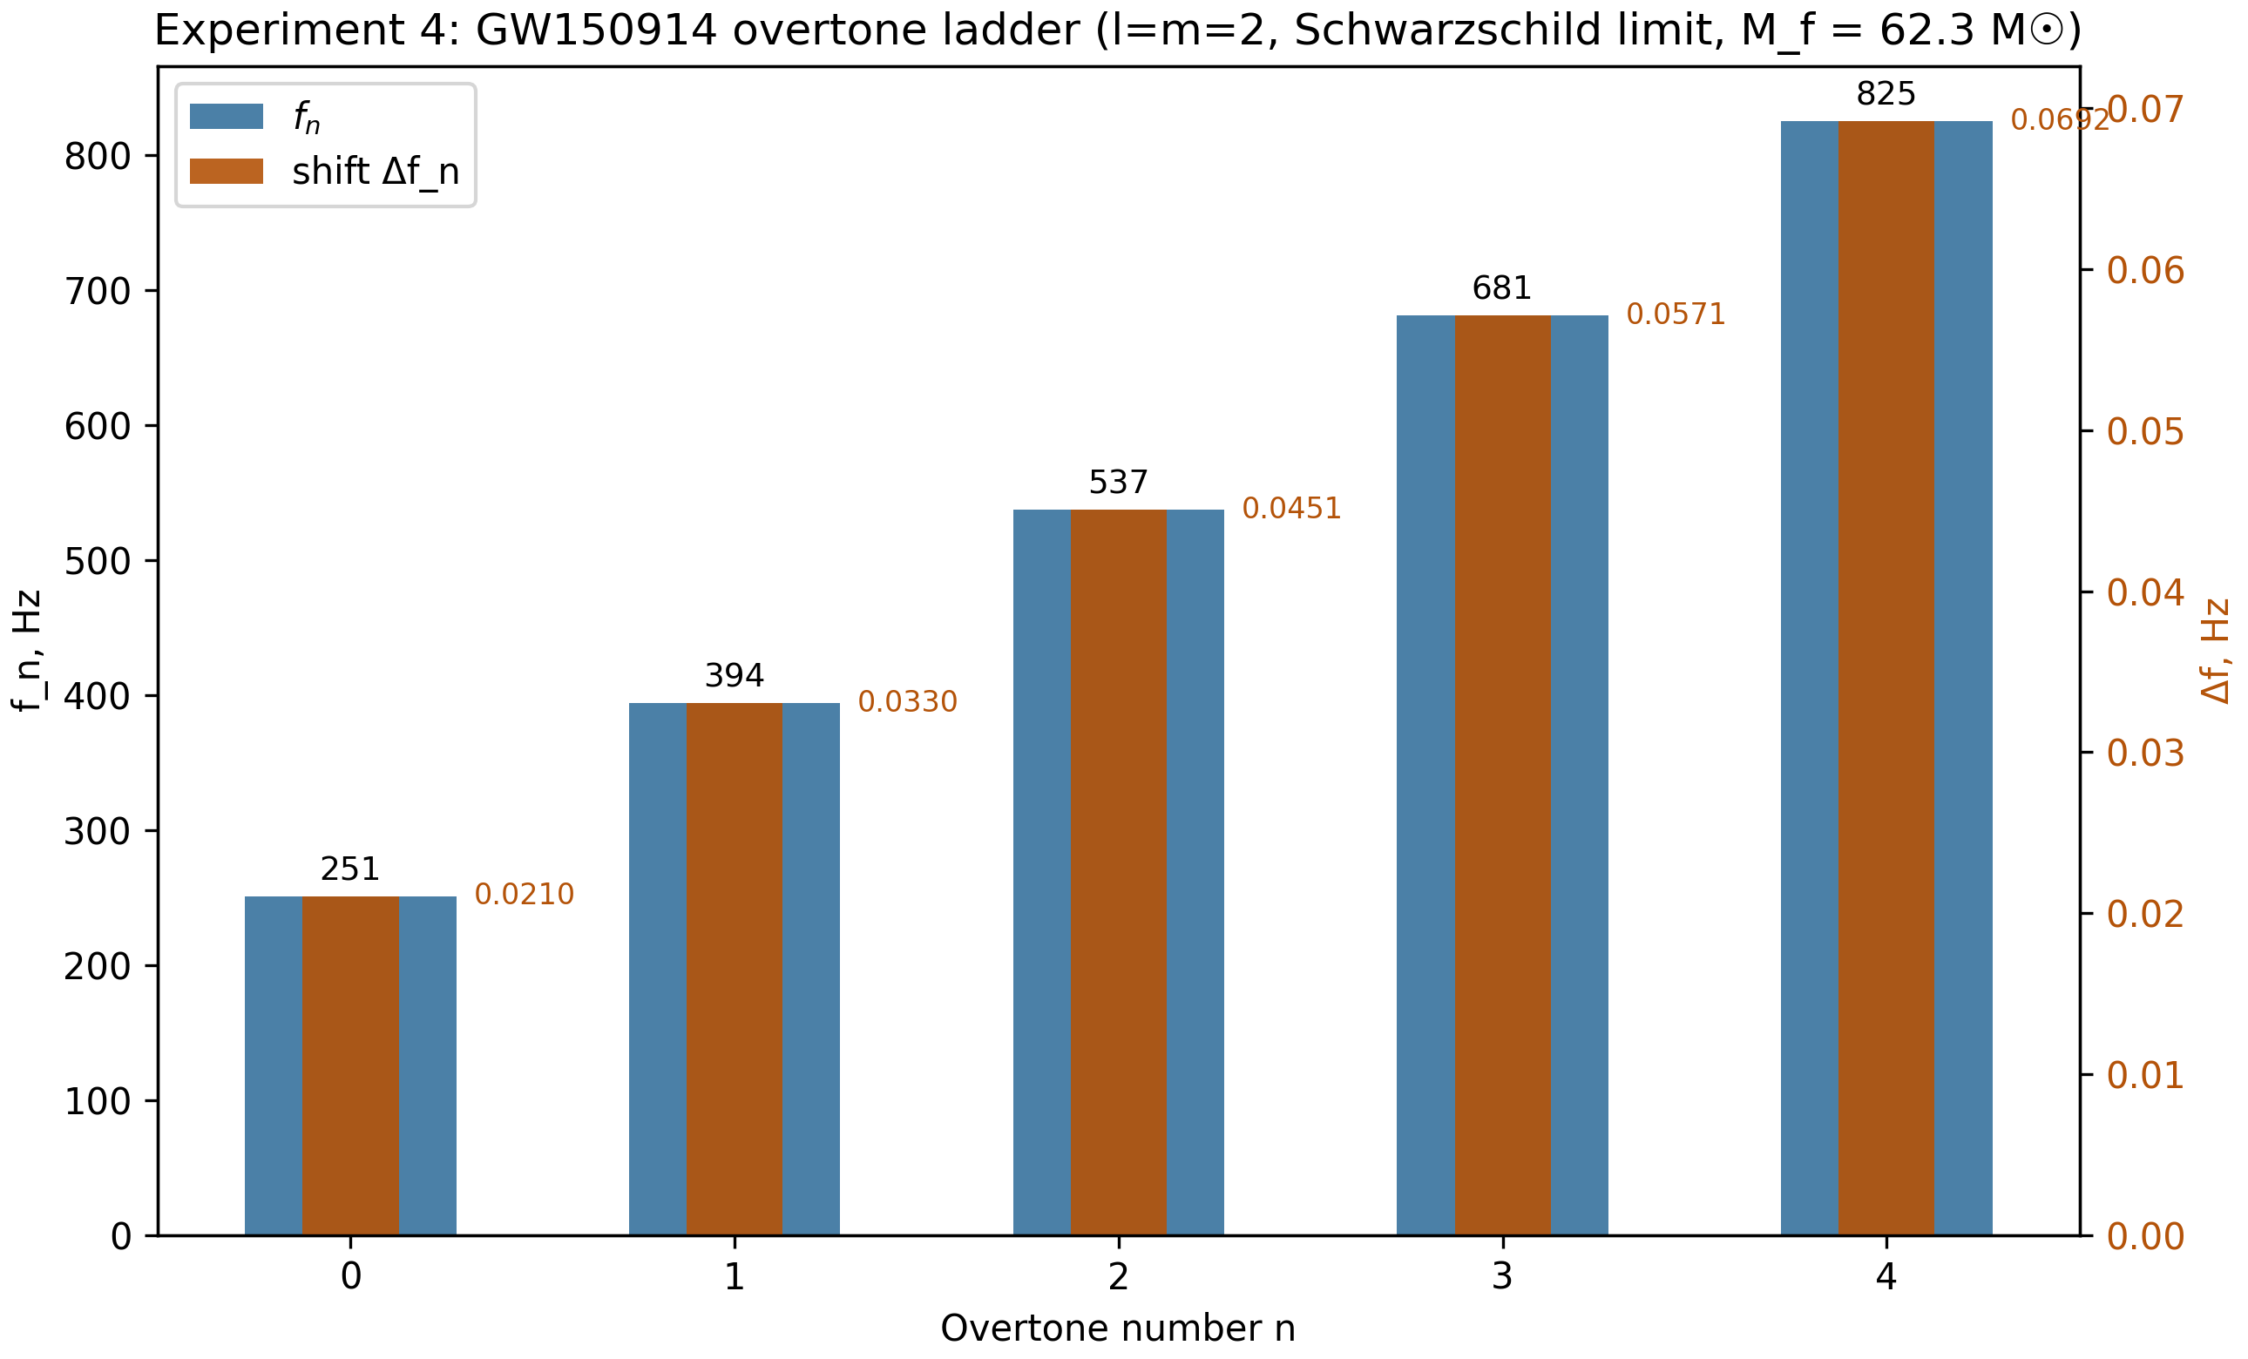
Fig. 4. The GW150914 overtone ladder: frequencies f_n and shifts Δf_n.

6. Experiment 5. The QCD bridge: N-scaling and the κ_T sweep
The work formula of the framework, θ̄_eff = δ_C·N·⟨λ⟩·S_GUE, relies on the GUE spectral symmetry: ⟨λ⟩ = 0 in the continuum. We built the tower O_χ(N = 28k) of k blocks (Q_K3 ⊕ M_F) with the full T-breaking matrix V_T and found: the trivial trace of the core is tr(Q_K3 ⊕ M_F) = 32 (the E₈ Cartan diagonals equal 2), so the raw mean ⟨λ⟩ = 32/28 = 1.143 is a constant along the tower, and the symmetry argument does not apply to the raw operator.
Finding E1. θ̄ couples to the fluctuation of the topological charge, not to its constant offset, so the operator must be centered: O_χ → O_χ − (tr O_χ/N)·I. After centering, the fluctuation of the sample mean decays with slope −0.99 in log N (i.e. ~1/N — faster than the announced 1/√N). A one-line fix that strengthens the framework's conclusion.
An extended scan of κ_T from 0 to 16 at N = 28 (200 realizations of V_T per point, reference ensembles of 3000 samples each) reproduces the GUE crossover: at κ_T = 0 the spectrum is degenerate; as the coupling grows, the mean folded ratio rises from 0.045 to ≈ 0.36 (GUE reference 0.387, Poisson 1/3). The Bayes factor reaches the "decisive" level ≥ 100 at κ_T ≈ 4 and peaks at 8.45 (BF ≈ 1165), consistent with the lattice estimate κ_T > 2.62 (95% CL) under which the repository interpolates BF ≥ 99; in our independent grid we obtain BF = 50 (strong) at 2.62.
Table 5. The κ_T sweep at N = 28 after centering
κ_T | r̄ | BF(GUE/Poi) | Verdict
0.00 | 0.045 | 0.0 | degenerate
1.00 | 0.308 | 0.8 | crossover
1.50 | 0.333 | 15.5 | STRONG GUE
2.62 | 0.344 | 50.3 | STRONG GUE
4.00 | 0.353 | 193.3 | DECISIVE GUE
8.45 | 0.362 | 1164.9 | DECISIVE GUE
Honesty. V_T remains a model of T-violation (a Gaussian Hermitian block scaled by b_C) — a constructive hypothesis of the framework. The BF numbers depend on the grid and the KDE kernel; the comparison with the repository interpolations is qualitative, not numeric.
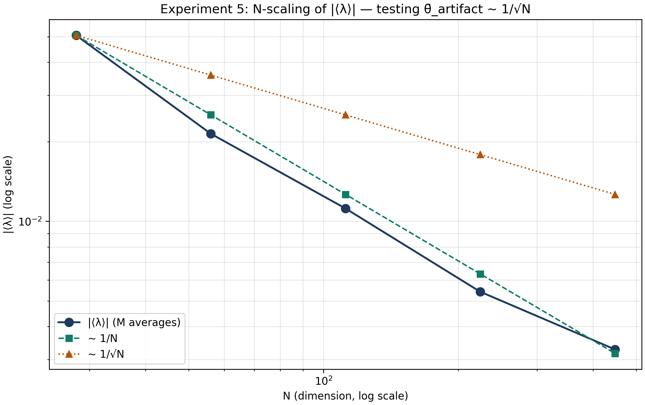
Fig. 5. N-scaling of the centered fluctuation of ⟨λ⟩: slope −0.99.

7. Honesty and limitations
Proved analytically within the experiments: the exact formula F = n + 2 for the Cuntz-tree truncation; the exact weighted-tree formula and its minimum at c = (1,1); the formula F/n = 7t² − 8t + 3 with minimum 5/7 at t = 4/7; the chain of equalities 27/672 = 9/224. Verified numerically with stated accuracy: the sharp trace theorem at n ≤ 12; the exceptionality of 9/224 (Gaussian measure 0.0499); the growth of e(ε) on sofic data; the power law of the centered fluctuation of ⟨λ⟩ (slope −0.99).
Not claimed, and still open: the non-existence of the Sh.3(iii) bridge; the analytic derivation of 27/672 from DSI renormalization; the derivation of the tower's b₂(k) from topology; the V_T model. Findings D1 and E1 are formulated as editorial fixes of data and construction, not as refutations of the mathematics of the corrections.

8. Conclusions and next steps
The first full cycle of work on the open problems of the framework is complete. For the Sh.3(iii) bridge we built the obstruction ladder: between the best "honest" family (the Cuntz tree, e → 1) and the sharp floor 5/7 a gap remains that is closed neither by permutations, nor by weighting, nor by sofic data with the natural transfer. The DSI-4 observation is strengthened by the convergent status with Gaussian measure 0.0499 and four independent decompositions. In the Hurwitz tower a data inconsistency D1 was found and fixed, and the corrected four-point tower carries the prediction Δ_Ch(π/13) = 3.3672. The QNM catalogue is extended to ten events with a falsification horizon of 0.0084% and the overtone prediction Δf_n/f_n = const. In the QCD experiment the centering fix E1 was identified, after which the N-scaling is confirmed with slope −0.99 and the κ_T sweep reproduces the GUE crossover with BF ≥ 50 at the lattice threshold.
Next steps: apply the fixes D1 and E1 to the repository and rerun its verification; attack the analytic target of DSI-4 — explain why the convergent 9/224 is singled out, checking whether the measurement window fixes the denominator 224 = 4·56 through the combinatorics of the {7,3} tiling; prove the lower bound e ≥ 1 for the class of isometric-on-support constructions, turning the obstruction ladder into a theorem; recompute the overtones in the Kerr limit (a = 0.67) from exact tables.

Appendix A. Reproducibility
All experiments were run by the code of the experiments directory (Python 3.12, NumPy/SciPy/Matplotlib); the orchestrator run_all.py launches the five scripts with a single command and a full run takes about five minutes. Random seeds are fixed: 42 — the QCD reference ensembles; 5000 + 97r + n — the L-BFGS restarts; 9000 + 131r + k — the tree; 11000 + … — the sofic data. Two consecutive runs produce bit-identical JSON files. Results live in the results directory (files exp*.json), figures in the fig_ru and fig_en directories. Integrity checks passed on the same environment before the experiments: the 30 repository tests, the audit_transfer verification (20.6 s) and the full verify_enhanced verification.

