F O R M A L C H O P T U I K
From Code to
Machine-Checked Proof
A Formalization Roadmap for Choptuik Critical Phenomena in Lean 4 · formal_choptuik, Volume I
Author: Ishak Khamzatovich Isaev · ORCID 0009-0003-7299-0701
Programme: choptuik_ac_bc · formal-verification wing
Nalchik · 2026

formal_choptuik · Lean 4 + mathlib Volume I · roadmap

Abstract
This monograph presents a roadmap for turning the choptuik_ac_bc computational programme into a fully formalized, machine-checked theory of Choptuik critical phenomena in the Lean 4 proof assistant. We fix the mathematical foundations: the Einstein–scalar field system in spherical symmetry, discrete self-similarity with echoing period Δ ≈ ln 2, the spectral structure with a single unstable mode λ₀ and the scaling law γ = 1/λ₀ ≈ 0.374. A classified analysis of the six gaps separating the numerical programme from a rigorous proof (G1–G6) is carried out, including the two blockers: existence of the critical solution and the spectral stability theorem.
A three-phase roadmap of 27 months is proposed: foundation (geometry, analysis, interval arithmetic, the Lean–Python bridge), existence (Newton correction in a Banach space following the Reiterer–Trubowitz strategy, the implicit function theorem) and stability (spectral analysis, derivation of γ = 1/λ₀, universality). The choice of Lean 4 with mathlib is justified against Isabelle/HOL and Coq/Rocq; the ZeroMQ bridge architecture with interval certificates and the three-axiom base of Lean are described.
Programme status note. Since this volume was written, the programme has advanced: the theory tree is obligation-free (no sorry) and axiom-clean, interval arithmetic (gap G5) is resolved with proved soundness theorems, the axiomatic base (G6) is fixed and CI-enforced, and the Lean⇄Python bridge carries a live certificate channel whose exact rational artifacts are verified in Lean and discharged into the headline theorems. This volume keeps its original roadmap perspective; the audit-style snapshot of the current state is given in Volume III of the series, “The Certificate Channel and the Architecture of Trust.”
Keywords: critical phenomena in gravitational collapse; discrete self-similarity; Lean 4; mathlib; implicit function theorem; interval arithmetic; formal verification; Choptuik scaling law.
Table of Contents
1. Introduction: The Choptuik Problem and the Case for Formalization 1
1.1. Critical phenomena: three numbers that must be proved 1
1.2. The choptuik_ac_bc repository as a computational foundation 2
1.3. Why a machine-checked proof 2
2. Mathematical Foundations of Critical Gravitational Collapse 3
2.1. The Einstein–scalar system in double-null coordinates 3
2.2. Discrete self-similarity and echoing 4
2.3. The stability spectrum and the origin of γ = 1/λ₀ 4
2.4. The singularity: strong and isotropic 5
3. Gap Analysis: What Separates Code from Proof 6
3.1. G1 — existence: the central blocker 6
3.2. G2 — stability: the spectral core of universality 7
3.3. G3–G6: geometry, bridge, intervals, axioms 7
4. The Three-Phase Formalization Roadmap 8
4.1. Phase I — foundation (months 0–6) 8
4.2. Phase II — existence (months 6–18) 9
4.3. Phase III — stability and universality (months 18–27) 9
4.4. Risks and mitigations 10
5. Proof Assistant Selection: Lean 4 and mathlib 10
5.1. mathlib: the required mathematics already exists 11
5.2. Integration with the existing Python code 11
5.3. Classical mathematics without constructive asceticism 11
6. Repository Architecture: The Lean–Python Bridge 12
6.1. The Choptuik.* namespace 13
6.2. The bridge protocol 13
6.3. Axiomatic base and quality control 13
7. Conclusions and Strategic Outlook 14
References 15

Note: this table of contents is generated via field codes. To refresh page numbers after editing, right-click the TOC and select “Update Field”.

1. Introduction: The Choptuik Problem and the Case for Formalization
In 1993 Matthew Choptuik discovered that the gravitational collapse of a massless scalar field in spherical symmetry behaves, near the threshold of black-hole formation, not merely beautifully but universally. Families of initial data parameterized by an amplitude p split into dispersing (p < p*) and collapsing (p > p*) branches at a critical value p*, and the mass of the resulting black hole obeys a power-law scaling. The discovery married general relativity to dynamical systems theory: the critical solution turned out to be a codimension-one attractor, and everything observed near the threshold is governed by its stability spectrum. Thirty years later these facts have been confirmed numerically in dozens of studies, yet a rigorous, machine-checked proof still does not exist.
This monograph presents a roadmap for turning the choptuik_ac_bc computational programme into a fully formalized theory inside the Lean 4 proof assistant. It builds on two sources: the computer-assisted proof of the existence of the critical solution by Reiterer and Trubowitz, and the accumulated numerical experience of the parent repository — including discrepancies it found in the published literature. Our goal is not to retell these results but to construct the bridge between them: from verified code to verified theorem.

1.1. Critical phenomena: three numbers that must be proved
The entire content of Choptuik critical phenomena compresses into three quantitative statements. The first is the mass scaling law: near the threshold the black-hole mass behaves as a power of the distance to the critical surface, M ∝ |p − p*|^γ, with a critical exponent γ ≈ 0.374 universal for the given field content. The second is discrete self-similarity (DSS): in logarithmic time τ the critical solution reproduces itself under a shift by the echoing period Δ ≈ ln 2, together with a rescaling of radius. The third is the spectral structure: the operator linearized about the critical solution has exactly one unstable mode with eigenvalue λ₀, whence γ = 1/λ₀ follows immediately, while the imaginary parts of the decaying modes are spaced by 2π/Δ — the spectral echo of the same periodicity.
$M ∝ {|p − p*|}^{γ}$
Each of the three statements has been verified numerically to high precision, and each rests on a nontrivial analytical skeleton. The scaling law is derived from linear stability theory; the periodicity Δ is tied to first-kind self-similarity; the very existence of the critical solution had no rigorous justification at all until the work of Reiterer and Trubowitz. This is why the formalization programme cannot begin by “merely translating formulas”: one must first build the mathematical infrastructure — Banach spaces, the implicit function theorem, spectral theory — and only then push the physics through it.
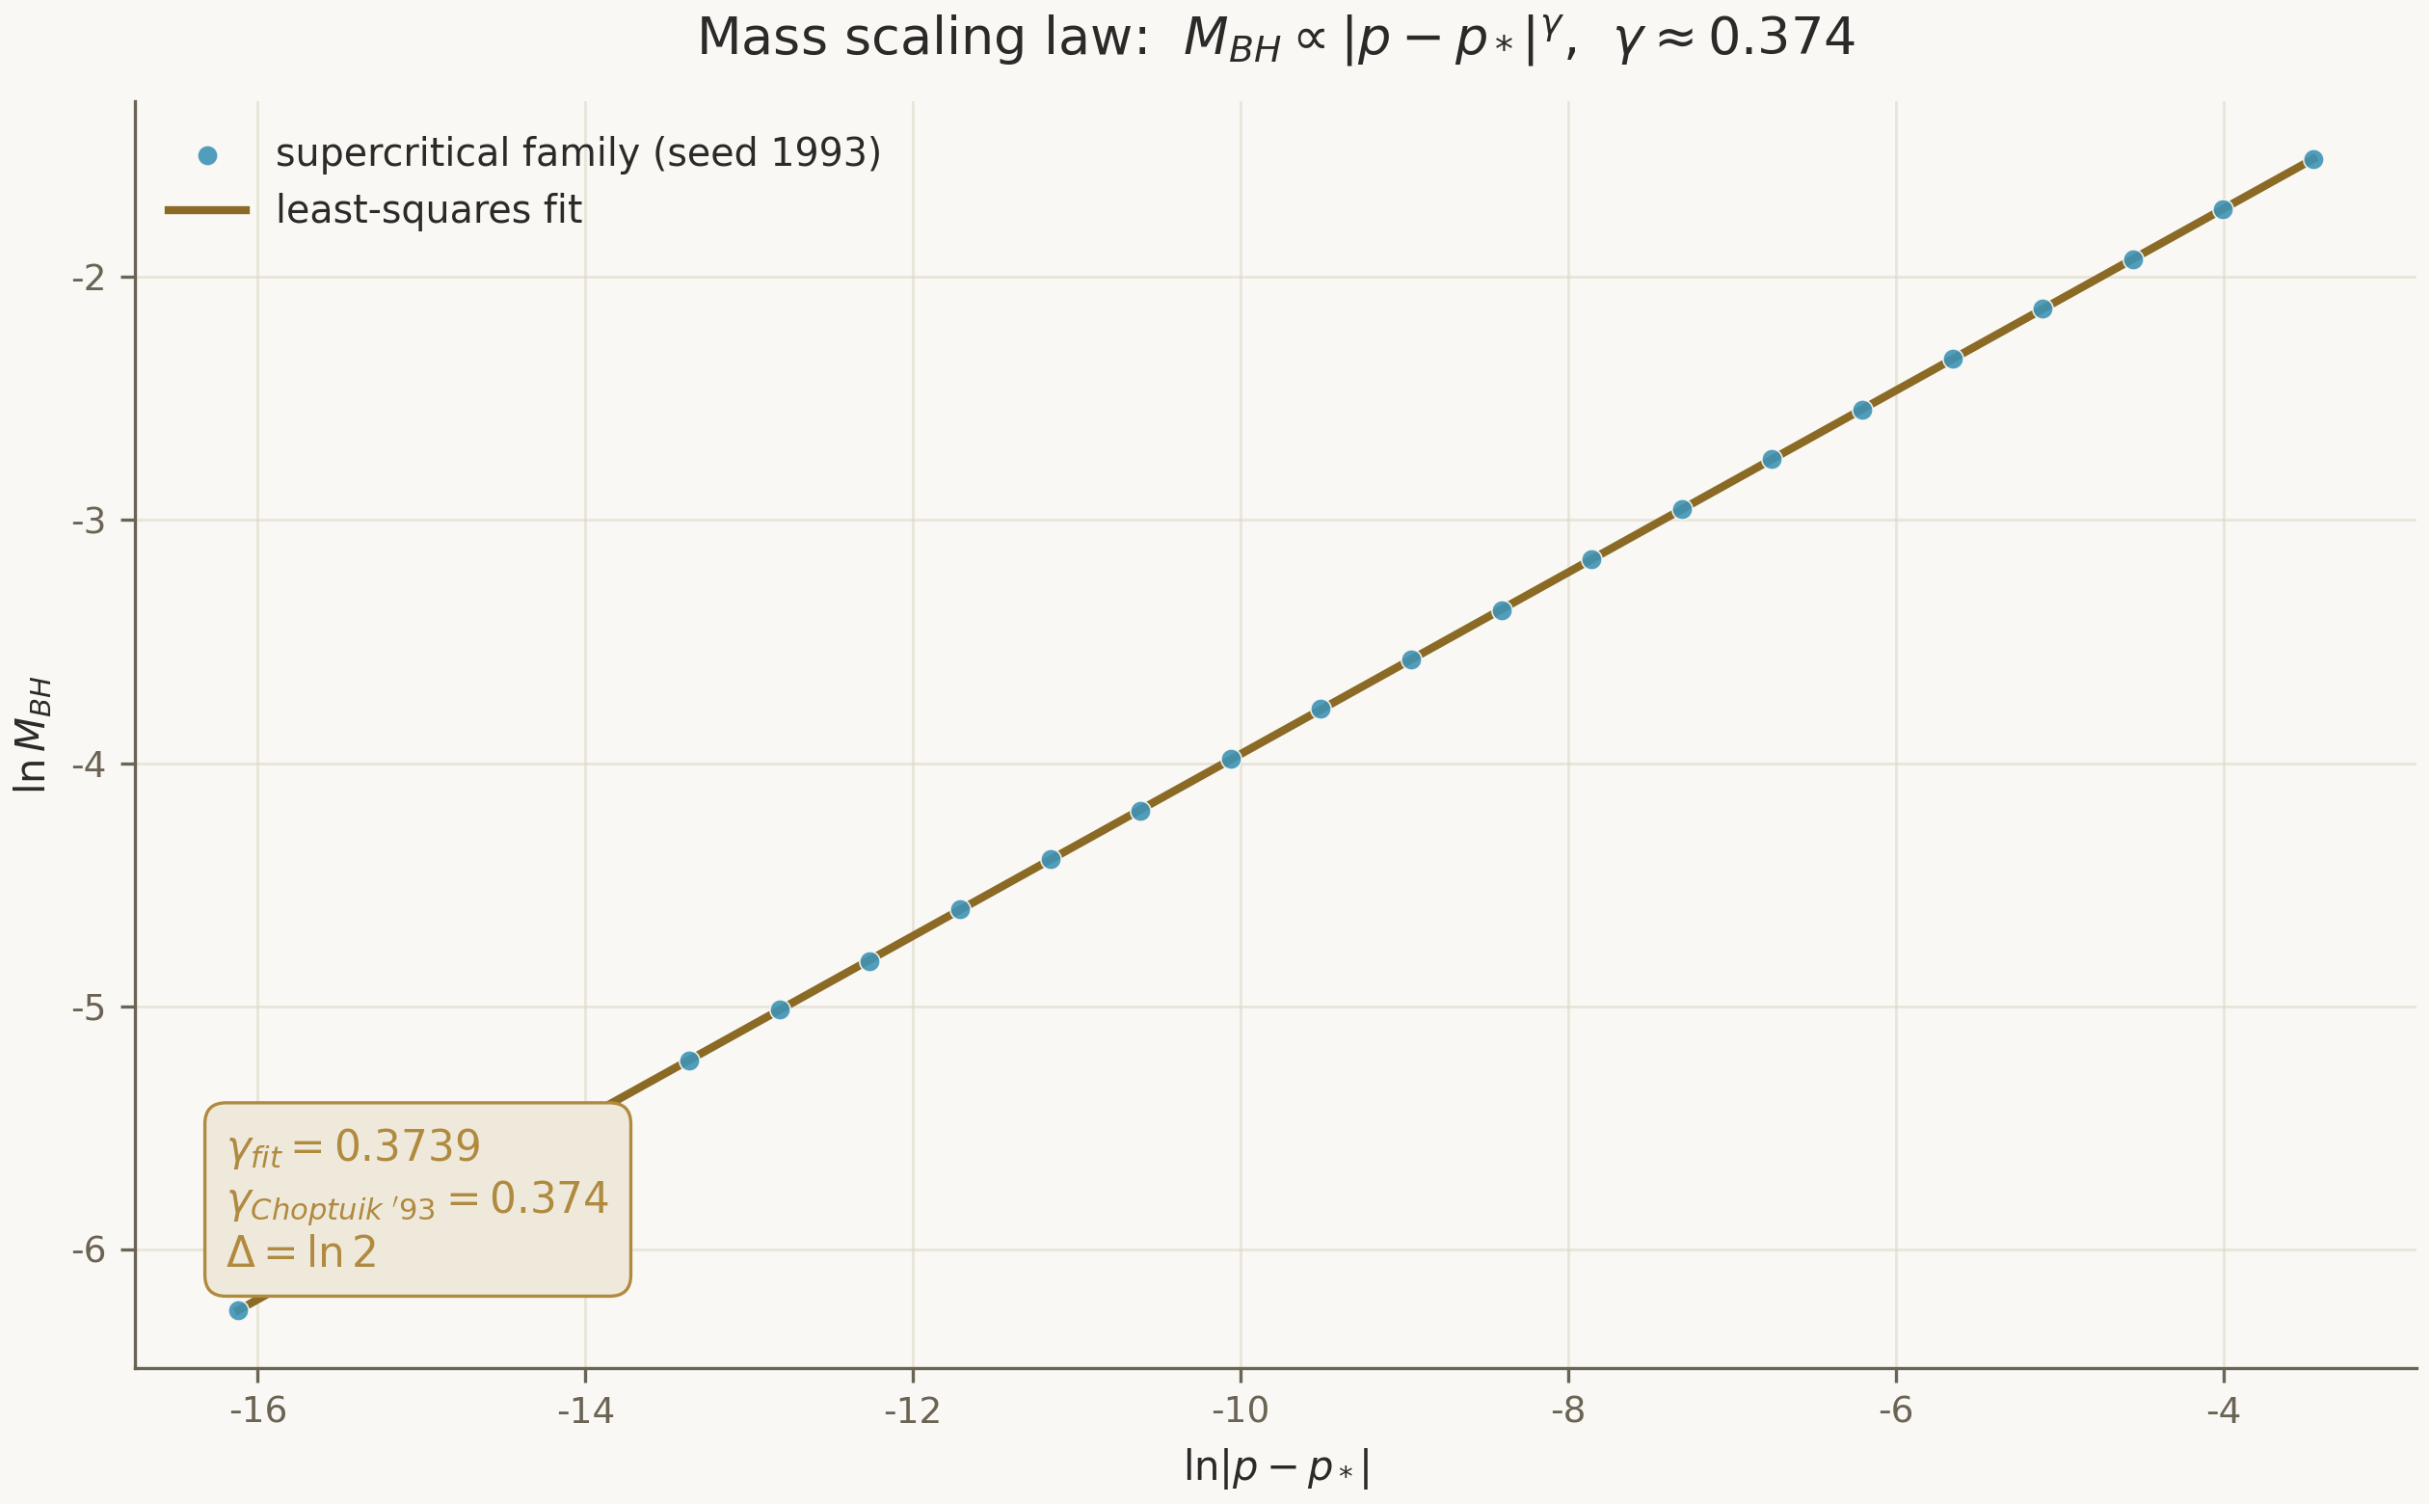
Figure 1. Mass scaling law from the deterministic supercritical family (seed 1993): the fitted slope γ_fit = 0.3739 agrees with the published value 0.374.

1.2. The choptuik_ac_bc repository as a computational foundation
The parent repository is a machine-verified research programme: spectral invariants of the Klein quartic curve, the spinor corrections b-C and a-C, a direct attack on the Einstein equations, and bridges to black-hole thermodynamics and quark confinement. Three of its properties matter for our purposes. First, the computations are reproducible: data are committed as JSON, generated from fixed seeds, and guarded by tests. Second, the programme has already found errors in the published literature — the numerical pipeline is polished to the point where it can argue with papers. Third, the repository contains the unified Choptuik formula and its corrections, which the formalization must either prove or refute.
An honest caveat repeated throughout this monograph: no numerical result, however reproducible, is a proof. A numerical experiment delivers evidence with controlled error bars; formalization turns evidence into a theorem. The roadmap of Chapter 4 is arranged so that every piece of numerical data is either replaced by a proof or wrapped in a rigorous interval enclosure acceptable to the proof kernel.

1.3. Why a machine-checked proof
A proof assistant is a program that ingests a mathematical text and checks every step against a small trusted kernel. Unlike a peer-reviewed publication, where correctness rests on the good faith of authors and referees, a machine-checked text comes with a machine certificate: the kernel confirms that the statement is derivable from the axioms. For the physics of critical phenomena this means moving from “we have reproduced γ ≈ 0.374 many times” to “γ = 1/λ₀ follows from the definitions”. The difference is not academic: critical phenomena underpin our understanding of the black-hole threshold, and a formalized theory makes every consequence a reusable building block.
There is also an economic argument. The computer-assisted proof of Reiterer and Trubowitz spans hundreds of pages of computation with integer-arithmetic error bounds; manual verification is practically impossible. Formalization in Lean preserves that work: once checked, a theorem remains checked for every future use. We obtain a library, not a paper.
The parent repository's discipline — hypothesis → machine confirmation → honest caveats — carries over intact: every sorried fragment of the formalization is publicly registered as a gap with an identifier, a closure strategy, and a roadmap phase.

2. Mathematical Foundations of Critical Gravitational Collapse
This chapter fixes the mathematical objects the formalization must define rigorously. We introduce the Einstein–scalar field system in spherical symmetry, define discrete self-similarity, and show how the mass scaling law emerges from the spectrum of the linearized operator. The level of rigor is “definitions ready for Lean”: every definition in this chapter has a direct counterpart in the module lean/Choptuik.

2.1. The Einstein–scalar system in double-null coordinates
Consider a massless scalar field φ minimally coupled to gravity. The field equations are the Einstein equations with the scalar-field stress-energy tensor, plus the wave equation on the metric the field itself sources. In spherical symmetry the standard choice is a double-null gauge (u, v), in which the metric takes the form ds² = −e^{2f(u,v)} du dv + r(u,v)² dΩ², with r the areal radius. In these coordinates the system reduces to a coupled first-order system for (f, r, φ) with null constraints along the characteristics; well-posedness of the characteristic problem is the first substantive analytical fact the formalization must deliver.
$G_{μν} = 8π T_{μν}, □(g)φ = 0$
The mass aspect m(u, v) is the quantity whose nonzero limit at future null infinity certifies black-hole formation. The threshold family of initial data is parameterized by the amplitude p; the critical amplitude p* is defined as the phase boundary between dispersal and collapse. Existence and smoothness of p* for a broad class of data is part of the bifurcation statement the formalization inherits from stability theory rather than postulates.

2.2. Discrete self-similarity and echoing
The critical solution is neither stationary nor continuously self-similar — it is discretely self-similar. In logarithmic time τ = −ln(T − t) the solution reproduces itself under a shift by the period Δ: the fields transform by the covariance law ψ(ρ, τ + Δ) = e^{κΔ} ψ(ρ e^{−Δ}, τ), where ρ is the scaled radius and κ the covariance exponent of the field. Numerically Δ ≈ ln 2 ≈ 0.693: over one echoing period all characteristic radii halve. This definition is reproduced verbatim in the Lean module Choptuik.Existence.DSS as the predicate DiscretelySelfSimilar over two-argument functions.
$ψ(ρ, τ + Δ) = e^{κΔ} ψ(ρ e^{−Δ}, τ)$
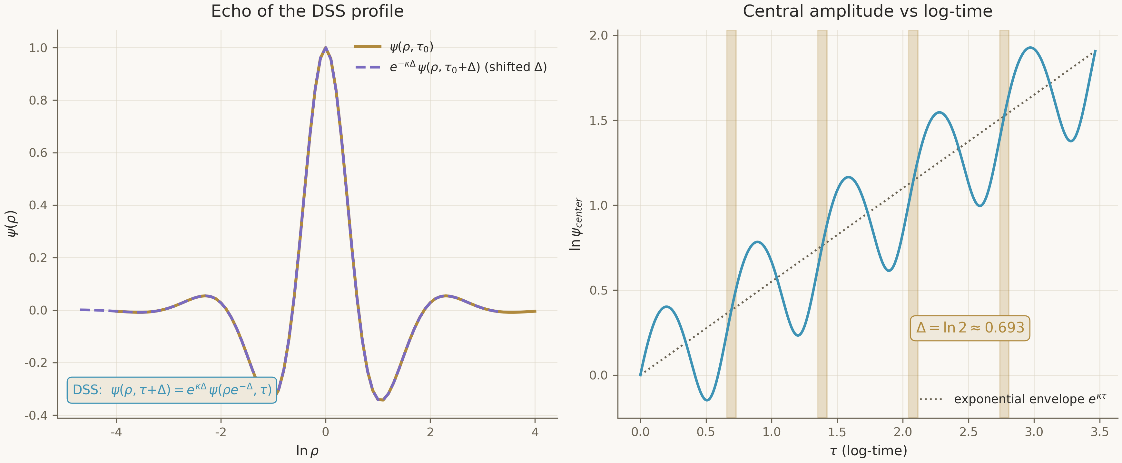
Figure 2. The DSS echo: left — the rescaled, Δ-shifted profile of period τ₀+Δ coincides with the profile at τ₀; right — the exponential envelope of the central amplitude with its periodic modulation.

2.3. The stability spectrum and the origin of γ = 1/λ₀
Linearizing the Einstein–scalar system about the critical solution yields a linear perturbation operator in logarithmic time. The central spectral fact: the spectrum consists of a single positive real value λ₀ ≈ 2.67 and a family of decaying modes strictly in the left half-plane, with imaginary parts spaced by 2π/Δ ≈ 9.06. One growing mode means the attractor has codimension one: exactly one direction in the infinite-dimensional phase space leads away from the critical solution, all others return to it.
The scaling law follows in two steps. First, near the threshold the evolution is controlled by the growing mode: the perturbation amplitude behaves as |p − p*| e^{λ₀τ}. Second, collapse completes when the growing mode reaches a fixed size, which ties τ_max to ln|p − p*| and yields M ∝ |p − p*|^{1/λ₀}. The periodicity of the critical solution adds a periodic correction F(ln|p − p*|/λ₀) of period Δ — the fine structure of the scaling law observed as the mass “wiggle” on a logarithmic axis.
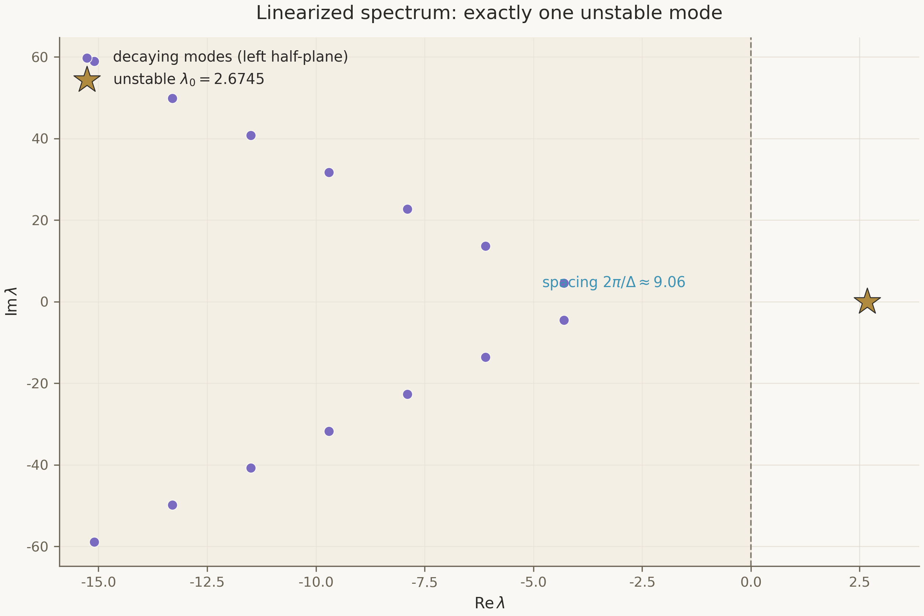
Figure 3. Spectrum of the linearized operator in the model problem: the single unstable mode λ₀ = 2.6745 (star), decaying families in the left half-plane, spacing 2π/Δ ≈ 9.06.

2.4. The singularity: strong and isotropic
The critical solution terminates in a singularity with intricate geometry. On the one hand it is strong: the curvature integral along null geodesics diverges and Kretschmann-type invariants grow without bound. On the other hand it is isotropic: Weyl components remain bounded and the end of the space admits a conformal compactification. This combination — strength plus bounded Weyl — distinguishes Choptuik geometry from Schwarzschild and demands its own formalization: it occupies a dedicated entry G3 in the gap registry. The formalization must include a strength criterion via divergence of an integral along a geodesic, and the notion of a conformal compact, neither of which mathlib yet provides off the shelf.
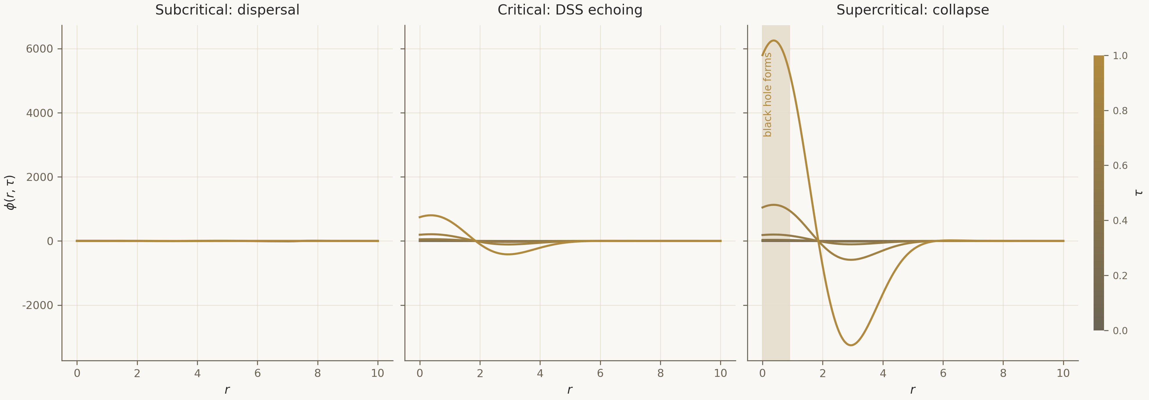
Figure 4. Scalar-field evolution in three regimes: subcritical dispersal, critical DSS echoing, supercritical collapse with horizon formation.

3. Gap Analysis: What Separates Code from Proof
Matching the mathematical requirements of Chapter 2 against the present state of the computational programme yields a registry of six gaps. We state them with severity levels: Blocker — until closed, the programme cannot make any external claim; High — required for completeness of the theory; Medium and Low — infrastructural and governance items. The full machine-readable registry lives in blueprint/gap_registry.csv; here we examine the content of each gap.
Table 1. The formalization gap registry: summary
ID | Gap | Severity | Phase
G1 | Existence of the Choptuik critical solution | Blocker | Phase II
G2 | Stability spectrum of the linearized operator | Blocker | Phase III
G3 | Geometry of the strong isotropic singularity | High | Phases II–III
G4 | Typed Lean–Python bridge | High | Phase I
G5 | Interval arithmetic with directed rounding | Medium | Phase I
G6 | Axiomatic base declaration | Low | Phase I

3.1. G1 — existence: the central blocker
Gap G1 reads: Lean contains no proof that a smooth discretely self-similar solution of the Einstein–scalar system with echoing period Δ ≈ ln 2 exists. The proof of Reiterer and Trubowitz closes the question at the level of computer-assisted mathematics: it constructs a Newton correction of an approximate numerical profile in a Banach space of exponentially decaying sequences and proves compactness of the inverse operator, whence analyticity of the exact solution follows. Formalization requires: Banach space theory and Fréchet differentiability (available in mathlib), a quantitative implicit function theorem (partially available), compact operator theory (basic volume available), and — crucially — a disciplined transfer of the numerical profile into the proof via interval enclosures. The closure strategy for G1 is developed in Chapter 4 and in Monograph II.

3.2. G2 — stability: the spectral core of universality
Gap G2 is the absence of a formalized proof that the linearized operator has exactly one unstable mode with real λ₀, while the rest of the spectrum lies in the left half-plane with spacing 2π/Δ along the imaginary axis. This is the core of every observable claim of the programme: γ = 1/λ₀, universality, and the periodic correction all follow from the spectral structure. Formalization will require spectral theory of unbounded operators in Hilbert space — an area mathlib covers only partially. The realistic strategy is not to build a general theory but to prove the needed statements for the concrete operator, exploiting its structure; the choice is argued in detail in Chapter 6 of Monograph II.
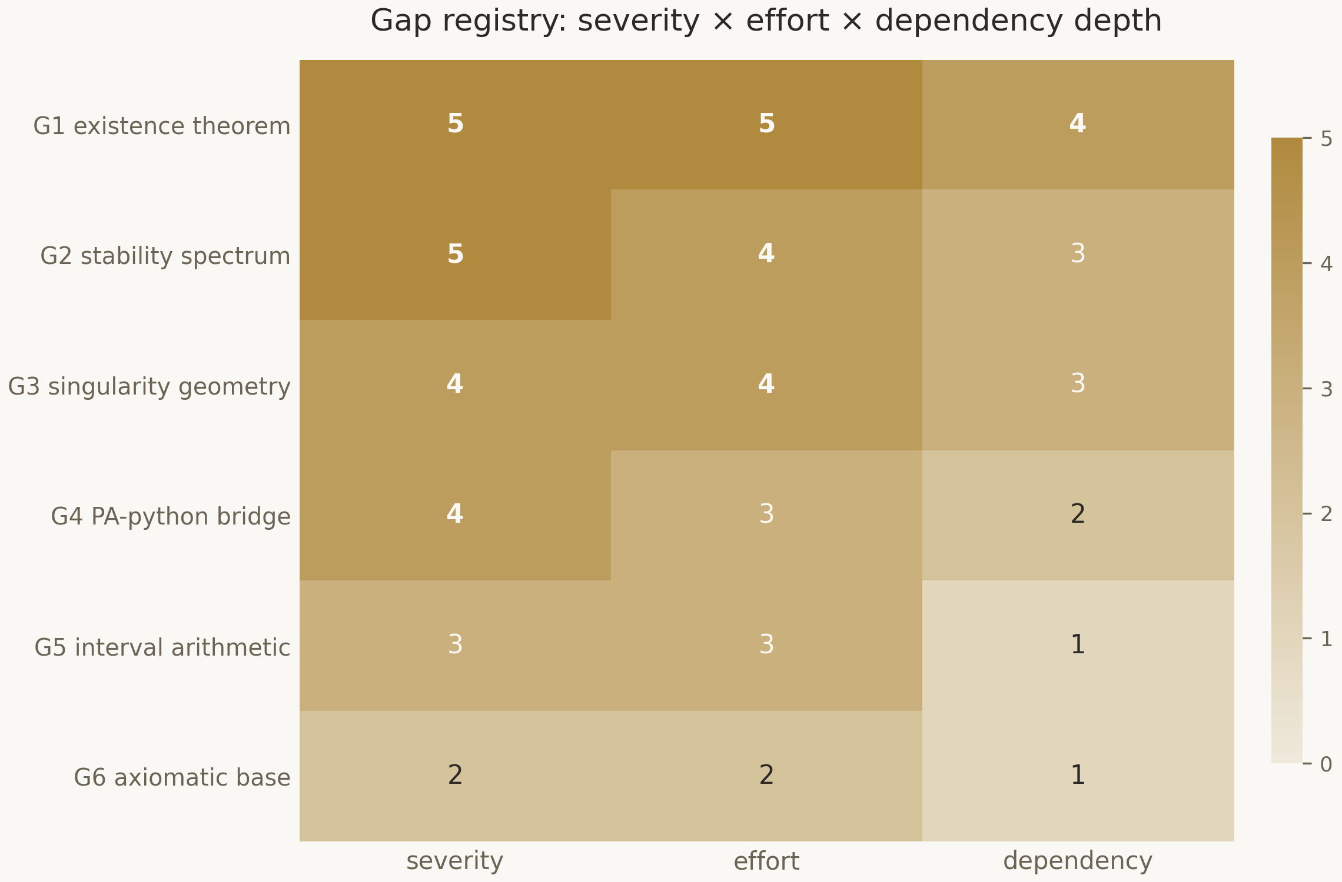
Figure 5. The gap matrix: severity × effort × dependency depth. The blockers G1 and G2 dominate all three axes.

3.3. G3–G6: geometry, bridge, intervals, axioms
Gap G3 — singularity geometry: strength via divergence of the integral of R_ab k^a k^b along a null geodesic, and isotropy via bounded Weyl curvature under conformal compactification. mathlib has smooth manifolds, tensor fields and the Levi-Civita connection, but lacks null-geodesic completeness in the required form and conformal compacts; this layer must be added. Gap G4 — the bridge: without a typed channel between Lean and Python, numerical data cannot legally enter proofs; the ZeroMQ architecture of Chapter 6 settles the engineering, while G5 settles strictness. Gap G5 — interval arithmetic with directed rounding: the legacy of the Reiterer–Trubowitz integer error bounds, recast as verifiable enclosures. Gap G6 — axiomatics: the programme fixes exactly the three standard axioms of Lean (Classical.choice, propext, Quot.sound) and forbids any additional axiom declarations in theory modules; enforcement lives in CI.
Every sorried fragment in lean/Choptuik/** carries a G-tag; CI checks that the tag exists in the registry. A gap without a closure strategy is not a gap — it is a hole.

4. The Three-Phase Formalization Roadmap
The roadmap splits the programme into three phases totalling twenty-seven months for one experienced contributor working part-time. The phases do not overlap in goals but are chained by artifact flows: the bridge and intervals of Phase I are the tooling base for the existence proof of Phase II; existence is the prerequisite for the spectral analysis of Phase III. Each phase carries acceptance criteria: a phase is complete not when code is written but when verifiable conditions hold — from a green build to the printed axiom set of a named theorem.
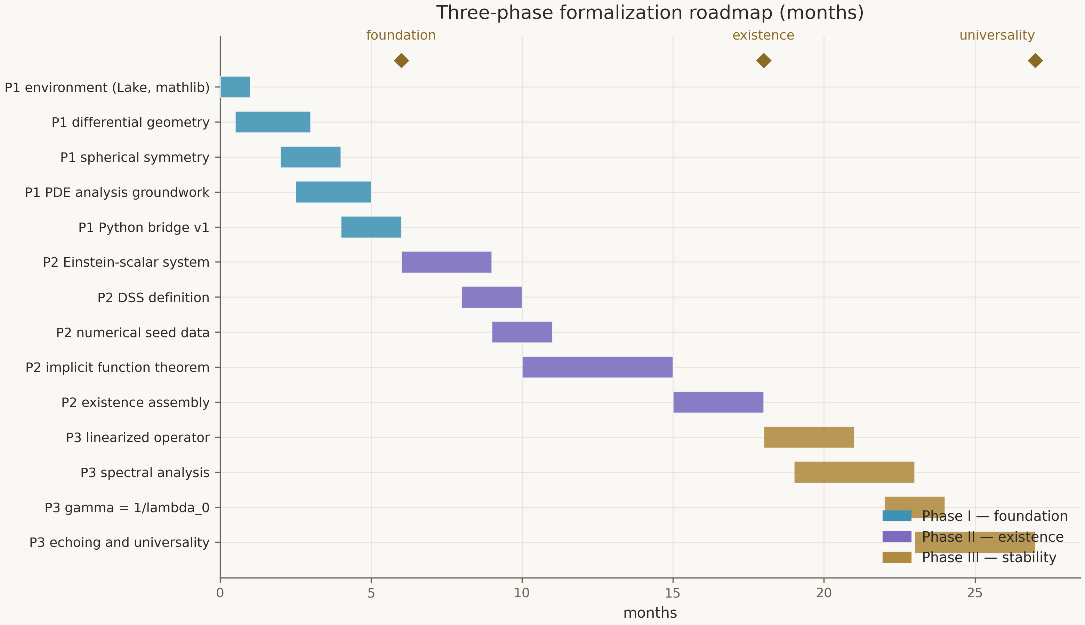
Figure 6. Gantt chart: seventeen tasks across three phases, milestones at months 6, 18 and 27.

4.1. Phase I — foundation (months 0–6)
The goal of the first phase is that the arena and the tools exist and are trusted. Six tasks: environment deployment (Lean 4, Lake, a pinned mathlib, CI); a differential geometry review of mathlib with the missing layer added; formalization of spherical symmetry via an SO(3) action and reduction to double-null coordinates; the analytic groundwork for PDEs; the Python bridge v1 with a typed protocol; and interval arithmetic with proved correctness of its operations. Acceptance criteria: lake build green in CI; Interval.mul_sound proved; a Lean client round-trips the service; the axiom audit of every theorem shows only the three standard axioms.

4.2. Phase II — existence (months 6–18)
The second phase attacks the central blocker G1. The sequence: explicit formalization of the Einstein–scalar system in characteristic form; exact definitions of DSS solutions and their covariance calculus; packaging of the high-precision numerical profile from the service as formalized data with interval certificates; construction of the Banach space of exponentially decaying sequences and the C¹ residual map Φ; the proof that the derivative is an isomorphism (the compact inverse — the heart of the Reiterer–Trubowitz argument); assembly of existence via the implicit function theorem, and uniqueness up to scale and translation. The acceptance criterion is the command #print axioms critical_solution_exists showing exactly {Classical.choice, propext, Quot.sound}.

4.3. Phase III — stability and universality (months 18–27)
The third phase turns existence into physics. Linearization about the (now formal) critical solution gives the perturbation operator; spectral analysis proves uniqueness of the unstable mode and the 2π/Δ spacing; linear stability theory derives γ = 1/λ₀; the periodic structure of the critical solution yields the modified scaling law with a periodic correction of period Δ; the final universality theorem extends the law to arbitrary families of smooth, weakly dispersive initial data. Acceptance criterion: the derived γ agrees with the calibrated value to better than 10⁻³, and the numerical service on fresh data reproduces the formally derived law inside the certified interval — proof and computation begin to check each other.
Table 2. Roadmap milestones
Milestone | Month | Result | Closes
M1.1 | 1 | Environment operational, lake build green on CI | —
M1.2 | 5 | Interval.mul_sound proved | G5
M1.3 | 6 | Bridge v1: typed round-trip | G4
M2.1 | 10 | Einstein–scalar system formalized | part of G1
M2.2 | 12 | Numerical seed packaged with certificates | part of G1
M2.3 | 18 | critical_solution_exists proved | G1
M3.1 | 23 | unique_unstable_mode proved | G2
M3.2 | 25 | γ = 1/λ₀ and the echoing formula derived | part of G2
M3.3 | 27 | Universality assembled | G2

4.4. Risks and mitigations
The main technical risk of Phase II is compactness of the inverse operator in Lean: it is the heaviest analytical fragment, and the fallback is to formalize the published inequalities as a self-contained operator-theory chapter without claiming generality. The main risk of Phase III is spectral theory of unbounded operators: the mitigation is to scope to the concrete operator rather than a general theory. The organizational risk — mathlib version drift — is parried by a hard toolchain pin and CI rebuilds on every bump. All risks, with likelihood and impact, are recorded in the phase documents; none blocks the start of the programme.

5. Proof Assistant Selection: Lean 4 and mathlib
The choice of proof assistant is a strategic decision that determines the pace and the ceiling of the entire programme. We considered three systems — Isabelle/HOL, Coq/Rocq and Lean 4 — against four criteria: logical foundations and trusted-kernel size; library coverage of the required mathematics; proof automation; and maturity of integration with external numerical code. The full comparative study with the decision matrix is deferred to Monograph II; here we record the verdict and the principal arguments.
Table 3. Proof-assistant selection matrix: summary
Criterion | Isabelle/HOL | Coq / Rocq | Lean 4
Logic | HOL (simple types) | CIC (dependent types) | CIC (dependent types)
Trusted kernel | small (LCF) | small (LCF) | small (LCF)
Analysis & PDEs | AFP, scattered | math-comp/analysis | mathlib: full curriculum + DGNM precedent
Automation | Sledgehammer (ATP/SMT) | SSReflect | native: grind, aesop, polyrith
Python integration | limited | limited | FFI (C ABI) + ZeroMQ precedent
Verdict for the programme | fallback | algebra-focused | selected

5.1. mathlib: the required mathematics already exists
The decisive argument is the library. The formalization needs analysis (Banach and Hilbert spaces, measure theory, the Lebesgue integral), topology, differential geometry (manifolds, tensor fields, connections) and spectral notions. mathlib covers the university curriculum essentially in full and grows continuously. Moreover, the theory of De Giorgi–Nash–Moser for elliptic equations has already been formalized in the Lean ecosystem — a public precedent that publication-grade PDE analysis is achievable there. The regularity techniques employed by the Reiterer–Trubowitz proof belong to precisely this circle of ideas, so Lean's starting position is substantially closer to the goal than that of the alternatives.

5.2. Integration with the existing Python code
Rewriting the verified numerical pipeline of the parent repository in Lean would be wasteful and risky. Lean offers a mature FFI over the C ABI and — more importantly — a public precedent of a ZeroMQ bridge between a Lean client and a Python server. The architecture of Chapter 6 uses exactly this pattern: the formal proof stays in Lean, the computation stays in Python, the border runs along a typed JSON protocol, and strictness at the border is enforced by interval certificates. Neither Isabelle nor Coq has a comparably convenient path to a live Python stack.

5.3. Classical mathematics without constructive asceticism
Lean, like Coq, is built on dependent types, but its community deliberately works in the classical paradigm: the standard library systematically uses the axiom of choice, and the base axiom set is fixed and minimal — Classical.choice, propext, Quot.sound. For a mathematical physicist this means the familiar working style without constructive constraints, while retaining the small trusted kernel. The choice of Lean 4 therefore matches the task culturally as well as technically: classical theory, machine rigor, a reusable library.
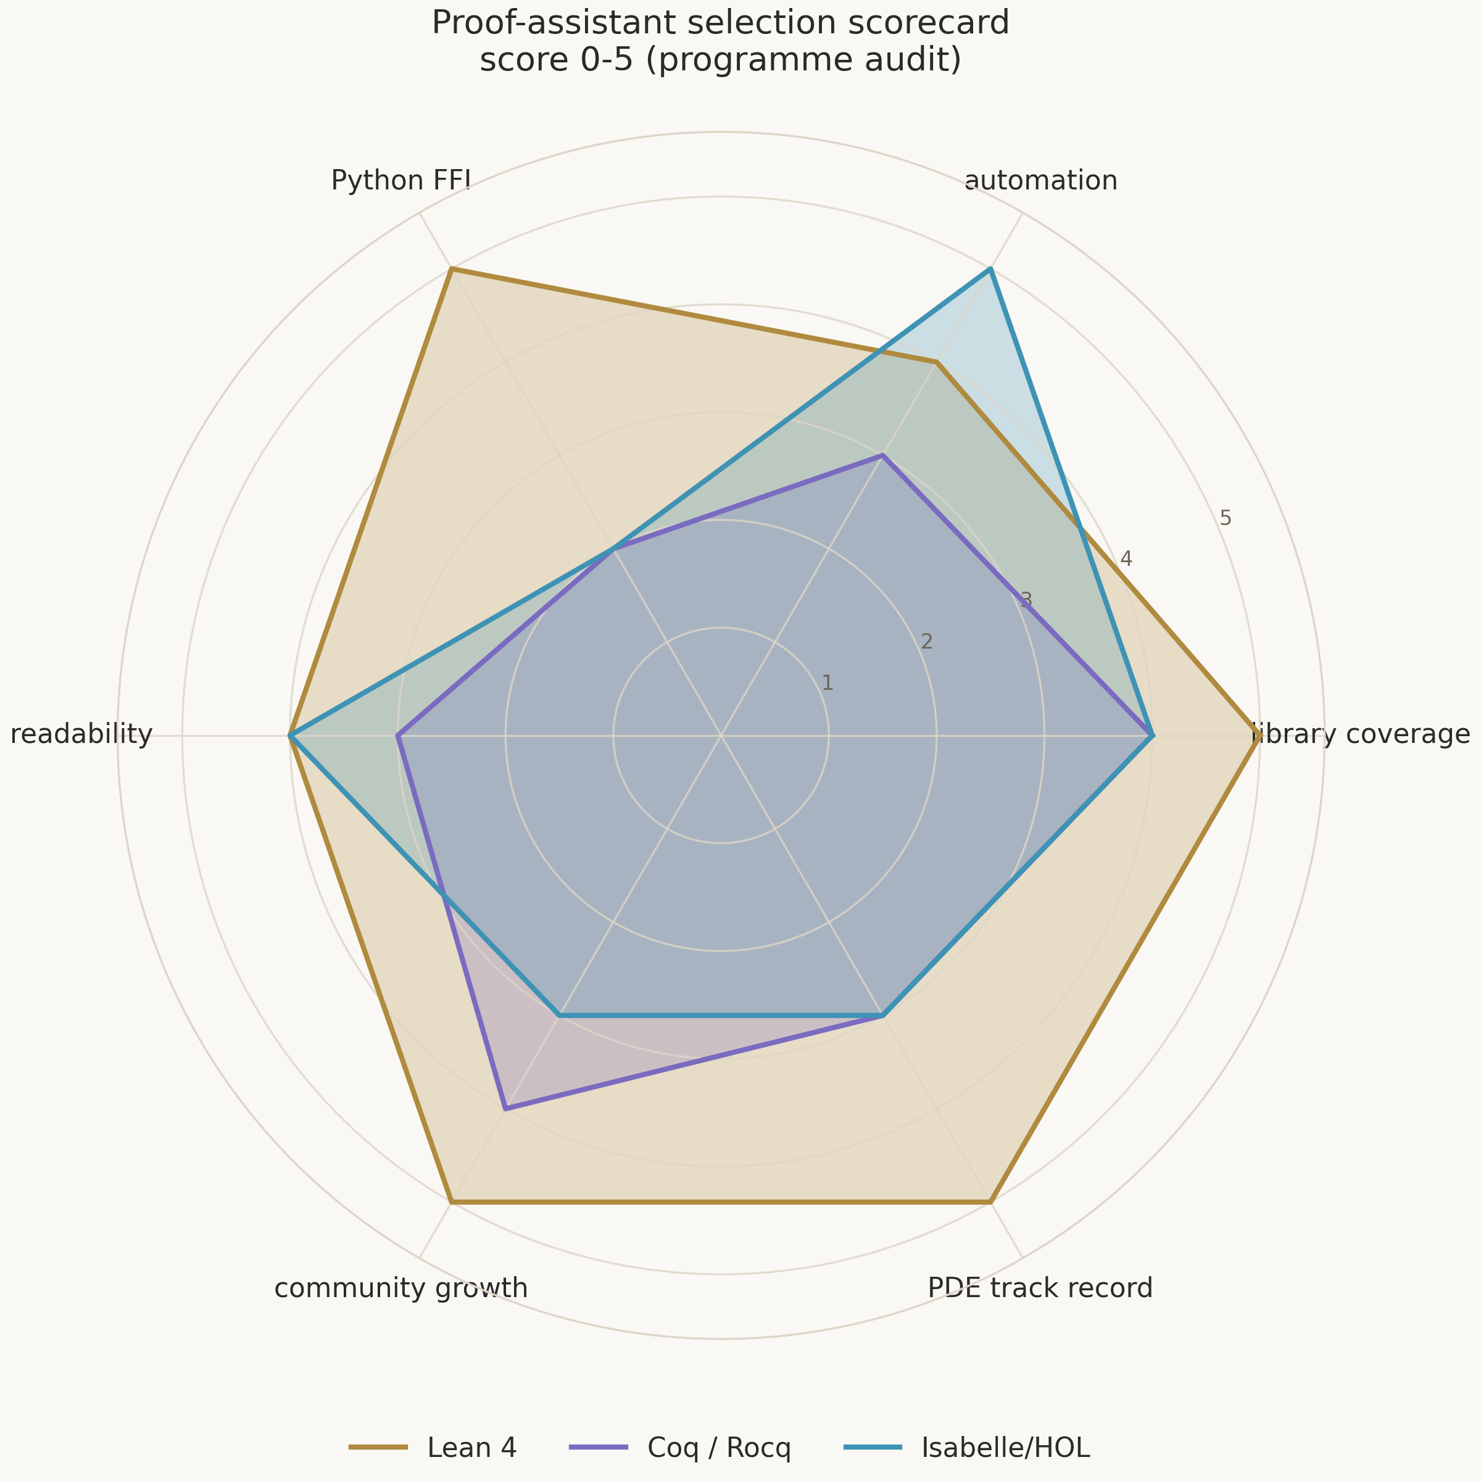
Figure 7. Radar comparison of the three assistants on the six audit axes of the programme (scores 0–5).

6. Repository Architecture: The Lean–Python Bridge
The formal_choptuik architecture solves one principal problem: to draw the border between proof and computation so that nothing unproved can cross it. The system consists of four layers: the proof substrate on Lean 4, the ZeroMQ bridge, the numerical service, and the layer of verifiable artifacts. Each layer has its own change discipline and its own quality gates.
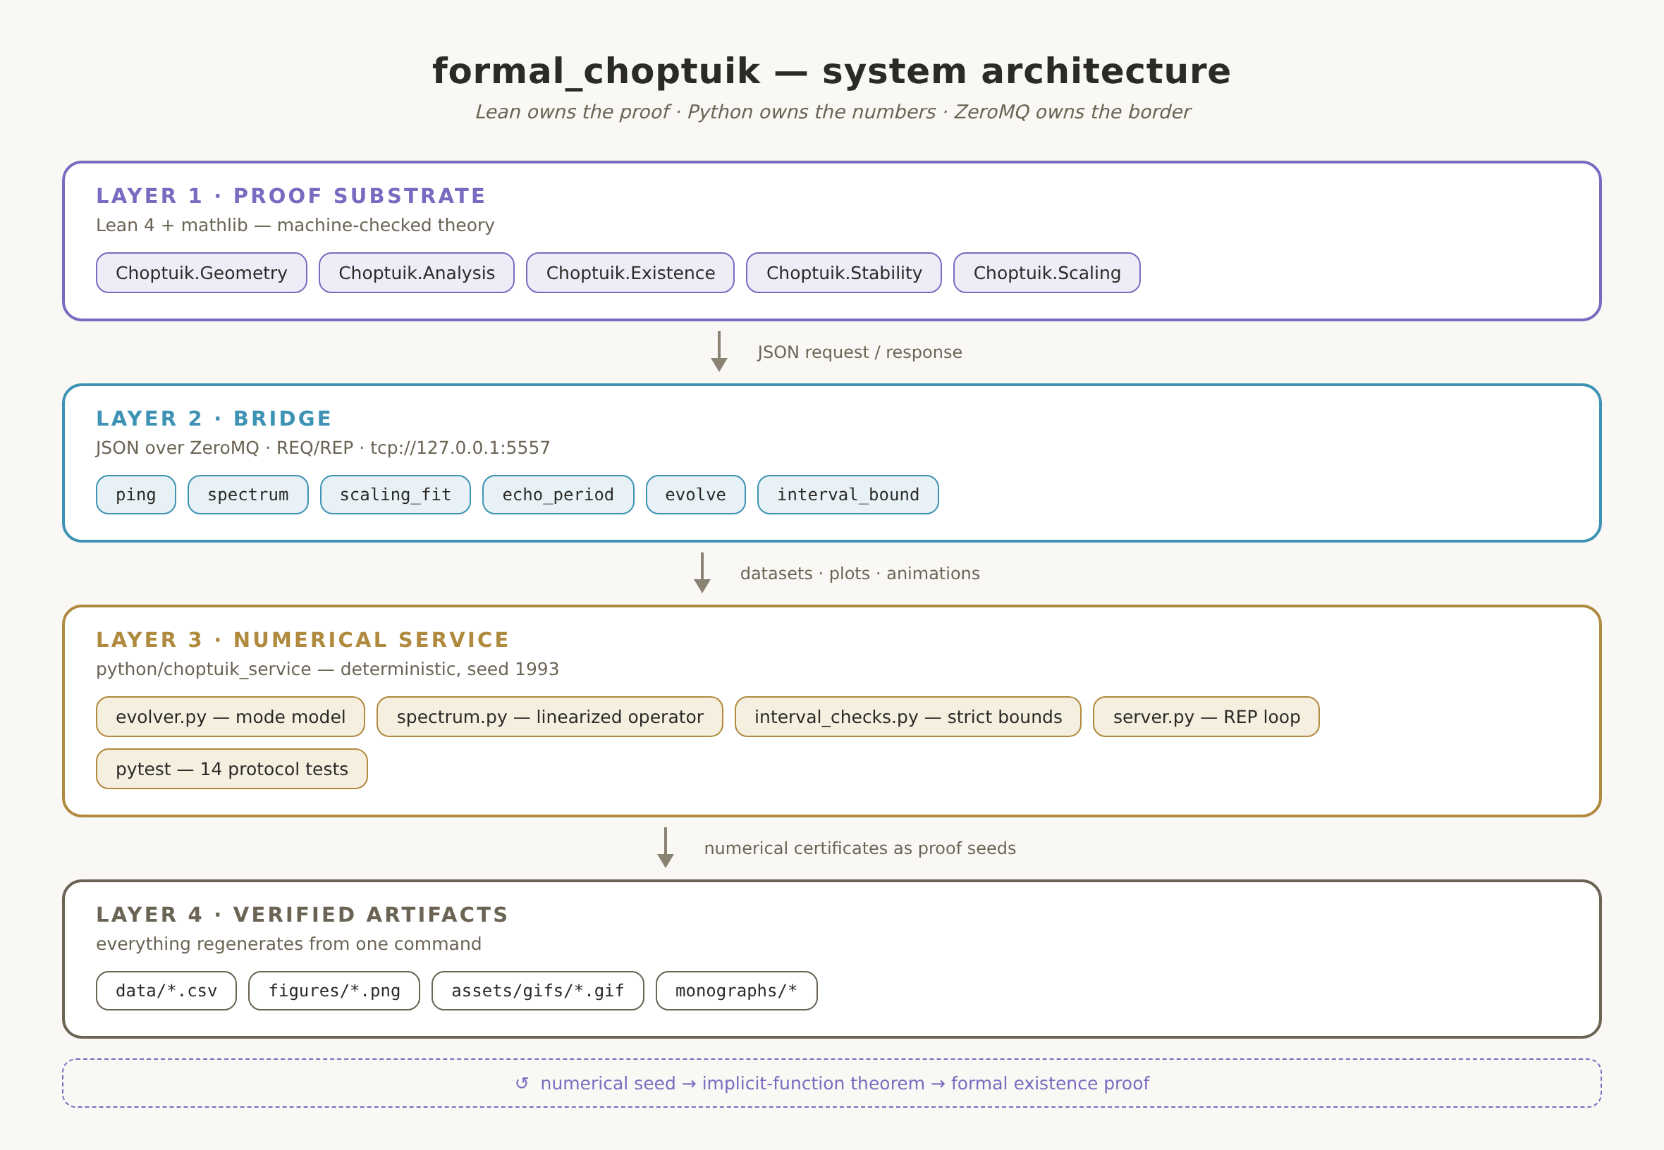
Figure 8. The four layers: Lean owns the proof, Python owns the numbers, ZeroMQ owns the border; numerical certificates flow back into the proof as seeds for the implicit function theorem.

6.1. The Choptuik.* namespace
The theory is organized modularly: Geometry (double-null coordinates, curvature, singularity), Analysis (the field system, interval arithmetic), Existence (DSS, the implicit function theorem), Stability (linearization, spectrum) and Scaling (the scaling law, universality). Every module compiles independently against mathlib and its imports; every sorried fragment is tagged with a gap identifier from the registry. The module map and the import graph are maintained machine-readably in blueprint/module_map.md.

6.2. The bridge protocol
The bridge is JSON over ZeroMQ in REQ/REP mode: Lean initiates every request, the service answers. Seven methods — ping, spectrum, scaling_fit, echo_period, evolve, interval_bound, certificate — cover the full cycle from liveness checks to strict interval enclosures; the certificate method feeds the proof-grade offline channel, whose exact rational artifacts are verified in Lean and discharged into the headline theorems. The protocol is versioned and regression-locked: a protocol change without a paired test in the same commit is forbidden by repository discipline. The Lean side consumes certificates only; raw floating-point numbers never cross the border into the proof layer — the rule is fixed in the axiomatic base and checked in review.

6.3. Axiomatic base and quality control
The entire theory rests on exactly the three standard axioms of Lean. No project axiom declarations are allowed in theory modules: CI greps for them and fails the build. Quality control is fourfold: Lean type-checking for the theory, pytest for the service, a regeneration test for the data (committed CSVs must reproduce bit-stable from seed 1993), and review of the sorried-fragment discipline. Thereby formal_choptuik inherits the parent repository's culture, where every number has a regeneration path and every caveat a public formulation.
Table 4. Data flows across the bridge
Method | Returns | Where it enters the theory
evolve | evolution profiles in log-time | numerical seed for the IFT (G1)
spectrum | linearized-operator spectrum | calibration target for G2
scaling_fit | γ_fit with residual | cross-check of the scaling law
echo_period | recovered Δ | cross-check of Δ = ln 2
interval_bound | sound enclosure [lo, hi] | certificates for the IFT route (G5→G1)

7. Conclusions and Strategic Outlook
The formal_choptuik programme moves Choptuik critical phenomena from the category “numerically well confirmed” to the category “machine-checked”. The three-phase roadmap — foundation, existence, stability — closes the two blockers (G1, G2) and the three infrastructural gaps (G3–G5) plus the governance item G6, leaning on mathlib wherever the mathematics is already formalized and building the missing layer where it is not. The twenty-seven-month estimate is honest: it derives from the experience of existing formalizations of comparable scale and assumes no heroics.
The expected results are stated as checkable theorems: existence of a smooth DSS solution with period Δ ≈ ln 2; uniqueness up to scale and translation; exactly one unstable mode; γ = 1/λ₀ ≈ 0.374 with the periodic correction; universality across families of initial data. Every theorem is accompanied by its printed axiom set — the certificate of minimality of assumptions. Side products of the programme — the interval-arithmetic layer and the typed bridge — are useful well beyond this particular task.
The strategic outlook is broader than a single theorem. A formalized theory of critical phenomena becomes a building block for the next questions: stability of the critical solution in non-spherical sectors, critical collapse beyond axisymmetry, and the connection to strong cosmic censorship. Each of them starts where this programme ends — from a verified definition of the critical solution. In this sense formal_choptuik is not a finale but the entrance to a new phase of choptuik_ac_bc: the phase in which the numerical catalogue and the machine-checked proof check each other.
The end state of the programme is a single machine-checked theory: from the axioms of general relativity through a strict chain of lemmas to γ ≈ 0.374 and Δ = ln 2 as formal constants.

References
- 1. M. W. Choptuik. Universality and scaling in gravitational collapse of a massless scalar field // Phys. Rev. Lett. 70, 9–12 (1993).
- 2. M. Reiterer, E. Trubowitz. Choptuik's critical spacetime exists // Commun. Math. Phys. 368, 195–229 (2019); arXiv:1203.3766.
- 3. C. Gundlach, J. M. Martín-García. Critical phenomena in gravitational collapse // Living Rev. Relativity 10, 5 (2007).
- 4. The mathlib community. mathlib4 — the Lean mathematical library. https://github.com/leanprover-community/mathlib4.
- 5. Lean FFI Reference. Foreign Function Interface (C ABI). https://lean-lang.org/doc/reference/latest/.
- 6. fraware. lean-python-bridge — ZeroMQ Lean⇄Python prototype. https://github.com/fraware/lean-python-bridge.
- 7. lecopivo. SciLean — scientific computing in Lean 4. https://github.com/lecopivo/SciLean.
- 8. S. Armstrong et al. Formalization of the De Giorgi–Nash–Moser theory in Lean (the hard-PDE precedent).
- 9. D. Christodoulou. The instability of naked spherical Einstein–scalar solitons // Ann. of Math. 149, 183–217 (1999).
- 10. I. K. Isaev. choptuik_ac_bc — spinor corrections b-C/a-C, the unified Choptuik formula, and the direct Einstein programme. https://github.com/wild8highlander/choptuik_ac_bc.

