CHESS-DYNAMICS-LAB
Chess Particle Dynamics:
A Certifiable Laboratory
The main monograph of the chess-dynamics-lab program: the three-layer particle model, the C1–C9 protocol and twelve certified theorems

Author: | Isaev Iskhak Khamzatovich
Series: | Main monograph
Program: | chess-dynamics-lab
Contents: | 12 chapters · 2 appendices · 5 figures
License: | Individual exclusive

© 2026 chess-dynamics-lab · Individual exclusive license

Contents

1. Introduction: from positions to particles 2
2. The algebra of the board: the symmetry group 3
3. Particle kinematics: move graphs and censuses 3
4. Mobility: the kinetic invariants 4
5. Threat fields: the potential layer K3 4
6. The Lagrangian: the energy of a position 5
7. The flow of moves: terminations and billiards 6
8. The knight tour: discovery and the Warnsdorff certificate 6
9. Certifying the generation: perft identities 7
10. The memory of the flow: Zobrist hashing 7
11. The search: alpha-beta and determinism 8
12. Mate certificates and the consolidated protocol 8
Appendix A. The consolidated table of constants 9
Appendix B. The reproduction guide 9
Bibliography 10
Bibliography 10

Note: this Table of Contents is generated via field codes. To ensure page number accuracy after editing, please right-click the TOC and select "Update Field."

MAIN MONOGRAPH · CHESS-DYNAMICS-LAB PROGRAM
Chess Particle Dynamics: A Certifiable Laboratory
The main monograph of the chess-dynamics-lab program: the three-layer particle model, the C1–C9 protocol and twelve certified theorems
Isaev Iskhak Khamzatovich
Keywords: chess, particles, threat fields, Lagrangian, discrete flow, retrograde analysis, verification protocol

1. Introduction: from positions to particles
This monograph completes the chess-dynamics-lab program: it brings together the twelve theorems T01–T12, the nine protocol checks C1–C9 and the seven-language polyglot core into a single corpus in which a chess game is described as the dynamics of a system of particles. Every numerical claim is certificate-reproducible by one command on any machine — from a server to a Termux phone.
The idea of viewing the chessboard as a physical system is as old as chess thought itself: pieces "press", "hang", are "pinned", squares are "weak" and "strong", an attack "flows" along the fronts. Usually these words remain metaphors. The chess-dynamics-lab program, grown from the methodology of the parent hodge-laboratory program, does the opposite: every metaphor receives an exact definition, every definition a theorem, and every theorem an executable check that is part of the protocol. A piece becomes a particle with its own kinematic invariants, a position a configuration of the particle system, and a move an elementary event of the flow.
The model has three layers. Layer K3 is the potential layer: every particle emits a threat field on the board, and the total field defines the structure of pressure and defense. Layer TORUS is the energy layer: a position carries a Lagrangian energy made of a material and a mobility term, and the full-game search minimizes exactly it. Layer KLEIN is the flow layer: the sequence of moves is a discrete flow of states with memory (Zobrist hashes), terminations (distance to mate) and geometry (closed trajectories on the torus of the board). The layer names are inherited from hodge-laboratory: K3, the torus and the Klein bottle are topological images denoting not the geometry of the board but the structure of the computation.
The distinguishing feature of the approach is certifiability. The statement "our move generation is correct" is not a declaration here but the perft theorem T08 with the reference values 20, 400, 8902, 197281, 4865609; the statement "the threat fields agree with the symmetries" is theorem T04 on equivariance with the exact pawn anomaly 176; the statement "the endgame bases are correct" is the Bellman machine with zero violations over all 767564 states of the KRK and KQK bases. The full list of checks closes with the verdict ALL CHECKS PASSED, and the same list, bit-identical, is reproduced in the seven languages of the polyglot core.
The monograph is organized as follows. Chapters 2–4 build the geometry and kinematics: the board group, the graph censuses and the mobility of particles. Chapters 5–7 introduce the physics proper: threat fields, the Lagrangian and the flow. Chapter 8 is devoted to the closed knight tour, a pearl of discrete geometry. Chapters 9–11 describe the computational frame: the certification of generation, the memory and the search. Chapter 12 assembles the mate certificates and the consolidated protocol. Appendix A contains the full table of constants, Appendix B the reproduction guide, including Termux.

2. The algebra of the board: the symmetry group
The 8 × 8 board is the set of squares S = {0, …, 7}² on which the square symmetry group D₄ of eight elements acts: four rotations and four reflections. The coloring of the squares defines the parity homomorphism χ(f, r) = (f + r) mod 2, and its kernel selects the color-preserving subgroup V₄ = {id, ρ₁₈₀, σ_{d1}, σ_{d2}}. Theorem T01 fixes two censuses: the action of V₄ on the 64 squares has exactly 20 orbits (eight diagonal orbits of size 2 and twelve orbits of size 4), while the full D₄ action has exactly 10 orbits by the Burnside lemma.
These numbers are not a curiosity but a working tool. Bishops live on one color, so their fields inherit the V₄ symmetries; the knight changes color with every move and its graph is bipartite; the queen mixes the colors and her graph is denser. Every invariant quantity of the model — the energy, the field mass, the number of equivariance violations — must be constant on the orbits, and protocol C1 verifies this agreement directly: the censuses computed by enumeration coincide with the censuses computed by the Burnside lemma. The board group turns out to be the "space of symmetries" in which all subsequent theorems live.
From the particle-physics viewpoint the group plays one more role: it specifies which particle configurations are distinguishable. A position rotated by 180 circ with a color swap is indistinguishable from the original for most invariants; a position reflected about the vertical is distinguishable when the side to move is fixed. The reduction of the state space by symmetries (chapter 12) saves roughly a quarter of the endgame base memory — a direct practical consequence of abstract group theory.

3. Particle kinematics: move graphs and censuses
Each particle type generates a move graph on the empty board: the vertices are squares, the edges are permitted displacements. Theorem T02 fixes the edge censuses: rook 448, bishop 280, knight 168, king 210, queen 728. The derivation is elementary and instructive: a rook has 14 moves on every square except on the border, where the rays are cut; the sum ∑_{f,r} (7 - f) + (7 - r) + f + r over all squares gives 16 × 28 = 448; the bishop is confined to its color, and its 280 = 2 × 140 edges are distributed along the diagonals; the queen, being the union of rook and bishop, yields 448 + 280 = 728.
The edge censuses are the first nontrivial certificate of the kinematic layer: they are verified by protocol C2 in all seven implementations of the polyglot core and instantly expose any error in the direction tables. Moreover, they provide the exact normalization of the threat fields: the field mass of the empty board from a single particle equals the degree of its vertex, and the energy identities of chapter 5 rest precisely on these numbers.
The knight move graph deserves a separate word: it is the only graph with a direction-free geometry of offsets (± 1, ± 2), (± 2, ± 1) invariant under all eight elements of D₄. Color bipartiteness and regularity on the inner 6 × 6 subboard make it an ideal object for tour theory — the subject of chapter 8 and theorem T07.

4. Mobility: the kinetic invariants
The mobility of a particle on a square is the degree of its vertex in the move graph; the mobility of a side is the number of its legal moves. Theorem T03 sums the mobilities over all 64 squares of the empty board: king 420, knight 336, bishop 560, rook 896, queen 1456, and fixes the maxima: queen 27 (center), rook 14, bishop 13, knight 8, king 8. Hence the upper bound of the kinetic energy of the standard set: 27 + 2 · 14 + 2 · 13 + 2 · 8 + 8 = 105 moves.
The start position yields the first energy certificate: both sides have exactly 20 legal moves each (16 pawn moves and 4 knight moves), and after 1.e4 the White mobility jumps to 30 — the pawn e2{-}e4 opened the bishop diagonal f1, the queen diagonal d1 and the third square of the knight g1. Both values are pinned by check C7 and serve as the smoke test of the whole generation: any deviation in blockings, castling or move rights changes these numbers.
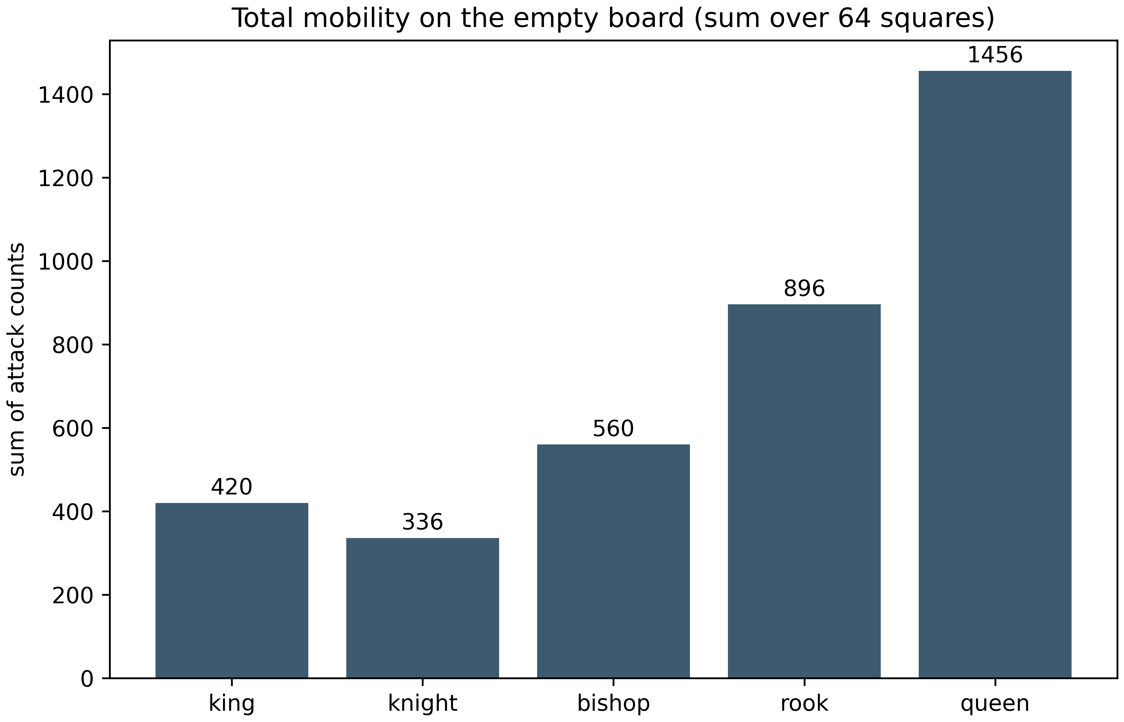
Fig. 1. Total mobility of the particles on the empty board (theorem T03, check C3).
Mobility enters the model twice. First, as a term of the Lagrangian (chapter 6): the kinetic coefficient μ = 0.1 reflects chess practice — space is expensive but cheaper than material. Second, as the generating function for move ordering in the search (chapter 11): the centralization of a particle correlates with its mobility, so the kinetic centralization bonus of the MVV-LVA heuristic is not empirics but a direct consequence of the structure of the move graphs.

5. Threat fields: the potential layer K3
Layer K3 is the potential layer of the model. Each particle emits a threat field Θ(c): for a square c the field equals the number of particles of side s attacking c. The total field mass is tied to the mobilities by the attack identity: ∑_{c} Θ_{s}(c) = ∑ pi a(π) — a discrete Fubini theorem interchanging the order of summation. In the start position each side carries a field of mass 38.
Theorem T04 proves two structural properties of the field. Additivity — the field of a particle system is the sum of the fields of the individual particles; this is what makes the very picture of "sources and potential" correct. Equivariance — for positions without pawns the field commutes with the board group: Θ_{g · p}(g · c) = Θ_{p}(c) for all g ∈ D₄; the attack is defined by the relative geometry of squares, invariant under the isometries. The pawn is an "oriented particle": it attacks strictly forward, and no non-identity element of D₄ preserves this direction. The exact equivariance defect — the pawn anomaly 176 = 88 + 88 violations in the start position — is fixed by the theorem and by check C6 in all seven languages.
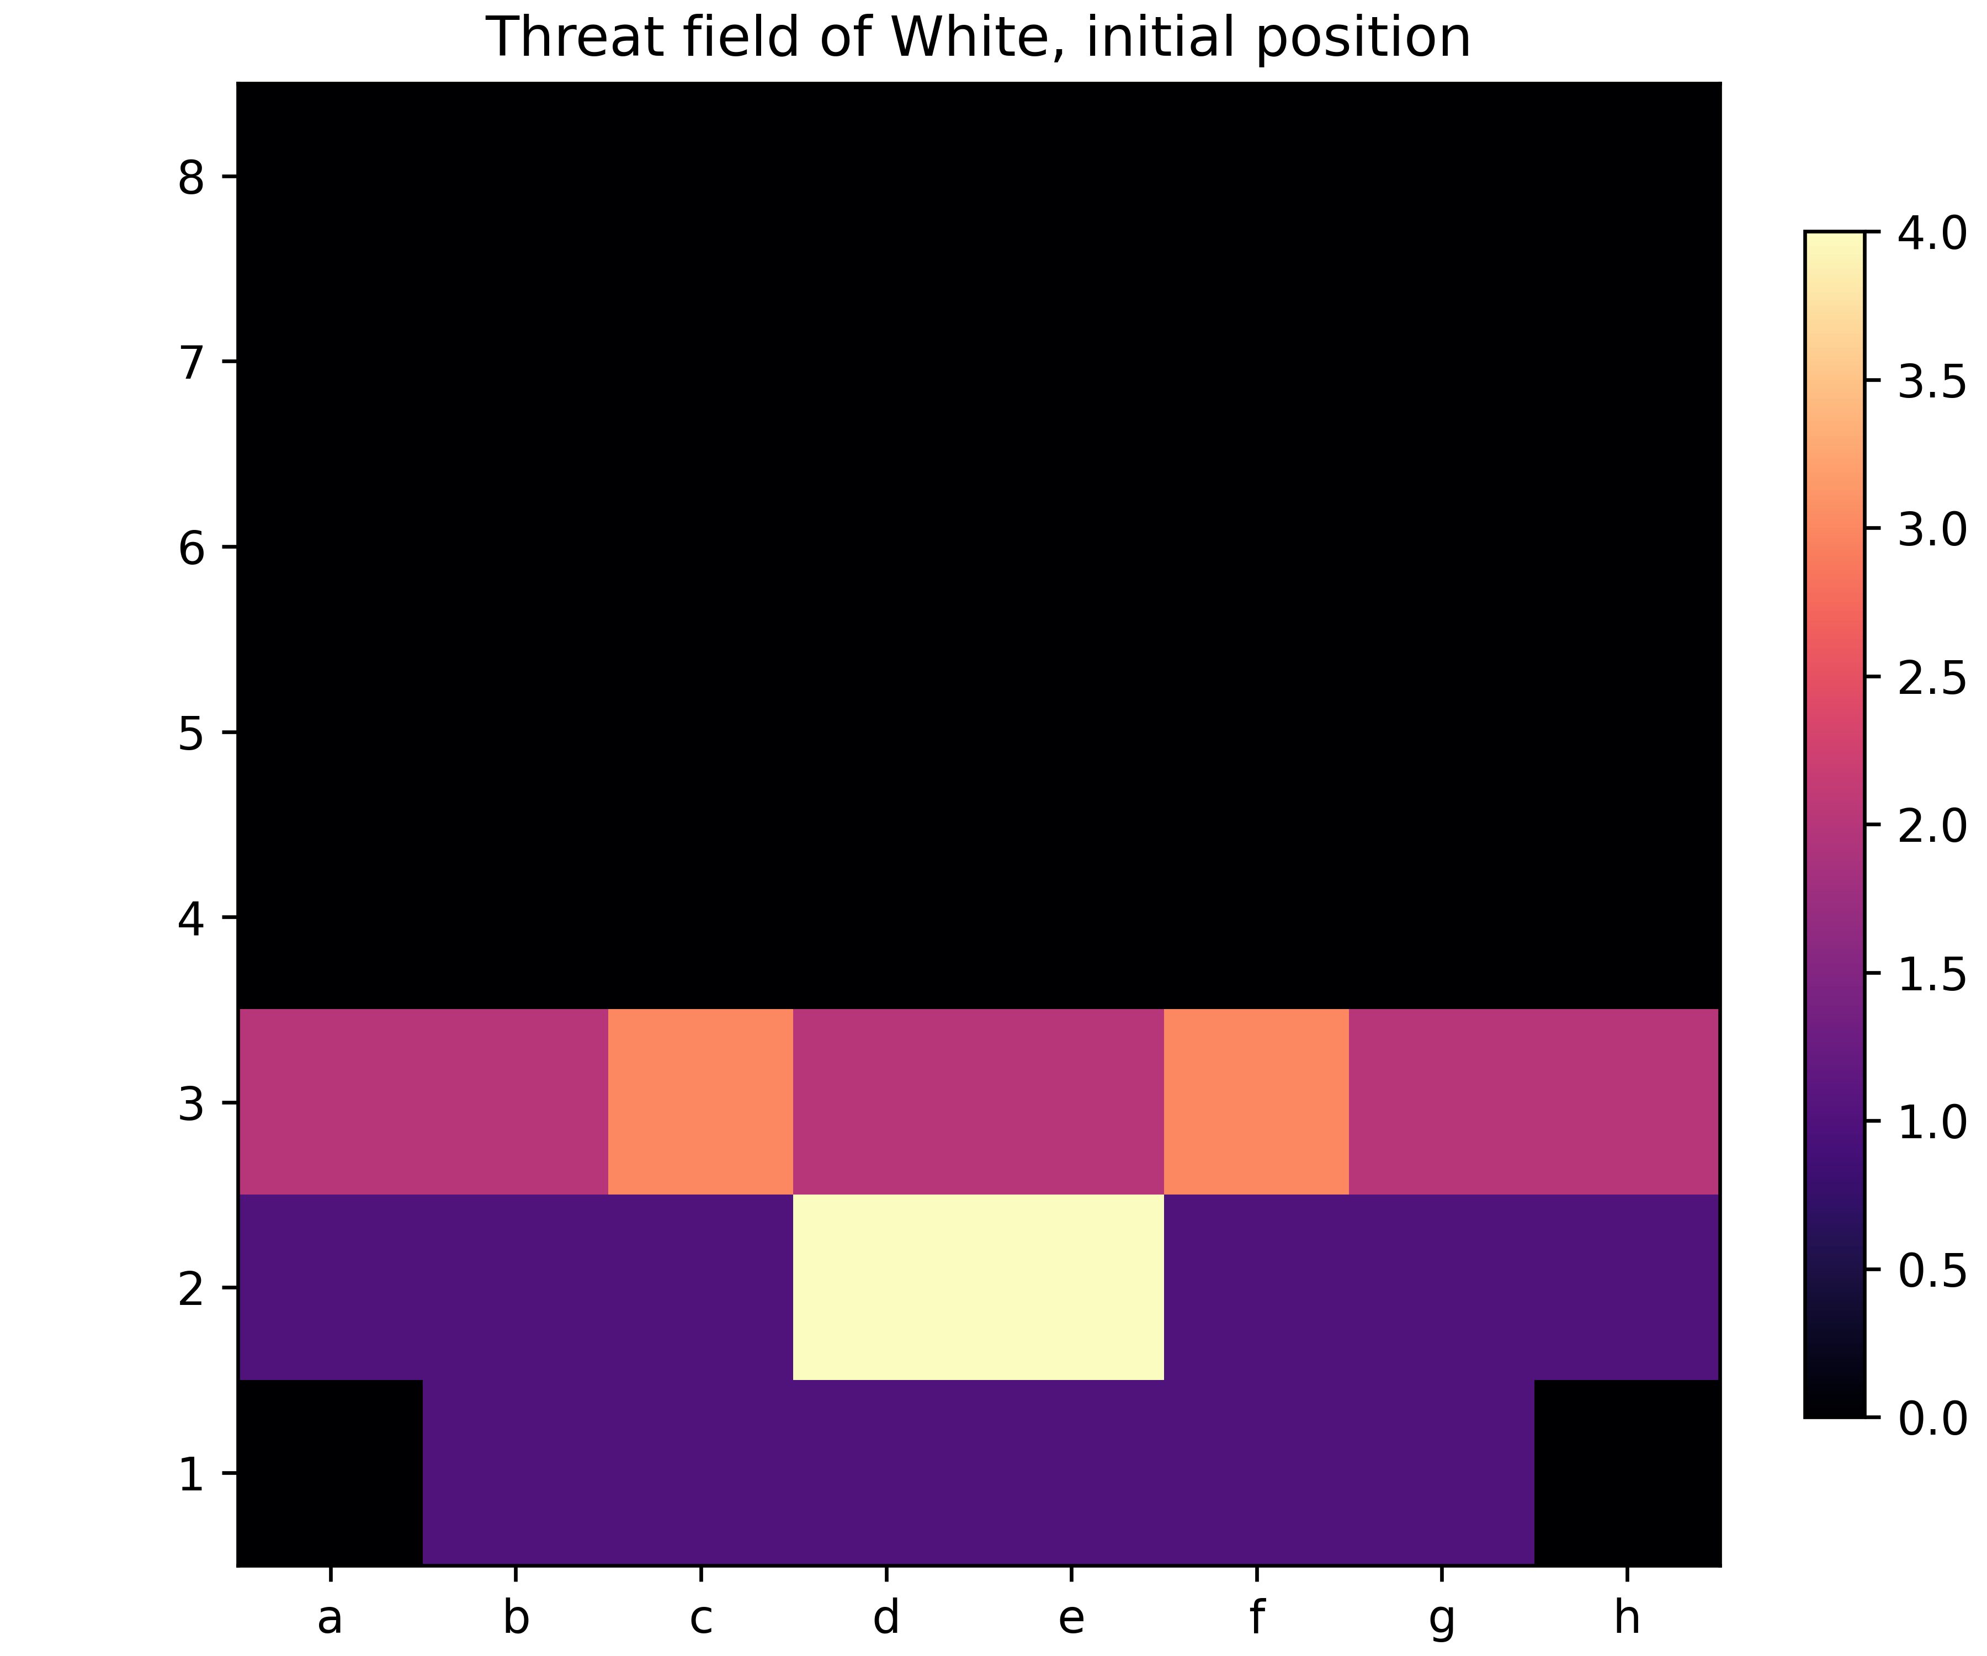
Fig. 2. The White threat field in the start position (layer K3, check C6).
The threat field is the quantity displayed as a heat map in the web laboratory; here it receives the strict status of a discrete potential with a known symmetry group and a known defect. It is the field, not "intuition", that defines the defensive links: a singly attacked undefended square is a source of tactics, and all such constructions appear in the search (chapter 11) through quiescence, which enumerates captures until the field calms down.

6. The Lagrangian: the energy of a position
Layer TORUS assigns energy to a position. The Lagrangian of T05: E = [M(∘) - M(•)] + μ [m(∘) - m(•)] with μ = 0.1, where M is the material in pawn units and m the mobility. The energy is integral in hundredths, deterministic and vanishes on symmetric positions. The start position is balanced; after 1.e4 White gains μ × 10 = +1.0 of kinetic energy — the first "real" dynamic quantity of the game.
Theorem T05 proves computability (finite sums over squares and legal moves), determinism (independence of the traversal order) and the bound of the kinetic term: the mobility of the standard set does not exceed 105 by T03. The sign of the energy is chosen "from the side to move" — the requirement of the negamax search of chapter 11: the parent maximizes the negated child, and the whole evaluation is automatically consistent with the alternation of sides.
The energy is the bridge between the physical metaphor and the computation: the search minimizes it, the web laboratory displays the energy panel, and protocol C7 pins its certificate values. The choice of the weights (100, μ = 0.1) is a convention laid into the definition and pinned by the protocol: the theorem does not claim that these weights are "optimal", it claims that under these weights all the properties are proved and all the numbers reproducible.

7. The flow of moves: terminations and billiards
Layer KLEIN regards the game as a discrete flow on the torus of the board. The first theorem of the layer, T06, gives the exact termination time: a particle starting from a corner with the vector (a, b) and reflecting off the rails returns to a corner after t* = lcm(W / gcd(a, W), H / gcd(b, H)) steps. This is the standard billiard computation on the torus transferred to the lattice: reflection is equivalent to unfolding the board, and the trajectory closes exactly when both periods meet.
The second part of the theorem is the damped billiard: every reflected velocity is multiplied by the coefficient γ = π⁴ / 256 ≈ 0.38, and the total path until rest equals |v₀| / (1 - γ) — a geometric progression converging to an exact limit. Protocol C4 verifies the "path/limit" ratio to 10⁻⁹ — a case where a continuous formula and a discrete simulation agree bit for bit.
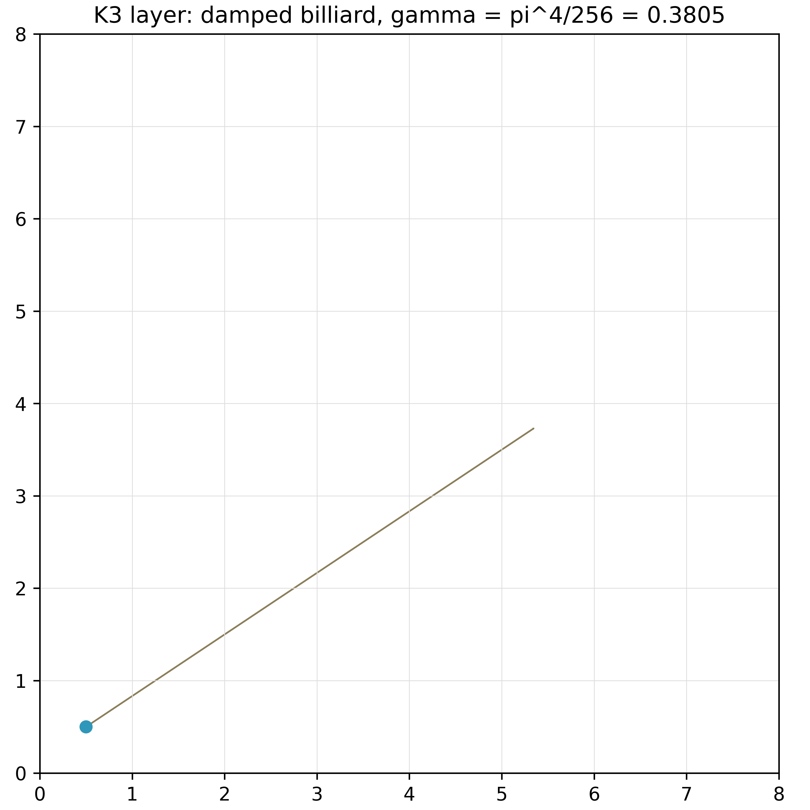
Fig. 3. The damped trajectory of a particle on the board ($\gamma = \pi^4/256$, check C4).
The meaning of the layer is a frame for "trajectories": the flow of moves receives geometry (closures on the torus), thermodynamics (damping) and memory (chapter 10). In the web laboratory this layer is visible as the animation of particles repeating legal moves and fading according to the law γ; here it is a theorem with exact termination times and path limits.

8. The knight tour: discovery and the Warnsdorff certificate
A closed knight tour is a route of 64 moves visiting every square exactly once and returning to the start. Theorem T07 pins the laboratory result: the Warnsdorff heuristic ("move to the square with the minimal degree of continuation") builds a closed tour starting at f5, with the closure d6 → f5, without backtracking — a greedy local choice leads to a globally perfect route.
A subtlety fixed by the theorem: the Warnsdorff heuristic is not an always-succeeds theorem — there are known starts from which naive application derails; the classical Schwenk theorem describes which boards have no closed tours at all. The laboratory therefore certifies a concrete result: the found tour is stored in results/knight_tour.json with a full verification of the properties (64 distinct squares, all knight steps, the closure) — and check C10 of the polyglot core reproduces it in all seven languages.
For the particle model the knight tour is the control experiment of the flow layer: it shows that greedy kinematics ("minimal next degree") can solve global enumeration problems without backtracking. The same principle — a local order instead of a global search — operates in the move ordering of the search (chapter 11) and in the retrograde induction (chapter 12).

9. Certifying the generation: perft identities
Perft is the number of leaves of the tree of legal continuations of depth d. Theorem T08 pins the world references for the start position: perft(1..5) = 20, 400, 8902, 197281, 4865609 — and the complete divide(3) table over all twenty initial moves (from 380 for the flank pawns to 600 after 1.e4). Agreement with the reference is equivalent to agreement of the sets of legal moves on the whole tree of depth d: it is an exhaustive test of the generation, localizing an error to a concrete initial move.
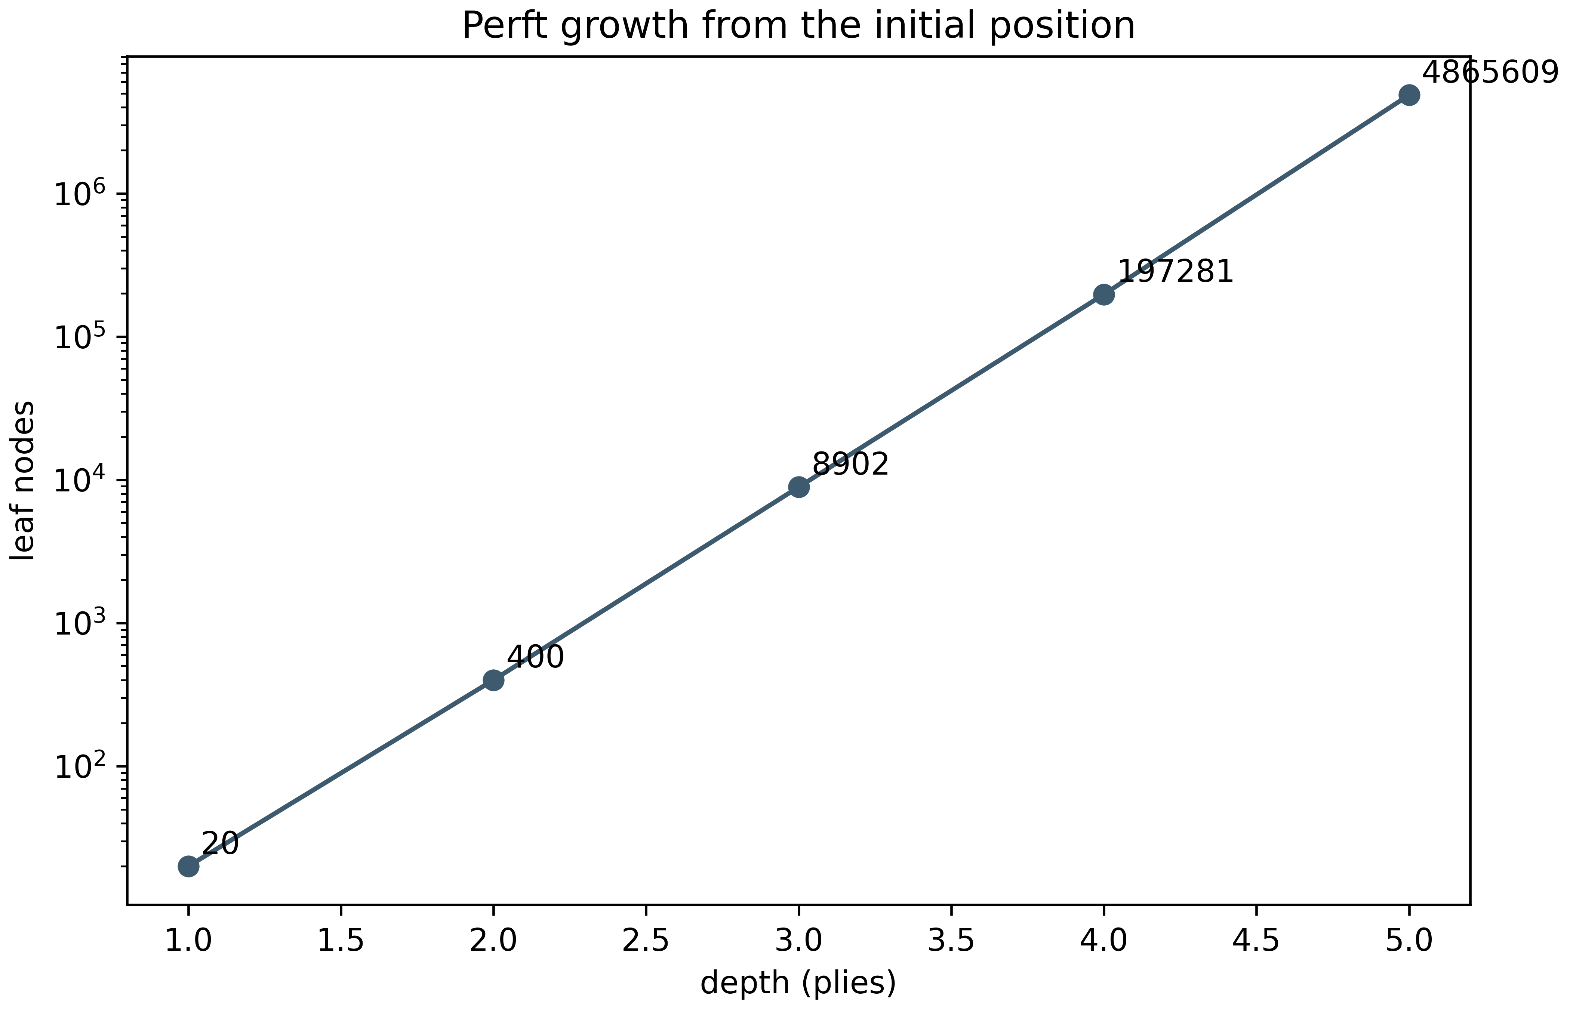
Fig. 4. Growth of the perft tree: 20 → 400 → 8902 → 197281 → 4865609 (check C5).
The development history confirms the diagnostic power of the method: the errors of en-passant indexing and of the pawn-capture rank check were exposed exactly as mismatches of individual divide(3) branches, after which the values converged and were frozen in the baseline. The entire subsequent frame — the search of chapter 11, the bases of chapter 12, the polyglot core — stands on this foundation: each of the seven languages must reproduce the perft chain before its results are accepted.

10. The memory of the flow: Zobrist hashing
A flow of states needs to distinguish states. Theorem T09 builds the memory on Zobrist hashes: the table of 1562 keys (12 × 128 piece keys, 1 side key, 16 castling keys, 9 en-passant keys) is generated by splitmix64 from the seed 0x1234567890ABCDEF. The bijectivity of the generator is proved with an explicit inverse: the odd multipliers are invertible modulo 2⁶⁴, and the xorshift cascades are unwound by the doubling series. The first values — σ(1) = 0x910A2DEC89025CC1, σ(2) = 0x975835DE1C9756CE — fix the cross-language reference.
The incremental identity h(make(P, m)) = h(P) ⊕ Δ(m) is proved by induction over moves with an explicit delta — including castling, en passant and promotions. Check C9 executes 40 games of up to 60 plies, comparing the incremental hash with the full recomputation at every step, and verifies the unmake restoration. The collision bound n(n-1)/2⁶⁵ gives 0.027 for a billion positions — the memory of the flow is reliable in all practical regimes of the laboratory.

11. The search: alpha-beta and determinism
The full-game loop minimizes the Lagrangian of T05 over the move tree. Theorem T10 proves the correctness of the windowed negamax — the classical Knuth–Moore argument in negamax form, complemented by quiescence (an enumeration of captures until the threat field calms down) and the mate encoding -MATE + ply, which prefers the shortest forcing. The bounds: the worst order gives b^{d} leaves, the best — b^{⌈ d/2 ⌉} + b^{⌊ d/2 ⌋} - 1.
Move ordering is the "kinematics of the search": the MVV-LVA heuristic with a kinetic centralization bonus. The measured numbers are pinned by the protocol: on the start position the search visits 79 nodes at depth 2 against 421 of the full tree, 731 against 9323 at depth 3, 3345 against 206604 at depth 4 and 19753 against 5072213 at depth 5 — the gain grows up to × 256.8, approaching the square root of the exponent. A total order on the moves (a stable sort over a total key) makes the search deterministic: the move, the score and the node count are bit-reproducible on any machine — the condition under which all the certificates of the program are comparable.

12. Mate certificates and the consolidated protocol
Mate in N is verified by two independent instruments. The forward search — iterative deepening with the reconstruction of the full principal variation; the backward one — retrograde analysis, which builds the distance to mate (DTM) for the whole space of three-piece endgames. Theorem T11 pins the base statistics: KRK — 399112 states, 4447032 edges, maximum DTM 32 plies (16 moves); KQK — 368452 states, 4869496 edges, maximum 20 plies (10 moves). Both maxima coincide with the classical tablebase values — an external cross-check unavailable to self-verification.
The base is closed by the Bellman machine: the optimality equation is verified over all states of both bases — zero violations. The forward search agrees with the bases by spot checks and the tactical reference: the Morphy mate a1a6 (3 plies, 46 nodes), the two-rook ladder b1b7 (3, 49), the knight-and-rook mate g1g8 (1, 1).
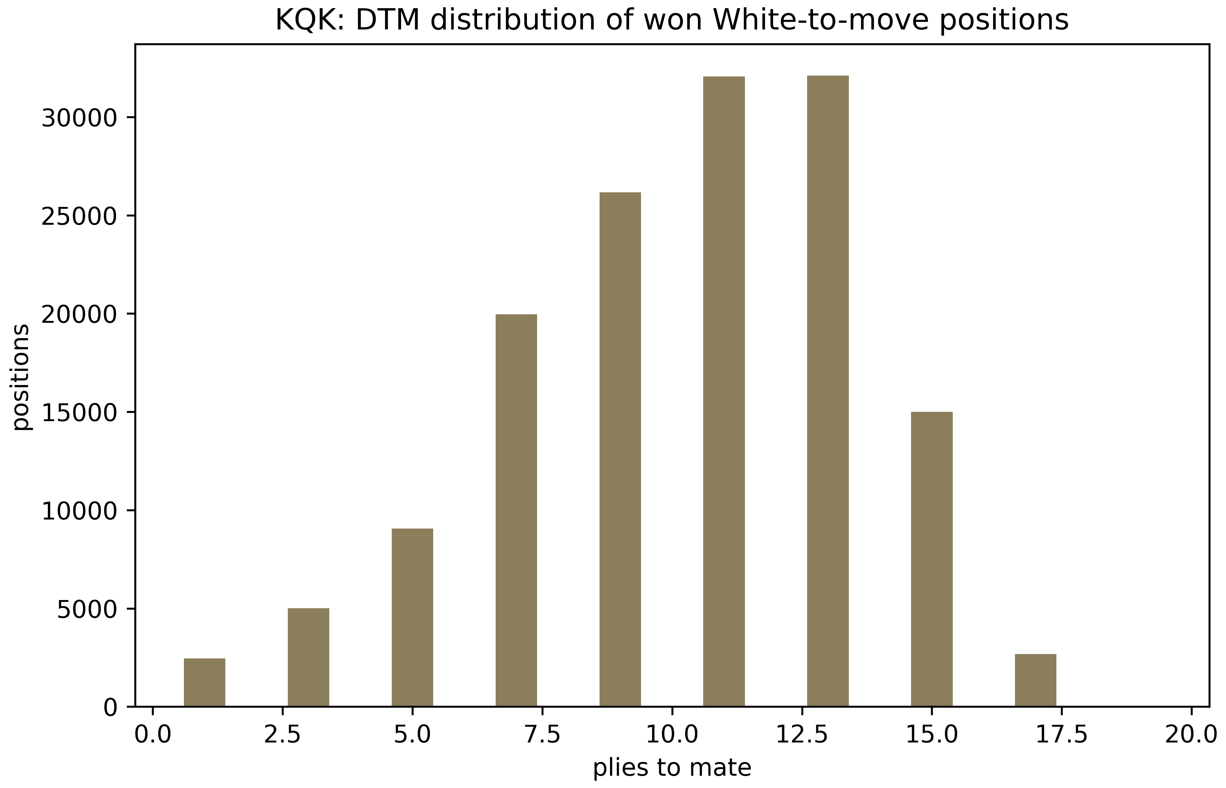
Fig. 5. The DTM distribution over the states of the endgame bases (theorem T11, check C8).
Theorem T12 assembles everything into the protocol: the nine checks C1–C9 close the theorems T01–T11 (C1 — algebra, C2 — graphs, C3 — mobility, C4 — flow, C5 — perft, C6 — fields, C7 — energy, C8 — bases and tactics, C9 — memory), the failure of any check is isolated and does not block the others, and the verdict ALL CHECKS PASSED is reproducible by one command. The polyglot battery C1–C10 prints a bit-identical verdict 10/10 in seven languages: Python, C and JavaScript are verified locally, Rust, Go, Julia and Java in GitHub Actions on every push. The program is closed: every theorem has an executable form.

Appendix A. The consolidated table of constants
Protocol constants of the chess-dynamics-lab program
Constant | Value | Theorem | Check
$V_4$ / $D_4$ orbits | 20 / 10 | T01 | C1
move graph edges R/B/N/K/Q | 448/280/168/210/728 | T02 | C2
mobility sums K/N/B/R/Q | 420/336/560/896/1456 | T03 | C3
maximum queen mobility | 27 | T03 | C3
start-position field (one side) | 38 | T04 | C6
pawn anomaly | 176 = 88 + 88 | T04 | C6
energy after 1.e4 (kinetic term) | +1.0 | T05 | C7
$t^*$, corner billiard (3, 2) | lcm(8/1, 8/2) = 8 | T06 | C4
damping | $\gamma = \pi^4/256$, path $|v_0|/(1-\gamma)$ | T06 | C4
closed knight tour | 64 moves from f5, closure d6→f5 | T07 | C10
perft(1..5) | 20/400/8902/197281/4865609 | T08 | C5
Zobrist key table | 1562 words, seed 0x1234567890ABCDEF | T09 | C9
splitmix64(1) | 0x910A2DEC89025CC1 | T09 | C9
collision bound at $n = 10^9$ | 0.0271 | T09 | C9
alpha-beta nodes, depth 2–5 | 79/731/3345/19753 | T10 | baseline
KRK: states / edges / max DTM | 399112 / 4447032 / 32 plies | T11 | C8
KQK: states / edges / max DTM | 368452 / 4869496 / 20 plies | T11 | C8
Bellman violations | 0 | T11 | C8
Morphy mate | a1a6, 3 plies, 46 nodes | T11 | C8

Appendix B. The reproduction guide
The laboratory deploys from the repository without external dependencies: the dynamics.py core is a single self-contained file on the Python standard library (matplotlib is optional, only for the plots). The full protocol: python3 dynamics.py --report — prints nine [PASS]/[FAIL] lines and the verdict; individual checks — python3 dynamics.py --run C5 (the deep mode is the --deep flag adding perft(5) and the full divide table). Position analysis: --analyze FEN --depth 4; forced mate: --mate FEN; self-play: engine/game_player.py --selfplay --depth 4; plots: --plots reports/plots.
The polyglot core: bash polyglot/run_all.sh runs the C1–C10 battery in all available languages and prints the summary table; in a clean environment python3 polyglot/python/chess_core.py suffices. Tests: python3 -m pytest tests/ -q (36 tests). The DTM bases ship compressed in results/ and are verified by the Bellman machine at every C8 run.
Android (Termux): pkg install python git; git clone the repository; python3 dynamics.py --report. The full --report takes tens of seconds on a smartphone (dominated by C5), individual checks seconds. For publishing a fork see INSTRUCTION.md: the scripts/termux_push.sh script creates a branch, commits and pushes the repository to a GitHub account in one command. The CI runs the protocol and the polyglot battery on the language matrix at every push, so the repository verdict is always current.

Bibliography

Bibliography
[1] Shannon C. E. Programming a Computer for Playing Chess // Philosophical Magazine. 1950. Vol. 41, No. 314. P. 256–275.
[2] Zobrist A. L. A New Hashing Method with Application for Game Playing / Tech. Rep. 88. University of Wisconsin, 1970; reprinted: ICCA Journal. 1990. Vol. 13, No. 2. P. 69–73.
[3] Knuth D. E., Moore R. W. An Analysis of Alpha-Beta Pruning // Artificial Intelligence. 1975. Vol. 6, No. 4. P. 293–326.
[4] Thompson K. Retrograde Analysis of Certain Endgames // ICCA Journal. 1986. Vol. 9, No. 3. P. 131–139.
[5] Schwenk A. J. Which Rectangular Chessboards Have a Knight’s Tour? // Mathematics Magazine. 1991. Vol. 64, No. 5. P. 325–332.
[6] Tromp J. The Number of Legal Go Positions // ICGA Journal. 2016. Vol. 39, No. 1. P. 3–13; see also J. Tromp’s materials on perft and chess position counting (johntromp.github.io).
[7] Isaev I. Kh. The Dynamic Principle: monads, layers and the protocols of verifiable mathematics. The hodge-laboratory program, 2025. GitHub: wild8highlander/hodge-laboratory.
[8] Isaev I. Kh. Chess Particle Dynamics: theorems T01–T12, the C1–C9 protocol and the polyglot core. The chess-dynamics-lab program, 2026. GitHub: wild8highlander/chess-dynamics-lab.
© 2026 chess-dynamics-lab · Individual exclusive license

