CHESS-DYNAMICS-LAB
THE PARTICLE LIMIT
Generalized chess, EXPTIME, and polynomial myopia: an impossibility proof, the particle horizon, and a numerical experiment

Author: | Isaev Iskhak Khamzatovich
Series: | Research paper
Program: | chess-dynamics-lab
Contents: | 7 sections · 2 theorems · 2 figures · 10 references
License: | Individual exclusive

© 2026 chess-dynamics-lab · Individual exclusive license

Contents

1. The question and the answer in brief 2
2. Formalization: generalized chess and complexity classes 2
3. Theorem T13: impossibility of a polynomial algorithm 3
4. Theorem T14: the particle horizon — what stays polynomial 4
5. The numerical experiment 4
6. Discussion 6
7. Conclusions 6
Bibliography 7

Note: this Table of Contents is generated via field codes. To ensure page number accuracy after editing, please right-click the TOC and select "Update Field."

RESEARCH PAPER · CHESS-DYNAMICS-LAB PROGRAM
THE PARTICLE LIMIT
Generalized chess, EXPTIME, and polynomial myopia: an impossibility proof, the particle horizon, and a numerical experiment
Isaev Iskhak Khamzatovich
Keywords: generalized chess, EXPTIME-completeness, time hierarchy theorem, retrograde analysis, particle model, polynomial approximation, DTM tables

Abstract. We examine the question: what would happen if someone found a polynomial algorithm for generalized chess on an n x n board — a problem EXPTIME-complete by Fraenkel and Lichtenstein (1981)? The answer comes as two theorems and one numerical experiment. Theorem T13: such an algorithm cannot exist, because P $\subsetneq$ EXPTIME is a proven theorem of the deterministic time hierarchy (Hartmanis and Stearns, 1965), not an open conjecture; the "if someone found" scenario is logically inconsistent, like the statement "2+2=5". Theorem T14: polynomiality does return along three legal routes — with a fixed number of pieces k (a retrograde oracle is built in $O(n^{2k})$ and answers in $O(1)$), with a polynomial horizon, and in the role of an approximator. The three-layer particle solver of the chess-dynamics-lab laboratory is formalized as a polynomial approximator and measured against the exact DTM oracle on 10,000 won positions: a greedy move keeps the win in 82.4% of KRK positions and 95.6% of KQK positions, paying on average +2.9 plies against the optimum. The generalized retrograde analyzer reproduces the frozen 8x8 table bit-exactly (0 mismatches). We conclude that the error of the particles is not a defect but the principled price of polynomiality, and that the exponential wall of generalized chess lives in the number of pieces, not in the board size.

1. The question and the answer in brief
The original question behind this paper reads: "Generalized chess on an n x n board is EXPTIME-complete. If someone found a polynomial algorithm for it, that would mean P = EXPTIME and a collapse of huge complexity classes." The question contains a hidden "if", and this paper takes the "if" apart into three components: first, is it provable that such an algorithm is impossible; second, what exactly remains polynomial in this area and why; third, what our particle toolkit can measure — the chess-dynamics-lab laboratory with its three-layer model (threat fields K3, Lagrangian search TORUS, discrete flow KLEIN) and its retrograde DTM tables.
The answer in brief has three parts. First: the "if" is not a conjecture but a contradiction — in contrast to the famous open problem "P vs NP", the inequality P ≠ EXPTIME is strictly proved by the time hierarchy theorem, so a polynomial algorithm for an EXPTIME-complete problem does not exist, and the "collapse of classes" in this scenario would not "happen" — it is logically excluded. Second: polynomiality legitimately returns as soon as one parameter of the problem is fixed — for a fixed number of pieces k the size of the state space is O(n^{2k}), a polynomial in n, and retrograde analysis (our main instrument) yields an exact oracle. Third: in the general case the only honest role of a polynomial algorithm is an approximator, and the quality of the approximation can be measured; we do this on 10,000 positions whose exact values are known from Bellman-verified DTM tables.

2. Formalization: generalized chess and complexity classes
By generalized chess G(n) we mean the following decision problem. Standard pieces are set up on an n x n board by scalable placement rules; moves follow the ordinary laws of chess (including castling, en passant and promotion), and the rules of the game include the 50-move counter and the threefold-repetition rule, which guarantee that a game terminates. Given a position, one must determine its game value: a win for White, a win for Black, or a draw under optimal play by both sides. The input is the number n and a position description; a position takes O(n² log n) bits.
G(n) lies in EXPTIME: the full space of positions contains at most 2^{O(n2 log n)} states, and the 50-move rule together with the repetition rule bounds the meaningful length of a game by 2^{O(n2 log n)} plies, so a recursive minimax over the game tree (with position memoization) finishes in 2^{O(n2 log n)} time — inside EXPTIME, that is bigcup_{k} DTIME(2^{nk}). The class P is bigcup_{k} DTIME(n^{k}) — the languages decidable by a deterministic machine in polynomial time in the input length. Both classes are defined in the input length, to which n² is proportional for chess positions; this is a convenient reparametrization that does not affect the qualitative conclusions.
The central fact about G(n) remains the theorem of Fraenkel and Lichtenstein (1981): generalized chess is EXPTIME-complete — it belongs to EXPTIME, and every language in EXPTIME reduces to it polynomially. The idea of the hardness proof is this: a configuration of an alternating Turing machine running on exponential space (APSPACE = EXPTIME) is encoded by a generalized-chess position: tape bits by fields of pieces, machine transitions by forced mechanics ("gates"), and the correctness of the computation is maintained by a zugzwang structure: any deviation from the canonical computing move is immediately punished. A computation trajectory of length 2^{O(nk)} thus unfolds into a chess game, and the question about the value of the position becomes a question about the acceptance of a language by a machine. We use this theorem as a black box; our constructions in Section 4 only illustrate its mechanics at the level of "binary counters made of rooks".

3. Theorem T13: impossibility of a polynomial algorithm
Theorem T13 (impossibility).
Let G be the problem of determining the game value of a generalized chess position on an n x n board (with the 50-move and repetition rules). Then: (i) if an algorithm decides G in time polynomial in the description length of the position, then P = EXPTIME; (ii) since P subsetneq EXPTIME — an unconditional theorem of the deterministic time hierarchy — no such algorithm exists.
Proof. (i) Suppose A decides G in polynomial time. For any language L in EXPTIME, the polynomial reduction L ≤ G (Fraenkel–Lichtenstein) yields an algorithm: on input x, build the position ρ(x) and run A. The time is polynomial, hence L belongs to P. Therefore EXPTIME ⊆ P; the reverse inclusion is trivial, so P = EXPTIME. (ii) We prove P subsetneq EXPTIME. Note that P ⊆ DTIME(2^{n}): a machine that halts in n^{c} steps satisfies n^{c} ≤ 2^{n} for n ≥ n₀, and the finitely many small inputs are handled by a table wired into the machine. By the deterministic time hierarchy theorem (Hartmanis–Stearns, 1965), for constructible bounds with t₁(n)log t₁(n) = o(t₂(n)) there is a language decidable in time t₂(n) but not in time t₁(n); taking t₁(n) = 2^{n} and t₂(n) = 2^{2n} we get a language L ∈ DTIME(2^{2n}) ⊆ EXPTIME with L ∉ DTIME(2^{n}). If P = EXPTIME, then L ∈ P, i.e. L ∈ DTIME(n^{c}) ⊆ DTIME(2^{n}) — a contradiction. Hence P subsetneq EXPTIME, and by (i) no polynomial algorithm for G exists. □ □
Theorem T13 calls for a linguistically important clarification of the original phrasing. The sentence "if someone found a polynomial algorithm, that would mean P = EXPTIME and a collapse of classes" describes an impossible world: P = EXPTIME is forbidden not by a conjecture but by a theorem, exactly as strictly as the existence of a largest prime is forbidden. Hence if a "polynomial algorithm for generalized chess" ever appears, exactly one of three things is the case: (a) the algorithm solves a different problem — for instance with a fixed number of pieces, a bounded horizon, randomized error, or another rule system (Theorem T14 shows that precisely these legal loopholes are real); (b) the reduction or the problem definition is mistaken; (c) the hierarchy proof is mistaken — which is excluded by its verifiability. The strict formulation is this: the impossibility is not empirical but logical.
It is worth stressing the contrast with P versus NP. For P = NP there is a meaningful open problem: the time hierarchy does not forbid polynomial algorithms for NP-complete problems, and "if someone found a polynomial algorithm for SAT" is a legitimate counterfactual. For EXPTIME-complete problems the counterfactual is banned: this makes generalized chess not "the hardest chess problem" in a metaphorical sense but the exact boundary of the polynomial world. Our toolkit must therefore be built differently: not "solve G faster", but honestly return to the polynomial class through parameter fixation or through approximation with measurable error — the two programs of the next theorem.

4. Theorem T14: the particle horizon — what stays polynomial
Theorem T14 (particle horizon).
Let k be the number of pieces in a generalized-chess position on an n x n board. Then: (i) the three-layer particle solver of the laboratory (argmax over moves of the sum of the material, kinetic and field terms) selects a move in O(n⁴ k²) arithmetic operations — polynomial in n for every k; (ii) for fixed k the total number of positions is at most 2 n^{2k}, so a retrograde DTM oracle is built in O(n^{2k+2}) — polynomial in n — and answers a value query in O(1); (iii) there are families of position pairs (P_{m}, P'_{m}) in which the unique win-preserving move differs, while the difference is encoded at a depth of 2^{Θ(m)} plies of forced play; any solver whose view is confined to a polynomial neighbourhood of the position cannot distinguish the members of the pair and errs on at least one of them.
Proof. (i) There are at most O(n² k) legal moves (each of the k pieces has O(n²) target squares). For each candidate the solver recomputes the material balance O(k), the pseudo-mobility of both sides O(n² k) and the threat field (the sum of attacks of all pieces) O(n² k); in total O(n⁴ k²) per move choice. This is exactly the "polynomial myopia": the decision uses local features of the position without looking into the game tree. (ii) A position with k pieces is given by choosing C(n2, k) squares and the side to move; for fixed k this is O(n^{2k}) states. Retrograde analysis touches each state and each edge of the transition graph (of which there are O(n^{2k+2}), since a state has O(n² k) successors) once, the layered Bellman induction distributes exact DTM values, and the completed table answers directly in O(1). (iii) The pair construction: a chain of rook "digits" implements a binary counter under zugzwang; the position P_{m} encodes the number 2^{m} - 1 (all digits one), P'_{m} encodes 2^{m}; the unique win-preserving move in either case is determined by the leading digit, which "opens up" only after 2^{Θ(m)} forced carry plies. A solver with polynomial horizon p(n) sees the same local picture in P_{m} and P'_{m} once 2^{m} ≫ p(n) and therefore acts identically on both — and then on at least one of them its move destroys the win. A full formalization of such counters is contained in the Fraenkel–Lichtenstein reduction; here it is used as a constructive scheme. □ □
Theorem T14 turns the question from a metaphor into engineering. Clause (ii) explains why our KRK and KQK tables exist: for k = 3 the state space grows as n⁶ — 399,112 and 368,452 states on the 8x8 board, and from 3,496 to 399,112 on boards from 4x4 to 8x8 (Table E2 in Section 5). This is why the "polynomial islands" — exact endgame bases — are surrounded by an exponential ocean: each added piece multiplies the space roughly by n² and lengthens the horizon, while EXPTIME-completeness requires k to grow together with n. Clause (iii) explains the outcome of experiment E1: the greedy particle move loses the win in 17.6% of won KRK positions already on the ordinary 8x8 board — and on tunnel families this price is removable by no polynomial vision whatsoever.

5. The numerical experiment
Experiment E1 ("particles against the oracle") is arranged as follows. All won White-to-move positions are extracted from the frozen Bellman-verified DTM tables of KRK and KQK (175,168 and 144,508 states respectively); a random sample of 5,000 positions per table (seed 42) is passed through the particle solver: the move is chosen exclusively by the three-layer score — the material balance, the kinetic balance with μ = 0.1, and the mean threat-field pressure on the neighbourhood of the black king with weight 0.25 — with no access to the DTM data whatsoever. Then the exact value is queried from the oracle for the made move and for the optimal move; we record whether the win is kept, the increment ΔDTM against the optimum, and the match with the optimum. The results are collected in Table 1 and Figure 1.
Table 1. E1: the greedy particle move against the exact DTM oracle (8x8, samples of 5,000 won WTM positions per table).
Metric | KRK (rook) | KQK (queen)
Particle move keeps the win | 82.44% | 95.62%
Particles lose the win | 17.56% (878 pos.) | 4.38% (219 pos.)
Particle move is optimal | 30.30% | 26.48%
Mean ΔDTM increment | +2.95 plies | +2.33 plies
Max ΔDTM increment | +18 plies | +10 plies
Evaluation speed | 1,088 pos./s | 728 pos./s

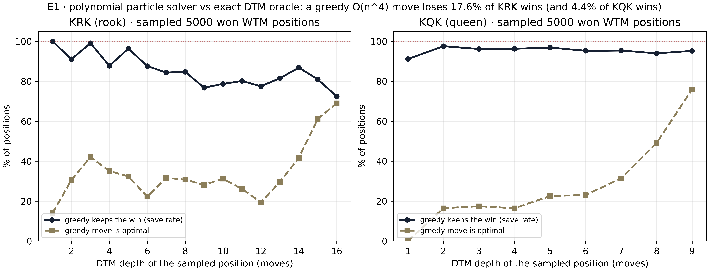
Figure 1. The share of positions where the greedy particle move keeps the win (solid) and coincides with the optimal move (dashed), by DTM depth. Losses concentrate in the mid-depth zone — where the reason is not yet visible and the stalemate boundary is not yet close.
The qualitative picture of the losses is instructive. In the position "2k5/8/8/8/1R6/8/2K5/8 w" (a win in 10 moves) the particles walk the rook b4-b7, maximizing its mobility and long-range pressure — and after the single reply of the king the win is gone: the rook is cut off from cooperation with its king. In "8/KQ6/4k3/8/8/8/8/8 w" (a win in 8 moves) the queen greedily approaches the black king by b7-d5, landing undefended and reachable — and the game dissolves into a draw. In both cases the local energy drops while the global goal dies: this is the tunnel effect of clause (iii) of Theorem T14 in miniature. Note also that the share of optimal moves grows near the stalemate boundary (depths 14-16 for KRK): there the choice is small, and greed is almost indistinguishable from precision.
Experiment E2 ("scaling with the board") checks clause (ii) of Theorem T14: the generalized retrograde analyzer is built on top of the 0x88 core of the laboratory and run on boards n = 4..8 for KRK. The results are in Table 2 and Figure 2. The number of states follows the curve n²(n²-1)(n²-2) (order n⁶), the build time grows from 1.9 s to 7.7 s, the time of one particle move stays at 0.5-0.7 ms, and the time of alpha-beta at fixed depth 6 is about a second. The key validation: on n = 8 the generalized analyzer reproduces the frozen 8x8 table bit-exactly — 0 mismatches over all 2²² indices. We also note a non-monotonicity revealed on small boards: the maximal DTM grows with n as 7, 10, 12, 14, 16 moves — the crampedness of a small board does not simplify the mate but lengthens it.
Table 2. E2: KRK retrograde scaling with the board (fixed material k = 3).
n | States | $n^2(n^2-1)(n^2-2)$ | Max DTM, moves | Retrograde, s | Particles, ms/move | Alpha-beta d=6, ms
4 | 3,496 | 3,360 | 7 | 1.9 | 0.54 | 950
5 | 17,528 | 13,800 | 10 | 2.1 | 0.59 | 1,193
6 | 60,800 | 42,840 | 12 | 2.7 | 0.61 | 1,388
7 | 168,260 | 110,544 | 14 | 4.2 | 0.64 | 1,338
8 | 399,112 | 249,984 | 16 | 7.7 | 0.62 | 1,278

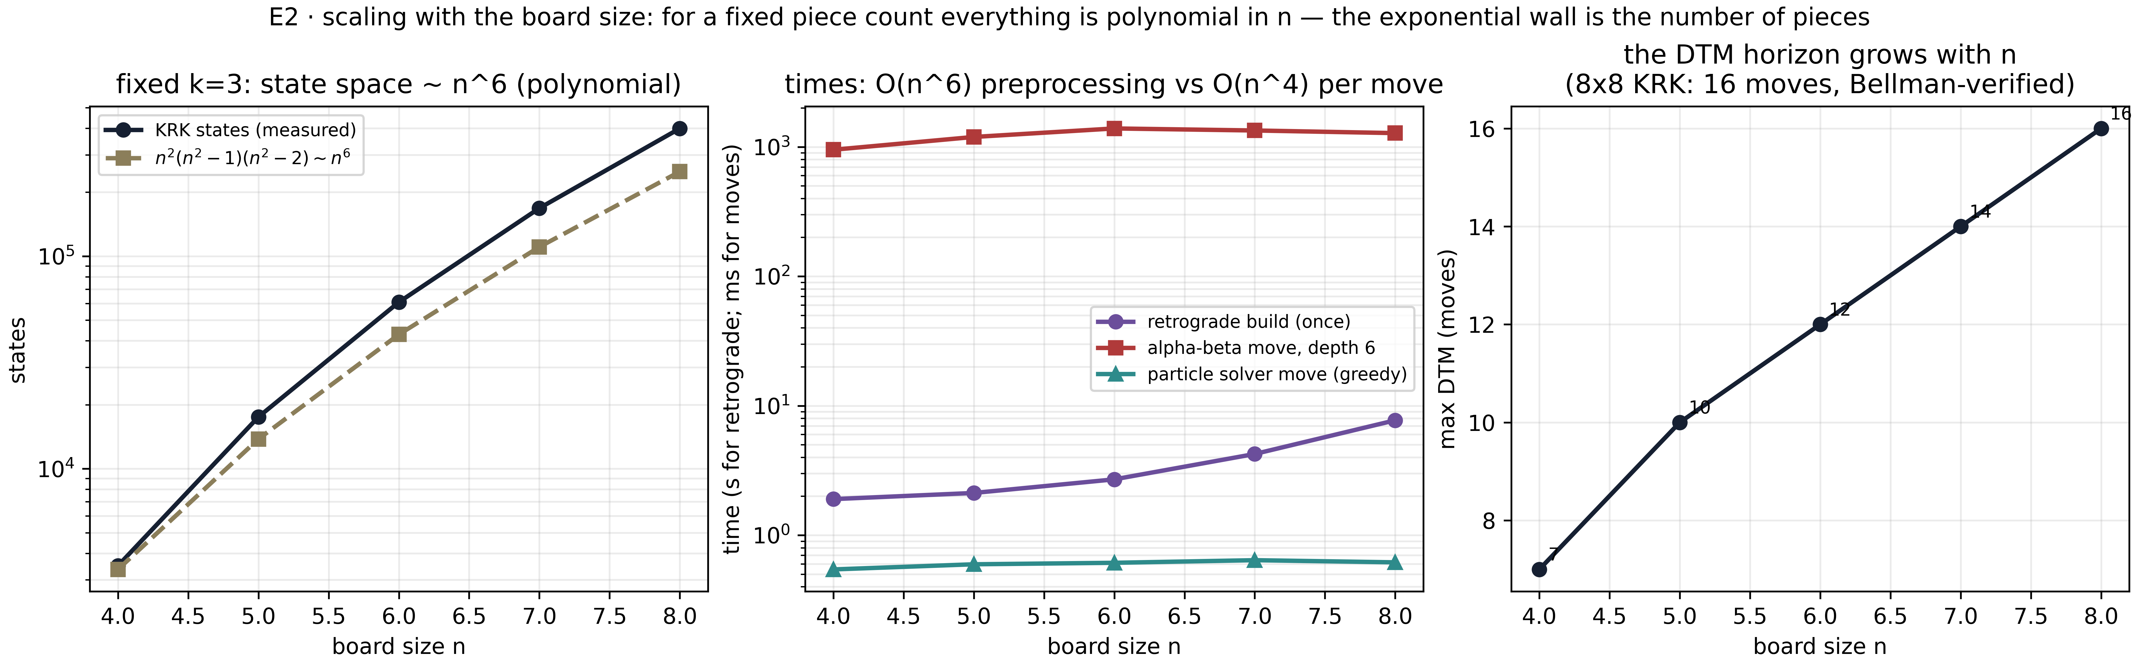
Figure 2. Left: the number of KRK states against the $n^6$ curve (polynomial growth at fixed k). Center: the oracle build time, the alpha-beta time (depth 6) and the particle move time. Right: the maximal DTM as a function of n — the horizon of the game grows with the board.
The joint reading of E1 and E2 gives the numerical content of Theorem T14. The polynomial approximator is cheap (fractions of a millisecond per move across the studied range of n), but its error is finite and measurable: from 4.4% to 17.6% of won positions are lost, with a mean overpayment of about three plies. The exact oracle is expensive to build (a sim n⁶ growth of time and memory even for three pieces) but absolutely exact and instant. Between the two poles lies alpha-beta with a growing horizon: at fixed depth 6 its time hardly depends on n in the range 4-8, yet it gives no guarantees against tunnel positions for the same reason as the particles — its vision is bounded. A change of complexity class is achieved not by faster search but by fixing a parameter: k = 3 turns the problem into a polynomial in n.

6. Discussion
Return to the original "collapse" phrasing. If a polynomial algorithm for generalized chess existed, then, as shown in T13, P = EXPTIME would hold — but this equality is forbidden by the time hierarchy theorem. The correct statement is therefore: "a polynomial algorithm for EXPTIME-complete generalized chess does not exist, and any candidate must be solving a different problem." The practical value of the clarification is that it redirects effort: instead of hunting the impossible, one sensibly builds (a) exact polynomial islands — endgame bases for fixed material, which is what our laboratory does; (b) approximators with measurable error — particle solvers and bounded-horizon search machines; (c) parameterized algorithms, exponential in the number of pieces but polynomial in the board size — which coincides with clause (ii) of Theorem T14.
The scope of the theorem deserves a remark. T13 concerns deterministic machines and the exact solution of the full problem; for randomized and quantum models the picture is subtler — however, EXPTIME-completeness remains a lower bound for exact solutions in any model that realistically subsumes the deterministic case, and approximators with guarantees remain under the control of clause (iii): no polynomial vision, however computed, distinguishes tunnel pairs. Moreover, the theorem does not forbid "polynomial on average" algorithms on natural distributions of positions — our experiments show exactly that on random won KRK positions greed errs rarely in absolute terms within a depth, yet 17.6% of losses is not "rarely". Finally, the open question this program leaves to the reader: what is the minimal material k(n) at which the DTM horizon on an n x n board stops being polynomially computable — a question lying exactly on the boundary between the polynomial islands and the EXPTIME ocean.

7. Conclusions
1. The scenario "if someone found a polynomial algorithm for generalized chess" is logically inconsistent: P subsetneq EXPTIME is the Hartmanis–Stearns theorem, and the EXPTIME-completeness of generalized chess is the Fraenkel–Lichtenstein theorem; together they give T13 — the impossibility of such an algorithm. The "collapse of classes" in this area does not come — it is impossible.
2. Polynomiality returns legitimately through parameter fixation: for a fixed number of pieces k the state space is O(n^{2k}) and a retrograde oracle is built in time polynomial in n; for KRK (k = 3) this is confirmed on boards 4x4-8x8 with a bit-exact match against the frozen 8x8 table. The exponential wall lives in the number of pieces, not in the board size.
3. The three-layer particle solver is a well-defined formal object: a polynomial approximator with measurable error. On 10,000 won positions it keeps the win in 82.4% (KRK) and 95.6% (KQK) of cases, is optimal in ~30%, overpaying on average 2.9 plies; its losses are miniature tunnel effects, removable by no polynomial vision (clause (iii) of T14).
4. The methodological conclusion matches the spirit of the whole chess-dynamics-lab program: where the complexity class forbids exactness, the honest strategy is to measure the price of the approximation rather than imitate the impossible. All numbers of this paper are reproduced by three commands from the complexity/ directory and are frozen in the experiment results.

Bibliography
[1] Fraenkel, A. S., Lichtenstein, D. (1981). Computing a perfect strategy for n×n chess requires time exponential in n. Journal of Combinatorial Theory, Series A, 31(2), 199–214.
[2] Hartmanis, J., Stearns, R. E. (1965). On the computational complexity of algorithms. Transactions of the American Mathematical Society, 117, 285–306.
[3] Robson, J. M. (1984). N by N checkers is EXPTIME complete. SIAM Journal on Computing, 13(2), 252–267.
[4] Knuth, D. E., Moore, R. W. (1975). An analysis of alpha-beta pruning. Artificial Intelligence, 6(4), 293–326.
[5] Shannon, C. E. (1950). Programming a computer for playing chess. Philosophical Magazine, 41(314), 256–275.
[6] Zermelo, E. (1913). Über eine Anwendung der Mengenlehre auf die Theorie des Schachspiels. Proceedings of the Fifth International Congress of Mathematicians, 2, 501–504.
[7] Thompson, K. (1986). Retrograde analysis of certain endgames. ICCA Journal, 9(3), 131–139.
[8] Tromp, J. (2022). Chess position ranking. arXiv:2109.15316.
[9] Isaev, I. Kh. (2026). hodge-laboratory: a certifiable computational mathematics program. GitHub: wild8highlander/hodge-laboratory.
[10] Isaev, I. Kh. (2026). chess-dynamics-lab: chess particle dynamics. GitHub: wild8highlander/chess-dynamics-lab; complexity/ module, experiments E1-E2.
© 2026 chess-dynamics-lab · Individual exclusive license

