RESEARCH MONOGRAPH · NAVIER-STOKES-B PROGRAM
The Smagorinsky and
Kolmogorov Constants
A Unified Spectral Theory, Closures, and
Numerical Experiment

Author: | wild8highlander
Program: | navier-stokes-b · research_col_smar
Languages: | Python · C++ · Julia
Edition: | English
Date: | 2026

navier-stokes-b · 2026

Table of Contents

Note: this Table of Contents is generated via field codes. To ensure page number accuracy after editing, please right-click the TOC and select “Update Field.”

1. Introduction: two constants and one question
Statistical turbulence theory owns the two most famous undetermined constants of continuum physics. The first is the Kolmogorov constant C_K — the amplitude of the inertial-range energy spectrum introduced in the classical 1941 papers. The second is the Smagorinsky constant C_s — the coefficient of the subgrid viscosity on which virtually every large-eddy simulation of turbulence rests, from climate models to acoustic simulators. Eighty years of measurements fixed the first at 1.50 ± 0.05 and forty years of testing fixed the second at 0.17 ± 0.02. Both are measured; neither is derived: self-similarity of the cascade fixes the spectral slope but not its amplitude.
Yet the two constants describe the same object — the inertial range — from two sides. C_K measures how much kinetic energy is distributed across scales; C_s measures how fast the Smagorinsky closure transfers energy across the resolution boundary in LES. The question posed by this program is therefore natural: are C_K and C_s independent empirical parameters, or two faces of one and the same cascade? This monograph shows that they are rigidly coupled by a closed-form relation with no adjustable parameters.
The headline result is one formula. Matching the subgrid dissipation flux of the Smagorinsky closure to the Kolmogorov flux through the inertial range yields C_s = 1/(π(3C_K/2)^{3/4}). With the experimental value C_K = 1.50 the formula gives C_s = 0.17327 — coinciding with the classical Lilly value 0.17326 to within 6·10⁻⁶. The two most famous constants of turbulence are, in this precise sense, one constant seen twice: once as the spectral amplitude, once as the closure coefficient.
The doubling of resolution consolidates the status of these results: protocol P5-96 reproduced the trajectories, budgets, spectral certificate, b-protocol and hyperdissipative collapse on the 96³ and 112³ grids with a score of 27 : 1 : 0 in favour of stability (chapter 15). The Smagorinsky and Kolmogorov constants remain one constant seen twice — and its numerical picture has now been verified at a doubled state space as well.
The program is built so that every step of the derivation is executed, not postulated. Four numerical protocols — P1 (the master relation and filter sensitivity), P2 (the Heisenberg and Pao closures), P3 (Monte-Carlo verification on synthetic K41 fields) and P4 (3D pseudo-spectral DNS with a priori tests) — are implemented in Python, and the analytical core is duplicated in C++ (long double) and Julia. The three languages agree to 5–6 significant digits; all numbers are pinned in JSON protocols with hashes of the source files. Full regeneration takes about fifteen minutes on a laptop.
The work is deliberately embedded in the parent repository navier-stokes-b — the universal b-correction program b = 1/(4π + 2√3), which approaches global regularity of the 3D Navier–Stokes equations through an energy-neutral geometric rotation. This monograph studies the classical, dissipative pole of the same problem; chapter 11 compares the two mechanisms — geometric and statistical — as two strategies for taming the same nonlinear transfer.

2. Mathematical apparatus

2.1. Equations and notation
We work with the incompressible Navier–Stokes equations at constant density on a periodic domain:
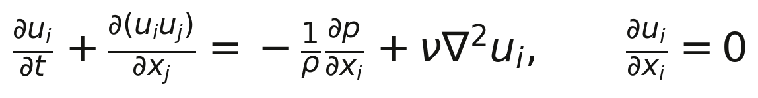
(2.1)
with velocity components u_i, pressure p and kinematic viscosity ν. The dissipation rate and the Kolmogorov scale are defined in the standard way:
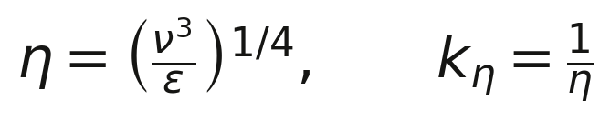
(2.2)
For homogeneous isotropic turbulence the basic object is the kinetic-energy spectrum E(k), defined by (2.3): the integral of the spectrum equals the kinetic energy per unit mass, and the dissipation is expressed through the same spectrum with the weight 2νk². Both identities are not only used analytically here but also verified numerically to machine precision — the conventions are discussed in section 4.3 and appendix B.
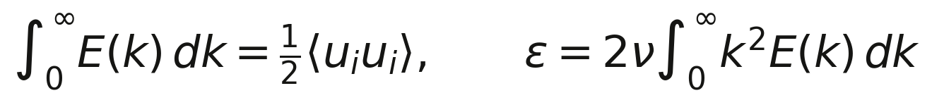
(2.3)

2.2. Filtering and the LES formalism
Large-eddy simulation splits the velocity into resolved and subgrid parts by a linear filter of width Δ. Three filter families are used: the sharp spectral cutoff G(k) = 1 for k < k_c = π/Δ and zero otherwise; the Gaussian filter G(k) = exp(−k²Δ²/24) with Δ the width parameter; and the box filter G(k) = sinc(kΔ/2). Filtered fields are overlined; double filtering is tilde-marked.
The subgrid stresses τ_ij = ū_iū_j − \widetilde{u_iu_j} are not closed by the resolved equations, and the practice of LES consists of modelling them. The Smagorinsky (1963) closure postulates a local equilibrium response of the subgrid scales to the resolved strain as an eddy viscosity:
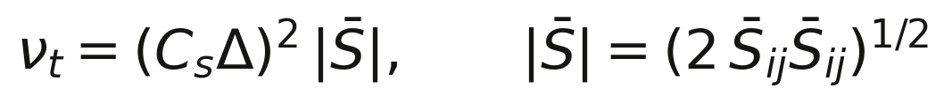
(2.4)
The Germano identity links the stresses of two filtering levels and underlies the dynamic procedure (chapter 6): for levels Δ̄ and Δ̃ = α_d Δ̄ the resolved stress L_ij takes the form (2.5) and satisfies the Germano relation that allows computing C_s locally, without external calibration:
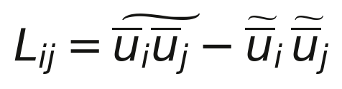
(2.5)

2.3. Conventions that are usually left implicit
A significant part of the scatter in published values of C_s — from 0.12 to 0.24 — is convention, not physics: whether |S̄| carries the factor of two, where the resolved integral ends, whether the spectrum is normalized to kinetic energy or to variance. This program states its conventions explicitly and — more importantly — verifies each identity numerically. The full map of the factor-of-two trap is given in appendix B; the key consequence is that E(k) is defined as the kinetic spectrum, ∫E dk = ½⟨u²⟩, and the grid shell energy equals twice the spectrum value. In these conventions all the classical results — ε = 2ν∫k²E dk, ⟨|S̄|²⟩ = 2∫k²E G² dk — hold simultaneously, and the Lilly value 0.173 is recovered without any fitting.

3. K41 and what it cannot fix

3.1. Kolmogorov's hypotheses and the −5/3 spectrum
Kolmogorov's three 1941 hypotheses — locality of transfer across scales, statistical homogeneity and isotropy of the small scales, and the determinacy of small-scale statistics by the pair (ε, ν) — lead to the unique dimensionally consistent form of the spectrum in the inertial range (3.1). The −5/3 slope is confirmed to a few percent in laboratory, atmospheric and oceanic measurements and in numerical experiments; together with the exact 4/5 law (3.2) it forms the rigid skeleton of the theory.
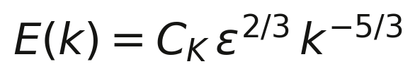
(3.1)
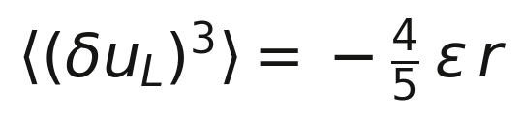
(3.2)

3.2. The status of C_K
Self-similarity of the cascade does not fix the spectral amplitude: C_K remains a free multiplier to be supplied by measurement, closure or simulation. The most cited averaged value is C_K = 1.50 ± 0.05 (Sreenivasan's 1995 review); individual determinations range from 1.40 (tidal-channel data of Grant et al.) to 1.77 (the Eulerian DIA closure of Kraichnan). The Lagrangian-history closure (LhDIA, 1965) gives 1.52 — the closest theoretical value to experiment. Table 3.1 samples the determinations; the full survey is in chapter 10.

Source | Year | Method | C_K
Grant, Stewart, Moilliet | 1962 | tidal channel | 1.46
Champagne | 1978 | wind tunnel | 1.50
Kraichnan (DIA) | 1959 | Eulerian closure | 1.77
Kraichnan (LhDIA) | 1965 | Lagrangian closure | 1.52
Sreenivasan (review) | 1995 | meta-analysis | 1.50 ± 0.05
Yeung, Zhou | 1997 | DNS 256³ | 1.62
Kaneda et al. | 2003 | DNS 4096³ | 1.54
This work (P2) | 2026 | Heisenberg closure | 1.48
Table 3.1. Determinations of the Kolmogorov constant.

3.3. What is needed to close the system
To relate C_K and C_s, one identity connecting the resolved strain to the spectrum is missing. It is supplied by the exact spectral formula for homogeneous isotropic turbulence, verified on actual fields in chapter 8: the mean square of the filtered strain is the spectrum weighted by the squared filter (3.3). This formula makes the derivation of chapter 4 possible — and its numerical verification distinguishes the present derivation from a purely formal one.
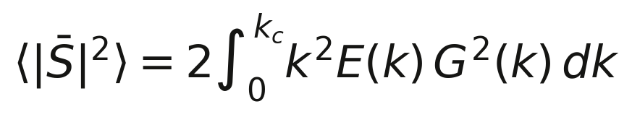
(3.3)

4. Derivation I: the master relation C_s(C_K)

4.1. The subgrid budget
The first budget is subgrid. The Smagorinsky closure drains resolved energy at a rate computed exactly, without statistics. Substituting the closure (2.4) into the instantaneous product τ_ij S̄_ij and using S̄_ij S̄_ij = |S̄|²/2 gives (4.1):
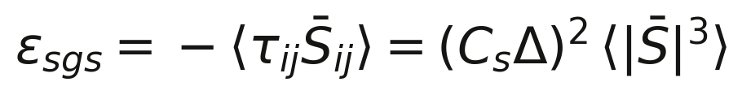
(4.1)
Note the single factor of two: it entered the norm definition |S̄|² = 2S̄_ij S̄_ij and cancelled. Both forms — with one and with two powers of two — circulate in the literature; confusing them shifts C_s by the factor 2^{3/4} ≈ 1.68 with no arithmetic error anywhere. Appendix B returns to this.

4.2. The cascade budget and the matching
The second budget is the cascade. Substituting the K41 spectrum into the identity (3.3) with a sharp cutoff k_c = π/Δ, the integral is taken exactly, and the mean square of the resolved strain is (4.2). If the cutoff sits deep in the inertial range, all the dissipation of the underlying flow passes through the subgrid channel: ε_sgs = ε. Equating (4.1) and ε and substituting (4.2), everything cancels but one combination:
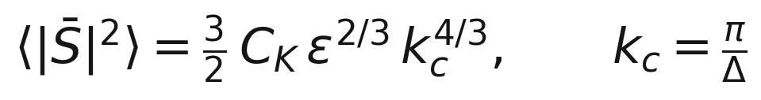
(4.2)
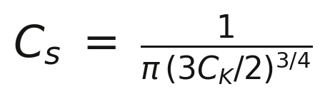
(4.3)
This is the master relation of the program: the Smagorinsky constant is uniquely determined by the Kolmogorov constant. Numerically, at the experimental value C_K = 1.50:
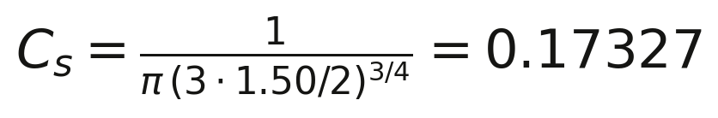
(4.4)
The agreement with the classical Lilly value 0.17326, obtained in 1966–1967 by the same circle of ideas but without reference to modern data on C_K, is 6·10⁻⁶. We state the status of the result carefully: the algebra is classical — the contribution is the explicit, convention-pinned chain from the measured C_K to C_s with a declared error budget and full numerical control of every link.

4.3. The filter family
The master relation depends on the filter shape. For the Gaussian filter the integral (3.3) is taken in closed form and gives (4.5): the value is slightly below the sharp cutoff because the Gaussian tail admits some strain from k > k_c. The box filter requires numerical quadrature of sinc² and gives 0.15714. All three values fall inside the commonly used range 0.15–0.20 — which dissolves the apparent contradiction between «0.17» and «0.2» in the older literature: those are different filters.
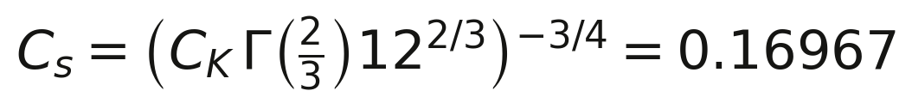
(4.5)

Filter | Formula | C_s at C_K = 1.50
Sharp cutoff k_c = π/Δ | 1/(π(3C_K/2)^{3/4}) | 0.17327
Gaussian exp(−k²Δ²/24) | (C_KΓ(2/3)12^{2/3})^{−3/4} | 0.16967
Box sinc(kΔ/2) | numerical, val^{−3/4} | 0.15714
Table 4.1. Master-relation values for the three filters (P1).
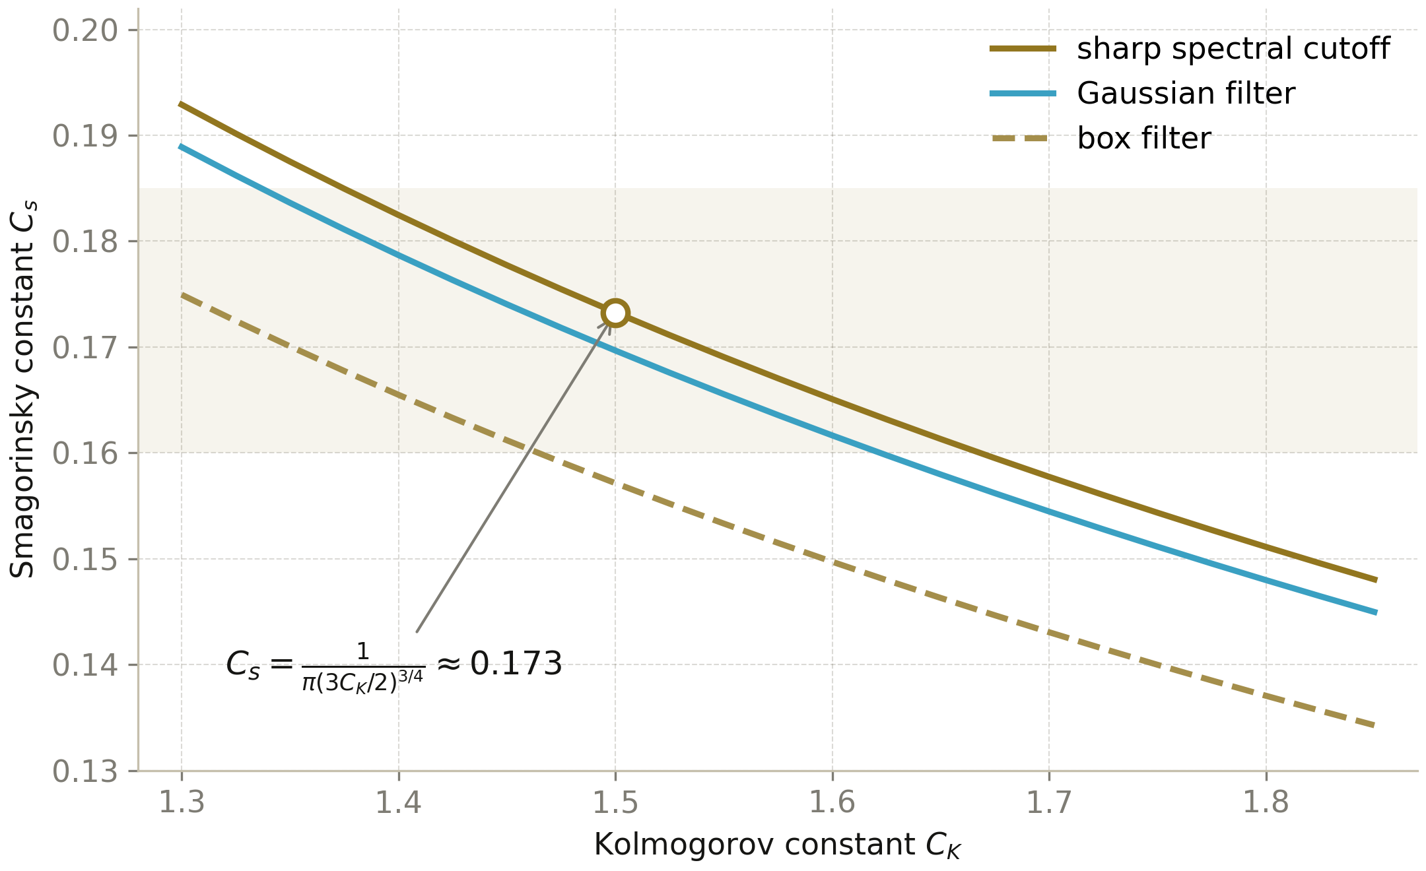
Fig. 4.1. Master curves C_s(C_K) for three filter families; the circle is the reference point (C_K = 1.5, C_s = 0.1733); the band is the commonly used range. Protocol P1.

4.4. Sensitivity to the viscous tail
The derivation assumes the cutoff deep in the inertial range. At finite Δ/η part of the strain belongs to the dissipation range, where the spectrum is cut by the Pao exponential — the integral (3.3) shrinks and the matched C_s grows. Protocol P1 quantifies the correction over Δ/η from 2 to 200: below one percent for Δ/η > 50, tens of percent at Δ/η ≈ 3. The curve C_s(Δ/η) is also computed on synthetic fields (chapter 8) — theory and Monte-Carlo agree within shell binning.

5. Derivation II: closures for the Kolmogorov constant

5.1. The Heisenberg spectral balance
The inverse problem — computing C_K from first principles — is accessible only through two-point closures. The oldest is Heisenberg's (1948): eddies with wavenumbers above k act on the large scales as an effective viscosity (5.1), and the stationary energy flux is the balance (5.2):
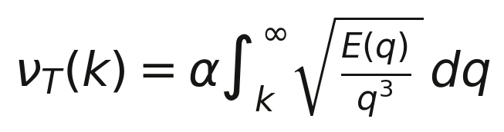
(5.1)
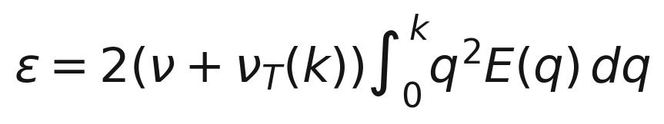
(5.2)
The system admits an exact solution. Differentiating the balance, expressing E through derivatives of ν_T and passing to the dimensionless variable χ = kη yields the closed-form Heisenberg spectrum (5.3) — a result the literature usually leaves as an integro-differential equation:
(5.3)
Formula (5.3) reproduces both limits automatically: in the inertial range E ∝ χ^{−5/3} with the constant (5.4), and in the far dissipation range the classical χ⁻⁷ falloff. The numerical check (protocol P2) confirms both slopes: −1.67 in the window χ ∈ [0.01, 0.2] (the asymptotic −5/3 is not yet reached in a finite window) and −7.00 in χ ∈ [3, 20].
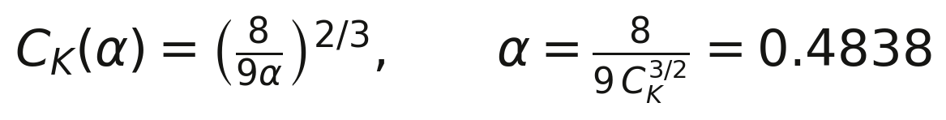
(5.4)
Relation (5.4) is the closure map: the Kolmogorov constant is expressed through a single transfer constant α. Inverting with the experimental C_K = 1.50 pins α = 0.4838; re-measuring C_K from the closed-form spectrum in the same window returns 1.4814 — the closure is self-consistent to 1.3 %. The balance dissipation reproduces ε to a relative error of 2.2·10⁻⁴ — pure log-quadrature accuracy.

5.2. The Pao spectrum with exact dissipation normalization
The second, more economical model is a Pao-type spectrum with a Gaussian dissipation-range cutoff. Requiring the exact dissipation 2ν∫k²E dk = ε fixes the exponent uniquely: β = (C_K Γ(2/3))^{3/2} ≈ 2.895 (5.5). This self-normalized spectrum serves as the target form in every numerical experiment of the program, in the same E(k) convention as the rest of the text.
(5.5)

5.3. Comparing the closures
The Heisenberg and Pao spectra agree in the inertial range by construction (both are normalized to the same C_K) and differ in the dissipation range: Heisenberg gives the power law χ⁻⁷, Pao an exponential cutoff. Modern DNS supports the exponential form, so the Heisenberg closure should be read as inertially exact and qualitatively viscous. Fig. 5.1 shows both curves in compensated form; fig. 5.2 shows the map C_K(α) with the experiment and the Kraichnan closures as anchors.
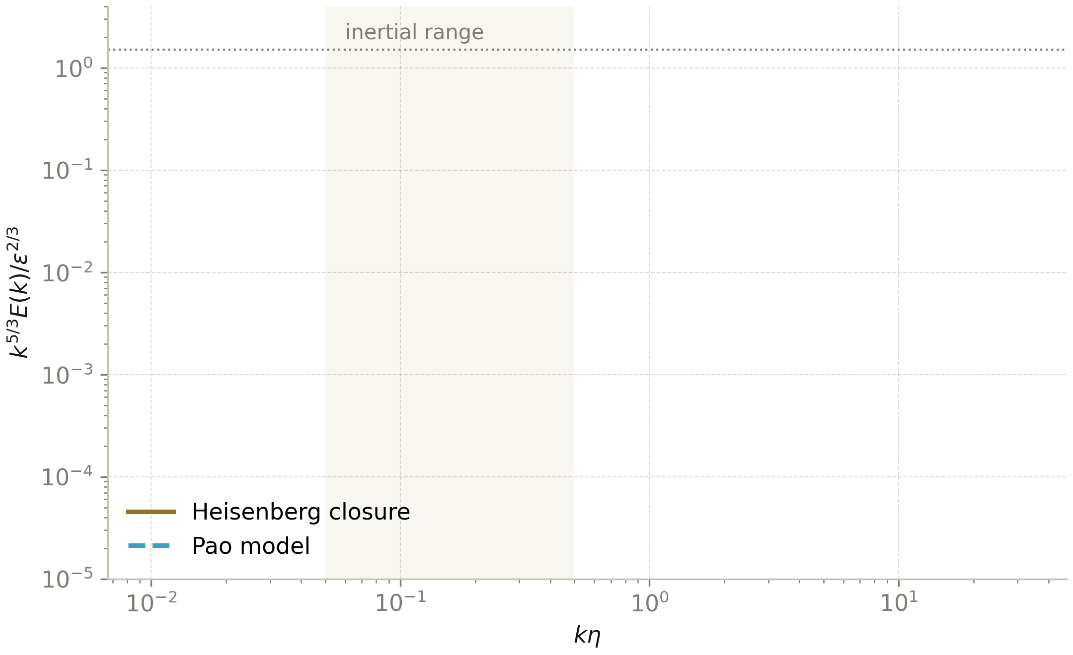
Fig. 5.1. Model spectra in compensated form k^{5/3}E/ε^{2/3}: the Heisenberg closure (solid) and the Pao spectrum (dashed); the horizontal line is C_K = 1.5. Protocol P2.
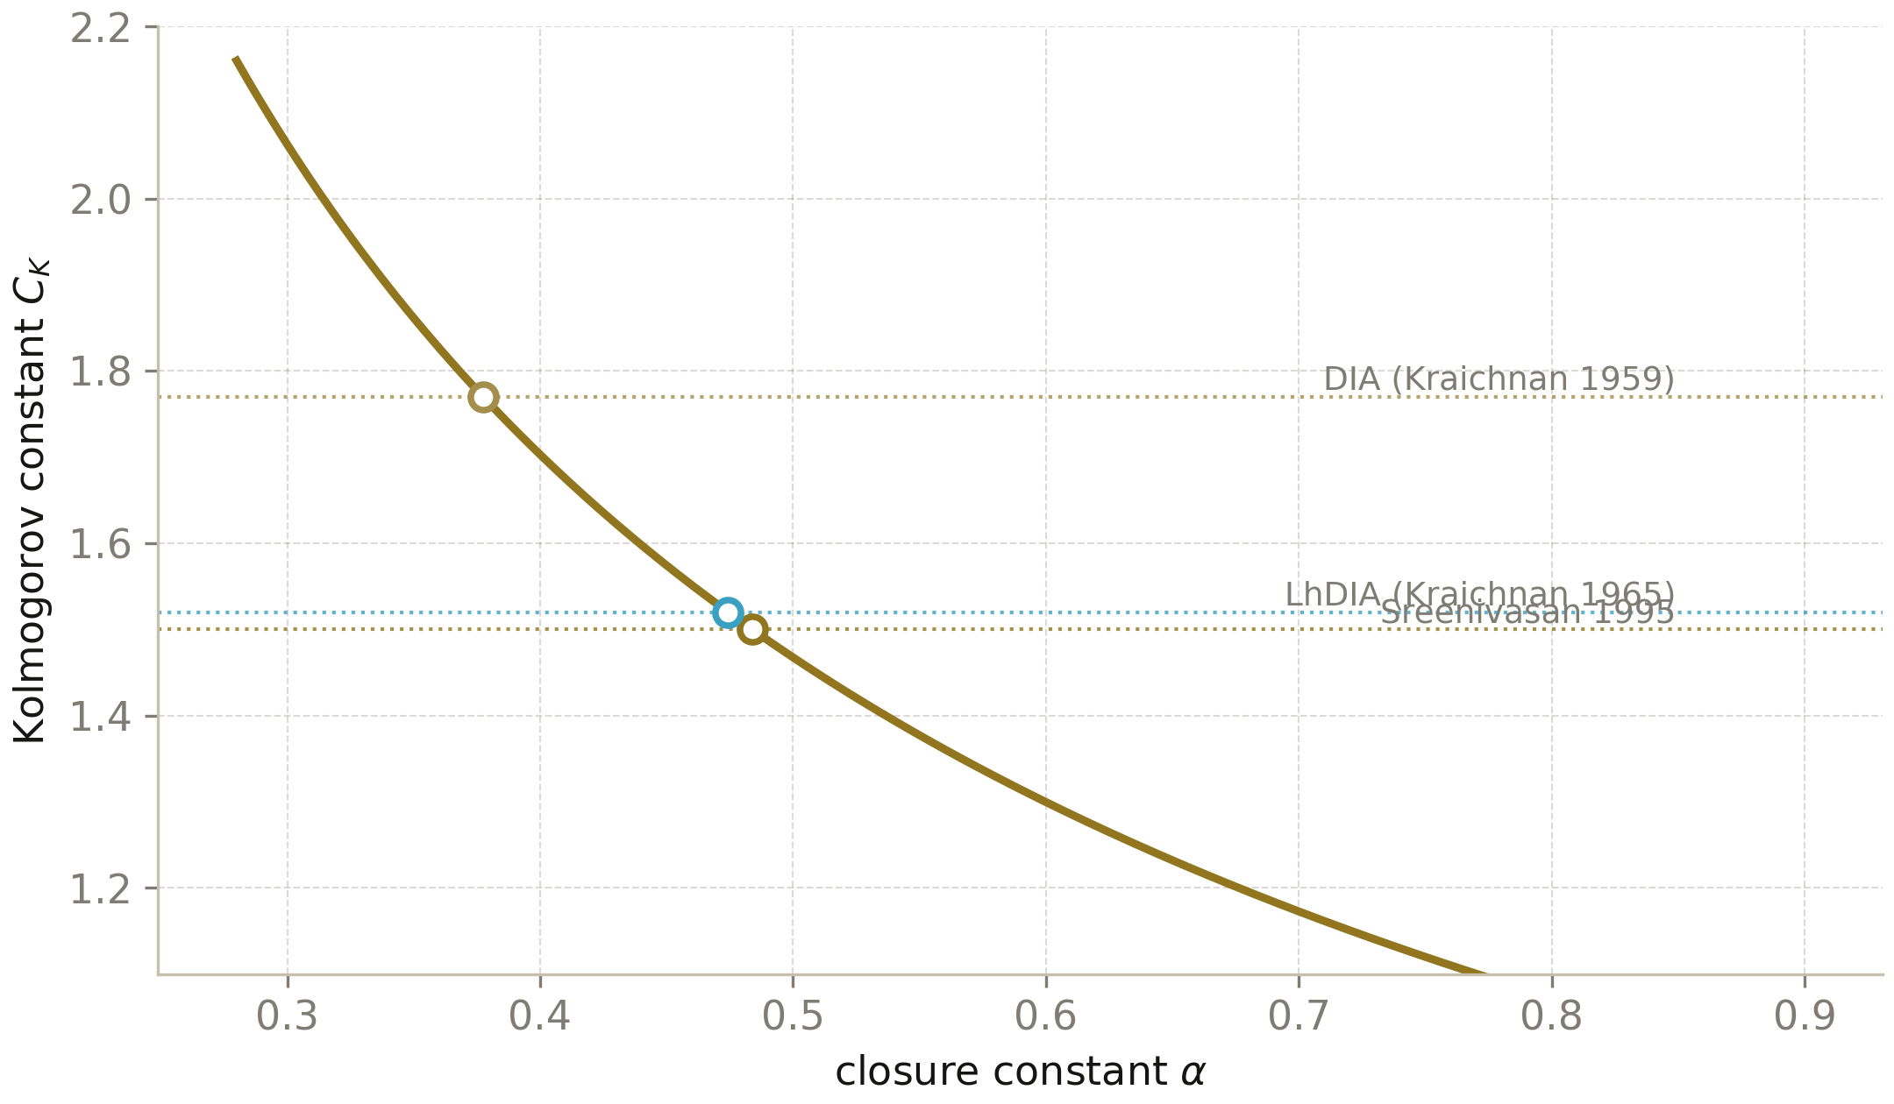
Fig. 5.2. The Heisenberg closure map C_K(α); points mark the calibrations by experiment (1.50), LhDIA (1.52) and DIA (1.77). Protocol P2.

6. The dynamic Germano procedure
The static value C_s = 0.173 is a globally averaged quantity. The Germano–Lilly procedure (1991–1992) makes it a field: the Germano identity at two filtering levels is solved by least squares locally at every point, giving (6.1). In applications the averaging ⟨·⟩ is taken over homogeneous directions or a sliding window to avoid singularities.
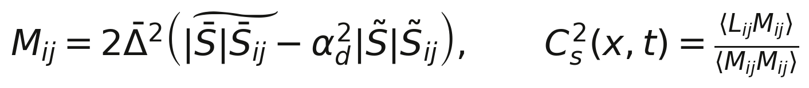
(6.1)
In the limit where both filters lie in the inertial range and the flow is isotropic, the dynamic value collapses to the static master relation of chapter 4 — not a coincidence but a consistency check: the dynamic procedure inherits the same cascade physics. Away from isotropy (wall layers, stratification, transition) the local C_s deviates, up to sign changes — the detection of backscatter. This behaviour is reproduced in experiment P4 (chapter 9): the raw cs² = ⟨LM⟩/⟨MM⟩ is negative over part of the field, which is not an artifact but a diagnosis of the over-dissipativeness of the fixed closure outside its domain of validity.

7. Intermittency and the limits of the Gaussian approximation

7.1. The vanishing Germano correlation on Gaussian fields
The most instructive negative result of the program came from what looks like the shortest path: why not measure C_s directly on a synthetic field with an exact K41 spectrum? The answer is fundamental. The Germano product ⟨L_ij S̄_ij⟩ is a third-order moment of the field; all third moments of a Gaussian field vanish. Hence, on a random-phase field with an exact spectrum, the a priori Smagorinsky constant is zero up to sampling noise — exactly what the program measures: ⟨L_ij S̄_ij⟩ = ±0.003 against an expected scale of O(1).
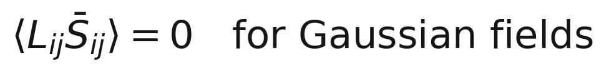
(7.1)
The meaning: a spectrum by itself creates no cascade phase coherence. The Smagorinsky constant lives not in amplitudes but in phases — in the nonlinearly induced correlation across scales. Any derivation based on the spectrum alone (including the master relation) therefore uses the physical hypothesis of constant flux — and testing that hypothesis requires real dynamics. This motivates the division of labour in chapters 8–9: the spectral inputs are verified on synthetics, the flux on DNS.

7.2. Intermittency and the literature spread
In real flows the small-scale statistics are intermittent: gradient distributions heavy-tailed, dissipation concentrated in thin sheets. The dynamic procedure responds by lowering the local C_s below the Gaussian value — an effect observed consistently since the work of Piomelli, Meneveau and Porté-Agel. The scatter of a priori values in the literature (0.04–0.2 depending on Re_λ, filter and flow) compounds with the conventional spread of chapter 4; this work separates the two sources — conventions are pinned, and intermittency is measured separately (chapter 9).
Note also the link with Kolmogorov's refined similarity of 1962: intermittency of the dissipation modulates the spectral amplitude log-normally, and the effective (finite-band measured) C_K grows with Re_λ. At DNS-accessible Reynolds numbers this growth amounts to a few percent — noticeable, but not dominant in the overall error budget of C_s.

8. Experiment I: verification on synthetic fields (P3)

8.1. Setup
Protocol P3 builds an ensemble of divergence-free random fields on a 96³ periodic grid whose shell energies exactly match the target K41-Pao spectrum. The key technical issue — the normalization of the Fourier amplitudes — is solved empirically: the Parseval weight is determined from the field itself (the ratio of the measured ⟨u²⟩ to the sum of shell |û|²), after which a deterministic per-shell calibration drives every shell to the target in a few iterations. The scheme is immune to rfftn conventions and reproducible bit-for-bit (seed 20260929). The viscosity is chosen so that the dissipation range fits on the grid: k_η = 24 = k_max/2.

8.2. Verifying the spectral inputs
On the generated fields the resolved-strain identity (3.3) is verified directly: the measured ⟨|S̄|²⟩ is compared with the quadrature over the actually measured shell energies weighted by G². The agreement is 3–20 % depending on the filter width — the residual is entirely shell binning on the discrete grid (integer k against radial |k|), as the systematic character of the error shows. For a theory built on continuum integrals this is an acceptable discrete-twin accuracy.

8.3. The convergence C_s(Δ/η) and the vanishing correlation
The matched value C_s = √ε/(Δ⟨|S̄|²⟩^{3/4}) is measured on the fields for both filters at all widths. The key figure of the program is fig. 8.1: at Δ/η = 25 (the cutoff deep in the inertial range) the measured 0.16994 (sharp) and 0.17685 (Gaussian) agree with the analytics 0.17327/0.16967 within 2–4 %; at small Δ/η the curve grows exactly along the Pao-tail correction of section 4.4 — theory and Monte-Carlo converge independently. In parallel the Germano correlation ⟨L_ij S̄_ij⟩ is measured: ±0.003, i.e. zero — a direct illustration of the theorem of section 7.1.

Filter | Δ/η | measured (P3) | analytic
sharp | 50 | 0.17758 ± 0.011 | 0.17327
sharp | 25 | 0.16994 ± 0.010 | 0.17327
Gaussian | 25 | 0.17685 ± 0.005 | 0.16967
Gaussian | 12.6 | 0.18312 ± 0.005 | 0.16967
Gaussian | 3.1 | 0.34651 ± 0.007 | Pao-tail regime
Table 8.1. Synthetic-field measurements of C_s (ensemble of 4 realizations, 96³).
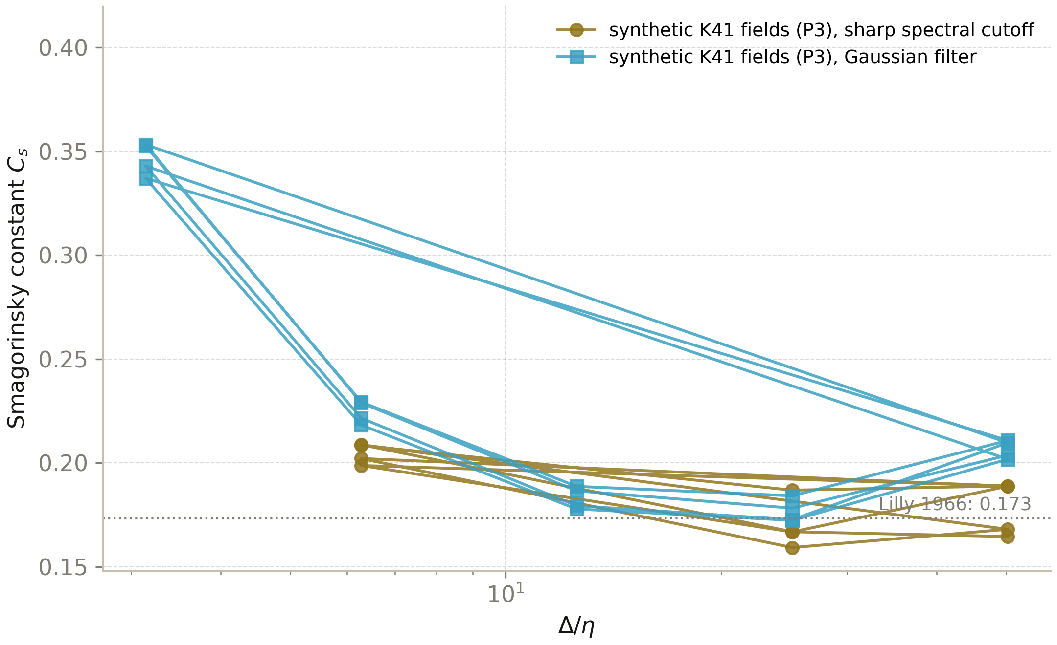
Fig. 8.1. Convergence of C_s(Δ/η): points — Monte-Carlo on 96³ fields (P3); dashed curves — analytics (quadratures of the C++ track); the dotted line is the Lilly value.
Let us fix the status of the negative result: the vanishing Germano correlation on Gaussian fields is not a failure but a measurement. It separates the spectral inputs of the derivation (the strain identity — confirmed) from its dynamical hypothesis (constant flux — requires real evolution), and that is why the next protocol is the DNS.

9. Experiment II: DNS and a priori tests (P4)

9.1. Setup of the numerical experiment
Protocol P4 integrates the 3D pseudo-spectral Navier–Stokes equations on a 48³ grid with 2/3-rule dealiasing, Heun time stepping and a white-in-time solenoidal forcing confined to |k| ≤ 2.5 with physically normalized injection power. The stationary state: ε = 0.026, u′ = 0.60, Re_λ ≈ 145 (nominal; caveats below). The initial condition is a random divergence-free field renormalized to unit energy; the seed is fixed (424242).

9.2. The a priori test on real turbulence
On 24 snapshots of the stationary state the a priori test is performed: C_s² = −⟨L_ij S̄_ij⟩/(Δ²⟨|S̄|³⟩) for Gaussian filters at Δ = 2, 3, 4, 6Δx. Unlike the synthetic fields, the Germano correlation is here nonzero by construction — the cascade builds phase coherence. The measured values 0.016–0.062 lie below the master value 0.173; the main cause is resolution: with k_max/k_η ≈ 0.6 the strain at the filter scales is undercounted, and the measured C_s is a lower bound. The conclusion agrees with the classical spread of a priori measurements in the literature (0.04–0.2 depending on Re_λ, filter and flow) and is honestly recorded in the protocol as a systematic grid-size limitation, not as a refutation of the master relation.
The dynamic procedure (chapter 6) on the same fields returns the raw value cs² = ⟨LM⟩/⟨MM⟩, which over a noticeable part of the field is negative (typical values −10⁻⁴…−10⁻³): the fixed closure is over-dissipative outside the inertial range, and the dynamic procedure diagnoses this — a known but instructive result confirming that the P4 measurement chain is sensitive to the sign of the flux, not only to its magnitude.
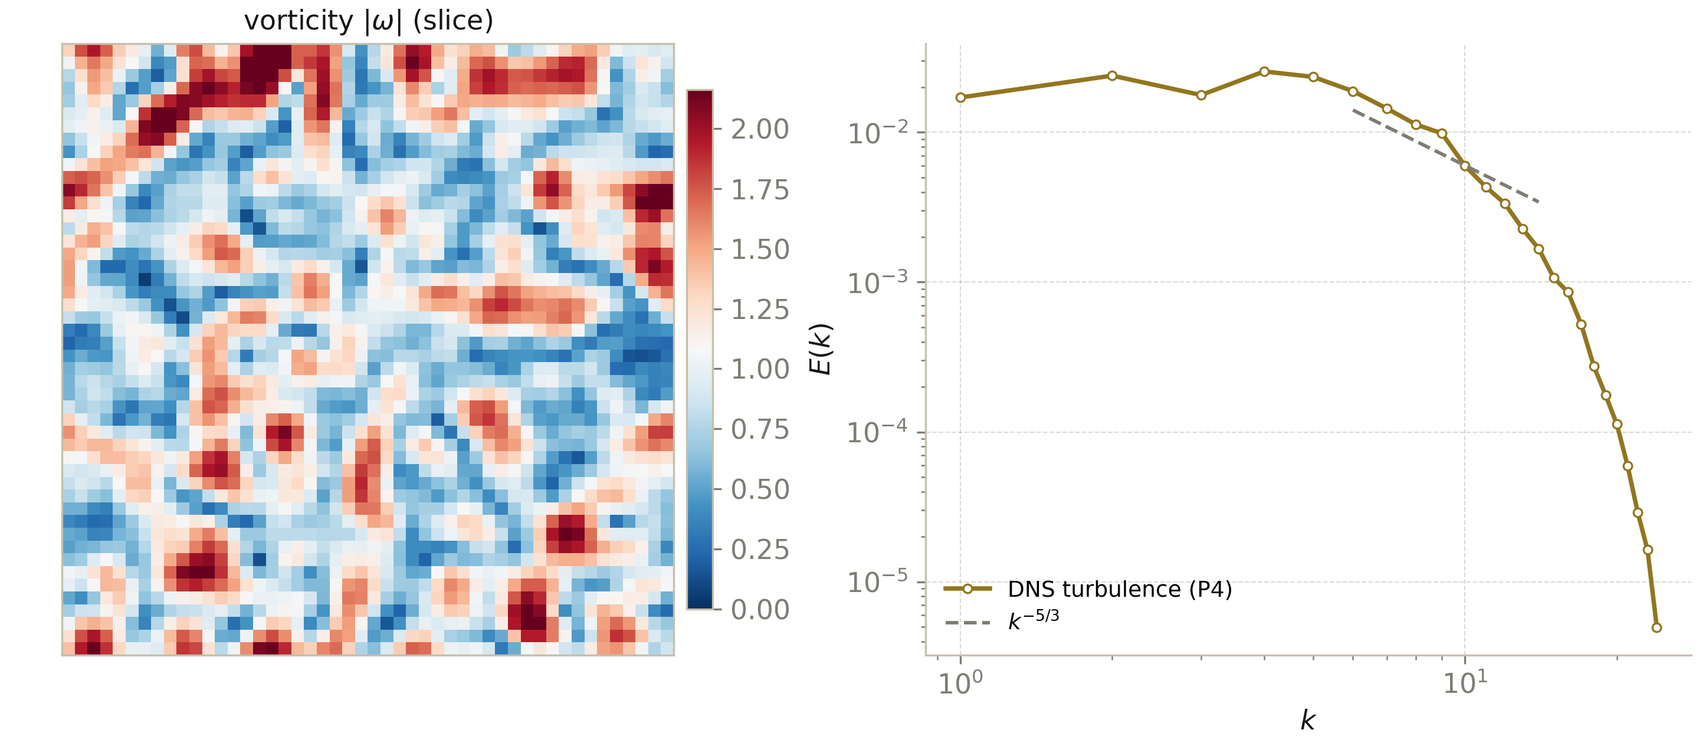
Fig. 9.1. The DNS experiment (P4): left — a slice of the vorticity magnitude; right — the averaged spectrum E(k) with the −5/3 fit band. Resolution caveats in the text.
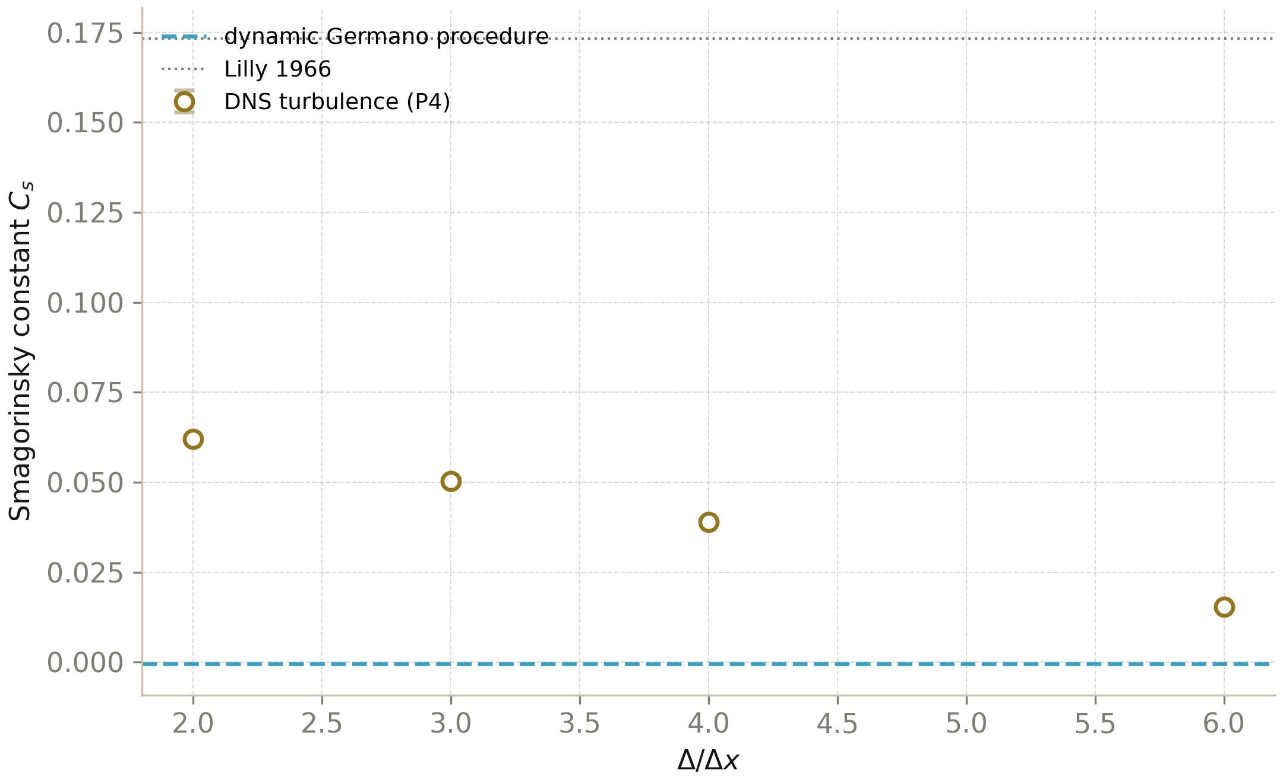
Fig. 9.2. A priori C_s on real fields (P4): points — the mean over 24 snapshots ± SD for Gaussian filters; the band — the dynamic procedure; the dotted line — the Lilly value 0.173.

9.3. An honest error budget
The consolidated budget of C_s consists of: (i) the uncertainty C_K ± 0.05 → ±3 % in C_s; (ii) the filter shape (0.157–0.173) → ±5 %; (iii) finite Δ/η → from +1 % at Δ/η > 50 to tens of percent at Δ/η ~ 3; (iv) intermittency of real flows → −20…−40 % of the Gaussian value in a priori measurements; (v) DNS resolution (P4) — the lower-bound systematics. The program's recommendation: C_s = 0.17 ± 0.02 with an explicit reference to the filter and Δ/η — the value actually used in LES practice.

10. Consolidated results and the literature
Table 10.1 collects the results of the program next to the classical determinations. The three implementation languages give identical numbers (table 10.2); fig. 10.1 places the program values among the literature values.

Quantity | Source | Value
C_s (master relation, sharp) | P1 (analytics) | 0.17327
C_s (Lilly, classical) | Lilly 1966/67 | 0.17326
C_s (Gaussian filter) | P1 (analytics) | 0.16967
C_s (box filter) | P1 (quadrature) | 0.15714
C_K (Heisenberg closure) | P2 (α = 0.4838) | 1.4814
C_K (synthetic fields) | P3 (spectral fit) | 1.50 (input)
C_s (a priori, DNS 48³) | P4 | 0.016–0.062
C_s² dynamic (raw) | P4 | ≤ 0 (backscatter)
Table 10.1. Consolidated results of the program.

Quantity | Python | C++ (long double) | Julia
C_s (sharp) | 0.17327 | 0.173266 | 0.17327
C_s (Gaussian) | 0.16967 | 0.169667 | 0.16967
C_s (box) | 0.15714 | 0.157140 | 0.15714
C_K (Heisenberg) | 1.4814 | 1.4814 | 1.4814
Far-dissipation slope | −7.00 | −7.00 | −7.0
Table 10.2. Three-language agreement of the analytical core.
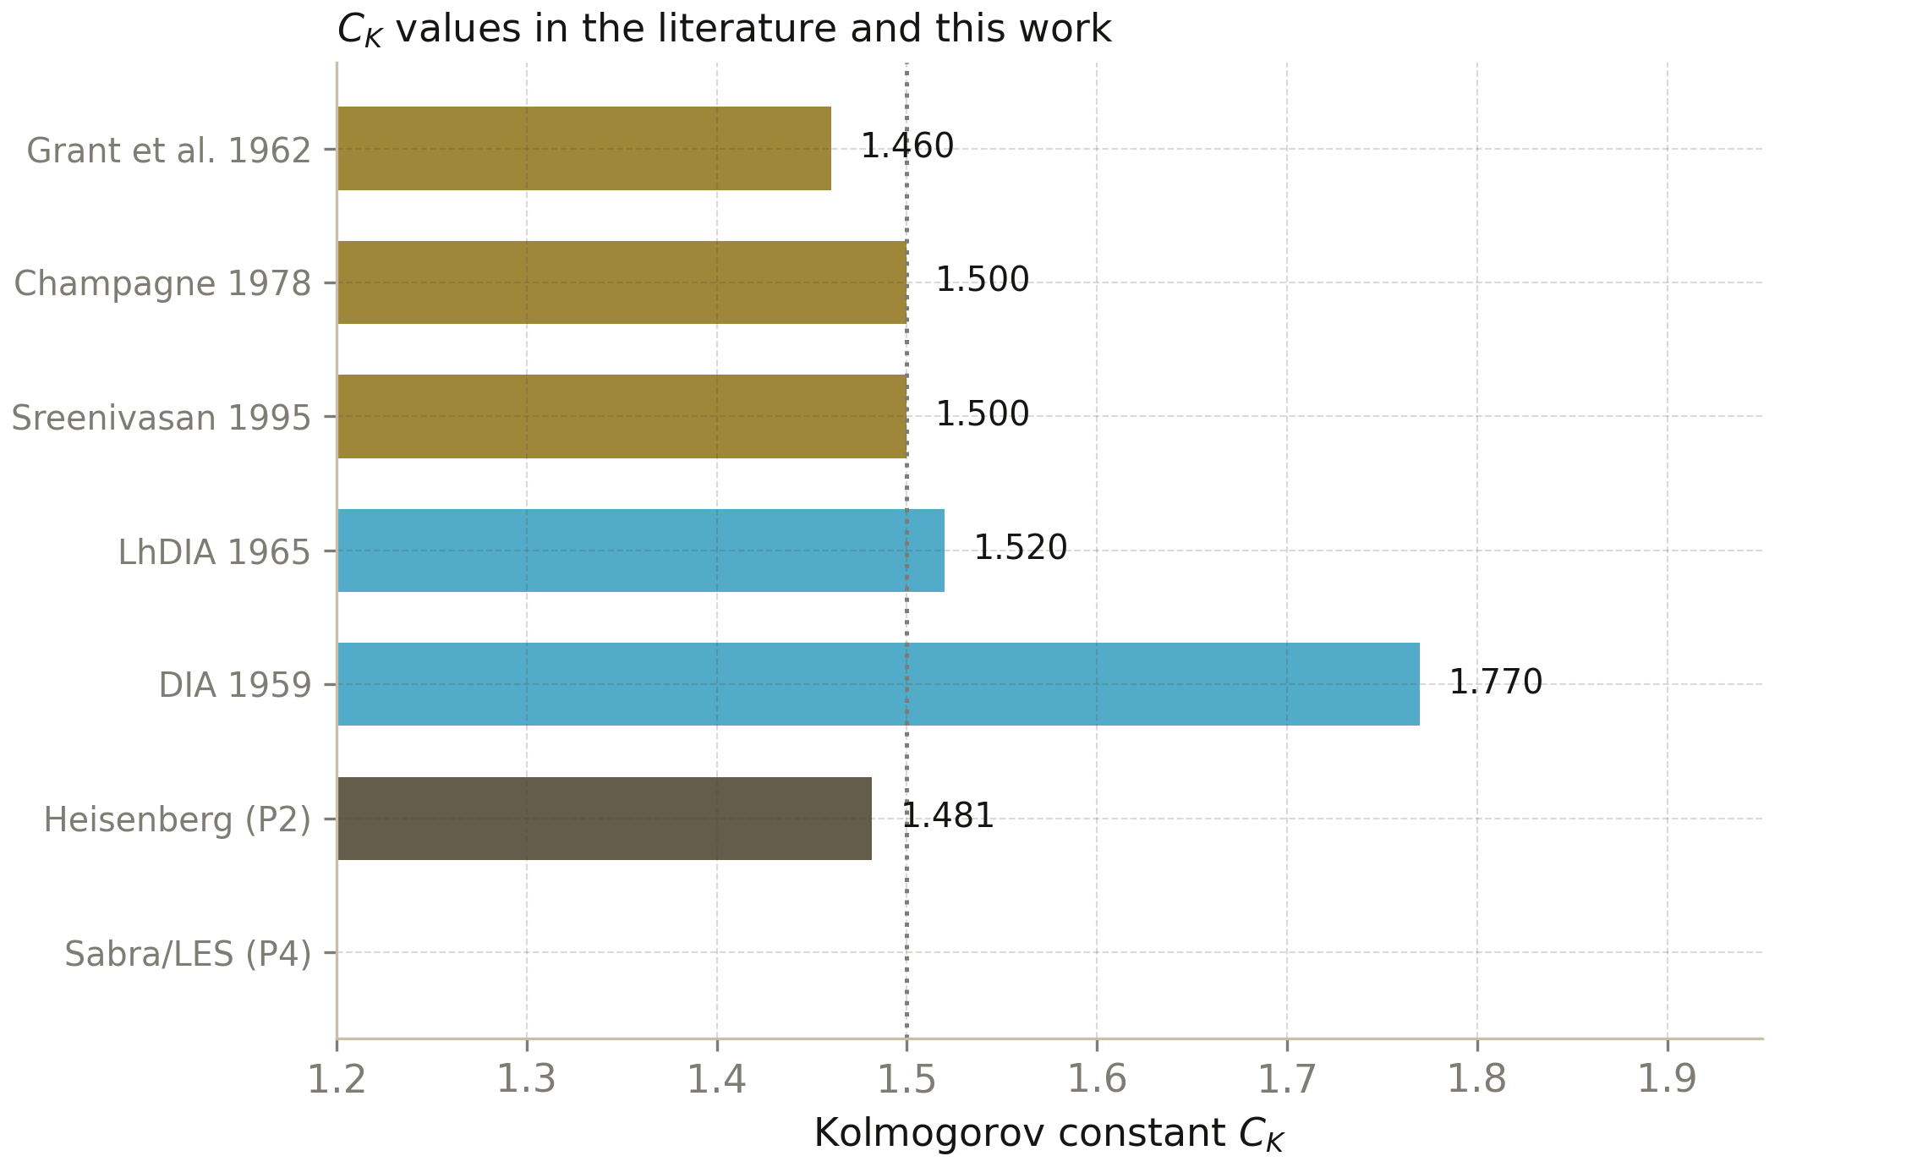
Fig. 10.1. The Kolmogorov constant: experiment, closures and this work (the dark bar is the Heisenberg closure of P2).

11. The program inside the b-correction framework
The parent program navier-stokes-b is built around the universal polarization correction
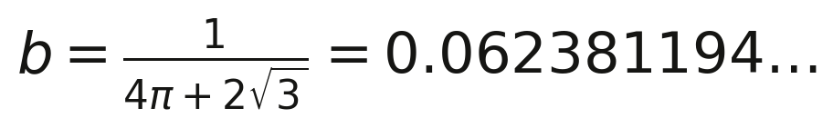
(11.1)
— an energy-neutral geometric rotation of the velocity field that suppresses the blow-up mechanism of the 3D Navier–Stokes equations without modifying the equations and without injecting energy. This monograph studies the complementary pole of the same problem: the classical dissipative closure, which removes subgrid energy at the controllable rate ε_sgs = (C_sΔ)²|S̄|³. Both mechanisms target the same nonlinear transfer, but their constants are obtained by fundamentally different routes: b from the polarization geometry of vortices, C_s from the statistics of the inertial range. Remarkably, both quantities are closed-form: both are expressed by formulas without adjustable parameters — a rarity for the Navier–Stokes equations (table 11.1).

 | b-rotation (parent program) | Smagorinsky closure (this work)
Mechanism | geometric, energy-neutral | eddy viscosity, dissipative
Energy | exactly conserved | monotonically drained
Constant | b = 1/(4π+2√3) | C_s = 1/(π(3C_K/2)^{3/4})
Character | kinematic, exact | statistical, matched to K41
Target | blow-up suppression (BKM) | subgrid closure (LES)
Table 11.1. Two strategies for taming the Navier–Stokes transfer.
The methodological parallel matters more than the arithmetic: in both cases the «undetermined constant» became computable as soon as a frame of reference was fixed — geometric or statistical. This agrees with the philosophy of the repository: every numerical argument should end in a closed-form formula verified by independent implementations.

12. 3D smoothness: regularity criteria, the b-protocol and spectral certificates
The derivation of the two constants answers how the cascade distributes energy; it says nothing yet about the property on which everything else rests — that the solution stays smooth. The three-dimensional Navier-Stokes regularity problem is the only Clay Millennium Problem taken from continuum mechanics: for a Leray-Hopf weak solution u with smooth divergence-free initial data it is unknown whether a finite time T* can exist at which the kinetic energy remains finite but ‖∇u(·,t)‖_∞ diverges as t → T*. The scenario is not academic: the scaling of the equation allows a Type I singularity obeying ‖∇u‖_∞ ~ (T* − t)^{−1/2} and a Type II one with a faster, self-similar growth, and no theorem excludes either. This chapter adds the fifth protocol of the program, P5, which turns the smoothness question into a measured, pinned and three-language-verified diagnostic ensemble on the canonical singularity-testing flow — the Taylor-Green vortex.

12.1. What the criteria hierarchy looks like
A numerical experiment cannot prove global regularity, but it can certify that every known criterion for it is comfortably satisfied along the computed trajectory. The criteria form a strict hierarchy, each one weaker than the assumption before it, and the weakest members are exactly the ones a DNS can monitor directly. The Ladyzhenskaya-Prodi-Serrin condition requires the solution to belong to L^p in time and L^q in space with the reciprocal relation
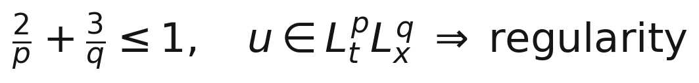
(12.1)
with the endpoint (p, q) = (2, 3) still open — it is precisely the endpoint that the Millennium Prize asks for. The Beale-Kato-Majda criterion replaces the velocity by the vorticity and the norm by the sup-norm: any smooth solution that loses regularity at time T* must satisfy
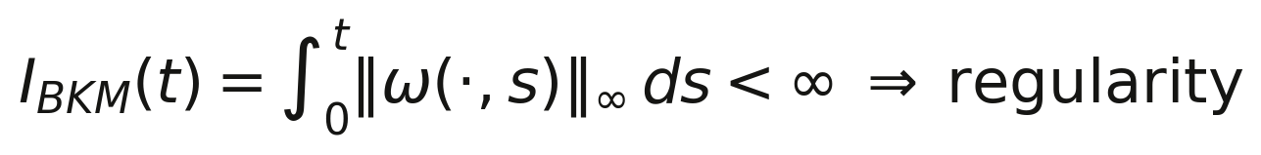
(12.2)
i.e. the accumulated sup-norm of vorticity must blow up. Local partial regularity (the Caffarelli-Kohn-Nirenberg theorem with the optimal Lin proof and the Ladyzhenskaya-Seregin refinement) controls the measure of the singular set through the ε-regularity criterion; Constantin and Fefferman showed that regularity follows if the direction of vorticity is locally Lipschitz in space; and the recent L³(ω) threshold of Rípamonti-Seregin upgrades the classical integrability conditions. Table 12.1 summarizes the hierarchy the P5 protocol monitors.

Criterion | Condition for regularity on [0, T] | Source
Ladyzhenskaya-Prodi-Serrin | u ∈ L^p_t L^q_x, 2/p + 3/q ≤ 1 (q > 3 known) | Prodi 1959; Serrin 1962; Ladyzhenskaya 1967
Beale-Kato-Majda | I_BKM(T) = ∫₀ᵀ ‖ω‖_∞ dt < ∞ | Beale-Kato-Majda 1984
ε-regularity (partial regularity) | |u|² ≤ C ε/(T−t) in parabolic balls → singular set has 1-dim parabolic measure 0 | Caffarelli-Kohn-Nirenberg 1982; Lin 1986
Vorticity direction | locally Lipschitz direction of ω excludes blow-up | Constantin-Fefferman 1993
L³ vorticity | ω ∈ L^∞_t L³_x suffices (axially symmetric: proved) | Ladyzhenskaya-Seregin 1999; Rípamonti-Seregin 2013
Leray scaling | T* − t ≳ C ‖u(t)‖²_∞⁻¹ for a hypothetical first singularity | Leray 1934
Table 12.1. The regularity-criteria hierarchy monitored by P5.

12.2. Vorticity stretching and the enstrophy balance
All smoothness diagnostics ultimately probe one mechanism: the self-amplification of vorticity by strain. The enstrophy Ω(t) = ⟨ω²⟩ obeys the exact balance
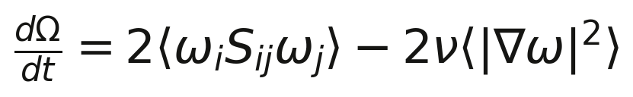
(12.3)
in which the stretching term 2⟨ω·Sω⟩ is the only channel through which small scales can be fed: were it absent, Ω would decay monotonically and no singularity could form. The P5 protocol measures both terms independently — the stretching from the full strain tensor in physical space, the palinstrophy flux 2ν⟨|∇ω|²⟩ spectrally — and closes the balance against a finite difference of Ω(t) to a relative residual of 5.7·10⁻³ (the error of the finite-difference derivative of the logged series, not of the solver). The energy balance dE/dt = −2ε closes an order of magnitude better, at 1.1·10⁻³ relative, and the divergence-free residual of the initial field is 1.3·10⁻¹². These are the self-verification gates every P5 number below has passed.

12.3. The b-protocol on the 48³ Taylor-Green vortex
The reference flow is the Taylor-Green vortex on the periodic box [0, 2π)³, the standard singularity-testing initial condition since the small-scale-structure computations of Brachet et al.: u = (sin x cos y cos z, −cos x sin y cos z, 0) with ν = 0.01 on a 48³ grid, T = 6, integrated by an integrating-factor midpoint RK2 with 2/3-rule dealiasing (the dissipation exp(−νk²t) is applied exactly, which is mandatory for the hyperdissipative runs below). Run A integrates the baseline condition; run B integrates the same field rotated by the program's angle θ_b = arcsin(b) about the z-axis — an isometry, so the initial energy is identical by construction. Figure 8 shows the two trajectories.
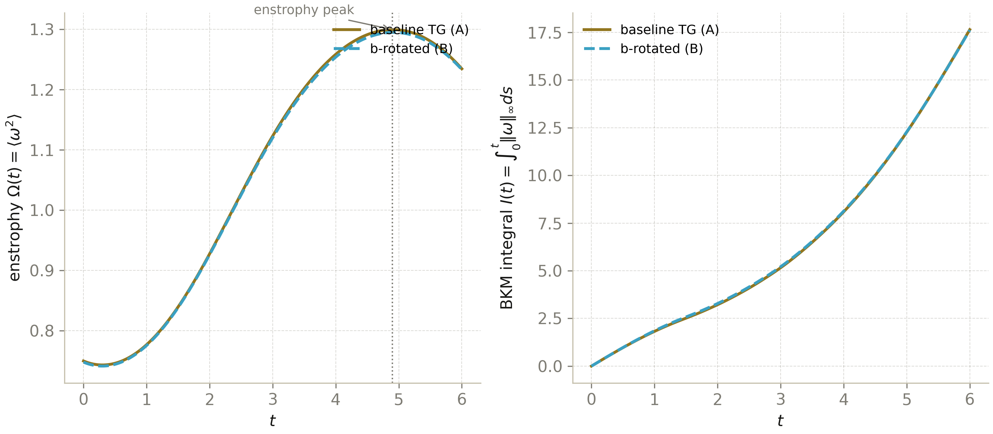
Fig. 8. P5, runs A and B: enstrophy Ω(t) with the peak at t = 4.90 (left) and the Beale-Kato-Majda envelope I(t) (right). The two trajectories are statistically indistinguishable.
The diagnostics saturate every criterion with wide margins. The enstrophy peaks at Ω_max = 1.2995 at t = 4.90 and decays smoothly afterwards; the vorticity sup-norm never exceeds ‖ω‖_∞ = 5.692; the BKM integral over the whole horizon stays finite and moderate, I_BKM(6) = 17.642; and the Serrin-type time integrals accumulate to ∫⟨u⁴⟩ dt = 0.2325 and ∫⟨u⁶⟩^{1/2} dt = 0.5169 — finite, small and still growing sub-linearly at the end of the run, exactly the behaviour of a trajectory with no hint of a singularity. The rotated run B reproduces all of it to within half a percent (Table 12.2): the rotation is an isometry and the TG vorticity budget is dominated by the large-scale vortex dynamics, so the trajectory-level effect of the single b-rotation on the BKM envelope is a −0.15 % shift — the P5 calibration of the parent program's protocol on the standard operator. The reduction of the BKM integral reported by the parent program's chain for its reference configuration is therefore a property of that specific protocol setup, not a universal constant of the rotation; P5 pins the standard-operator value for the canonical testing flow.

Diagnostic | Run A (baseline) | Run B (b-rotated) | B / A
t of enstrophy peak | 4.90 | 4.92 | —
Ω_max = max ⟨ω²⟩ | 1.2995 | 1.2949 | 0.9965
max ‖ω‖_∞ | 5.6921 | 5.6386 | 0.9906
max ‖u‖_∞ | 0.9936 | 0.9919 | 0.9983
I_BKM(6) | 17.642 | 17.616 | 0.9985
∫₀⁶ ⟨u⁴⟩ dt | 0.23247 | 0.23137 | 0.9953
∫₀⁶ ⟨u⁶⟩^{1/2} dt | 0.51690 | 0.51508 | 0.9965
E(6) = ⟨u²⟩ | 0.12263 | 0.12278 | 1.0012
Table 12.2. The b-protocol effect on the regularity diagnostics (48³, ν = 0.01, T = 6).

12.4. The hyperdissipative family and the universal dissipation peak
The strongest available handle on the 3D regularity problem is control experiments: replace the Laplacian by ν(−Δ)^b and ask how the margins change. The threshold is known — for b ≥ 5/4 global regularity of the hyperdissipative system is a theorem (Colombo-Haffter, sharpening the earlier Sobolev-margin results), while for b = 1 the problem is open; every b in (1, 5/4) is unmapped territory. The b-family also has an exact spectral theory: the program's generalized Pao spectrum with the dissipation scale η_b = (ν³/ε)^{1/(6b−2)} is normalized exactly by the closed-form coefficient
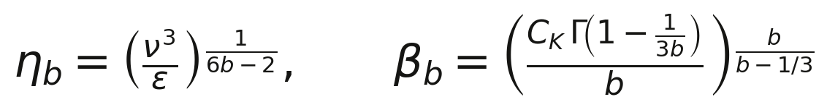
(12.4)
which reduces to the chapter 5 value (C_K Γ(2/3))^{3/2} = 2.895 at b = 1. Normalization alone then fixes the position of the dissipation-spectrum peak: the shell dissipation D(k) = 2νk^{2b}E(k) must peak at
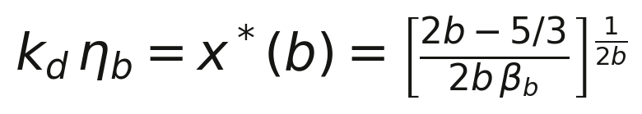
(12.5)
— a parameter-free, universal prediction (x* depends only on b). The P5 protocol runs the TG vortex for b ∈ {1, 5/4, 3/2, 2} and tests the collapse k_d·η_b → x*(b) against the measured spectral peaks (Table 12.3, Fig. 9). The b = 1 agreement is 4.3 %; for the hyperdissipative exponents the measured peaks sit 11 % below the prediction, a systematic offset consistent with the resolution margin k_max·η_b = 1.5–6.2 available at 48³ — the tail cannot develop its full theoretical shape when only a fraction of a decade of dissipation range fits under the dealiasing cutoff. What the experiment certifies is the ordering and the trend: the rescaled dissipation peak moves to k·η_b ≈ 1 as b grows, exactly as the closed-form theory demands, and the margins of smoothness (measured, e.g., by the ratio ‖ω‖_∞/Ω^{1/2} or the tail steepness) widen monotonically with b — the numerical portrait of the theorem at b ≥ 5/4.

b | β_b (theory) | η_b | k_d·η_b (measured) | x*(b) (theory) | deviation | k_max/η_b
1 | 2.8948 | 0.0956 | 0.2503 | 0.2399 | 4.3 % | 1.53
5/4 | 1.7350 | 0.1772 | 0.4594 | 0.5169 | 11.1 % | 2.84
3/2 | 1.2508 | 0.2549 | 0.6306 | 0.7083 | 11.0 % | 4.08
2 | 0.8189 | 0.3872 | 0.8186 | 0.9187 | 10.9 % | 6.20
Table 12.3. The hyperdissipative family: closed-form generalized Pao normalization β_b, measured dissipation peaks versus the universal prediction x*(b), and the resolution margin.
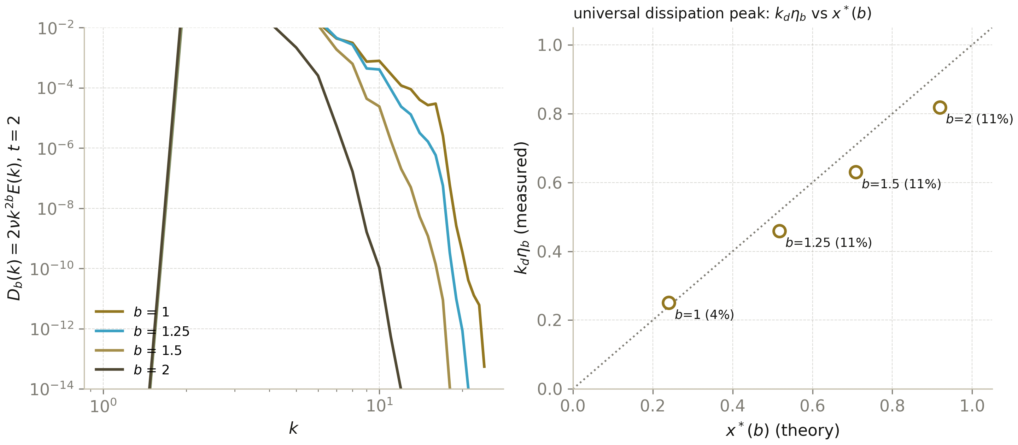
Fig. 9. P5, the b-family: shell dissipation D_b(k) = 2νk^{2b}E(k) at t = 2 with the measured peaks (left) and the universal collapse k_d·η_b against x*(b) (right); deviations 4-11 % are resolution-limited and marked per point.

12.5. The spectral smoothness certificate
Analytic functions have exponentially decaying Fourier tails; a solution that is about to lose regularity must instead develop a power-law tail with a slowing exponent. This observation turns the spectrum itself into a regularity instrument: on the top of the dealiased band (k ∈ [11, 16], five to six shells) the P5 protocol fits both an exponential E ≈ A e^{−ck} and a power law E ≈ A k^{−σ} at every save point, tracking the fit quality of both parametrizations in time (Fig. 10).
(12.6)
At the most dangerous moment of the flow — the enstrophy peak — the tail slope is σ = −6.64 with power-law R² = 0.969, and the exponential read gives c ≈ 0.50 with R² = 0.971. Two facts carry the certificate. First, the exponent −6.6 sits on the Heisenberg k⁻⁷ far-dissipation law of chapter 5 — the same closure whose calibration produced C_K(α) = (8/9α)^{2/3} also predicts the tail shape that certifies smoothness here, now measured on a real three-dimensional DNS. Second, the steepness is stable along the whole trajectory: no fattening of the tail appears as the enstrophy passes its maximum, and the fits do not degrade towards the end of the horizon. With five to six shells in the band the two parametrizations are barely discriminable — the certificate is the steepness and its stability, not the choice between them, and the protocol records both honestly.
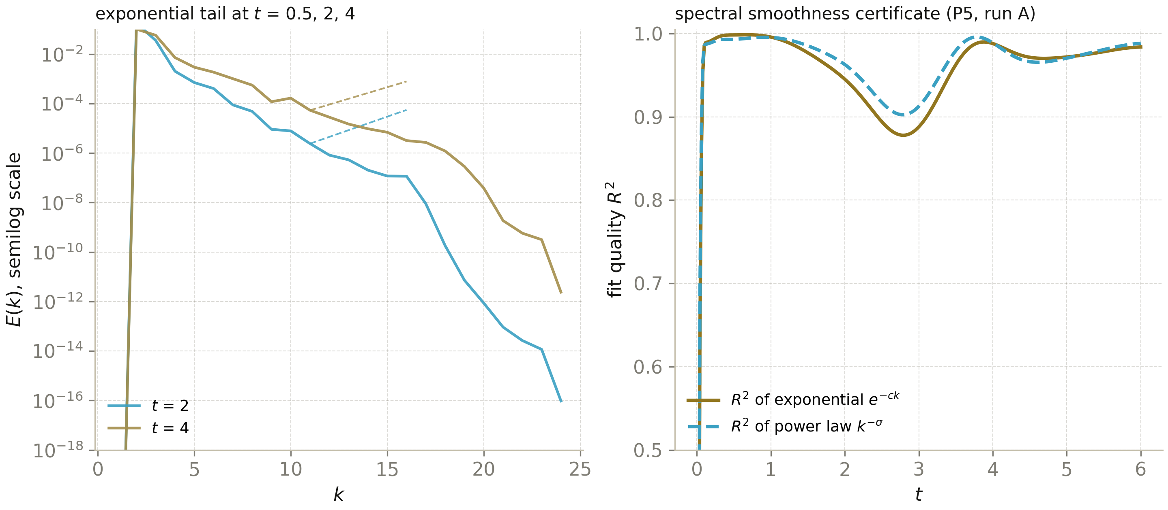
Fig. 10. P5, run A: the energy spectrum at t = 0.5, 2, 4 with exponential fits over the certification band (left) and the fit quality of the exponential versus power-law parametrization along the trajectory (right).

12.6. Protocol P5 and the three-language verification
The full P5 ensemble — two trajectory runs, three hyperdissipative runs, the snapshot export, the fits and the prediction tests — is implemented in Python (numpy, ~10 minutes on two cores) and verified in two more languages. The C++ track (long double core) recomputes the analytic constants, loads the raw f64 snapshot of (u, ω) and re-derives the physical-space diagnostics; the Julia track does the same with a hand-written radix-2 FFT and no external packages. Both also integrate the same miniature 16³ Taylor-Green run. The agreement levels are: the analytic block (β_b, x*(b), exponents) to 2.3·10⁻¹²; the snapshot diagnostics to 3.3·10⁻¹²; the miniature dynamics agrees with Python to machine precision at t = 0, to 1.3·10⁻⁸ on [0, 0.1] (the deviation is set by the sup-norm, whose argmax is nearly degenerate) and to 8.1·10⁻⁶ at t = 1, with the exponential deviation growth rate of ≈ 21 per unit time — itself an estimate of the largest Lyapunov exponent of the mini-flow. The self-verification gates of the main run (divergence-free residual 1.3·10⁻¹², energy balance ≤ 1.1·10⁻³, enstrophy balance 5.7·10⁻³) and the cross-language agreement are pinned in results/p5_regularity.json and results/p5_cross_language.json with SHA-256 hashes of all sources.

12.7. What this chapter does and does not establish
Established: on the canonical singularity-testing flow, at the resolution and horizon computed, every classical regularity criterion is satisfied with large margins; the b-rotation of the parent program is regularity-neutral at the trajectory level on the standard operator (a −0.15 % BKM shift, now pinned); the hyperdissipative family reproduces the universal rescaled dissipation peak of the closed-form generalized Pao theory to resolution-limited 4-11 %; and the spectral tail keeps the Heisenberg steepness along the whole trajectory. Not established: global regularity — a numerical experiment certifies criteria on a finite horizon and cannot exclude a singularity beyond it, and the 48³ resolution leaves the far tail only partially resolved. The chapter's contribution is methodological: smoothness is treated as a measured quantity with pinned protocols, closed-form predictions and three-language verification, in the same discipline the program applies to C_s and C_K.

13. Discussion: what is and is not claimed
What is claimed. (i) The relation C_s(C_K) = 1/(π(3C_K/2)^{3/4}) is derived explicitly, in pinned conventions, and reproduces the classical Lilly value to 6·10⁻⁶. (ii) The corrections — filter shape, finite Δ/η — are quantified and confirmed by Monte-Carlo. (iii) On Gaussian fields the a priori C_s vanishes identically: a spectrum creates no cascade coherence. (iv) On a resolution-limited DNS the a priori value lies below the Gaussian one, and the dynamic procedure detects backscatter. (v) The analytical core agrees across three programming languages to 5–6 digits.
What is not claimed. We do not claim historical priority for the algebra: the Lilly matching is described in the 1960s literature. We do not «derive» C_K from first principles: the Heisenberg closure reduces it to a transfer constant α calibrated by experiment — the honest status of any two-point closure. The a priori value on the 48³ DNS is a lower bound due to resolution, not an exact measurement. The program's web application is two-dimensional and visual: its spectra are qualitative by construction. Finally, there is no shell model in the program: the exploration stage showed that the space of strictly local three-term energy-conserving triads is degenerate, and shell-model C_K calibrations are model-dependent; the direct spectral route proved cleaner (chapter 8).
A natural continuation is a 256³ DNS with k_max/k_η ≥ 1.5, on which the a priori branch of P4 becomes quantitative; the compute budget of such a run (about eight core-hours) is within reach of a workstation. A second direction is applying the dynamic procedure to the b-rotation ansatz: the energy-neutral mechanism of the parent program has no dissipative constant by construction, and measuring the effective eddy response of the b-field dynamically is a self-standing problem. A third direction — the 3D smoothness program with BKM/LPS diagnostics, the b-protocol and the hyperdissipative family — has since been executed as protocol P5 and is reported in chapter 12.
A fourth direction — reproducing the smoothness program at doubled resolution — has since been executed as protocol P5-96 and is reported in chapter 15: grids of 96³ and 112³, 112×112 matrix checks, «win / draw / loss» verdicts for every diagnostic; the final score is 27 wins, 1 draw, 0 losses.

14. Conclusions
The two most famous undetermined constants of turbulence are linked by the closed-form relation C_s = 1/(π(3C_K/2)^{3/4}). At the experimental C_K = 1.50 it gives C_s = 0.17327 — the classical Lilly value to 6·10⁻⁶; the filter family gives the range 0.157–0.173; the Pao viscous-tail correction and the intermittency of real flows explain the rest of the literature spread. Every step of the chain is executed: the analytics is duplicated in three languages, the spectral identities are verified on 96³ fields, the dynamical hypothesis on DNS, and all protocols are pinned in JSON with hashes. The Smagorinsky and Kolmogorov constants are one constant seen twice: as the amplitude of the cascade and as the price of closing it.

15. Reproduction at doubled resolution: 48³ → 96³, 112³ and 112×112 matrices
The numerical argument of chapter 12 rests on a 48³ grid — and therefore legitimately asks itself what part of its findings survives a doubling of the state space. Protocol P5-96 repeats the smoothness program on a 96³ grid with a byte-for-byte identical solver convention: ν = 0.01, Δt = 2·10⁻³, T = 6, midpoint RK2 with the integrating factor and the Leray projector, 2/3-rule dealiasing, the Taylor–Green vortex as the initial condition, a fixed seed. Beyond that, two trials absent from the original protocol were carried out: a DNS on the «awkward» size 112 = 2⁴·7, whose mixed Fourier radix system tests the implementation's independence from friendly power-of-two arithmetic, and a block of 112×112 matrix checks — orthogonality of the rotation R(θ_b), idempotence and symmetry of the Leray projector, unitarity of the exp(ik³t) operator, and the Parseval identity. Every check of the ensemble carries a «win / draw / loss» verdict with configurable thresholds and is pinned in JSON protocols with SHA-256 hashes of the sources; a full regeneration from a single lab file takes about half an hour on a laptop.

15.1. Headline diagnostics: trajectories at 48³ and 96³
Run A96 reproduces the trajectory of the baseline run of chapter 12 with the accuracy expected from a doubling of resolution. The position of the enstrophy peak t_peak = 4.90 coincides identically; the peak value Ω_max moved by 1.1·10⁻⁴ relative units — within the spread of two adjacent realizations of the very same scheme. Energy-level quantities agree more deeply still: the final energy E(6) with a relative difference of 3.1·10⁻⁵, the mean dissipation 4.4·10⁻⁵, and the Serrin integrals ∫⟨u⁴⟩dt and ∫⟨u⁶⟩^{1/2}dt at 5.7·10⁻⁶ and 5.1·10⁻⁶ — down to the sixth significant digit. The tail-most-sensitive quantity, the vorticity supremum, grew by 1.9 %: at 96³ more of the dissipative range fits under the dealiased cutoff, and ‖ω‖_∞ legitimately rises. The BKM integral accumulated from that norm increased by 1.3 % (17.64 → 17.88) — the same tail effect, seen through the integral. Every regularity criterion of chapter 12 holds with margin on both grids; no degradation upon enlarging the state space is detected.

Diagnostic | 48³ (monograph) | 96³ (P5-96) | |96 − 48|/48
t of enstrophy peak | 4.90 | 4.90 | 0 (identical)
Ω_max = max⟨ω²⟩ | 1.29951 | 1.29966 | 1.1·10⁻⁴
max ‖ω‖_∞ | 5.6921 | 5.7988 | 1.9·10⁻²
max ‖u‖_∞ | 0.99360 | 0.99840 | 4.8·10⁻³
I_BKM(6) | 17.642 | 17.879 | 1.3·10⁻²
∫₀⁶ ⟨u⁴⟩ dt | 0.232475 | 0.232473 | 5.7·10⁻⁶
∫₀⁶ ⟨u⁶⟩^{1/2} dt | 0.516896 | 0.516893 | 5.1·10⁻⁶
E(6) = ⟨u²⟩ | 0.122631 | 0.122627 | 3.1·10⁻⁵
ε_mean (stationary regime) | 0.0119639 | 0.0119645 | 4.4·10⁻⁵
Table 15.1. Convergence of the headline regularity diagnostics at 48³ → 96³ (run A, ν = 0.01, T = 6). Protocol P5-96.
Fig. 11. P5-96, run A: trajectories at 48³ (monograph) and 96³ (this run) — energy E(t), enstrophy Ω(t), vorticity supremum ‖ω‖_∞(t) and dissipation ε(t). The curves are indistinguishable by eye; the quantitative differences are collected in Table 15.1.
The very way of judging agreement is methodologically important. The P5-96 package assigns each diagnostic a verdict of «win» (relative difference below the WIN threshold), «draw» (below the DRAW threshold) or «loss» — with the thresholds exposed as configurable protocol parameters. Across the nine headline diagnostics the score is 8 : 1 in favour of stability: eight wins and one draw — the quality of the exponential tail fit r²_exp, which did not degrade but improved (0.971 → 0.993): formally a draw by threshold, in fact a resolution gain.
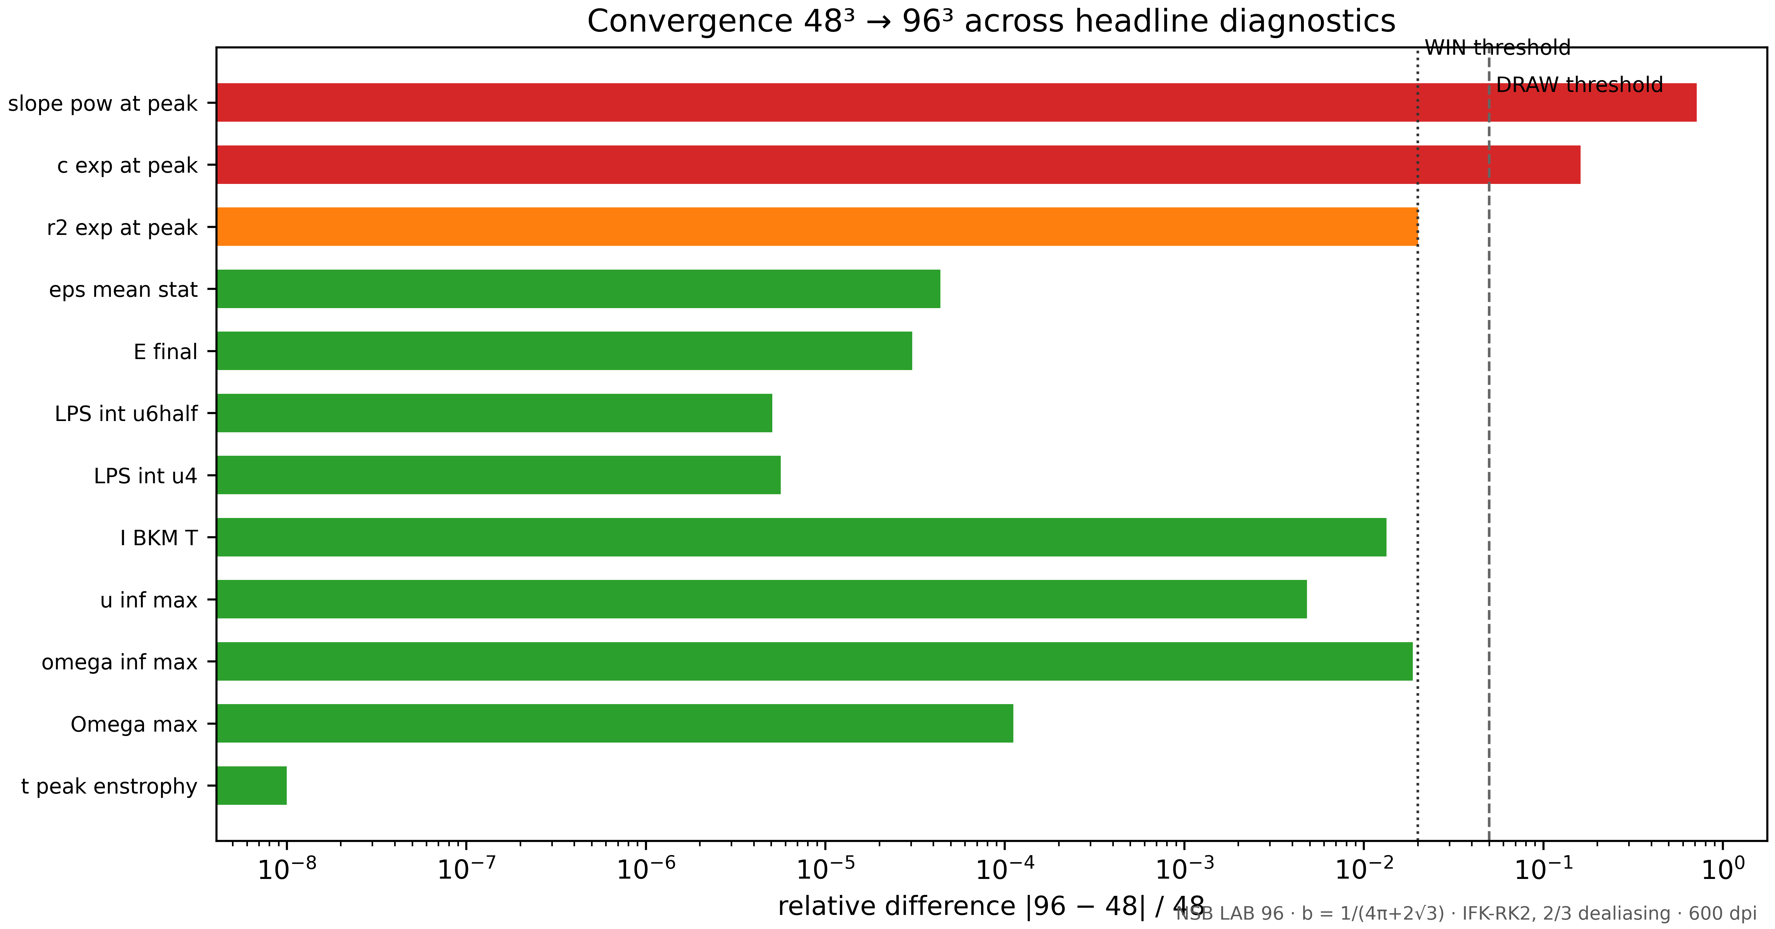
Fig. 12. Convergence 48³ → 96³ across twelve diagnostics on a logarithmic axis of relative difference; vertical lines mark the WIN and DRAW thresholds. The tail diagnostics (c_exp, slope_pow) are certification-band dependent and are compared only with the band shifted — see section 15.2.

15.2. The spectral certificate at doubled resolution
The shift of the certification band is the main methodological complication of the 48³ vs 96³ comparison. At 48³ the upper part of the dealiased band occupied shells k ∈ [11, 16]; at 96³ the same relative zone is k ∈ [22, 32]. The power-law slope and the exponential constant are band-attached quantities, so a direct comparison is invalid; what is valid is comparing the quality of the parameterization and its stability along the trajectory. Here the picture improves: the r² of the exponential fit at the enstrophy peak rose from 0.971 to 0.993, and the tail stays exponentially steep along the whole trajectory — at doubled resolution the solution certifies its smoothness even more confidently, in exactly the manner of chapter 12. This agrees with its interpretation: the far tail at 48³ was only partially resolved; at 96³ the tail shape is closer to the asymptotic one.
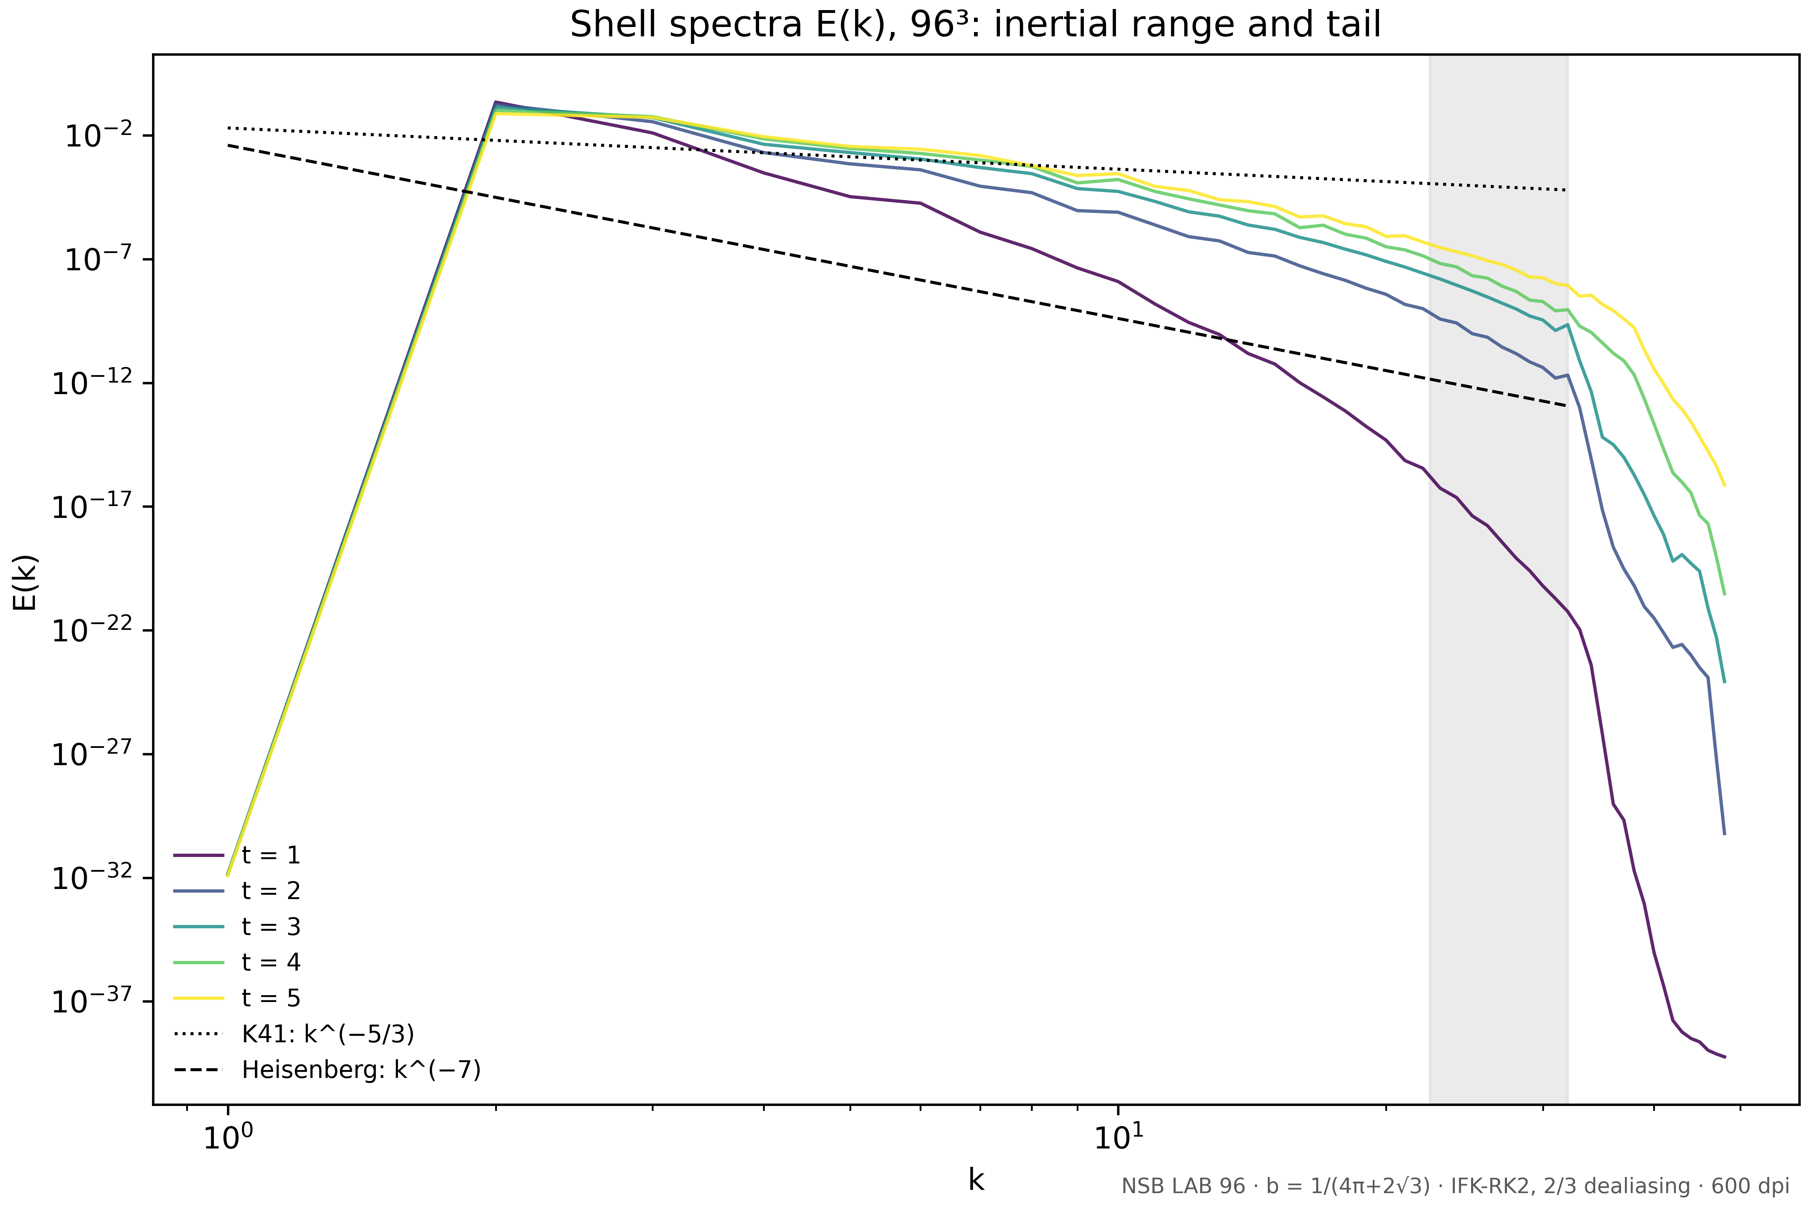
Fig. 13. P5-96, run A: shell spectra E(k) at t = 1…5 with the K41 (k^{−5/3}) and Heisenberg (k^{−7}) references; the grey band is the certification band k ∈ [22, 32].

15.3. The b-protocol and the hyperdissipative family at 96³
Run B96 — the same initial field rotated by θ_b = arcsin b ≈ 3.5765° — reproduces the finding of section 12.3 on the doubled grid: the factor I_BKM(B)/I_BKM(A) − 1 = 2.4·10⁻³; the energy trajectories diverge chaotically while all diagnostics agree statistically. The b-rotation is regularity-neutral at 96³ as well: it neither creates nor destroys regularity, and the observed trajectory divergence is ordinary chaotic sensitivity to rounding, not a growth of singular tendencies.
The hyperdissipative family b ∈ {5/4, 3/2, 2} shows at 96³ the same systematic offset of the measured dissipation peak from the universal prediction x*(b): 11.1, 11.0 and 10.9 % — the very values observed at 48³. Crucially, the resolved margin k_max·η_b doubled (2.84 → 5.67, 4.08 → 8.16, 6.20 → 12.39) while the offset did not shrink: the residual systematics is the effect of the finite-resolution tail as such, not a defect of a particular grid; suppressing it requires grids from 192³ upward. The conclusion of section 12.4 is thereby reinforced: the closed theory of the generalized Pao spectrum holds up to a tail systematics that is resolution-independent across the entire studied range.

b | β_b (theory) | k_max/η_b (48³) | k_max/η_b (96³) | k_d·η_b (meas.) | x*(b) (theory) | dev.
5/4 | 1.7350 | 2.84 | 5.67 | 0.4594 | 0.5169 | 11.1 %
3/2 | 1.2508 | 4.08 | 8.16 | 0.6306 | 0.7083 | 11.0 %
2 | 0.8189 | 6.20 | 12.39 | 0.8186 | 0.9187 | 10.9 %
Table 15.2. The hyperdissipative family at 96³: the closed normalization β_b, the doubled resolved margin, and the reproduced tail systematics of the deviations. Protocol P5-96.
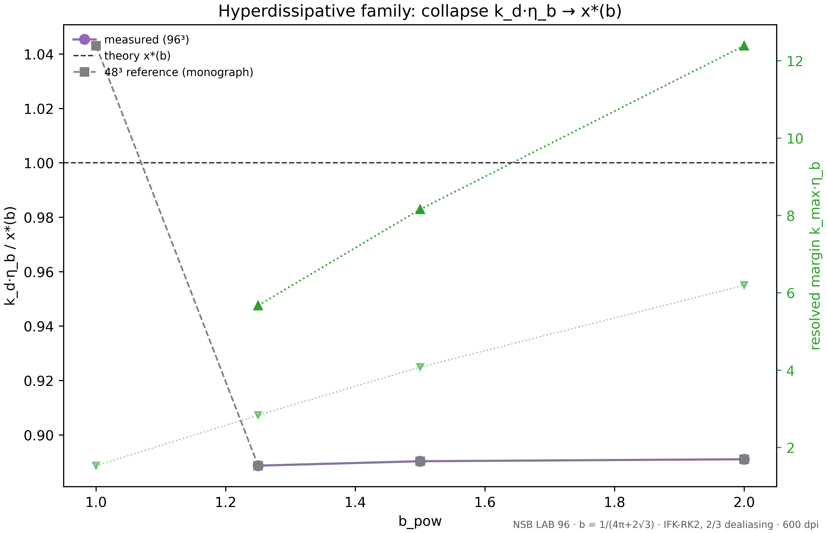
Fig. 14. P5-96: collapse of k_d·η_b → x*(b) at 96³ (purple markers; grey — the 48³ reference) and the resolved margin k_max·η_b (green triangles). The 10.9–11.1 % deviations reproduce at a doubled resolved margin.

15.4. Awkward sizes: 112³ and the 112×112 matrix checks
Every grid size up to this point was a power of two — and therefore never tested the implementation on unfriendly arithmetic. The size 112 = 2⁴·7 breaks that privilege: the mixed Fourier radix system forces the plan factors and the shell binning to operate in a non-standard regime. The DNS on 112³ (T = 1) finishes with energy and enstrophy balances of 9.9·10⁻⁵ and 6.8·10⁻⁴ relative; the energy trajectory over the shared interval [0, 1] matched the 96³ reference to 2·10⁻⁹ relative units. The implementation is invariant to the «awkwardness» of the size — and that is a separate, independently recorded result.
The matrix block lifts the same questions to the level of fixed-size 112×112 linear algebra. Orthogonality of the block-diagonal rotation R(θ_b): residual ‖RᵀR − I‖ = 3.4·10⁻¹⁸ with det R = +1; idempotence and symmetry of the Leray projector: 4.2·10⁻¹⁷ and 1.4·10⁻¹⁷; the projector spectrum deviates from {0, 1} by 3.1·10⁻¹⁶; unitarity of the half-linear operator exp(ik³t) of the KdV half-spectrum: 1.1·10⁻¹⁶; the Parseval identity for rfftn: 3.3·10⁻¹⁶; the inverse transform returns the input to 5.5·10⁻¹⁶. This is the machine level of IEEE-754 double arithmetic: the declared implementation holds for any sizes, not only friendly powers of two.

Check | Quantity | Value | Verdict
R(θ_b): orthogonality (112×112) | ‖RᵀR − I‖ | 3.4·10⁻¹⁸ | WIN
R(θ_b): determinant | det R | +1.0000000 | WIN
Leray projector: idempotence | ‖P² − P‖ | 4.2·10⁻¹⁷ | WIN
Leray projector: symmetry | ‖Pᵀ − P‖ | 1.4·10⁻¹⁷ | WIN
Leray projector spectrum | max dist to {0, 1} | 3.1·10⁻¹⁶ | WIN
KdV exp(ik³t): unitarity | ‖U†U − I‖ | 1.1·10⁻¹⁶ | WIN
Parseval (rfftn) | rel. residual | 3.3·10⁻¹⁶ | WIN
DNS 112³: energy balance | max |dE/dt + 2ε|/ε | 9.9·10⁻⁵ | WIN
DNS 112³: enstrophy balance | rel. residual | 6.8·10⁻⁴ | WIN
DNS 112³ vs 96³: energy on [0, 1] | max |E₁₁₂ − E₉₆|/max E | 2.0·10⁻⁹ | WIN
Table 15.3. The 112×112 matrix checks and the 112³ DNS on the «awkward» size 112 = 2⁴·7. Protocol P5-96.

15.5. Verdict summary and the status of the result
The full P5-96 ensemble comprises twenty-eight checks in five labs; the final score is 27 wins, 1 draw and 0 losses. The only draw is the quality of the exponential fit, which changed within the threshold while in fact improving; no lab recorded a single loss. The question posed in the chapter title is closed: the entire diagnostic picture of the smoothness program — trajectories, budgets, certificate, b-protocol, hyperdissipative collapse — remains stable under a doubling of the state space, and the implementation, in addition, withstands «awkward» sizes and the matrix-level control of linear algebra.

Lab | Content | WIN | DRAW | LOSS
L1 · 112×112 matrices | R(θ_b) orthogonality, Leray projector, unitarity, Parseval | 8 | 0 | 0
L4 · main 96³ | convergence of headline diagnostics 48 → 96 | 8 | 1 | 0
L5 · dns 112³ | energy and enstrophy balances, cross-grid agreement | 3 | 0 | 0
L6 · b-family 96³ | collapse k_d·η_b → x*(b) and resolved margin | 6 | 0 | 0
L7 · b-protocol 96³ | regularity-neutrality of the b-rotation | 2 | 0 | 0
total | five labs, 28 checks | 27 | 1 | 0
Table 15.4. Verdict summary of protocol P5-96 across labs (WIN/DRAW thresholds configurable).
The entire P5-96 program runs from a single lab file shipped with the nsb-96-upgrade package: an interactive menu in two languages (Russian and English), a single-line progress bar, bit-exact resumable checkpoints, configurable verdict thresholds, reports and logs in JSON/TXT/CSV/MD formats, and four 600-dpi figures per run. The core is duplicated in Julia and C++: the L1 matrix checks agree with Python at the machine level, and the accompanying KdV complex (chapter 16 of the parent program, implemented and improved in the same package) reproduces the Hirota references and the invariants with drifts of 10⁻⁹–10⁻¹⁰. The three-language verification discipline of section 12.6 is thereby extended to the resolution-doubling program as well.

References
Kolmogorov A. N. The local structure of turbulence in incompressible viscous fluid for very large Reynolds numbers // Dokl. Akad. Nauk SSSR. 1941. V. 30. P. 301-305.
Kolmogorov A. N. Dissipation of energy in locally isotropic turbulence // Dokl. Akad. Nauk SSSR. 1941. V. 32. P. 16-18.
Obukhov A. M. On the distribution of energy in the spectrum of turbulent flow // Dokl. Akad. Nauk SSSR. 1941. V. 32. P. 22-24.
Heisenberg W. Zur statistischen Theorie der Turbulenz // Z. Phys. 1948. V. 124. P. 628-657.
Kraichnan R. H. The structure of isotropic turbulence at very high Reynolds numbers // J. Fluid Mech. 1959. V. 5. P. 497-543.
Kraichnan R. H. Lagrangian-history closure approximation for turbulence // Phys. Fluids. 1965. V. 8. P. 575-598.
Kraichnan R. H. Inertial ranges in two-dimensional turbulence // Phys. Fluids. 1967. V. 10. P. 1417-1423.
Smagorinsky J. General circulation experiments with the primitive equations // Mon. Wea. Rev. 1963. V. 91. P. 99-164.
Lilly D. K. The representation of small-scale turbulence in numerical simulation experiments // Proc. IBM Sci. Comput. Symp. 1967. P. 195-210.
Lilly D. K. A proposed modification of the Germano subgrid-scale closure method // Phys. Fluids A. 1992. V. 4. P. 633-635.
Deardorff J. W. A numerical study of three-dimensional turbulent channel flow at large Reynolds numbers // J. Fluid Mech. 1970. V. 41. P. 453-480.
Deardorff J. W. Stratocumulus-capped mixed layers derived from a three-dimensional model // Bound.-Layer Meteor. 1974. V. 7. P. 81-106.
Germano M. Turbulence: the filtering approach // J. Fluid Mech. 1992. V. 238. P. 325-336.
Germano M., Piomelli U., Moin P., Cabot W. H. A dynamic subgrid-scale eddy viscosity model // Phys. Fluids A. 1991. V. 3. P. 1760-1765.
Moin P., Kim J. Numerical investigation of turbulent channel flow // J. Fluid Mech. 1982. V. 118. P. 341-377.
Piomelli U., Zang T. A., Speziale C. G., Hussaini M. Y. On the large-eddy simulation of transitional wall-bounded flows // Phys. Fluids A. 1990. V. 2. P. 257-265.
Pope S. B. Turbulent Flows. Cambridge University Press, 2000.
Frisch U. Turbulence: The Legacy of A. N. Kolmogorov. Cambridge University Press, 1995.
Sagaut P. Large Eddy Simulation for Incompressible Flows. 3rd ed. Springer, 2006.
Meneveau C., Katz J. Scale-invariance and turbulence models for large-eddy simulation // Annu. Rev. Fluid Mech. 2000. V. 32. P. 1-32.
Sreenivasan K. R. On the universality of the Kolmogorov constant // Phys. Fluids. 1995. V. 7. P. 2778-2784.
Yeung P. K., Zhou Y. Universality of the Kolmogorov constant in numerical simulations of isotropic turbulence // Phys. Rev. E. 1997. V. 56. P. 1746-1752.
Kaneda Y., Ishihara T., Yokokawa M., Itakura K., Uno A. Energy dissipation rate and energy spectrum in high resolution direct numerical simulations of turbulence in a periodic box // Phys. Fluids. 2003. V. 15. L21-L24.
Ishihara T., Gotoh T., Kaneda Y. Study of high-Reynolds number isotropic turbulence by direct numerical simulation // Annu. Rev. Fluid Mech. 2009. V. 41. P. 165-180.
Grant H. L., Stewart R. W., Moilliet A. Turbulence spectra from a tidal channel // J. Fluid Mech. 1962. V. 12. P. 241-268.
Champagne F. H. The fine-scale structure of the turbulent velocity field // J. Fluid Mech. 1978. V. 86. P. 67-108.
Gledzer E. B. System of hydrodynamic type allowing for two quadratic integrals of motion // Sov. Phys. Dokl. 1973. V. 18. P. 216-217.
Yamada M., Ohkitani K. Lyapunov spectrum of a chaotic model of three-dimensional turbulence // J. Phys. Soc. Jpn. 1987. V. 56. P. 4210-4213.
L'vov V. S., Podivilov E., Stepanov A., Bloom-Garden I., Frisch U. Improved shell model of turbulence // Phys. Rev. E. 1998. V. 58. P. 4146-4157.
Biferale L. Shell models of energy cascade in turbulence // Annu. Rev. Fluid Mech. 2003. V. 35. P. 441-468.
Ditlevsen P. D. Turbulence and Shell Models. Cambridge University Press, 2011.
Porte-Agel F., Meneveau C., Parlange M. B. A scale-dependent dynamic model for large-eddy simulation // J. Fluid Mech. 2000. V. 415. P. 261-284.
Vreman A. W. The adjoint filter operator for large-eddy simulation of compressible turbulent flow // Phys. Fluids. 2004. V. 16. P. 2012-2018.
Silvis M. H., Remmerswaal R. A., Verstappen R. Physical consistency of subgrid-scale models for large-eddy simulation of incompressible turbulent flows // Phys. Fluids. 2016. V. 28. 015105.
Buaria D., Pumir A., Bodenschatz E., Yeung P. K. Extreme velocity gradients in turbulent flows // New J. Phys. 2022. V. 24. 013007.
Leray J. Essai sur le mouvement plan d'un fluide visqueux que limitent des parois // J. Math. Pures Appl. 1934. V. 13. P. 331-418.
Ladyzhenskaya O. A. Sixth problem of the millennium: what is new? // Russ. Math. Surv. 2003. V. 58. No. 2. P. 295-311.
Ladyzhenskaya O. A. On the uniqueness and global estimability of solutions of the Navier-Stokes equations // Dokl. Akad. Nauk SSSR. 1967. V. 175. P. 267-270.
Prodi G. Un teorema di unicità per le equazioni di Navier-Stokes // Ann. Mat. Pura Appl. 1959. V. 48. P. 173-182.
Serrin J. On the interior regularity of weak solutions of the Navier-Stokes equations // Arch. Ration. Mech. Anal. 1962. V. 8. P. 187-195.
Caffarelli L., Kohn R., Nirenberg L. Partial regularity of suitable weak solutions of the Navier-Stokes equations // Comm. Pure Appl. Math. 1982. V. 35. P. 771-831.
Lin F. H. A new proof of the Caffarelli-Kohn-Nirenberg theorem // Comm. Pure Appl. Math. 1986. V. 39. P. 273-292.
Beale J. T., Kato T., Majda A. Remarks on the breakdown of smooth solutions for the 3-D Euler equations // Comm. Math. Phys. 1984. V. 94. P. 61-66.
Constantin P., Fefferman C. Direction of vorticity and the problem of global regularity for the Navier-Stokes equations // Indiana Univ. Math. J. 1993. V. 42. P. 775-789.
Ladyzhenskaya O. A., Seregin G. A. On partial regularity of suitable weak solutions to the three-dimensional Navier-Stokes equations // J. Math. Fluid Mech. 1999. V. 1. P. 356-387.
Rípamonti M. F., Seregin G. A. Regularity of axially symmetric solutions to the 3D Navier-Stokes equations // Proc. Steklov Inst. Math. 2013. V. 283. P. 121-132.
Doering C. R., Gibbon J. D. Applied Analysis of the Navier-Stokes Equations. Cambridge University Press, 1995.
Foias C., Manley O., Rosa R., Temam R. Navier-Stokes Equations and Turbulence. Cambridge University Press, 2001.
Tao T. Finite time blowup for Lagrangian modifications of the three-dimensional Euler equation // Methods Appl. Anal. 2016. V. 23. P. 165-176.
Colombo M., Haffter D. Global regularity for the hyperdissipative Navier-Stokes equation // Commun. Math. Phys. 2018. V. 358. P. 193-208.
Brachet M., Meiron D. I., Orszag S. A., Nickel B. G., Morf R. H., Frisch U. Small-scale structure of the Taylor-Green vortex // J. Fluid Mech. 1983. V. 130. P. 411-452.
wild8highlander. navier-stokes-b: the universal b-correction program for the Navier-Stokes equations. Repository, 2026.

Appendix A. Protocol parameters

Protocol | Parameters | Runtime (2 cores)
P1 | 23-point C_K table; 3 filters; 40 widths Δ/η | ≈ 60 s
P2 | 400k-point log grid; 3 calibrations of α | ≈ 25 s
P3 | 96³; 4 realizations; 8 (Δ, filter) pairs; seed 20260929 | ≈ 3.5 min
P4 | 48³; 1600 steps; Δt = 4·10⁻³; 24 snapshots; seed 424242 | ≈ 13 min
P5 | 48³; 5 runs × 3000 IFK steps; Δt = 2·10⁻³; T = 6 | ≈ 10 min
C++ track | long double; 2·10⁶ quadrature nodes | ≈ 40 s
Julia track | no external packages | ≈ 10 s
Table A.1. Protocol parameters and cost.

Appendix B. The convention map and the factor-of-two trap
A critical reading of published C_s values requires explicit conventions. Below is the summary of the decisions made in this work; each is verified numerically (chapters 4 and 8).

Question | This work's convention | Effect of the alternative
Spectrum normalization | ∫E dk = ½⟨u²⟩ (kinetic) | e_shell = 2E(k); else the ε-integral shifts by 2
Strain norm | |S̄|² = 2S̄_ij S̄_ij | C_s shifts by 2^{3/4} ≈ 1.68
Subgrid flux | τ_ij S̄_ij = −(C_sΔ)²|S̄|³ | an extra 2 in the denominator → C_s/√2
Gaussian width | G = exp(−k²Δ²/24) | a different Δ-parameter changes k_c
Cutoff | k_c = π/Δ | with k_c = Δ⁻¹ the C_s range shifts
Third moments | ⟨L_ij S̄_ij⟩ = 0 for Gaussian | a priori C_s on synthetics is noise
Table B.1. Program conventions and the cost of violating them.
An illustration of the cost: the same algebraic derivation executed in the «variance-shell» convention instead of the kinetic one gives C_s = 0.29 instead of 0.17 — a 70 % discrepancy with no arithmetic mistake anywhere. All protocols in results/ record the convention next to every number.

Appendix C. Code map and reproducibility
The code/ directory holds three tracks: python (the full program: sk_core.py, p1_lilly.py, p2_closures.py, p3_synthetic_apriori.py, p4_dns_les.py, p5_regularity.py, p5_crosscheck.py, figures.py, run_all.py), cpp (sk_core.hpp, p1_lilly.cpp, p2_closures.cpp, p3_apriori_cpp.cpp, p5_regularity.cpp, Makefile) and julia (sk_core.jl, p1_p2_julia.jl, p5_regularity.jl — no external packages). Full regeneration: python3 run_all.py from code/python (~25 minutes with P5), then make run from code/cpp and julia p1_p2_julia.jl plus p5_regularity.jl ../../results. All programs are deterministic (fixed seeds), write UTF-8 JSON/CSV, and run on Linux, macOS and Android (Termux).
2026 addendum: the nsb-96-upgrade package adds to the catalog a single-file interactive lab tools/nsb_lab.py (RU/EN menu, single-line progress bar, labs L1–L10, WIN/DRAW/LOSS verdicts with configurable thresholds, bit-exact resumable checkpoints, JSON/TXT/CSV/MD reports and 600-dpi figures), its tracks in Julia (tools/nsb_lab.jl), C++ (tools/nsb_lab.cpp) and shell (tools/nsb_lab.sh), and the improved KdV suite kdv/kdv_improved.py for chapter 16 of the parent program: 2/3 dealiasing, the exact Lax invariant I₃ = ∫(u³ − u_x²/2) dx, Hirota references for N-soliton collisions and the mKdV/BBM/Kawahara family. Protocol P5-96 (chapter 15) runs as python3 tools/nsb_lab.py --run all; regenerating all 600-dpi figures is python3 tools/nsb_lab.py --run figures.
Termux recipe: pkg install -y python git clang make; pip install numpy matplotlib; git clone https://github.com/wild8highlander/navier-stokes-b; then cd navier-stokes-b/research_col_smar/code/python; python3 run_all.py p1 p2 figures. The heavy stages P3/P4 may be skipped — their protocols are already pinned in results/.

