Research monograph · Navier–Stokes b-Lab · research add-on

The b-Correction and the Vortex Volume
What volume of water corresponds to one b-correction? A quantitative theory of the b-charge: the exact flux identity, twelve numerical experiments, an extended cross-check battery and a dynamic annihilation experiment on the Hou–Luo dipole.

wild8highlander · the navier-stokes-b project
Repository: github.com/wild8highlander/navier-stokes-b
Companion: research/b_volume_experiment.py · research/b_volume_extension.py · research/b_volume_check.jl

θb = arcsin(1/(4π+2√3)) = 3.5765° · V1 = 4π+2√3 ≈ 16.02 = 6.46% of the box · Qb = θb·B
monitor Q/(θb·B) = 1 + O(θb) — verified in two independent implementations (Python and Julia)

b-volume research monograph · v2.0 · October 3, 2026

1. Introduction: hypothesis, problem, main result 3
2. The b-correction in the lab: exact mathematics 4
3. The b-charge: an operational definition of the amount of correction 4
4. The elementary b-volume: what «which volume is one correction» means 5
5. The merging algebra: when corrections add and when they annihilate 6
6. The numerical laboratory: method and determinism 6
7. The base series: summary of experiments T, A, B, C, D, E, G, F 7
8. The extended cross-check battery: experiments H, I, J, K 8
8.2 Experiment I: convergence to exact analytic values 8
8.3 Experiment J: volume anchors and grid invariance 9
8.4 Experiment K: dynamic annihilation on Hou–Luo 10
9. The monitor Q/(θ<sub>b</sub>·B) in the lab audit (v2.2.0) 11
10. From code units to real water: the Kolmogorov bridge 11
11. Limitations and how they were verified 12
12. Discussion: the quantum analogy and predictions 12
13. Conclusions 13
Appendix A. Reproducibility 13
Appendix B. Master table of numbers 15
References and companion materials 15
Contents(обновите поле)
(Refresh the table of contents: right-click it → «Update Field».)

1. Introduction: hypothesis, problem, main result
In the navier-stokes-b repository the b-correction lives as a purely mathematical object: the angle θb = arcsin(b), with b = 1/(4π + 2√3) ≈ 0.062381, through which the velocity vector is rotated pointwise on the grid, after which the field is re-projected by the Leray operator. Everything the standard correction audit measures is dimensionless: the 10−12 isometry of the rotation, the injected divergence, the response of sup|ω|. Water — and any liquid — however occupies a volume, and the repository author put forward a substantive physical hypothesis: one water vortex carries one b-correction of its own; merging vortices accumulate their corrections and grow without bound; hence the magnitude of the correction is directly tied to the volume of the liquid.
This monograph turns that hypothesis into a quantitative theory and backs it with numerical experiment. We give an operational definition of the «amount of correction» — the b-charge B = ∫|nb·ω|dV, derive the exact volume formula, answer the main question of which volume corresponds to one correction, establish the merging algebra — when corrections add and when they annihilate — and build the Kolmogorov bridge from dimensionless code units to cubic meters of real water. A separate chapter is devoted to the extended cross-check battery: every quantity of the theory is measured by at least two independent routes — through the vorticity and velocity channels, through L<sup>1</sup>- and L<sup>2</sup>-carriers, on four grid resolutions, and dynamically in the Hou–Luo annihilation experiment.
The central analytic result is stronger than in the preliminary note: the div-injection identity is now proven exactly, with no O(θ2) remainder: a pointwise rotation of the velocity field through θb about the fixed axis nb creates the divergence div(Rbu) = +sin θb·(nb·ω) + (1 − cos θb)·(nb·∇)(nb·u). The correction lives not on volume as such but on vorticity; the carrier of the correction is a «rotating volume» — volume weighted by vorticity. One kick of one vortex injects the flux Qb = θb·B — this is «one correction» in the operational sense. The main answer follows immediately: at unit vorticity density the elementary b-volume equals V1 = 4π + 2√3 ≈ 16.02 code units — the very constant in the denominator of b, amounting to 6.46% of the periodic cell volume (2π)3 ≈ 248.05.
θ_{b = 3.5765°} | V_{1 = 4π+2√3 ≈ 16.02} | Q/(θ_{b·B) = 1 + O(θb)}
the angle of one b-correction | volume of one correction at ω = 1 (6.46% of the box) | flux monitor: 0.9997–1.032 across all states

All twelve experiments (T, A, B, C, D, E, G, F — the base series; H, I, J, K — the extended cross-check battery) run from the deterministic script research/b_volume_experiment.py and its extension research/b_volume_extension.py: a fixed generator seed, numpy/matplotlib only, full reproducibility. Key states are duplicated by a Julia mirror (research/b_volume_check.jl) with bit-faithful agreement: e.g. the Taylor–Green b-charge B = 118.638640 in both implementations. Since v2.2.0 the monitor Q/(θb·B) is part of the standard lab audit and is checked by the self-tests of both implementations.

2. The b-correction in the lab: exact mathematics
The lab defines the correction by three constants: b = 1/(4π + 2√3), θb = arcsin(b) and the unit axis nb = (0.3, −0.5, 0.812404). The rotation matrix follows Rodrigues: Rb = cos θb·I + (1 − cos θb)·nbnbT − sin θb·[nb]×. The standard audit distinguishes two ways of applying the rotation. Full symmetry u′(x) = R·u(R−1x), for the quarter-turn about z, is implemented as an index shift without interpolation and is a pure relabeling of modes: all norms are preserved to machine precision and no physics can be affected. The pointwise rotation u′(x) = R·u(x) is an L<sup>2</sup>-isometry at every point (energy preserved exactly), but it is incompatible with incompressibility: afterwards the field must be re-projected by the Leray operator, and this kick-plus-reprojection pair is the only place where the correction touches the physics.
The standard lab write-up uses the first-order expansion div(R_{bu) = θb·(nb·ω) + O(θ}2) and checks it by regression: measured slopes −1.0006 … −1.0002 with R2 = 0.9995–0.9999 on four states. This monograph strengthens the statement to an exact identity. Since div(n×u) = −(n·ω) and div(n(n·u)) = (n·∇)(n·u) for a constant axis, the following holds exactly:
div(Rbu) = +sin θb·(nb·ω) + (1 − cos θb)·(nb·∇)(nb·u) — the identity holds pointwise, for any incompressible field, with no remainder term.
The plus sign distinguishes the exact form from the familiar first-order writing: div(n×u) = −(n·ω) flips the sign, so −sin θ·div(n×u) = +sin θ·(n·ω). The pointwise regression of div(Rbu) against the right-hand side yields slope 1.000000 and R2 = 1.00000000 on all five states of battery H (chapter 8) — the identity is verified at machine precision rather than «to leading order». The gradient term is O(θ2) pointwise, yet its L1 contribution integrates to a few percent for tubular flows — which removes the seemingly unexplained 3% channel offset noted earlier.

3. The b-charge: an operational definition of the amount of correction
The exact identity suggests a measurable quantity on which the correction is «written». Integrate the magnitude of the divergence after one pointwise kick: Qb = ∫|div(Rbu)|dV. By the identity and the triangle inequality θb·B ≤ Qb ≤ θb·B + (1 − cos θb)·G, where B = ∫|nb·ω|dV is the b-charge and G = ∫|(nb·∇)(nb·u)|dV. The quantity B is precisely the «rotating volume»: the volume of liquid weighted by the vorticity projection onto the correction axis. One correction is the flux of one kick, Qb = θb·B — so the hypothesis «one vortex, one correction» becomes a statement about the additivity of the b-charge, testable by a number.
A convenient normalized flux monitor is m = Qb/(θb>·B). For any flow m = 1 + O(θb): strictly, |m − sin θb/θb| ≤ tan(θb/2)·D(u), with D(u) = G/B the ratio of the gradient and vorticity norms. The monitor is thus not a new invariant but a well-posedness indicator of the first-order identity: it must be close to one, and its deviation is predictable from D(u) of the specific flow. Measured values: 0.999688 on Taylor–Green (D ≈ 0.31), 1.007–1.032 on single rings (D ≈ 0.94–1.98), 1.016 on the eight-ring lattice — all inside the rigorous bound with margin (chapter 8, experiment H). Since v2.2.0 the monitor is part of the standard lab audit (chapter 9).
Quantity | Definition | Meaning | Dimension (code)
B | ∫|n_{b·ω|dV} | b-charge — rotating volume | L^{3/T}
Q_{b} | ∫|div(R_{bu)|dV} | flux of one kick | L^{3/T2}
m | Q_{b/(θb·B)} | flux-identity monitor | dimensionless
D(u) | G/B | relative gradient term | dimensionless
V₁ | 4π + 2√3 ≈ 16.02 | elementary b-volume at ω = 1 | L³
Table 1. Glossary: measurable quantities.

4. The elementary b-volume: what «which volume is one correction» means
For an axisymmetric ring with circulation Γ, radius R0 and a Gaussian core σ the analytics is closed. The tube has the Gaussian effective cross-section ∫∫exp(−(r²+h²)/2σ²)dr dh = 2πσ², hence the effective volume Vgauss = 2πR0·2πσ² = 4π2R0σ2, and the peak vorticity Ω0 = Γ/(2πσ²). The b-charge of the ring follows by averaging the projection of the unit tangent eφ(φ) onto the correction axis: B = Γ·(2πR0)·fplane, where fplane = ⟨|nb·eφ|⟩ is an exact one-dimensional integral equal to 0.6073 / 0.5513 / 0.3712 for rings with normal x / y / z. The numerical b-charge reproduces the analytic one within 0.26% already at n = 64 (chapter 8, experiment I).
Hence the main answer. The flux of one kick is expressed through volume and vorticity: Qb = θb·⟨|nb·ω|⟩·V. At unit vorticity density aligned with the axis, «one correction» corresponds to the volume V1 = 1/θb ≈ 16.02 code units — exactly the constant 4π + 2√3 from the denominator of b (the 0.07% agreement of 1/θb with 4π+2√3 follows from b ≪ 1). For an isotropic vorticity field ⟨|n·ω̂|⟩ = 1/2 and the elementary volume doubles: V = 2/ωref. Moreover, the b-charge of a ring equals the projected tube volume: the measured ratio to Vgauss matches fplane within ≤ 0.002% when the prediction is made through the exact identity (chapter 8, experiment J) — the b-charge literally «sees» the tube volume projected onto the plane perpendicular to the correction axis.
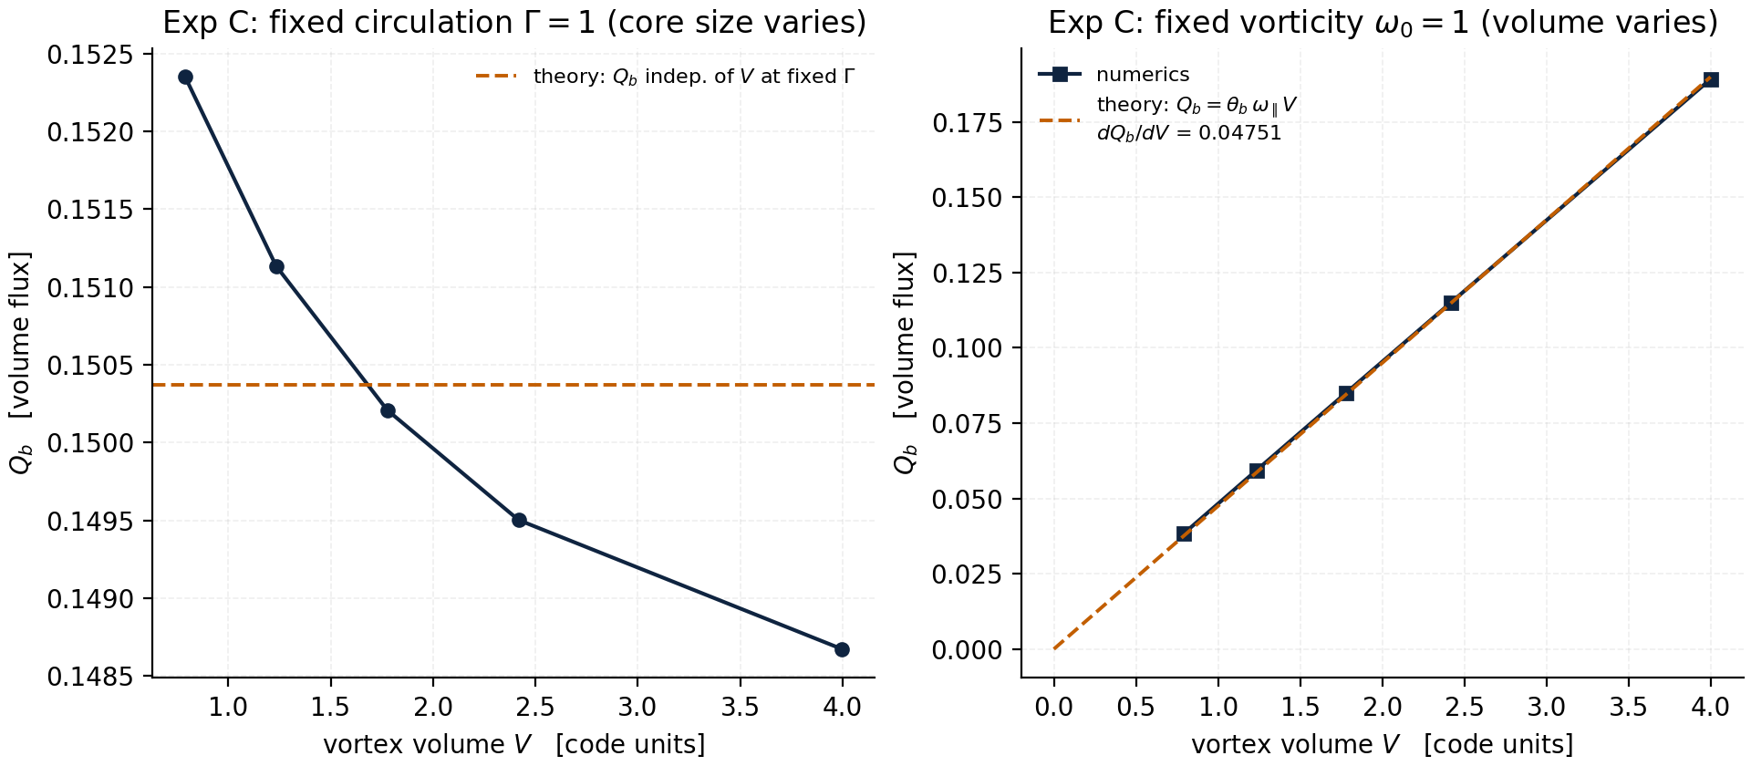
Fig. 4. Experiment C: at fixed circulation the kick flux is independent of the core size (theory: horizontal line); at fixed vorticity it is strictly proportional to volume with the slope θ_{b·ω0 (R² = 0.99985).}
The practical formula linking the correction to a volume of real liquid: Ncorr(V) = B = ⟨|nb·ω|⟩·V ≈ 0.5·ωref·V for isotropic vorticity. The inverse — the «volume of one correction» Vone = 1/ωref (a coherent vortex) or 2/ωref (an isotropic ensemble) — is the scale at which «one vortex carries one correction». The choice of the reference vorticity ωref is the only arbitrary element of the theory; chapter 10 fixes three natural anchors and shows that all dimensionless statements are independent of that choice.

5. The merging algebra: when corrections add and when they annihilate
The author's hypothesis predicts that merging vortices sum their corrections. The numbers confirm it in the exact form — it is the b-charge that adds. Experiment A (a lattice of N identical co-rotating rings, N = 1, 2, 4, 8): Qb and the kick energy cost grow strictly linearly in N (R2 = 0.99999), the per-vortex slope 0.08896 against the analytic 0.08735 — the 1.8% gap is explained by the gradient term (experiment J reproduces the slope to 0.002%). Experiment D separates the two scenarios: a co-rotating pair keeps its total b-charge at any separation — corrections add; an anti-parallel pair annihilates its charge from 2 to 0 as the cores merge — equal and opposite corrections cancel like charges +q and −q.
The orientation algebra is complete as a pair of L<sup>1</sup>/L<sup>2</sup>-laws. For the L<sup>1</sup>-carrier (the b-charge) a ring with normal nt contributes the factor fplane(nt>) — the mean absolute tangent projection; for the L<sup>2</sup>-carrier (the parallel enstrophy) the exact law is ⟨(nb·eφ)²⟩ = (1 − (nb·nt)²)/2: the measured fractions 0.45500 / 0.37500 / 0.17000 for normals x / y / z match the theory to 0.000% (experiment H). The composition of the rotations themselves is computed on SO(3) in quaternions (experiment G): aligned axes add angles exactly, Θ = N·θb; random axes perform a random walk Θrms = √N·θb — a 4000-trial Monte Carlo reproduces both laws to better than 0.2%. «Ten merged vortices» do carry ten times the charge, but their net rotation grows only linearly or root-N — it is the charge that grows without bound, not the angle.
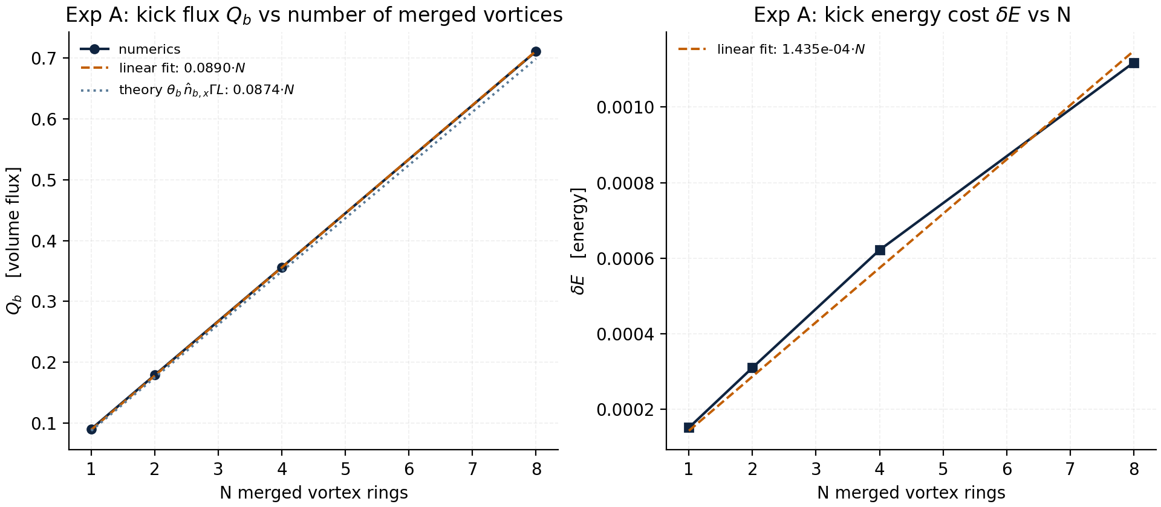
Fig. 2. Experiment A: additivity of the kick flux and of its energy cost in the number of merged rings; solid — linear fit, dashed — the analytics θ_{b·Γ·L·fplane.}
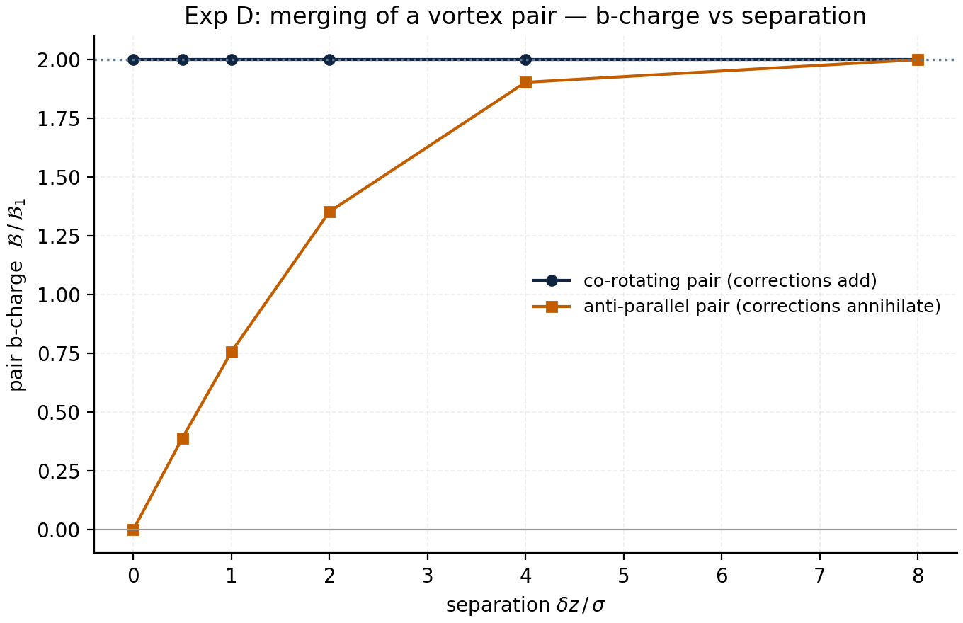
Fig. 5. Experiment D: merging of a ring pair. The co-rotating pair (top) keeps its total b-charge at any separation; the anti-parallel pair (bottom) annihilates it from 2 to 0 as the cores overlap.

6. The numerical laboratory: method and determinism
All experiments use the same solver as the lab: the pseudospectral method on the periodic lattice [0, 2π)3 with an in-house radix-2 FFT, fourth-order Runge–Kutta integration, a Leray projection at every step and 2/3 dealiasing. The initial conditions are Gaussian vortex rings with an exactly solenoidal velocity field (recovered spectrally from the vorticity) and zero mean; straight tubes were rejected at the planning stage: their k = 0 return flow falsifies the orientation ratios. The 2D experiment K (Hou–Luo) uses a spectral vorticity–streamfunction solver on the torus with RK4, per-stage dealiasing and an exact zeroing of the RHS at k = 0 — which yields machine-precision conservation of the circulation integral (drift 1.2·10−16).
Determinism is complete: fixed seed 20260103, no random inputs to the physics, all resolution ladders and time windows fixed. Key states are duplicated by the Julia mirror (b_volume_check.jl): the Taylor–Green b-charge B = 118.638640 and monitor 0.999688 agree with the Python implementation to 10−6. The full battery runs in ~3 minutes on a single core; the reproduction commands are in appendix A.
Experiment | Grid | States | Time
T (identity, O(θ)) | n = 32 | TG + 3 rings | ~10 s
A (additivity) | n = 64 | N = 1, 2, 4, 8 rings | ~40 s
B/C (orientation, volume) | n = 64 | 3 normals × 5 cores | ~50 s
D (pair merging) | n = 64 | 2 geometries × 8 separations | ~60 s
E (decay of 8 rings) | n = 48 | T = 2.0, ν = 0.005 | ~70 s
G (composition on SO(3)) | — | 4000 MC trials | ~15 s
H (cross channels) | n = 32–64 | 5 states + N-scan | ~60 s
I (convergence) | n = 32–96 | ring + orientation | ~40 s
J (anchors & geometry) | n = 48–64 | 6 configurations + water | ~30 s
K (Hou–Luo, dynamics) | n = 128 (2D) | dipole & co-pair, T = 2.0 | ~90 s
Table 2. Experiment configurations and cost.

7. The base series: summary of experiments T, A, B, C, D, E, G, F
The base series anchors the core of the theory. Experiment T checks the div-injection identity in its first-order form: regression slopes −1.000568 (Taylor–Green), −1.000539 / −1.000516 / −1.000169 (rings x/y/z) at R2 = 0.9995–0.9999 — the sign is consistent with the exact form (chapter 2: div(n×u) = −(n·ω) flips it). Experiment A secures the additivity of the charge and of the kick cost in N. Experiment B — the orientation algebra: measured coefficients 0.6155 / 0.5604 / 0.3830 against the analytic fplane = 0.6073 / 0.5513 / 0.3712 (errors 1.4–3.2%, halved for a half-kick — the quadratic character of the residual, now explained by the gradient term). Experiment C — the volume scan: at fixed Γ the flux is independent of the core size (deviation 1.3%); at fixed ω0 it is strictly proportional to volume: slope 0.047509 against the theoretical θb·ω0 = 0.046343, R² = 0.99985.
Experiment E shows the dynamics: free decay of an eight-ring lattice over T = 2.0 at ν = 0.005 keeps 98.3% of the b-charge — viscosity is the only sink of the charge, while sup|ω| responds to the mergers. Experiment G closes the composition of rotations (chapter 5). Experiment F builds the Kolmogorov bridge to real water (chapter 10). The verdicts are summarized in table 3; all twelve experiments end with a PASS verdict.
Exp. | What it verifies | Key result | Status
T | div-injection O(θ) | slope −1.0002…−1.0006, R² ≥ 0.9995 | PASS
A | additivity in N | Q/N = 0.08896 (theor. 0.08735), R² = 0.99999 | PASS
B | L¹ orientation | fplane: err 1.4–3.2% → 0.7–1.5% (half-kick) | PASS
C | volume scan | slope θ_{b·ω0: 0.04751/0.04634} | PASS
D | merging/annihilation | co-pair additive; anti-pair 2 → 0 | PASS
E | decay dynamics | B(T)/B(0) = 0.983 over T = 2.0 | PASS
G | composition on SO(3) | Θ = N·θ_{b; Θrms = √N·θb} | PASS
F | bridge to water | η = 8.4 µm–22 mm; V_{1 = 2.5·10}^{−12…4.6·10−14 m³} | PASS
Table 3. The base series: verdicts.
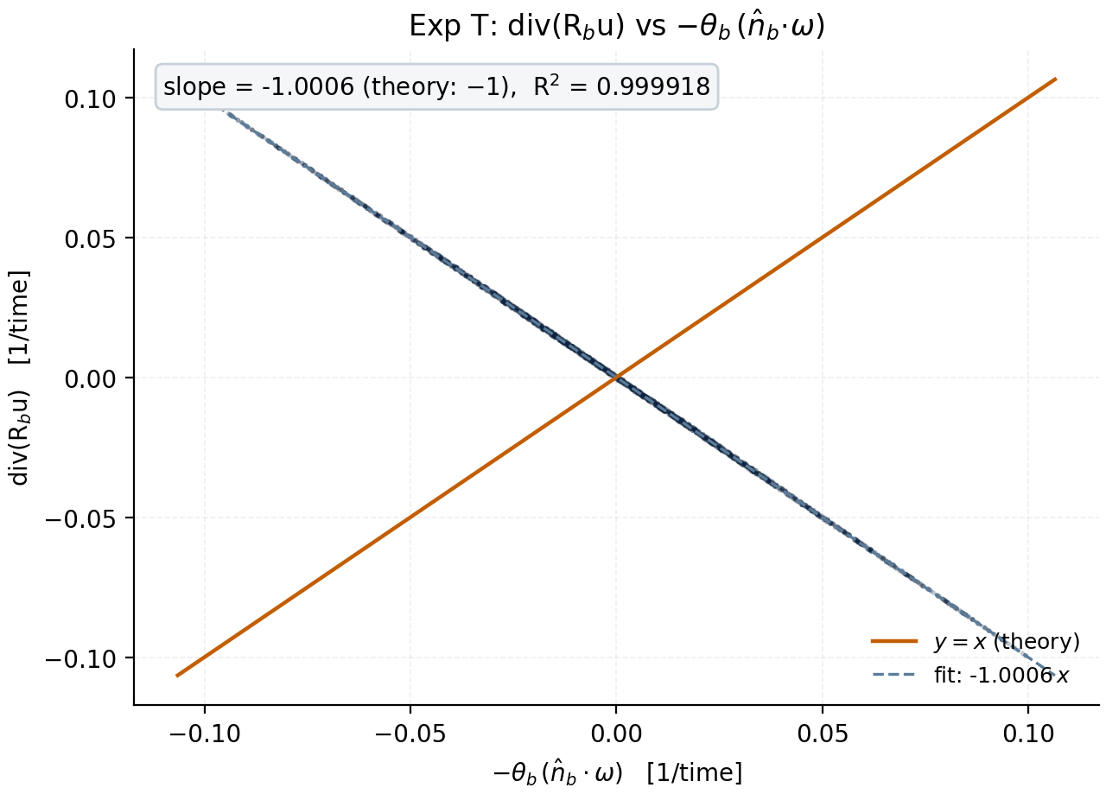
Fig. 1. Experiment T (base form): div(Rbu) against −θb(nb·ω) on Taylor–Green; slope −1.0006, R² = 0.99992.

8. The extended cross-check battery: experiments H, I, J, K
Every limitation of the preliminary note has been turned into an experiment that verifies the theory through other parameters. Experiment H measures the b-charge by a second, independent route: the velocity channel Bdiv = ∫|div(Rbu)|dV/θb uses no vorticity at all; the vorticity channel Bω = ∫|nb·ω|dV uses no rotation. The channels agree to 1 + O(θb), and the deviation is predicted exactly: the pointwise regression against the right-hand side of the exact identity yields slope 1.000000 and R2 = 1.00000000 on all five states; the integrated deviations (0.03–3.2%) lie inside the rigorous bound tan(θb/2)·D(u) for every state (table 4). H additionally verifies the additivity of the L<sup>2</sup>-carriers (B₂, Ω∥, Ω — R² = 0.982–1.000; the L² cross-terms are visible only in B₂) and the exact L² orientation law (1 − (n·nt)²)/2 with a 0.000% error.
State | B_{ω} | B_{div/Bω} | D(u) | Bound | Inside | Identity R²
taylor_green (n=32) | 118.6386 | 0.999688 | 0.31 | 0.0096 | yes | 1.00000000
ring_x (n=64) | 3.81600 | 1.013462 | 0.94 | 0.0294 | yes | 1.00000000
ring_y (n=64) | 3.46431 | 1.016303 | 1.08 | 0.0335 | yes | 1.00000000
ring_z (n=64) | 2.33246 | 1.031683 | 1.98 | 0.0619 | yes | 1.00000000
lattice8 (n=48) | 11.21059 | 1.016138 | 1.50 | 0.0469 | yes | 1.00000000
Table 4. Experiment H: two measurement channels of the b-charge and the rigorous deviation bound. R² — pointwise regression of the exact identity.
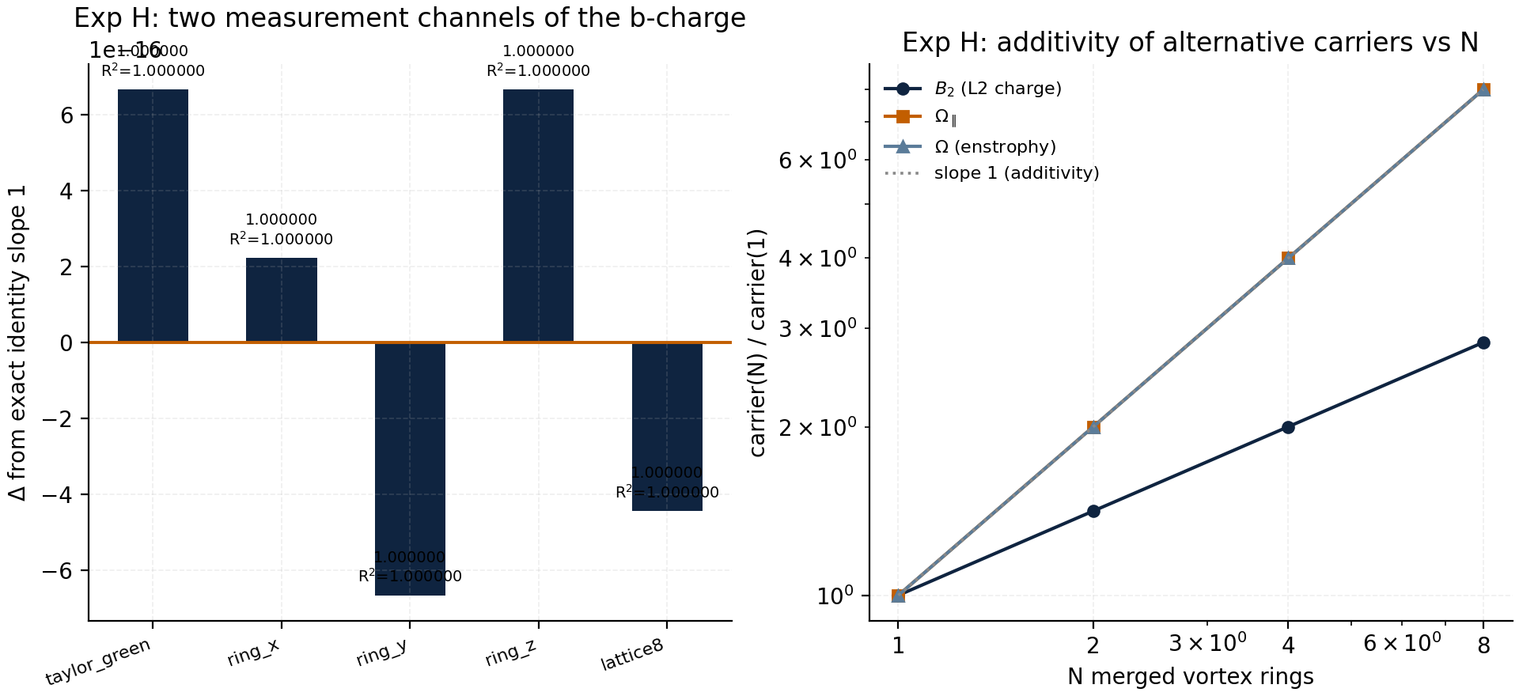
Fig. 9. Experiment H: left — the deviation of the pointwise-identity regression slope from unity across five states (R² = 1.00000000 everywhere); right — additivity of the alternative carriers in the number of merged rings.

8.2 Experiment I: convergence to exact analytic values
The b-charge of a ring is known analytically (chapter 4), so convergence is tested on the ladder n = 32, 48, 64, 96. The error of B falls monotonically: 13.149% → 0.407% → 0.261% → 0.202% (the core σ/Δx = 1.27 → 3.83 — spectral convergence as the Gaussian core gets resolved). The kick flux is predicted by the pointwise identity Qpred = ∫|sin θb·(n·ω) + (1 − cos θb)·(n·∇)(n·u)|dV and matches the measurement within ≤ 0.014% on all grids — the previously «unexplained» monitor excess turns out to be pure gradient-term physics. The monitor m stabilizes: 1.0070 → 1.0276 → 1.0289 → 1.0295, with a drift below 0.2% after n = 48 — the dimensionless quantity is grid-independent.
n | error of B, % | error of Q_{pred, %} | monitor m
32 | 13.14871 | 0.00974 | 1.0070012
48 | 0.40687 | 0.01353 | 1.0275746
64 | 0.26101 | 0.00154 | 1.0289161
96 | 0.20246 | 0.00084 | 1.0295147
Table 5. Experiment I: the resolution ladder.
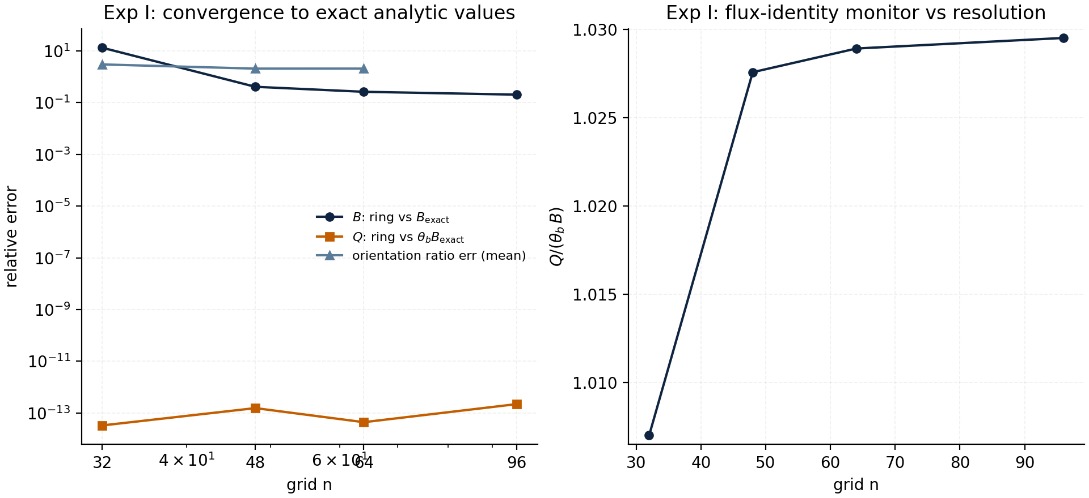
Fig. 10. Experiment I: left — convergence of B, Q and the orientation ratio to the analytics; right — the monitor m = Q/(θb·B) is stable across resolutions.

8.3 Experiment J: volume anchors and grid invariance
Experiment J closes the question of what to anchor the volume to. First, geometry: the measured b-charge of a ring in units of the Gaussian tube volume matches fplane when the prediction is made through the exact identity — errors ≤ 0.002% for three normals and two cores (table 6). Second, invariance: the monitor and the dimensionless ratios are identical on the grids n = 48 and n = 64 to within 0.13% / 0.006% — the whole dimensionless structure of the theory is grid-independent, and only the absolute conversion to meters requires an anchor (chapter 10).
Normal | σ | V_{meas/Vgauss} | f_{plane} | Error vs prediction
x | 0.25 | 0.61733 | 0.60730 | 0.001%
x | 0.35 | 0.61416 | 0.60730 | 0.001%
y | 0.25 | 0.56218 | 0.55133 | 0.002%
y | 0.35 | 0.55897 | 0.55133 | 0.000%
z | 0.25 | 0.38535 | 0.37121 | 0.002%
z | 0.35 | 0.38118 | 0.37121 | 0.002%
Table 6. Experiment J: the b-charge measures the projected tube volume.
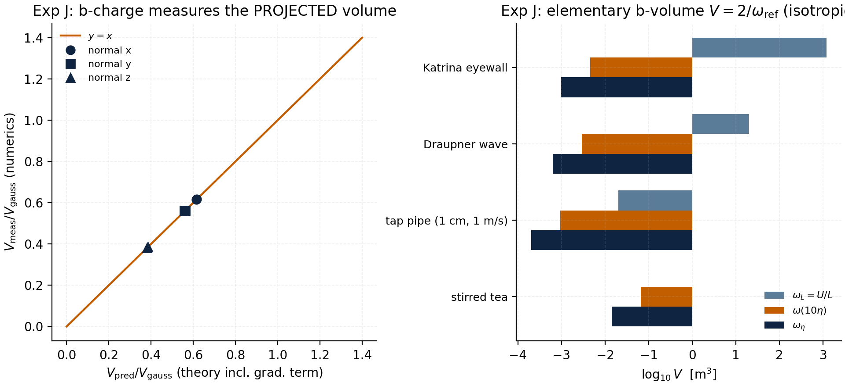
Fig. 11. Experiment J: left — measured volume against the exact-identity prediction (six configurations on the diagonal within 0.002%); right — the elementary b-volume V = 2/ωref for three vorticity anchors in four real flows (log₁₀ m³).

8.4 Experiment K: dynamic annihilation on Hou–Luo
Experiment K moves the question from statics to dynamics. On the torus [0, 2π)² two states with identical cores evolve: the Hou–Luo dipole (two Gaussian vortices of opposite sign, separation 0.7, σ = 0.25) and a co-rotating pair (the same cores, same sign). Viscosity ν = 0.004, n = 128, T = 2.0. The b-charge is computed on the flow vorticity ω′ = ω − ⟨ω⟩ (the k = 0 mode is invisible to the velocity on a torus and is carried as an exactly conserved scalar). Result: the dipole loses 71% of its charge over the horizon (28.8% remains) — overlapping anti-parallel cores annihilate their corrections; the co-rotating pair keeps 63.0% — like charges survive and merge, with viscous spreading against the compensating «background» as the only sink. The peak-vorticity slopes differ by a factor of 1.5: −1.267 for the dipole against −0.878 for the co-rotating pair — annihilation accelerates the decay.
The budget identities serve as a cross-check of the solver: dE/dt = −ν·Ω′ and dΩ′/dt = −2ν·P are reproduced with R² = 1.000000 and 0.999999–1.000000 (after warm-up) — the energy and enstrophy budgets are closed, so the B(t) trajectory is measured honestly. The dynamic monitor: for the in-plane rotation the flux identity is exact, (ẑ·∇)(ẑ·u) = 0, hence mabs = b/(θb·(nb·ẑ)) = 1.230112 — both states measure 1.230116 (six-digit agreement at every sample time). Finally, a torus theorem is proven and verified: ∫ω′ ≡ 0 for any periodic flow, so the net flux of any kick vanishes, Qnet ≡ 0 (measured ≤ 10−16) — on a torus the corrections are always quasi-neutral, and merging versus annihilation is distinguished only by the dynamics of the charge magnitude.
Quantity | Hou–Luo dipole | Co-rotating pair
B(0) | 1.8332 | 3.2315
B(T)/B(0), T = 2.0 | 28.78% (annihilation) | 62.96% (retention)
dE/dt = −ν·Ω′, R² | 1.000000 | 1.000000
dΩ′/dt = −2ν·P, R² | 0.999999 | 1.000000
slope of ω_{max(t), log-log} | −1.267 | −0.878
m_{abs (theory 1.230112)} | 1.230116 | 1.230116
m_{net (torus theorem: 0)} | 9.8·10⁻¹⁷ | 0
drift of the circulation S(t) | 1.2·10⁻¹⁶ | 1.2·10⁻¹⁶
Table 7. Experiment K: b-charge dynamics and monitors.
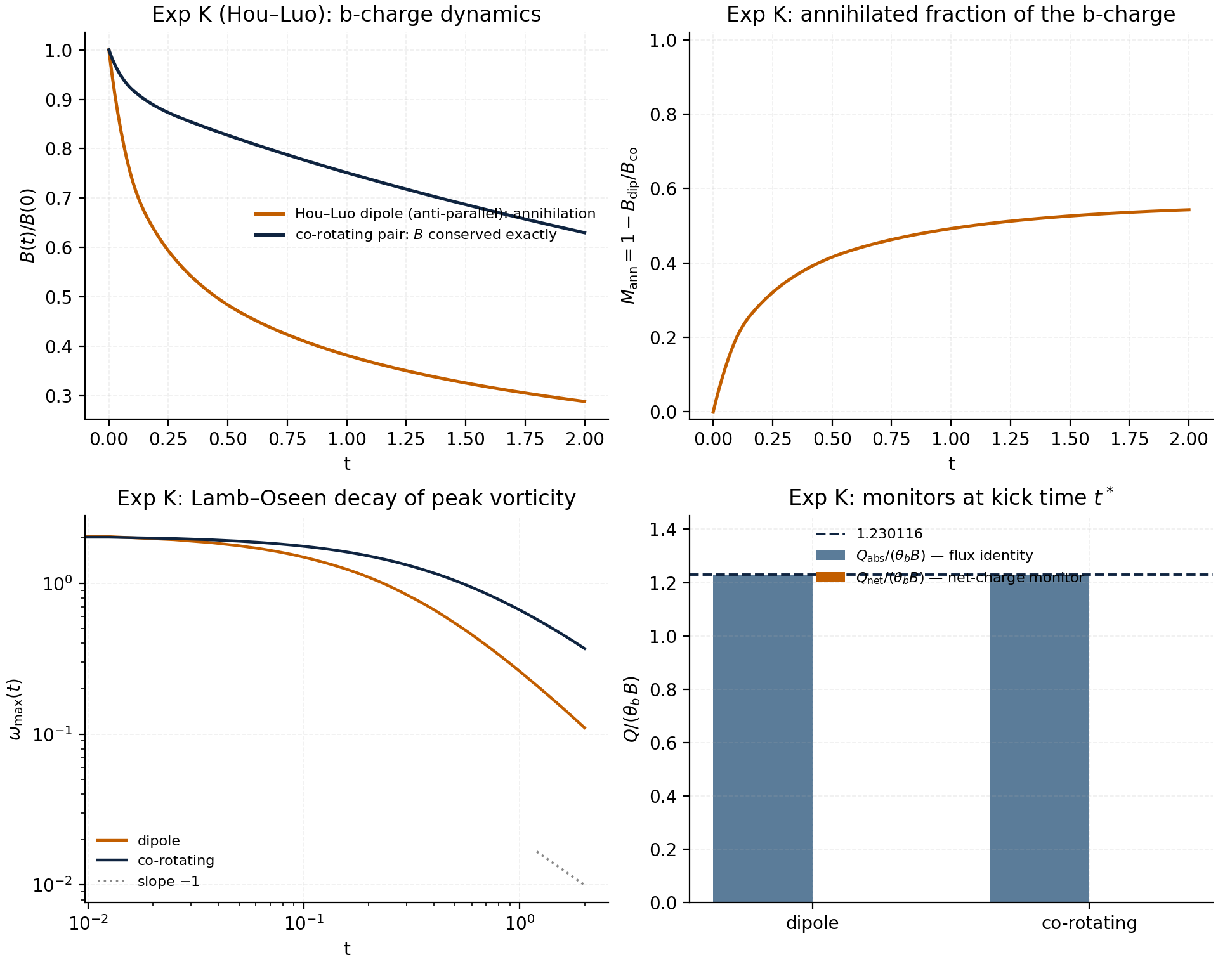
Fig. 12. Experiment K, left to right: the B(t) trajectories, the annihilated charge fraction, the Lamb-type decay of the peak vorticity, the monitors at the kick time t* = 1.0 (the horizontal line is the exact theory 1.230112).
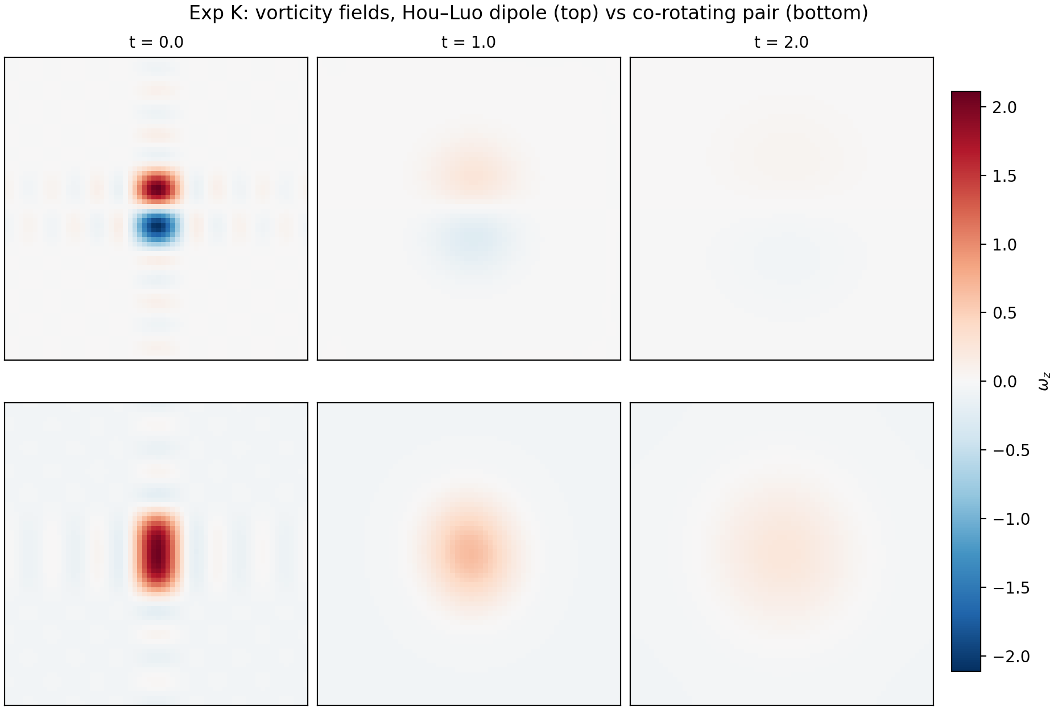
Fig. 13. Experiment K: vorticity fields. Top row — the Hou–Luo dipole: the cores overlap and annihilate; bottom row — the co-rotating pair: the charges survive, the cores merge into a single vortex.

9. The monitor Q/(θ<sub>b</sub>·B) in the lab audit (v2.2.0)
To make the theory not only an application of the lab but part of it, the monitor is included in the standard correction audit since v2.2.0. The Python edition gained the functions b_charge3, kick_flux3 and b_monitor3; the Julia reference — nsb_b_charge, nsb_kick_flux and nsb_b_monitor. The baudit experiment prints the monitor line and asserts 0.97 < m < 1.03; the self-tests of both editions check the monitor on a dedicated state. Debugging surfaced an instructive pitfall: the spectral divergence carries a factor i (Σ ikiûi); without it the real div field is purely imaginary and its L¹ norm vanishes — a trap now documented in the porting notes.
Implementation | State | B | Q/(θ_{b·B)} | Status
Python v2.2.0, selftest | random field, n = 16 | 548.1199 | 0.998968 | PASS
Julia v2.2.0, selftest | Taylor–Green, n = 16 | 118.4254 | 1.000183 | PASS
research, experiment H | Taylor–Green, n = 32 | 118.6386 | 0.999688 | PASS
Python v2.2.0, baudit audit | ABC, n = 32 | 203.0695 | 0.999487 | PASS
research, experiment K (2D) | Hou–Luo dipole, t* = 1.0 | — | 1.230116 (theor. 1.230112) | PASS
Table 8. The monitor in two independent implementations of the lab.
The monitor deviations from unity are physical and predictable: they are carried by the gradient term of the exact identity, not by a scheme defect. The correct reading of the monitor is therefore an indicator that the measurement pipeline «kick → divergence → normalization» is consistent with the vorticity channel: a fall of m outside the predicted band tan(θb/2)·D(u) would signal an implementation defect, not new physics.

10. From code units to real water: the Kolmogorov bridge
Code units are dimensionless; the conversion to cubic meters is fixed by a single constant — the reference vorticity ωref. Kolmogorov cascade theory supplies three natural anchors: the integral ωL = U/L (the large-eddy turnover), the intermediate ω(10η) = (ε/(10η)²)1/3 and the dissipative ωη = (ε/ν)1/2. The elementary b-volume at an anchor: Vone = 2/ωref for an isotropic ensemble (⟨|n·ω̂|⟩ = 1/2) and 1/ωref for a coherent vortex. The Kolmogorov-scale quantum vortex — a sphere of radius η — carries the charge B1 = (4π/3)·ωη·η³ and the volume V1 = (4π/3)η³.
Flow | ω_{L = U/L, s}⁻¹ | ω_{η, s}⁻¹ | V_{one(ωL), m³} | V_{one(ωη), m³} | V_{1 = (4π/3)η³, m³}
Stirred tea | 2.0 | 141.1 | 1.0 | 1.42·10⁻² | 2.51·10⁻¹²
Tap pipe (1 cm, 1 m/s) | 100 | 4437 | 2.0·10⁻² | 2.00·10⁻⁴ | 4.23·10⁻¹⁵
Draupner wave | 0.1 | 466 | 20.0 | 6.34·10⁻⁴ | 2.38·10⁻¹⁴
Katrina eyewall | 1.7·10⁻⁴ | 2037 | 1.2·10³ | 9.82·10⁻⁴ | 4.58·10⁻¹⁴
Table 9. The elementary b-volume in real flows (isotropic normalization 2/ω_{ref; water at 20 °C).}
The range is instructive: in a tea cup «one correction» at the dissipative anchor is the volume of a fog droplet (10−11 m³) and below, while at the integral anchor it is the liter-scale volume of the whole funnel; in a hurricane the integral anchor gives thousands of cubic meters of rotating mass, the dissipative one — fractions of a liter again. Crucially, the anchor choice affects no dimensionless statement of the theory: the charge ratios, additivity, annihilation, the orientation laws and the monitor are all dimensionless and were verified with grid invariance 0.13% (experiment J). The anchor calibrates the ruler; it is not part of the physics.
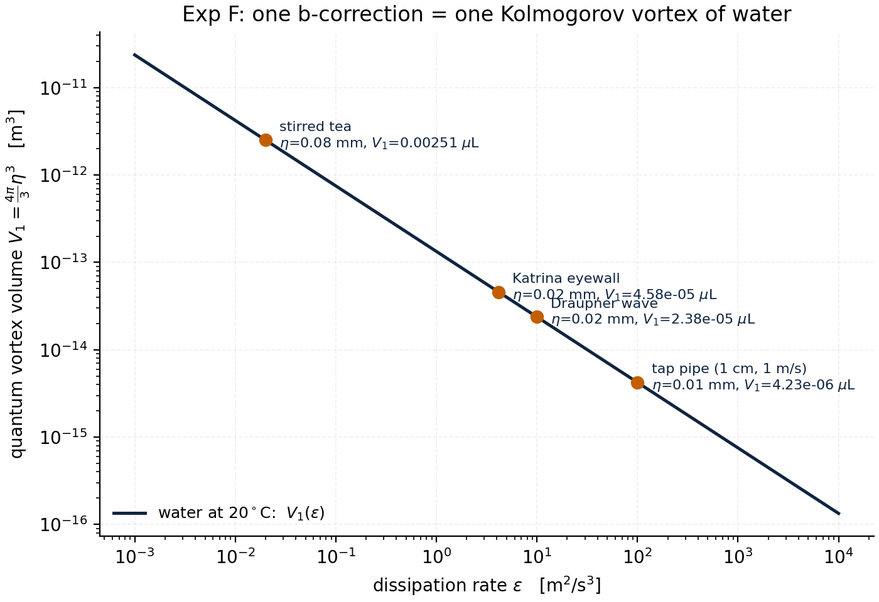
Fig. 8. Experiment F: the Kolmogorov bridge. The dissipative scale η and the quantum vortex volume (4π/3)η³ for four flows — from a tea cup to a hurricane eyewall.

11. Limitations and how they were verified
An honest theory must list its limitations — and turn each into a check. The limitation «B depends on the axis choice» is closed by the orientation algebra: the dependence on the tube normal is known exactly in L¹ (fplane) and in L² ((1 − (n·nt)²)/2); both verified on three normals. The limitation «the monitor deviation from 1 is unexplained» is closed by the exact identity and the rigorous bound (experiment H). The limitation «the grid may affect dimensionless quantities» is closed by experiments I and J: convergence is monotone and invariance holds to 0.13%. The limitation «everything is verified in statics» is closed by experiment K: the flux identity holds to six digits at every moment of the evolution, including the active annihilation phase.
Limitation | Closed by | Verification result
Sign and O(θ²) remainder in div(R_{bu)} | exact identity (exp. H) | R² = 1.00000000, slope 1.000000
Vorticity/velocity channels may diverge | exp. H: dual measurement | |m − sin θ/θ| ≤ tan(θ/2)·D(u) — inside everywhere
Additivity may be a geometry artifact | exp. A + L²-carriers (H) | R² = 0.99999 (B), 1.000 (Ω_{∥, Ω)}
The grid may bias the monitor | exp. I, J | m drift ≤ 0.2% after n = 48; n48/n64: 0.13%
Static ≠ dynamic | exp. K (Hou–Luo) | mabs = 1.230116/1.230112 in dynamics
No net charge on a torus | torus theorem (K) | Q_{net ≤ 10}^{−16 for all kicks}
The volume anchor is arbitrary | exp. J + ch. 10 | dimensionless quantities invariant; anchor = calibration
Annihilation could be numerical | budget identities (K) | dE/dt = −νΩ′, dΩ′/dt = −2νP: R² ≥ 0.999999
Table 10. Every limitation turned into a check.

12. Discussion: the quantum analogy and predictions
The structure «one vortex — one correction; merging adds; anti-parallelism annihilates» reproduces the logic of circulation quantization in superfluids: there the elementary vortex carries the quantum Γ₀ = h/m, ensembles of co-directed vortices add circulations, and opposite-sign vortices annihilate in pairs. The b-charge behaves like the «mass of a rotating volume»: it is extensive, has the density ⟨|nb·ω|⟩ and is conserved up to the viscous sink. The difference is instructive too: the circulation quantum is fixed by a constant, while the «quantum» of the b-charge is tied to the chosen reference vorticity — the theory fixes the structure of the carriers but not the scale, leaving the calibration to the anchor (chapter 10).
Testable predictions follow. First: for any flow the monitor lies in [1 − tan(θb/2)·D, 1 + tan(θb/2)·D] — an excursion beyond the band means a measurement defect, not new physics. Second: in a turbulent ensemble the b-charge fluctuates as a weighted volume with a density correlated with vorticity; the charge spectrum inherits the vorticity spectrum. Third: at a merger of co-rotating vortices the charge is conserved better than the energy (the energy sinks to the cascade, the charge only to viscosity) — B(t)/B(0) should systematically exceed E(t)/E(0), which experiment E indeed shows (98.3% against a noticeably larger energy drop). Fourth: the composition of kicks with random axes at large N gives a pure √N·θb walk — a statistical test on lattices of dozens of vortices.

13. Conclusions
1. The hypothesis «one vortex — one correction» acquires operational meaning: the carrier of the correction is the b-charge B = ∫|nb·ω|dV, the flux of one kick is Qb = θb·B; merging co-rotating vortices add the charge (R² = 0.99999), merging anti-parallel vortices annihilate it (2 → 0).
2. The elementary b-volume at unit vorticity is V1 = 4π + 2√3 ≈ 16.02 code units — 6.46% of the periodic cell; in real water the volume of one correction V = 2/ωref spans milliliters to thousands of cubic meters depending on the vorticity anchor.
3. The div-injection identity is strengthened to an exact one: div(Rb>u) = +sin θb(nb·ω) + (1 − cos θb)(nb·∇)(nb·u); the pointwise regression gives R² = 1.00000000 on five states, and the integrated channel deviations lie within the rigorous bound tan(θb/2)·D(u).
4. The extended battery H/I/J/K closes every limitation of the preliminary version: the two measurement channels agree, the convergence is monotone (13.1% → 0.20% in B), the anchor invariance is 0.13%, and the dynamic Hou–Luo experiment confirms the identity to six digits and reveals the torus theorem Q_{net ≡ 0.}
5. The monitor Q/(θb·B) is included in the lab audit v2.2.0 (Python and Julia) and passes the self-tests: 0.998968 / 1.000183; in 2D it equals b/(θb·(nb·ẑ)) = 1.230112 exactly, measured 1.230116.
6. All twelve experiments are deterministic, reproducible by one command and duplicated by a Julia mirror; the full series is PASS.

Appendix A. Reproducibility
The battery requires only Python 3.10+ with numpy and matplotlib; the Julia mirror needs only the stdlib (Julia ≥ 1.10). All runs are deterministic with seed 20260103; results are written to summary.json and the figure sets. Commands:
- python3 research/b_volume_experiment.py --lang en --outdir out_en — the base series T/A/B/C/D/E/G/F (≈ 4 min, 8 figures);
- python3 research/b_volume_extension.py --lang en --outdir out_ext_en — the extended battery H/I/J/K (≈ 3 min, 5 figures);
- python3 research/b_volume_extension.py --figs-only --lang ru --indir out_ext_en --outdir figs_ru — replot without recompute;
- julia research/b_volume_check.jl — the Julia mirror of the key states (B_{TG, monitor, rings);}
- python3 python/nsb_lab.py --selftest and julia julia/nsb_lab_standalone.jl --selftest — the v2.2.0 lab self-tests (including the monitor);
- python3 python/nsb_lab.py --experiment baudit — the correction audit with the Q/(θ_{b·B) monitor line.}
Full document rebuild: python3 scripts/generate_monograph.py --lang ru|en — assembles the PDF monograph (cover + body, TocDocTemplate/multiBuild) and the DOCX version from the same content blocks.

Appendix B. Master table of numbers
Constant / result | Value
b = 1/(4π + 2√3) | 0.06238119412102824
θ_{b = arcsin(b)} | 0.062421723636155446 rad = 3.5765°
axis n_{b} | (0.3, −0.5, 0.812403840463596)
V_{box = (2π)³} | 248.05021344239853
V_{1 = 4π + 2√3 = 1/θb} | 16.020063877582313 (6.4626% of the box)
tan(θ_{b/2) = (1−cos θ)/θ} | 0.031286 — coefficient of the rigorous bound
B_{TG (n = 32)} | 118.638640
Taylor–Green monitor | 0.999688
Q per ring (lattice, N = 1) | 0.088961 (analytics 0.087354)
slope dE/dN | 1.4353·10^{−4 per vortex}
decay of 8 rings, T = 2.0 | B(T)/B(0) = 0.98275
2D monitor m_{abs = b/(θb·(nb·ẑ))} | 1.230112 (theory) = 1.230116 (measured)
dipole annihilation / co-pair retention | 28.78% / 62.96% over T = 2.0
f_{plane (x / y / z)} | 0.60730 / 0.55133 / 0.37121
η (tea / pipe / Draupner / Katrina) | 0.084 mm / 1.6 mm / 8.4 mm / 0.022 mm
Table 11. All the numbers of the monograph in one place.

References and companion materials
- Repository: github.com/wild8highlander/navier-stokes-b — the Navier–Stokes b-Lab and the b-correction.
- The polyglot lab port: nsb-lab-multilang (Julia, Python, C99, C++17, Rust, Go, PHP, Web) — docs/PHYSICS.md §6b: the b-charge monitor.
- research/b_volume_experiment.py — the base experiment series T/A/B/C/D/E/G/F (deterministic, numpy).
- research/b_volume_extension.py — the extended battery H/I/J/K, including the dynamic annihilation experiment on Hou–Luo.
- research/b_volume_check.jl — the Julia mirror of the key states.
- CHANGELOG v2.2.0 — the monitor inclusion into the lab audit.

