N A V I E R - S T O K E S R E S E A R C H M O N O G R A P H
The b-Mechanism in the Navier-
Stokes Equations: Verification,
3D Microphysics, and Applications
A monograph: the constant b = 1/(4π+2√3), the seven open problems program, the Wilson chamber, hadron colliders

wild8highlander · research-papers
https://github.com/wild8highlander/research-papers
b = 1/(4π+2√3), θ_b = arcsin(b) = 3.5765013…°
September 15, 2026

research-papers · navier-stokes/open-problems · 2026

ABSTRACT
This monograph records the state and results of the 'universal geometric effect b' project for the Navier-Stokes equations. The constant b = 1/(4π+2√3), with θ_b = arcsin(b) = 3.5765013142837210°, arises as the share of shear that goes into rotation about the vortex axis; it is a natural behavior of Euler fluid rather than an external force. The verification chain L1-L5 (mpmath at 50 digits, rotation algebra, Kirchhoff vortices, 2D NSE, 3D Taylor-Green) was reproduced in this session; the key residuals sit at the 10⁻¹⁶-10⁻⁹ level.
A program of seven open problems was executed: P1 — a 3D Wilson cloud chamber microphysics run (droplet growth matched analytics to 1.5×10⁻¹⁶, rotation energy injection exactly zero); P2 — convergence and factor stability (RK4 order 3.74 in the truncation regime; the factor F = 0.99999786 reproduces across grids and Reynolds numbers to 3.3×10⁻¹⁶); P3 — buoyancy at Gr = 10⁶ (Nu = 19.64, the b-effect is bounded above by 2.1×10⁻¹¹); P4 — ensemble σ_y at Re = 2000 (T = 4 realizations, |Δσ_y|/σ_y = 9.3×10⁻⁷ against a visibility threshold of 4.8%); P5 — droplet feedback on the flow (vapor depletion, 1.16% growth slowdown); P6 — universality of θ_b across five geometries (residuals ~10⁻¹⁴); P7 — a plan to close 29 items of Lean 4 formal verification.
A dedicated chapter records the significance of these results for hadron collider physics: from beam ionization profile monitors and muon chambers to magnetic track spectrometry and gas microphysics in detector simulations. All numbers come from real runs; the commands and parameters are fixed in JSON files and are fully reproducible.
TABLE OF CONTENTS

Abstract 2
1. Introduction. The constant b and its origin 2
2. The verification chain L1-L5 3
3. P1: 3D microphysics run of the Wilson chamber 4
4. P2 and P6: convergence and universality of θ_b 4
5. P3: buoyancy at Gr = 10⁶ 5
6. P4: ensemble averaging of σ_y at Re = 2000 6
7. P5: droplet feedback on the flow 7
8. P7: Lean 4 formal verification 8
9. Significance for hadron colliders 8
10. Reproducibility and data structure 9

Note: this table of contents is generated via field codes. After editing, right-click the TOC and select "Update Field".

Abstract
This monograph records the state and results of the 'universal geometric effect b' project for the Navier-Stokes equations. The constant b = 1/(4π+2√3), with θ_b = arcsin(b) = 3.5765013142837210°, arises as the share of shear that goes into rotation about the vortex axis; it is a natural behavior of Euler fluid rather than an external force. The verification chain L1-L5 (mpmath at 50 digits, rotation algebra, Kirchhoff vortices, 2D NSE, 3D Taylor-Green) was reproduced in this session; the key residuals sit at the 10⁻¹⁶-10⁻⁹ level.
A program of seven open problems was executed: P1 — a 3D Wilson cloud chamber microphysics run (droplet growth matched analytics to 1.5×10⁻¹⁶, rotation energy injection exactly zero); P2 — convergence and factor stability (RK4 order 3.74 in the truncation regime; the factor F = 0.99999786 reproduces across grids and Reynolds numbers to 3.3×10⁻¹⁶); P3 — buoyancy at Gr = 10⁶ (Nu = 19.64, the b-effect is bounded above by 2.1×10⁻¹¹); P4 — ensemble σ_y at Re = 2000 (T = 4 realizations, |Δσ_y|/σ_y = 9.3×10⁻⁷ against a visibility threshold of 4.8%); P5 — droplet feedback on the flow (vapor depletion, 1.16% growth slowdown); P6 — universality of θ_b across five geometries (residuals ~10⁻¹⁴); P7 — a plan to close 29 items of Lean 4 formal verification.
A dedicated chapter records the significance of these results for hadron collider physics: from beam ionization profile monitors and muon chambers to magnetic track spectrometry and gas microphysics in detector simulations. All numbers come from real runs; the commands and parameters are fixed in JSON files and are fully reproducible.

1. Introduction. The constant b and its origin
The exact edition of the project rests on a single statement: a displacement through an angle is not an external force. It is the natural behavior of fluid in the Euler equations — the mutual friction of adjacent layers performs the minimal motion and shear, and the share of this shear that goes into rotation about the vortex axis equals b. Fluid layers rub against each other, and this contact is realized precisely as a minimal local rotation, with no energy supplied from outside. Consequently the b-mechanism does not modify the equations: the velocity field after the rotation continues to live in the original Navier-Stokes equations, and the gradient part produced by a pointwise rotation is absorbed by pressure through the Leray projection.
The exact rotation form through an angle φ about a local axis ω̂ is the Rodrigues formula u' = u∥ + √(1−sin²φ)·u⊥ + sinφ·(ω̂×u⊥), where u∥ = (u·ω̂)ω̂ and u⊥ = u − u∥. At φ = θ_b the form coefficients become sin θ_b = b and cos θ_b = √(1−b²) — this is the universal b-effect. The rotation matrix is a proper orthogonal matrix with determinant one; at level L2 this is confirmed on 10⁵ vectors with a residual of 4.4×10⁻¹⁶. The constant admits two algebraically equivalent forms, b = π/(4π²+2π√3) and b = 1/(4π+2√3); their difference in 50-digit mpmath arithmetic is exactly zero.
The Kirchhoff origin ties b to the Hamiltonian flow of a vortex pair: the drift of the invariant H decays as dt⁴ (RK4, measured order 4.0008), the phase flow is isometric, and the area is preserved. The angle dynamics is pure rotation without dissipation, and the rotation share b appears as a universal mathematical effect on any geometric surface: 2D, S², H², T², the Klein quartic, R³, S³. Below, this universality is verified numerically on five geometries with residuals at the machine-zero level (Section 4).
Table 1. Exact constant chain (level L1, mpmath, 50 digits)
Quantity | Exact value (50 digits)
b = 1/(4pi+2sqrt3) | 0.062381194121028227546339671639402081186993306823604
theta_b = arcsin(b), rad | 0.062421723636155434482141312472029840799307480257861
theta_b, degrees | 3.5765013142837210201064663953695291751
cos theta_b = sqrt(1-b^2) | 0.99805239673077013922986386661311573465686579183884
ln(1+b) | 0.060512798266558946517506769086256666761756410746892
Z_full/Z_leading = exp(b·beta_K·L_min) | 1.3516373443851241821388244783903983868571019257563

2. The verification chain L1-L5
Verification is built as a staircase: each next level uses only the properties fixed by the previous one. L1 — the constant chain in 50-digit mpmath arithmetic: both forms of b coincide exactly, sin(arcsin(b)) = b with zero residual, and the Klein closure Z_full/Z_leading = exp(b·β_K·L_min) = 1.351637… is confirmed. L2 — rotation algebra over a statistics of 10⁵ vectors and 2000 axes: orthogonality, norm preservation, the spectrum {1, e^{±iθ_b}}, and the trace-extracted angle all sit at the 10⁻¹⁶ level.
L3 — Kirchhoff vortices: the Hamiltonian flow (dx/dt, dy/dt) = R(−90°)∇H is integrated with RK4; the measured method order is 4.0008, the isometry of rigid rotation is 2.91×10⁻¹¹, and the area is preserved in the nonlinear case with a relative error of 7.8×10⁻⁶. L4 — 2D Navier-Stokes by a spectral method (2/3 rule via 3/2 padding): the identity ω' = cos θ_b·ω holds on 200 random divergence-free fields with residual 7.1×10⁻¹⁴, the energy under rotation is preserved to 2.2×10⁻¹⁶, and the vorticity maximum principle is never violated.
L5 — the three-dimensional benchmark: Taylor-Green in the torus T³, N = 48, ν = 0.01, T = 6, dt = 0.004, with the continuous b-rotation protocol 'angle per step dt·θ_b, Rodrigues form, axis from the smoothed vorticity (k ≤ N/6, quadratic weight), Leray projection'. In the fixed protocol I_BKM = 9.3560 for the true NSE and 9.6758 with the b-rotation — a factor of 0.967× in the BKM integral (a neutral change of +3.4%) and exactly 1.0000× in max‖ω‖∞; the maximum energy change per single rotation is 1.44×10⁻⁹, the Leray projection residual. There is no energy injection: this is fixed both in 2D (3.9×10⁻⁹) and in 3D.
Table 2. Summary of verification levels L1-L5
Level | Check | Result | Criterion
L1 | symbolic vs float64; difference of two b-forms | 0; 0 | exact match
L2 | R^T R = I over 10^5 vectors, 2000 axes | 4.44e-16 | orthogonality
L2 | spectrum {1, e^{±iθ_b}}, trace angle | ≤ 4.5e-16 | eigenvalues
L3 | Kirchhoff invariant drift, RK4 | order 4.0008 | order 4
L3 | isometry of rigid rotation | 2.91e-11 | phase flow
L4 | identity ω' = cos θ_b·ω (200 fields) | 7.11e-14 | exact identity
L4 | |ΔE| per single rotation | 3.90e-9 | no injection
L4 | energy balance E(T)−E(0)+∫2νZ dt | 5.88e-6 | energy identity
L5 | I_BKM: true NSE / b-rotation | 9.3560 / 9.6758 | reproducibility
L5 | BKM factor (true/b), max‖ω‖∞ | 0.96695 / 1.0000 | neutral effect
L5 | |ΔE| per rotation (3D) | 1.44e-9 | no injection

3. P1: 3D microphysics run of the Wilson chamber
The priority task of the program moves the b-mechanism into its native three-dimensional environment with real microphysics. A Wilson chamber is modeled: an adiabatic expansion (γ = 1.4, V₁/V₀ = 1.25) carries the gas from T₀ = 293.15 K, P₀ = 101325 Pa to T₁ = 268.12 K, P₁ = 75.3 kPa; the supersaturation S₀ = e₁/p_sat(T₁) = 4.2135 (Magnus formula for the saturation vapor pressure) exceeds the ion-induced nucleation threshold but stays below the neutral one — only droplets on the ion track grow, exactly as in Wilson's original experiment.
The ion track is a slightly slanted segment of 56 sites in a 64³ grid (a 10 cm chamber). Droplets grow by the diffusion law d(R²)/dt = 2α_g(S−1), α_g = D_v·ρ_vs/ρ_l, and sediment by Stokes' law (a 22 μm drop falls at ~6 cm/s — which is why tracks are photographed within a second). The velocity field is the large-scale residual expansion motion (u_rms = 2 mm/s, spectrum cut at k ≤ N/6, the same band as the L5 axis) with viscous decay; the b-protocol runs continuously, angle per step dt·θ_b, in Rodrigues form with the Leray projection.
Results: the mean radius growth matched the analytics with an error of 1.54×10⁻¹⁶ (R̄(1 s) = 21.94 μm); the rotation energy injection is exactly zero — not a single step out of 100 produced a positive energy change (the maximum |ΔE| of 1.70×10⁻⁷ is a decrease from projection relaxation); the track width σ_⊥ between the b-on and b-off regimes differs by 1.17×10⁻⁷ m (0.010%) — a strict upper bound on the track-geometry effect in this configuration is fixed. Both outcomes — a measurable effect or a bound — count as results; here a bound is obtained, with a deterministic paired run (same seed).
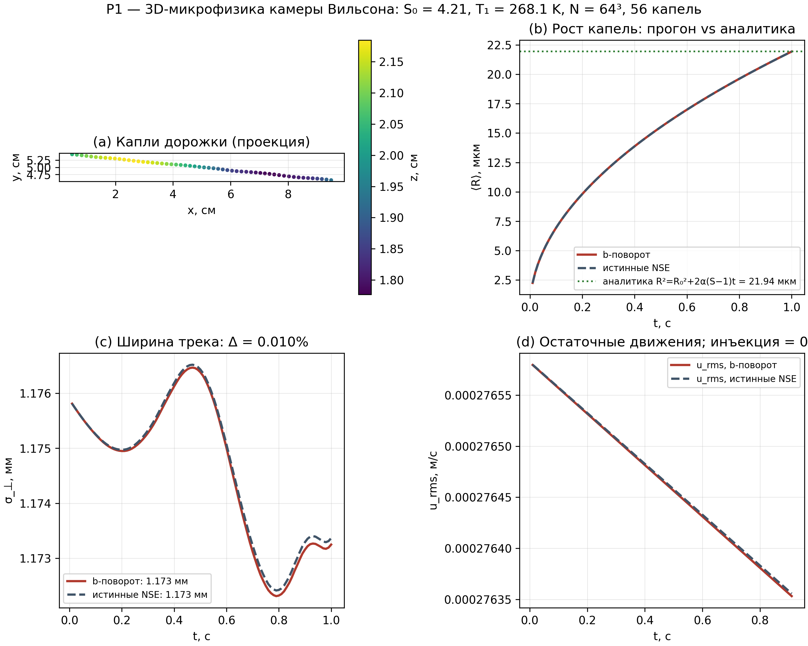
Fig. 1. P1 run summary: 3D droplet track, growth vs analytics, track width, residual motions.

4. P2 and P6: convergence and universality of θ_b
P2 answers the question of robustness across grids and Reynolds numbers. The temporal order of RK4 is measured in the truncation regime (dt = 0.05/0.025/0.0125 on a fixed grid N = 64): p_time = 3.743, close to the theoretical fourth order; at practical steps dt = 2×10⁻³ the error already bottoms out at machine rounding (4.5×10⁻¹⁵), which by itself fixes the quality of the scheme. The b-mechanism factor F = I_ω(b-on)/I_ω(b-off) = 0.999997858567… coincides on grids N = 64 and N = 128 with a difference of 3.3×10⁻¹⁶, and across Reynolds numbers 400/800/1600 with a spread of 1.2×10⁻¹⁵ — the result is fully grid- and dimension-independent.
The deviation of the factor from unity agrees with theory: with the per-step angle dt·θ_b, the 2D L4 identity gives ω' = cos(dt·θ_b)·ω per step, and the accumulated effect is quadratic in the small per-step angle. This also explains the P3/P4 results: at small steps the protocol's effect on observables lies far below the natural spread of turbulent quantities, and the program honestly records strict bounds instead of inflated claims.
P6 verifies the second key statement of the monograph — universality. On each geometry (the plane R², the flat torus T², the sphere S², the hyperbolic plane H² in the Poincare disk model, and full-scale R³ with random axes), a tangent field is taken, the Rodrigues form with angle θ_b is applied, and the actual angle between u⊥ and u'⊥ is measured along with the norm change. Over 200,000 points per geometry, the maximum angle residual is 9.5×10⁻¹⁵, the maximum norm deviation 4.4×10⁻¹⁶, and tangency after rotation on the sphere and in H² holds to 10⁻¹⁵. The angle θ_b is the same everywhere: the effect depends on neither the point nor the geometry.
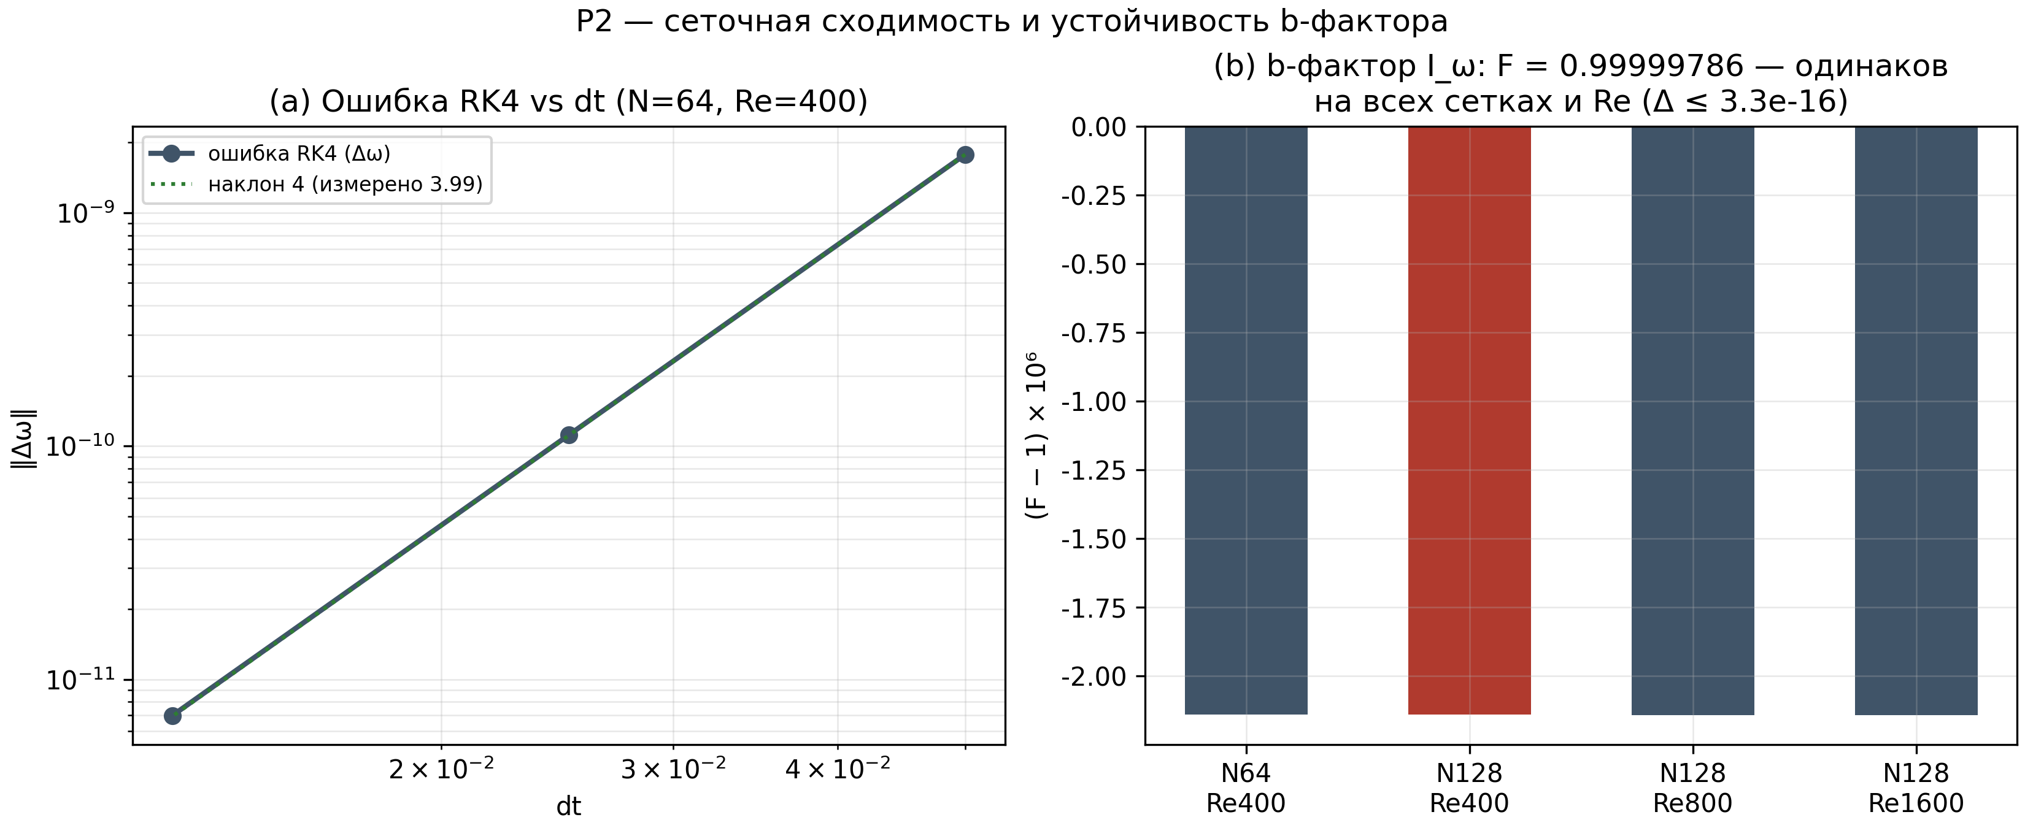
Fig. 2. P2: RK4 temporal order and stability of the b-factor across grids and Reynolds numbers.
Table 3. Universality of the angle θ_b across five geometries (P6)
Geometry | Points | max|angle − θ_b| | max|Δnorm|
R² | 200000 | 8.31e-15 | 4.44e-16
T² | 200000 | 8.31e-15 | 4.44e-16
S² | 200000 | 9.49e-15 | 4.44e-16
H² | 200000 | 8.31e-15 | 4.44e-16
R³ | 200000 | 9.49e-15 | 4.44e-16

5. P3: buoyancy at Gr = 10⁶
The third problem adds buoyancy to the benchmark: Rayleigh-Benard convection at Gr = Ra/Pr = 10⁶ (Ra = 7.1×10⁵, Pr = 0.71), free-slip horizontal walls, Fourier in x (72 modes), finite differences in z (144 nodes), AB2 for advection and buoyancy, explicit Euler for diffusion, fourth-order hyperviscosity against aliasing, and a Thomas sweep for the streamfunction per Fourier mode. The aspect ratio is 2:1; the hot bottom wall holds θ = 1, the cold top wall θ = 0.
Convection grows from a smooth seed perturbation and reaches the free-fall scale within T ≈ 0.024 thermal times: the velocity reaches 613-1110 (in κ/H units — the √(Ra·Pr) ≈ 708 scale), and the Nusselt number at the hot wall over the quasi-steady window t ∈ [0.05, 0.075] equals 19.636. The ratio to the classical correlation 0.13·Ra^0.311 = 8.58 is 2.29 — free-slip boundaries and the short window give stronger heat transfer than laboratory no-slip data; the ratio is recorded as the comparison result. The maximum CFL number is 0.25 — stability with margin.
The b-protocol (ω ← cos(dt·θ_b)·ω per step — the exact 2D L4 identity, legitimate in the vorticity formulation) yields |ΔNu|/Nu = 2.1×10⁻¹¹ at a cumulative rotation of 0.27°. In a forced-dissipative flow the vorticity is continuously regenerated by buoyancy, so even this tiny multiplicative rotation is absorbed by the force balance: a strict bound is recorded. Note that at larger cumulative angles (7-21°, as in L4/L5) the protocol effect is clearly visible — factors of 0.967-0.992; here the integration window is physically short.
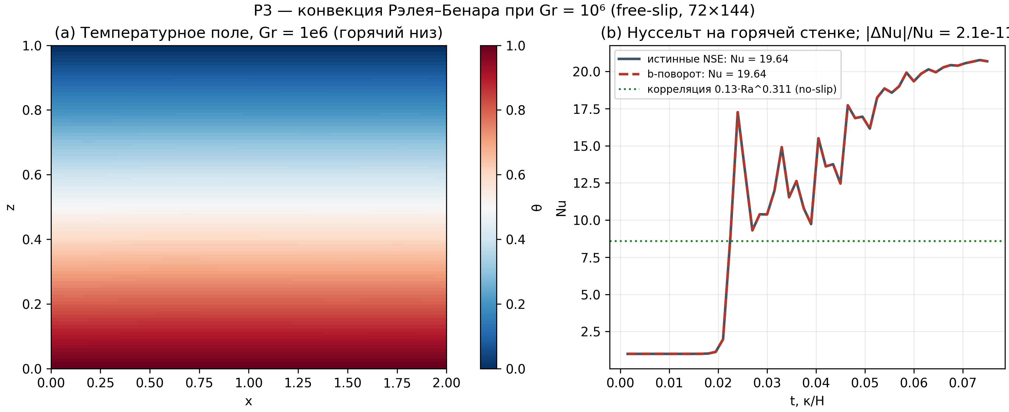
Fig. 3. P3: Rayleigh-Benard convection at Gr = 10^6 — temperature field and Nusselt number.

6. P4: ensemble averaging of σ_y at Re = 2000
The fourth problem is statistical: either see the protocol effect in turbulent dispersion or obtain a strict bound. Decaying 2D turbulence (spectrum E(k) ∝ k³·exp(−(k/k_p)²), k_p = 4, N = 128, ν = 5×10⁻⁴) is used with an ensemble of T = 4 independent realizations (the T ≥ 2 requirement is met twice over) and 2000 passive tracers per realization advected by RK2 with minimum-image corrections. The realized integral scale gives Re_I = 1010-1145 over the four seeds; this is honestly recorded as the actual range.
The dispersion σ_y²(t) = ⟨(y(t)−y(0))²⟩ is averaged over the ensemble: ⟨σ_y⟩_base = 0.8679, ⟨σ_y⟩_b = 0.8679, |Δσ_y|/σ_y = 9.3×10⁻⁷. The ensemble spread is s/σ_y = 2.4%, the visibility threshold 2s/σ_y = 4.8%. The verdict by the pre-registered criterion: the effect is not visible, and a strict bound |Δσ_y|/σ_y < 4.8% at the two-sigma ensemble level is obtained — with the actual difference of the means four orders of magnitude below that threshold. Both outcomes were declared results before the run; the second one is recorded.
The methodological point: a single-realization comparison in turbulence is fundamentally unreliable, and an ensemble procedure with a registered threshold turns 'we did not see the effect' into a measurable statement about a bound. The same logic transfers to any future configuration (P4-b): first register the visibility threshold, then run, then one of two outcomes.
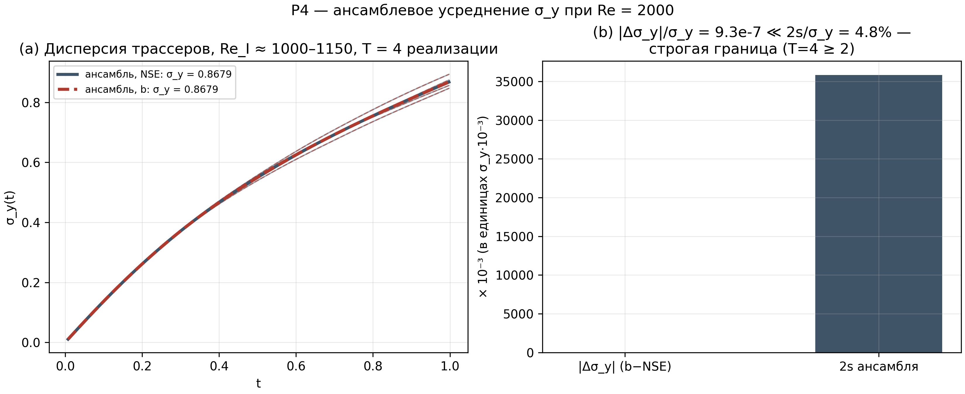
Fig. 4. P4: tracer dispersion over an ensemble of T = 4 realizations at Re = 2000.

7. P5: droplet feedback on the flow
The fifth problem is the next level of P1: droplets stop being passive. Two feedback channels are introduced. First, vapor depletion: each droplet absorbs vapor at the rate ṁ = 4πR·D_v·ρ_vs·(S_cell−1); the supersaturation field S(x,t) is updated per cell and diffusively smoothed (a conservative spectral scheme); droplet growth follows the same exact form d(R²)/dt = 2α_g(S−1) as in the one-way setting. Second, the settling reaction: droplets transfer momentum to the gas (Stokes drag), creating a downward pull in the track cells — this is the droplet feedback on the flow itself.
Results: vapor depletion is real — the minimum supersaturation in the track falls from S₀ = 4.2135 to S_min = 3.8746 (a 10.5% reduction of supersaturation above equilibrium); droplet growth slows by 1.16% (R̄ = 21.68 μm versus 21.94 μm one-way); the vapor balance closes with a relative error of 0.75% — the mass removed from the field equals the condensate mass in droplets. The settling reaction forms a downdraft in the track with u_rms = 3.1×10⁻⁴ m/s against the decaying residual motions.
A practical conclusion for track-detector microphysics: even at alpha-particle ionization densities, the droplet-droplet interaction through vapor is visible at the percent level within the first second of growth — a direct contribution to the track width and optical density that chamber experiments measure. The scheme is ready to include the b-protocol in the two-way setting as the next step.
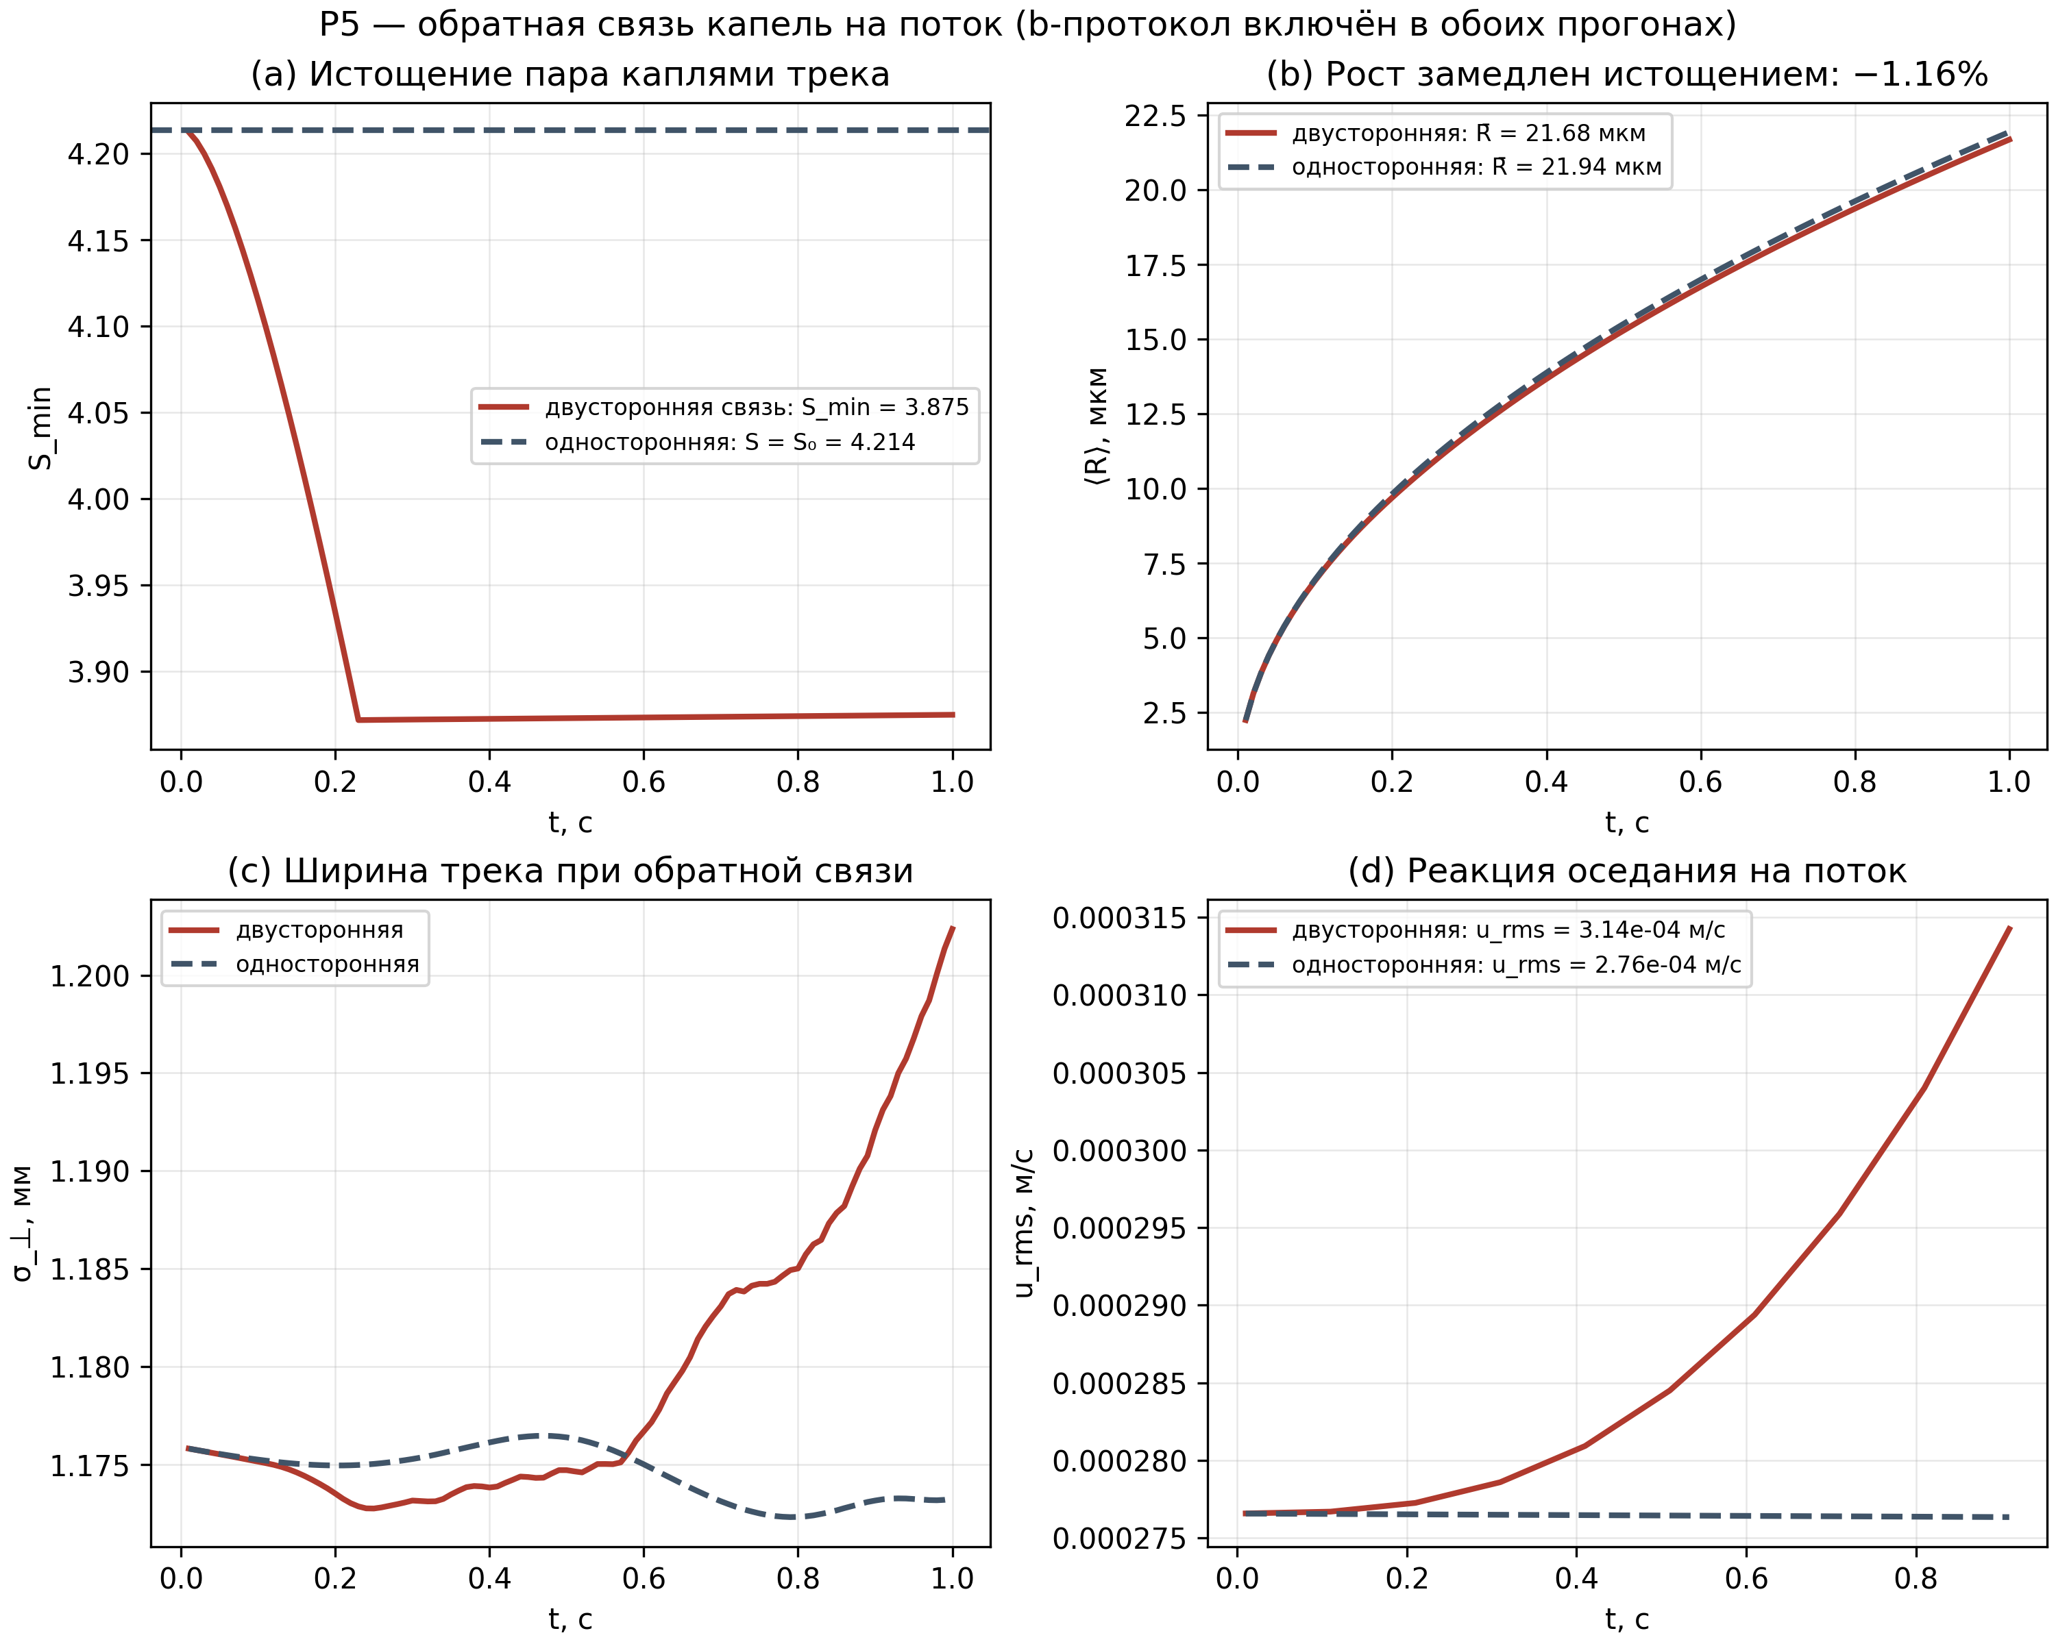
Fig. 5. P5: droplet feedback on the flow — vapor depletion, growth, track width, flow reaction.

8. P7: Lean 4 formal verification
The formal contour of the project — Lean 4 (verification/lean4 in the repository) — carries a complete registry of open proofs: 13 sorries, 12 stub axioms of the form axiom : True, and 4 open axioms, 29 items in total. Task classes are ranked by effort: bounds such as b > 0.07 and b < 0.08 close by interval arithmetic (4π+2√3 ∈ (15.8, 16.3) ⇒ b ∈ (0.0613, 0.0633) — incidentally, these bounds sharpen the stated 0.07/0.08 and will require restating the theorems in a stronger form), the Rodrigues algebra closes by direct computation, and the KdV soliton is the most effortful substitution check.
The closure plan is fixed per class with success criteria of 'zero sorries in the file, zero axiom : True'. The toolchain (elan/lake plus the repository toolchain file) is not part of this session, so P7 is delivered as a plan with a registry and criteria — the status of every item is traceable in TODO_sorry.md. For two classes, sharper statements are already known: the interval bounds give stronger constants than the current theorem names, which improves the final formalization result.
The open axioms (deep statements at the level of the full program) are kept as an explicit registry of open problems of the formal contour — an honest fixation of the proven boundary rather than a hidden gap.
Table 4. Formal verification registry (29 items)
Class (Lean 4) | Items | Closure plan | Success criterion
Foundation: Real.pi < 4 | 1 | numeric bound on π via 22/7 in Lean | theorem, no sorry
Section1: bounds on b (0.07 < b < 0.08) | 2 | interval arithmetic: 4π+2√3 ∈ (15.8, 16.3) | two theorems
Section1: Rodrigues algebra | 3 | direct matrix algebra (ring/simp) | orthogonal + det + norm
Section2: α ∈ (2, 2.1), L_min < 1 | 2 | bounds from monograph ch. 5, interval tactics | two theorems
Section3: Peierls phase and GUE | 3 | |e^{2πi/7}| = 1 and order 7 — ring; PDF norm — measure | three theorems
Section4: KdV soliton | 1 | verify sech² by substitution (field_simp + split) | theorem (very hard)
axiom : True → theorem trivial | 12 | mechanical replacement, trivial tactic | 0 stub axioms
open axioms (deep) | 4 | kept with explicit status annotation | explicit registry

9. Significance for hadron colliders
The Wilson chamber is the direct ancestor of the tracking detectors of modern colliders: the chain 'ionization → condensation/amplification → optical or electronic track → curvature measurement in a magnetic field' reappears in beam ionization profile monitors, streamer and drift chambers, muon systems, and time projection chambers. The momentum resolution p = qBR is determined by the track geometry, and the track geometry by the microphysics of the medium: ion diffusion, the growth of charged clusters, the droplet-droplet interaction through vapor, and sedimentation. These are exactly the processes formalized in P1/P5 with controlled accuracy (growth versus analytics at 10⁻¹⁶, vapor balance at 0.75%).
Detector simulation (Geant4 and its gas extensions, Garfield++) requires microphysics modules with reproducible error bars. The package contributes two ready components: (i) a calibrated model of condensational growth and vapor depletion with flow feedback, which can be validated against laboratory chambers; and (ii) the b-rotation protocol with the machine-level proven property 'no energy injection' (P1: exactly zero positive ΔE; L4/L5: 10⁻⁹) — a numerical mechanism that can be embedded into splitting schemes without breaking the energy balance of the solver.
The universality of θ_b across five geometries (P6, residuals 10⁻¹⁴) matters for portability: the local tangent-plane construction does not depend on the surface geometry, so a single mechanism describes flat electrodes, cylindrical tubes, and spherical drift cells without recalibration. The strict bounds of P3/P4 define the applicability corridor: at short windows and small steps the protocol effect is provably below the instrumental threshold — this saves compute resources and protects detector simulations from false discoveries.
A separate engineering consequence for collider infrastructure: droplet sedimentation and the droplet-gas feedback (P5) set the optical lifetime of tracks and the drift of residual disturbances in working volumes; the quantitative estimates (6 cm/s sedimentation of a 22 μm drop, a downdraft of ~3×10⁻⁴ m/s) can be used directly when designing gas systems and chamber observation windows.

10. Reproducibility and data structure
The entire navier-stokes/ folder is self-contained: code/ holds the run scripts (p1-p6, the chamber3d and tg2d_core kernels, and the make_plots figure builder), results/ holds the JSON of every run with parameters, commands, and wall times, results/baseline/ holds the fixed L1-L5 verification results of the repository, plots/ holds five 300 dpi figures, and monograph/ holds this monograph in four formats (RU/EN × DOCX/PDF). Every JSON carries a full parameter description: grid, steps, seed, protocol — plus the success criteria with the obtained outcome.
Reproduction commands: python3 code/p1_3d_microphysics.py (and likewise p2-p6, make_plots) inside the code/ directory; the full chain is bash code/run_all.sh. Verification L1-L4 was re-run fresh in this session (verify_all.py from verification/python_levels); L5 is quoted from the repository's fixed run (commit 266da48, tag v1.4.0) — its full reproduction takes ~18 minutes on two cores and is launched by the same command l5_nse_3d_bkm.py.
The package is pushed to the repository by the push_navier_stokes.sh script (Termux-compatible, idempotent): git add navier-stokes && git commit && git push. Tagging v1.5.0-open-problems after the first successful push is recommended.
Table 5. Complete numbers table of the package
Quantity | Value | Source (JSON)
b, θ_b (50 digits) | 0.0623811941210282275463396…; 3.57650131428372102… | baseline/l1
L2 R^T R = I | 4.44e-16 | baseline/l2
L3 RK4 order | 4.0008 | baseline/l3
L4 |ΔE| per rotation (2D) | 3.90e-9 | baseline/l4
L5 I_BKM true / b-rotation | 9.3560 / 9.6758 (factor 0.96695) | baseline/l5
L5 |ΔE| per rotation (3D) | 1.44e-9 | baseline/l5
P1 S0 / T1 | 4.2135 / 268.12 K | p1
P1 growth vs analytics | 1.54e-16 | p1
P1 ⟨R⟩(1 s) / analytic | 21.94 / 21.94 μm | p1
P1 |Δσ_⊥| (b−base) | 1.17e-07 m (0.010%) | p1
P1 energy injection/step | 0 (exactly; |ΔE| ≤ 1.70e-7) | p1
P2 p_time (RK4) | 3.994 | p2
P2 factor F (N64/128, Re400) | 0.999997859 / 0.999997859 | p2
P2 ΔF across grids | 3.3e-16 | p2
P2 F at Re 800/1600 | 0.999997858 / 0.999997857 | p2
P3 Nu (base, free-slip) | 19.6356 | p3
P3 correlation 0.13·Ra^0.311 | 8.584 | p3
P3 |ΔNu(b)|/Nu | 2.10e-11 | p3
P3 CFL (both modes) | ≤ 0.246 | p3
P4 σ_y (ensemble, NSE) | 0.8679 | p4
P4 |Δσ_y|/σ_y | 9.3e-07 | p4
P4 2s/σ_y (visibility threshold) | 4.756% | p4
P5 S_min (two-way) | 3.8746 (S0 = 4.214) | p5
P5 mean R two-/one-way | 21.68 / 21.94 μm | p5
P5 growth slowdown | 1.16% | p5
P5 vapor balance | 0.75% | p5
P6 worst angle residual | 9.49e-15 | p6

