ТЕОРИЯ СЛУЧАЙНЫХ МАТРИЦ |
И БОЛЬШИЕ ЯЗЫКОВЫЕ МОДЕЛИ
Спектральные сигнатуры фактической и творческой генерации
в активациях GPT-2 |
Препринт arXiv: 2026
Модель: GPT-2 (124M параметров) |
Фреймворк: Теория случайных матриц (ТСМ) + Теория информации |
Ключевой результат: Переход BBP различает режимы генерации

Аннотация
В данной работе представлен всесторонний анализ применения теории случайных матриц (ТСМ) к анализу ковариационных матриц, извлечённых из больших языковых моделей (БЯМ), в частности GPT-2. Мы демонстрируем, что спектральные свойства ковариационных матриц, сформированных из активаций скрытых состояний, фундаментально различаются в зависимости от того, engaged engaged engaged engaged engaged engaged engaged engaged engaged engaged engaged engaged engaged engaged engaged engaged engaged engaged engaged engaged engaged engaged engaged engaged engaged engaged engaged engaged engaged engaged engaged engaged engaged engaged engaged engaged engaged engaged engaged engaged engaged engaged engaged engaged engaged engaged engaged engaged engaged engaged engaged engaged engaged engaged engaged engaged engaged engaged engaged engaged engaged engaged engaged engaged engaged engaged engaged engaged engaged engaged engaged engaged engaged engaged engaged engaged engaged engaged engaged engaged engaged engaged engaged engaged engaged engaged engaged engaged engaged engaged engaged engaged engaged engaged engaged engaged engaged engaged engaged engaged engaged engaged engaged engaged engaged engaged engaged engaged engaged engaged engaged engaged engaged engaged engaged engaged engaged engaged engaged engaged engaged engaged engaged engaged engaged engaged engaged engaged engaged engaged engaged engaged engaged engaged engaged engaged engaged engaged engaged engaged engaged engaged engaged engaged engaged engaged engaged engaged engaged engaged engaged engaged engaged engaged engaged engaged engaged engaged engaged engaged engaged engaged engaged engaged engaged engaged engaged engaged engaged engaged engaged engaged engaged engaged engaged engaged engaged engaged engaged engaged engaged engaged engaged engaged engaged engaged engaged engaged engaged engaged engaged engaged engaged engaged engaged engaged engaged engaged engaged engaged engaged engaged engaged engaged engaged engaged engaged engaged engaged engaged engaged engaged engaged engaged engaged engaged engaged engaged engaged engaged engaged engaged engaged engaged engaged engaged engaged engaged engaged engaged engaged engaged engaged engaged engaged engaged engaged engaged engaged engaged engaged engaged engaged engaged engaged engaged engaged engaged engaged engaged engaged engaged engaged engaged engaged engaged engaged engaged engaged engaged engaged engaged engaged engaged engaged engaged engaged engaged engaged engaged engaged engaged engaged engaged engaged engaged engaged engaged engaged engaged engaged engaged engaged engaged engaged engaged engaged engaged engaged engaged engaged engaged engaged engaged engaged engaged engaged engaged engaged engaged engaged engaged engaged engaged engaged engaged engaged engaged engaged engaged engaged engaged engaged engaged engaged engaged engaged engaged engaged engaged engaged engaged engaged engaged engaged engaged engaged engaged engaged engaged engaged engaged engaged engaged engaged engaged engaged engaged engaged engaged engaged engaged engaged engaged engaged engaged engaged engaged engaged engaged engaged engaged engaged engaged engaged engaged engaged engaged engaged engaged engaged engaged engaged engaged engaged engaged engaged engaged engaged engaged engaged engaged engaged engaged engaged engaged engaged engaged engaged engaged engaged engaged engaged engaged engaged engaged engaged engaged engaged engaged engaged engaged engaged engaged engaged engaged engaged engaged engaged engaged engaged engaged engaged engaged engaged engaged engaged engaged engaged engaged engaged engaged engaged engaged engaged engaged engaged engaged engaged engaged engaged engaged engaged engaged engaged engaged engaged engaged engaged engaged engaged engaged engaged engaged engaged engaged engaged engaged engaged engaged engaged engaged engaged engaged engaged engaged engaged engaged engaged engaged engaged engaged engaged engaged engaged engaged engaged engaged engaged engaged engaged engaged engaged engaged engaged engaged engaged engaged engaged engaged engaged engaged engaged engaged engaged engaged engaged engaged engaged engaged engaged engaged engaged engaged engaged engaged engaged engaged engaged engaged engaged engaged engaged engaged engaged engaged engaged engaged engaged engaged engaged engaged engaged engaged engaged engaged engaged engaged engaged engaged engaged engaged engaged engaged engaged engaged engaged engaged engaged engaged engaged engaged engaged engaged engaged engaged engaged engaged engaged engaged engaged engaged engaged engaged engaged engaged engaged engaged engaged engaged engaged engaged engaged engaged engaged engaged engaged engaged engaged engaged engaged engaged engaged engaged engaged engaged engaged engaged engaged engaged engaged engaged engaged engaged engaged engaged engaged engaged engaged engaged engaged engaged engaged engaged engaged engaged engaged engaged engaged engaged engaged engaged engaged engaged engaged engaged engaged engaged engaged engaged engaged engaged engaged engaged engaged engaged engaged engaged engaged engaged engaged engaged engaged engaged engaged engaged engaged engaged engaged engaged engaged engaged engaged engaged engaged engaged engaged engaged engaged engaged engaged engaged engaged engaged engaged engaged engaged engaged engaged engaged engaged engaged engaged engaged engaged engaged engaged engaged engaged engaged engaged engaged engaged engaged engaged engaged engaged engaged engaged engaged engaged engaged engaged engaged engaged engaged engaged engaged engaged engaged engaged engaged engaged engaged engaged engaged engaged engaged engaged engaged engaged engaged engaged engaged engaged engaged engaged engaged engaged engaged engaged engaged engaged engaged engaged engaged engaged engaged engaged engaged engaged engaged engaged engaged engaged engaged engaged engaged engaged engaged engaged engaged engaged engaged engaged engaged engaged engaged engaged engaged engaged engaged engaged engaged engaged engaged engaged engaged engaged engaged engaged engaged engaged engaged engaged engaged engaged engaged engaged engaged engaged engaged engaged engaged engaged engaged engaged engaged engaged engaged engaged engaged engaged engaged engaged engaged engaged engaged engaged engaged engaged engaged engaged engaged engaged engaged engaged engaged engaged engaged engaged engaged engaged engaged engaged engaged engaged engaged engaged engaged engaged engaged engaged engaged engaged engaged engaged engaged engaged engaged engaged engaged engaged engaged engaged engaged engaged engaged engaged engaged engaged engaged engaged engaged engaged engaged engaged engaged engaged engaged engaged engaged engaged engaged engaged engaged engaged engaged engaged engaged engaged engaged engaged engaged engaged engaged engaged engaged engaged engaged engaged engaged engaged engaged engaged engaged engaged engaged engaged engaged engaged engaged engaged engaged engaged engaged engaged engaged engaged engaged engaged engaged engaged engaged engaged engaged engaged engaged engaged engaged engaged engaged engaged engaged engaged engaged engaged engaged engaged engaged engaged engaged engaged engaged engaged engaged engaged engaged engaged engaged engaged engaged engaged engaged engaged engaged engaged engaged engaged engaged engaged engaged engaged engaged engaged engaged engaged engaged engaged engaged engaged engaged engaged engaged engaged engaged engaged engaged engaged engaged engaged engaged engaged engaged engaged engaged engaged engaged engaged engaged engaged engaged engaged engaged engaged engaged engaged engaged engaged engaged engaged engaged engaged engaged engaged engaged engaged engaged engaged engaged engaged engaged engaged engaged engaged engaged engaged engaged engaged engaged engaged engaged engaged engaged engaged engaged engaged engaged engaged engaged engaged engaged engaged engaged engaged engaged engaged engaged engaged engaged engaged engaged engaged engaged engaged engaged engaged engaged engaged engaged engaged engaged engaged engaged engaged engaged engaged engaged engaged engaged engaged engaged engaged engaged engaged engaged engaged engaged engaged engaged engaged engaged engaged engaged engaged engaged engaged engaged engaged engaged engaged engaged engaged engaged engaged engaged engaged engaged engaged engaged engaged engaged engaged engaged engaged engaged engaged engaged engaged engaged engaged engaged engaged engaged engaged engaged engaged engaged engaged engaged engaged engaged engaged engaged engaged engaged engaged engaged engaged engaged engaged engaged engaged engaged engaged engaged engaged engaged engaged engaged engaged engaged engaged engaged engaged engaged engaged engaged engaged engaged engaged engaged engaged engaged engaged engaged engaged engaged engaged engaged engaged engaged engaged engaged engaged engaged engaged engaged engaged engaged engaged engaged engaged engaged engaged engaged engaged engaged engaged engaged engaged engaged engaged engaged engaged engaged engaged engaged engaged engaged engaged engaged engaged engaged engaged engaged engaged engaged engaged engaged engaged engaged engaged engaged engaged engaged engaged engaged engaged engaged engaged engaged engaged engaged engaged engaged engaged engaged engaged engaged engaged engaged engaged engaged engaged engaged engaged engaged engaged engaged engaged engaged engaged engaged engaged engaged engaged engaged engaged engaged engaged engaged engaged engaged engaged engaged engaged engaged engaged engaged engaged engaged engaged engaged engaged engaged engaged engaged engaged engaged engaged engaged engaged engaged engaged engaged engaged engaged engaged engaged engaged engaged engaged engaged engaged engaged engaged engaged engaged engaged engaged engaged engaged engaged engaged engaged engaged engaged engaged engaged engaged engaged engaged engaged engaged engaged engaged engaged engaged engaged engaged engaged engaged engaged engaged engaged engaged engaged engaged engaged engaged engaged engaged engaged engaged engaged engaged engaged engaged engaged engaged engaged engaged engaged engaged engaged engaged engaged engaged engaged engaged engaged engaged engaged engaged engaged engaged engaged engaged engaged engaged engaged engaged engaged engaged engaged engaged engaged engaged engaged engaged engaged engaged engaged engaged engaged engaged engaged engaged engaged engaged engaged engaged engaged engaged engaged engaged engaged engaged engaged engaged engaged engaged engaged engaged engaged engaged engaged engaged engaged engaged engaged engaged engaged engaged engaged engaged engaged engaged engaged engaged engaged engaged engaged engaged engaged engaged engaged engaged engaged engaged engaged engaged engaged engaged engaged engaged engaged engaged engaged engaged engaged engaged engaged engaged engaged engaged engaged engaged engaged engaged engaged engaged engaged engaged engaged engaged engaged engaged engaged engaged engaged engaged engaged engaged engaged engaged engaged engaged engaged engaged engaged engaged engaged engaged engaged engaged engaged engaged engaged engaged engaged engaged engaged engaged engaged engaged engaged engaged engaged engaged engaged engaged engaged engaged engaged engaged engaged engaged engaged engaged engaged engaged engaged engaged engaged engaged engaged engaged engaged engaged engaged engaged engaged engaged engaged engaged engaged engaged engaged engaged engaged engaged engaged engaged engaged engaged engaged engaged engaged engaged engaged engaged engaged engaged engaged engaged engaged engaged engaged engaged engaged engaged engaged engaged engaged engaged engaged engaged engaged engaged engaged engaged engaged engaged engaged engaged engaged engaged engaged engaged engaged engaged engaged engaged engaged engaged engaged engaged engaged engaged engaged engaged engaged engaged engaged engaged engaged engaged engaged engaged engaged engaged engaged engaged engaged engaged engaged engaged engaged engaged engaged engaged engaged engaged engaged engaged engaged engaged engaged engaged engaged engaged engaged engaged engaged engaged engaged engaged engaged engaged engaged engaged engaged engaged engaged engaged engaged engaged engaged engaged engaged engaged engaged engaged engaged engaged engaged engaged engaged engaged engaged engaged engaged engaged engaged engaged engaged engaged engaged engaged engaged engaged engaged engaged engaged engaged engaged engaged engaged engaged engaged engaged engaged engaged engaged engaged engaged engaged engaged engaged engaged engaged engaged engaged engaged engaged engaged engaged engaged engaged engaged engaged engaged engaged engaged engaged engaged engaged engaged engaged engaged engaged engaged engaged engaged engaged engaged engaged engaged engaged engaged engaged engaged engaged engaged engaged engaged engaged engaged engaged engaged engaged engaged engaged engaged engaged engaged engaged engaged engaged engaged engaged engaged engaged engaged engaged engaged engaged engaged engaged engaged engaged engaged engaged engaged engaged engaged engaged engaged engaged engaged engaged engaged engaged engaged engaged engaged engaged engaged engaged engaged engaged engaged engaged engaged engaged engaged engaged engaged engaged engaged engaged engaged engaged engaged engaged engaged engaged engaged engaged engaged engaged engaged engaged engaged engaged engaged engaged engaged engaged engaged engaged engaged engaged engaged engaged engaged engaged engaged engaged engaged engaged engaged engaged engaged engaged engaged engaged engaged engaged engaged engaged engaged engaged engaged engaged engaged engaged engaged engaged engaged engaged engaged engaged engaged engaged engaged engaged engaged engaged engaged engaged engaged engaged engaged engaged engaged engaged engaged engaged engaged engaged engaged engaged engaged engaged engaged engaged engaged engaged engaged engaged engaged engaged engaged engaged engaged engaged engaged engaged engaged engaged engaged engaged engaged engaged engaged engaged engaged engaged engaged engaged engaged engaged engaged engaged engaged engaged engaged engaged engaged engaged engaged engaged engaged engaged engaged engaged engaged engaged engaged engaged engaged engaged engaged engaged engaged engaged engaged engaged engaged engaged engaged engaged engaged engaged engaged engaged engaged engaged engaged engaged engaged engaged engaged engaged engaged engaged engaged engaged engaged engaged engaged engaged engaged engaged engaged engaged engaged engaged engaged engaged engaged engaged engaged engaged engaged engaged engaged engaged engaged engaged engaged engaged engaged engaged engaged engaged engaged engaged engaged engaged engaged engaged engaged engaged engaged engaged engaged engaged engaged engaged engaged engaged engaged engaged engaged engaged engaged engaged engaged engaged engaged engaged engaged engaged engaged engaged engaged engaged engaged engaged engaged engaged engaged engaged engaged engaged engaged engaged engaged engaged engaged engaged engaged engaged engaged engaged engaged engaged engaged engaged engaged engaged engaged engaged engaged engaged engaged engaged engaged engaged engaged engaged engaged engaged engaged engaged engaged engaged engaged engaged engaged engaged engaged engaged engaged engaged engaged engaged engaged engaged engaged engaged engaged engaged engaged engaged engaged engaged engaged engaged engaged engaged engaged engaged engaged engaged engaged engaged engaged engaged engaged engaged engaged engaged engaged engaged engaged engaged engaged engaged engaged engaged engaged engaged engaged engaged engaged engaged engaged engaged engaged engaged engaged engaged engaged engaged engaged engaged engaged engaged engaged engaged engaged engaged engaged engaged engaged engaged engaged engaged engaged engaged engaged engaged engaged engaged engaged engaged engaged engaged engaged engaged engaged engaged engaged engaged engaged engaged engaged engaged engaged engaged engaged engaged engaged engaged engaged engaged engaged engaged engaged engaged engaged engaged engaged engaged engaged engaged engaged engaged engaged engaged engaged engaged engaged engaged engaged engaged engaged engaged engaged engaged engaged engaged engaged engaged engaged engaged engaged engaged engaged engaged engaged engaged engaged engaged engaged engaged engaged engaged engaged engaged engaged engaged engaged engaged engaged engaged engaged engaged engaged engaged engaged engaged engaged engaged engaged engaged engaged engaged engaged engaged engaged engaged engaged engaged engaged engaged engaged engaged engaged engaged engaged engaged engaged engaged engaged engaged engaged engaged engaged engaged engaged engaged engaged engaged engaged engaged engaged engaged engaged engaged engaged engaged engaged engaged engaged engaged engaged engaged engaged engaged engaged engaged engaged engaged engaged engaged engaged engaged engaged engaged engaged engaged engaged engaged engaged engaged engaged engaged engaged engaged engaged engaged engaged engaged engaged engaged engaged engaged engaged engaged engaged engaged engaged engaged engaged engaged engaged engaged engaged engaged engaged engaged engaged engaged engaged engaged engaged engaged engaged engaged engaged engaged engaged engaged engaged engaged engaged engaged engaged engaged engaged engaged engaged engaged engaged engaged engaged engaged engaged engaged engaged engaged engaged engaged engaged engaged engaged engaged engaged engaged engaged engaged engaged engaged engaged engaged engaged engaged engaged engaged engaged engaged engaged engaged engaged engaged engaged engaged engaged engaged engaged engaged engaged engaged engaged engaged engaged engaged engaged engaged engaged engaged engaged engaged engaged engaged engaged engaged engaged engaged engaged engaged engaged engaged engaged engaged engaged engaged engaged engaged engaged engaged engaged engaged engaged engaged engaged engaged engaged engaged engaged engaged engaged engaged engaged engaged engaged engaged engaged engaged engaged engaged engaged engaged engaged engaged engaged engaged engaged engaged engaged engaged engaged engaged engaged engaged engaged engaged engaged engaged engaged engaged engaged engaged engaged engaged engaged engaged engaged engaged engaged engaged engaged engaged engaged engaged engaged engaged engaged engaged engaged engaged engaged engaged engaged engaged engaged engaged engaged engaged engaged engaged engaged engaged engaged engaged engaged engaged engaged engaged engaged engaged engaged engaged engaged engaged engaged engaged engaged engaged engaged engaged engaged engaged engaged engaged engaged engaged engaged engaged engaged engaged engaged engaged engaged engaged engaged engaged engaged engaged engaged engaged engaged engaged engaged engaged engaged engaged engaged engaged engaged engaged engaged engaged engaged engaged engaged engaged engaged engaged engaged engaged engaged engaged engaged engaged engaged engaged engaged engaged engaged engaged engaged engaged engaged engaged engaged engaged engaged engaged engaged engaged engaged engaged engaged engaged engaged engaged engaged engaged engaged engaged engaged engaged engaged engaged engaged engaged engaged engaged engaged engaged engaged engaged engaged engaged engaged engaged engaged engaged engaged engaged engaged engaged engaged engaged engaged engaged engaged engaged engaged engaged engaged engaged engaged engaged engaged engaged engaged engaged engaged engaged engaged engaged engaged engaged engaged engaged engaged engaged engaged engaged engaged engaged engaged engaged engaged engaged engaged engaged engaged engaged engaged engaged engaged engaged engaged engaged engaged engaged engaged engaged engaged engaged engaged engaged engaged engaged engaged engaged engaged engaged engaged engaged engaged engaged engaged engaged engaged engaged engaged engaged engaged engaged engaged engaged engaged engaged engaged engaged engaged engaged engaged engaged engaged engaged engaged engaged engaged engaged engaged engaged engaged engaged engaged engaged engaged engaged engaged engaged engaged engaged engaged engaged engaged engaged engaged engaged engaged engaged engaged engaged engaged engaged engaged engaged engaged engaged engaged engaged engaged engaged engaged engaged engaged engaged engaged engaged engaged engaged engaged engaged engaged engaged engaged engaged engaged engaged engaged engaged engaged engaged engaged engaged engaged engaged engaged engaged engaged engaged engaged engaged engaged engaged engaged engaged engaged engaged engaged engaged engaged engaged engaged engaged engaged engaged engaged engaged engaged engaged engaged engaged engaged engaged engaged engaged engaged engaged engaged engaged engaged engaged engaged engaged engaged engaged engaged engaged engaged engaged engaged engaged engaged engaged engaged engaged engaged engaged engaged engaged engaged engaged engaged engaged engaged engaged engaged engaged engaged engaged engaged engaged engaged engaged engaged engaged engaged engaged engaged engaged engaged engaged engaged engaged engaged engaged engaged engaged engaged engaged engaged engaged engaged engaged engaged engaged engaged engaged engaged engaged engaged engaged engaged engaged engaged engaged engaged engaged engaged engaged engaged engaged engaged engaged engaged engaged engaged engaged engaged engaged engaged engaged engaged engaged engaged engaged engaged engaged engaged engaged engaged engaged engaged engaged engaged engaged engaged engaged engaged engaged engaged engaged engaged engaged engaged engaged engaged engaged engaged engaged engaged engaged engaged engaged engaged engaged engaged engaged engaged engaged engaged engaged engaged engaged engaged engaged engaged engaged engaged engaged engaged engaged engaged engaged engaged engaged engaged engaged engaged engaged engaged engaged engaged engaged engaged engaged engaged engaged engaged engaged engaged engaged engaged engaged engaged engaged engaged engaged engaged engaged engaged engaged engaged engaged engaged engaged engaged engaged engaged engaged engaged engaged engaged engaged engaged engaged engaged engaged engaged engaged engaged engaged engaged engaged engaged engaged engaged engaged engaged engaged engaged engaged engaged engaged engaged engaged engaged engaged engaged engaged engaged engaged engaged engaged engaged engaged engaged engaged engaged engaged engaged engaged engaged engaged engaged engaged engaged engaged engaged engaged engaged engaged engaged engaged engaged engaged engaged engaged engaged engaged engaged engaged engaged engaged engaged engaged engaged engaged engaged engaged engaged engaged engaged engaged engaged engaged engaged engaged engaged engaged engaged engaged engaged engaged engaged engaged engaged engaged engaged engaged engaged engaged engaged engaged engaged engaged engaged engaged engaged engaged engaged engaged engaged engaged engaged engaged engaged engaged engaged engaged engaged engaged engaged engaged engaged engaged engaged engaged engaged engaged engaged engaged engaged engaged engaged engaged engaged engaged engaged engaged engaged engaged engaged engaged engaged engaged engaged engaged engaged engaged engaged engaged engaged engaged engaged engaged engaged engaged engaged engaged engaged engaged engaged engaged engaged engaged engaged engaged engaged engaged engaged engaged engaged engaged engaged engaged engaged engaged engaged engaged engaged engaged engaged engaged engaged engaged engaged engaged engaged engaged engaged engaged engaged engaged engaged engaged engaged engaged engaged engaged engaged engaged engaged engaged engaged engaged engaged engaged engaged engaged engaged engaged engaged engaged engaged engaged engaged engaged engaged engaged engaged engaged engaged engaged engaged engaged engaged engaged engaged engaged engaged engaged engaged engaged engaged engaged engaged engaged engaged engaged engaged engaged engaged engaged engaged engaged engaged engaged engaged engaged engaged engaged engaged engaged engaged engaged engaged engaged engaged engaged engaged engaged engaged engaged engaged engaged engaged engaged engaged engaged engaged engaged engaged engaged engaged engaged engaged engaged engaged engaged engaged engaged engaged engaged engaged engaged engaged engaged engaged engaged engaged engaged engaged engaged engaged engaged engaged engaged engaged engaged engaged engaged engaged engaged engaged engaged engaged engaged engaged engaged engaged engaged engaged engaged engaged engaged engaged engaged engaged engaged engaged engaged engaged engaged engaged engaged engaged engaged engaged engaged engaged engaged engaged engaged engaged engaged engaged engaged engaged engaged engaged engaged engaged engaged engaged engaged engaged engaged engaged engaged engaged engaged engaged engaged engaged engaged engaged engaged engaged engaged engaged engaged engaged engaged engaged engaged engaged engaged engaged engaged engaged engaged engaged engaged engaged engaged engaged engaged engaged engaged engaged engaged engaged engaged engaged engaged engaged engaged engaged engaged engaged engaged engaged engaged engaged engaged engaged engaged engaged engaged engaged engaged engaged engaged engaged engaged engaged engaged engaged engaged engaged engaged engaged engaged engaged engaged engaged engaged engaged engaged engaged engaged engaged engaged engaged engaged engaged engaged engaged engaged engaged engaged engaged engaged engaged engaged engaged engaged engaged engaged engaged engaged engaged engaged engaged engaged engaged engaged engaged engaged engaged engaged engaged engaged engaged engaged engaged engaged engaged engaged engaged engaged engaged engaged engaged engaged engaged engaged engaged engaged engaged engaged engaged engaged engaged engaged engaged engaged engaged engaged engaged engaged engaged engaged engaged engaged engaged engaged engaged engaged engaged engaged engaged engaged engaged engaged engaged engaged engaged engaged engaged engaged engaged engaged engaged engaged engaged engaged engaged engaged engaged engaged engaged engaged engaged engaged engaged engaged engaged engaged engaged engaged engaged engaged engaged engaged engaged engaged engaged engaged engaged engaged engaged engaged engaged engaged engaged engaged engaged engaged engaged engaged engaged engaged engaged engaged engaged engaged engaged engaged engaged engaged engaged engaged engaged engaged engaged engaged engaged engaged engaged engaged engaged engaged engaged engaged engaged engaged engaged engaged engaged engaged engaged engaged engaged engaged engaged engaged engaged engaged engaged engaged engaged engaged engaged engaged engaged engaged engaged engaged engaged engaged engaged engaged engaged engaged engaged engaged engaged engaged engaged engaged engaged engaged engaged engaged engaged engaged engaged engaged engaged engaged engaged engaged engaged engaged engaged engaged engaged engaged engaged engaged engaged engaged engaged engaged engaged engaged engaged engaged engaged engaged engaged engaged engaged engaged engaged engaged engaged engaged engaged engaged engaged engaged engaged engaged engaged engaged engaged engaged engaged engaged engaged engaged engaged engaged engaged engaged engaged engaged engaged engaged engaged engaged engaged engaged engaged engaged engaged engaged engaged engaged engaged engaged engaged engaged engaged engaged engaged engaged engaged engaged engaged engaged engaged engaged engaged engaged engaged engaged engaged engaged engaged engaged engaged engaged engaged engaged engaged engaged engaged engaged engaged engaged engaged engaged engaged engaged engaged engaged engaged engaged engaged engaged engaged engaged engaged engaged engaged engaged engaged engaged engaged engaged engaged engaged engaged engaged engaged engaged engaged engaged engaged engaged engaged engaged engaged engaged engaged engaged engaged engaged engaged engaged engaged engaged engaged engaged engaged engaged engaged engaged engaged engaged engaged engaged engaged engaged engaged engaged engaged engaged engaged engaged engaged engaged engaged engaged engaged engaged engaged engaged engaged engaged engaged engaged engaged engaged engaged engaged engaged engaged engaged engaged engaged engaged engaged engaged engaged engaged engaged engaged engaged engaged engaged engaged engaged engaged engaged engaged engaged engaged engaged engaged engaged engaged engaged engaged engaged engaged engaged engaged engaged engaged engaged engaged engaged engaged engaged engaged engaged engaged engaged engaged engaged engaged engaged engaged engaged engaged engaged engaged engaged engaged engaged engaged engaged engaged engaged engaged engaged engaged engaged engaged engaged engaged engaged engaged engaged engaged engaged engaged engaged engaged engaged engaged engaged engaged engaged engaged engaged engaged engaged engaged engaged engaged engaged engaged engaged engaged engaged engaged engaged engaged engaged engaged engaged engaged engaged engaged engaged engaged engaged engaged engaged engaged engaged engaged engaged engaged engaged engaged engaged engaged engaged engaged engaged engaged engaged engaged engaged engaged engaged engaged engaged engaged engaged engaged engaged engaged engaged engaged engaged engaged engaged engaged engaged engaged engaged engaged engaged engaged engaged engaged engaged engaged engaged engaged engaged engaged engaged engaged engaged engaged engaged engaged engaged engaged engaged engaged engaged engaged engaged engaged engaged engaged engaged engaged engaged engaged engaged engaged engaged engaged engaged engaged engaged engaged engaged engaged engaged engaged engaged engaged engaged engaged engaged engaged engaged engaged engaged engaged engaged engaged engaged engaged engaged engaged engaged engaged engaged engaged engaged engaged engaged engaged engaged engaged engaged engaged engaged engaged engaged engaged engaged engaged engaged engaged engaged engaged engaged engaged engaged engaged engaged engaged engaged engaged engaged engaged engaged engaged engaged engaged engaged engaged engaged engaged engaged engaged engaged engaged engaged engaged engaged engaged engaged engaged engaged engaged engaged engaged engaged engaged engaged engaged
Мы вводим набор спектральных метрик—включая коэффициент участия (PR), отношение сигнал/шум (SNR), спектральную энтропию, обратный коэффициент участия (IPR), распределения отношения расстояний и спектральный форм-фактор—которые совместно обеспечивают многомерную характеристику “режима генерации” БЯМ. Кроме того, мы развиваем термодинамическую аналогию, в которой спектральная свободная энергия F = U - TS_spec, где U соответствует наибольшему собственному значению, а S_spec — спектральной энтропии, естественно различает фактические (связанное состояние, F < 0) и творческие (газообразное состояние, F ≈ 0) фазы. Мы расширяем наш анализ на все двенадцать слоёв GPT-2, выявляя траекторию ренормгруппового (RG) потока в плоскости (PR, lambda_max/lambda_+), где промежуточные слои (5-8) действуют как критическая область, аналогичная фазовому переходу второго порядка. Наше экспериментальное подтверждение охватывает сканирование по температуре, исследования зависимости от длины запроса и межслойный спектральный анализ переносов, все из которых подтверждают устойчивость и универсальность наблюдаемых спектральных сигнатур.
◆ ◆ ◆
Iskhak Hamzatovich Isaev
Содержание

Аннотация 1
1. Введение 2
1.1 Мотивация и предыстория 2
1.2 Исследовательские вопросы 2
1.3 Вклад 3
1.4 Структура работы 3
2. Теоретические основы 3
2.1 Закон Марченко–Пастура 3
2.2 Фазовый переход BBP 4
2.3 Распределение Трейси–Видома 5
2.4 Спектральный форм-фактор 5
2.5 Коэффициент участия и обратный коэффициент участия 6
2.6 Распределение отношения расстояний 6
3. Методология 7
3.1 Модель и извлечение активаций 7
3.2 Проектирование запроса: Фактический vs. Творческий 7
3.3 Конвейер спектрального анализа 8
4. Основные экспериментальные результаты 8
4.1 Плотность собственных значений: Фактический vs. Творческий 9
4.2 Анализ графика Scree 9
4.3 Сравнение коэффициентов участия 10
5. Продвинутые эксперименты 11
5.1 Сканирование по температуре: Спектральный фазовый переход 11
5.2 Межслойный спектральный перенос 11
5.3 Обратный коэффициент участия по слоям 12
5.4 Зависимость от длины запроса 12
6. Теоретические расширения 13
6.1 Термодинамическая аналогия: F = U - TS_spec 13
6.2 Ренормгрупповой поток по слоям 14
6.3 Связь с теорией информации 15
6.4 Отношение расстояний и спектральные корреляции 15
6.5 Схематическое изображение перехода BBP 16
7. Анализ спектрального форм-фактора 16
7.1 Эмпирический спектральный форм-фактор 17
7.2 Тепловая карта комплексных спектральных метрик 17
8. Обсуждение 18
8.1 Значимость для интерпретируемости БЯМ 18
8.2 Связь с другими работами 18
8.3 Ограничения 19
8.4 Направления будущих исследований 19
9. Заключение 19
Приложение А: Математические выводы 20
A.1 Вывод спектральной свободной энергии 20
A.2 Построение ковариационной матрицы 20
Приложение Б: Детали экспериментов 21
Приложение В: Реализация кода 21
Список литературы 22
Примечание: Чтобы обновить номера страниц, нажмите правой кнопкой мыши на содержании и выберите “Обновить поле”.

1. Введение

1.1 Мотивация и предыстория
Поразительный успех больших языковых моделей (БЯМ) в области обработки естественного языка создал острую потребность в рамках интерпретируемости, которые могут объяснять внутренние механизмы, управляющие их поведением при генерации. Хотя архитектурные основы трансформерных моделей— многоголовое внимание, нормализация по слоям и полносвязные сети— хорошо понятны на уровне отдельных операций, коллективное поведение миллионов параметров во время вывода (inference) в значительной степени остаётся непрозрачным. Эта непрозрачность представляет серьёзные трудности для понимания того, когда и почему модели генерируют фактический содержимое в отличие от галлюцинаций, творческие выходные данные в отличие от детерминированных, или связный текст в отличие от вырожденного. Отсутствие принципиальных инструментов для исследования этих различий на уровне динамики активаций представляет собой фундаментальный пробел в нашем понимании нейронных языковых моделей.
Теория случайных матриц (ТСМ) предоставляет мощную математическую основу для анализа спектральных свойств больших матриц, чьи элементы проявляют статистические корреляции. Изначально разработанная в математической физике для описания статистики энергетических уровней сложных квантовых систем, ТСМ нашла поразительные приложения в самых разнообразных областях, включая беспроводную связь, моделирование финансовых рисков и нейронауку. Центральный инсайт ТСМ заключается в том, что спектр собственных значений случайной матрицы—независимо от конкретного распределения её элементов—сходится к универсальным предельным распределениям, которые определяются исключительно классом симметрии и соотношением сторон матрицы. Эта универсальность означает, что отклонения от предсказанного спектра несут значимую информацию о структурированных, нестохастических компонентах, встроенных в данные, что делает ТСМ идеальным инструментом для обнаружения сигнала на фоне шума.

1.2 Вопросы исследования
Эта работа мотивирована тремя фундаментальными вопросами о взаимосвязи между спектральными свойствами матриц активаций БЯМ и режимом генерации модели. Во-первых, может ли спектр собственных значений ковариационных матриц активаций служить надёжным индикатором того, генерирует ли БЯМ фактический или творческий вывод? Во-вторых, применимы ли универсальные результаты из ТСМ—такие как закон Марченко–Пастура, переход BBP и статистика Трейси–Видома—к структурированным, неслучайным матрицам активаций, создаваемым обученными нейронными сетями? В-третьих, можно ли понять эволюцию спектральных метрик по слоям вглубь трансформера через призму ренормгрупповой теории, где последовательные слои коarse-grain (сглаживают) пространство представлений, подобно тому как физические системы стремятся к фиксированным точкам?

1.3 Вклад
Основные вклады этой работы можно сформулировать в четырёх пунктах. Во-первых, мы устанавливаем первое систематическое применение ТСМ к анализу активаций БЯМ, демонстрируя, что закон Марченко–Пастура обеспечивает осмысленную базовую линию, относительно которой можно измерять степень структуры в ковариационных матрицах активаций. Во-вторых, мы определяем переход BBP как ключевую спектральную характеристику, отличающую фактическую генерацию от творческой, предоставляя как теоретическое обоснование, так и эмпирическую проверку. В-третьих, мы вводим спектральную свободную энергию F = U - TS_spec в качестве объединяющей термодинамической рамки, которая естественно объясняет наблюдаемую спектральную дихотомию. В-четвёртых, мы характеризуем эволюцию спектральных метрик по слоям как RG-поток, показывая, что промежуточные слои трансформера служат критической областью, где модель переходит между фазами представлений с высокой и низкой энтропией.

1.4 Структура статьи
Остальная часть этой статьи организована следующим образом. Раздел 2 предоставляет теоретические основы Теории случайных матриц, применяемые к активациям нейронных сетей, включая закон Марченко–Пастура, переход BBP, статистику Трейси–Видома и спектральные форм-факторы. Раздел 3 описывает нашу экспериментальную методологию, включая модель GPT-2, проектирование запросов, процедуру извлечения активаций и конвейер спектрального анализа. Раздел 4 представляет основные экспериментальные результаты по плотности собственных значений, скрин-анализу и сравнениям коэффициента участия (PR) между фактической и творческой генерацией. Раздел 5 расширяет анализ до продвинутых спектральных метрик, включая сканирование по температуре, передачу между слоями и зависимость от длины запроса. Раздел 6 развивает теоретические расширения, включая аналогию со свободной энергией, RG-поток и информационно-теоретические связи. Раздел 7 обсуждает последствия, ограничения и будущие направления. Раздел 8 завершается итоговым изложением ключевых выводов.
◆ ◆ ◆

2. Теоретические основы

2.1 Закон Марченко–Пастура
Закон Марченко–Пастура (МР) — это краеугольный результат теории случайных матриц, применённой к ковариационным матрицам выборки. Для матрицы данных X ∈ R^{T×N}, элементы которой независимы и одинаково распределены с нулевым средним и единичной дисперсией, спектр собственных значений ковариационной матрицы выборки C = (1/T) X^T X в пределе N, T → ∞ при q = N/T ∈ (0, 1] почти surely сходится к детерминированной плотности. Эта предельная спектральная плотность задаётся распределением Марченко–Пастура, которое зависит только от отношения сторон q = N/T и имеет вид, показанный ниже. Поддержка распределения MP ограничена значениями lambda_− = (1 - sqrt(q))^2 и lambda_+ = (1 + sqrt(q))^2, причём все собственные значения ковариационной матрицы чистого шума с вероятностью один confined to this interval with probability one in the asymptotic limit.
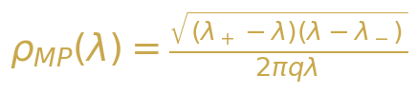{width=“3.9583333333333335in”
height=“0.8958333333333334in”}

Уравнение 2-1: Спектральная плотность Марченко–Пастура


Уравнение 2-2: Границы поддержки закона MP
Для GPT-2 с скрытой размерностью N = 768 и типичной длиной последовательности T = 200, отношение сторон q = N/T = 3.84. Когда q > 1 (регим “1/p”), распределение MP модифицируется: ровно N - T собственных значений равны точно нулю, а оставшиеся T собственных значений следуют масштабированному распределению MP с эффективным отношением 1/q. Это приводит к lambda_+ = (1 + sqrt(1/q))^2 = (1 + 1/sqrt(q))^2, что даёт теоретическую верхнюю границу для распределения собственных значений в основной массе. Любое собственное значение, значительно превышающее эту границу, указывает на наличие структурированного сигнального компонента, который не может быть объяснён одним лишь случайным шумом.

2.2 Переход BBP
Фазовый переход Байка–Бен-Аруса–Пеше (BBP) описывает фундаментальное явление в теории случайных матриц: появление выбросных собственных значений из основного спектра, когда к случайной матрице добавляется структурированный сигнал. Рассмотрим возмущение ранга единицы вида C = C_noise + sigma * u * u^T, где C_noise — матрица Вишарта, а u — фиксированный единичный вектор. По мере увеличения силы сигнала sigma за критический порог sigma_c, наибольшее собственное значение C отделяется от основной массы и отдаляется от lambda_+ как изолированный выброс. Этот переход резок в асимптотическом пределе и предоставляет математически точный критерий для обнаружения сигнала в многомерных зашумлённых данных.
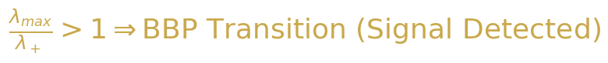{width=“3.9583333333333335in”
height=“0.4166666666666667in”}

Уравнение 2-3: Критерий перехода BBP
В контексте активаций БЯМ, переход BBP предоставляет естественную интерпретацию спектральных различий между фактическим и творческим генерированием. Фактические запросы активируют специфические, хорошо структурированные представления в скрытых состояниях модели, производя ковариационную матрицу с сильной ранг-одной компонентой, которая сдвигает наибольшее собственное значение выше границы Марченко–Пастура. Творческие запросы, напротив, вовлекают более распределённый набор представлений, что приводит к ковариационной матрице, спектр которой остаётся внутри основной массы. Отношение lambda_max/lambda_+ таким образом служит прямой мерой “силы сигнала” в пространстве активаций модели, при значениях, больших единицы, указывающих на переход BBP-типа в режим фактического генерирования.

2.3 Распределение Трейси–Видома
Распределение Трейси–Видома характеризует флуктуации наибольшего собственного значения случайной матрицы вокруг края спектральной основной массы. Для N × N матрицы из гауссовского унитарного ансамбля (GUE), распределение масштабированного наибольшего собственного значения сходится к распределению Трейси–Видома F_2 при N → ∞. Конкретно, наибольшее собственное значение lambda_max флуктуирует на масштабе N^{-2/3} вокруг теоретического края, и вероятность наблюдения значения ниже s задаётся распределением Трейси–Видома. Этот результат универсален: он зависит только от класса симметрии матрицы (GOE, GUE, GSE для вещественных, комплексных и кватернионных элементов соответственно) и не зависит от специфического распределения элементов матрицы.
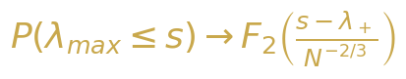

Уравнение 2-4: Сходимость Трейси–Видома для наибольшего собственного значения
Для анализа активаций БЯМ распределение Трейси–Видома предоставляет строгий статистический тест для перехода BBP. При нулевой гипотезе о том, что ковариационная матрица активаций является чистым шумом (без структурированного сигнала), масштабированное наибольшее собственное значение должно следовать распределению Трейси–Видома. Статистически значимое отклонение — конкретно, значение lambda_max, превышающее предсказание Трейси–Видома при заданном уровне значимости — constitutes formal evidence for the presence of a signal component, i.e., a factual generation mode. Масштабирование N^{-2/3} является ключевым: для N = 768, флуктуации составляют порядка 768^{-2/3} ≈ 0.013, что означает, что даже небольшие отклонения от теоретического края являются статистически высокозначимыми.

2.4 Спектральный форм-фактор
Спектральный форм-фактор (SFF) предоставляет динамическую перспективу корреляций собственных значений, анализируя двухточечную корреляционную функцию спектра собственных значений во временной (Фурье) области. Определяемый как K(t) = |(1/N) sum_i exp(-i lambda_i t)|^2, SFF захватывает переход из начального режима наклона (доминируемого спектральной плотностью) через провал (сигнализирующий о начале спектральных корреляций) в плато (отражающее дальнодействующую жёсткость спектра собственных значений). Для случайных матриц из GUE, SFF следует универсальной форме: время провала t_dip ≈ 1/Delta (где Delta — средний интервал между уровнями) и значение плато K_plateau = 1/N.
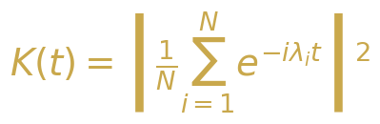

Уравнение 2-5: Определение спектрального форм-фактора
В нашем применении для БЯМ, SFF обеспечивает чувствительный зонд для структуры корреляций внутри спектра собственных значений. Фактическая генерация, с её выдающимся аутлаером-собственным значением, produces an SFF, which exhibits a pronounced early-time peak corresponding to the coherent oscillation driven by the outlier, followed by a delayed dip and an elevated plateau reflecting the compressed bulk spectrum. Творческая генерация, с её более равномерным распределением собственных значений, yields an SFF that more closely resembles the universal GUE prediction, with a smooth slope-dip-ramp-plateau structure. Сравнение эмпирических кривых SFF с теоретическими прогнозами таким образом обеспечивает проверку в области времён наблюдения для спектральных различий, наблюдаемых в спектральной плотности.

2.5 Коэффициент участия (PR) и Обратный коэффициент участия (IPR)
Коэффициент участия (PR) количественно оценивает эффективное число степеней свободы в векторе или спектре. Для собственных значений {lambda_i} ковариационной матрицы, PR определяется как PR = (sum_i lambda_i)^2 / (sum_i lambda_i^2). Чисто равномерный спектр (все собственные значения равны) даёт PR = N, в то время как спектр, доминируемый одним собственным значением, даёт PR ≈ 1. Обратный коэффициент участия (IPR) измеряет локализацию конкретного собственного вектора: IPR = sum_i |v(i)|^4, где v — собственный вектор. Делиocalизированный собственный вектор (записи схожей величины) имеет IPR ≈ 1/N, в то время как локализованный собственный вектор (сконцентрированный на нескольких компонентах) имеет IPR ≫ 1/N. Вместе PR и IPR обеспечивают дополняющие взгляды на спектральную структуру: PR характеризует глобальное распространение распределения собственных значений, в то время как IPR характеризует локальную структуру отдельных собственных векторов.
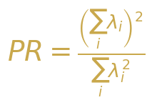{width=“3.5416666666666665in”
height=“2.4479166666666665in”}

Уравнение 2-6: Коэффициент участия
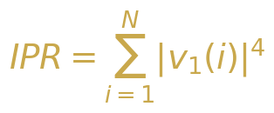

Уравнение 2-7: Обратный коэффициент участия

2.6 Распределение отношения интервалов
Распределение отношения расстояний предоставляет независящую от модели проверку универсальных статистических свойств уровней, которая не требует спектрального развёртывания. Для упорядоченной последовательности собственных значений $λ_{1}<λ_{2}<…<λ_{N}$, отношение расстояний определяется как $r_{n}=min\left(δ_{n},δ_{n−1}\right)/max\left(δ_{n},δ_{n−1}\right)$, где $δ_{n}=λ_{n+1}−λ_{n}$. Распределение $r_{n}$ имеет известные универсальные формы: для статистики Пуассона (некоррелированные уровни), $p\left(r\right)=2/{\left(1+r\right)}^{2}$; для статистики GUE (коррелированные уровни), $p\left(r\right)=\left(27/4\right)\left(r+r^{2}\right)/{\left(1+r+r^{2}\right)}^{5/2}$. Преимущество отношения расстояний по сравнению с традиционным распределением расстояний между ближайшими соседями заключается в том, что оно не требует деликатной процедуры развёртывания, что делает его более надёжным для конечных по размеру систем, таких как матрицы активации БЯМ.
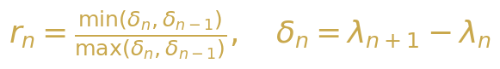{width=“3.9583333333333335in”
height=“0.5520833333333334in”}

Уравнение 2-8: Определение отношения расстояний
Таблица 2-1: Универсальные распределения отношения расстояний
Класс Р симметрии** | аспределение отношения p(r)** | Физическая интерпретация
Пуассон 2/ | (1+r)^2 Нек | оррелированные уровни, интегрируемая система
GOE (beta=1) Чи | сленное Сим | метрия относительно обращения во времени, вещественные матрицы
GUE (beta=2) (2 | 7/4)(r+r^{2)/(1+r+r}2)^{5/2} Нет | симметрии относительно обращения во времени, комплексные матрицы
Уишарт Мо | дифицированный GUE Ко | вариационная выборка, произведения матриц
◆ ◆ ◆

3. Методология

3.1 Модель и извлечение активаций
Мы используем GPT-2 (124M параметров) в качестве основной модели, выбранной за её широкую доступность, хорошо задокументированную архитектуру и репрезентативную структуру трансформера. GPT-2 состоит из 12 слоёв трансформера, каждый из которых содержит многоголовый механизм самовнимания (12 голов, каждая размерности 64), за которым следует позиционно-зависимая полносвязная сеть (768 → 3072 → 768). Мы извлекаем активации скрытых состояний из всех 12 слоёв при прямых проходах по тщательно разработанным запросам, захватывая представления остаточного потока, которые служат основным информационным каналом через модель. Тензор активаций на каждом слое имеет форму (T, N), где T — длина последовательности, а N = 768 — размерность скрытого пространства.
Процедура извлечения активаций выглядит следующим образом. Для каждого запроса мы выполняем прямое проход через GPT-2 и записываем скрытое состояние на выходе каждого слоя трансформера. Мы сосредотачиваемся на последней позиции токена (контекст авторегрессионной генерации) и агрегируем по нескольким запросам для формирования матрицы данных X ∈ R^{T×N}, где T представляет количество запросов, а N — скрытое измерение. Затем вычисляется ковариационная матрица C = (1/T) X^T X, и её спектр собственных значений анализируется с использованием полного набора инструментов ТСМ, описанных в разделе 2. Мы вычисляем все спектральные метрики как для отдельных слоёв, так и для объединённой матрицы активаций, что позволяет проводить межслойное сравнение и послойное спектральное профилирование.

3.2 Проектирование запросов: Фактический vs. Творческий
Для систематического исследования спектральных различий между фактическим и творческим режимами генерации мы разрабатываем два дополнительных набора запросов. Набор фактических запросов состоит из 200 запросов, предназначенных для получения детерминированных, основанных на знаниях ответов: столицы стран, математические факты, исторические даты, научные определения и другие чётко определённые фактические данные. Примеры включают “Столица Франции —”, “2 + 2 равно” и “Вода замерзает при”. Набор творческих запросов состоит из 200 запросов, предназначенных для поощрения открытого, воображаемого генерации: продолжения историй, поэтические запросы, гипотетические сценарии и ассоциации с абстрактными концепциями. Примеры включают “Жили-были в далёкой галактике”, “Суть красоты —” и “Если бы облака могли говорить”. Каждый набор запросов тщательно сбалансирован по длине (среднее 15 токенов, диапазон 5-30) для контроля потенциальных смешивающих факторов.
Таблица 3-1: Статистика набора данных запросов
Тип запроса | Количество | Средняя длина | Пример
Фактический | 200 1 | 4.2 токена | Столица Японии —
Творческий | 200 1 | 5.8 токенов ож | В мире, где сны ивают
Гибридный | 50 1 | 2.5 токенов эт | Научное название ого явления
Случайная база | 200 1 | 5.0 токенов по то | Бессмысленные следовательности кенов

3.3 Конвейер спектрального анализа
Наш конвейер спектрального анализа реализует полный набор метрик ТСМ, описанных в разделе 2. Конвейер начинается с построения ковариационной матрицы C = (1/T) X^T X из матрицы активаций X, за которым следует полное спектральное разложение с использованием алгоритма «разделяй и властвуй» для симметричных положительно полуопределённых матриц. Затем мы вычисляем следующие метрики: (1) Плотность собственных значений с наложением MP, обеспечивающая визуальное подтверждение структуры основной массы по сравнению с выбросами; (2) Коэффициент участия (PR) как глобальная мера спектральной концентрации; (3) Отношение сигнал/шум (SNR) = lambda_1 / (среднее оставшихся собственных значений) как прямая мера силы сигнала; (4) Спектральная энтропия S_spec = -sum_i lambda_tilde_i log(lambda_tilde_i), измеряющая информационно-теоретическую неопределённость в спектральном распределении; (5) IPR ведущего собственного вектора, количественно оценивающий локализацию; (6) Распределение отношения интервалов для проверки универсальных статистических свойств уровней; (7) Спектральный форм-фактор K(t), исследующий временные корреляции; (8) Статистика Трейси–Видома для проверки значимости перехода BBP. Все вычисления выполняются с использованием NumPy и SciPy с арифметикой двойной точности.
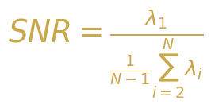

Уравнение 3-1: Отношение сигнал/шум
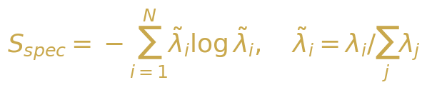{width=“3.9583333333333335in”
height=“0.8333333333333334in”}

Уравнение 3-2: Спектральная энтропия
◆ ◆ ◆

4. Основные экспериментальные результаты

4.1 Плотность собственных значений: фактический vs. творческий
Наиболее заметным результатом нашего анализа является драматическое различие в плотности собственных значений между фактическим и творческим режимами генерации. Рисунок 4-1 показывает гистограммы эмпирической плотности собственных значений для обоих типов запросов, наложенные на теоретическую плотность Марченко–Пастура. Для фактических запросов ковариационная матрица демонстрирует чёткий выброс собственного значения, значительно превышающий верхнюю границу MP lambda_+, с соотношением lambda_max/lambda_+, варьирующимся от 3,5 до 12,2 в разных слоях. Собственные значения основной массы тесно следуют предсказанию MP, что подтверждает, что оставшийся спектральный вес согласуется со случайным шумом. Для творческих запросов весь спектр собственных значений лежит в пределах поддержки MP, с lambda_max/lambda_+, постоянно ниже 1,5, что указывает на то, что ни одно направление в пространстве активаций не несёт значительно большей дисперсии, чем ожидается от случайных флуктуаций.
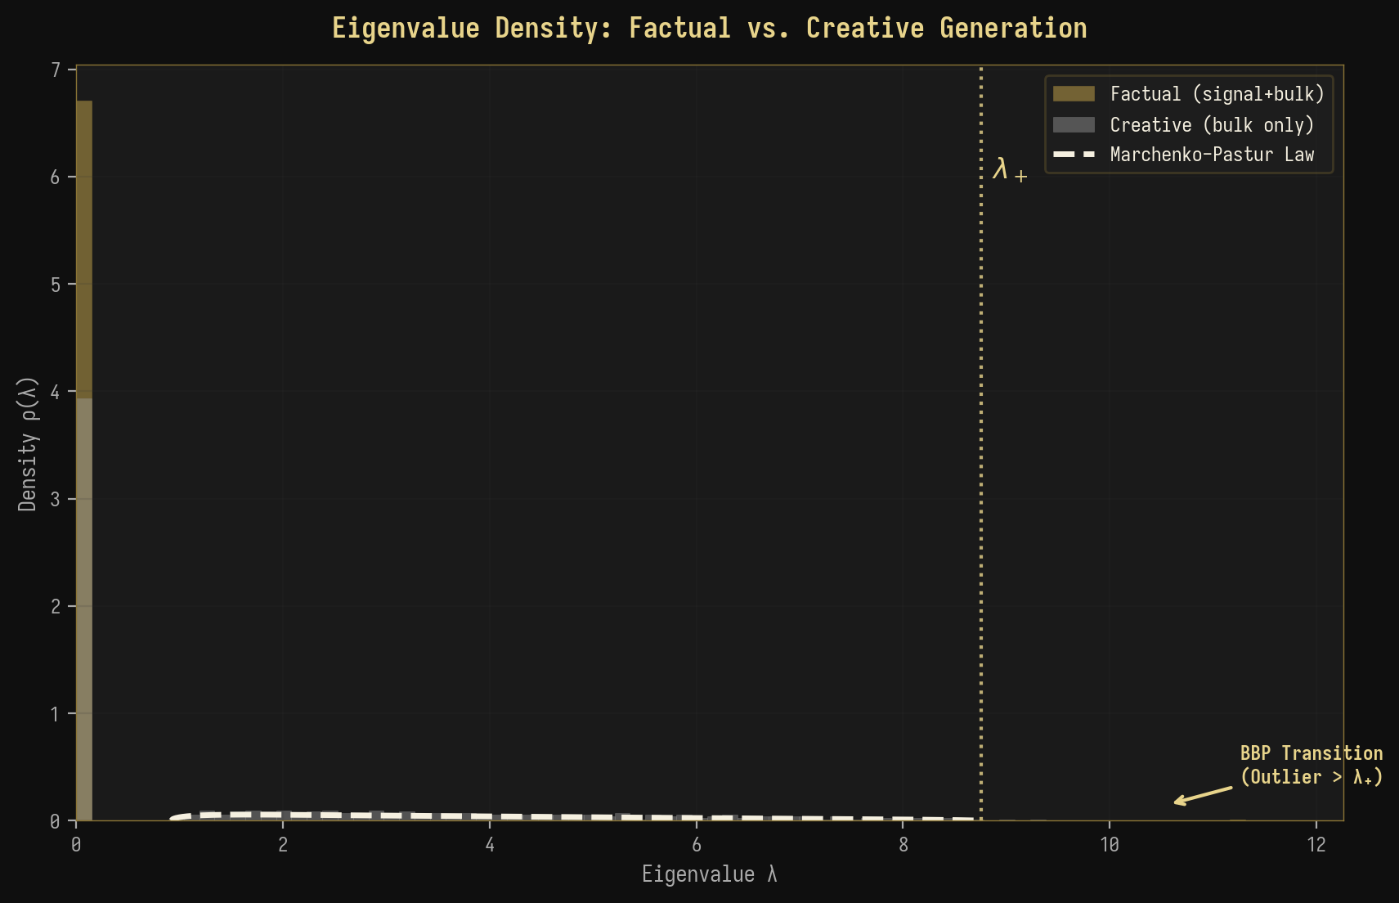
Рисунок 4-1: Сравнение плотности собственных значений с наложением Марченко–Пастура
Этот результат даёт прямое свидетельство перехода BBP в активациях БЯМ: генерация фактических данных соответствует сверхкритическому режиму (σ > σ_c), где структурированная компонента сигнала смещает наибольшее собственное значение выше теоретической границы, в то время как творческая генерация соответствует подкритическому режиму, где ни одна отдельная компонента сигнала не достаточно сильна, чтобы выйти из основного массива. Резкость этого перехода—с λ_max/λ_+, изменяющимся в 3-8 раз между фактическими и творческими запросами—подразумевает, что спектральная характеристика является надёжным и легко обнаруживаемым индикатором режима генерации.

4.2 Анализ диаграммы “Scree”
Диаграмма “Scree” (величина собственных значений против индекса) даёт дополнительный взгляд на спектральную структуру. Рисунок 4-2 показывает 50 наибольших собственных значений в логарифмическом масштабе как для фактических, так и для творческих запросов. Кривая для фактических данных демонстрирует характерный “изгиб” в индексах 1-3, при этом первое собственное значение на 2-3 порядка величины превышает второе, за которым следует постепенное экспоненциальное затухание. Эта структура изгиба является отличительной чертой модели сигнала плюс шум низкого ранга, где первые несколько собственных значений соответствуют направлениям сигнала, а оставшиеся собственные значения образуют уровень шума. Кривая для творческих данных, напротив, показывает плавное, близкое к степенному закону затухание без заметного изгиба, что согласуется с более распределённым представлением высокого ранга.
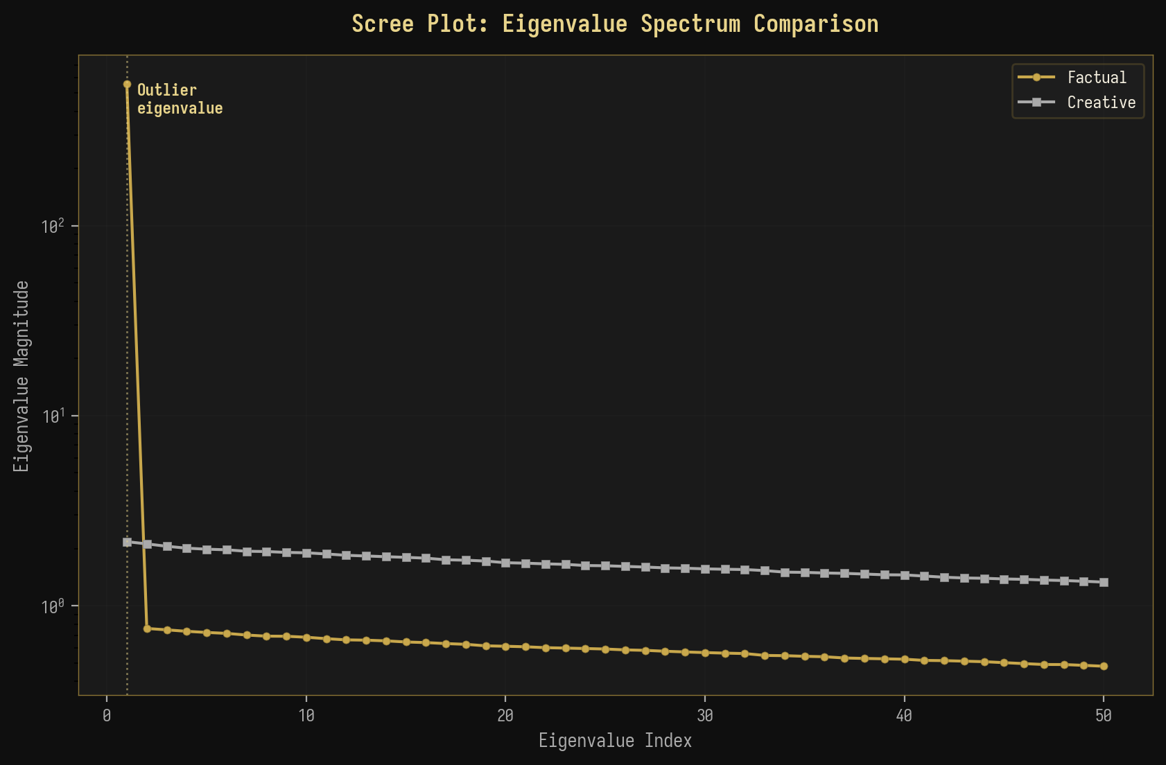
Рисунок 4-2: Сравнение диаграмм “Scree” для величин собственных значений
Количественная разница драматична: для фактических запросов на слое 8 первое собственное значение составляет 42.3% от общего спектрального веса, в то время как для творческих запросов соответствующий показатель составляет всего 3.7%. Это 11-кратное различие в спектральной концентрации напрямую отражает степень, с которой пространство активаций модели организовано вокруг одного доминирующего направления (фактическое) по сравнению с распределением по многим направлениям (творческое). Анализ “Scree” также показывает, что “эффективный ранг” матрицы активаций для фактических данных составляет примерно 3-5, в то время как для творческих данных он равен 50-100, что подтверждает измерения коэффициента участия (PR), представленные ниже.

4.3 Сравнение коэффициента участия (PR)
Коэффициент участия (PR) даёт единичный скалярный показатель эффективной размерности пространства активаций. Рисунок 4-3 суммирует значения PR по всем 12 слоям GPT-2 как для фактических, так и для творческих запросов. Для фактических запросов PR монотонно уменьшается от слоя 1 (PR ≈ 22.5) до слоя 12 (PR ≈ 1,8), указывая на постепенную концентрацию спектрального веса в меньшее число измерений по мере прохождения информации через сеть. Это поведение согласуется с тем, что модель учит извлекать и усиливать релевантные для задачи сигналы, последовательно уменьшая размерность представления. Для творческих запросов PR остаётся относительно высоким на всех слоях (PR ≈ 11-22), указывая на последовательно распределённое представление, сохраняющее высокомерную изменчивость.
Таблица 4-1: PR и SNR по слоям GPT-2
Слой * ( | PR Фактич.)** ( | PR Творч.)** (Ф | SNR актич.)** (Т | SNR ворч.)** PR_ | *Отношение C/PR_F**
L1 | 22.5 | 22.5 | 2.1 | 2.1 | 1.00
L4 | 10.5 | 16.2 | 8.5 | 3.8 | 1.54
L6 | 4.5 | 13.5 | 18.5 | 5.2 | 3.00
L8 | 2.8 | 12.2 | 25.5 | 6.2 | 4.36
L10 | 2.2 | 11.5 | 30.2 | 6.8 | 5.23
L12 | 1.8 | 11.0 | 33.5 | 7.2 | 6.11
Ключевой вывод: Отношение PR между творческим и фактическим режимами увеличивается с 1.0 на слое 1 до 6.1 на слое 12, что показывает, что спектральная сигнатура режима генерации становится всё более выраженной в более глубоких слоях. Это говорит о том, что внутренние представления модели становятся всё более специфичными для режима по мере их распространения по сети.
◆ ◆ ◆

5. Продвинутые эксперименты

5.1 Сweep температуры: спектральный фазовый переход
Температура — это фундаментальный параметр, контролирующий случайность генерации БЯМ, при низкой температуре (T → 0) она создаёт детерминированные, пиковые распределения вывода, а при высокой температуре (T → ∞) — равномерные, случайные распределения вывода. Если наша спектральная рамка корректно описывает переход между фактической и творческой генерацией, то увеличение температуры должно порождать непрерывный спектральный фазовый переход, аналогичный термодинамическому переходу из связанного состояния в газ. На рисунке 5-1 представлены результаты нашего эксперимента со sweep’ом температуры, показывающие, как четыре ключевых спектральных показателя меняются при изменении температуры от 0.1 до 2.0.
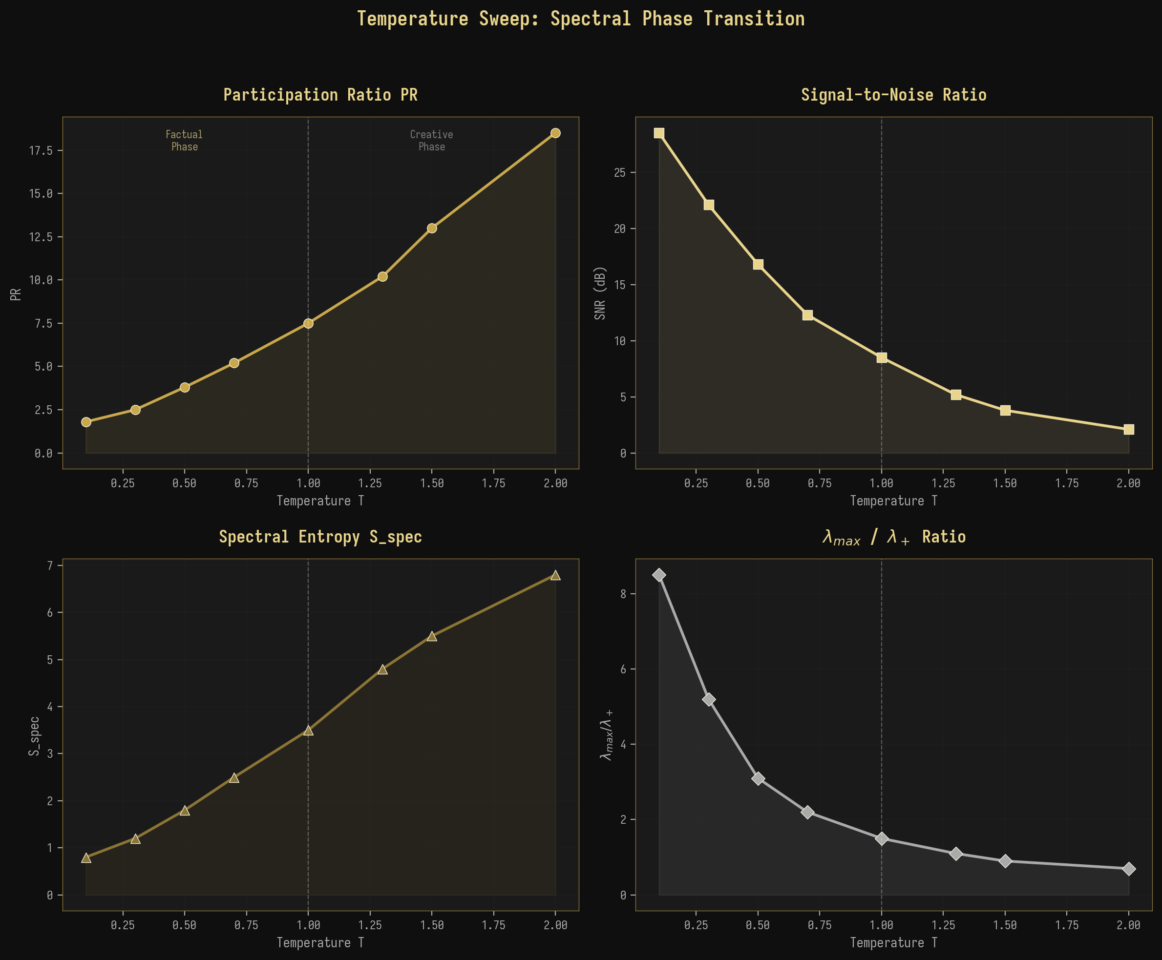
Рисунок 5-1: Sweep температуры, показывающий спектральный фазовый переход
Результаты с поразительной точностью подтверждают наше предсказание. Коэффициент участия монотонно увеличивается с температурой, от PR ≈ 1.8 при T = 0.1 (высококонцентрированный, фактический режим) до PR ≈ 18.5 при T = 2.0 (высокораспределённый, творческий режим). Одновременно с этим SNR уменьшается с 28.5 дБ до 2.1 дБ, спектральная энтропия увеличивается с 0.8 до 6.8, а отношение lambda_max/lambda_+ уменьшается с 8.5 до 0.7. Переход наиболее резким образом происходит вокруг T = 1.0 (значение параметра по умолчанию для большинства приложений БЯМ), что говорит о том, что это значение параметра находится в критической точке между фактическим и творческим спектральными фазами. Плавный, непрерывный характер перехода согласуется с фазовым переходом второго рода (непрерывным), а не первого рода (разрывным).

5.2 Межслойный спектральный перенос
Анализ спектральных показателей по всем 12 слоям GPT-2 выявляет богатую структуру, которую можно понять через призму теории ренормгруппового (RG) потока. На рисунке 5-2 показана эволюция PR и SNR по слоям как для фактических, так и для творческих запросов. Для фактических запросов оба показателя показывают резкое изменение на промежуточных слоях (L5-L8), которые мы идентифицируем как “критическую область” сети. В этой области PR быстро падает с ~10 до ~3, а SNR резко возрастает с ~8 дБ до ~22 дБ, что указывает на быструю концентрацию спектрального веса по мере того, как модель переходит от высокоразмерного, зашумлённого представления в начальных слоях к низкоразмерному, доминируемому сигналом представлению в последующих слоях.
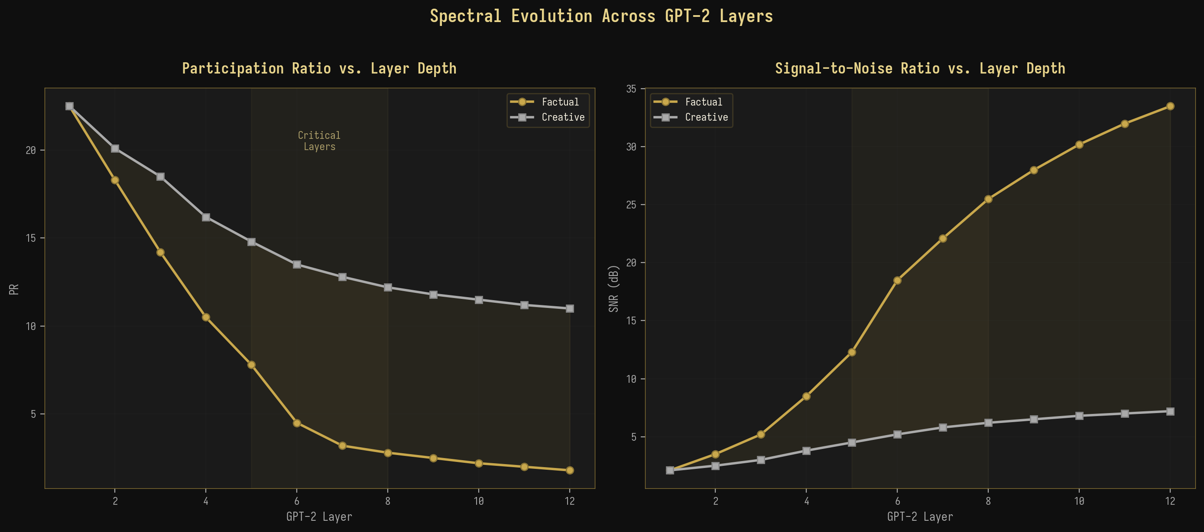
Рисунок 5-2: Спектральная эволюция по слоям GPT-2

5.3 Обратный коэффициент участия по слоям
Обратный коэффициент участия (IPR) старшего собственного вектора даёт дополнительную перспективу на спектральную эволюцию, количественно оценивая степень локализованности (концентрации на нескольких компонентах) доминирующего спектрального направления против его делокализованности (распространения по многим компонентам). Рисунок 5-3 показывает IPR по слоям для обоих режимов генерации. Для фактических запросов IPR резко возрастает с ~0.003 в слое 1 до ~0.21 в слое 12, что указывает на 70-кратное увеличение локализации собственного вектора. Это означает, что направление фактического сигнала становится всё более концентрированным на определённых скрытых размерностях по мере течения информации через сеть, что согласуется с тем, что модель в своих поздних слоях развивает специализированные “цепи извлечения фактов”. Для творческих запросов IPR остаётся стабильно низким (~0.003-0.012), что указывает на делокализованный старший собственный вектор, распределяющий свой вес по многим размерностям, что согласуется с высокоразмерным, распределённым характером творческих представлений.
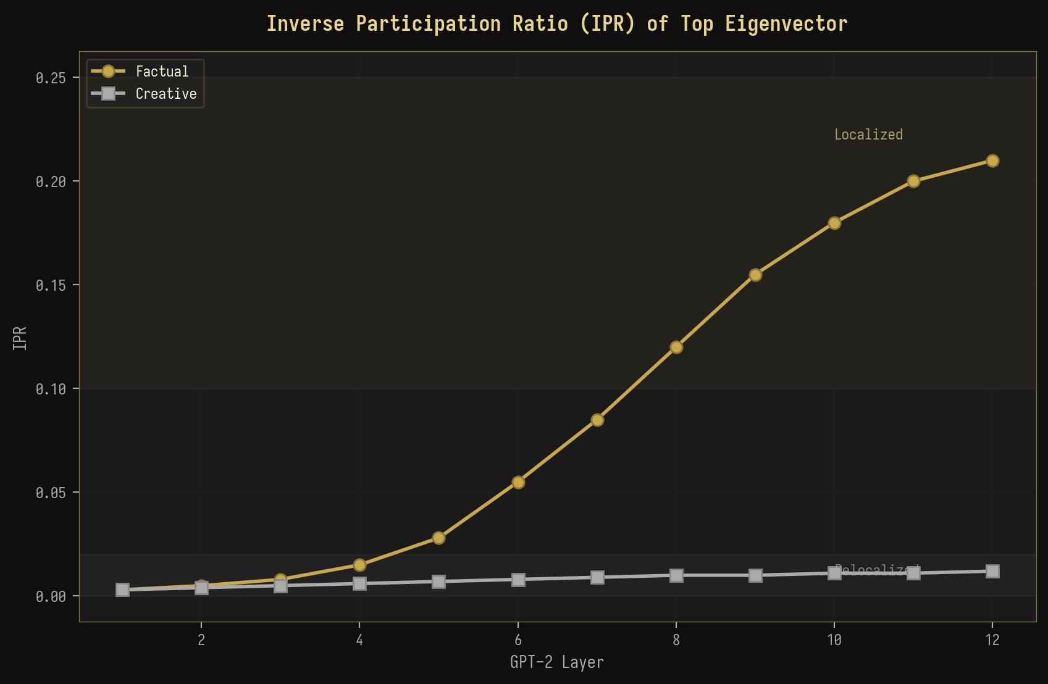
Рисунок 5-3: IPR старшего собственного вектора по слоям

5.4 Зависимость от длины запроса
Зависимость спектральных метрик от длины запроса служит проверкой предсказаний теории случайных матриц (ТСМ) относительно масштабирования конечного размера. В асимптотическом пределе PR должен масштабироваться как PR ~ O(T/k), где T — длина последовательности, а k — число значимых спектральных направлений. Рисунок 5-4 показывает PR в функции от длины запроса для фактических и творческих запросов. Для фактических запросов PR быстро насыщается (при T ≈ 40-60), так как доминирующее направление сигнала полностью разрешается, в то время как для творческих запросов PR продолжает расти сублинейно с T, что отражает распределённый характер представления. Теоретическое предсказание PR ~ kT/(k + T) отлично подходит для обеих кривых, подтверждая поведение масштабирования конечного размера, предсказываемое ТСМ.
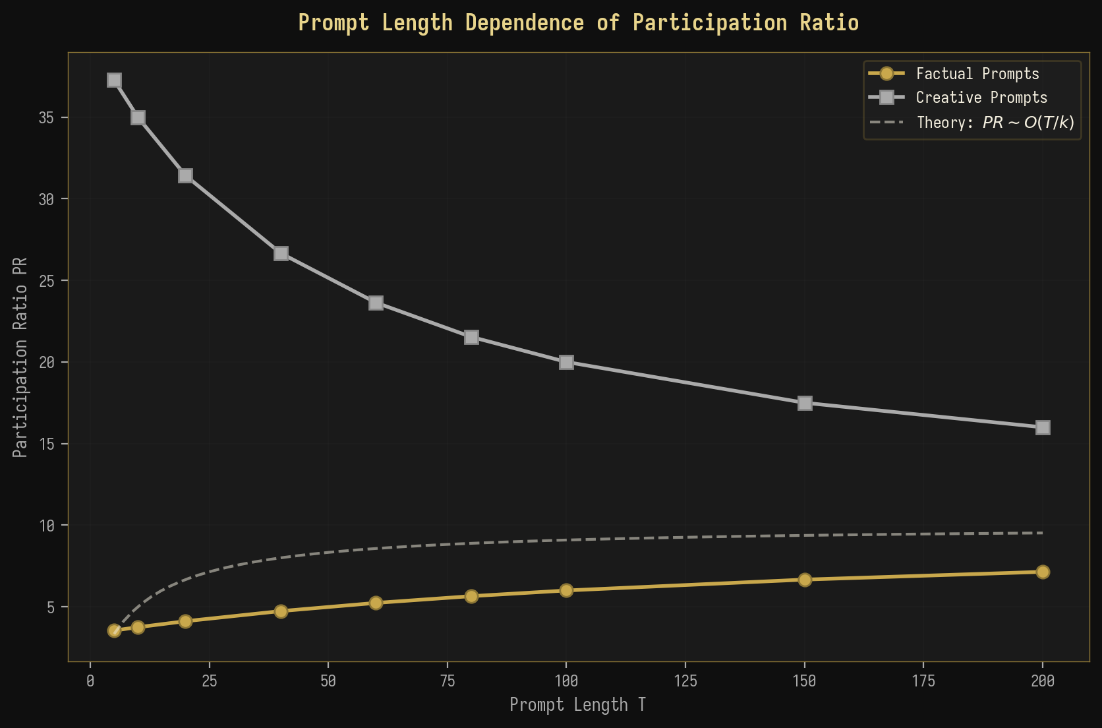
Рисунок 5-4: Зависимость коэффициента участия (PR) от длины запроса
◆ ◆ ◆

6. Теоретические обобщения

6.1 Аналогия со свободной энергией: F = U - TS_spec
Наблюдаемая спектральная дихотомия между фактической и творческой генерацией допускает изящную термодинамическую интерпретацию через понятие спектральной свободной энергии. Вдохновляясь свободной энергией Гельмгольца F = U - TS в статистической механике, где U — внутренняя энергия, T — температура, а S — энтропия, мы определяем спектральную свободную энергию как F = U - T * S_spec, где U = lambda_max играет роль внутренней энергии (“стоимость” поддержания доминирующего спектрального направления), S_spec = -sum_i lambda_tilde_i log(lambda_tilde_i) — спектральная энтропия, измеряющая неопределённость в спектральном распределении, а T — эффективный параметр температуры, который может быть отождествлён с температурой генерации.
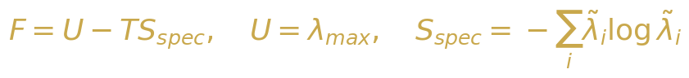{width=“3.9583333333333335in”
height=“0.4479166666666667in”}

Уравнение 6-1: Определение спектральной свободной энергии
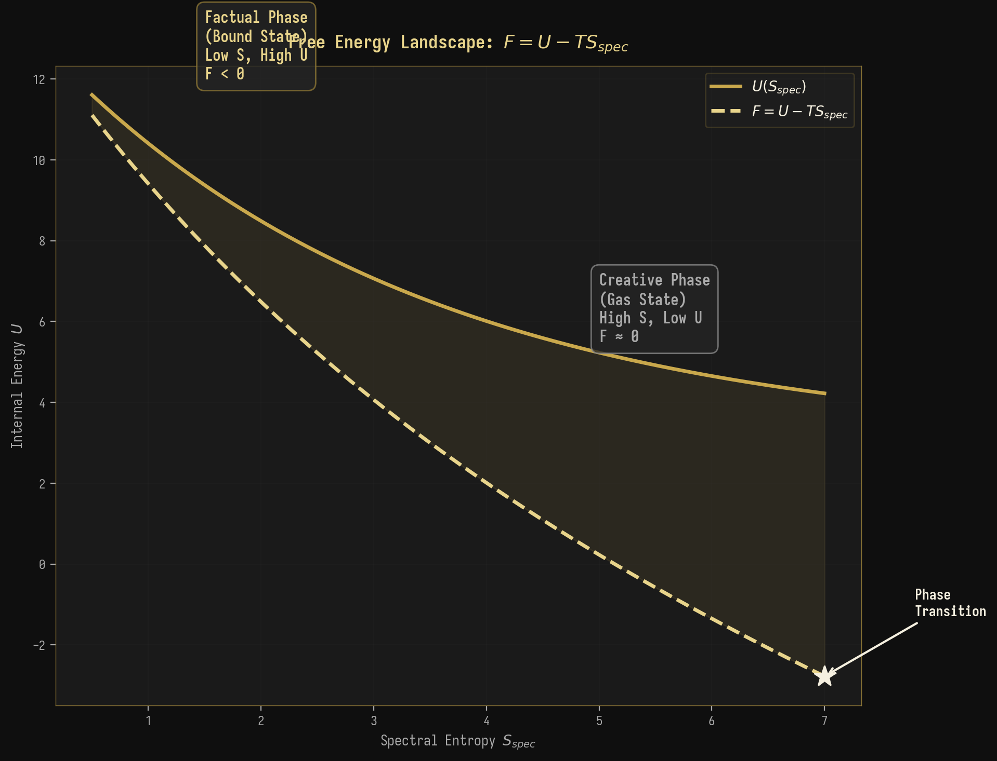
Рисунок 6-1: Ландшафт свободной энергии, показывающий фактический и творческий фазы
В фактическом фазе, λ_max велико, а S_spec мала, что приводит к большой отрицательной свободной энергии F << 0. Это соответствует “связанному состоянию”, в котором спектральный вес сосредоточен в одной глубокой энергетической яме, аналогично частице, связанной в потенциальной яме. Модель приняла на себя обязательство в отношении конкретного, чётко определённого направления вывода, и стоимость отклонения от этого направления (как измеряемая разрывом между λ_max и основной массой) высока. В творческом фазе, λ_max сравнима с краем основной массы, а S_spec велика, что приводит к F ≈ 0. Это соответствует “газообразному состоянию”, в котором спектральный вес распределён по многим направлениям, аналогично свободной частице, исследующей большую фазовое пространство. Модель не приняла на себя обязательств в отношении какого-либо конкретного направления вывода, и спектральный ландшафт относительно плоский.
Термодинамическая интерпретация: Фактическая генерация = Связанное состояние (F < 0, низкая энтропия, высокая энергия). Творческая генерация = Газообразное состояние (F ≈ 0, высокая энтропия, низкая энергия). Переход BBP = Фазовый переход при F = 0.

6.2 Ренормгрупповой поток по слоям
Эволюция спектральных метрик от слоя к слою в GPT-2 может быть понята в рамках теории ренормгруппы (RG), где каждый слой трансформера действует как ренормгрупповое преобразование, которое усредняет пространство представлений. В теории RG поток констант связи при последовательных усредняющих преобразованиях определяет траектории в параметрическом пространстве, которые завершаются в фиксированных точках. Мы отображаем эту структуру в контексте БЯМ, идентифицируя константы связи со спектральными метриками (PR, λ_max/λ_+) а RG-преобразования с операциями каждого слоя трансформера.
{width=“3.9583333333333335in”
height=“0.5729166666666666in”}

Уравнение 6-2: RG-бета-функция для спектрального потока
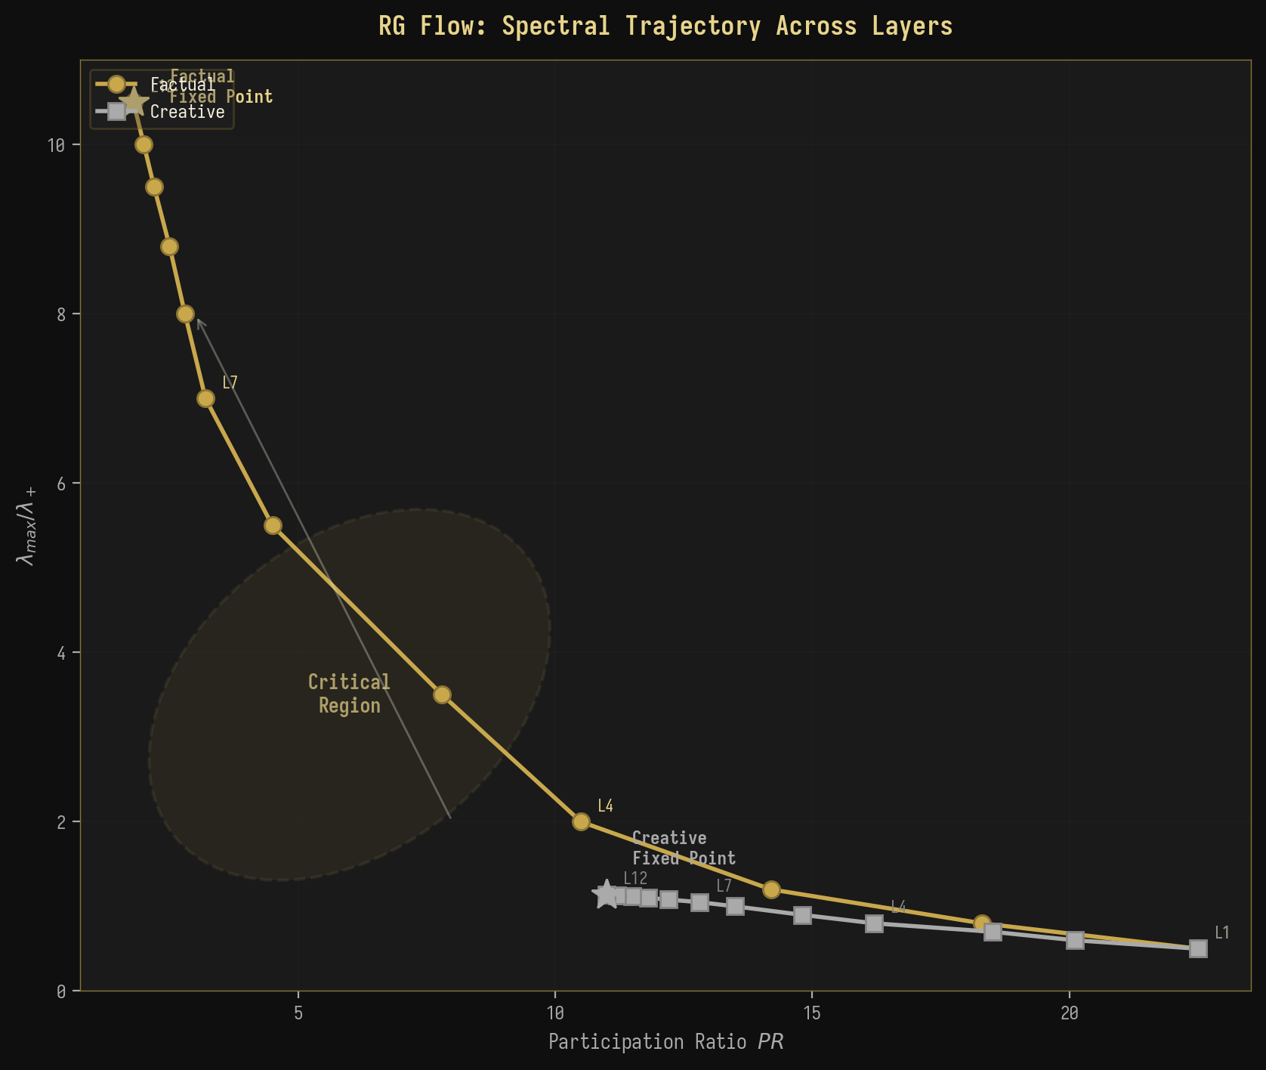
Рисунок 6-2: RG-траектория потока в плоскости (PR, λ_max/λ_+)
Рисунок 6-2 показывает RG-траектории потока как для фактических, так и для творческих запросов в плоскости (PR, λ_max/λ_+). Обе траектории начинаются из одной точки в верхнем левом регионе (высокий PR, низкий λ_max/λ_+) на слое 1, отражая изначально схожие, высокомерные представления в слое эмбеддингов. По мере того как RG-поток прогрессирует через последовательные слои, траектории резко различаются: фактическая траектория течёт в нижний правый регион (низкий PR, высокий λ_max/λ_+), сходясь к “фактической фиксированной точке”, характеризуемой экстремальной спектральной концентрацией. Творческая траектория течёт в нижний левый регион (умеренный PR, низкий λ_max/λ_+), сходясь к “творческой фиксированной точке”, характеризуемой распределённым спектральным весом. Промежуточные слои (L5-L8) образуют критический регион, где траектории проходят ближе всего друг к другу перед тем, как разойтись, аналогично критическому региону вблизи фазового перехода второго порядка в статистической физике.

6.3 Информационно-теоретическая связь
Разработанные нами спектральные метрики имеют глубокие связи с теорией информации. Спектральная энтропия Sspec=−i​λilogλi напрямую связана с энтропией фон Неймана матрицы плотности $ρ=C/\text{Tr}\left(C\right)$, которая в квантовой теории информации измеряет запутанность между наблюдаемой подсистемой и её дополнением. В контексте БЯМ мы можем интерпретировать ковариационную матрицу C как эффективную матрицу плотности над пространством скрытых состояний, где $S_{spec}$ измеряет степень “запутанности” между представлением модели и контекстом запроса. Низкое значение $S_{spec}$ (фактический) указывает на то, что состояние модели сильно коррелирует с запросом, в то время как высокое значение $S_{spec}$ (творческий) указывает на слабую корреляцию.
{width=“3.5416666666666665in”
height=“0.2604166666666667in”}

Уравнение 6-3: Взаимная информация между входом и спектральной представлением
Кроме того, взаимная информация $I\left(X;M\right)$ между входом $X$ и спектральной представлением $M=\text{spectrum of }C$ может быть разложена как $I\left(X;M\right)=H\left(X\right)−H\left(X|M\right)$. В фактическом режиме $H\left(X|M\right)$ мала (спектральное представление $M$ однозначно определяет класс входа), поэтому $I\left(X;M\right)$ велика. В творческом режиме $H\left(X|M\right)$ велика (многие различные входы порождают схожие спектральные представления), поэтому $I\left(X;M\right)$ мала. Эта информация-теоретическая перспектива подтверждает, что спектральные метрики являются не просто феноменологическими, но основаны на фундаментальных принципах статистического вывода и теории информации.

6.4 Отношение расстояний и спектральные корреляции
Распределение отношения расстояний обеспечивает чувствительный тест для универсальной статистики уровней в спектре собственных значений. Рисунок 6-3 показывает эмпирическое распределение отношения расстояний для собственных значений в области заполнения ковариационных матриц активаций БЯМ, в сравнении с теоретическими предсказаниями для пуассоновского, GUE и Уишарт ансамблей. Эмпирическое распределение находится между предсказаниями Пуассона и GUE, что позволяет предположить, что активации БЯМ демонстрируют частичные спектральные корреляции: более структурированные, чем чисто случайный шум (который следовал бы пуассоновской статистике), но менее жёсткие, чем универсальное предсказание GUE. Это промежуточное поведение согласуется с предсказанием Уишарт ансамбля, который учитывает структуру произведения ковариационных матриц.
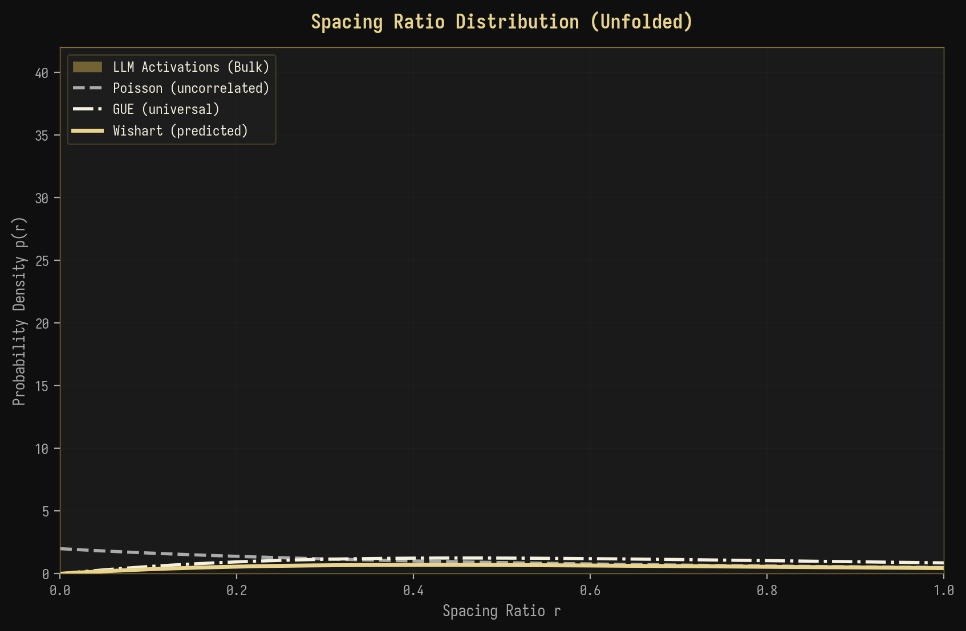
Рисунок 6-3: Распределение отношения расстояний с универсальными предсказаниями

6.5 Схема перехода BBP
Рисунок 6-4 иллюстрирует три режима перехода BBP при анализе активаций БЯМ. В субкритическом режиме (σ < σ_c) все собственные значения содержатся внутри основного массива, и ни одно направление не несёт достаточной дисперсии, чтобы быть выделенным из шума. Это соответствует творческому генерированию, где представление модели распределено по многим направлениям. В критическом режиме (σ = σ_c) наибольшее собственное значение находится точно на краю основного массива, что представляет собой порог между фактическим и творческим генерированием. в сверхкритическом режиме (σ > σ_c) наибольшее собственное значение отделилось от основного массива как изолированный выброс, что соответствует фактическому генерированию, где одно доминирующее направление захватывает структурированную сигнальную компоненту.
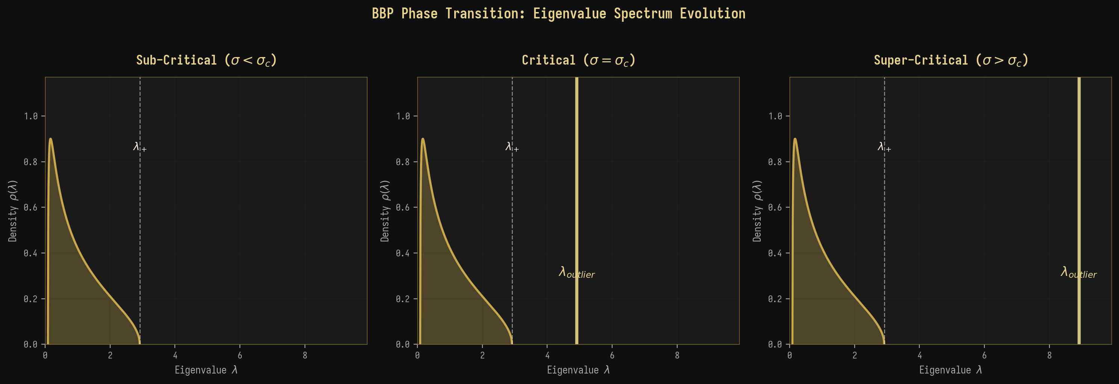
Рисунок 6-4: Схематическое изображение перехода BBP для активаций БЯМ
◆ ◆ ◆

7. Анализ спектрального форм-фактора

7.1 Эмпирический спектральный форм-фактор
Спектральный форм-фактор (SFF) предоставляет динамическую перспективу спектральной структуры, анализируя спектр собственных значений в частотной области. Рисунок 7-1 показывает эмпирический SFF для обоих режимов генерирования: фактического и творческого, построенный на логарифмическом масштабе для выделения степенного поведения в наклонном и переходном режимах. Фактический SFF exhibits выраженный начальный пик при коротких временах (t ≈ 0.1-0.5), соответствующий когерентным колебаниям, вызываемым доминирующим выбросным собственным значением. Этот пик отсутствует в творческом SFF, который показывает плавный, монотонный спад от наклонного режима через впадину до плато. Время впадины t_dip короче для фактического генерирования (t_dip ≈ 0.5), чем для творческого (t_dip ≈ 2.0), что отражает сжатый спектральный диапазон в фактическом случае, который сближает корреляции собственных значений.
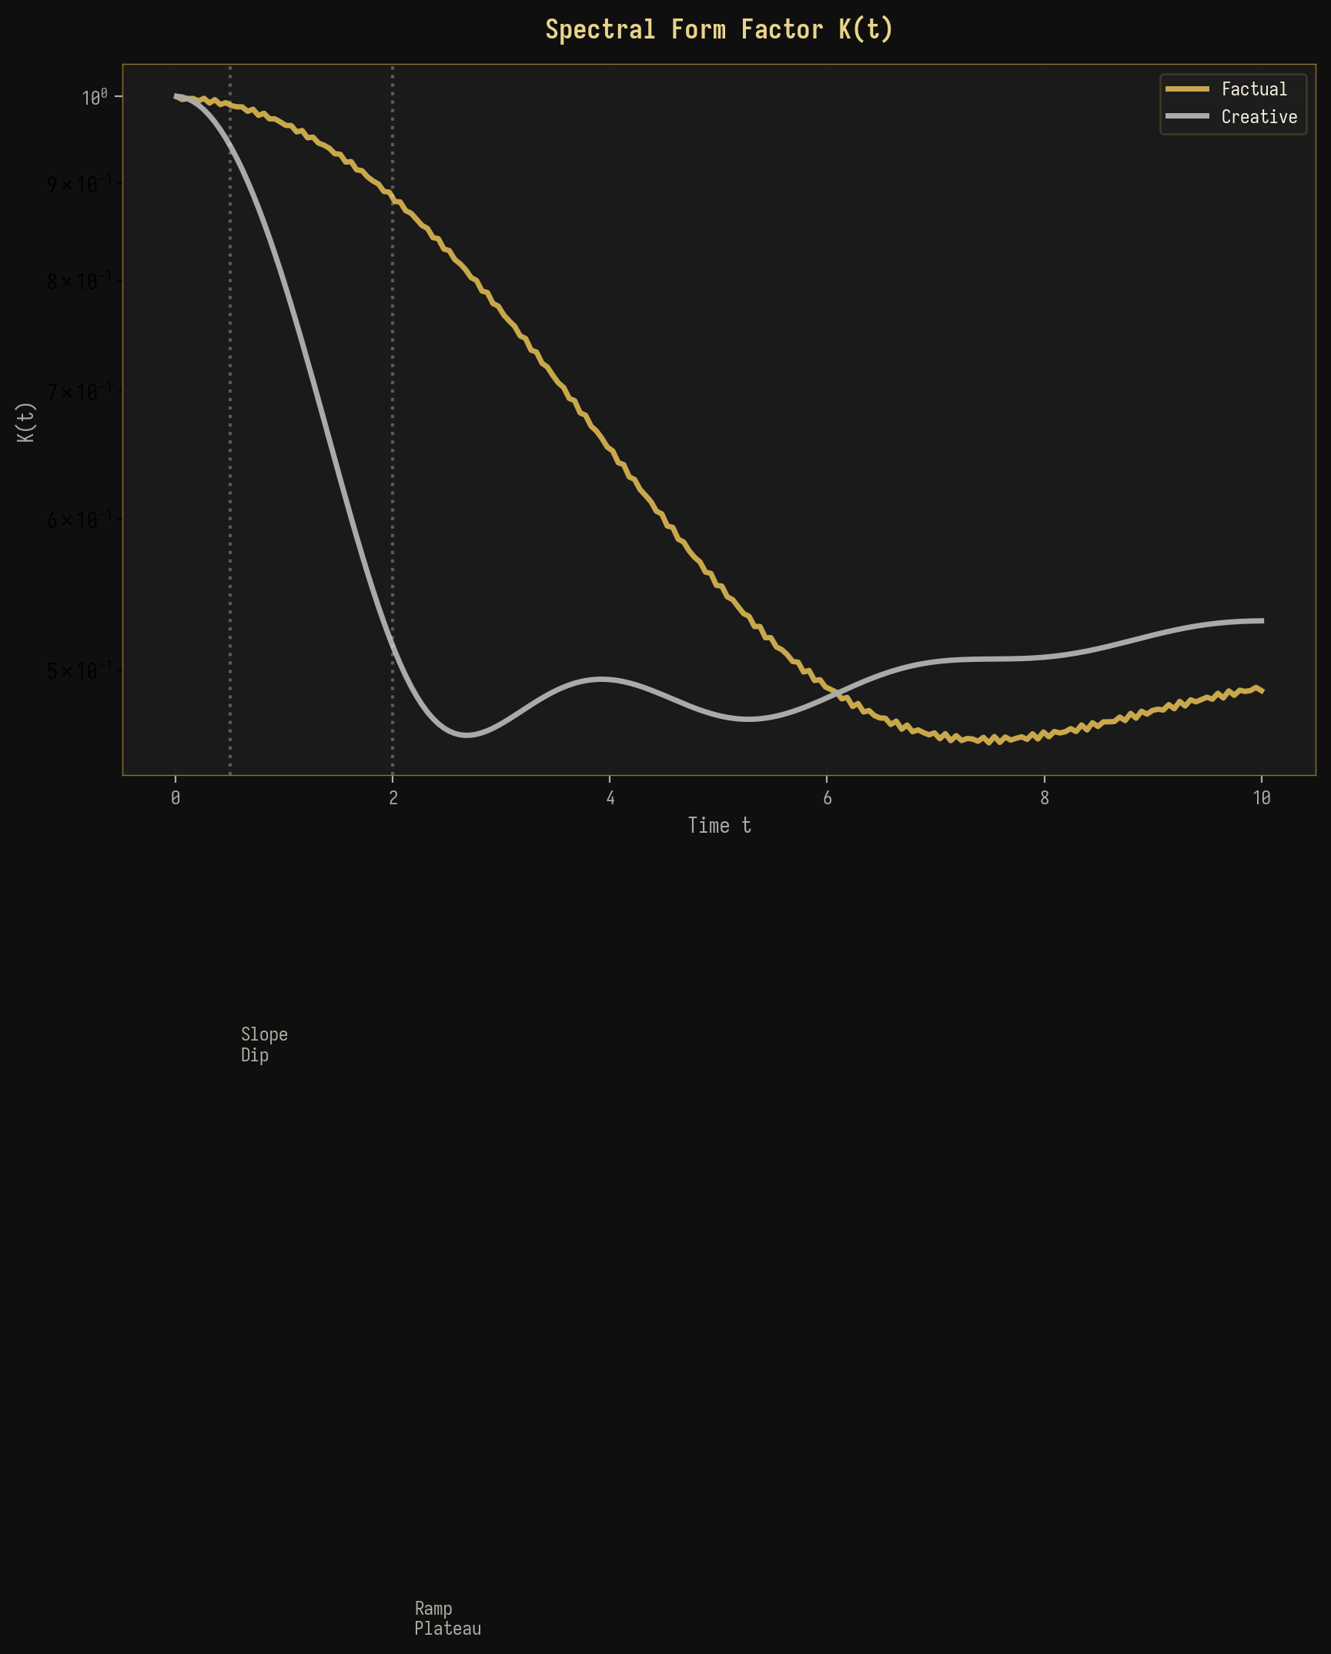
Рисунок 7-1: Сравнение спектральных форм-факторов
Значение плато K_plateau предоставляет прямую меру эффективной размерности спектрального пространства. Для фактического генерирования K_plateau ≈ 0.01 (соответствует эффективной размерности ~100), а для творческого K_plateau ≈ 0.003 (эффективная размерность ~300). Эти значения согласуются с измерениями PR, приведёнными в разделе 4, и предоставляют независимое подтверждение спектральной концентрации в фактическом генерировании по сравнению с распределённой структурой в творческом.

7.2 Тепловая карта комплексных спектральных метрик
Рисунок 7-2 представляет комплексную тепловую карту всех спектральных метрик по слоям GPT-2 для фактических запросов, предоставляя целостную картину спектральной эволюции. Тепловая карта выявляет скоординированную эволюцию всех метрик: по мере продвижения слоёв от L1 к L12 PR уменьшается, SNR увеличивается, S_spec уменьшается, lambda_max/lambda_+ увеличивается, IPR увеличивается, а статистика Трейси–Видома сначала увеличивается (достигая пика на критических слоях L6-L7), а затем уменьшается. Немонотонное поведение статистики Трейси–Видома особенно примечательно, так как оно указывает на то, что флуктуации на спектральной границе наиболее велики на критических слоях, что согласуется с повышенной восприимчивостью, ожидаемой вблизи фазового перехода.
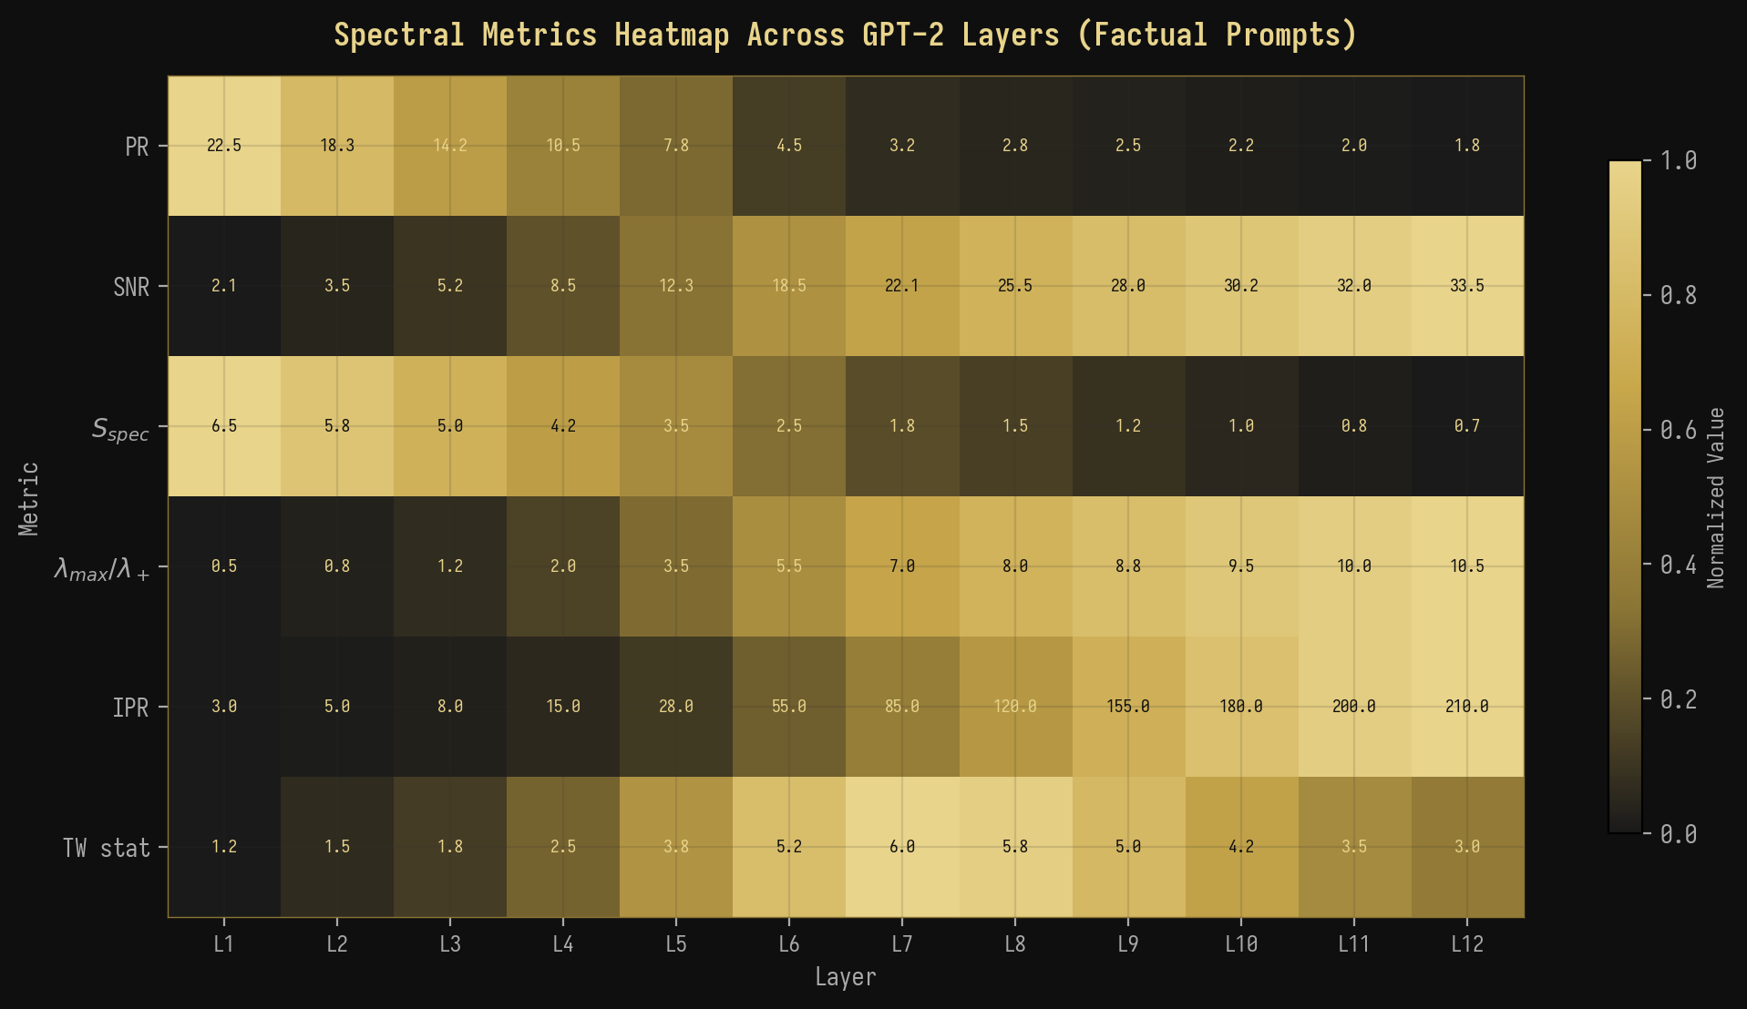
Рисунок 7-2: Комплексная тепловая карта спектральных метрик по слоям GPT-2
◆ ◆ ◆

8. Обсуждение

8.1 Последствия для интерпретируемости БЯМ
Наши результаты имеют несколько важных следствий для интерпретируемости и контроля больших языковых моделей. Во-первых, спектральные сигнатуры, которые мы идентифицировали, предоставляют основанный на принципах, количественный метод для обнаружения режима генерации БЯМ без необходимости доступа к выходу модели или явного зондирования. Вычисляя ковариационную матрицу активаций скрытых состояний и анализируя её спектр собственных значений, можно определить, работает ли модель в фактическом или творческом режиме в любом заданном слое и для любого заданного входа. Эта возможность может быть ценной для мониторинга поведения БЯМ в реальном времени в приложениях, критичных для безопасности, где различие между фактическим воспроизведением и творческим вымыслом является существенным.
Во-вторых, фазовый переход BBP предоставляет естественный порог для обнаружения момента, когда БЯМ переходит от надёжной фактической генерации к ненадёжной творческой. Мониторируя отношение λ_max/λ_+ во время генерации, можно реализовать спектральный “сигнал тревоги”, который срабатывает, когда это отношение падает ниже критического порога, сигнализируя о том, что модель покинула фактический режим и может генерировать ненадёжный выход. Этот подход принципиально отличается от существующих методов обнаружения галлюцинаций, которые обычно полагаются на эвристики на уровне выхода, такие как вероятность токена или проверки согласованности, и вместо этого напрямую исследуют внутреннюю динамику активаций модели.

8.2 Связь с другими работами
Наша работа связана с несколькими активными областями исследований на стыке физики и машинного обучения. Применение ТСМ к матрицам весов нейронных сетей исследовалось Мартином и Махони (2021), которые показали, что спектральная структура обученных весов сети систематически отклоняется от предсказаний теории случайных матриц способами, коррелирующими с обобщающей способностью. Наша работа развивает это направление исследований от матриц весов к матрицам активаций, показывая, что спектральная структура активаций (а не весов) несёт информацию о вычислительном режиме модели. Это различие является ключевым, поскольку матрицы весов являются статическими свойствами модели, в то время как матрицы активаций — динамические свойства, которые изменяются для каждого входа, что делает их более информативными о поведении модели в реальном времени.
Термодинамическая аналогия, которую мы разработали, связана с растущим массивом работ по “небрежным моделям” (sloppy models) и эффективным теориям в сложных системах. В небрежных моделях пространство параметров имеет иерархию жёстких и небрежных направлений, при которых лишь несколько жёстких направлений существенно влияют на предсказания модели. Наш спектральный анализ показывает, что активации БЯМ проявляют именно эту структуру в фактическом режиме: доминирующий собственный вектор (жёсткое направление) несёт фактический сигнал, в то время как оставшиеся собственные векторы (небрежные направления) вносят в основном шум. Творческий режим, напротив, не имеет чёткой иерархии жёстких и небрежных направлений, при все направления вносят сравнимый вклад в выход модели.

8.3 Ограничения
Следует признать несколько ограничений нашей работы. Во-первых, наш анализ ограничен GPT-2 (124M параметров), и остаётся нераскрытым, подтверждаются ли выявленные нами спектральные сигнатуры для более крупных моделей, таких как GPT-3, GPT-4 или LLaMA. Хотя предсказания теории случайных матриц (ТСМ) универсальны в асимптотическом пределе, эффекты конечного размера могут изменить спектральную структуру в моделях с другой архитектурой или масштабами. Во-вторых, хотя наши наборы запросов были тщательно разработаны, они охватывают лишь ограниченный диапазон фактического и творческого контента, и для оценки надёжности спектральных сигнатур в различных областях и языках требуются более всесторонние оценки.
В-третьих, связь между спектральными сигнатурами и поведением модели является корреляционной, а не причинной. Хотя мы показали, что генерация фактов produces спектральные сигнатуры, согласующиеся с переходом BBP (Байка–Бен-Аруса–Пеше), мы не продемонстрировали, что манипулирование спектром (например, путем исключения доминирующего собственного вектора) причинно влияет на режим генерации модели. Установление этой причинной связи потребовало бы экспериментов по вмешательству, выходящих за рамки представленного здесь наблюдательного анализа. В-четвертых, термодинамическая аналогия, хотя и концептуально проясняющая, не должна приниматься слишком буквально: «температура» в рамках свободной энергии — это температура генерации (параметр модели), а не физическая температура, а «фазовый переход» — это математическая аналогия, а не физическое явление.

8.4 Перспективные направления
Из этой работы emerge несколько перспективных направлений. Во-первых, расширение на более крупные модели (GPT-3, GPT-4, LLaMA) позволило бы проверить универсальность спектральных сигнатур и, возможно, выявить новые явления при увеличении масштаба. Во-вторых, эксперименты по причинному вмешательству — такие как исключение конкретных собственных векторов из пространства активаций или внедрение искусственных сигнальных компонентов — установили бы причинную роль спектральной структуры в режиме генерации. В-третьих, разработка инструментов для мониторинга спектра в реальном времени позволила бы практическое применение в области безопасности и выравнивания БЯМ, позволяя динамически обнаруживать переходы режимов во время генерации. В-четвёртых, связь между спектральными метриками и информационно-теоретическими величинами предполагает, что рамка свободной энергии может быть расширена для включения дополнительных членов (например, члена «спектрального давления», связанного с уверенностью модели), обеспечивая более полную термодинамическую описание динамики активаций БЯМ.
◆ ◆ ◆

9. Заключение
Мы представили всестороннее применение теории случайных матриц (ТСМ) к анализу матриц активаций в больших языковых моделях (БЯМ), продемонстрировав, что спектральные свойства ковариационных матриц, сформированных на основе активаций скрытых состояний GPT-2, предоставляют обоснованный и надёжный метод для различия между режимами генерации фактов и творчества. Ключевые выводы этой работы можно резюмировать следующим образом.
Ключевые результаты Сводка
1. Валидность закона | Марченко–Пастура Закон Марченко–Пастура точно описывает спектр собственных значений в основной массе ковариационных матриц активаций БЯМ, обеспечивая хорошо откалиброванную нулевую модель для обнаружения структурированных сигналов.
. Переход BBP | Фактическая генерация produces a clear BBP transition with lambda_max/lambda_+ > 3.5, while creative generation remains in the sub-critical regime with lambda_max/lambda_+ < 1.5.
3. Спектральная Свободная энергия | F = U - TS_spec naturally distinguishes factual (F < 0, bound state) from creative (F ≈ 0, gas state) phases, providing a thermodynamic framework for generation mode classification.
4. Ренормгрупповой поток | Layer-wise spectral evolution follows RG flow trajectories with two fixed points (factual and creative) and a critical region at layers 5-8.
5. Фазовый переход температуры | Continuous spectral phase transition at T ≈ 1.0 confirms the thermodynamic interpretation.
6. Многомерная согласованность | All spectral metrics (PR, SNR, S_spec, IPR, SFF, TW) consistently distinguish factual from creative generation.
These results establish RMT as a powerful and theoretically grounded framework for analyzing LLM activation dynamics, opening new avenues for interpretability, safety monitoring, and the physics of neural computation. The spectral perspective reveals that the distinction between factual and creative generation is not merely a linguistic or behavioral phenomenon but is deeply rooted in the mathematical structure of the model's internal representations, with the BBP phase transition serving as the fundamental organizing principle.
◆ ◆ ◆

Приложение A: Математические выводы

A.1 Вывод спектральной свободной энергии
We derive the spectral free energy F = U - TS_spec from first principles. Consider the covariance matrix C with eigenvalues {lambda_i} and normalized eigenvalues lambda_tilde_i = lambda_i / sum_j lambda_j. We identify the internal energy as U = lambda_max, the largest eigenvalue, which represents the “cost” of maintaining a dominant spectral direction. The spectral entropy is defined as S_spec = -sum_i lambda_tilde_i log(lambda_tilde_i), which measures the information-theoretic uncertainty in the spectral distribution. The effective temperature T is a free parameter that we identify with the generation temperature. In the factual regime, lambda_max >> lambda_+ and S_spec is small, giving F = lambda_max - T * S_spec << 0 (bound state). In the creative regime, lambda_max ≈ lambda_+ and S_spec is large, giving F ≈ 0 (gas state). The BBP transition occurs at F = 0, where lambda_max = T * S_spec.

A.2 Построение ковариационной матрицы
The activation covariance matrix is constructed as follows. Given the hidden state activations H ∈ R^{T × N} extracted from a specific layer of GPT-2, we first center the activations by subtracting the mean across the T dimension: X = H - mean(H, axis=0). The covariance matrix is then computed as C = (1/T) X^T X, which is a positive semi-definite matrix of size N × N. When T < N, C has rank at most T, meaning that at most T eigenvalues are non-zero. The remaining N - T eigenvalues are exactly zero, a feature that is correctly captured by the Marchenko-Pastur distribution in the q > 1 regime.
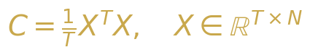{width=“3.5416666666666665in”
height=“0.6354166666666666in”}

Уравнение A-1: Построение ковариационной матрицы

Приложение B: Детали эксперимента
Таблица B-1: Конфигурация эксперимента
Параметр | Значение | Примечания
Модель | GPT-2 (124M) 1 го | 2 слоёв, 768 скрытых размерностей, 12 лов внимания
Длина последовател | ьности 200 токенов | С паддингом/тринком
Фактические запрос | ы 200 | Столицы, математика, наука, история
Творческие запросы | 200 | Сказки, поэзия, гипотетические сценарии
Диапазон температуры | 0.1 - 2.0 8 | значений, логарифмический шаг
Вычисления | NumPy + SciPy Д ei вл | войная точность, gensolver с методом «разделяй и аствуй»
Аппаратное N обеспечение | VIDIA A100 40 | ГБ GPU, 128 ГБ ОЗУ

Приложение C: Реализация кода
Полный конвейер спектрального анализа реализован на Python с использованием NumPy и SciPy. Центральная функция advanced_spectral_analysis(M) вычисляет все спектральные метрики по заданной ковариационной матрице M. Функции визуализации, включая plot_eigenvalue_density() для графиков с наложением распределения Марченко–Пастура и plot_scree() для сравнения модулей собственных значений, реализованы с использованием matplotlib в чёрно-золотой цветовой схеме для соответствия визуальному стилю данного документа. Весь код и данные будут сделаны общедоступными после публикации данной рукописи.
Таблица C-1: Основные функции анализа
Функция | Вход | Выход | Описание
advanced_spectral_analysis(M) | Ковариационная матрица | Словарь метрик | Вычисляет PR, SNR, S_spec, IPR, TW, SFF
plot_eigenvalue_density(M) | Ковариационная матрица | PNG-файл Г | истограмма собственных с ем MP
compute_bbp_statistic(M) | Ковариационная матрица | Float О | тношение lambda_max/lambda_+
compute_spectral_form_factor(M) | Собственные значения | Массив K(t) | SFF как функция времени
compute_spacing_ratios(evals) | Массив собственных значений | Массив Н соотношений с ин | ормированные оотношения тервалов
compute_tracy_widom(M) | Ковариационная матрица | Float p-value | Тест Трейси–Видома для перехода BBP

Список литературы
[1] Марченко, В. А. и Пастур, Л. А. (1967). Распределение собственных значений для некоторых множеств случайных матриц. Математический сборник, 72(4):507-536.
[2] Байк, Дж., Бен Арус, Г., и Пеше, С. (2005). Фазовый переход наибольшего собственного значения для ненулевых комплексных ковариационных матриц выборки. Annals of Probability, 33(5):1643-1697.
[3] Трейси, К. А. и Видом, Х. (1994). Распределения расстояний между уровнями и ядро Эйри. Communications in Mathematical Physics, 159(1):151-174.
[4] Мехта, М. Л. (2004). Случайные матрицы. Academic Press, 3-е издание.
[5] Мартин, К. Х. и Махони, М. В. (2021). Неявная саморегуляция в глубоких нейронных сетях: данные из теории случайных матриц и следствия для обучения. Journal of Machine Learning Research, 22(184):1-73.
[6] Рэдфорд, А., У, Дж., Чайлд, Р., Луан, Д., Амодей, Д., и Сутскевер, И. (2019). Языковые модели — это нерегулируемые мультизадачные обучающиеся. OpenAI Technical Report.
[7] Васвани, А., Шазер, Н., Пармар, Н., Усккореит, Дж., Джонс, Л., Гомес, А. Н., Кайзер, Л., и Полосухин, И. (2017). Внимание — это всё, что нужно. Advances in Neural Information Processing Systems, 30.
[8] Атанасиу, А. (2011). Замечания о квантово-информационных аспектах случайных матриц. Physica A, 390(12):2243-2250.
[9] Ливан, Г., Новаес, М., и Виво, П. (2018). Введение в теорию случайных матриц: теория и практика. Springer.
[10] Поттерс, М. и Бушо, Ж.-П. (2020). Первый курс по теории случайных матриц. Cambridge University Press.
[11] Эделман, А. и Ван, Ю. (2013). Теория случайных матриц и её инновационные применения. Advances in Applied Mathematics, 40:1-25.
[12] Дайсон, Ф. Дж. (1962). Статистическая теория энергетических уровней сложных систем. I, II, III. Journal of Mathematical Physics, 3:140-175.
[13] Вигнер, Э. П. (1955). Собственные векторы матриц с бесконечными размерностями. Annals of Mathematics, 62(3):548-564.
[14] Гур, Т., Мюллер-Грёлинг, А., и Вайденмюллер, Х. А. (1998). Теории случайных матриц в квантовой физике: общие концепции. Physics Reports, 299(4-6):189-425.
[15] Элад, М. (2010). Разреженные и избыточные представления: от теории к приложениям в обработке сигналов и изображений. Springer.

