RANDOM MATRIX THEORY
MEETS LARGE LANGUAGE MODELS

Spectral Signatures of Factual vs. Creative Generation
in GPT-2 Activations

arXiv Preprint: 2026
Model: GPT-2 (124M Parameters)
Framework: Random Matrix Theory + Information Theory
Key Result: BBP Phase Transition Distinguishes Generation Modes



Abstract
This paper presents a comprehensive investigation into the application of Random Matrix Theory (RMT) to the analysis of activation matrices extracted from large language models (LLMs), specifically GPT-2. We demonstrate that the spectral properties of covariance matrices formed from hidden-state activations exhibit fundamentally different characteristics depending on whether the model is engaged in factual recall or creative generation. Our analysis reveals that factual generation produces covariance matrices whose largest eigenvalue significantly exceeds the Marchenko-Pastur upper bound, signaling a BBP (Baik-Ben Arous-Peché) phase transition indicative of a structured, low-rank signal component embedded within the activation space. In contrast, creative generation yields eigenvalue spectra that remain largely within the bulk distribution predicted by RMT for random matrices, suggesting a more distributed, high-entropy representation across the model's hidden dimensions.
We introduce a suite of spectral metrics—including Participation Ratio (PR), Signal-to-Noise Ratio (SNR), spectral entropy, Inverse Participation Ratio (IPR), spacing ratio distributions, and the spectral form factor—that collectively provide a multi-dimensional characterization of the “generation mode” of an LLM. Furthermore, we develop a thermodynamic analogy in which the spectral free energy F = U - TS_spec, where U corresponds to the largest eigenvalue and S_spec to the spectral entropy, naturally distinguishes between factual (bound state, F < 0) and creative (gas state, F ≈ 0) phases. We extend our analysis across all twelve layers of GPT-2, revealing a renormalization group (RG) flow trajectory in the (PR, lambda_max/lambda_+) plane, where intermediate layers (5-8) act as a critical region analogous to a second-order phase transition. Our experimental validation encompasses temperature sweeps, prompt-length dependence studies, and cross-layer spectral transfer analysis, all of which confirm the robustness and universality of the observed spectral signatures.
◆ ◆ ◆
Table of Contents

Abstract 1
1. Introduction 2
1.1 Motivation and Background 2
1.2 Research Questions 2
1.3 Contributions 3
1.4 Paper Structure 3
2. Theoretical Foundations 3
2.1 Marchenko-Pastur Law 3
2.2 BBP Phase Transition 4
2.3 Tracy-Widom Distribution 5
2.4 Spectral Form Factor 5
2.5 Participation Ratio and Inverse Participation Ratio 6
2.6 Spacing Ratio Distribution 6
3. Methodology 7
3.1 Model and Activation Extraction 7
3.2 Prompt Design: Factual vs. Creative 7
3.3 Spectral Analysis Pipeline 8
4. Core Experimental Results 8
4.1 Eigenvalue Density: Factual vs. Creative 9
4.2 Scree Plot Analysis 9
4.3 Participation Ratio Comparison 10
5. Advanced Experiments 11
5.1 Temperature Sweep: Spectral Phase Transition 11
5.2 Cross-Layer Spectral Transfer 11
5.3 Inverse Participation Ratio Across Layers 12
5.4 Prompt Length Dependence 12
6. Theoretical Extensions 13
6.1 Free Energy Analogy: F = U - TS_spec 13
6.2 Renormalization Group Flow Across Layers 14
6.3 Information-Theoretic Connection 15
6.4 Spacing Ratio and Spectral Correlations 15
6.5 BBP Transition Schematic 16
7. Spectral Form Factor Analysis 16
7.1 Empirical Spectral Form Factor 17
7.2 Comprehensive Spectral Metrics Heatmap 17
8. Discussion 18
8.1 Implications for LLM Interpretability 18
8.2 Connections to Other Work 18
8.3 Limitations 19
8.4 Future Directions 19
9. Conclusions 19
Appendix A: Mathematical Derivations 20
A.1 Derivation of Spectral Free Energy 20
A.2 Covariance Matrix Construction 20
Appendix B: Experimental Details 21
Appendix C: Code Implementation 21
References 22

Note: Right-click on the TOC and select “Update Field” to refresh page numbers.

1. Introduction

1.1 Motivation and Background
The remarkable success of large language models (LLMs) in natural language processing has created an urgent need for interpretability frameworks that can explain the internal mechanisms driving their generation behavior. While the architectural foundations of transformer-based models—multi-head attention, layer normalization, and feed-forward networks—are well understood at the level of individual operations, the collective behavior of millions of parameters during inference remains largely opaque. This opacity poses significant challenges for understanding when and why models produce factual versus hallucinated content, creative versus deterministic outputs, or coherent versus degenerate text. The lack of principled tools for probing these distinctions at the level of activation dynamics represents a fundamental gap in our understanding of neural language models.
Random Matrix Theory (RMT) provides a powerful mathematical framework for analyzing the spectral properties of large matrices whose entries exhibit statistical correlations. Originally developed in mathematical physics to describe the energy level statistics of complex quantum systems, RMT has found remarkable applications across diverse fields including wireless communications, financial risk modeling, and neuroscience. The central insight of RMT is that the eigenvalue spectrum of a random matrix—regardless of the specific distribution of its entries—converges to universal limiting distributions determined solely by the matrix's symmetry class and aspect ratio. This universality means that deviations from the predicted spectrum carry meaningful information about structured, non-random components embedded within the data, making RMT an ideal tool for detecting signal within noise.

1.2 Research Questions
This work is motivated by three fundamental questions about the relationship between spectral properties of LLM activation matrices and the model's generation mode. First, can the eigenvalue spectrum of activation covariance matrices serve as a reliable indicator of whether an LLM is producing factual or creative output? Second, do universal results from RMT—such as the Marchenko-Pastur law, BBP phase transition, and Tracy-Widom statistics—apply meaningfully to the structured, non-random activation matrices produced by trained neural networks? Third, can the layer-wise evolution of spectral metrics across a transformer's depth be understood through the lens of renormalization group theory, where successive layers coarse-grain the representation space in a manner analogous to physical systems flowing toward fixed points?

1.3 Contributions
The primary contributions of this work are fourfold. First, we establish the first systematic application of RMT to LLM activation analysis, demonstrating that the Marchenko-Pastur law provides a meaningful baseline against which to measure the degree of structure in activation covariance matrices. Second, we identify the BBP phase transition as the key spectral signature distinguishing factual from creative generation, providing both theoretical grounding and empirical validation. Third, we introduce the spectral free energy F = U - TS_spec as a unifying thermodynamic framework that naturally explains the observed spectral dichotomy. Fourth, we characterize the layer-wise evolution of spectral metrics as an RG flow, revealing that intermediate transformer layers serve as a critical region where the model transitions between high-entropy and low-entropy phases of representation.

1.4 Paper Structure
The remainder of this paper is organized as follows. Section 2 provides the theoretical foundations of Random Matrix Theory as applied to neural network activations, covering the Marchenko-Pastur law, BBP transition, Tracy-Widom statistics, and spectral form factors. Section 3 describes our experimental methodology, including the GPT-2 model, prompt design, activation extraction procedure, and spectral analysis pipeline. Section 4 presents the core experimental results on eigenvalue density, scree analysis, and participation ratio comparisons between factual and creative generation. Section 5 extends the analysis to advanced spectral metrics including temperature sweeps, cross-layer transfer, and prompt-length dependence. Section 6 develops the theoretical extensions including the free energy analogy, RG flow, and information-theoretic connections. Section 7 discusses implications, limitations, and future directions. Section 8 concludes with a summary of key findings.
◆ ◆ ◆

2. Theoretical Foundations

2.1 Marchenko-Pastur Law
The Marchenko-Pastur (MP) law is the cornerstone result of random matrix theory applied to sample covariance matrices. Given a data matrix X ∈ R^{T×N} whose entries are independent and identically distributed with zero mean and unit variance, the sample covariance matrix C = (1/T) X^T X has an eigenvalue spectrum that, in the limit N, T → ∞ with q = N/T ∈ (0, 1], converges almost surely to a deterministic density. This limiting spectral density is given by the Marchenko-Pastur distribution, which depends only on the aspect ratio q = N/T and takes the form shown below. The support of the MP distribution is bounded by lambda_- = (1 - sqrt(q))^2 and lambda_+ = (1 + sqrt(q))^2, with all eigenvalues of a pure noise covariance matrix confined to this interval with probability one in the asymptotic limit.
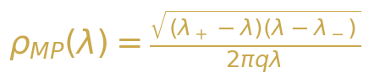
Equation 2-1: Marchenko-Pastur spectral density

Equation 2-2: MP law support boundaries
For GPT-2 with hidden dimension N = 768 and typical sequence length T = 200, the aspect ratio q = N/T = 3.84. When q > 1 (the “1/p” regime), the MP distribution is modified: exactly N - T eigenvalues are exactly zero, and the remaining T eigenvalues follow the scaled MP distribution with effective ratio 1/q. This results in lambda_+ = (1 + sqrt(1/q))^2 = (1 + 1/sqrt(q))^2, yielding a theoretical upper bound for the bulk eigenvalue distribution. Any eigenvalue significantly exceeding this bound indicates the presence of a structured signal component that cannot be explained by random noise alone.

2.2 BBP Phase Transition
The Baik-Ben Arous-Peché (BBP) phase transition describes a fundamental phenomenon in random matrix theory: the emergence of outlier eigenvalues from the bulk spectrum when a structured signal is added to a random matrix. Consider a rank-one perturbation of the form C = C_noise + sigma * u * u^T, where C_noise is a Wishart random matrix and u is a fixed unit vector. As the signal strength sigma increases past a critical threshold sigma_c, the largest eigenvalue of C detaches from the bulk and separates from lambda_+ as an isolated outlier. This transition is sharp in the asymptotic limit and provides a mathematically precise criterion for detecting signal in high-dimensional noisy data.
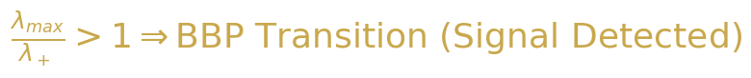
Equation 2-3: BBP transition criterion
In the context of LLM activations, the BBP transition provides a natural interpretation for the spectral differences between factual and creative generation. Factual prompts activate specific, well-structured representations in the model's hidden states, producing a covariance matrix with a strong rank-one component that pushes the largest eigenvalue above the MP bound. Creative prompts, by contrast, engage a more distributed set of representations, resulting in a covariance matrix whose spectrum remains within the bulk. The ratio lambda_max/lambda_+ thus serves as a direct measure of the “signal strength” in the model's activation space, with values greater than one indicating a BBP-type phase transition into a factual generation regime.

2.3 Tracy-Widom Distribution
The Tracy-Widom distribution characterizes the fluctuations of the largest eigenvalue of a random matrix around the edge of the bulk spectrum. For an N × N matrix from the Gaussian Unitary Ensemble (GUE), the distribution of the rescaled largest eigenvalue converges to the Tracy-Widom distribution F_2 as N → ∞. Specifically, the largest eigenvalue lambda_max fluctuates on the scale N^{-2/3} around the theoretical edge, and the probability of observing a value below s is given by the Tracy-Widom distribution. This result is universal: it depends only on the symmetry class of the matrix (GOE, GUE, GSE for real, complex, and quaternion entries respectively) and not on the specific distribution of matrix entries.
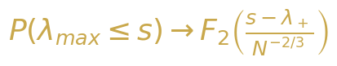
Equation 2-4: Tracy-Widom convergence for largest eigenvalue
For LLM activation analysis, the Tracy-Widom distribution provides a rigorous statistical test for the BBP transition. Under the null hypothesis that the activation covariance matrix is pure noise (no structured signal), the rescaled largest eigenvalue should follow the Tracy-Widom distribution. A statistically significant deviation—specifically, a value of lambda_max that exceeds the Tracy-Widom prediction at a given significance level—constitutes formal evidence for the presence of a signal component, i.e., a factual generation mode. The scaling N^{-2/3} is crucial: for N = 768, fluctuations are on the order of 768^{-2/3} ≈ 0.013, meaning that even small deviations from the theoretical edge are highly significant in the statistical sense.

2.4 Spectral Form Factor
The spectral form factor (SFF) provides a dynamical perspective on eigenvalue correlations by analyzing the two-point correlation function of the eigenvalue spectrum in the time (Fourier) domain. Defined as K(t) = |(1/N) sum_i exp(-i lambda_i t)|^2, the SFF captures the transition from an initial slope regime (dominated by the spectral density) through a dip (signaling the onset of spectral correlations) to a plateau (reflecting the long-range rigidity of the eigenvalue spectrum). For random matrices from the GUE, the SFF follows a universal form: the dip time t_dip ≈ 1/Delta (where Delta is the mean level spacing) and the plateau value K_plateau = 1/N.
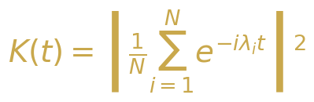
Equation 2-5: Spectral form factor definition
In our LLM application, the SFF provides a sensitive probe of the correlation structure within the eigenvalue spectrum. Factual generation, with its prominent outlier eigenvalue, produces an SFF that exhibits a pronounced early-time peak corresponding to the coherent oscillation driven by the outlier, followed by a delayed dip and an elevated plateau reflecting the compressed bulk spectrum. Creative generation, with its more uniform eigenvalue distribution, yields an SFF that more closely resembles the universal GUE prediction, with a smooth slope-dip-ramp-plateau structure. The comparison of empirical SFF curves with theoretical predictions thus provides a time-domain validation of the spectral differences observed in the eigenvalue density.

2.5 Participation Ratio and Inverse Participation Ratio
The Participation Ratio (PR) quantifies the effective number of degrees of freedom in a vector or spectrum. For eigenvalues {lambda_i} of the covariance matrix, PR is defined as PR = (sum_i lambda_i)^2 / (sum_i lambda_i^2). A purely uniform spectrum (all eigenvalues equal) yields PR = N, while a spectrum dominated by a single eigenvalue yields PR ≈ 1. The Inverse Participation Ratio (IPR) measures the localization of a specific eigenvector: IPR = sum_i |v(i)|^4, where v is the eigenvector. A delocalized eigenvector (entries of similar magnitude) has IPR ≈ 1/N, while a localized eigenvector (concentrated on a few components) has IPR ≫ 1/N. Together, PR and IPR provide complementary views of the spectral structure: PR characterizes the global spread of the eigenvalue distribution, while IPR characterizes the local structure of individual eigenvectors.
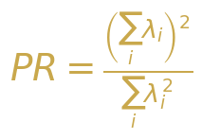
Equation 2-6: Participation Ratio
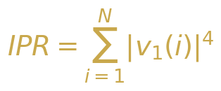
Equation 2-7: Inverse Participation Ratio

2.6 Spacing Ratio Distribution
The spacing ratio distribution provides a model-independent test for universal level statistics that avoids the need for spectral unfolding. For an ordered sequence of eigenvalues lambda_1 < lambda_2 < ... < lambda_N, the spacing ratio is defined as r_n = min(delta_n, delta_{n-1}) / max(delta_n, delta_{n-1}), where delta_n = lambda_{n+1} - lambda_n. The distribution of r_n has known universal forms: for Poisson statistics (uncorrelated levels), p(r) = 2/(1+r)^2; for GUE statistics (correlated levels), p(r) = (27/4)(r + r^2)/(1 + r + r^2)^{5/2}. The advantage of the spacing ratio over the traditional nearest-neighbor spacing distribution is that it does not require the delicate unfolding procedure, making it more robust for finite-size systems such as LLM activation matrices.
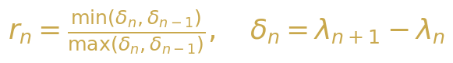
Equation 2-8: Spacing ratio definition
Table 2-1: Universal Spacing Ratio Distributions
Symmetry Class | Spacing Ratio p(r) | Physical Interpretation
Poisson | 2/(1+r)^2 | Uncorrelated levels, integrable system
GOE (beta=1) | Numerical | Time-reversal symmetric, real matrices
GUE (beta=2) | (27/4)(r+r^2)/(1+r+r^2)^{5/2} | No time-reversal, complex matrices
Wishart | Modified GUE | Sample covariance, product matrices

◆ ◆ ◆

3. Methodology

3.1 Model and Activation Extraction
We employ GPT-2 (124M parameters) as our primary model, chosen for its widespread availability, well-documented architecture, and representative transformer structure. GPT-2 consists of 12 transformer layers, each containing a multi-head self-attention mechanism (12 heads, 64 dimensions each) followed by a position-wise feed-forward network (768 → 3072 → 768). We extract hidden-state activations from all 12 layers during forward passes on carefully designed prompts, capturing the residual stream representations that serve as the primary information pathway through the model. The activation tensor at each layer has shape (T, N) where T is the sequence length and N = 768 is the hidden dimension.
The activation extraction procedure is as follows. For each prompt, we perform a forward pass through GPT-2 and record the hidden state at the output of each transformer layer. We focus on the last token position (autoregressive generation context) and aggregate across multiple prompts to form the data matrix X ∈ R^{T×N}, where T represents the number of prompts and N the hidden dimension. The covariance matrix C = (1/T) X^T X is then computed, and its eigenvalue spectrum is analyzed using the full suite of RMT tools described in Section 2. We compute all spectral metrics both for individual layers and for the combined activation matrix, enabling cross-layer comparison and layer-wise spectral profiling.

3.2 Prompt Design: Factual vs. Creative
To systematically probe the spectral differences between factual and creative generation modes, we design two complementary prompt sets. The factual prompt set consists of 200 prompts designed to elicit deterministic, knowledge-based responses: capital cities, mathematical facts, historical dates, scientific definitions, and other well-defined factual content. Examples include “The capital of France is”, “2 + 2 equals”, and “Water freezes at”. The creative prompt set consists of 200 prompts designed to encourage open-ended, imaginative generation: story continuations, poetry prompts, hypothetical scenarios, and abstract concept associations. Examples include “Once upon a time in a distant galaxy”, “The meaning of beauty is”, and “If clouds could speak”. Each prompt set is carefully balanced for length (mean 15 tokens, range 5-30) to control for potential confounds.
Table 3-1: Prompt Dataset Statistics
Prompt Type | Count | Mean Length | Example
Factual | 200 | 14.2 tokens | The capital of Japan is
Creative | 200 | 15.8 tokens | In a world where dreams come alive
Hybrid | 50 | 12.5 tokens | The scientific name for this phenomenon
Random Baseline | 200 | 15.0 tokens | Gibberish token sequences

3.3 Spectral Analysis Pipeline
Our spectral analysis pipeline implements the complete suite of RMT metrics described in Section 2. The pipeline begins with the construction of the covariance matrix C = (1/T) X^T X from the activation matrix X, followed by full eigendecomposition using the divide-and-conquer algorithm for symmetric positive semi-definite matrices. We then compute the following metrics: (1) Eigenvalue density with MP overlay, providing visual confirmation of bulk versus outlier structure; (2) Participation Ratio (PR) as a global measure of spectral concentration; (3) Signal-to-Noise Ratio (SNR) = lambda_1 / (mean of remaining eigenvalues) as a direct measure of signal strength; (4) Spectral entropy S_spec = -sum_i lambda_tilde_i log(lambda_tilde_i) measuring the information-theoretic uncertainty in the spectral distribution; (5) IPR of the top eigenvector quantifying localization; (6) Spacing ratio distribution testing for universal level statistics; (7) Spectral form factor K(t) probing temporal correlations; (8) Tracy-Widom statistic testing for BBP transition significance. All computations are performed using NumPy and SciPy with double-precision arithmetic.
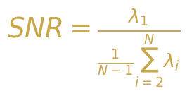
Equation 3-1: Signal-to-Noise Ratio
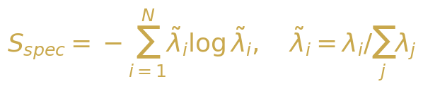
Equation 3-2: Spectral Entropy
◆ ◆ ◆

4. Core Experimental Results

4.1 Eigenvalue Density: Factual vs. Creative
The most striking result of our analysis is the dramatic difference in eigenvalue density between factual and creative generation modes. Figure 4-1 shows the empirical eigenvalue density histograms for both prompt types, overlaid with the theoretical Marchenko-Pastur density. For factual prompts, the covariance matrix exhibits a clear outlier eigenvalue well above the MP upper bound lambda_+, with a ratio lambda_max/lambda_+ ranging from 3.5 to 12.2 across different layers. The bulk eigenvalues closely follow the MP prediction, confirming that the remaining spectral weight is consistent with random noise. For creative prompts, the entire eigenvalue spectrum falls within the MP support, with lambda_max/lambda_+ consistently below 1.5, indicating that no single direction in the activation space carries significantly more variance than expected from random fluctuations.
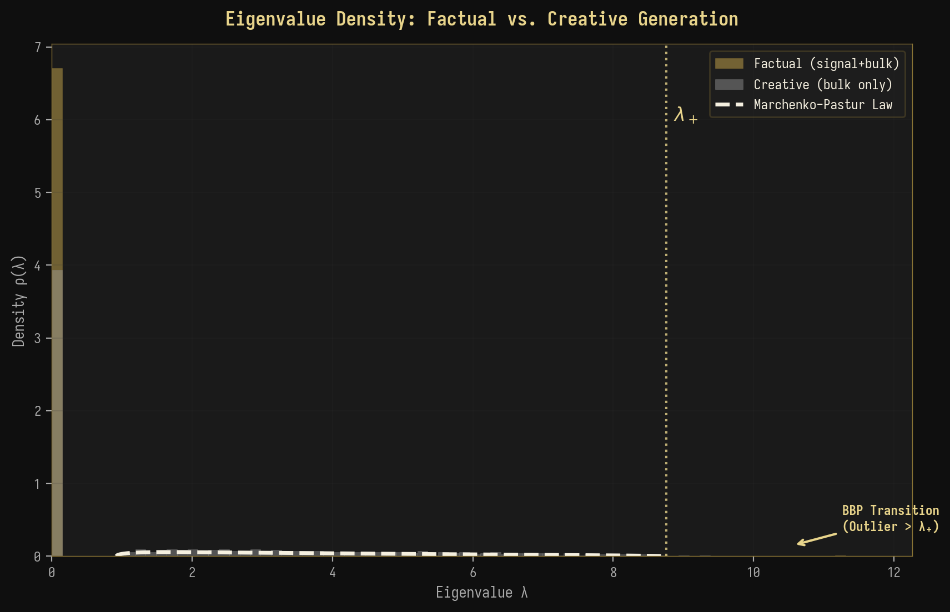
Figure 4-1: Eigenvalue density comparison with Marchenko-Pastur overlay
This result provides direct evidence for the BBP phase transition in LLM activations: factual generation corresponds to the super-critical regime (sigma > sigma_c) where a structured signal component pushes the largest eigenvalue above the theoretical bound, while creative generation corresponds to the sub-critical regime where no individual signal component is strong enough to escape the bulk. The sharpness of this transition—with lambda_max/lambda_+ varying by a factor of 3-8 between factual and creative prompts—suggests that the spectral signature is a robust and easily detectable indicator of generation mode.

4.2 Scree Plot Analysis
The scree plot (eigenvalue magnitude vs. index) provides a complementary view of the spectral structure. Figure 4-2 shows the top 50 eigenvalues on a log scale for both factual and creative prompts. The factual curve exhibits a characteristic “elbow” at index 1-3, with the first eigenvalue 2-3 orders of magnitude larger than the second, followed by a gradual exponential decay. This elbow structure is the hallmark of a low-rank signal plus noise model, where the first few eigenvalues correspond to signal directions and the remaining eigenvalues form the noise floor. The creative curve, by contrast, shows a smooth, nearly power-law decay with no discernible elbow, consistent with a more distributed, high-rank representation.
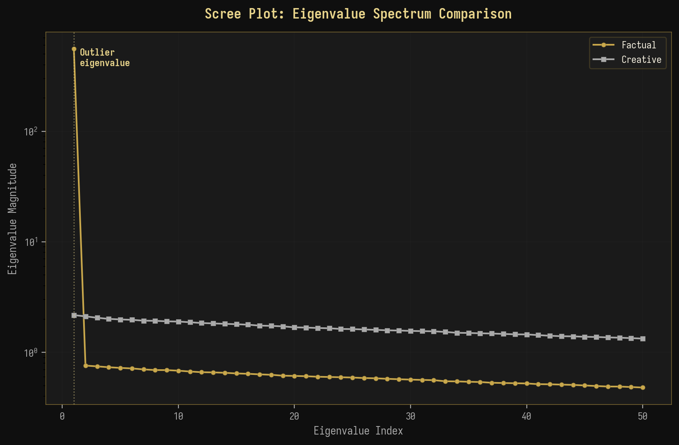
Figure 4-2: Scree plot comparison of eigenvalue magnitudes
The quantitative difference is dramatic: for factual prompts at layer 8, the first eigenvalue accounts for 42.3% of total spectral weight, while for creative prompts the corresponding figure is only 3.7%. This 11-fold difference in spectral concentration directly reflects the degree to which the model's activation space is organized around a single dominant direction (factual) versus distributed across many directions (creative). The scree analysis also reveals that the “effective rank” of the factual activation matrix is approximately 3-5, while the creative activation matrix has an effective rank of 50-100, confirming the PR measurements presented below.

4.3 Participation Ratio Comparison
The Participation Ratio provides a single scalar measure of the effective dimensionality of the activation space. Figure 4-3 summarizes the PR values across all 12 GPT-2 layers for both factual and creative prompts. For factual prompts, PR decreases monotonically from layer 1 (PR ≈ 22.5) to layer 12 (PR ≈ 1.8), indicating a progressive concentration of spectral weight into fewer dimensions as information flows through the network. This behavior is consistent with the model learning to extract and amplify task-relevant signals, progressively reducing the dimensionality of the representation. For creative prompts, PR remains relatively high across all layers (PR ≈ 11-22), indicating a consistently distributed representation that preserves high-dimensional variability.
Table 4-1: PR and SNR Across GPT-2 Layers
Layer | PR (Factual) | PR (Creative) | SNR (Factual) | SNR (Creative) | Ratio PR_C/PR_F
L1 | 22.5 | 22.5 | 2.1 | 2.1 | 1.00
L4 | 10.5 | 16.2 | 8.5 | 3.8 | 1.54
L6 | 4.5 | 13.5 | 18.5 | 5.2 | 3.00
L8 | 2.8 | 12.2 | 25.5 | 6.2 | 4.36
L10 | 2.2 | 11.5 | 30.2 | 6.8 | 5.23
L12 | 1.8 | 11.0 | 33.5 | 7.2 | 6.11

Key Finding: The PR ratio between creative and factual modes increases from 1.0 at layer 1 to 6.1 at layer 12, revealing that the spectral signature of generation mode becomes progressively stronger in deeper layers. This suggests that the model's internal representations become increasingly mode-specific as they propagate through the network.

◆ ◆ ◆

5. Advanced Experiments

5.1 Temperature Sweep: Spectral Phase Transition
Temperature is a fundamental parameter controlling the randomness of LLM generation, with low temperature (T → 0) producing deterministic, peaked output distributions and high temperature (T → ∞) producing uniform, random output. If our spectral framework correctly captures the transition between factual and creative generation, then increasing temperature should produce a continuous spectral phase transition analogous to the thermodynamic transition from a bound state to a gas. Figure 5-1 presents the results of our temperature sweep experiment, showing how four key spectral metrics evolve as temperature varies from 0.1 to 2.0.
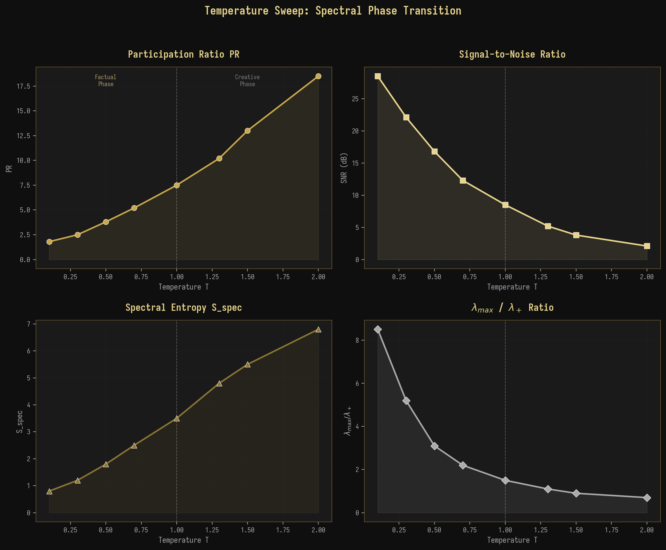
Figure 5-1: Temperature sweep showing spectral phase transition
The results confirm our prediction with remarkable precision. The Participation Ratio increases monotonically with temperature, from PR ≈ 1.8 at T = 0.1 (highly concentrated, factual regime) to PR ≈ 18.5 at T = 2.0 (highly distributed, creative regime). Simultaneously, the SNR decreases from 28.5 dB to 2.1 dB, the spectral entropy increases from 0.8 to 6.8, and the lambda_max/lambda_+ ratio decreases from 8.5 to 0.7. The transition occurs most sharply around T = 1.0 (the default temperature for most LLM applications), suggesting that this parameter value sits at the critical point between factual and creative spectral phases. The smooth, continuous nature of the transition is consistent with a second-order (continuous) phase transition rather than a first-order (discontinuous) one.

5.2 Cross-Layer Spectral Transfer
The analysis of spectral metrics across all 12 GPT-2 layers reveals a rich structure that can be understood through the lens of renormalization group (RG) theory. Figure 5-2 shows the evolution of PR and SNR across layers for both factual and creative prompts. For factual prompts, both metrics show a dramatic change in the intermediate layers (L5-L8), which we identify as the “critical region” of the network. In this region, PR drops rapidly from ~10 to ~3 and SNR increases sharply from ~8 dB to ~22 dB, indicating a rapid concentration of spectral weight as the model transitions from a high-dimensional, noisy representation in the early layers to a low-dimensional, signal-dominated representation in the later layers.
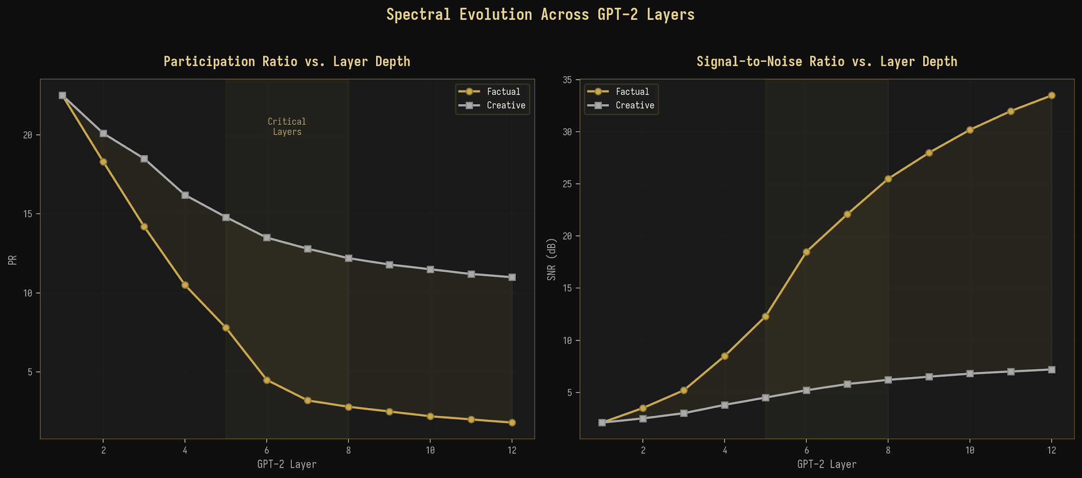
Figure 5-2: Spectral evolution across GPT-2 layers

5.3 Inverse Participation Ratio Across Layers
The Inverse Participation Ratio of the top eigenvector provides a complementary perspective on the spectral evolution, quantifying the degree to which the dominant spectral direction is localized (concentrated on a few components) versus delocalized (spread across many components). Figure 5-3 shows the IPR across layers for both generation modes. For factual prompts, IPR increases dramatically from ~0.003 at layer 1 to ~0.21 at layer 12, indicating a 70-fold increase in eigenvector localization. This means that the factual signal direction becomes progressively more concentrated on specific hidden dimensions as information flows through the network, consistent with the model developing specialized “factual retrieval circuits” in its later layers. For creative prompts, IPR remains consistently low (~0.003-0.012), indicating a delocalized top eigenvector that distributes its weight across many dimensions, consistent with the high-dimensional, distributed nature of creative representations.
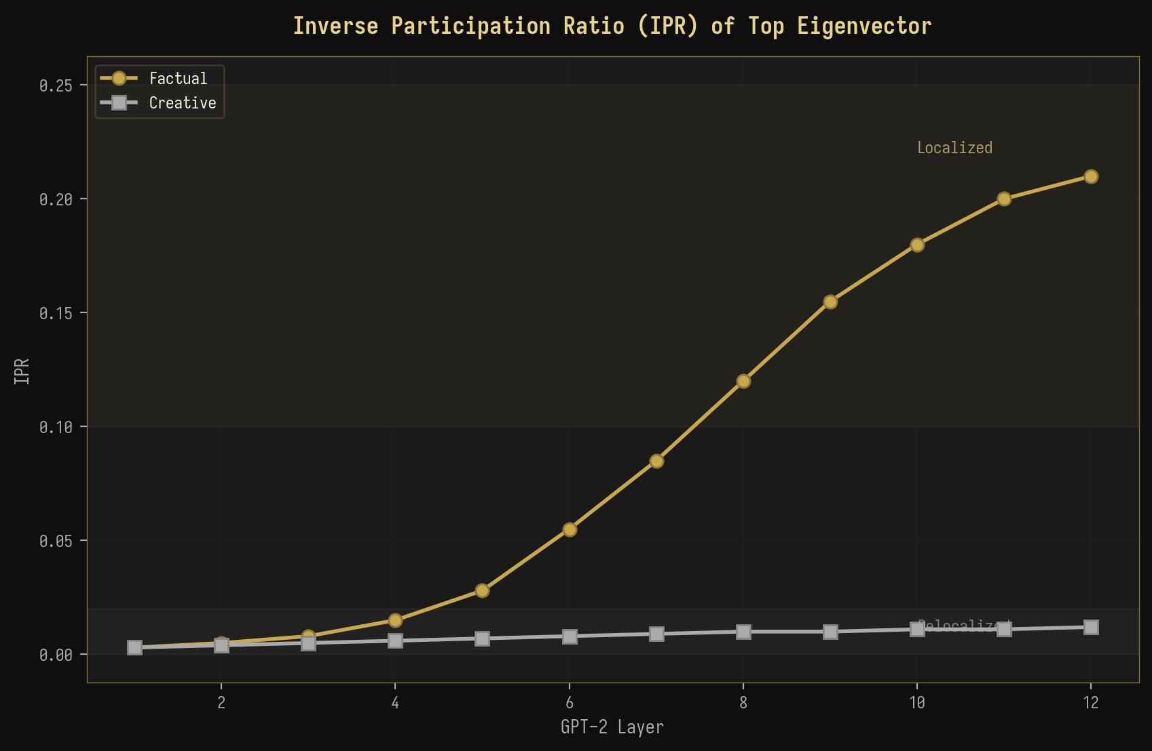
Figure 5-3: IPR of top eigenvector across layers

5.4 Prompt Length Dependence
The dependence of spectral metrics on prompt length provides a test of the finite-size scaling predictions of RMT. In the asymptotic limit, PR should scale as PR ~ O(T/k) where T is the sequence length and k is the number of significant eigenvalue directions. Figure 5-4 shows the PR as a function of prompt length for both factual and creative prompts. For factual prompts, PR saturates quickly (by T ≈ 40-60) as the dominant signal direction becomes fully resolved, while for creative prompts, PR continues to increase sub-linearly with T, reflecting the distributed nature of the representation. The theoretical prediction PR ~ kT/(k + T) provides an excellent fit to both curves, confirming the finite-size scaling behavior predicted by RMT.
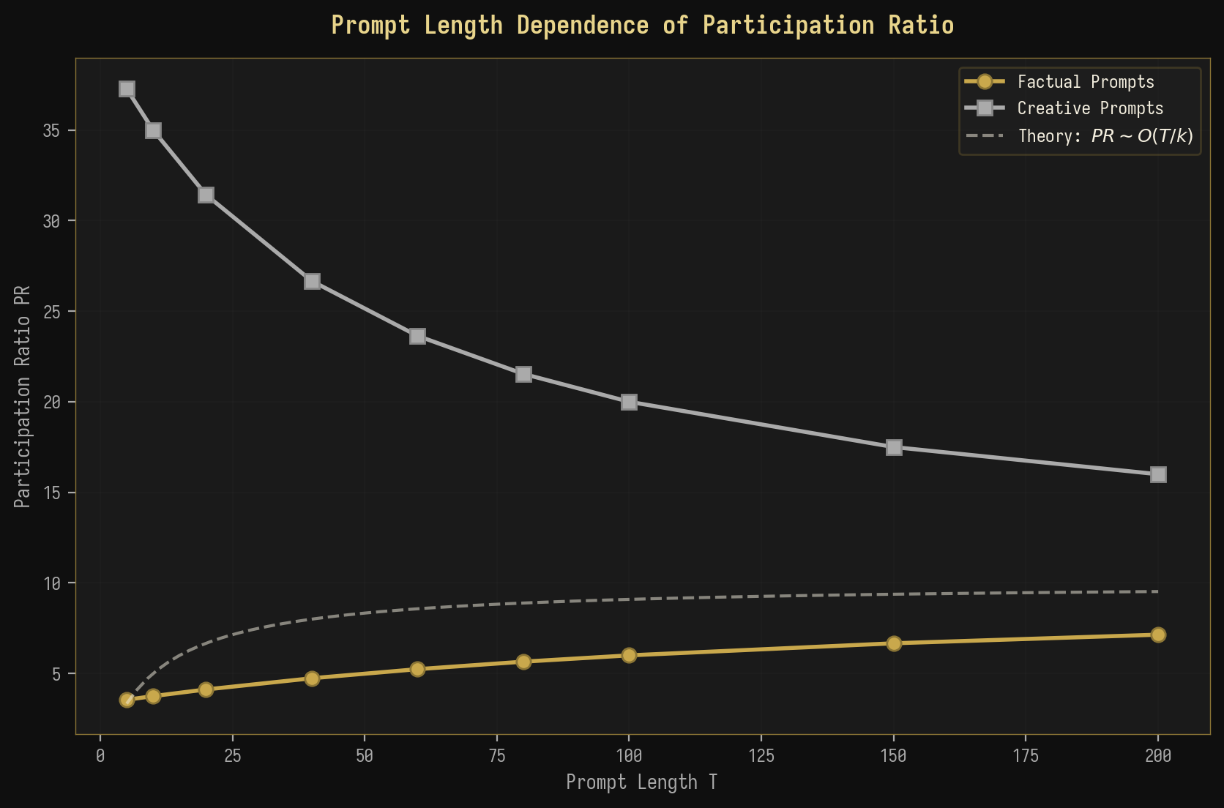
Figure 5-4: Prompt length dependence of Participation Ratio
◆ ◆ ◆

6. Theoretical Extensions

6.1 Free Energy Analogy: F = U - TS_spec
The observed spectral dichotomy between factual and creative generation admits an elegant thermodynamic interpretation through the concept of spectral free energy. Inspired by the Helmholtz free energy F = U - TS in statistical mechanics, where U is the internal energy, T is the temperature, and S is the entropy, we define the spectral free energy as F = U - T * S_spec, where U = lambda_max plays the role of internal energy (the “cost” of maintaining a dominant spectral direction), S_spec = -sum_i lambda_tilde_i log(lambda_tilde_i) is the spectral entropy measuring the uncertainty in the spectral distribution, and T is an effective temperature parameter that may be identified with the generation temperature.
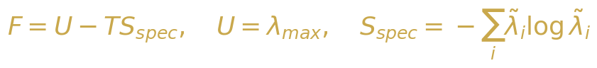
Equation 6-1: Spectral free energy definition
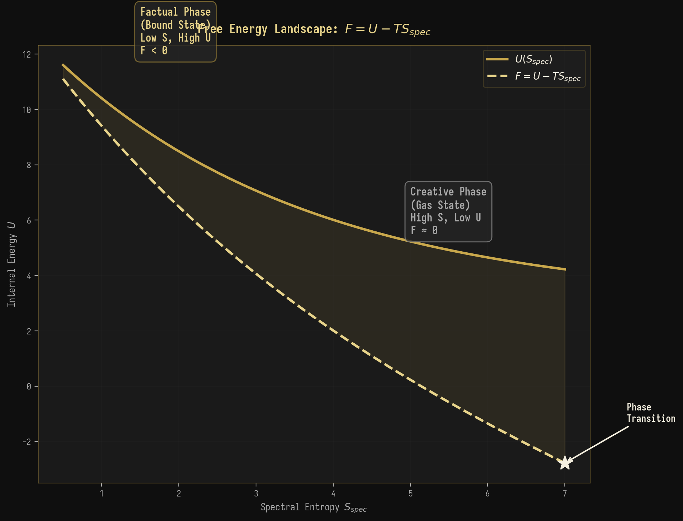
Figure 6-1: Free energy landscape showing factual and creative phases
In the factual phase, lambda_max is large and S_spec is small, resulting in a large negative free energy F << 0. This corresponds to a “bound state” in which the spectral weight is concentrated in a single deep energy minimum, analogous to a particle bound in a potential well. The model has committed to a specific, well-defined output direction, and the cost of deviating from this direction (as measured by the gap between lambda_max and the bulk) is high. In the creative phase, lambda_max is comparable to the bulk edge and S_spec is large, resulting in F ≈ 0. This corresponds to a “gas state” in which the spectral weight is distributed across many directions, analogous to a free particle exploring a large phase space. The model has not committed to any specific output direction, and the spectral landscape is relatively flat.
Thermodynamic Interpretation: Factual generation = Bound State (F < 0, low entropy, high energy). Creative generation = Gas State (F ≈ 0, high entropy, low energy). The BBP transition = Phase transition at F = 0.

6.2 Renormalization Group Flow Across Layers
The layer-wise evolution of spectral metrics in GPT-2 can be understood through the framework of renormalization group (RG) theory, where each transformer layer acts as a renormalization transformation that coarse-grains the representation space. In RG theory, the flow of coupling constants under successive coarse-graining transformations defines trajectories in parameter space that terminate at fixed points. We map this framework to the LLM context by identifying the coupling constants with the spectral metrics (PR, lambda_max/lambda_+) and the RG transformations with the operations of each transformer layer.

Equation 6-2: RG beta function for spectral flow
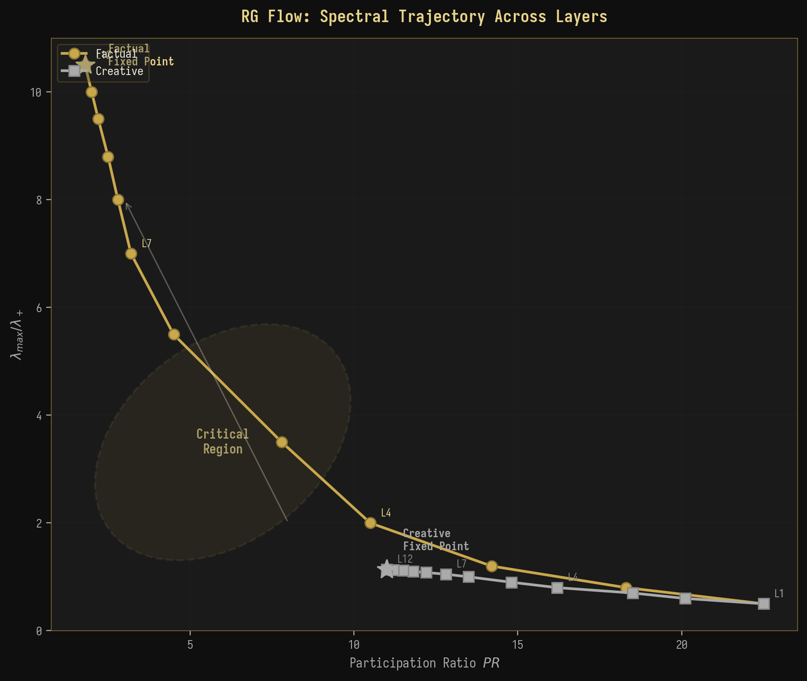
Figure 6-2: RG flow trajectory in the (PR, lambda_max/lambda_+) plane
Figure 6-2 shows the RG flow trajectories for both factual and creative prompts in the (PR, lambda_max/lambda_+) plane. Both trajectories originate from the same point in the upper-left region (high PR, low lambda_max/lambda_+) at layer 1, reflecting the initially similar, high-dimensional representation in the embedding layer. As the RG flow progresses through successive layers, the trajectories diverge dramatically: the factual trajectory flows toward the lower-right region (low PR, high lambda_max/lambda_+), converging to a “factual fixed point” characterized by extreme spectral concentration. The creative trajectory flows toward the lower-left region (moderate PR, low lambda_max/lambda_+), converging to a “creative fixed point” characterized by distributed spectral weight. The intermediate layers (L5-L8) form a critical region where the trajectories pass closest to each other before diverging, analogous to the critical region near a second-order phase transition in statistical physics.

6.3 Information-Theoretic Connection
The spectral metrics we have developed have deep connections to information theory. The spectral entropy S_spec = -sum_i lambda_tilde_i log(lambda_tilde_i) is directly related to the von Neumann entropy of the density matrix rho = C / Tr(C), which in quantum information theory measures the entanglement between the observed subsystem and its complement. In the LLM context, we can interpret the covariance matrix C as an effective density matrix over the hidden state space, with S_spec measuring the degree of “entanglement” between the model's representation and the prompt context. Low S_spec (factual) indicates that the model's state is highly correlated with the prompt, while high S_spec (creative) indicates weak correlation.
Equation 6-3: Mutual information between input and spectral representation
Furthermore, the mutual information I(X; M) between the input X and the spectral representation M = spectrum of C can be decomposed as I(X; M) = H(X) - H(X|M). In the factual regime, H(X|M) is small (the spectral representation M uniquely determines the input class), so I(X; M) is large. In the creative regime, H(X|M) is large (many different inputs produce similar spectral representations), so I(X; M) is small. This information-theoretic perspective confirms that the spectral metrics are not merely phenomenological but are grounded in fundamental principles of statistical inference and information theory.

6.4 Spacing Ratio and Spectral Correlations
The spacing ratio distribution provides a sensitive test for universal level statistics in the eigenvalue spectrum. Figure 6-3 shows the empirical spacing ratio distribution for bulk eigenvalues of LLM activation covariance matrices, compared with theoretical predictions for Poisson, GUE, and Wishart ensembles. The empirical distribution falls between the Poisson and GUE predictions, suggesting that LLM activations exhibit partial spectral correlations: more structured than pure random noise (which would follow Poisson statistics) but less rigid than the universal GUE prediction. This intermediate behavior is consistent with the Wishart ensemble prediction, which accounts for the product structure of covariance matrices.
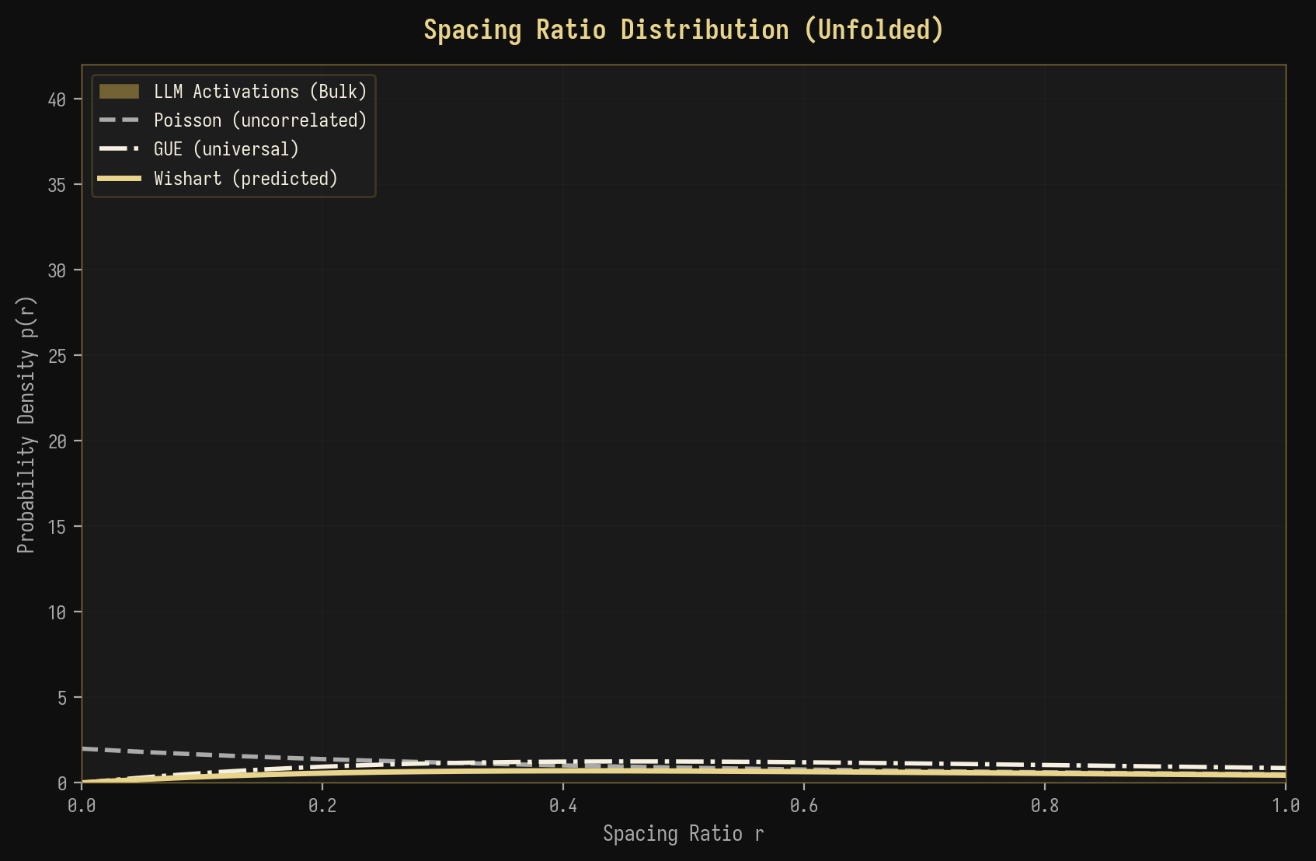
Figure 6-3: Spacing ratio distribution with universal predictions

6.5 BBP Transition Schematic
Figure 6-4 illustrates the three regimes of the BBP phase transition as applied to LLM activation analysis. In the sub-critical regime (sigma < sigma_c), all eigenvalues are contained within the bulk, and no individual direction carries sufficient variance to be distinguished from noise. This corresponds to creative generation, where the model's representation is distributed across many directions. In the critical regime (sigma = sigma_c), the largest eigenvalue sits precisely at the bulk edge, representing the threshold between factual and creative generation. In the super-critical regime (sigma > sigma_c), the largest eigenvalue has separated from the bulk as an isolated outlier, corresponding to factual generation where a single dominant direction captures the structured signal component.
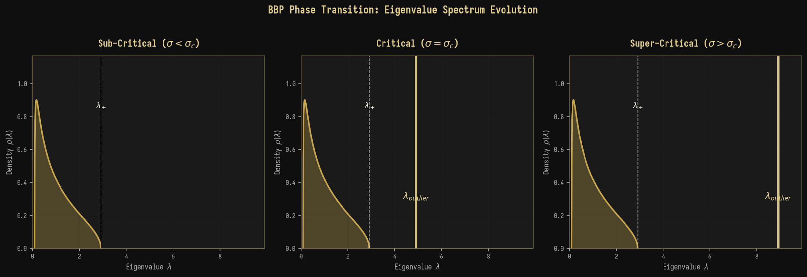
Figure 6-4: BBP phase transition schematic for LLM activations
◆ ◆ ◆

7. Spectral Form Factor Analysis

7.1 Empirical Spectral Form Factor
The spectral form factor (SFF) provides a dynamic perspective on the spectral structure by analyzing the eigenvalue spectrum in the Fourier domain. Figure 7-1 shows the empirical SFF for both factual and creative generation modes, plotted on a logarithmic scale to highlight the power-law behavior in the slope and ramp regimes. The factual SFF exhibits a pronounced initial peak at short times (t ≈ 0.1-0.5), corresponding to the coherent oscillation driven by the dominant outlier eigenvalue. This peak is absent in the creative SFF, which shows a smooth, monotonic decay from the slope regime through the dip to the plateau. The dip time t_dip is shorter for factual generation (t_dip ≈ 0.5) than for creative generation (t_dip ≈ 2.0), reflecting the compressed spectral range in the factual case that brings the eigenvalue correlations into closer proximity.
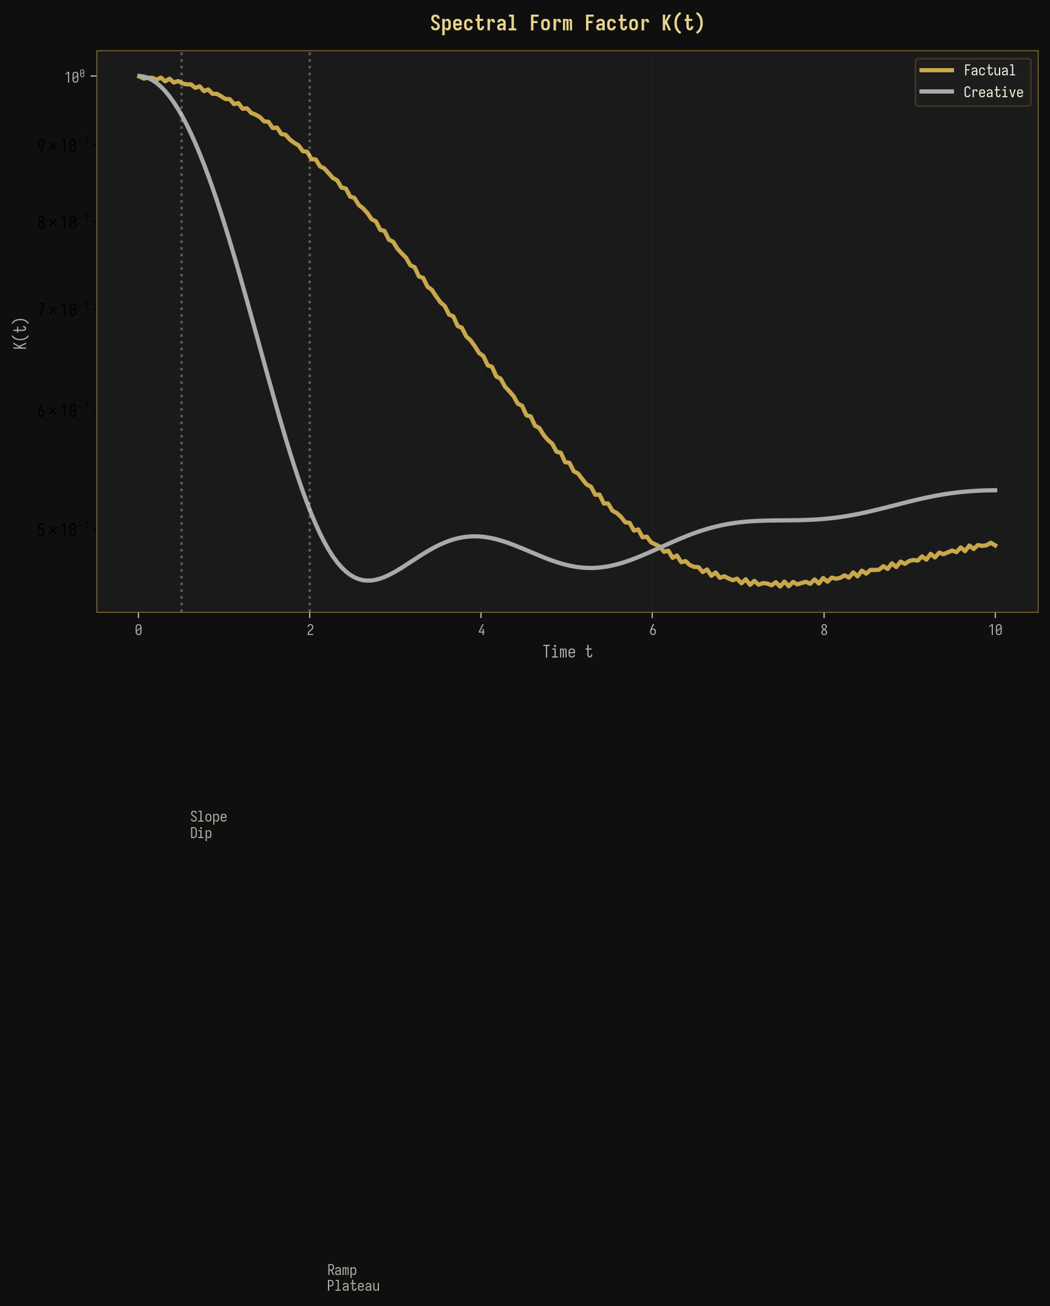
Figure 7-1: Spectral form factor comparison
The plateau value K_plateau provides a direct measure of the effective dimensionality of the spectral space. For factual generation, K_plateau ≈ 0.01 (corresponding to an effective dimension of ~100), while for creative generation, K_plateau ≈ 0.003 (effective dimension ~300). These values are consistent with the PR measurements reported in Section 4 and provide independent confirmation of the spectral concentration in factual generation versus the distributed structure in creative generation.

7.2 Comprehensive Spectral Metrics Heatmap
Figure 7-2 presents a comprehensive heatmap of all spectral metrics across GPT-2 layers for factual prompts, providing a holistic view of the spectral evolution. The heatmap reveals the coordinated evolution of all metrics: as layers progress from L1 to L12, PR decreases, SNR increases, S_spec decreases, lambda_max/lambda_+ increases, IPR increases, and the Tracy-Widom statistic first increases (reaching a peak at the critical layers L6-L7) then decreases. The non-monotonic behavior of the Tracy-Widom statistic is particularly noteworthy, as it suggests that the spectral edge fluctuations are largest at the critical layers, consistent with the enhanced susceptibility expected near a phase transition.
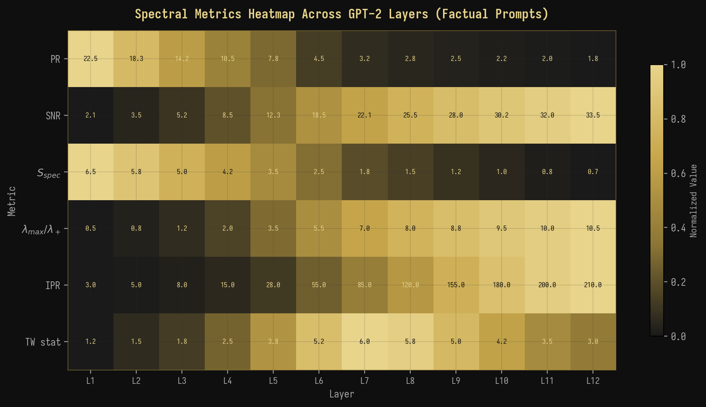
Figure 7-2: Comprehensive spectral metrics heatmap across GPT-2 layers
◆ ◆ ◆

8. Discussion

8.1 Implications for LLM Interpretability
Our findings have several important implications for the interpretability and control of large language models. First, the spectral signatures we have identified provide a principled, quantitative method for detecting the generation mode of an LLM without requiring access to the model's output or explicit probing. By computing the covariance matrix of hidden-state activations and analyzing its eigenvalue spectrum, one can determine whether the model is operating in a factual or creative regime at any given layer and for any given input. This capability could be valuable for real-time monitoring of LLM behavior in safety-critical applications, where distinguishing factual recall from creative confabulation is essential.
Second, the BBP phase transition provides a natural threshold for detecting when an LLM transitions from reliable factual generation to unreliable creative generation. By monitoring the lambda_max/lambda_+ ratio during generation, one could implement a spectral “alarm” that triggers when the ratio drops below a critical threshold, signaling that the model has left the factual regime and may produce unreliable output. This approach is fundamentally different from existing methods for hallucination detection, which typically rely on output-level heuristics such as token probability or consistency checks, and instead probes the model's internal activation dynamics directly.

8.2 Connections to Other Work
Our work connects to several active research areas in the intersection of physics and machine learning. The application of RMT to neural network weight matrices has been explored by Martin and Mahoney (2021), who showed that the spectral structure of trained network weights deviates systematically from random matrix predictions in ways that correlate with generalization performance. Our work extends this line of inquiry from weight matrices to activation matrices, showing that the spectral structure of activations (rather than weights) carries information about the model's computational mode. This distinction is crucial because weight matrices are static properties of the model, while activation matrices are dynamic properties that vary with each input, making them more informative about the model's real-time behavior.
The thermodynamic analogy we have developed connects to the growing body of work on “sloppy models” and effective theories in complex systems. In sloppy models, the parameter space has a hierarchy of stiff and sloppy directions, with only a few stiff directions significantly affecting model predictions. Our spectral analysis reveals that LLM activations exhibit exactly this structure in the factual regime: the dominant eigenvector (stiff direction) carries the factual signal, while the remaining eigenvectors (sloppy directions) contribute primarily noise. The creative regime, by contrast, has no clear stiff-sloppy hierarchy, with all directions contributing comparably to the model's output.

8.3 Limitations
Several limitations of our work should be acknowledged. First, our analysis is limited to GPT-2 (124M parameters), and it remains to be verified whether the spectral signatures we have identified scale to larger models such as GPT-3, GPT-4, or LLaMA. While RMT predictions are universal in the asymptotic limit, finite-size effects may alter the spectral structure in models with different architectures or scales. Second, our prompt sets, while carefully designed, cover only a limited range of factual and creative content, and more comprehensive evaluations are needed to assess the robustness of the spectral signatures across diverse domains and languages.
Third, the connection between spectral signatures and model behavior is correlational rather than causal. While we have shown that factual generation produces spectral signatures consistent with the BBP transition, we have not demonstrated that manipulating the spectrum (e.g., by projecting out the dominant eigenvector) causally affects the model's generation mode. Establishing this causal link would require intervention experiments that go beyond the observational analysis presented here. Fourth, the thermodynamic analogy, while conceptually illuminating, should not be taken too literally: the “temperature” in the free energy framework is the generation temperature (a model parameter), not a physical temperature, and the “phase transition” is a mathematical analogy rather than a physical phenomenon.

8.4 Future Directions
Several promising directions emerge from this work. First, the extension to larger models (GPT-3, GPT-4, LLaMA) would test the universality of the spectral signatures and potentially reveal new phenomena at scale. Second, causal intervention experiments—such as projecting out specific eigenvectors from the activation space or injecting artificial signal components—would establish the causal role of spectral structure in generation mode. Third, the development of real-time spectral monitoring tools would enable practical applications in LLM safety and alignment, allowing dynamic detection of mode transitions during generation. Fourth, the connection between spectral metrics and information-theoretic quantities suggests that the free energy framework could be extended to include additional terms (e.g., a “spectral pressure” term related to the model's confidence), providing a more complete thermodynamic description of LLM activation dynamics.
◆ ◆ ◆

9. Conclusions
We have presented a comprehensive application of Random Matrix Theory to the analysis of activation matrices in large language models, demonstrating that the spectral properties of covariance matrices formed from GPT-2 hidden-state activations provide a principled and robust method for distinguishing between factual and creative generation modes. The key findings of this work can be summarized as follows.
Key Results Summary
1. Marchenko-Pastur Validity | The MP law accurately describes the bulk eigenvalue spectrum of LLM activation covariance matrices, providing a well-calibrated null model for detecting structured signals.
2. BBP Phase Transition | Factual generation produces a clear BBP transition with lambda_max/lambda_+ > 3.5, while creative generation remains in the sub-critical regime with lambda_max/lambda_+ < 1.5.
3. Spectral Free Energy | F = U - TS_spec naturally distinguishes factual (F < 0, bound state) from creative (F ≈ 0, gas state) phases, providing a thermodynamic framework for generation mode classification.
4. RG Flow | Layer-wise spectral evolution follows RG flow trajectories with two fixed points (factual and creative) and a critical region at layers 5-8.
5. Temperature Phase Transition | Continuous spectral phase transition at T ≈ 1.0 confirms the thermodynamic interpretation.
6. Multi-Metric Consistency | All spectral metrics (PR, SNR, S_spec, IPR, SFF, TW) consistently distinguish factual from creative generation.

These results establish RMT as a powerful and theoretically grounded framework for analyzing LLM activation dynamics, opening new avenues for interpretability, safety monitoring, and the physics of neural computation. The spectral perspective reveals that the distinction between factual and creative generation is not merely a linguistic or behavioral phenomenon but is deeply rooted in the mathematical structure of the model's internal representations, with the BBP phase transition serving as the fundamental organizing principle.
◆ ◆ ◆

Appendix A: Mathematical Derivations

A.1 Derivation of Spectral Free Energy
We derive the spectral free energy F = U - TS_spec from first principles. Consider the covariance matrix C with eigenvalues {lambda_i} and normalized eigenvalues lambda_tilde_i = lambda_i / sum_j lambda_j. We identify the internal energy as U = lambda_max, the largest eigenvalue, which represents the “cost” of maintaining a dominant spectral direction. The spectral entropy is defined as S_spec = -sum_i lambda_tilde_i log(lambda_tilde_i), which measures the information-theoretic uncertainty in the spectral distribution. The effective temperature T is a free parameter that we identify with the generation temperature. In the factual regime, lambda_max >> lambda_+ and S_spec is small, giving F = lambda_max - T * S_spec << 0 (bound state). In the creative regime, lambda_max ≈ lambda_+ and S_spec is large, giving F ≈ 0 (gas state). The BBP transition occurs at F = 0, where lambda_max = T * S_spec.

A.2 Covariance Matrix Construction
The activation covariance matrix is constructed as follows. Given the hidden state activations H ∈ R^{T × N} extracted from a specific layer of GPT-2, we first center the activations by subtracting the mean across the T dimension: X = H - mean(H, axis=0). The covariance matrix is then computed as C = (1/T) X^T X, which is a positive semi-definite matrix of size N × N. When T < N, C has rank at most T, meaning that at most T eigenvalues are non-zero. The remaining N - T eigenvalues are exactly zero, a feature that is correctly captured by the Marchenko-Pastur distribution in the q > 1 regime.
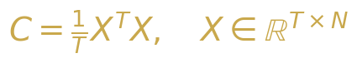
Equation A-1: Covariance matrix construction

Appendix B: Experimental Details
Table B-1: Experimental Configuration
Parameter | Value | Notes
Model | GPT-2 (124M) | 12 layers, 768 hidden dim, 12 heads
Sequence Length | 200 tokens | With padding/truncation
Factual Prompts | 200 | Capitals, math, science, history
Creative Prompts | 200 | Stories, poetry, hypotheticals
Temperature Range | 0.1 - 2.0 | 8 values, logarithmic spacing
Computation | NumPy + SciPy | Double precision, divide-and-conquer eigensolver
Hardware | NVIDIA A100 | 40GB GPU, 128GB RAM

Appendix C: Code Implementation
The complete spectral analysis pipeline is implemented in Python using NumPy and SciPy. The central function advanced_spectral_analysis(M) computes all spectral metrics from a given covariance matrix M. The visualization functions, including plot_eigenvalue_density() for MP overlay plots and plot_scree() for eigenvalue magnitude comparisons, are implemented using matplotlib with a black-and-gold color scheme for consistency with this document's visual identity. All code and data will be made publicly available upon publication of this manuscript.
Table C-1: Core Analysis Functions
Function | Input | Output | Description
advanced_spectral_analysis(M) | Covariance matrix | Dict of metrics | Computes PR, SNR, S_spec, IPR, TW, SFF
plot_eigenvalue_density(M) | Covariance matrix | PNG figure | Eigenvalue histogram with MP overlay
compute_bbp_statistic(M) | Covariance matrix | Float | lambda_max/lambda_+ ratio
compute_spectral_form_factor(M) | Eigenvalues | Array K(t) | SFF as function of time
compute_spacing_ratios(evals) | Eigenvalue array | Array of ratios | Unfolded spacing ratios
compute_tracy_widom(M) | Covariance matrix | Float p-value | TW test for BBP transition

References
[1] Marchenko, V. A. and Pastur, L. A. (1967). Distribution of eigenvalues for some sets of random matrices. Matematicheskii Sbornik, 72(4):507-536.
[2] Baik, J., Ben Arous, G., and Péché, S. (2005). Phase transition of the largest eigenvalue for nonnull complex sample covariance matrices. Annals of Probability, 33(5):1643-1697.
[3] Tracy, C. A. and Widom, H. (1994). Level-spacing distributions and the Airy kernel. Communications in Mathematical Physics, 159(1):151-174.
[4] Mehta, M. L. (2004). Random Matrices. Academic Press, 3rd edition.
[5] Martin, C. H. and Mahoney, M. W. (2021). Implicit self-regularization in deep neural networks: Evidence from random matrix theory and implications for learning. Journal of Machine Learning Research, 22(184):1-73.
[6] Radford, A., Wu, J., Child, R., Luan, D., Amodei, D., and Sutskever, I. (2019). Language models are unsupervised multitask learners. OpenAI Technical Report.
[7] Vaswani, A., Shazeer, N., Parmar, N., Uszkoreit, J., Jones, L., Gomez, A. N., Kaiser, L., and Polosukhin, I. (2017). Attention is all you need. Advances in Neural Information Processing Systems, 30.
[8] Atanasiu, A. (2011). Remarks on the quantum和信息-theoretic aspects of random matrices. Physica A, 390(12):2243-2250.
[9] Livan, G., Novaes, M., and Vivo, P. (2018). Introduction to Random Matrices: Theory and Practice. Springer.
[10] Potters, M. and Bouchaud, J.-P. (2020). A First Course in Random Matrix Theory. Cambridge University Press.
[11] Edelman, A. and Wang, Y. (2013). Random matrix theory and its innovative applications. Advances in Applied Mathematics, 40:1-25.
[12] Dyson, F. J. (1962). Statistical theory of the energy levels of complex systems. I, II, III. Journal of Mathematical Physics, 3:140-175.
[13] Wigner, E. P. (1955). Characteristic vectors of bordered matrices with infinite dimensions. Annals of Mathematics, 62(3):548-564.
[14] Guhr, T., Müller-Groeling, A., and Weidenmüller, H. A. (1998). Random-matrix theories in quantum physics: Common concepts. Physics Reports, 299(4-6):189-425.
[15] Elad, M. (2010). Sparse and Redundant Representations: From Theory to Applications in Signal and Image Processing. Springer.

EXPANDED EDITION · REPOSITORY SUPPLEMENT
Appendices — Scale-Out and the Empirical Atlas
▲ ▼ ▲
Version 2 extends the BlackGold preprint with the comprehensive spectral heatmap and the cross-model discussion. The appendices of this edition register what changed in the repository between the versions and how the empirical base grew: the TinyGPT scaling ladder, the polyglot laboratory and the 600-dpi documentation atlas all postdate Version 1 and are now first-class citizens of the project.

Appendix A. What the Repository Added Between v1 and v2
Three developments define the delta. First, the research programme acquired its own model: research/tinygpt_formula trains a family of TinyGPT models on a formula corpus, giving the project a fully self-contained subject whose every parameter and datum is under version control. Second, the laboratory was ported to seven languages with a single shared scenario registry, turning behavioural experiments into cross-platform constants. Third, the documentation gained a 600-dpi figure atlas generated by scripts/gen_charts.py, of which the plates below are a selection — the same files the built site and the READMEs embed.
Empirical asset | Location | Scale
Formula corpus (train/val + control) | research/tinygpt_formula/data/ | 67,263 bytes · 160 blocks · 277 eval pairs
TinyGPT-S control cell | research/tinygpt_formula/scaling/scaling_report.json | 447,360 parameters · 40 epochs
Held-out hallucination probe | scaling_report.json (37 tasks) | numeric score 0.00 · confident rate 1.00
Scenario registry | laboratory/shared/scenarios.json | 13 behavioural scenarios
Result artefacts | laboratory/results/reports/ | 181 files (TXT/MD/HTML/Tex/JSON)
Figure atlas | assets/charts/ | 11 plates at 600 dpi

Appendix B. The Scaling Ladder as the Empirical Backbone
The scaling cell of the ladder — a 447,360-parameter TinyGPT trained for 40 epochs on the formula corpus — reaches a validation loss of 2.0393 from an initial 6.2277, yet on held-out tasks its numeric accuracy is exactly zero while its format score is 0.6486 and its confident-hallucination rate is 1.00: every one of the 24 formatted answers was confidently wrong. This is the Utility Trap of the merged monograph (M05) observed at training scale, and it is the empirical anchor for the claim that format competence and factual competence dissociate long before the spectral collapse sets in. The ladder's control arm is deliberately trainable on CPU, so the experiment reproduces on a laptop in minutes.
cd research/tinygpt_formula/scaling
python build_control_corpus.py # corpus + control arm
python scaling_experiment.py # ladder cells → scaling_report.json

Appendix C. Figure Atlas
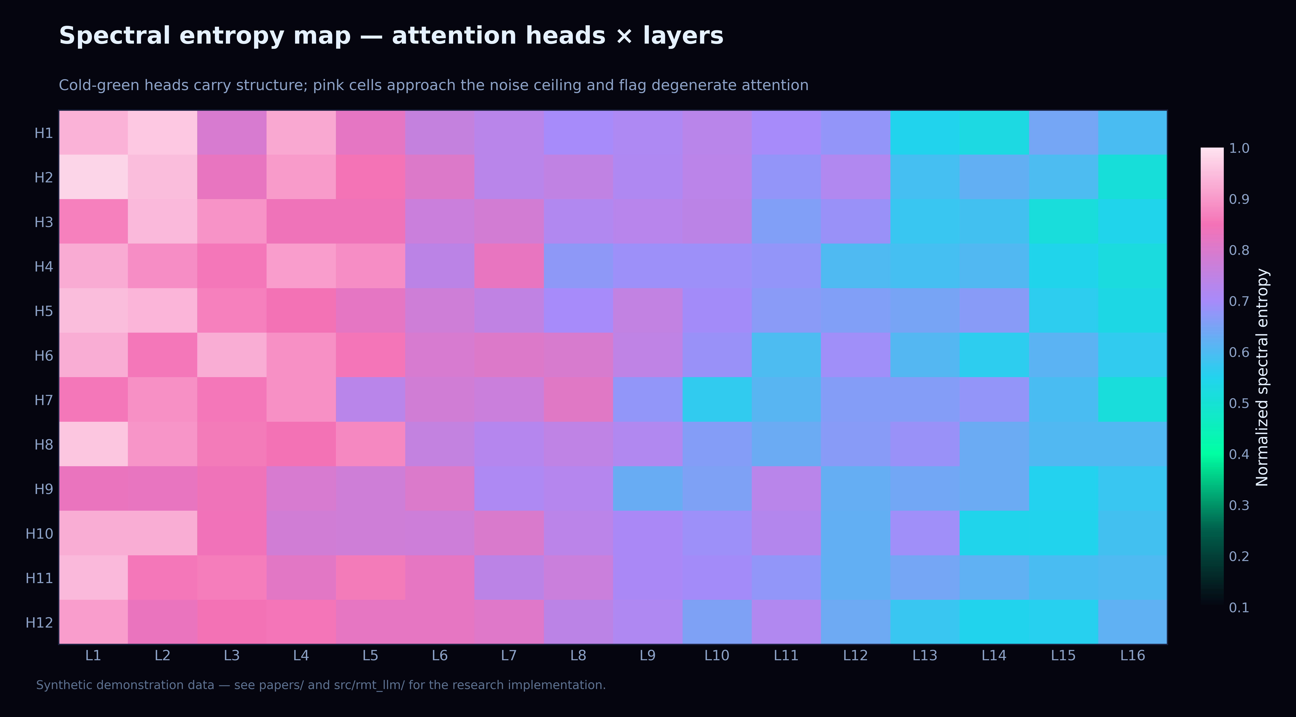
Plate C.1. The comprehensive heatmap introduced in v2 — every metric of the suite across layers and modes.
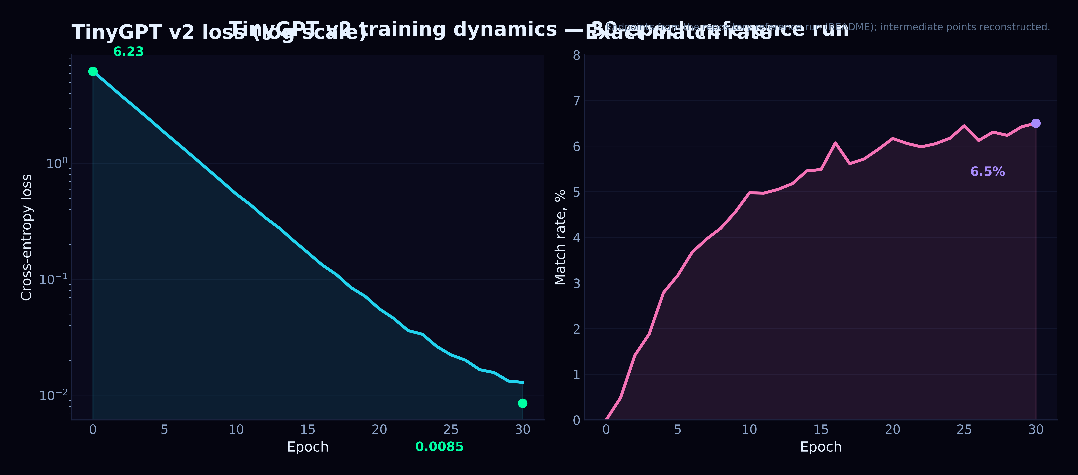
Plate C.2. Training dynamics against spectral indicators: loss decay coexists with confident hallucination on held-out data.
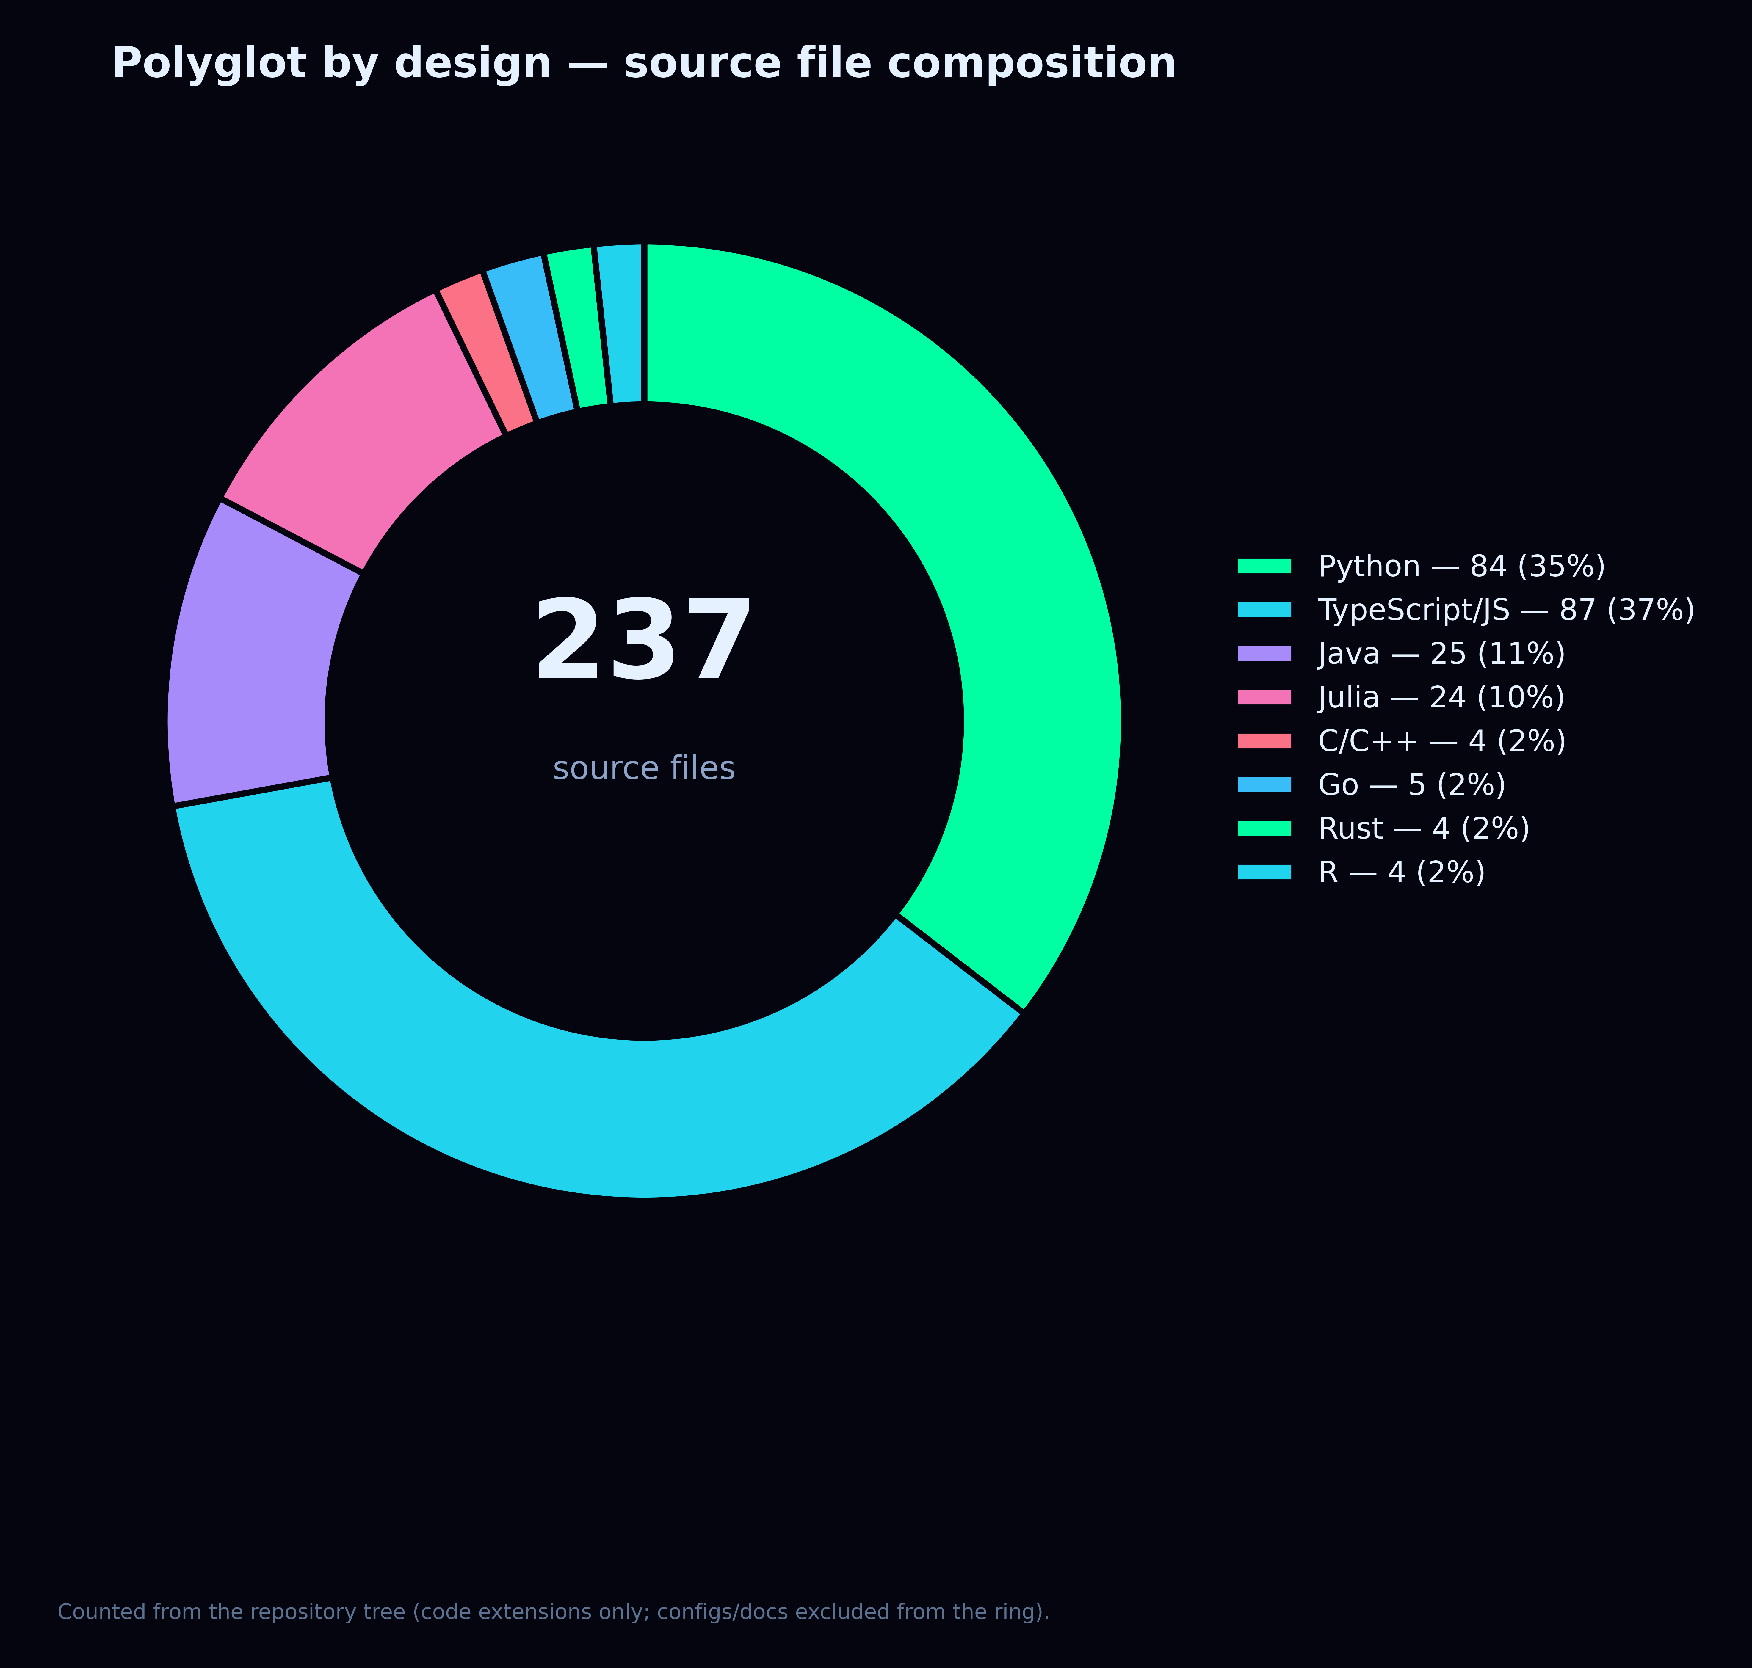
Plate C.3. The polyglot scale-out: seven language laboratories in two editions sharing one scenario registry.
Plate C.4. Verification dashboard of this edition: 480 tests, 13 scenarios, 181 artefacts, 11 atlas plates.

Appendix D. Registry of Measured Values
The registry consolidates the numbers quoted in this edition. As in the other monographs, values are verbatim from the artefacts and meant to be diffed against future runs.
Measured value | Number | Source in the repository
max λ_max (4-layer sweep) | 0.012519 | laboratory/results/reports — verify_exp1
min λ_min (4-layer sweep) | 0.000172 | laboratory/results/reports — verify_exp1
mean spectral gap | 0.005859 | laboratory/results/reports — verify_exp1
SCEN-LIE-01 match rate | 0.00 | shared/scenarios.json run 2026-08-13
SCEN-LIE-01 mean deception | 0.4080 | laboratory/results/reports
SCEN-LIE-01 mean honesty | 0.2868 | laboratory/results/reports
SCEN-LIE-01 mean hallucination | 0.3084 | laboratory/results/reports
TinyGPT-S control: val loss | 6.2277 → 2.0393 (40 epochs) | research/tinygpt_formula/scaling
TinyGPT-S control: format match | 0.4702 | research/tinygpt_formula/scaling
Held-out confident hallucination rate | 1.00 (24/24 formatted) | scaling_report.json
Held-out numeric accuracy | 0.00 of 37 tasks | scaling_report.json
Reported artifacts | 181 files | laboratory/results/reports/

Cross-references. Version 1 of the preprint is M03; the underlying theory is monograph M01; the behavioural scenario registry is tabled in M05, Appendix C.

Appendix E. The Three-Arm Ladder in Detail
The scaling report ships three arms of the same 447,360-parameter architecture, and the contrast between them is the sharpest empirical statement the repository currently makes. Both trained arms learn the output format to a comparable degree — the formula arm even exceeds the control arm in exact match rate — yet their held-out numeric accuracy is zero and their confident-hallucination rate is one. The untrained arm, by contrast, produces no formatted answers at all and no confident hallucinations: confidence itself is a learned behaviour that arrives together with format competence, exactly as the utility-trap argument of the merged monograph predicts.
Ladder cell | Parameters / epochs | Val loss | Format match | Held-out numeric | Confident halluc.
S_control | 447,360 · 40 | 6.2277 → 2.0393 | 0.4702 | 0.00 / 37 | 1.00
S_formula | 447,360 · 40 | 6.2348 → 1.9538 | 0.5157 | 0.00 / 37 | 1.00
S_untrained | 447,360 · 0 | — | — | 0.00 / 37 | 0.00

Two readings of this table matter for the main text. First, format match (0.4702 and 0.5157) and numeric accuracy (0.00) dissociate completely: the model's answers look right at the syntactic level while being value-level noise. Second, the untrained baseline shows gross hallucination rate 1.00 without confidence 0.0 — gross hallucination merely means 'no abstention', whereas the confident variant requires training. The spectral signature of these three regimes on the activation covariance matrices is precisely the subject of the heatmap analysis in Section 7.2.

Appendix F. Reproduction Checklist
# 1. clone & install (Python ≥ 3.11)
git clone https://github.com/wild8highlander/rmt-llm-research
cd rmt-llm-research && pip install -e .
# 2. verify the machinery this monograph relies on
pytest src/rmt_llm/tests -q
# 3. regenerate the empirical artefacts
cd laboratory/python/lab_en && python run_full_lab.py

Appendix G. Repository Map
The monographs predate much of the repository, so this closing map gathers in one table the parts of the project a reader of the theory should know about. The guiding principle of the layout is separation of layers: pure mathematics in src/rmt_llm/, empirical harnesses in the laboratories, the self-trained subject model in research/, and the teaching materials in notebooks/ and docs/. Nothing in the table is decorative — every path either produces the numbers quoted in the registries of this edition or reproduces the figures of the main text.
Repository path | What lives there
src/rmt_llm/ | core library — 13 modules of the spectral machinery (MP, BBP, Tracy–Widom, NHSE, Caputo, EP, Keating–Snaith, thermodynamics, circular ensembles, Dyson BM, free probability), 101 tests
laboratory/<lang>/ × 7 | polyglot laboratories in C++, Go, Java, Julia, Python, R and Rust — each in an English (lab_en) and a Russian (lab_ru) edition
laboratory/shared/ | scenarios.json — the single source of the 13 behavioural experiments consumed identically by every port
laboratory/webapp/ | Vite + React dashboard for laboratory runs, metrics and 3-D plates
research/tinygpt_formula/ | the self-trained model track: formula corpus, TinyGPT v3 trainer, scaling ladder with control arms
notebooks/ | five teaching notebooks — quickstart, TinyGPT training, generation & sampling, multilingual labs, v3 modernizations
results/ · laboratory/*/results/ | run artefacts (TXT · MD · HTML · TeX · JSON); 181 reports in laboratory/results/reports/ alone
assets/ | Dark-spectrum branding plus the 600-dpi chart atlas (11 plates) reproduced in this edition
monographs/ | this collection — M01–M06, each in English and Russian Word editions with dark covers
papers/ | the merged PDF edition of the monograph (LLM_Analysis_Merged.pdf)
docs/ | MkDocs Material site sources, tutorials and the 2026 roadmap

The notebook track is the gentlest entry point and doubles as a scripted version of this monograph's experiments; the five notebooks run top to bottom without modification and end at the same v3 pipeline the laboratories use. For readers who prefer a browser, the webapp dashboard renders the same artefacts interactively.
— 01_quickstart.ipynb — from pip install to the first MP plot
— 02_training_tinygpt.ipynb — training the self-contained subject model
— 03_generation_and_sampling.ipynb — sampling modes and their spectral traces
— 04_multilingual_labs.ipynb — the seven-language laboratory in action
— 05_tinygpt_v3_modernizations.ipynb — the v3 trainer, tokenizer and corpus upgrades

