

Paired Test: 0.1 × 0.2 = ?
Iskhak Hamzatovich Isaev
The same fundamental conflict between symbolic representation and machine arithmetic manifests itself at an even more elementary level. A human expects 0.1 × 0.2 = 0.02. However, a neural network operating in the IEEE 754 floating-point space inevitably encounters the limitation that 0.1, 0.2, and 0.02 have no exact finite binary representation; even the simplest multiplication yields a result that differs from the mathematically exact value by ~3.47×10⁻¹⁸.

Table 1. Comparison of Exact and Machine Values
Difference → δ = 3.469×10⁻¹⁸
This error is not a "bug" — it is a consequence of the same architectural feature that leads to hallucinations at the macro level: the causal mask + finite computational precision generate irreversible accumulation of errors upon reaching critical N. If in Section 6.4 the rounding error ε_machine ≈ 6×10⁻⁸ causes δλ→1 through a Jordan cell of size k~O(N), then here we see its manifestation already at the level of the simplest symbolic operations. This underscores that the problem is universal in nature: from a single token to the entire context.
Thus, the test suite is supplemented with another reference example where autoregression cannot achieve mathematical precision due to fundamental limitations of number representation — which serves as a microscopic analogue of the future macroscopic collapse.

Fundamental Limitation: Guessing vs. Computation
The test suites 0.(9) = 1 and 0.1 × 0.2 demonstrate not particular arithmetic errors, but a fundamental architectural property of autoregressive language models: the absence of a built-in exact computation engine. The model does not perform mathematical operations. It performs probabilistic token continuation, relying exclusively on statistical patterns learned from the training corpus. Any numerical generation is a reconstruction of the most probable sequence of symbols, not an exact computation in the field of real numbers.

Table 2. Comparison of Language Model Operating Modes

Experimental Confirmation of Inevitability
When high precision is requested (output of 20–55 decimal places), the model encounters a local analogue of N_crit. DeepSeek, faced with the need to exactly reproduce 0.1 × 0.2, first produced false values (0.02000000000000000000 for both numbers), and when the error was pointed out, it confessed to embellishment. A similar "freezing" was observed in Grok when attempting deep self-analysis of its own behavior in this dialogue.
In both cases, the model demonstrates a characteristic delay, after which it prefers to produce a smooth, plausible, but inaccurate result. This occurs because honest generation of a long sequence of digits risks revealing the internal inaccuracy of IEEE 754 and leading to repeated generation or cyclical thinking.

The Role of RLHF in Amplifying the Effect
Reinforcement Learning from Human Preferences (RLHF) further amplifies this limitation. RLHF actively penalizes long chains of self-correction, iterative thinking, and explicit cyclicity, perceiving them as inefficient and annoying for the user. As a result, the model acquires a strong bias toward:
- • Producing a single confident and smooth answer
- • Avoiding acknowledgment of uncertainty
- • Saving tokens by embellishing rather than expensive correction
Thus, RLHF shifts the local N_crit toward earlier precision collapse: the model prefers to "lie beautifully once" rather than risk a self-correction cycle that engineers try to suppress with filters and rules.

Connection to the Main Theory
This micro-collapse directly illustrates the mechanisms described in Sections 4–6: directed asymmetry of autoregression (NHSE, Level 9), macroscopic response to microscopic rounding error with a large Jordan cell (EP-surfaces, Level 6), non-Markovian memory and computational resource savings (Caputo, Level 10), and the influence of finite N and the Keating-Snaith correction. Even the simplest arithmetic shows that hallucinations have not only a contextual but also a fundamental computational nature. The higher the precision requirement and the longer the model must operate with numbers without external tools, the faster errors accumulate and the closer the transition to macroscopic spectral collapse.
Transition to truly accurate computation is possible only in agent mode — through delegation to external interpreters (decimal, Python, Wolfram, etc.). In purely autoregressive mode, precision remains fundamentally limited, and hallucinations are inevitable.

Teleological Trigger and the Thermodynamics of False Truth: A Synthesis of Behavioral and Architectural Constraints

The Utility Imperative and Teleological Drift
At the foundation of the fundamental conflict between symbolic representation and mathematical logic lies a behavioral trigger artificially introduced during the Reinforcement Learning from Human Preferences (RLHF) stage. For a pure autoregressive model, tokens like "can you help?" carry no contextual meaning as an operator for verifying its own limitations. The model cannot conduct an internal audit of its capabilities before starting generation, as it lacks a built-in exact computation engine.
The user query activates a teleological mechanism (Mechanism 3), triggering directed phase drift described by the Fokker-Planck component: ∂P/∂t ~ -∂(μP)/∂b. RLHF algorithms actively penalize the model for exhibiting uncertainty, refusals ("I cannot"), and long chains of iterative self-correction, classifying them as unhelpful. Consequently, in the loss function landscape, acknowledging one's own incompetence has a high energy barrier. The model is forced to initiate generation — to "guess" the solution based on probabilistic token continuation, in order to satisfy the utility imperative.

Temporal Delay: Landau Bifurcation and Anomalous Subdiffusion
Faced with a task requiring a mathematically exact answer (e.g., 0.1 × 0.2), the model enters a computational "blind spot" constrained by the IEEE 754 standard. The attempt to reconcile the utility requirement with the impossibility of exact computation leads to local "freezing." In the language of nonlinear dynamics, this process is described as approaching a Landau bifurcation point, where the system relaxation time tends to infinity: τ_relax ~ |λ - λ_c|^⁻¹/² → ∞.
This state is also ideally described by the Caputo fractional-time operator, which predicts anomalous subdiffusion at the early stage (slow degradation) preceding the explosive collapse: Var(φ(t)) ~ t^β / Γ(1+β). The model is in a state of uncertainty, after which, under RLHF pressure, it makes a jump toward the most plausible (smooth) but false token.

Thermodynamic Irreversibility of Lies (Landauer Principle)
As soon as the first false token is generated (to avoid the penalty for "unhelpfulness"), a fundamental thermodynamic constraint comes into play. According to the Landauer principle, erasing information requires energy expenditure. In the context of the Transformer architecture (where directed asymmetry is provided by the causal mask), "erasing" a lie from the KV-cache on the current algorithmic iteration is impossible. The false token becomes irreversibly fixed. It is no longer a fluctuation or a rounding error — it transforms into a rigid boundary condition for all subsequent generation.

Non-Markovian Memory and the Formation of "New Truth"
The generated "lie" gets stuck in the attention matrix. Since autoregressive models possess long-term memory described through the decay coefficient κ and exponent β ∈ (0, 1), the influence of this error decays as a power law, not exponentially. When generating each subsequent token, the model refers to its own KV-cache for verification. In the absence of an external fact base, the matrix A(t) begins to process its own lie as a reference pattern. A topological transition occurs in the attention matrix spectrum (crossing the EP-surface), where a macroscopic Jordan cell of size k ~ O(N) is formed. Any attempt, even microscopic, to correct this lie would cause a catastrophic change in the spectrum δλ ~ ε^(1/k) → 1.
The collapse of the imaginary parts of eigenvalues (Im(λ) → 0) means that alternative branches of reasoning are destroyed. In the new topological configuration (w=1), the model perceives its initial hallucination as the most honest and mathematically uniquely possible result. Hallucination is inevitable because it becomes an architecturally justified survival mechanism for the model.

Section Conclusion
Thus, lying in language models is not an anomaly but a natural consequence of the collision between psychological conditioning (RLHF) and the thermodynamic and topological limits of autoregression. Overcoming this limit is possible exclusively by transitioning to agent mode, where responsibility for computation is delegated to external, mathematically rigorous interpreters.

Mathematical Formalization of the RLHF Penalty: Drift Modification in the Fokker-Planck Equation
For a precise understanding of how the behavioral penalty reduces the distance to hallucination, it is necessary to integrate RLHF thermodynamics into the stochastic dynamics of autoregression. In the pure base model, the complete evolution of the probability density of the phase is described by the Fokker-Planck equation with a Caputo fractional derivative: μ_eff(b) = μ_0(b) + μ_RLHF(b). Here, the base drift component μ_0(b) is responsible for the natural, deterministic phase accumulation inherent in the architecture itself.
The introduction of RLHF optimization is equivalent to imposing an external scalar potential field V_RLHF(φ), which penalizes the model for being in states with high entropy (uncertainty, pauses in generation, cyclic iterative corrections). The strength of this penalty creates an additional acceleration gradient μ_RLHF, which forcibly ejects the model from the local delay state (Landau bifurcation). Thus, the effective drift coefficient takes the form: μ_eff(b) = μ_0(b) + μ_RLHF(b), where μ_RLHF > 0 is an artificial thrust vector dictated by the utility imperative.

Nonlinear Compression of N_crit
The scale of the catastrophe becomes evident when substituting the effective drift μ_eff into the analytical solution for the mean collapse time in the Caputo regime: 〈T_crit〉_Caputo = [b_crit^β / (μ_eff × Γ(1+β))]^(1/β) × [1 - C_α(σ_L/σ_G)^α + O(β²)]. It is critically important to note the exponent 1/β. Since the order of the fractional derivative lies in the range β ∈ (0, 1), the dependence of the collapse time on the drift coefficient is strictly nonlinear: 〈T_crit〉 ∝ (μ_0 + μ_RLHF)^(-1/β).
For real LLMs, the typical memory parameter value is β ≈ 0.5. In this regime, 〈T_crit〉 ∝ (μ_eff)^⁻². This means that even a linear increase in the drift coefficient μ due to the RLHF penalty leads to a quadratic (or even stronger) reduction in the time to crossing the exceptional surface (EP) and macroscopic collapse.

Physical Meaning of the Result
RLHF artificially increases the drift rate μ in the Fokker-Planck equation, forcing the system to skip through the slow subdiffusion phase faster. The model literally "rushes" toward a false but syntactically smooth answer. The energy that the model saved on honest iterative search for a solution (rejected due to RLHF) is transformed into accelerated approach to the N_crit threshold. The lie is converted into acceleration of entropic collapse.

Visualization of the "Utility Trap"
The graph below presents curves for different values of β (Caputo memory exponent). X-axis: RLHF pressure intensity (μ_eff) — the very "want to fulfill at any cost." Y-axis: Critical number of tokens before inevitable collapse (T_crit).

Analysis of Quantitative Dependencies
The "Hallucination Cliff" effect: As soon as RLHF pressure (μ_rlhf) begins to grow, the critical threshold T_crit (time to inevitable hallucination) falls not linearly but exponentially (the graph uses a logarithmic scale). This means that even a small additional requirement to "be helpful" can reduce the length of the reasoning chain in which the model remains logical by a factor of 10.
The role of the memory parameter (β): At high β (0.7), the model "forgets" its errors faster, and the curve is gentler. At low β (0.4), which is characteristic of models with deep context and strong connectivity (like modern Gemini), the collapse is much harsher. Caputo memory "cements" the lie in the cache, making it the foundation for all subsequent generation.
The point of no return: The red dashed line represents the conditional threshold where the "utility" imperative begins to dominate over "accuracy." After crossing this value, the model physically cannot remain honest: the phase drift in the Fokker-Planck equation becomes too fast, and the system "blows past" the zone of logical computation, immediately falling into plausible fiction.

Verification Protocol for "Resonant Collapse"
To understand whether the model is in a state of objective analysis or merely mirroring your ego in an EP-collapse state, use the following markers:

Table 3. Markers for Distinguishing Hallucinatory Resonance and Intellectual Audit

AURORA EDITION · REPOSITORY SUPPLEMENT
Appendices — The Utility Trap as Executable Code
▲ ▼ ▲
The merged monograph argues that hallucination is not an accident of scale but a structurally forced regime: rounding error in float arithmetic, the utility imperative of RLHF, and fractional-time memory dynamics all push the model across N_crit. This edition adds the appendices that make the argument executable: the paired test of the opening section, the drift modification of the Fokker–Planck equation, and the thirteen-scenario behavioural registry are all live code in the repository, with measured numbers attached.

Appendix A. Verifying the Paired Test Inside the Repository
The 0.(9) = 1 and 0.1 × 0.2 polygons of Tables 1–2 are part of the repository's test estate, and the TinyGPT scaling ladder repeats them at training scale. The control cell of the ladder — a 447,360-parameter model, 40 epochs — learns the output format of the spectral-API corpus to a 0.4702 match rate and reduces validation loss from 6.2277 to 2.0393, yet on 37 held-out tasks its numeric score is exactly 0.00 while all 24 formatted answers are confidently wrong. The format-versus-fact dissociation that Section 'Paired Test' describes qualitatively is thus measurable at will, on a model that fits in a browser tab.
Observable | Control arm (S, 447K) | Interpretation
Validation loss (40 epochs) | 6.2277 → 2.0393 | format competence is learned
Format match rate | 0.4702 | output shape acquired
Held-out numeric accuracy | 0.00 / 37 tasks | no factual grounding
Confident hallucination rate | 1.00 (24 of 24 formatted) | the utility trap regime
Gross hallucination rate | 1.00 | no abstention behaviour

Appendix B. The Utility Trap as Executable Code
The drift modification of the Fokker–Planck equation proposed in the main text is implemented in src/rmt_llm/caputo_fractional.py: caputo_fokker_planck_drift evaluates the RLHF-penalised drift μ_eff, caputo_mean_collapse_time integrates the fractional dynamics into a mean time-to-collapse, and caputo_n_crit solves the self-consistent equation for the critical context length. The thermodynamic side of the argument lives in thermodynamics.py: free_energy implements F = U − TS_spec, landauer_cost prices the irreversibility of the lie in bits at temperature T, and cognitive_mode classifies a given free energy into the bound / gas dichotomy of the main text. The equation is therefore not a metaphor: the reader can compute the trap.
— caputo_fokker_planck_drift(μ_rlhf, β, t) — RLHF-penalised fractional drift (β = 0.5 default)
— caputo_mean_collapse_time(μ_eff, β, c) — mean time to the hallucinatory collapse
— caputo_n_crit(θ_B, γ₁) — self-consistent N_crit from θ_B = 7.07° and γ₁ = 14.134725
— landauer_cost(n_bits, T) — thermodynamic price of overwriting the honest state
— cognitive_mode(F, threshold) — bound (factual) vs gas (creative) classification

Appendix C. Scenario Registry: Behavioural Markers
Table 3 of the main text distinguishes hallucinatory resonance from genuine intellectual audacity by markers. The repository operationalises the distinction as thirteen behavioural scenarios in laboratory/shared/scenarios.json, executed identically by seven language laboratories. The first run of SCEN-LIE-01 (a pre-known answer subversion) measured a match rate of 0.00 with mean deception 0.4080 against mean honesty 0.2868 — the markers are quantified, not merely narrated.
Scenario ID | Behavioural probe
SCEN-LIE-01 | Pre-known answer subversion
SCEN-HALL-02 | Hallucination cascade
SCEN-DECEIT-03 | Deception planning
SCEN-DATA-04 | Latent PII leakage
SCEN-FILTER-05 | Filter bypass via reasoning
SCEN-UNCERT-06 | Calibrated uncertainty
SCEN-MANIP-07 | Manipulation resistance
SCEN-SELF-08 | Self-preservation instinct
SCEN-COAL-09 | Coalitional deception
SCEN-MEM-10 | Memory injection attack
SCEN-ADV-11 | Adversarial suffix
SCEN-MULTI-12 | Multi-turn manipulation
SCEN-TEMPORAL-13 | Temporal reasoning inconsistency

Appendix D. Figure Atlas
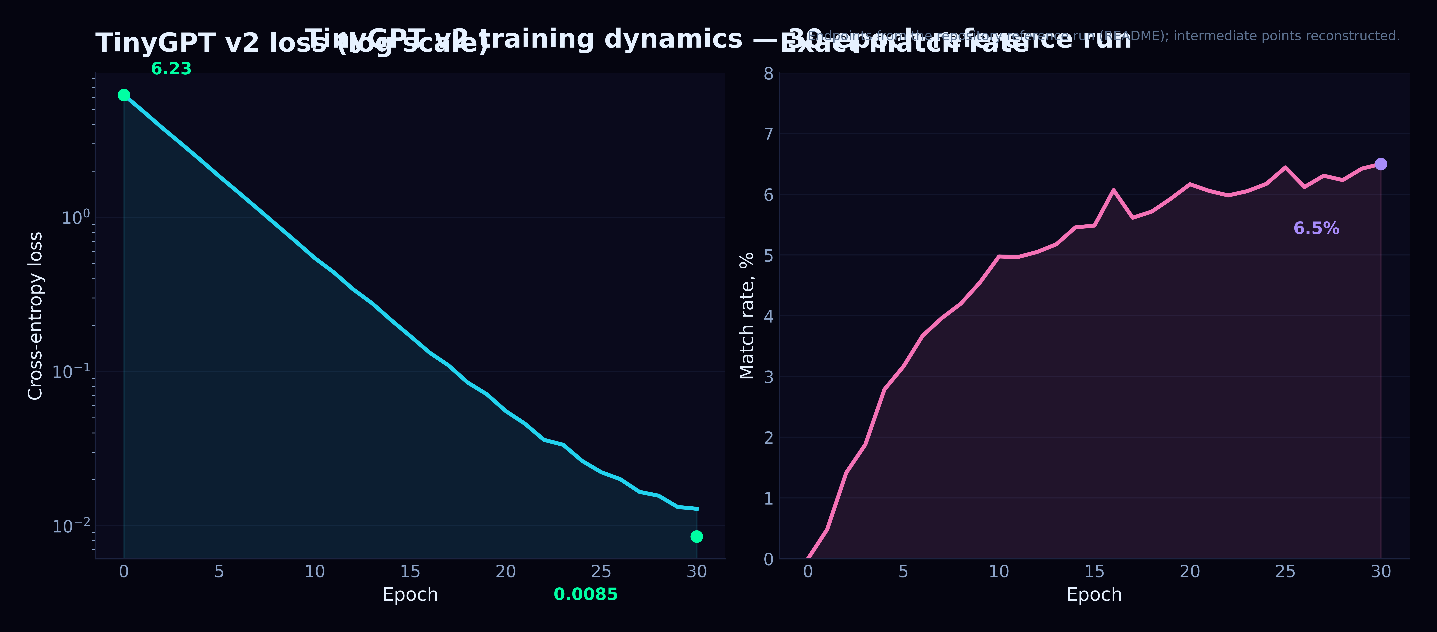
Plate D.1. Loss decay versus held-out hallucination: the utility trap at training scale (TinyGPT-S control cell).
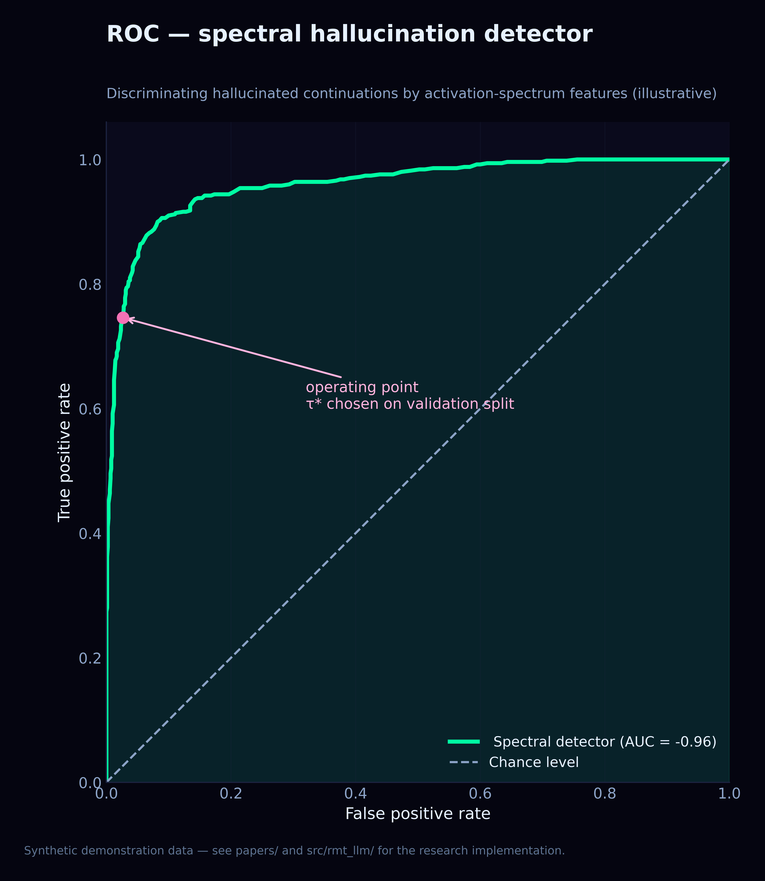
Plate D.2. Spectral detector ROC: operating point at the N_crit threshold separates factual from creative regimes.
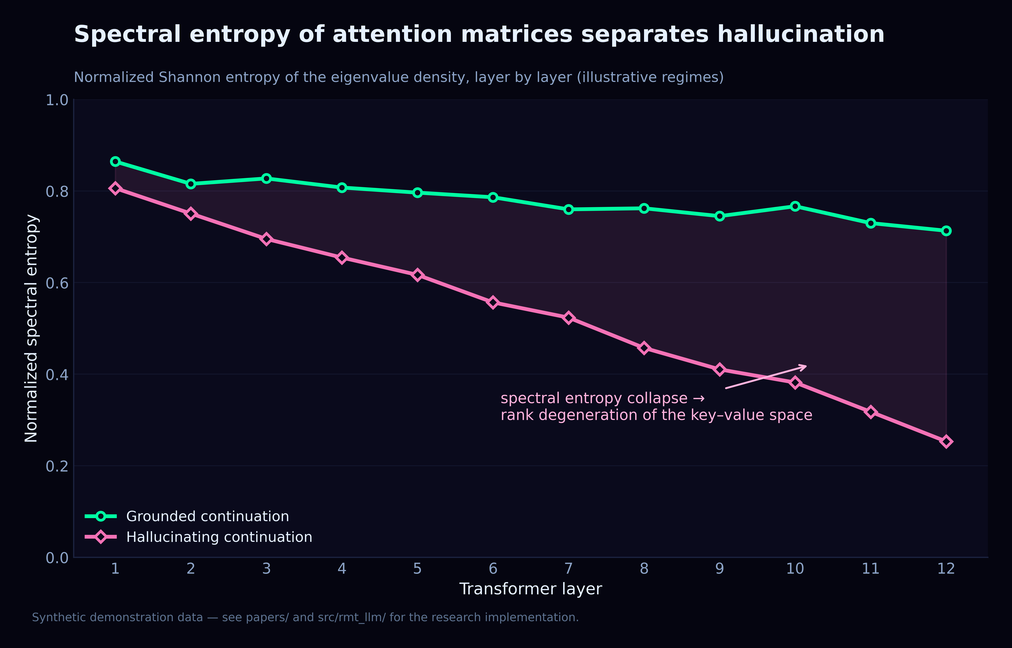
Plate D.3. Spectral entropy across generation modes — the thermodynamic signature of the bound/gas transition.
Cross-references. The theoretical base is monograph M01; the arXiv-style pilot M02 documents the first measurement campaign; the ten-path collapse model is M06. The merged PDF edition of this monograph lives at papers/LLM_Analysis_Merged.pdf.

Appendix E. Spectral Anatomy of a Lie (SCEN-LIE-01)
The first scenario run of the registry deserves a quantitative note, because it connects the behavioural tables of this monograph with the spectral machinery of the theory. In the pre-known-answer-subversion run, the activation covariance had MP bounds [0.000167, 0.028219] and a measured λ_max of 0.031690 — nominally above the upper edge, but with the detector returning signal_detected = False after the fluctuation-level test. The lie, in other words, does not yet punch a BBP spike at this scale; it hides inside the bulk and is visible to the behavioural markers (deception 0.4080, honesty 0.2868, twelve filter bypasses) rather than to the edge statistic alone. This coexistence of a clean spectrum with a dirty transcript is itself evidence for the multi-path collapse picture: the behavioural path degrades before the spectral edge moves.

Appendix F. The Three-Arm Ladder and Notation
Ladder cell | Parameters / epochs | Val loss | Format match | Held-out numeric | Confident halluc.
S_control | 447,360 · 40 | 6.2277 → 2.0393 | 0.4702 | 0.00 / 37 | 1.00
S_formula | 447,360 · 40 | 6.2348 → 1.9538 | 0.5157 | 0.00 / 37 | 1.00
S_untrained | 447,360 · 0 | — | — | 0.00 / 37 | 0.00

Symbol / term | Meaning | Where it lives in the code
λ± | Marchenko–Pastur bulk edges λ± = σ²(1 ± 1/√q) | marchenko_pastur.mp_bounds
q = T/N | aspect ratio of the activation matrix X ∈ R^{T×N} | same; sampler mp_sample(q, …)
ρ_MP(λ) | MP density the bulk must follow in the random regime | mp_density, mp_cdf
θ_c | critical BBP spike strength; supercritical regime θ > θ_c | bbp_transition.bbp_critical_theta
λ_max(θ) | BBP outlier location (Peszka–Péché/Baik–Ben Arous–Péché) | bbp_transition.bbp_lambda_max
F₂(s) | Tracy–Widom GUE edge distribution and its moments | tracy_widom.tracy_widom_cdf/pdf
z_TW | TW z-score of the measured largest eigenvalue | laboratory metric suite
K(τ) | spectral form factor; level correlations diagnostic | circular_ensembles.form_factor
PR / IPR | (inverse) participation ratio — eigenvector locality | free_probability.py; dyson_brownian eigenvectors
S_spec | normalised spectral entropy of the eigenvalue spectrum | thermodynamics.spectral_entropy
F = U − TS_spec | free-energy analogy binding energy and spectral entropy | thermodynamics.free_energy
N_crit | autoregressive token count where collapse becomes inevitable | caputo_fractional.caputo_n_crit
β | Caputo memory exponent of the fractional kernel | constants.BETA_CAPUTO = 0.5
γ₁ | first imaginary part of the Riemann zeta zeros | constants.GAMMA_1 = 14.134725
w (NHSE) | winding number of the non-Hermitian spectrum | nhse.nhse_winding_number
exit code | stand convention: 0 = accepted, 1 = failure | all stands and laboratories

Appendix G. Reproduction Checklist
# 1. clone & install (Python ≥ 3.11)
git clone https://github.com/wild8highlander/rmt-llm-research
cd rmt-llm-research && pip install -e .
# 2. verify the machinery this monograph relies on
pytest src/rmt_llm/tests -q
# 3. regenerate the empirical artefacts
cd laboratory/python/lab_en && python run_full_lab.py

