Talons v0.1

User Primer

Author: Jimmy Lu

Date: June, 2014

Table of Contents

1. Introduction 1

2. System Requirements and Installation 1

3. Setting Up Aircraft 1

3.1. Geometry Definition 2

3.2. Mass Definition 3

3.3. Propulsion Characteristics 4

3.4. Flight Conditions 4

4. Analyze and Interpreting Results 5

4.1. Aircraft Performance 5

4.2. Stability & Control 6

4.3. Ground Handling 7

# Introduction

Talons is a flight sciences analysis tool for conceptual design validation and performance predictions of small low speed fixed-wing aircraft. It is capable of predicting stability & control characteristics, initial ground handling qualities and flight performance. The planform/configuration of the aircraft is fully user-defined, capable of analyzing conventional, flying wing or canard configuration, as well as single/multi engine(s).

Analysis has been validated to flights below 3000 m and Mach < 0.3, with a Reynolds number below 200,000. Aerodynamics is fully linear, which is valid for flight regime far away from aerodynamic stall. Aerodynamics analysis is realized using Athena Vortex Lattice (AVL), an inviscid vortex lattice solver.

Stability & control and performance analyses are all performed in a static sense. No dynamic analyses are performed at this point.

# System Requirements and Installation

Talons requires version 7.17 (R2012a) of MATLAB Compiler Runtime (MCR), which can be downloaded for free from <http://www.mathworks.com/products/compiler/>. The software has been developed and tested under Windows 7.

No installation is required. Simply extract all files and directories in the zip file to the desired location and run Talons.exe.

# Setting Up Aircraft

When you first start up Talons, you should get a screen as shown in Figure 1.

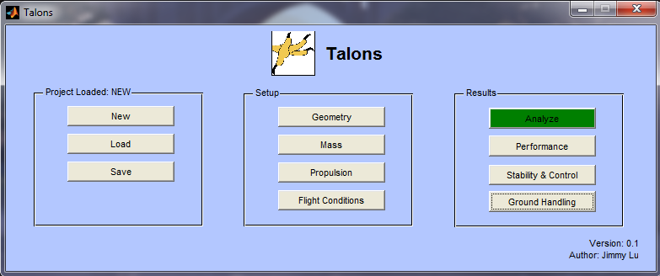

Figure 1: Talons Startup Screen

The tool is broken up into three distinct sections:

* The left is file management, used to load/save a particular configuration that you have defined.
* The middle is aircraft set up, used to define aircraft configuration, propulsion data, mass properties and flight conditions.
* The right is the predictions and result display.

## Geometry Definition

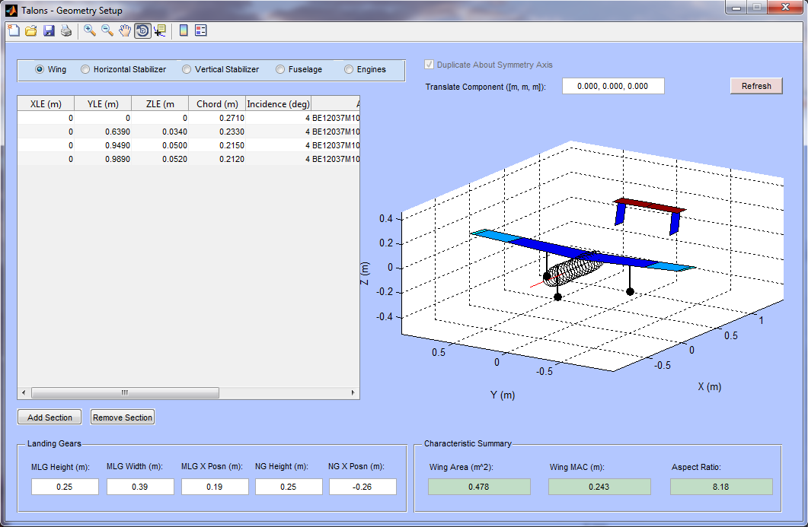

Figure 2: Geometry Setup

As a first step, you should define the geometry of the aircraft. As shown in Figure 2, there are 5 separate sections in the geometry definition:

* **Wing**: the main lifting surface of the aircraft. The wing geometry is automatically duplicated about the symmetry plane (y=0). At each break along the span, user specifies the LE coordinates, chord length, twist angle and airfoil. The aileron/elevon (for flying wing) control surfaces can also be defined.
* **Horizontal stabilizer**: the tail or canard for longitudinal stability and control. The hstab geometry is automatically duplicated about the symmetry plane (y=0).
* **Vertical stabilizer**: the fin for lateral-directional stability and control. You may optionally choose to duplicate the definition about the symmetry plane (y=0) using the upper right checkbox (e.g. for an airplane with multiple fins).
* **Fuselage**: using a .dat file to specify the axisymmetric fuselage.
* **Engines**: specifies the locations of the thrust lines (i.e. line of action of each propulsive device).

With the exception of the wing, all other aerodynamic surfaces are optional, based on the configuration of the aircraft.

The landing gears are defined at the bottom left of the screen. For now, the landing gears are not retractable.

The coordinate system is different from the usual flight dynamics aircraft coordinate system. Positive x points to the rear, positive y points to the right and positive y points up. This is the same coordinate system as used in AVL for geometry definition.

The sketch of the geometry is shown in the right hand plot. You will need to hit the refresh button if you have updated any geometry values to update the graph.

## Mass Definition

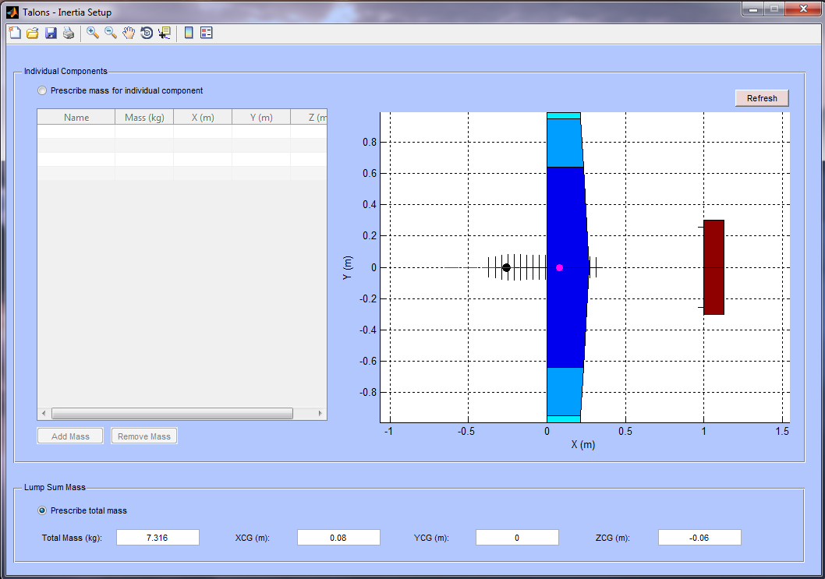

Figure 3: Mass Properties

Inertia, as shown in Figure 3, can be defined in two ways:

* **Prescribe individual components**: you can specify each component (e.g. wing, servo-actuator, spar) as a point mass.
* **Prescribe a lump-sum mass**: if you already know the total mass and CG of the aircraft, you can specify it as a lump-sum.

The total CG is shown in the right hand plot as the pink dot. You will need to hit the refresh button if you have updated any mass values to update the graph.

## Propulsion Characteristics

For each propulsive unit you have defined in the Geometry Setup, Talons assumes identical propulsive properties; that is, they all have the same engine and propeller. The propulsion properties are defined in Figure 4.

The thrust model is specified through an equation with the variables V as airspeed, h as pressure altitude and T as ambient temperature. The fuel/energy consumption model is specified through an equation with the variables V as airspeed, h as pressure altitude and T as ambient temperature.

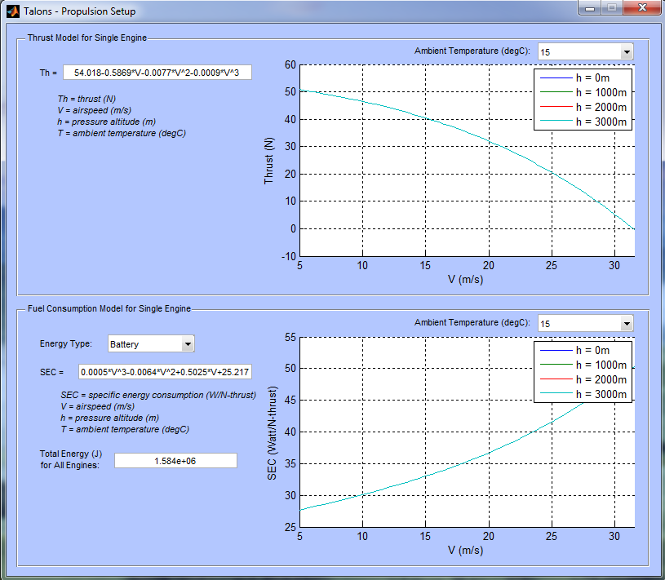

Figure 4: Propulsion Setup

## Flight Conditions

Other crucial data that are required for analysis are included in the Flight Conditions section, as seen in Figure 5. In this window, you specify:

* The runway pressure altitude
* Target cruise height above runway
* Delta temperature from ISA for the flight
* Target cruise airspeed
* The viscous drag: assumed to be uniform for the entire operational regime.
* Useable CLmax: the CLmax above which stall is likely to occur. Operationally, it is recommended to set this value to the point where the lift curve substantially deviates from linearity.
* Dynamic viscosity of air in the flight regime

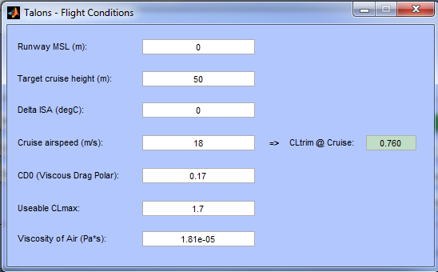

Figure 5: Flight Conditiosn Setup

# Analyze and Interpreting Results

When you have defined all the details above, you are ready for analysis. Open the Analyze window and hit Run. If you have missed some critical definitions, the analysis will fail and an error message will be displayed to let you know which section has not been sufficiently defined.

Otherwise, a window like Figure 5 will be displayed, which shows the linearized lift and pitch moment curves, in and out of the maximum ground effect.

## Aircraft Performance

The aircraft performance prediction is shown in Figure 6. The following characteristics are analyzed:

* **Turning performance at cruise**: the minimum turn radius and maximum load factor for steady level turn are displayed on a graph with respect to airspeed. The solid dot indicates cruise condition.
* **Climb/descent performance**: the maximum rate of climb and descent are plotted against airspeed at the runway pressure altitude and the maximum cruise altitude as defined in the Flight Conditions window. Note that since the aerodynamics model is linear, the minimum drag point as shown in the climb performance chart may be at a higher airspeed than indicated.
* **Trimmed drag polar**: this plot indicates where on the trimmed drag polar the cruise condition is. Its location relative to the defined CLmax is also indicated.
* **Endurance and range**: using the propulsion data supplied, the range and endurance can be calculated. The values, however, are calculated based on constant cruise values and do not take into account takeoff, climb and landing segments.
* **Takeoff and landing performance**: using the rotation and flare data supplied in the window, the takeoff distance and stopping distance are calculated.

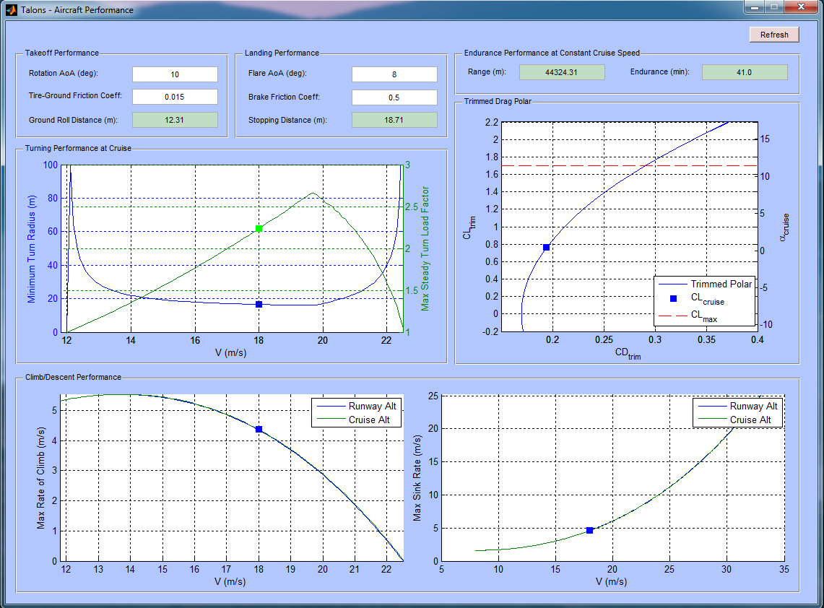

Figure 6: Aircraft Performance Results

You can conduct perturbation analysis by iterating over the flight conditions. Simply click the Refresh button when any flight condition value has changed to re-calculate the performance predictions.

## Stability & Control

Static longitudinal stability and static lateral-directional stability characteristics are predicted. Propulsive effects can be included or excluded from the prediction (i.e. max throttle vs. idle throttle) using the dropdown menu from the upper right corner. The control surface hinge moments are displayed on the right hand side. See Figure 7 for a sample output.

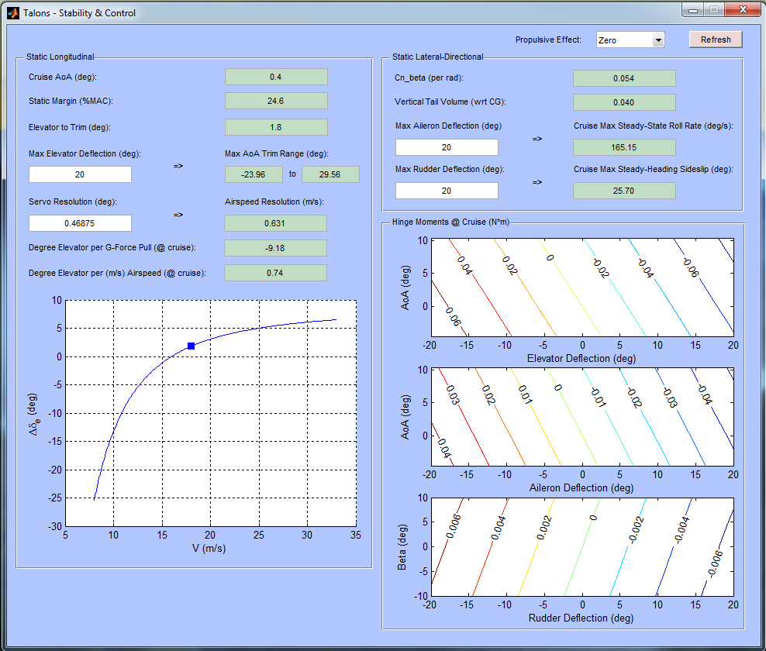

Figure 7: Stability & Control

You can conduct perturbation analysis by iterating over the flight conditions. Simply click the Refresh button when any flight condition value has changed to re-calculate the predictions.

## Ground Handling

The static ground handling characteristics are predicted in Figure 8. The static tipback angle and overturn tendency are predicted.

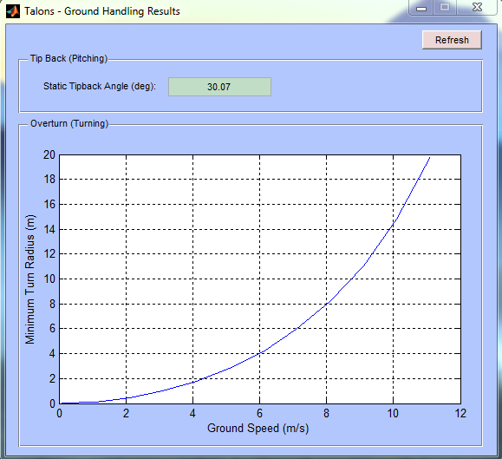

Figure 8: Ground Handling