OFFICIAL SOFTWARE SUITE • MICROSOFT FLIGHT SIMULATOR
SceneryX — User Manual
A comprehensive guide to scenery management, interactive world exploration, Smart LOD regulation, and hardware graphics optimization.
- SOFTWARE VERSION: Release Candidate v1.1.0 (Build RC_v1.0.9 Engine)
- SIMULATOR COMPATIBILITY: MSFS 2020 & MSFS 2024 (Store, Steam & Cloud Streamed)
- PUBLISHER & ARCHITECTURE: Sidestick Priority (x64 Native)
1. Introduction & General Architecture
SceneryX is a high-performance, native 64-bit desktop application specifically engineered for flight simulation enthusiasts on Microsoft Flight Simulator (MSFS 2020 and MSFS 2024). Designed as a central command dashboard, it unifies scenery library organization, intelligent package conflict resolution, flight route optimization, dynamic Level of Detail (Smart LOD) governance, live telemetry logging, and hardware-tailored graphics calibration.
Core Architecture Principles:
- Absolute Stability & Safety: Your original simulator configuration files (UserCfg.opt) are cloned and backed up prior to any modification, allowing instantaneous, one-click rollback.
- Dual-Environment Detection: Native, seamless support for both MSFS 2020 (Community and Official directories) and MSFS 2024 (including dedicated Community2024, Official2020, Official2024, and cloud-streamed packages).
- 1/2 Sync Calibration: Precise frame-rate matching based on your monitor’s physical refresh rate to completely eradicate frame pacing stutters and micro-jitter.
2. Installation, License Activation & First Launch

Installation is performed via the SceneryX_Setup.exe wizard. If a previous version of SceneryX is detected, the installer applies an in-place upgrade without overwriting your configured paths, scenery database, or custom preferences.
- Launch SceneryX_Setup.exe.
- On the Product License Activation screen, enter your Gumroad license key (a 32-character hexadecimal key in standard UUID format).
- The installer audits your hardware baseline and creates two balanced default profiles (2D Display Standard and VR Headset Standard) in:
%APPDATA%\SceneryX\custom_profiles\
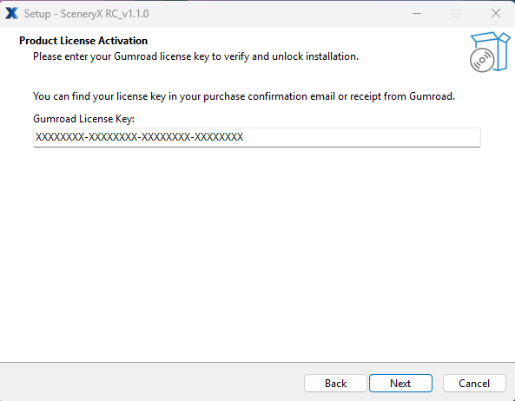
3. Main Interface & Navigation Layouts
SceneryX offers two complementary navigation workflows, selectable anytime under Settings:
3.1 Classic Sidebar Layout (Flight Ops)
The left-hand sidebar hosts the filtering hierarchy, country selection, library investment statistics, flight optimizer shortcuts, and the full alphabetical list of airfields with single-click navigation.
3.2 Tactical Radial Hub Layout
Centered directly over each airport marker on the world map, the Tactical Radial Hub deploys four interactive quadrants displaying installed scenery packages, scheduled airline routes, runway specifications, and GSX Pro profile status.
3.3 Top Live Telemetry Bar & Bottom Command Deck

- Top Status Bar: Displays the total count of scanned airfields categorized by license type: Airports, Payware, Freeware, Asobo, and Default MSFS. It also features dynamic global intelligence banners, including:
  - Polar Outpost: Highlights the most remote northern or southern airfield in your library (e.g., SVALBARD, LONGYEAR (ENSB) AT 78.2°N).
  - Top Destination: Automatically identifies your most scenery-dense country (e.g., TOP DESTINATION: FR (59 ADDON SCENERIES)).

- Bottom Command Deck: Features a universal search bar (ICAO, Airport Name, City, or Country), the Export Sceneries toolkit, the one-click Rescan Packages button, and quick access to Settings and UI layouts.

- Export Scenery Collection: Allows exporting your scenery library across two scopes:
  - Export Scope: Choose between All Sceneries (complete physical and streamed collection) or Filtered List (currently active map query).
  - Export Formats: Export as a CSV Spreadsheet (compatible with Excel, Volanta, and Elevatex) or as a structured JSON Backup for external flight sim tools.
Figure 2.1 — Global world map overview with regional clusters, status counters, and top intelligence banner.
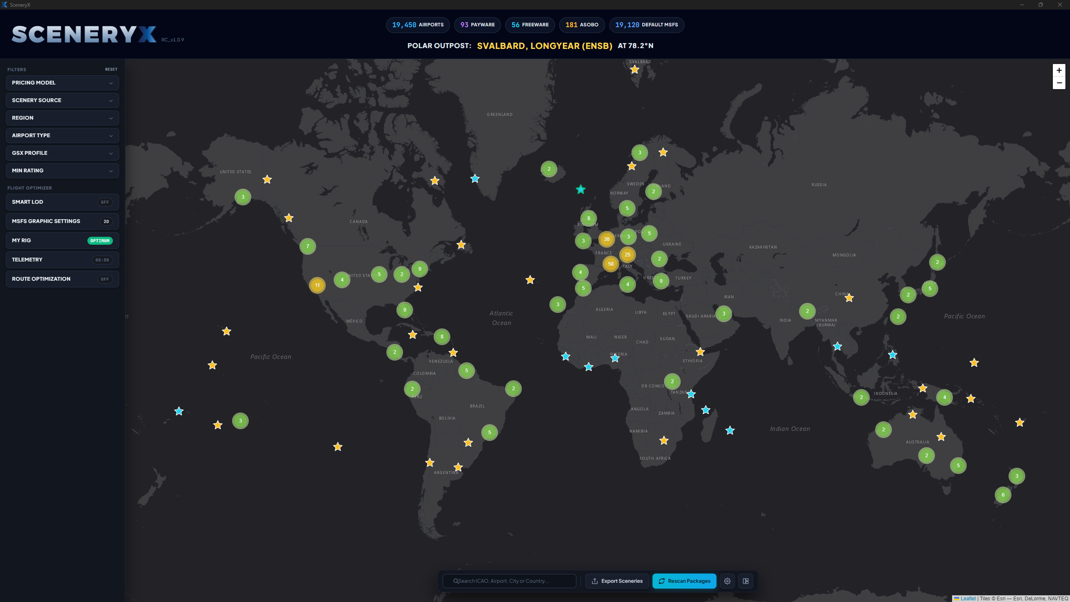
Figure 2.2 — Top intelligence metrics: library breakdown and top country addon concentration.

Figure 2.3 — Bottom command bar: multi-criteria search, scenery export, and package rescan.


Figure 2.4 — Detailed regional view (France) showing clustered airfields and custom highlighted airports.

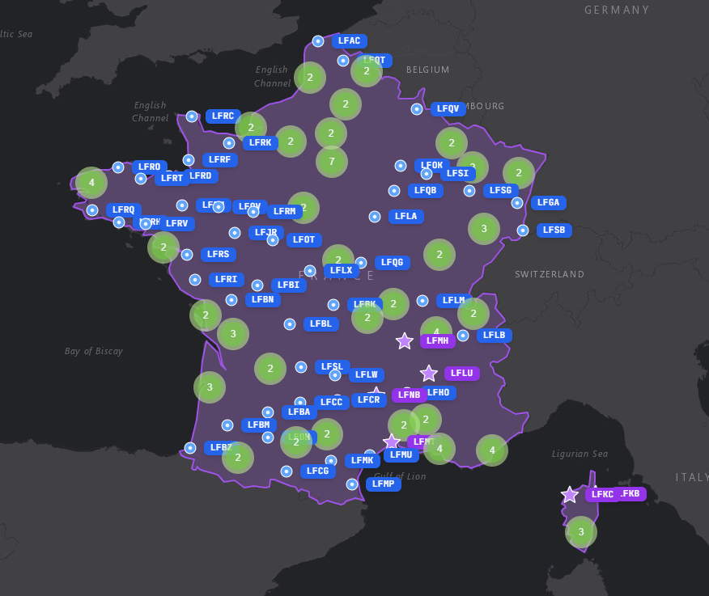

Figure 2.5 — Export Scenery Collection modal supporting and JSON formats.
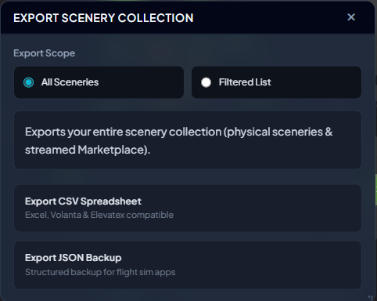
4. Tactical Radial Hub & Airfield Intelligence
Clicking on any airport marker reveals the circular Tactical Radial Menu, granting instant access to three deep-dive inspection windows:
4.1 Airport Details & GSX Pro Integration
- Airport Telemetry: Displays exact decimal latitude/longitude, classification (INTERNATIONAL, REGIONAL, GENERAL AVIATION, HELI/WATER), and field elevation (ft).
- Runway Specifications: Lists runway designators (e.g., 05/23), surface type (Asphalt, Concrete, Grass), total length, and width in both feet and meters.
- Scenery Price & Valuation: Displays the estimated market value of the installed package and allows recording your actual purchase price (Price Paid) to track your total simulator investment.
- Personal Rating: Interactive 1-to-5-star rating system for personal library curation.
- GSX Profile Management: Detects active ground service profiles. If missing, use the direct link to Search Flightsim.to, or drag and drop any .zip or .ini profile directly into the DROP ZONE for automated extraction and installation into %APPDATA%\virtuali\Airports.
4.2 Available Add-ons & Live Store Comparator
- Package Multi-Stack: Lists all installed versions (Payware, Asobo World Updates, Default base scenery) with version numbers, installation paths, and disk footprints.
- Instant Isolation: One-click toggle to isolate a package and disable duplicate geometries.
- Integrated Store Comparator: Real-time price tracking across more than 15 flight simulation storefronts (Orbx Direct, Flightsim.to Store, iniBuilds Store, Contrail Web Shop, simMarket, Aerosoft Shop), ranked from lowest to highest price.
4.3 Operating Airlines & Route Network
- Real-World Operator Matrix: Visual airline board displaying carrier logos serving the selected airfield (e.g., Air Berlin, Condor, Transavia, TUI fly, TAP Portugal, easyJet, Jet2.com, Luxair).
- Addon Coverage Ratio: Displays the exact percentage of destinations in that airline’s network that you own as high-quality addons (% Payware, % Freeware, % Asobo, % Default).
- Interactive Destination Tracking: Selecting any carrier plots their scheduled routes directly across the world map with color-coded ownership badges (OWNED, PAYWARE, ASOBO, DEFAULT).
4.4 Radial Map Filters (Multi-Ring Filter Hub)
In addition to the classic sidebar, the Radial Hub features an outer filter ring allowing you to filter the active map view directly by Pricing Model, Airport Type, Scenery Source, Region, GSX Profile, and Min Rating.

Figure 3.1 — Tactical Radial Menu centered over Madeira Funchal Airport (LPMA/FNC).

Figure 3.2 — Airport Details window: runway specs, valuation, rating, and GSX drag-and-drop dropzone.
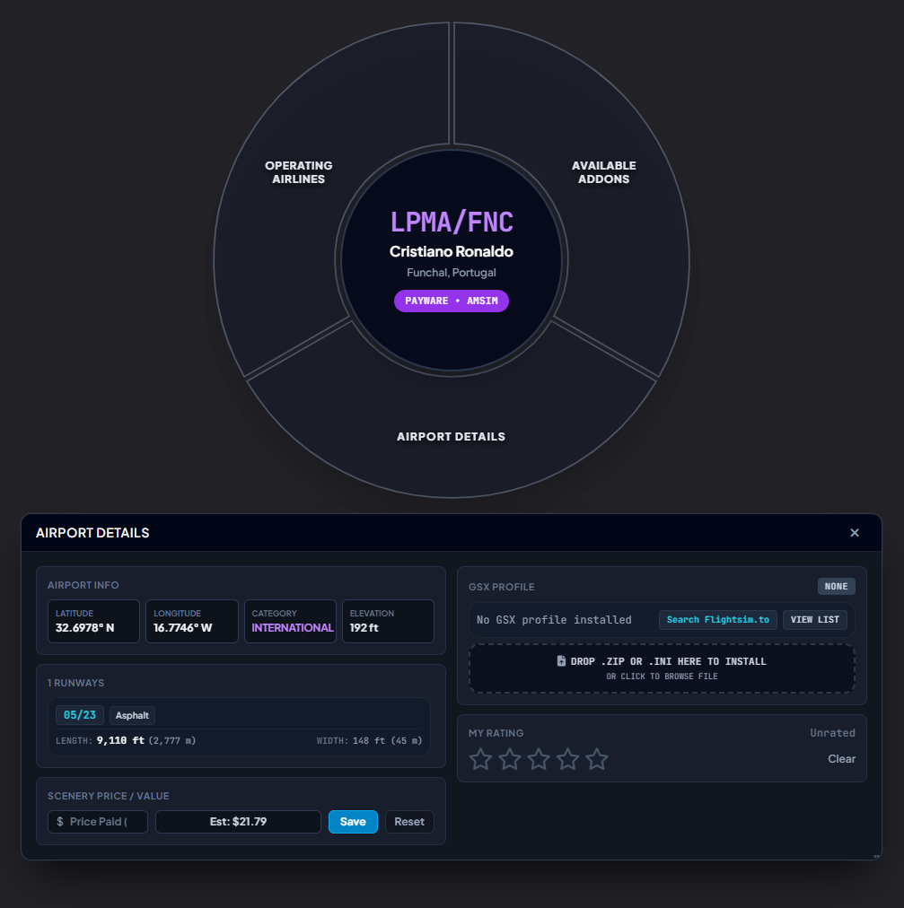
Figure 3.3 — Available Add-ons modal with live multi-store price comparator.
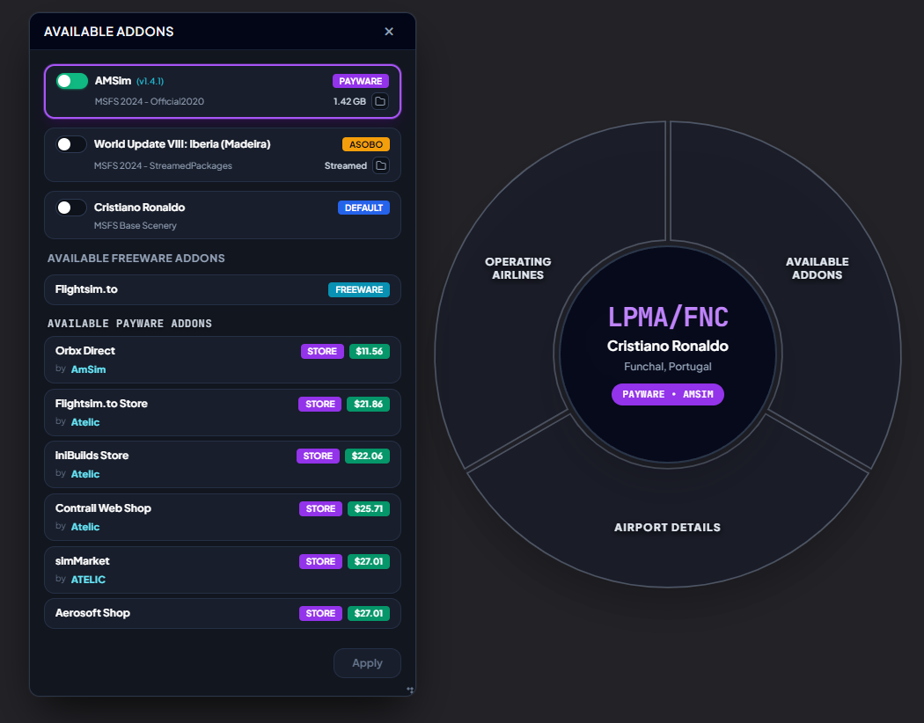
Figure 3.4 — Operating Airlines window: airline logos, route coverage ratio, and visual route lines.
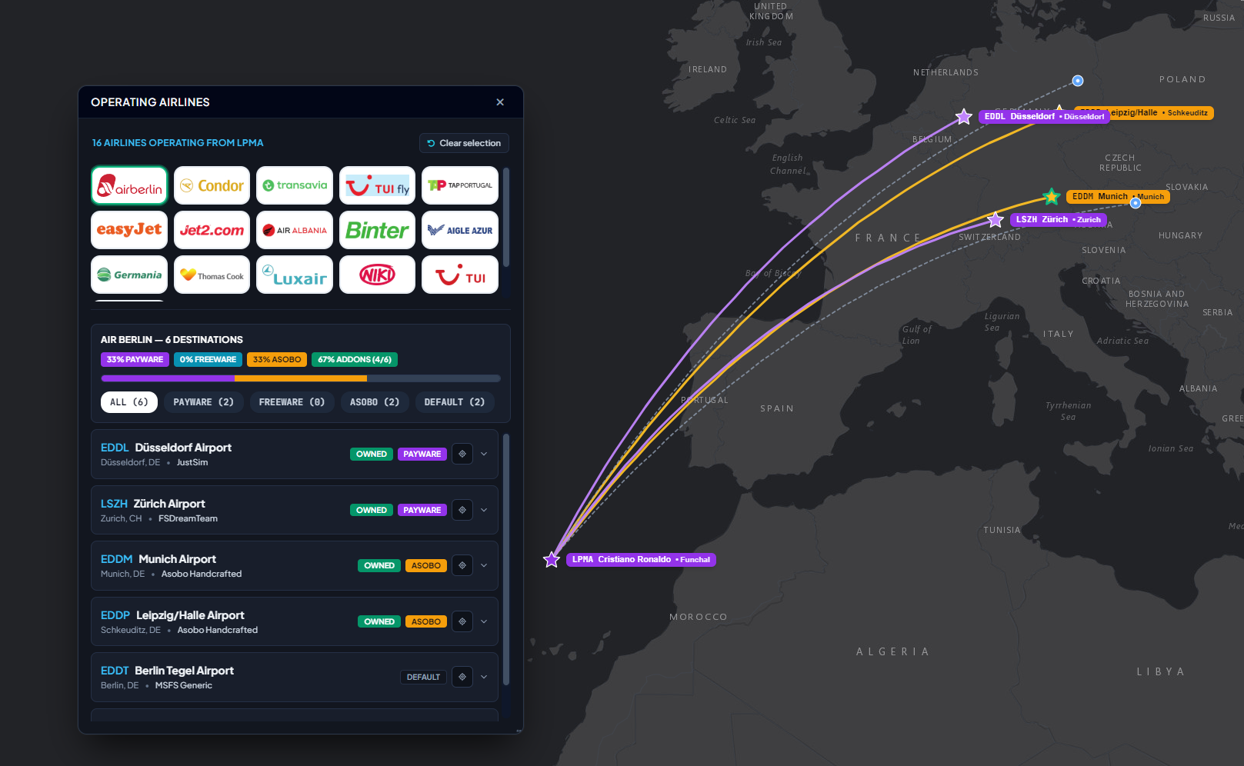
Figure 3.5 — Radial Multi-Ring Filter Hub configured for Pricing Models.
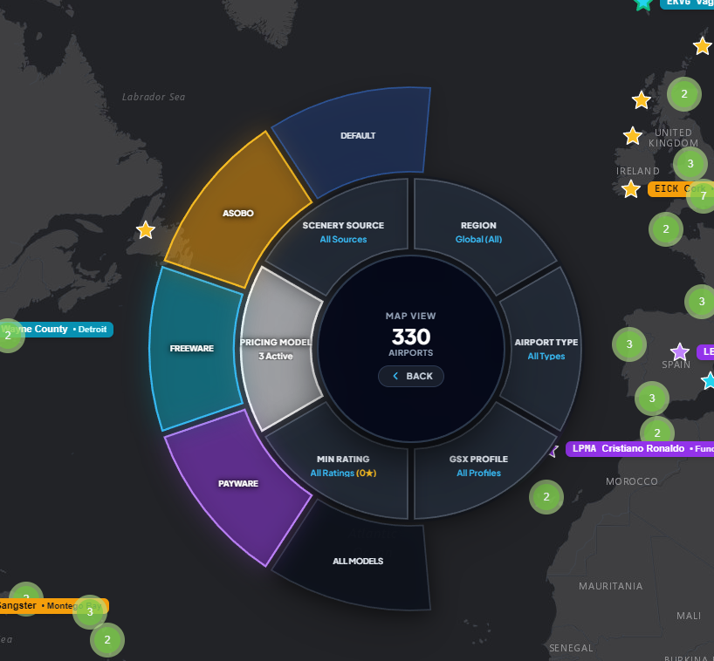

Figure 3.6 — Radial Multi-Ring Filter Hub configured for Airport Types.
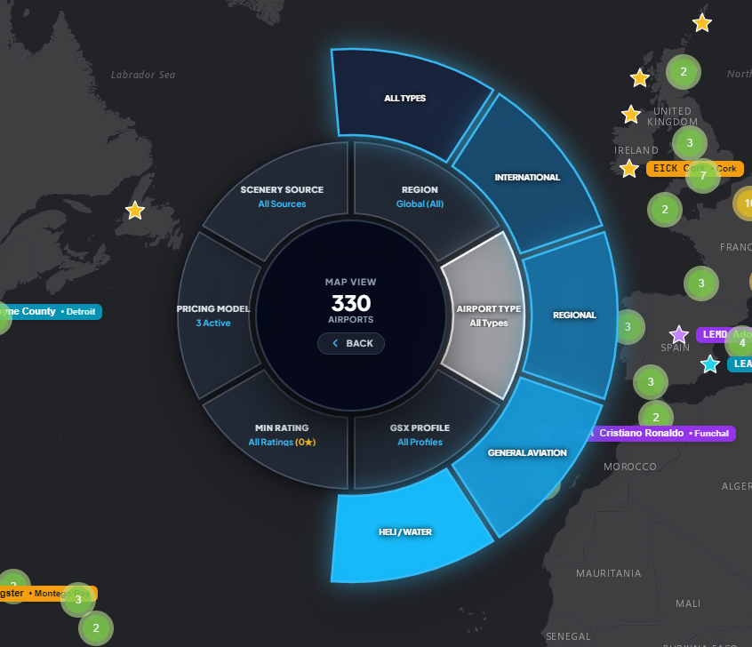
5. Scenery Library Manager & Multi-Criteria Filtering (Sidebar Mode)
The collapsible sidebar filter engine provides granular control over your collection:
- Pricing Model: Filter simultaneously across Payware (purple), Freeware (cyan), Asobo Handcrafted (orange), and Default MSFS (dark blue).
- Scenery Source: Segment by local Community, official packages, or MSFS 2024 cloud-streamed packages.
- Geographical Region: Filter across 11 distinct global sectors (Western Europe, Eastern Europe, North America, Central America, South America, Asia, Middle East, North Africa, Sub-Saharan Africa, Oceania, and Pacific Ocean).
- Airport Type: International Hubs, Regional fields, General Aviation (GA), or Heliports/Seaplane bases.
- GSX Profile: Isolate airports that have valid ground profiles installed versus those missing profiles.
- Minimum Rating: Filter fields based on your custom star ratings.
Figure 4.1 — Sidebar filter panel: Pricing Model selector with color-coded categories.
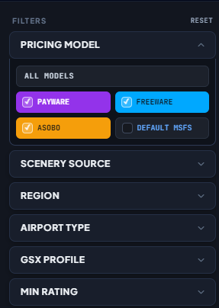
Figure 4.2 — Sidebar filter panel: Geographic Region selector with multi-zone checkboxes.
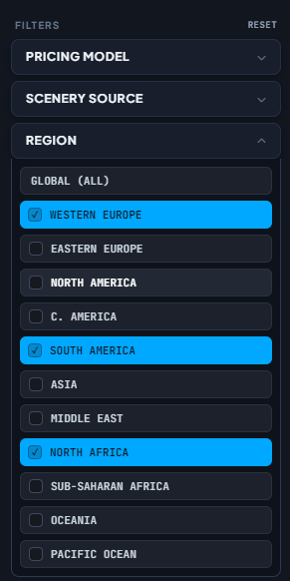
6. Flight Route Optimizer & SimBrief Corridor Isolation
The Flight Route Optimization module eliminates out-of-memory errors (OOM) and frame pacing degradation during medium and long-haul flights by temporarily deactivating sceneries outside your active flight trajectory.
- Route Definition: Enter departure and arrival ICAO codes (e.g., KJFK ➔ LFPG) or click « IMPORT SIMBRIEF » to fetch your active dispatch plan.
- Optimization Mode:
  - Direct A ➔ B: Activates only your departure and arrival sceneries, putting all intermediary airports into standby.
  - En-Route Corridor: Defines an airway buffer (e.g., 60 NM) keeping en-route alternates and overflown hub sceneries active.
- Resource Metrics: SceneryX calculates the exact number of isolated sceneries and the freed memory footprint (e.g., 328 Isolated Sceneries, 1.74 GB RAM Freed, 410 MB VRAM Freed).
- Click « OPTIMIZE » to apply the configuration.
Figure 6 — Flight Route Optimization window plotting KJFK to LFPG with real-time memory savings metrics.
7. Dynamic Smart LOD Governor & Auto Cloud Recovery
The Smart LOD dynamic governor eliminates MainThread CPU bottlenecks on the ground while maximizing visual range at high altitudes.
- Smart Dynamic Terrain LOD Engine: Toggle on/off the real-time altitude governor.
- Dynamic LOD Thresholds & Targets:
  - Terrain LOD (TLOD): Set your minimum ground Floor (e.g., 100) and maximum Cruise target (e.g., 200). Live altitude telemetry and current LOD values are displayed in real time.
  - Objects LOD (OLOD): Independently adjust object complexity to reduce CPU overhead around airport terminals.
- Target FPS & Auto Cloud Recovery: Enter your target frame rate (e.g., 82 FPS). When entering thick cloud formations or encountering heavy frame pacing strain, Auto Cloud Recovery dynamically scales volumetric clouds to maintain your target framerate.
- Profiles Management: Save and switch between custom profiles (e.g., Balanced Airliner, Heavy VFR, Bush Flying).
Figure 7 — Smart LOD configuration panel with dynamic altitude sliders and Auto Cloud Recovery.
8. « MY RIG » Diagnostic & System Optimizer
The MY RIG & SYSTEM control panel provides an automated operating system audit and hardware telemetry baseline.
8.1 System Optimizer (Windows & GPU Calibration)
The WINDOWS DIAGNOSIS banner displays an overall system status (OPTIMAL) and evaluates 7 key parameters:
- GPU Scheduling (HAGS): Verifies Hardware-Accelerated GPU Scheduling (required for DLSS 3 Frame Generation). Includes one-click access to Windows 11 settings.
- Windows Game Mode: Direct toggle switch to prioritize MSFS thread execution and pause background tasks.
- Windows Power Plan: Ensures the system runs on Ultimate Performance or High Performance to prevent CPU core parking.
- Re-Size BAR (ReBAR): Validates full CPU access to the entire GPU VRAM pool for smooth asset streaming.
- DirectX Shader Cache: Displays live cache footprint (e.g., 56.4 MB) against recommended quotas (10 GB or Unlimited) to prevent DirectX compilation stutters.
- GPU Driver & Control Panel: Checks installed driver versions and provides quick shortcuts to the NVIDIA App and classic Control Panel.
- Virtualization-Based Security (VBS / HVCI): Analyzes core isolation virtualization impact on flight simulation CPU throughput.
8.2 Hardware Specs & Display Calibration
The RIG ARCHITECTURE overview audits your physical components:
- Processor (CPU): Physical cores, threads, and architecture.
- Graphics Card (GPU): Model, dedicated VRAM, and driver build.
- System Memory (RAM): Total capacity, clock frequency (MHz), and XMP/EXPO status.
- Storage / MSFS Drive: Detects PCIe NVMe models, read/write speeds, and free disk headroom.
- Primary Display & Cadence: Displays connected monitors (e.g., DISPLAY1 @ 180 Hz, DISPLAY2 @ 165 Hz). Clicking a display automatically binds it and calibrates the exact 1/2 Sync target (e.g., 82 FPS or 90 FPS) directly into your simulator configuration.
- VR Headset: Detects active VR hardware (e.g., Pimax Crystal Light, Meta Quest, Varjo) and operating refresh rates.
- Network & Latency: Real-time link speed (1 Gbps Full Duplex) and ping monitoring.
- Runtime Accelerators: Live status of DirectX 12, ReBAR, HAGS, DLSS version, and Frame Generation.
Figure 8.1 — MY RIG System Optimizer tab displaying the 7-point Windows and GPU audit checklist.
Figure 8.2 — MY RIG Hardware Specs tab displaying system architecture and high-refresh display calibration.
9. MSFS Graphics Optimizer & UserCfg.opt Manager
The Graphics Optimizer provides direct, safe editing of your simulator's graphics settings across three dedicated environments: SHARED, 2D DISPLAY, and VR HEADSET.
9.1 2D Display Configuration (Flat Screen Flight)
- Frame Rate & Sync: Resolution selector, Max Frame Rate limiter, V-Sync toggle, and 1/2 V-Sync Interval (e.g., 50% @ 82 FPS for a 165 Hz display).
- NVIDIA Reflex & Frame Generation: Reflex Low Latency activation, DLSSG (2X) Frame Generation, and Framerate Multipliers.
- Real-Time Performance Gauges: Live MainThread CPU Load bar (e.g., 46% Smooth) with target pacing recommendations.
9.2 VR Headset Configuration (Virtual Reality Flight)
- Headset & Sync: Dedicated stereo frame synchronization and reprojection modes.
- Optimizations & DLSS: Anti-Aliasing & Upscaling presets (e.g., DLSS Quality • 67% Render • Sharp Cockpits), Dynamic Settings toggle, and Foveated Rendering with adjustable scale sliders (e.g., 50%) to reduce peripheral GPU workload by 10–15%.
- VRAM & GPU Memory Budget: Real-time VRAM allocation bar (e.g., 5.1 / 16 GB, 32%) ensuring ample safety headroom for heavy airport textures.
- Profile Management: One-click options to save custom graphics profiles or click « RESTORE ORIGINAL CFG » for instant recovery.
Figure 9.1 — MSFS Graphics Settings: 2D Display mode with 1/2 Sync limiter and DLSS Frame Generation.
Figure 9.2 — MSFS Graphics Settings: VR Headset mode with Foveated Rendering and VRAM budget tracking.
10. Live Flight Monitoring & Telemetry Blackbox
The Live Flight Monitoring window functions as your simulator's telemetry dashboard and flight recorder:
- Flight Telemetry Controls: Start/stop flight data recording with live connection badges (SIMCONNECT LIVE and SMART LOD LIVE).
- Flight Identification: Detects active aircraft type, flight origin, destination, and scenery optimization profile.
- Performance Telemetry:
  - Displayed FPS vs. Base FPS: Distinguishes between native simulator frames and interpolated DLSS 3 frames.
  - CPU MainThread Frametime: Real-time CPU latency in milliseconds (ms).
  - Hardware Telemetry: Live GPU usage (%) and temperature (°C), CPU load (%) and temperature (°C), allocated VRAM (GB), and texture cache usage.
  - 30s Trend Graph: Live sparkline graph visualizing frame pacing stability over the last 30 seconds.
- Recorded Flight Reports: Access your post-flight telemetry logs to analyze 1% Low framerates and identify stutter triggers.
Figure 10 — Live Flight Monitoring console tracking frame times, CPU/GPU temperatures, and SimConnect telemetry.
11. In-Game Cockpit Toolbar Panel (HUD 2D & VR)
Installed directly into Microsoft Flight Simulator via the « INSTALL » button located in Settings, the SceneryX in-game toolbar panel injects a lightweight Head-Up Display (HUD) accessible directly from the simulator's top bar during flight.
- Adjust TLOD and OLOD sliders on the fly without pausing the simulator or opening external menus.
- Monitor live CPU MainThread frame latency (ms), GPU frame time, and FPS in both 2D and VR cockpit views.
- Toggle Auto Cloud Recovery dynamically when approaching low-visibility or stormy weather layers.
12. Settings, Path Management & Advanced Preferences
The Settings & Configuration panel centralizes all application behaviors across four tabs:
- MSFS Scenery Paths: Multi-folder management with individual enable/disable switches, file browsing, and Windows Explorer shortcuts:
  - MSFS 2024 - Community
  - MSFS 2024 - Community2024
  - MSFS 2024 - StreamedPackages
  - MSFS 2024 - Official2020
  - MSFS 2024 - Official2024
  - GSX Pro Profiles Directory (%APPDATA%\Virtuali\GSX\MSFS)
- SimBrief Integration: Pilot ID or username input field for automatic flight plan retrieval.
- Map Airport Labels: Independent toggles for Show ICAO Code, Show Airport Name, and Show City.
- Camera & Map Settings: Set default startup viewport (World, Europe, North America), Selection Zoom slider (default 8.0), and Pan Duration slider (default 1.1s).
- Navigation Style: Switch between Tactical Radial Menu and Classic Side Panel.
- Interactive Guided Tour: Launch the built-in 25-step interactive walkthrough anytime to tour all software features.
- Dynamic LOD Delegation: Optional toggle to delegate dynamic LOD regulation exclusively to the external MSFS_AutoFPS.exe utility instead of SceneryX Smart LOD.
- In-Game Toolbar Panel: One-click INSTALL button to deploy or update the in-sim cockpit toolbar widget.
- Crash Reporting & Privacy: Fully transparent diagnostic toggles (Send Crash Reports Automatically and Share Anonymized Flight Statistics).
- Database Maintenance: One-click Reset Database button to rebuild the local cache if packages change.
Figure 12.1 — Settings: Scenery Paths management for MSFS 2020/2024 packages and GSX Pro.
Figure 12.2 — Settings: SimBrief Pilot ID, Map Labels, and Camera Pan calibration.
Figure 12.3 — Settings: Navigation Mode, 25-step Interactive Walkthrough, Language, and Currency.
Figure 12.4 — Settings: Dynamic LOD engine delegation (MSFS_AutoFPS), In-Game Toolbar installer, and Privacy.
13. Troubleshooting & Support
- Configuration Safety Rollback: If simulator graphics ever behave unexpectedly, open MSFS Graphics Settings and click « Restore Original CFG » to revert to your untouched backup.
- Application Logs: Diagnostic logs are stored in %APPDATA%\SceneryX\logs\.
- Technical Support: For inquiries, technical assistance, or bug reports, contact us directly at:
contact@sidestickpriority.com

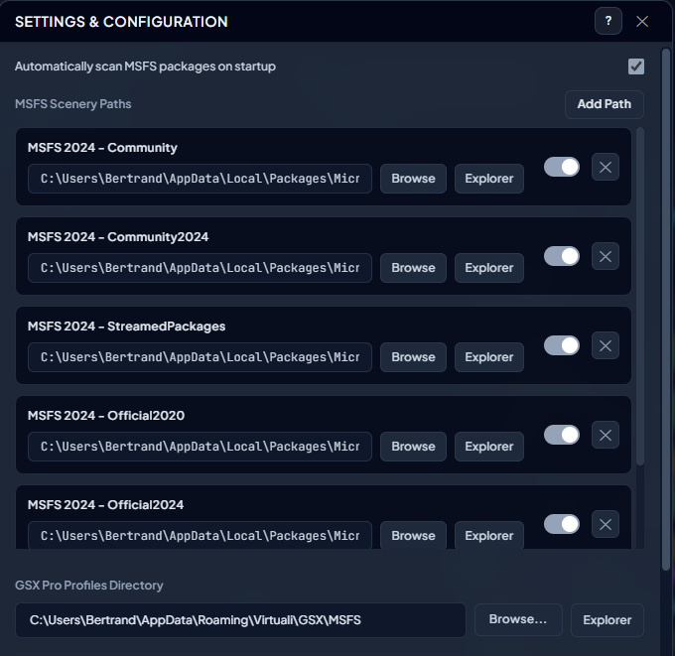
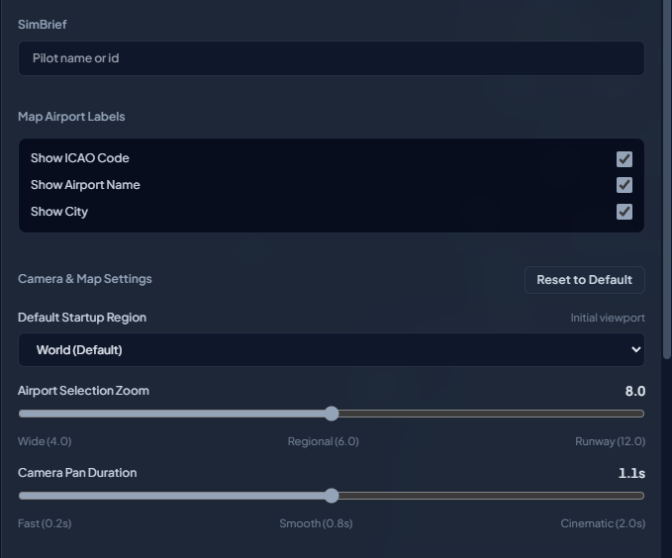
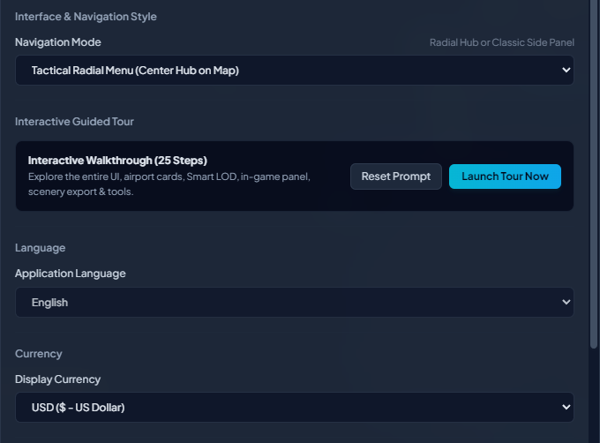
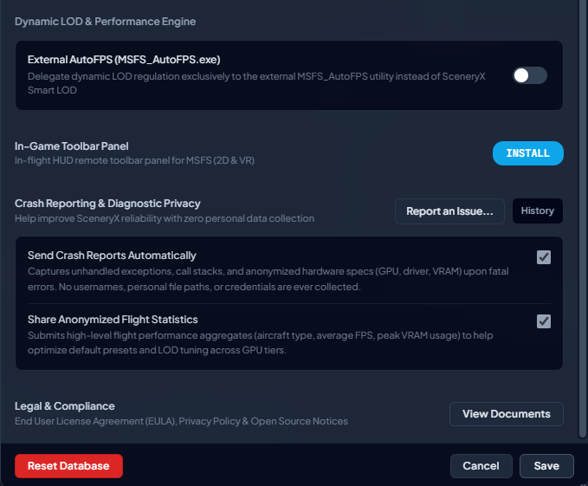

Figure 2 — Overview of the interactive world map and global library status.

