XInstall – XML Installation Document

XInstall is an XML based installation program. To run the installation program you will first create a configuration file called, config.xml and defined the action tags to tell the XInstall how to perform an installation process. The following table list valid actions that can be recognized by XInstall:

Action Name | Action Attributes | Required | Remark
dbbackup |  |  | To perform a database backup operation.
dbbackup | action | true | To have the dbbackup tag to perform a given action. The valid value are backup
dbbackup | backupdbname | true | Name of the database being backup.
dbbackup | filename | ture | Name of the backup file.
dbbackup | backupfrom | true | Name of the server that contains the database to be backup.
dbbackup | backupto | true | The location of the backup file. This can be an UNC path
dbbackup | trustedconnection | false | A flag indicate if dbbackup should use a trusted connection to connect to a given server.
dbbackup | username | false | User name used to connect to a given sql server if trusted connection is not used.
dbbackup | userpassword | false | User password that associates with a given user that used by dbbackup to connect to a sql server if trusted connection is not used.
dbrestore |  |  | Restore a database from a location to a given sql server.
dbrestore | action | true | An action that tells what dbrestore should do. Only valid action is rstore.
dbrestore | databasename | true | Name of the database that will be restored.
dbrestore | filename | true | Name of the backup file.
dbrestore | datapath | true | Path for the physical data file.
dbrestore | logpath | true | Path for the physical log file
dbrestore | Restorefrom | true | Location of the backup file. This can be an UNC path name.
dbrestore | trustedconnection | false | A flag that tells whether dbrestore should use a trusted connection. By default this is set to true.
dtsbackup |  |  | Backup/restore a set of DTS packages.
dtsbackup | action | True | An action that directs what dtsbackup should do. Valid actions are, backup and restore. Backup will backup available DTS packages to a given location and restore will restore available DTS packages to an assigned SQL Server.
dtsbackup | backupto | false | Location of where the backup DTS packages to put to. This can be a valid path name or any valid UNC path name.
dtsbackup | Restorefrom | false | Location of the DTS packages to be restored. This can be any valid UNC path name or a valid path name.
dtsbackup | dssqlserver | false | A destination sql server that the DTS packages should be restored to.
dtsbackup | sssqlserver | false | Source sql server that contains DTS packages to be backupped.
dtsbackup | trustedconnection | false | The flag that tells dtsbackup should used a trusted connection to connect to a given sql server. By default this is set to true.
dtsbackup | ssuser | false | Source sql server user name if trusted connection is not used
dtsbackup | ssuserpassword | false | Source sql server user password associated with ssuser when trusted connection is not used.
dtsbackup | dsuser | false | Destination sql server user name when trusted connection is not used.
dtsbackup | dsuserpassword | false | Destination sql server user password associated with dsuser when trusted connection is not used.
iisback |  |  | An action tag that backs up a given IIS service metabase.
iisback | action | true | An attribute that tells what iisback should do. The current support action are:  - backup – backup a metabase of a given iis server  - restore – restore a metabase for a given server  - delete – delete a backup of metabase for a given iis server.
iisback | backupfile | ture | This can be a name of metabase to be backup or the backup name of the metabase to be deleted.
iisback | Outputfile | false | An output log file name for the iisback.
iisweb |  |  | An action tag that perform the create website operation on a give iis server.
iisweb | action | true | An action that direct iisweb what to do. The valid action that can be performed are:  - create – create a website on a given iis server.  - start – start a website on a given iis server  - stop – stop a website on a given iis server  - pause – pause website on a given iis server.
iisweb | targetserver | true | Name of the iis server that iisweb will work on.
iisweb | websitename | true | Name of the website being created
iisweb | websiteroot | true | The root path of the website
iisweb | websitehostname | true | The host name for this website. The will setup the value you assigned to the host header value in inetmgr so that people can refer to user friendly name instead of typing a long web url name.
iisweb | dontstart | false | A Boolean value that tells if iisweb should not start the website.
iisweb | port | false | Port that assigned to the website being created.
iisvdir |  |  | An action tag that creates a virtual directory on a given iis server.
iisvdir | action | true | The action that directs what iisvdir should do. The valid action are:  - create – create a virtual directory on a website for a given iis server.  - delete – delete a virtual directory on a website for a given iis server.  - query – query a given virtual directory on a website for a given iis server.
iisvdir | targetserver | true | A valid iis server that iisvdir will work on.
iisvdir | websitename | true | A website for the virtual directory to be created under.
iisvdir | appfriendlyname | true | A friendly name for a virtual directory.
iisvdir | virtualdirname | true | Name of the virtual directory to be created.
iisvdir | mappath | true | Path that virtual directory mapped to.
regex |  |  | Action tag that perform a regular expression for search and replace.
regex | action | true | Action that directs what regex should do. The only valid action now is “replace”.
regex | file | true | File that used to search for a given pattern and replace the found target pattern. File can be a wild card, such as action*.dll will search all the dll files that start with action.
regex | searchpattern | true | A valid regular expression to be searched.
regex | replacewith | true | A string that used to replace found target pattern.
regkey |  |  | An action tag that perform a registry operation.
regkey | action | true | An action directs what regkey should do, the valid actions are:  - create – create an registry key for a given machine.  - delete – delete an registry key for a given machine.
regkey | machinename | false | A machine that the regkey works on.
regkey | basehkey | false | A base hive key that regkey will work on. If not set, default to HKEY_LOCAL_MACHINE
regkey | subkey | true | A subkey that will be open.
regkey | path | true | A key path to be created.
regkey | keyname | true | Key to be crate under path
regkey | value | true | Value assigned to the key just created.
robocopy |  |  | An action tag that performs the copy operation.
robocopy | action | true | An action that directs what robocopy should do. A valid actions are:  - mir – perform a mirror operation. By having this action set, robocopy will examine source and destination to see if the source has changed, if new files or directories has been added, the these new files/directories will be copied over; if the files or directories have been removed from the source, then the same files/directories in the destination will be removed.  - copysub – copy the sub-directories and files from source to  - destination. This is like to perform an xcopy /s/e/c.  - move – move the source to destionation. Like DOS move command.  - purge – purge the files/directories that do not exist in the source from the destination .  - create – create an empty directory structure in the destination same as the source.
robocopy | sourcedirectory | true | The source directory that robocopy will copy from
robocopy | destinationdirectory | true | The destination directory that robocopy should copy to
robocopy | outputfile | false | An log file that robocopy should write to.

You can use any text editor to edit or create a config.xml file. The following is a sample of valid config.xml file that install the COS application:

<?xml version="1.0" encoding="utf-8" ?>
<package
<setup>
<iisback server="tkfssbi01"
action="backup"
backupfile="chengkai"
outputfile="webaction.log" />

<iisweb action="create"
targetserver="tkfssbi01"
websitename="CosWeb"
websiteroot="e:\COS\ver_1.5\CosWeb"
websitehostname="tkfssbi01_cos"
dontstart="true"
port="85"
outputfile="webaction.log" />

<regkey action="create"
machinename="tkfssbi01"
basehkey="HKEY_LOCAL_MACHINE"
subkey="System\CurrentControlSet\Services\Eventlog\Application"
path="COS"
keyname="Default"
value=" " />

<iisvdir action="create"
targetserver="tkfssbi01"
websitename="CosWeb"
appfriendlyname="cos"
virtualdirname="cos"
mappath="e:\cos\ver_1.5\CosWeb"
frindlyname="Cos"
outputfile="webaction.log" />

<regex action="replace"
file="\\tkfssbi01\e$\COS\Ver_1.5\CosWeb\web.config"
searchpattern="%uid%|%pw%"
replacewith="CosUser" />

<iisweb action="start"
targetserver="tkfssbi01"
websitename="CosWeb"
websiteroot="e:\COS"
websitehostname="tkfssbi01"
outputfile="webaction.log" />

</setup>
</package>

To install the packages, under the command prompt, type XInstall

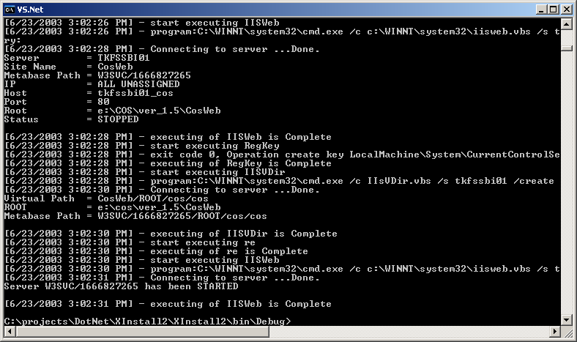

For checking the log file that XInstall generated, cd to the logs directory created by XInstall under the current directory and use NT resource command list to view it or you can use any text editor to view if you don’t have list command available,
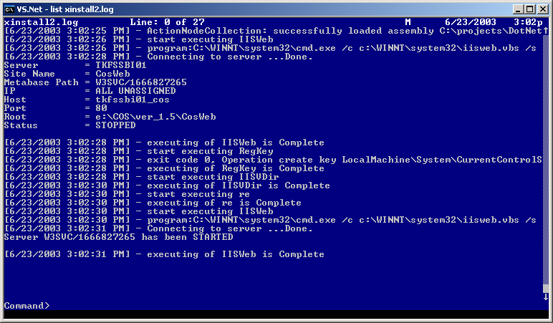

For any other problem or comment, please contact a-chlian.

