Field:
Format:
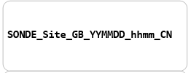
Example:
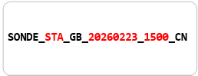

Lab:
Format:
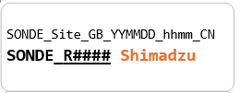
Note: the CN is added to the end to indicate it’s a shimadzu sample
Example:
